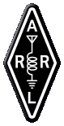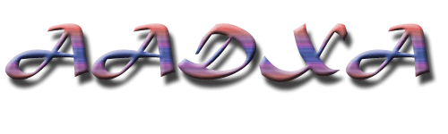

Thank you for your interest in Atchafalaya Amateur DX Association. Our current membership is $12 a year payable to AADXA, INC.
Please send check or money order to AADXA Membership P.O. Box 337 Amelia, La. 70340-0337
Note if you are a new member or 2 or more years since your last membership; paying after January 1st, the dues are prorated to the amount of months left in the year by $1(example- If joining in July, Dues will only be $5 for the rest of the year).

Name...................................................................Call.............................
Ham class........................................... ARRL Member .........Y...........N
Address..................................................................................................
City/State/Zipcode.................................................................................
Phone number (For internal use only)...................................................
Email (To be put on website)...................................................................
Email (For internal use only).................................................................

All Family Members are Free. Please List Below.

Name...................................................................Call.............................
Ham class........................................... ARRL Member .........Y...........N
Address..................................................................................................
City/State/Zipcode.................................................................................

Name...................................................................Call.............................
Ham class........................................... ARRL Member .........Y...........N
Address..................................................................................................
City/State/Zipcode.................................................................................

