ROTRON
Technical Products
627 Lake Street, Kent, OH 44240-2660 U.S.A.
Telephone: 330-677-3875 Fax: 330-677-3306
E-mail: rod.hower@ametek.com
www.ametektmd.com

August, 02 2002

Rod Hower - Senior Project Engineer AMETEK-Rotron

Programming Flash Via Serial SCI on the TMS320LF2402 and 2401 DSP

Requirements: Windows based PC with a serial communications port (COM1 or COM2)
DB-9 serial cable, male on one end female on the other end.
You will need ‘Winzip’ to perform the next step. An evaluation version can be obtained for free at http://www.winzip.com/ddchomea.htm.
Install the file ‘serial_1.0.2.zip’. Double click on the file and winzip will start.
Locate the file ‘setup.exe’ within the winzip file section.
Double click on this file to start the installer. Click ‘next’ and then ‘yes’ to accept the licensing. It will then ask to pick a destination folder.
Click on browse and search for the folder that you should have already created in Windows (for example, I chose ‘ametekdsp’*)
This will install the serial bootload program.
Second level – the program created a folder ‘Sample Coff Files’.
You can delete this folder and create your own folder name that you will store production program files in, for example ‘program files’.
*NOTE: Do not change the name of the default directory ‘ametekdsp’ after installing the program. If you do change this name you will have to re-install the program or change the registry to reflect the new folder name.
It may be useful to right click on the file named ‘SerHost.exe’ and select ‘create shortcut’. Drag this shortcut to your desktop for easy access.

The computer should be configured for proper operation. Most computers will have default settings that will work. To verify proper configuration, click on the start button, chose ‘settings’, then ‘control panel’. In control panel, double click on the icon that says ‘system’. Within system, click on the tab that says ‘device manager’.
There’s a folder called ‘ports (COM & LPT)’. Expand this folder and double click on Communication port (COM1). Select the tab that says ‘port settings’.
Make sure it has the following settings;
Bits per second, 9600 Data bits, 8
Parity, none Stop bits, 1 Flow control, none
Click on the advanced tab and make sure that the transmit and receive buffers are set to high (14 and 16).

Programming
The following procedure should be used for programming the control.
- Make sure the programming interface box is switched off.
- Make sure the selection switch is in the ‘program’ position.

- Plug in the small 8-pin cable so the red striped wire is beside the dipswitch (S1)
There are two rows on the cable. The outside row (opposite side of ribbon cable
wires should be plugged into the 8-pin connector on the control (J1).

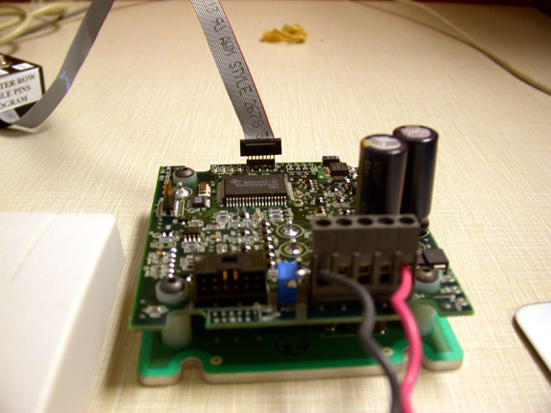

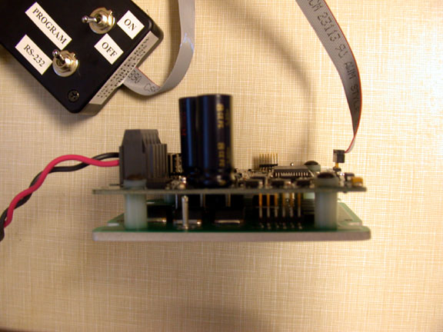

Pictures of how you plug in the ribbon cable for programming the 20 Amp External DSP control.

- Turn on the programmer power switch.
- Double click on the ‘SerHost.exe’ icon on your computer.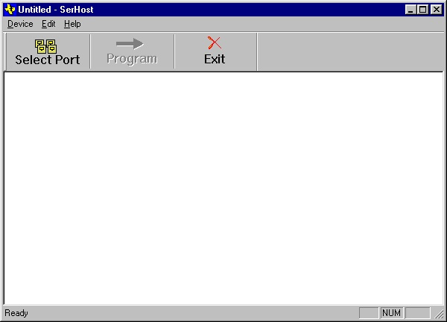

- The first screen will ask which COM port you are using (the one you connected your serial cable too. Preferably it should be COM1.

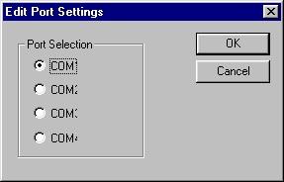

- Click on the ‘program’ icon in the SerHost toolbar.

- Select the proper program file, xxx.out in the file where you keep your production programs.

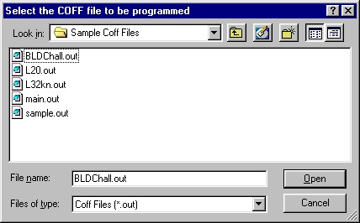

- Click ‘Open’
- The programmer will communicate with the target board and display a sector operation and password control. Click ‘OK’ and a series of screens will be displayed indicating it is programming.

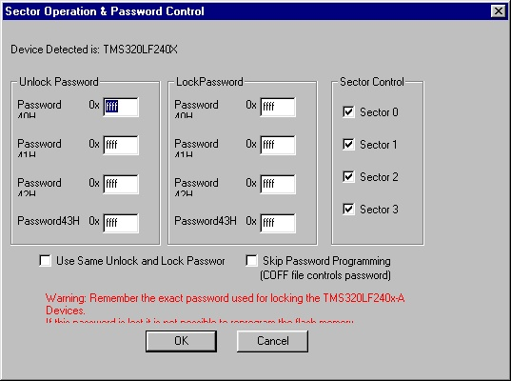

11) When it successfully finishes, you will see this screen.

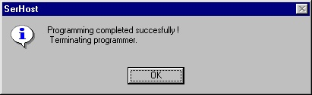

12) Click on ‘OK’ and repeat steps 1 - 11 to program another control.

