Packet Radio
I have my station on the air… What’s Next?

Connecting with a Node
C Connecting onward (S)
B Bye
M or J Heard List

Connecting through (Via) a Digipeater
Selecting a “target” and a “path”
c n7end V n7one, n7two

Using “Unproto”
Public transmission without a connection
Use “CQ” or “ALL” in Unproto
CONVerse mode
cmd: Control Mode (Ctrl-C)

Connecting Keyboard-to-Keyboard
Default is callsign

Connecting to a Personal Bulletin Board System (PBBS)
Default is callsign-1

The structure of various Packet networks
Peer-To-Peer
Backbone

Winlink2000
Remote Message Server (RMS)
Callsign-10 is default
Using Terminal Program
SP SMTP:email@address.com

Packet Maps
Estimate altitudes

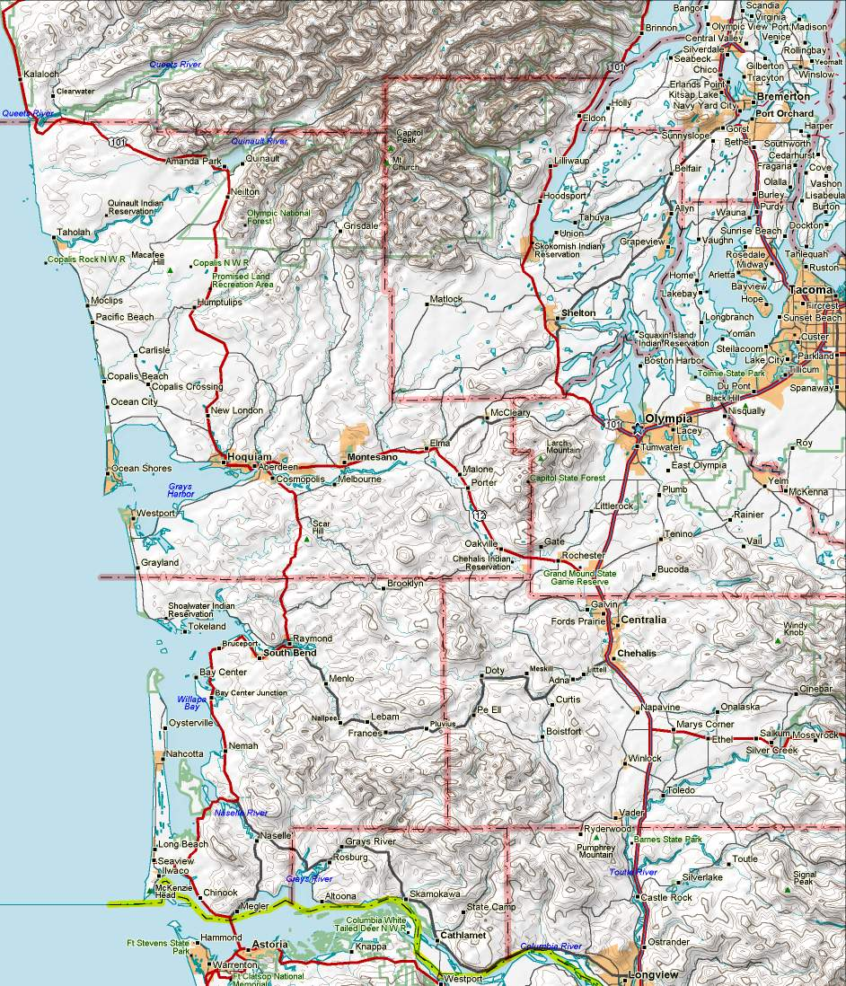
HOLYX
NEILTN
MINOT
ELYSSA
W7EMD
WA7PC
W7RDR
COCEOC
AC7YY-10
K7IEU-10
KD7X-10
AA7ZV-10
K7WG-10
SMTN
W7EOC
MCDEM
VICTOR
WA7OLY
AC7SR-3
Node Digi Call RMS Location Station Keyboard BBS Location
ELYSSA k7idx AA7ZV-10 Puyallup W7EMD w7emd w7emd Camp Murray ECC
HOLYX wa7pc-6 AC7YY-10 Centralia COCEOC ac7yy-4 cocbbs Centralia EOC
MINOT w7eoc-9 K7GA-10 Cathlamet W7EOC w7eoc w7eoc-1 Grays Harbor EOC
NEILTN w7eoc-8 K7IEU-10 Raymond AC7SR-3 ac7sr-3 ac7sr-4 Lewis Co EOC
NICOLI k7ga-8 KD7X-10 Oak Harbor MCDEM aa7cg mcdem Mason Co EOC
SMTN n7sk-7 KF7DJC-10 Centralia WA7PC wa7pc wa7pc-1 Pacific Co EOC
N7DRD-10 Ocean Park W7RDR w7rdr w7rdr-1 Pacific Co AEOC
W5KAV-10 Rochester WA7OLY wa7oly wa7oly-3 Thurston Co EOC

W7EMD-10
Packet Stations 145.630 v5.1
December 2010 de nm7r
K7GA-10
NICOLI
COCBBS
BCFD
Mason
Pacific
Thurston
Lewis
Wahkiakum
Grays Harbor
For stations in this area, see map: “Packet_Seattle”
For stations in this area, see map: “Packet_Portland”
OVILLE
N7DRD-10
KF7DJC-10
W5KAV-10
N7UJK -8 145.63
N7UJK -9 145.05
N7UJK -10 bridge
NM7R-8 145.63
NM7R-9 144.96
NM7R-10 bridge

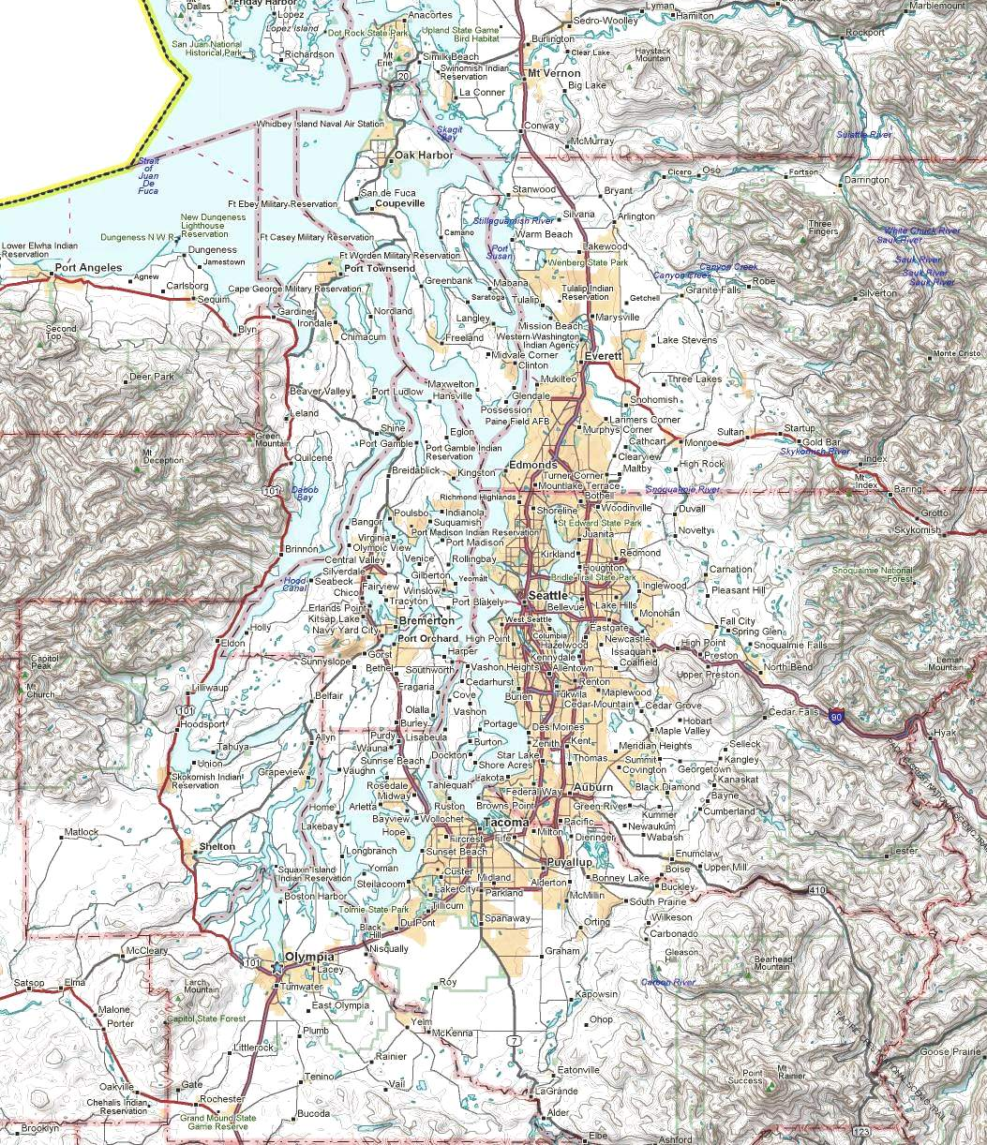
N7UJK-8

N7UJK-9
N7UJK-10
KC7HXC-10
HXCSL
WA7OLY
ELYSSA
W7EMD
KD7X-10
AA7ZV-10
K7WG-10
SMTN
MCDEM
VICTOR
W0QJM-10
KB2SKP-10
AA9MQ-1
K7ORY-12
KD7WDG
MINOT
Packet Stations
Puget Sound Area
Sept. 8, 2010 de nm7r v7.0
Stations Outlined in BLUE
Are on 145.63
Stations Outlined in RED
Are on 145.05
TDGLY
MJQPAC
KC7TDG-13
PCMST
GRAHAM
NOTAC
Node Digi Call Freq _ Node Digi Call Freq _ Station Keybrd BBS Location _
ELYSSA k7idx 145.63 GRAHAM ad7aw-10 145.05 MCDEM aa7cg mcdem Mason Co EOC
VICTOR n7yge-3 145.63 PCMST kc7qic-10 145.05 W7EMD w7emd w7emd Camp Murray ECC
SMTN n7sk-7 145.63 MJQPAC kd7mjq-10 145.05 WA7OLY wa7oly wa7oly Thurston Co EOC
MINOT w7eoc-9 145.63 RMS Location Freq _
K7EK-1 (DX Cluster) 145.63 KD7X-10 Oak Harbor 145.63 Digi Freq_1 Freq_2 Bridge _
K7EK-8 (X-net) 145.63 W0QJM-10 Coupeville 145.63 N7UJK-9 145.05 145.63 v N7UJK-10
SOTAC k7ek-5 145.63 K7WG-10 Shelton 145.63 NOTAC 145.63 223.46 C SOTAC
MEDINA wa7tpb 145.63 AA7ZV-10 Puyallup 145.63 SOTAC 145.05 223.46 C NOTAC
SEABBS k7ek 145.63 K7EK-4 Spanaway 145.63 K7ORY-12 145.63 223.58 X KD7WDG
NOTAC w0lvj-6 145.05 KB2SKP-10 Bremerton 145.63 KD7WDG 145.01 223.58 X K7ORY-12
TDGLY kc7tdg-5 145.05 KC7HXC-10 Renton 145.05
HXCSL kc7hxc-5 145.05
K7EK-4
SEABBS
SOTAC
KB2SKP-7
MEDINA
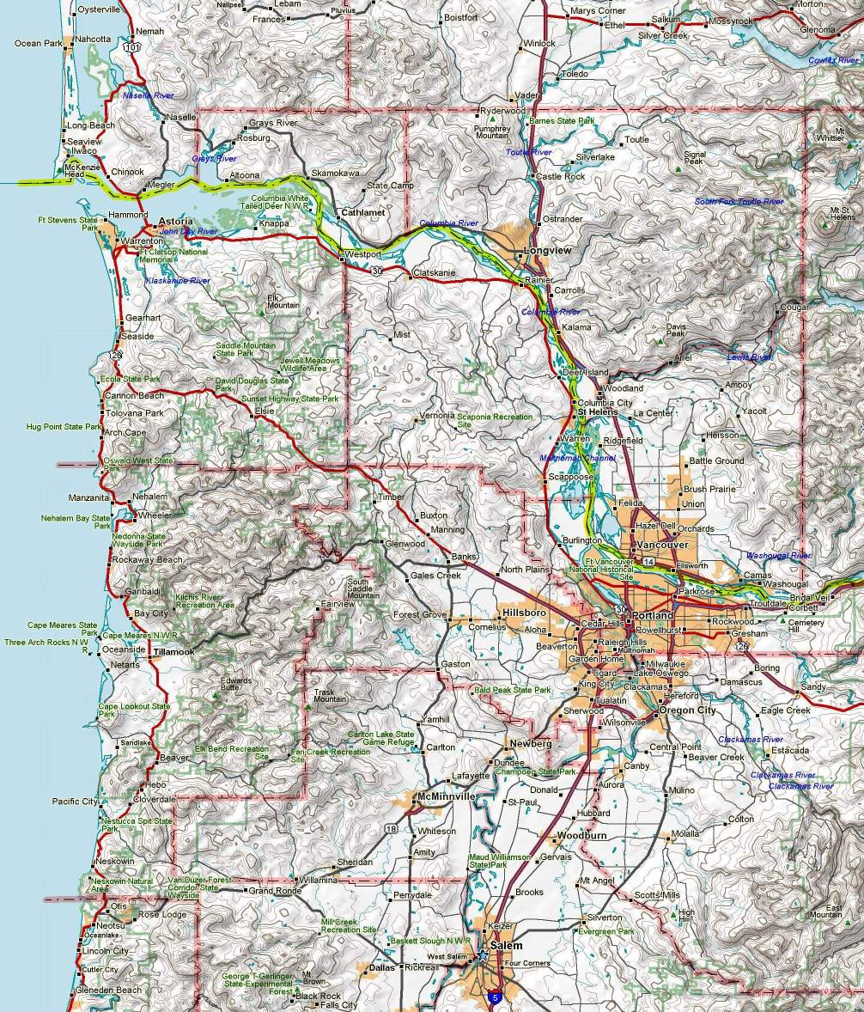
RMS Freq Location Node Freq Node Freq Node Freq Digi Freq
K7GA-10 145.63 Cathlamet NICOLI 145.63 CEDAR 145.63 ARESWC 145.63 W7BU-5 144.96
W7BU-10 144.96 Warrenton JAY 144.96 KELSO 145.09 WSTPLK 144.93
N7AST-10 144.93 Clatsop EOC AST 144.93 PARET 441.50 CEDAR 144.93
IQICMS 145.63 Portland TILLMK 145.03 FG1 145.63 DMASCS 144.95

KB7EOC-10 144.95 Tillamook BVRTN2 145.05 MTHOOD 145.05 HEBO 145.03
W7GC-12 441.50 Hebo PARC 144.91 HCKNSN 145.63 WESCOM 144.93
K7TRP-10 145.05 Beaverton GOBLE 144.91 NM7R-8 145.63 NM7R-9 144.96 NM7R-10 <bridge>
W7AEP-10 144.95 Albany LYONS (1) 144.95

Packet Stations Portland
April 2010 de nm7r v3.0
JAY
NM7R-9
NM7R-10
W7BU-10
W7BU-5
CEDAR
HCKNSN
DMASCS
GOBLE
KELSO
BVRTN2
MTHOOD
HEBO
TILLMK
PARET
VRNONA
WSTPLK
WESCOM
K7RTP-10
W7GC-12
KB7EOC-10
KD7SRE-11
N7AST-10
AST
ARESWC

W0RLI-2
LYONS
W7AEP-10
PARC
FG1
NICOLI
K7GA-10
IQICMS

