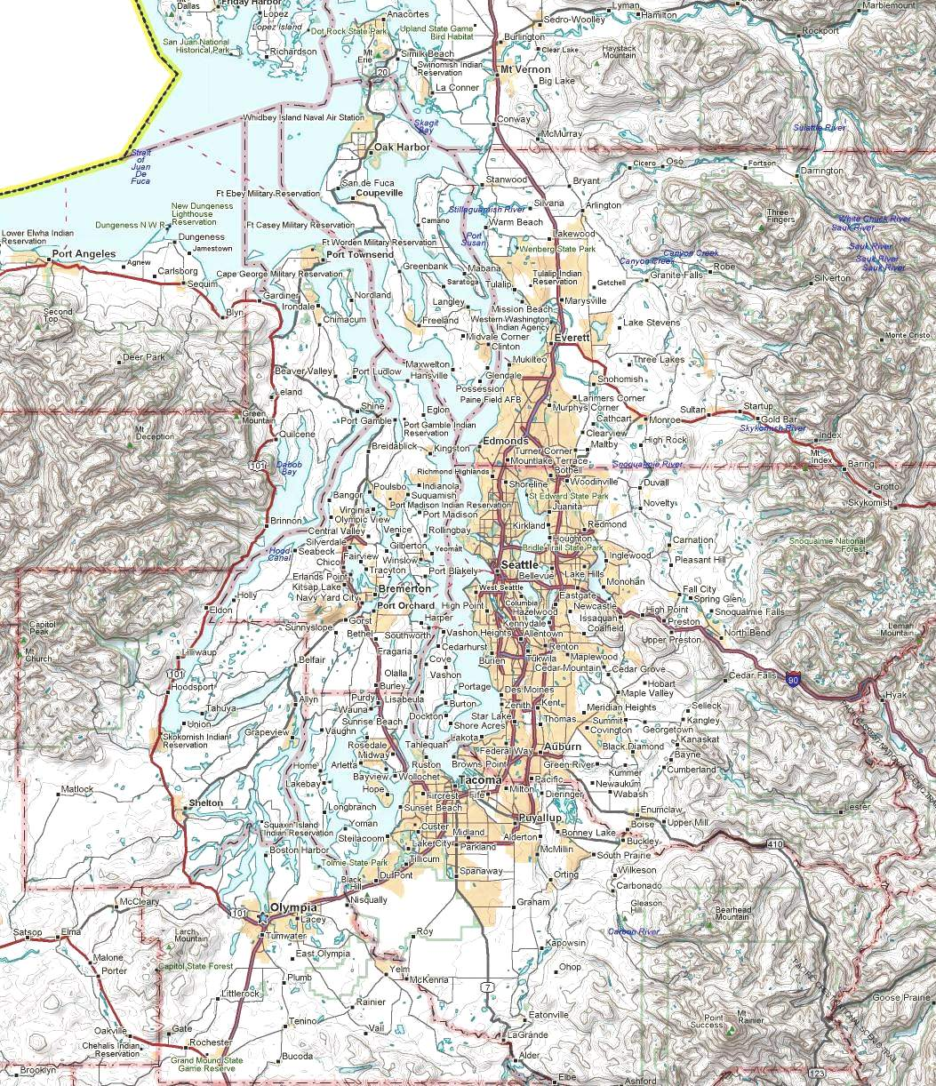
N7UJK-8

N7UJK-9
N7UJK-10
KC7HXC-10
HXCSL
NodeDigi CallFreq _NodeDigi CallFreq _StationKeybrdBBSLocation _
ELYSSAk7idx145.63GRAHAMad7aw-10145.05MCDEMaa7cgmcdemMason Co EOC
VICTORn7yge-3145.63PCMSTkc7qic-10145.05W7EMDw7emdw7emdCamp Murray ECC
SMTNn7sk-7145.63MJQPACkd7mjq-10145.05WA7OLYwa7olywa7olyThurston Co EOC
MINOTw7eoc-9145.63RMSLocationFreq _
K7EK-1(DX Clstr)145.63KD7X-10Oak Harbor145.63DigiFreq_1Freq_2 Bridge _
K7EK-8(X-net)145.63W0QJM-10Coupeville145.63N7UJK-9145.05145.63v N7UJK-10
SOTACk7ek-5145.63K7WG-10Shelton145.63NOTAC145.63223.46C SOTAC
NOTACw0lvj-6145.05AA7ZV-10Puyallup145.63SOTAC145.05223.46C NOTAC
SEABBSk7ek145.63K7EK-4Spanaway145.63K7ORY-12145.63223.58X KD7WDG
TDGLYkc7tdg-5145.05KB2SKP-10Bremerton145.63KD7WDG145.01223.58X K7ORY-12
HXCSLkc7hxc-5145.05KC7HXC-10Renton145.05
K7EK-4
SEABBS
SOTAC
WA7OLY
ELYSSA
W7EMD
KD7X-10
AA7ZV-10
K7WG-10
SMTN
MCDEM
VICTOR
W0QJM-10
SEA
KB2SKP-10
AA9MQ-1
K7ORY-12
KD7WDG
MINOT
Packet Stations
Puget Sound Area
June 6, 2010 de nm7r v6.0
Stations Outlined in BLUE
Are on 145.63
Stations Outlined in RED
Are on 145.05
TDGLY
MJQPAC
KC7TDG-13
PCMST
GRAHAM
Stations Outlined in GRAY
Are on 145.01
NOTAC
KB2SKP-7

