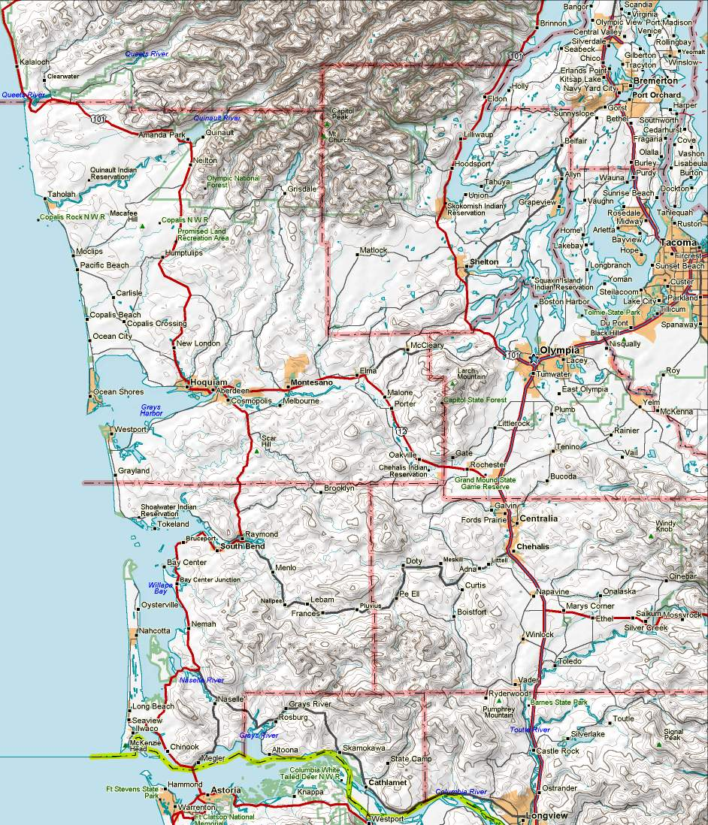
HOLYX
NM7R-8
NM7R-10
NEILTN
MINOT
N7UJK-8
N7UJK-10
ELYSSA
W7EMD
WA7PC
W7RDR
COCEOC
AC7YY-10
K7IEU-10
KD7X-10
AA7ZV-10
K7WG-10
SMTN
W7EOC
MCDEM
VICTOR
WA7OLY
AC7SR-3
Node Digi Call Bridge To: RMS Location Station Keyboard BBS Location
ELYSSA k7idx KD7X-10 Oak Harbor MCDEM aa7cg mcdem Mason Co EOC
NEILTN w7eoc-8 K7WG-10 Shelton W7EMD w7emd w7emd Camp Murray ECC
SMTN n7sk-7 K7GA-10 Cathlamet WA7OLY wa7oly wa7oly Thurston Co EOC
HOLYX wa7pc-6 AA7ZV-10 Puyallup W7EOC w7eoc w7eoc-1 Grays Harbor EOC
MINOT w7eoc-9 AC7YY-10 Centralia COCEOC ac7yy-4 cocbbs Centralia EOC
NICOLI k7ga-8 K7IEU-10 Raymond AC7SR-3 ac7sr-3 ac7sr-4 Lewis Co EOC
nm7r-8 nm7r-10 144.96 WA7PC wa7pc wa7pc-1 Pacific Co EOC
n7ujk-8 n7ujk-10 145.01 W7RDR w7rdr w7rdr-1 Long Beach AEOC

W7EMD-10
Packet Stations 145.630 v3.0
April 2010 de nm7r

K7GA-10
NICOLI
COCBBS
BCFD
Mason
Pacific
Thurston
Lewis
Wahkiakum
Grays Harbor
For stations in this area, see map: “Packet_Seattle”
For stations in this area, see map: “Packet_Portland”

