Kevin and John,
TS 2000
Deane reviewed the TS 2000 with me and he thought it wasn't hearing incoming traffic very well. Limited S-meter movement. He thought maybe some kind of attenuation is set in it hampering receive. He did get out and was heard by Jerry in PV and sounded fine. But, doesn't know the rig as well as he'd like. (It would be idea if we found someone that knows it well. Keep and eye open for that to truly test the rig.)
We connected the antenna to Antenna 1, one of the two HF antenna rear connections. As you face the rear of the rig, it's second from the left.
We confirmed that it is tied to an HF antenna that's good for 40 meters and up. It is cut for the ham bands above that. Our "tests" trying it on the 2m port didn't work because the antenna is only HF. The short jumper with no slack DOES connect to an HF antenna.
We should not try and broadcast on 2m now as there's no antenna on that port.
It could hear OK on 10 meters.

Antennas left to right:

- Unknown – possibly the HF antenna with a remote tuner at the top
- To left of outcrop – 6m folded dipole vertical
- Urgent Link mult-band ALE antenna
- VHF Station Master (there are 2 of them the other is not shown)
- Probably the 480 antenna for the Sheriff’s CDM 1550
- Blank – could support a possible addition antenna
- Probably the 220 Stationmaster
- 10m folded dipole vertical
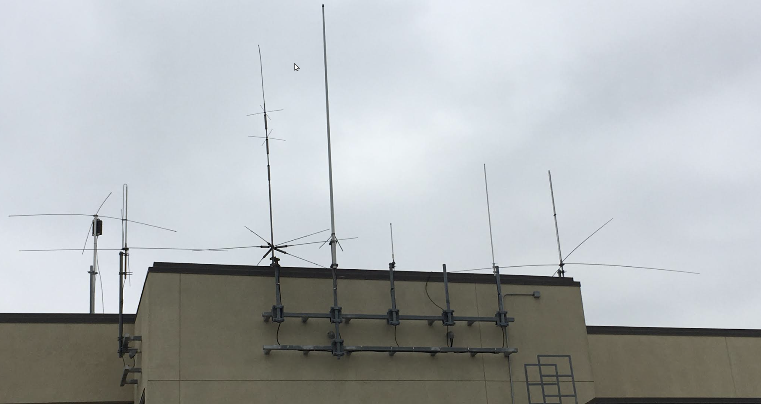
TS 2000 position SWR
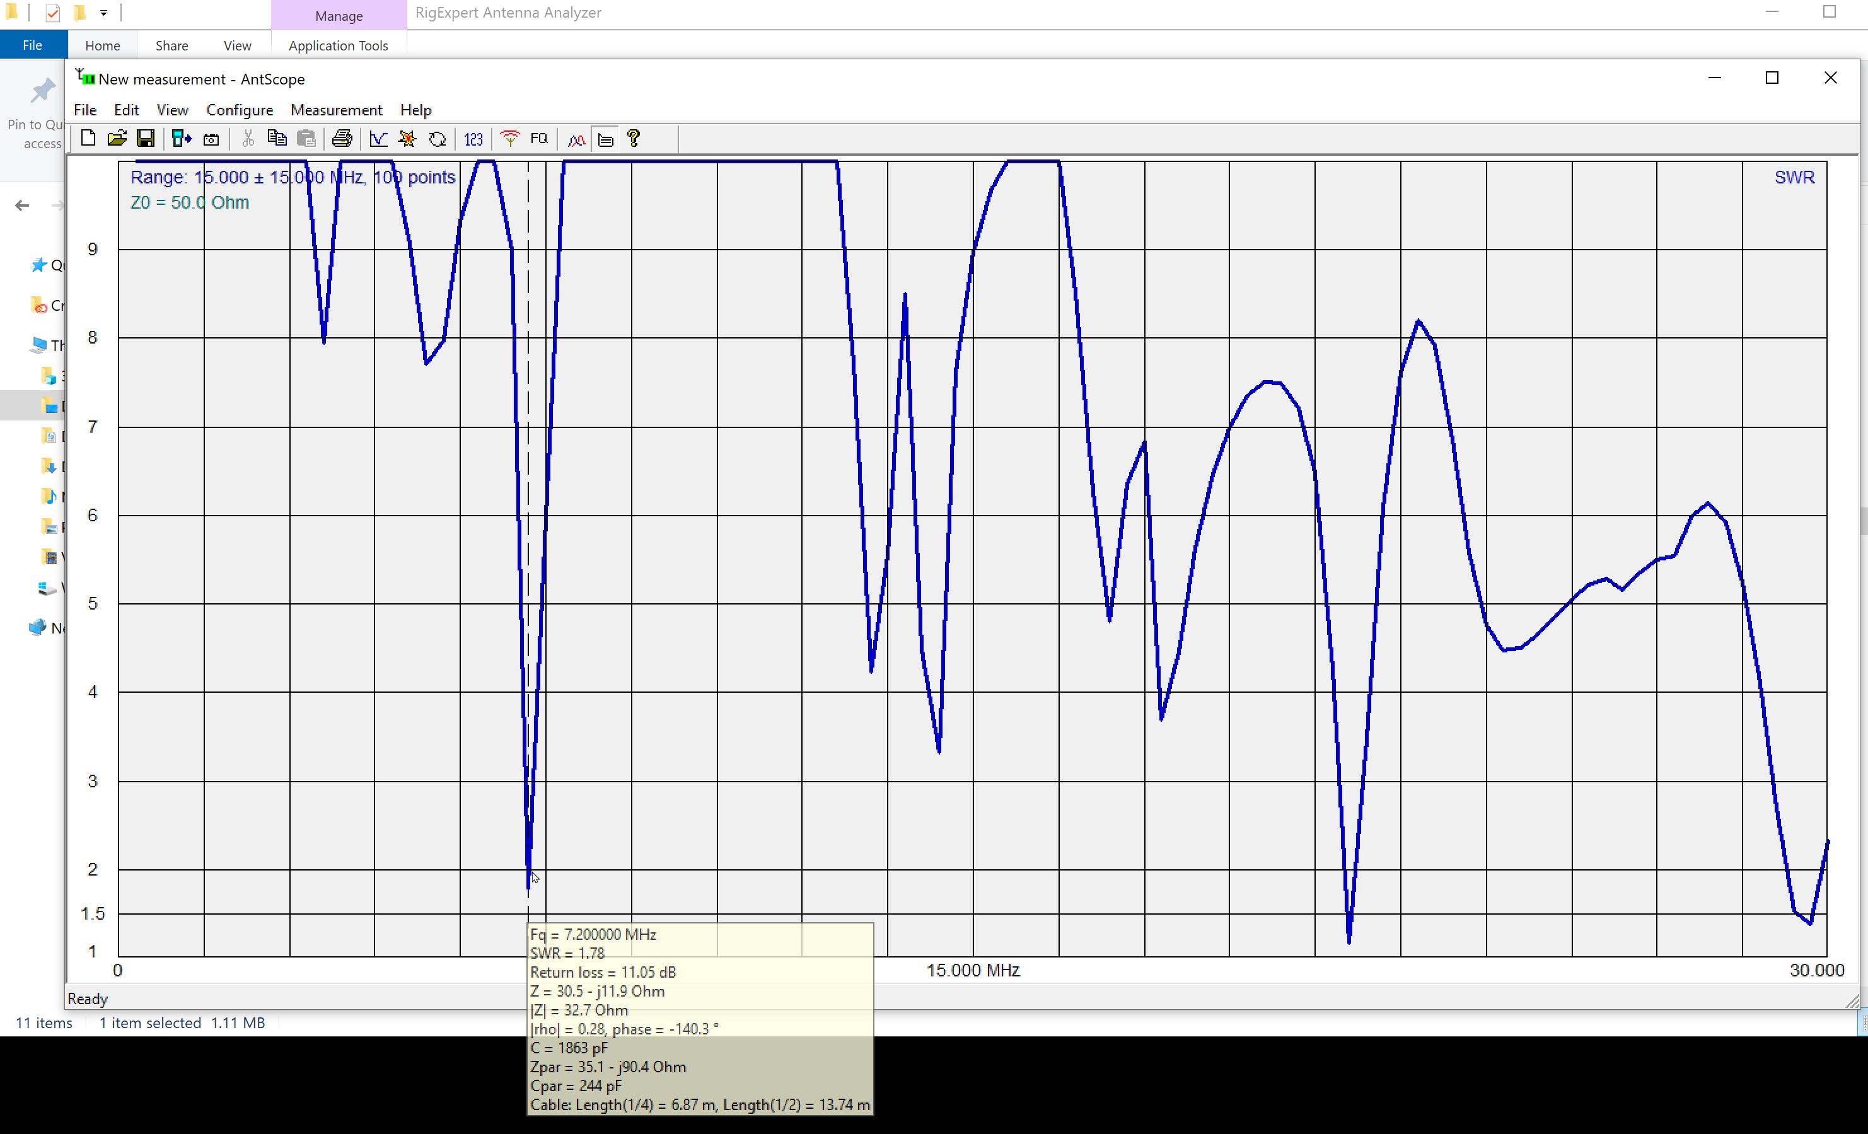

ORION 10-meter
We found that our 10-meter Orion is set for a very out-of-date set code plug. The multiple individual DCS old channels do NOT come close to fitting in with the SCRRBA band plans. There's limit freq's there and we'd interfere with area repeaters
https://www.scrrba.org/BandPlans/BandPlans.htm
BUT, the good news is DCS's channel that DOES fit the 10 m plan is 29.50.
We tested all the channels and we found "Lennox" to be correct at 29.50. LMT will try and have it active the next time the do the MNN and we can try it.
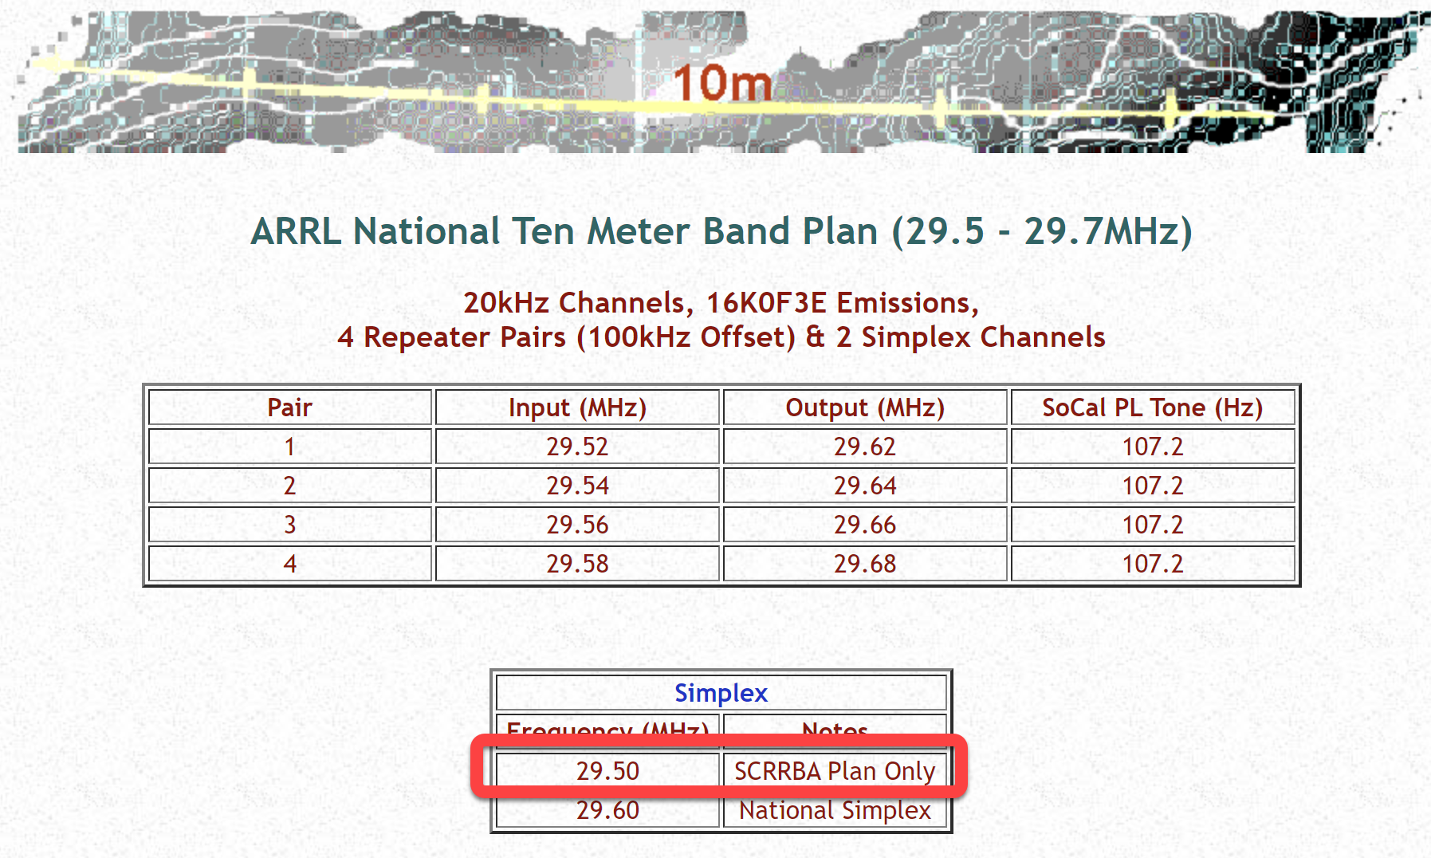
Alinco 6-meter
Same for the 6 meter machine. Since it does have a channel 51.50 set. That's good for us as the DCS channel and we've checked in a few times there. Similarly, we should avoid outside of 51.50 so we don't interfere there as well. https://www.scrrba.org/BandPlans/6m.htm Lots of digital stuff there.
The Icom and Motorola 2-meter antennas ARE 2-meter antennas. The Icom tests a bit better SWR-wise. But, not so much that it would account for the better sound John hears at his station. Still, they work and test well.

Icom
2-meter test
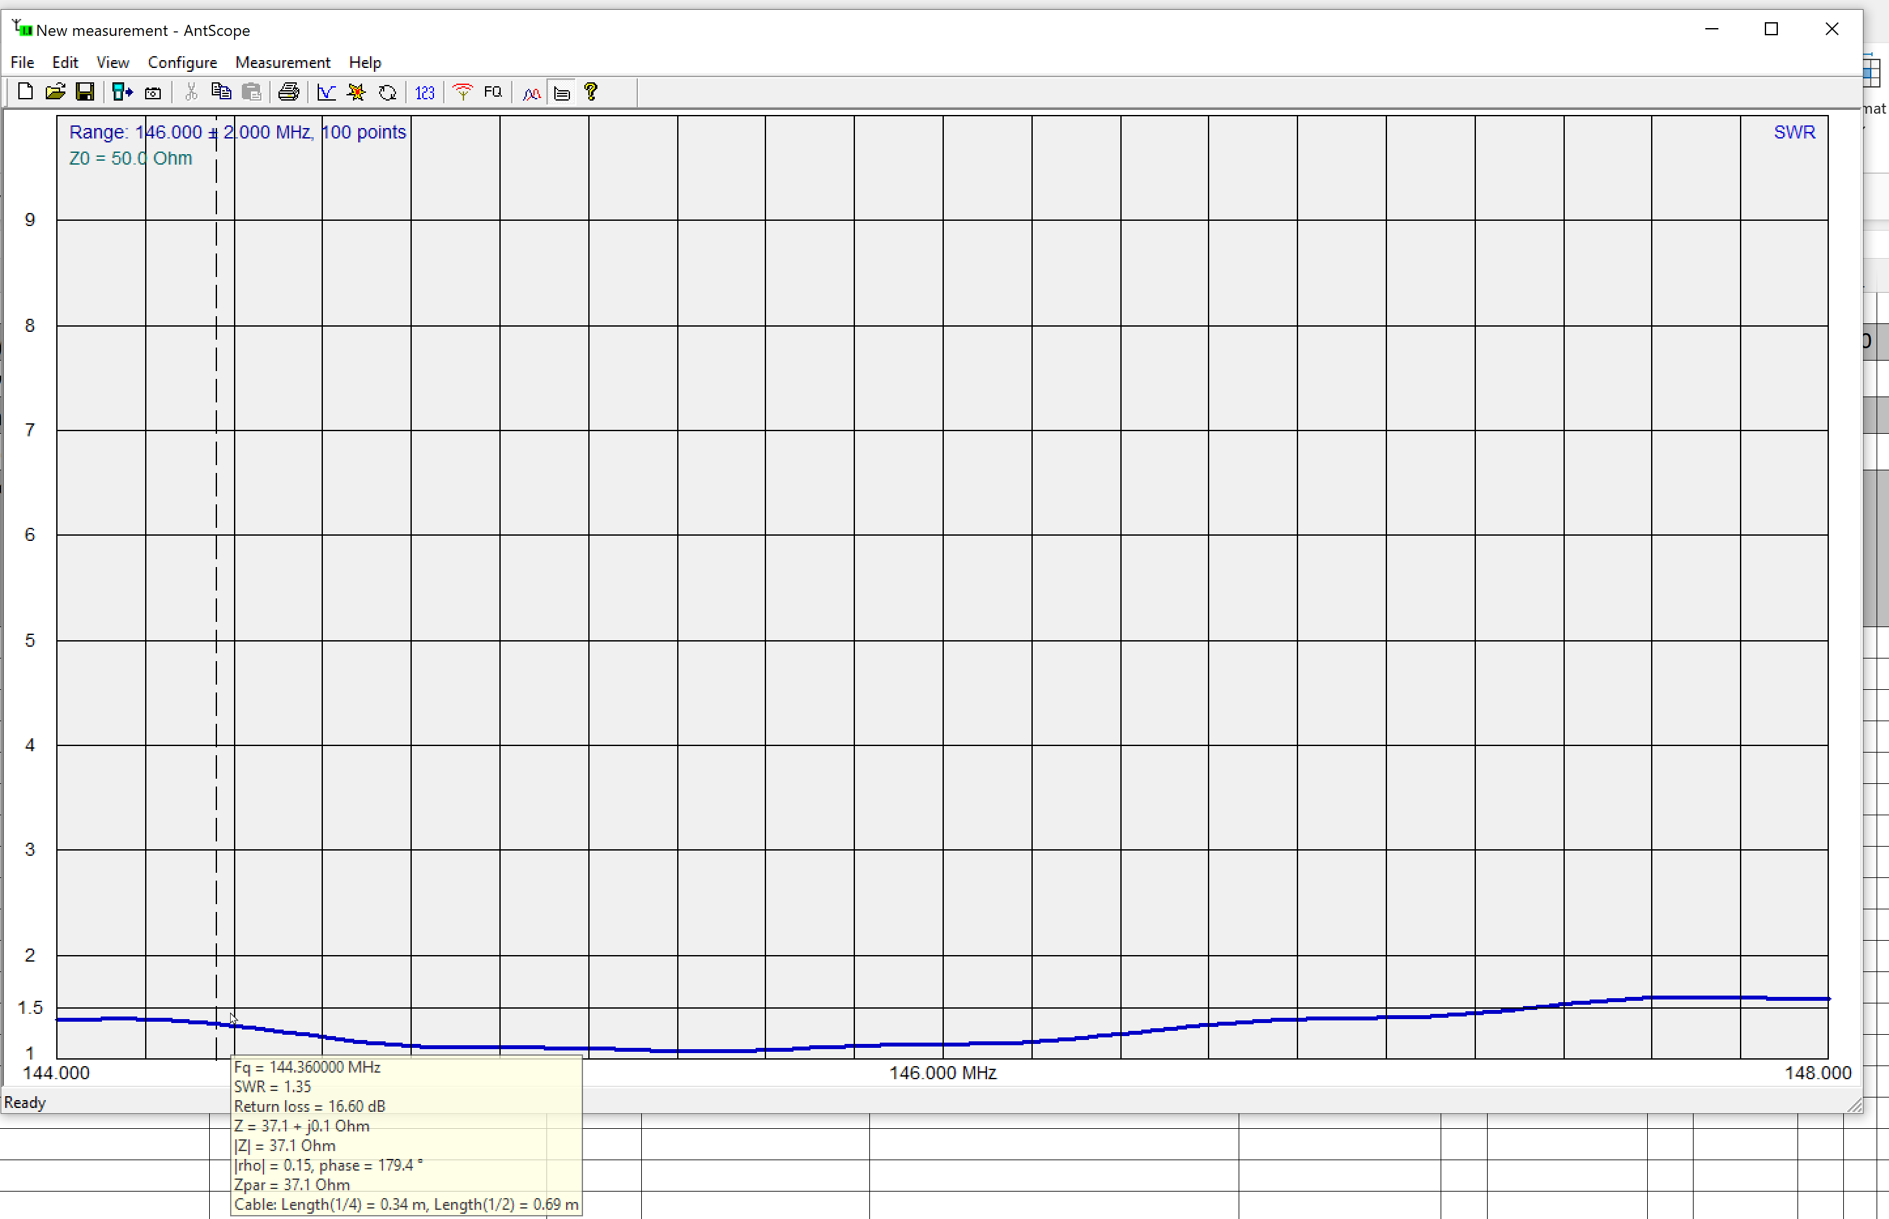
Icom 2 meter antenna …. 440 test…
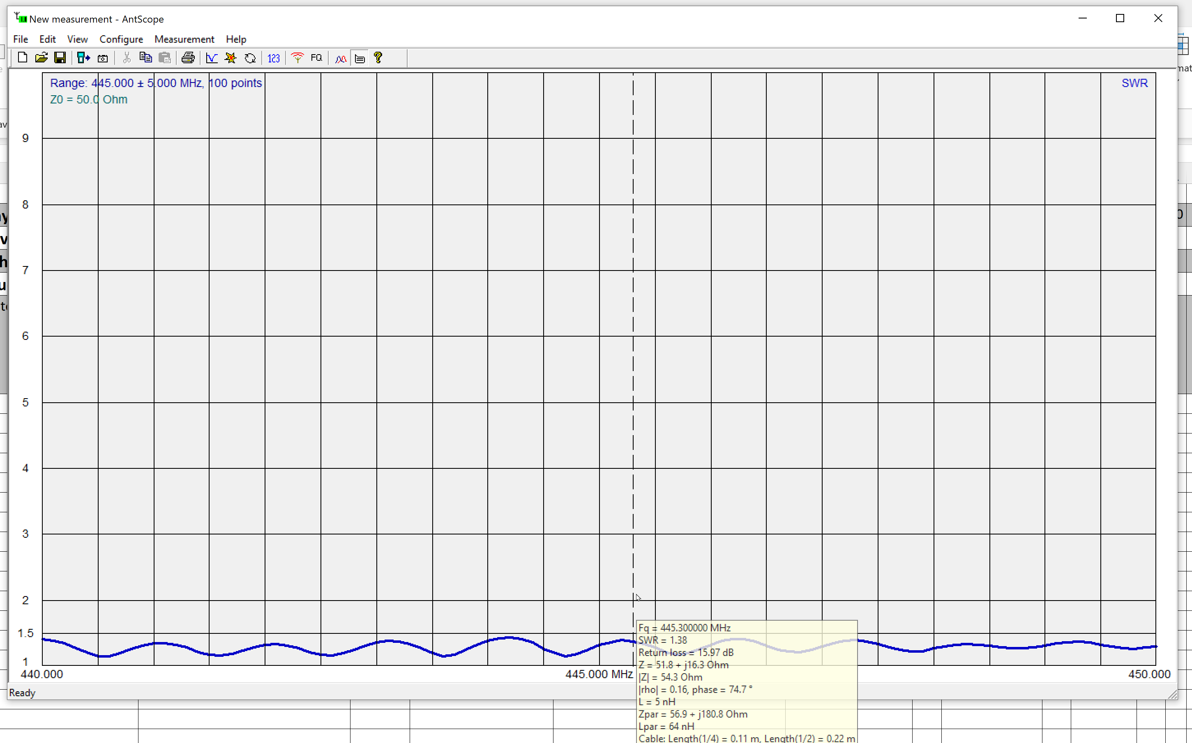

Moto
2-meter test
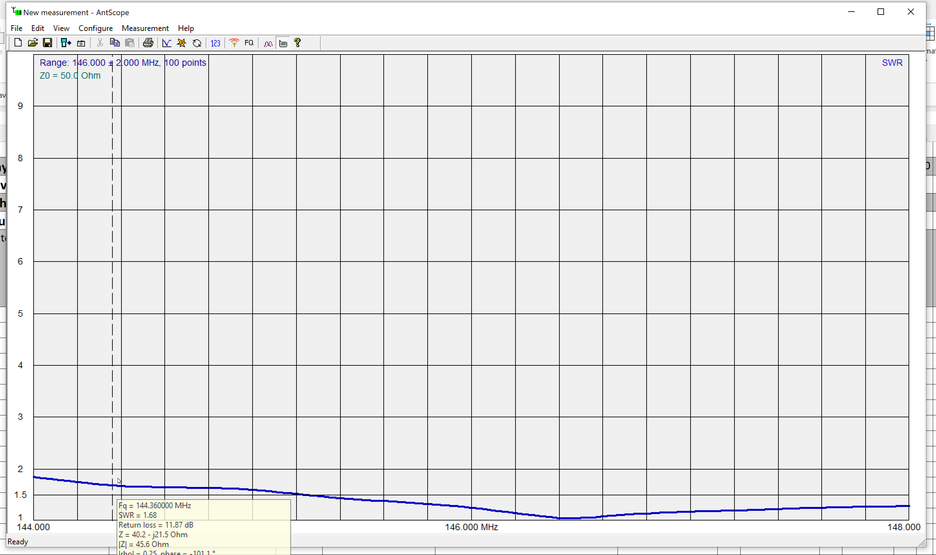

G-707 (future Yaesu 8900)
I've updated the code plug while I was here to match, mostly, what's in my two V-71 go boxes. So, you'll find a mix of 2-m and 440 channels in it. I just tested hitting the K6CHE 440 repeater and got a terrific signal report. I also appeared getting in find on the PV-based 4A repeater.
K6CPT 1 is on 1 and 2 is one channel 3 similar to the Icom with both tone and non-tone versions, some for our station tac channel with PL on channel 11.
Channel 173 is .030 digi channel. Dial counterclockwise from 1 to get to it (180 memories.)
See below for programmed freq's. We have DCS's code plug and a good range of ARES included out local channels for ARES South. The list has notes below.
Deane is confident that we can run the 8900 similarly to how we ran the V71 during the last drill with the ability to monitor net control on one side and do digital on the other. (Or whatever). The radio WILL do 6 and 10 but he suggests we turn them off since we'll not have an antenna capable of those. (Typically, you'd run 2m and 440 on one side and 6 and 10 on the other.
We discussed how to wire it to the base power supply to the right on the shelf. Kevin and I can do this once I get OK from Mana.
UHF 1550 idea to use on 440 for ham band
The radio is high split UHF, 450-512 mHz. It won’t work on the ham bands. It is a Sheriff’s analog radio useful for monitoring the Dispatch and Mutual Aid channels. Transmit requires a County call sign and should be done only in an emergency.

G707 Code plug by channel with notes
