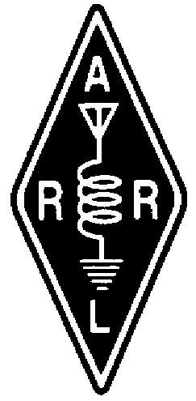TheRADIO AMATEURS OF CORRY
VOLUME 9 No. 2 June 2002
FCC proposes two new amateur bands

Good news for ham radio this week! FCC has proposed going along with ARRL’s request for new domestic (US-only), secondary HF allocation at 5.25 to 5.4 MHz. The FCC also is ready to permit operation on a 136-kHz “sliver band” in the low-frequency (LF) region. And, in response to a third ARRL request, the FCC has proposed elevating Amateur Radio to primary status at 2400 to 2402 MHz.
“I’m just as tickled as I can be,” ARRL President Jim Haynie, W5JBP, said upon hearing the news. “This is a classic example of our ARRL at work. ”The FCC voted unanimously May 2 to adopt the Notice of Proposed Rulemaking in ET Docket 02-98. The Commission released a Public Notice May 9, and the NPRM is expected to be released soon. A comment deadline will be announced as soon as it’s available.
The FCC said the new 5-MHz band would help amateurs “better match their choice of frequency to existing propagation conditions.” The band, if approved, would be the first new amateur HF allocation since World Administrative Radio Conference 1979 gave amateurs 30, 17 and 12 meters—the so-called “WARC Bands.” Assuming the 5-MHz band eventually is authorized, it could be a few years before it actually becomes available.
The League said its successful WA2XSY experiments demonstrated that amateurs can coexist with current users and that the band is very suitable for US-to-Caribbean paths. In comparisons with 80 and 40 meters, the WA2XSY operation also showed the 60-meter band to be the most reliable of the three. The ARRL also argued that a new 150-kHz allocation at 5 MHz could relieve periodic overcrowding on 80 and 40.
If allocated to amateurs on a secondary basis, hams would have to avoid interfering with—and accept interference from—current occupants of the spectrum, as they already do on 30 meters. The band 5.250 to 5.450 MHz now is allocated to Fixed and Mobile services on a co-primary basis in all three ITU regions.
The ARRL asked the FCC for two LF allocations in October 1998--135.7 to 137.8 kHz and 160 to 190 kHz. The FCC said its action on one part of that LF request proposes changes that would enhance the ability of amateur radio operators to conduct technical experiments, including propagation and antenna design experiments, in the ‘low frequency’ (LF) range of the radio spectrum.”
Several countries in Europe and elsewhere already have 136-kHz amateur allocations. The first amateur transatlantic contact on the band was recorded in February 2001.Hams would be secondary to the Fixed and Maritime Mobile services in the 136-kHz allocation. The League said its engineering surveys suggest that hams could operate without causing problems to power line carrier (PLC) systems already active in that vicinity or to government assignments. Unallocated Part 15 PLC systems are used by electric utilities to send control signals, data and voice.
The FCC said its proposal to upgrade the Amateur Service allocation at 2400 to 2402 MHz to primary “seeks to protect current amateur use of this band.” Hams have shared their other 2.4 GHz spectrum on a secondary basis with government users. Amateurs already are primary at 2390 to 2400 and from 2402 to 2417 MHz. The ARRL has said primary status in the intervening spectrum slice was needed “to provide some assurances of future occupancy of the band segments for the next generation of amateur satellites. ”The ARRL has expressed its belief that hams can continue to accommodate Part 15 and Part 18 devices at 2.4 GHz.
-ARRL Letter

President’s Column
By Ralph Miller N3LXG

The month of June is a busy month with our club picnic on the 8th, the beginning of summer, and will have Field Day on the 22nd and 23rd. Both events will be held at the Red Top Pavilion in Mead Park, Corry.
Field Day is a key exercise in emergency preparedness. It tests effective communications under adverse conditions. In general, the equipment is operated using emergency power, the antenna is improvised, transmitter power levels are lower because the power amplifier is at home and the conditions are rustic. The bands are congested with a variety of operators at all levels of skill and experience. It is a grand opportunity to gain first hand operating experience. We have members of our club that are expert operators that are very willing to share their skills and experience. Everyone has something to contribute. Come out and join in the learning experience.
Since September 11th there has been an increased focus on preparation, our challenge as radio amateurs is to be prepared to serve when needed. We may not be in a position to acquire the latest equipment, most of us are not, but we can learn to be proficient with what we have. Speaking for myself there are features of my equipment that I haven’t used or that I need to refer to the manual to use. Participation in the local nets also provides an opportunity to test our equipment and sharpen our operating skills. So this summer let’s commit to grow our skills and learn something new.
Come out and join in. As a club we can accomplish anything we set our collective minds to. Thank you for your support and have a great summer.

73
Ralph
N3LXG

April 2002 Meeting Minutes

The meeting was called to order by President Ralph N3LXG at 7:30 PM with 16 members present. Roll Call of Officers: absent, Vice Pres. Dan KB3EMH and excused, Sec. Jerry W3GHO. The secretary report was read by acting Sec. Norma W3CG.
Motion to accept the minutes as read by Leonard WB3AYW, seconded by Quentin W3AHH. Carried.
The Treasurer's Report was read by Mike N3GCY. Motion to accept as read by Quentin W3AHH, seconded by Bob WA3HDK. Carried.

Bills presented:
*ARRL Insurance for $82.00 - mailing of RAC membership cards for $8.34 to Sec. Jerry W3GHO.
*Reservation fees of $15.00 each to be paid to Mead Park for the June 8th picnic and Field Day June 22 and 23. Motion by Bob WA3HDK to pay the bills as presented, seconded by Leonard WB3AYW. Carried. Mead Park now requires that payment accompany reservations. Jim WT3O questioned having to pay for Field Day because we were granted free use for it in the past and said he was going to check on it.
A personal $25.00 donation by Ralph N3LXG was presented to the Red Cross.
Calendar Review by Pres. Ralph N3LXG: June 8, RAC Picnic at Mead Park, April 28, Ripley, NY Hamfest, May 31, June 1 and 2, Rochester Hamfest, and July 13, Union City Wireless Association at old CB Grounds at Union City.

Committee Reports:
*By-Laws by Ralph, N3LXG. determined that the last copy on file with the ARRL was dated April 17, 1969 and Mike N3GCY has a copy. The committee has held one meeting and will continue until the By-Laws are completed.
*VFW Breakfast by Leonard WB3AYW. To be held April 7 and volunteers are needed for the second shift. Mike N3GCY volunteered.
*Repeater by Jim WT3O. Batteries have not been purchased yet.
*Field Day - Jim WT3O volunteered to be chairman, and Ron N3KLN volunteered to be co-chairman.
*VFW Plaque - Rob N3OCL is ordering it and at a later date it will be presented at a VFW meeting.
Our next meeting date will be on the First Tuesday of the month, May 7.
Craig K3PLV will present a video of his Jersey DX pedition. 8000 QSOs were made during the recent expedition.
Drawing - a Screw and Nut Driver Set donated by Ralph N3LXG was won by Jerry KC2AUS.
The 50/50 sum was added to the general fund.
Motion to adjourn by Bob WA3HDK and seconded by John N3NKV. 8:25 PM
Refreshments were provided by Ralph N3LXG.

Norma W3CG, Acting Sec.

May 2002 Minutes

The meeting was called to order by President Ralph N3LXG at 7:30 PM with 16 members present and guests, Todd and Emily Johnson.
The minutes of the last meeting were read by acting Sec. Norma W3CG. Requested addition to the minutes was that a maximum of $120.00 was to be spent for batteries for the repeater. Motion to accept the minutes by Leonard WB3AYW, seconded by Harold WD4OOX. Carried
Roll Call of Officers: Present - President Ralph N3LXG, Vice. President Dan KB3EMH and excused Sec. Jerry W3GHO. Due to the absence of the Treas., no report was given.
Bills presented were $3.42 by W3GHO for membership mailings, $103.88 by WT3O for batteries, and the newsletter bill had been mailed to the Treas. Motion by Herb N2PCN to pay the bills, seconded by Quentin W3AHH. Carried.
It was decided that the picnic dinner on June 8, was to be served at 12 noon. Moved, seconded and carried that the club would furnish pop. The committee is Norma W3CG, Debbie N2MQ, Joanna N3WNS, and Rob N3OCL.

Announcements by N3LXG that Wilbur Sorenson K4ICE donated his radio equipment to the club and each member present received a listing. Wilbur is 90 years of age and loss of hearing now prevents him from operating. He requested that a 10 M Ringo and a 2 M Ringo Ranger antenna be taken down.
Motion by Herb N2PCN that a committee be appointed to determine what should be done with the equipment. Seconded by Leonard WB3AYW. WB3AYW was appointed Chairman and to add his two helpers later.
On June 13, at 6 PM, a RACES/ARES Course will be presented at the Union City picnic grounds. There is no charge. Anyone who is interested in getting qualified or taking a refresher course is welcome to attend.
The Breezeshooters Hamfest will be held at Butler on June 2. A drawing will be held for the 2 admission tickets donated to the club.
N3LXG now has a copy of the 1969, last By-Laws on file with the ARRL and presented 3 options for committee direction - 1. as written 2. modify 3. create a new set.
Motion by WB3AYW to go by the 1969 By-Laws and the committee to come back with recommended By-Laws. Seconded by N2PCN. Carried.

Reports
Repeater - by WT3O. Batteries are hooked up and working.
By-Laws - by N3LXG. A meeting is to be held May 14. Motion by WB3AYW to add WT3O to the committee. Seconded by N2PCN. Carried.
VFW Breakfast - by WB3AYW. Held on April 7, had enough workers and all went well. The check was given to Treas Mike N3GCY and the amount was unknown.
Field Day - by WT3O. To be at Red Top Pavillion, Mead Park on June 22-23. Ron N3KLN will furnish the generator, some rigs have been volunteered, N2PCN furnished some F.D. logs, and N3GCY is also to provide some. The ARRL is selling Field Day pins for $5.00 each if anyone wishes to order one. N2PCN provided the information.
Newsletter - by WA3HDK. John N3NKV is doing the next issue and the deadline for receiving articles will be May 24.

Old Business
Motion by WB3AYW to hold the June meeting on the first Tuesday. Seconded by N2PCN. Carried.
WT3O will contact the VFW at the proper time to present the plaque.

New Business
by N3LXG. In reference to the misplaced agreement to use the repeater tower, and since it had formerly been used by the PA State Police and a trucking co., it is possible that there is an easement at the Crawford County Courthouse, and if it is still there, could be transferred to the club.
Rob N3OCL agreed to check at the Courthouse and see what is on file.
Informal Request - by Dan KB3EMH. Brian Baker inquired as to use of the tower for wireless internet into Spartansburg. Following discussion, it was decided to table any answer until information is received as to the status of the tower.
Motion by WB3AYW to have meetings in June, July, and August. Seconded by WT3O. Carried
ARRL Educational Tapes - N3LXG expressed interest in the purchase of the International/Program Videos at a cost of $120.00 Craig K3PLV said he has some of them and will report on what he has at the next meeting.
Dues of $5.00 were submitted by Herb N2PCN and Ned Warren N3CZE.
Door Prize - telephone with caller ID was furnished by N3LXG. Won by Emily Johnson, who donated it to the club.
Program - A video of Jersey DX pedition was presented by Craig K3PLV.

Adjournment - motion by John N3NKV, seconded by WA3HDK. 8:35 PM

50/50: $21.00 to be added to the general Treas.

Refreshments were furnished by N3LXG.

Norma W3CG, Acting Sec.

June 2002 Meeting Minutes

The meeting was called to order at 7:30 PM by President Ralph N3LXG with 16 members and 2 guests present. Roll Call of Officers: Present, President N3LXG, Treasurer N3GCY and excused, Secretary W3GHO.
The minutes of the last meeting were read and approved.
The Treasurer's report was given by Mike N3GCY and a copy was put on file with the minutes. A bill due June 15 for liability insurance in the amount of $325 was presented. Motion to pay by WB3AYW, seconded by N2PCN. Carried.
The appreciation plaque to be presented to the VFW was on display and cost was $29.68 Motion to pay by Herb N2PCN, seconded by Harold WD4OOX. Carried.

Committee Reports
By-Laws by N3LXG of the May 14 committee meeting and copies were distributed to the membership by E-Mail. Motion by WD4OOX to remove the one year limit for an Associate Membership.
An Associate Membership was defined as paying full dues and without voting rights.
Motion by Leonard WB3AYW, seconded by Herb N2PCN to continue meetings on the first Tuesday. Carried.

Field Day by WT3O. Announced that John KA9ZQK volunteered to be Safety Officer.
Motion by WB3AYW, Seconded by Frank KE3PD to spend up to $100.00 for snacks and pop.
Donated equipment from Wilbur K4ICE - Motion by WB3AYW, seconded by WT3O that the HF and 10 M rigs with their accompanying equipment be retained by the club and kept at the Red Cross. Carried. Motion by WT3O, seconded by KE3PD to use the balance of the items individually each meeting night as door prizes. Carried. Motion by WT3O, seconded by KE3PD that a thank-you letter and a note prepared by the Secretary be read at club first and signed by members.
VFW Plaque - Quentin W3AHH agreed to check with the VFW as to a convenient time to present the plaque.

Old Business
N3LXG announced that Rob N3OCL had gotten the last 2 transfers in looking for the holder of the easement of the tower. KE3PD stated that information from the owners, Mr. and Mrs. Hopkins was that at the discontinuation of tower use by the PA State Police and the Trucking Co., that the tower had reverted back to the owners.
Craig K3PLV donated 3 ARRL video tapes to the club.
Dues were received from Todd Johnson and Mike Lohse N3MLY.
Motion to adjourn by WB3AYW, seconded by Ed N3XBA. 8:35 PM.
The door prize, a Micronta Field Strength/SWR Tester was won by Herb N2PCN. The 50/50 was $27.00

Norma W3CG, Acting Sec

VE News
Our neighbor club, The Union City Wireless Society recently completed their annual Amateur Radio classes. Instructors were Pete Albright AA2AD, Ron Reiff KF3DJ, and Bill Young W7RVY.
VE exams were conducted at the conclusion of the class. Qualifying for Technician for their first license were Daren Allen of Union City, Cory Brown of Union City, Betty Jones of Union City, Melvin Seely of Erie, and Chad Stover of Pittsfield.
Upgrading their class of license were George Younkin N3SRF of Lake City to General, and William Leupold KB3AAH of Erie, also to General.
Serving as VEs were Rob Jacobs N3OCL, Pete Albright AA2AD, Ron Reiff KF3DJ, Bill Young W7RVY and Norma Vanderhoff W3CG

Starting with the July 6th VE Session, The Villa Maria VE exams will take at a new location. They will be held at Panos Restaurant – City Diner & Bakery at 1523 E. 38th Street in southeast Erie. The time will remain the same.

Visit the RAC online at

http://www.qsl.net/w3yxe

VFW FUNDRAISER BREAKFAST April 7, 2002 Update

Another VFW fundraiser breakfast was held this past April 7th. The numbers attending were somewhat smaller than usual so the “take” was not quite as big as it usually is. Never the less, this breakfast is still one of the major reasons that our club dues are still only $5 a year.
The members volunteering for each 3-hour shift are to be commended for their time. The job is not an overpowering one when we have a good number turning out to help. The “early” shifts set everything up, cook and serve the buffet style line. The second shift is charged with continuing to cook, serve and then clean up the kitchen and dining room. Ample hands make easy work of the duties.
The next breakfast is scheduled for February 23, 2003. Please consider volunteering to help with this one. I am sure you will hear more about this after the beginning of the year. Leonard, WB3AYW, is the chairman of this activity. I am sure he will be happy to discuss your participation.

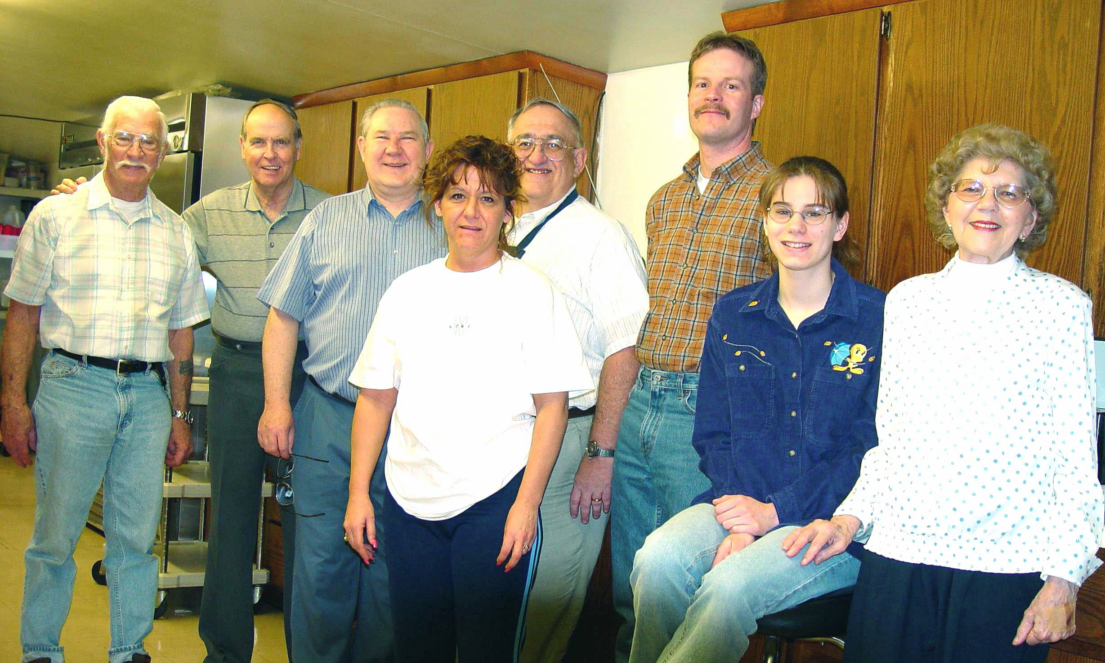  The first shift participants for this breakfast were: Hal, WD4OOX; Frank, KF3PD; Leonard, WB3AYW (Chairman); Bob, N3LBI; Rob, N3OCL; Joanna, N3WNS and Norma, W3CG. | 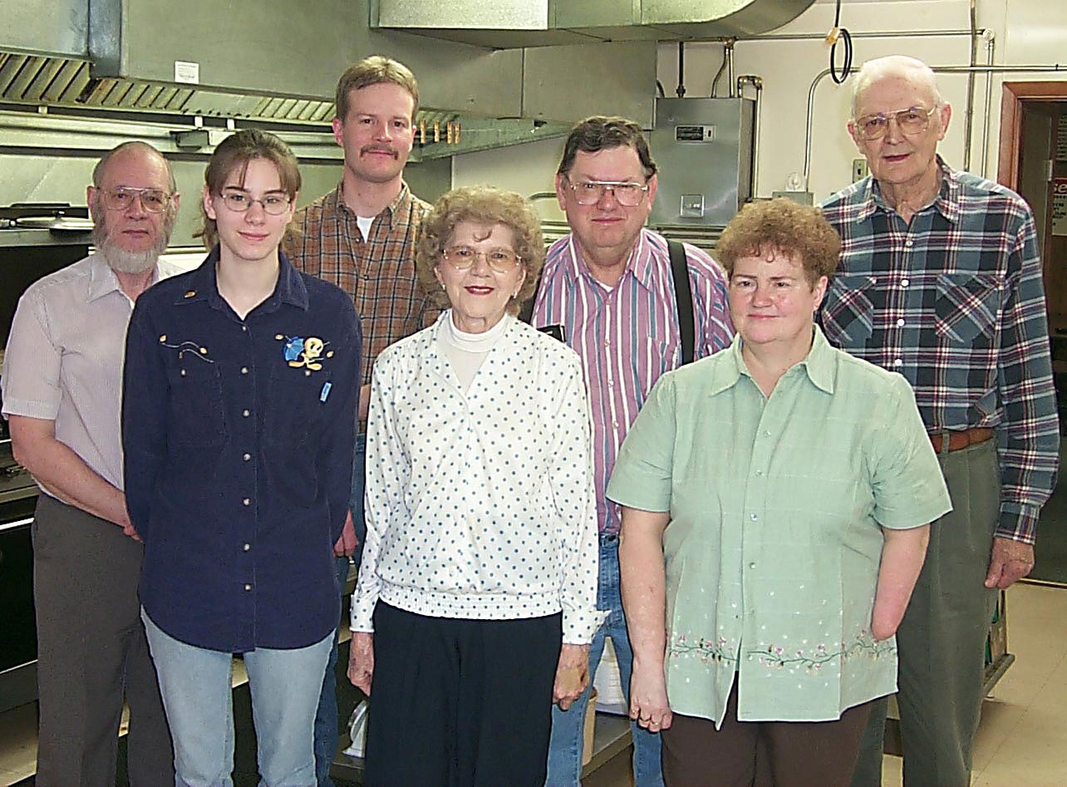  The second shift was manned by: Bob, WA3HDK; Joanna, N3WNS; Rob, N3OCL; Norma, W3CG; Jerry, KC2AUS; Debbie, N2MQ and Quentin, W3AHH.

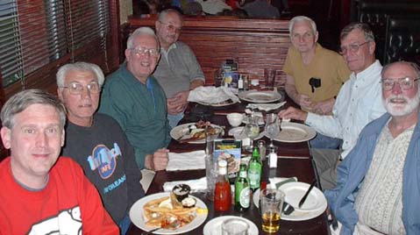  Mike Dziubkowski (N3GCY), Dick Moore (KA3CAB), Bob Dziubkowski (K3SBU),Tom Zielonka (KA3FZN), Jimmy Szymanowski (No Ham), Tom Hawes (WA3PRC), George Shreve (KA4JKY) As you can see all were having a good time at Hamvention.-- Bob K3SBU |   LOST:  The paperwork or agreement providing for the club's use of the tower. If found, please contact president Ralph Miller. Thanks

Thank You!

The Radio Amateurs of Corry would like to thank Wilbur Sorenson K4ICE for his donation of his radio equipment to the club. Plans call for his HF radio and 10-meter mobile radio to become part of the emergency communications station at the Red Cross.

Hamfests

July 14 th - North Hills ARC – Pittsburgh, PA
July 20th – Batavia, NY
August 4th-Lancaster, NY ARC
August 18th – Warren, Ohio
Sept 8th – Butler, PA

Ten Things Hams Always Remember
1. The day the license finally arrived.
2. The first rig.
3. The first QSO.
4. The last time the neighbors complained.
5. The Elmer who helped them get started.
6. The receipt of the first DX QSL card.
7. The VE (FCC examiner for older hams.) who gave you your test.
8. The thrill of seeing their call sign in print.
9. The low-budget, homebrew antenna that actually worked DX.
10. The time lightning took out some gear.
For Sale:
I have available a supply of used 8 ft ground rods with clamp free for the asking.
I have for sale an ICOM IC-706 with optic cable for remote operation and mobile mounting bracket for $450.00 and ICOM automatic mobile antenna tuner model AH-4 for $150.00. Also several HF mobile Ham-stick elements for 80-10 meters one per band. Price is negotiable.
-Jerry W3GHO

For Sale:

I have about 70 books on diodes, transistors, etc. These are not new but would be good for basic know-how. I also have a number of Nat'l Geographics for sale. I also have some Boat Anchors & much more. I will reach my 89th birthday before this is printed and I want to clean house to some degree You can call me via phone at 665-0561 or via E-MAIL w3bzj @ tbscc.com

GET READY FOR
The Mid-Summer Swap Meet and Ham Fest
July, 13 2002

Close by and easy to find
1.6 miles south of Union City, PA. On Route 8.
The Central CB Grounds.

Talk-in will be on the 146.70 Repeater

Time to clean out the shack. Box up your treasures and come and
redistribute them to those who are looking for just what you have.
Remember, One Ham’s trash is another Ham’s treasure!

Admission $3.00
Table (8 ft.) $5.00
Tailgate (20 ft. wide) $3.00
We will see you there!
For info contact:
Bill Young W7RVY
(814) 438-2151 or
w7rvy@juno.com

2002 RAC PICNIC
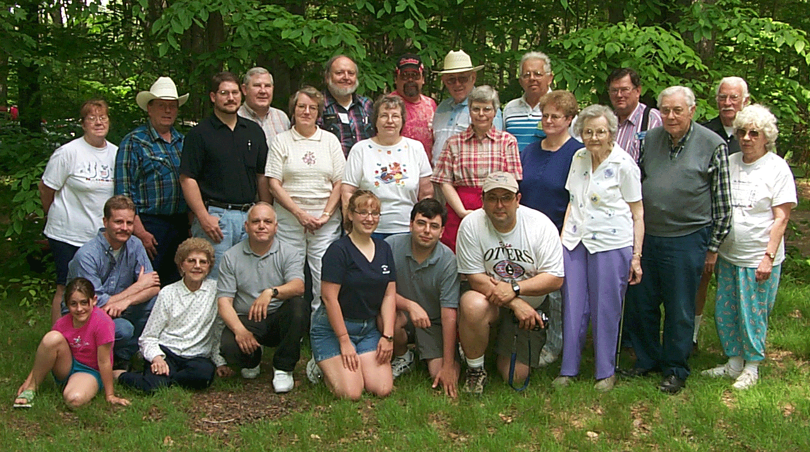
Kneeling: Amie Johnson, Rob, N3OCR; Norma, W3CG; Larry, WA3PGL; Megan;John, N3NKV; Joe, N3MLX;
Standing: Evelyn Owens; Jerry, W3GHO; Todd Johnson; Leonard, WB3AYW; Barb Shick, Rich, WA1YJZ; Marlene, WB3BLN; Mike, N3MLY; Ralph, N3LXG; Elaine Lis; Herb, N2PCN; Debbie N2MQ; Agnes McCray; Jerry, KC2AUS; Mac, W3BZJ; Hal, WD4OOX; Betty Cole.

The RADIO AMATEURS OF CORRY
P. O. Box 362
Corry, PA 16407

This newsletter is published quarterly
Editor: John Lis, N3NKV (825-5565)
Editor, Robert E. Bair WA3HDK (739-2206)
Jerry Owens, W3GHO

Submit material for the next issue on/or before
August 15. Next issue is September 3, 2002.

<<<<<E-mail articles to wa3hdk@arrl.net>>>>>

Club meetings are on the first Tuesday of each
month at the American Red Cross Building in Corry.

Club Officers--
President, Ralph Miller, N3LXG (489-0242)
Vice President, Dan Fargo, KB3EMH (663-5170)
Secretary, Jerry Ownes, W3GHO (664-7502)
Treasurer, Mike Dziubkowski N3GCY (664-7189)

