  TheRADIO AMATEURS OF CORRY
VOLUME 8 No. 3 SEPTEMBER 2001

RAC TO PARTICIPATE IN JOTA

Plans are being made to join in the world-wide Scouting celebration of JOTA (Jamboree on the Air) for 2001. This event has been a club activity since Bob Swarm, K3CKO first set up a station in Elgin Park in 1995.

Although we usually set up in Elgin Park, we have also participated in JOTA at Mead Park. This year’s activity will be at Elgin Park on October 19 and 20. Several hams have helped with JOTA. My memory sometimes fails me and I have not looked up the records, but those I can remember are: Bob, K3CKO; Bruce, KA3JVO; Jerry, W3GHO; Mac, W3BZJ; Bob, N3LBI and Bob, WA3HDK.

Ask any of these people and they will tell you it is a hart-warming experience. Most of the time the weather is warm and sunny, too, but I can remember times when it was windy, cold and wet. Here’s hoping it will be as nice this year as it has for the last two years.

The chairmanship for this year has not been announced and we are looking for volunteers. The job consists of setting up a HF station, much like field day, and supervising while Scouts ages 8 thru 16 years old talk to other Scouts all over the world. The Scouts furnish lots of enthusiasm, a lunch and dinner prepared in the field. It is quite an experience! In addition, the amateurs who participate are invited to “Red and White banquet”—usually at Connelway School. The program consists of Scouting stories, awards and a very nice dinner prepared by Scouts and Scout families.

I generally furnish the station equipment, and can do so again this year. But, if you would like to operate your own station, you may do so. I have been involved for several years now and it is time for a change.

VFW fund-raiser breakfast is November 18.
I believe, from correspondence with him, that Bob, K3CKO will provide and operate a digital station also. He has recently moved (see roster update elsewhere in this issue) but I don’t think that will change his plans. He has been a friend of Scouting ever since he was himself a Scout.

I had been summoned for Jury duty on the 18th, and noted that my participation in JOTA on the reply card. The Jury selection coordinator graciously re-scheduled the duty to the middle of December. (Oh, joy! It’s cold and messy then!)

Our operations are usually only one day in length. So put Saturday October 20th on your calendar. If you don’t want to actively participate, at least stop by and say hello.
--Bob, WA3HDK

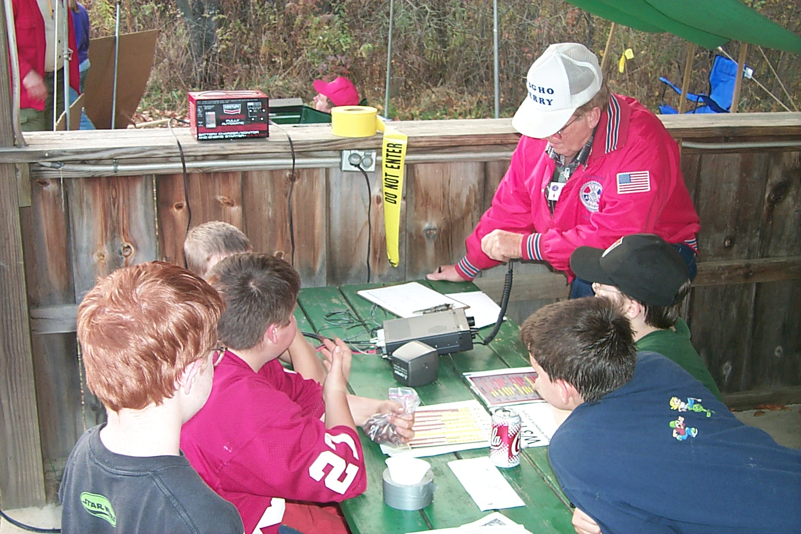
Jerry, W3GHO is surrounded by Scouts at the 2000 JOTA
___________________________________________

44th Jamboree-on-the-Air 2001
20 and 21 October 2001

JOTA is an annual Scouting and amateur radio event sponsored by the World Scouting Bureau of the World Organization of the Scout Movement. Thousands of amateur radio stations around the world participate. If conditions are right, it is common to contact a hundred Scouting countries during the weekend. (continued on page 2)

The usual communications method calls for speaking into a microphone. However, the following specialized communications are also used:

Slow Scan TV (SSTV)
Amateur TV (ATV)
OSCAR
Packet Radio
RTTY
EME

There will be many stations operating, including the following:
K2BSA/5 at Camp Wisdom, Dallas, Texas
HB9S, World Scouting Bureau Hq in Switzerland
GB2GP at Gilwell Park, England

JOTA begins worldwide on Saturday, 20 October at 0001 hrs local time and ends on Sunday, 21 October at 2359 hrs local time.

If your club (or you individually) participate in JOTA, please make sure that you forward a report of your activity via e-mail to ARRL.

A list of suggested operating frequencies appears in the September issue of QST (page 48) and on the ARRL Web.

Some Atlantic Division clubs are operating only during daylight hours (0900-1800) on Saturday, 20 October, and not on Sunday. Have fun !!!!!!!

--Bernie Fuller, N3EFN, Director-Atlantic Division
--Bill Edgar, N3LLR, Vice Director-Atlantic Division
(Courtesy ADTNEWS)
___________________________________________

A look at marketing
amateur radio.
I am not a marketing specialist. I am a Manufacturing Engineer. A Manufacturing Engineer has to look at the problem, figure out how to fix it, look at the alternatives, and put together a package to convince management that they will get something in return if they go for your idea. Suppose we take the same approach to amateur radio.
First, let’s look at how John Q. Public spends his leisure time in the year 2001. What does he like to do to get away from the hum-drum life of the work day? Here are a few things I jotted down. There are others but I think these are the major ones:
- Watching sports on TV
- Watching racing on TV.
- Watching soaps on TV.
- Watching movies.
Hmmm. I think I see a pattern here. “Watching”. It appears that John Q. Public does not actively take part in any hobby. He sits back in his easy chair and waits for someone else to entertain him. What is the difference between him and John CQ Ham? They both seek adventure in their leisure hours. The difference is that one “does it”, the other “watches someone else do it”. How did we as a people get stuck in this mentality? Have we been conditioned this way by our educational system? Have we been convinced that “we, ourselves”, cannot do things?
I have spent a lot of time over the years trying to sell armature radio to John Q Public. I have operated in public, I have operated the Boy Scout JOTA program, and I have had boy scouts come to my home to see how armature radio works. For the most part, I have failed to generate new ham operators. Why? I have been able to show them the latest and greatest in communication technology. I have always got responses like “Neat!” and “Cool!” But I missed the mark somehow. I think the answer is in the “Watching” syndrome. To the average person under 50 years old my program is just one more adventure program to watch. What I failed to do is convince them that they too could do this. They too, could take part in the high adventure of Ham Radio--Not just watch it.
In September I am going to take part in JOTA again. Boy Scouts love high adventure. This year I will try something new. I will set up a digital station running PSK31 and SSTV at the scout camp. WA3HDK will have the usual Single Sideband station there also. But this year I want to make the theme of the operation: “You too, can do this”. Between now and then I will think up every way possible to compete with the “Watching” syndrome. If we can’t convince them, we will loose them. Any I ideas you have, I would sure like to hear. You can E-mail me at k3cko@intergrafix.net.
--Bob, K3CKO
___________________________________________

Got a picture of your station in the ‘good old days? Submit it with pertinent info so we can publish it. Photos will be returned to you. Or, you can send me a scanned file in the jpeg format. I scan my pictures at 600 dpi.
RADIO AMATEURS OF CORRY
Minutes
June 12, 2001

Vice President Dan Fargo KB3EMH called an informal meeting to order at 7:30 PM, with 7 members present.

Roll Call of Officers - Absent - President Ralph N3LXG and Recording Secretary Jerry W3GHO.

Norma W3CG, acting Secretary, read minutes of the May membership meeting.

Mike N3GCY gave a Treasurer’s report.

Cost of the ARRL Liability Insurance was $325.00

Norma W3CG submitted a Picnic bill of $12.29 for pop and ice and this was paid.

Dates announced
June 23-24 Field Day,
July 15 Corry Fly In, 8 AM to noon.
October 19 &20 JOTA,
November 18 VFW Breakfast,
December 8 Christmas Party.

Announcements
Two renewal memberships were Ned Warren KB3CCE and Willis Cook KD3II.

Thanks was extended to the Picnic Committee for the preparations and the number present listed as 23.

A club record container to be kept at the Red Cross bldg. is to be picked up by Jerry W3GHO.

Mike KE3JP of Greenville is not prepared to tune the 440 repeater at this time.

The xyl of Ralph N3LXG was scheduled to have surgery at Buffalo Hospital today.

Guy Williams KE5KO of Texas expects to visit in Corry, possibly in late June.

Discussions
Tower painting and plywood at tower base

By-Laws to be completed and attention to be given to quorum necessary to hold a formal meeting.
ARRL to be notified of the RAC post office box address.

An Amateur Radio display at the Corry Airport Fly-In Breakfast.

Newsletter.

50/50 drawing Won by Leonard WB3AYW

Adjournment 8:22 P.M.
--Norma Vanderhoff, W3CG, Acting Secretary

Radio Amateurs of Corry
Minutes
July 10, 2001

President Ralph, N3LXG, called the meeting to order at 7:30 PM.

Roll Call of Officers Present was the President, Vice President and Treasurer.

Norma W3CG read minutes of the June meeting.

Mike N3GCY gave treasurer’s report.

Mentioned that dues of KB3BZJ had been paid to another member and not yet turned over to the Treasurer.

Committee Reports
Bylaw Mike N3GCY distributed copies to those present for additions or corrections to be made.

Repeater given by Jim WT3O.

Social no report

Old Business
Leonard WB3AYW to check with Repeater Committee of painting the tower and base.

Liability Insurance reported by Dan KB3EMH that it had been taken care of.

Field Day reported by WT3O that our club antennas were not provided so no contacts were made.

Bank signatures decided that all officers should sign.

Bylaws changes were hashed and decided by those present. Not clarified as to why Club Trustee has been omitted.

Motion by Bob K3SBU to send minutes of previous meeting and agenda for the next meeting. Seconded by WA3HDK.

Motion by Leonard, WB3AYW to send Bylaws to members. Seconded by Bob, WA3HDK. Mike, N3GCY to make corrections and send by e-mail and including note to say "as approved as of the next meeting" To modify at next meeting and vote on at the third meeting.

Jim WT3O expressed his dislike of club business being discussed on the air and said he wanted it in the minutes that this was not to be done. Also expressed dislike of conversations without mention of any specific names being mentioned and felt it referred to him. Any discussion was referred to the next meeting.

Motion by Leonard WB3AYW to have Field Day at Corry next year. 2nd by Jim WT3O. Not carried..

50/50 2M antenna won by Mike N3GCY.

Adjourned at 9:22 p.m.
--Norma, W3CG, Acting Secretary

RADIO AMATEURS OF CORRY
Minutes

August 14, 2001

Called to order at 7:30 P.M. by President Ralph N3JXG with 12 members and 1 visitor present. Roll Call of Officers present, President, Vice President and Treasurer.

Reading of the minutes of the last meeting by Norma W3CG.

Treasury report was given by Mike N3GCY.

Current Business
Volunteers are needed for the Titusville Parade to be held on August 18. Mike N3CGY is in charge. To date, volunteers are Hugh N3MBR, Frank KE3PD, Dan KB3EMH, Bob K3SBU, Ann N3VHV, Bob WA3HDK, Jerry W3GHO, and Lee WA3HJC.

Committee Reports
Bylaw- changes were discussed and made by the membership during the reading by Mike N3GCY.

Repeater- given by Leonard WB3AYW. No interest by the committee in painting the tower. Base to be painted by Jerry W3GHO and key to the building where paint is stored to be supplied by Bob WA3HDK. Keys to building are held by Will KD3II, Jim WT3O, Bob WA3HDK, and Frank KE3PD.

Social- Annual Meeting/Christmas party menu to be presented in the near future.

Corry Airport Fly-In Breakfast - an Amateur Radio display and demonstration was well received. Handled by Mike N3GCY, Doug Dziubkowski and Lee WA3HJC.

Old Business
Mike N3GCY to get bank card from PNC Bank and send to Ralph N3LXG for signature. Card to be returned to the bank when signatures are completed.

Announcements
By Bob WA3HDK that Jerry W3GHO has purchased a club record container which will be placed at the Red Cross building in September.

By Ralph N3LXG that the Union City Club plans to hold code and theory classes and the Corry Club is welcome and encouraged to attend or send anyone who is interested.

President Ralph, N3LXG, will be out of town at the time of the September meeting.

New Business
President Ralph will consult with officers on a date change for club meeting night.

Bob, WA3HDK and Leonard, WB3AYW were appointed to conduct the annual audit.

50/50 - a battery charger won by Ed, N3XBA.

Motion to adjourn by W3BZJ. 8:58 P.M.

Note: As of September 1999 when Jim WT3O cancelled our participation in communications for the Findley Lake races, a CB Unit replaced us.

Norma W3CG, acting Secretary

MEN FROM MARS SEPT 01
By Jerry Owens, AAR3GF 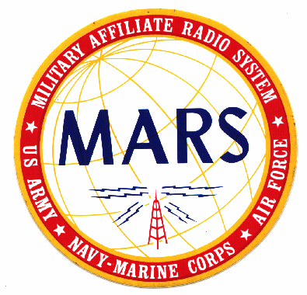
There has been a lot of activity in the MARS system since the last Radio Amateurs of Corry Newsletter and I will endeavor to touch on some of it here and catch up on the news. Making interoperatibility happen between the Army, Air Force and Navy MARS has been the goal of much of the efforts lately.

One such activity was a joint open house and air show at Barnes Air National Guard base in Westfield, MA on August 25 and 26 2001. The Canadian Snow Birds performed and Air Force MARS members from Massachusetts hosted a special event station using the call sign AGA1BA on 13.993 Mhz USB Army and Navy Chiefs were asked to have their members join this special event by checking in on both days.

On the same weekend of August 25, 2001 PA Army MARS hosted an interoperatibility meeting for Army, Navy and Air Force MARS members (JFIG) high on top of Tuscarora Mountain in south central PA on US Route 30 just east of McConnellsburg, PA the weather was great and the view from the overlook was breath taking. The all day meeting took place at the Mountain House Restaurant out on the Deck with the view. Several Local MARS members attended and participated in the event: Arnold AAT3JG, Jerry AAR3GF, Dave AAT3EN and Doug AAR3IR Carpooling was the order of the day for the 5-hour drive.
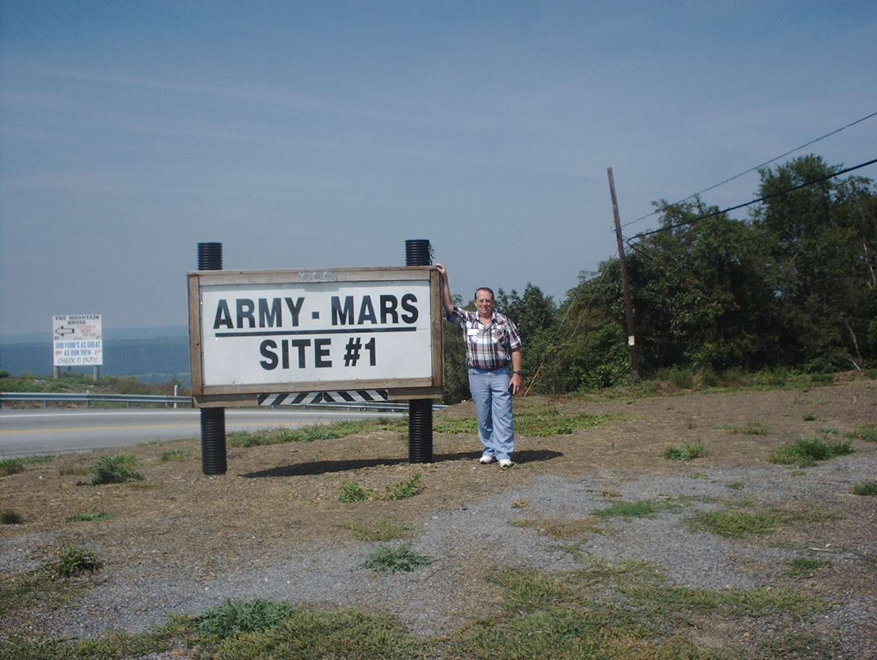 Jerry AAR3GF/W3GHO standing by sign that denotes Army MARS Communications Site.
Many of the speakers from Army and Air Force MARS gave insight on the handling of Traffic and Emergency Communications via digital means as well as voice repeaters and High Frequency nets. The support of the National Guard, Red Cross and other services were covered as well as a free Message service for members of the United States Armed forces.

A highlight of the trip was the open house tour of PA MARS site One just across the highway from the Mountain Top Restaurant. This a set of Army Communication trailers with emergency power, many antennas, and lots of equipment ranging from VHF repeaters to HF rigs with the new digital mode PSK31. It was enough to make any red blooded ham and MARS member green with envy. (Army Green, that is.)
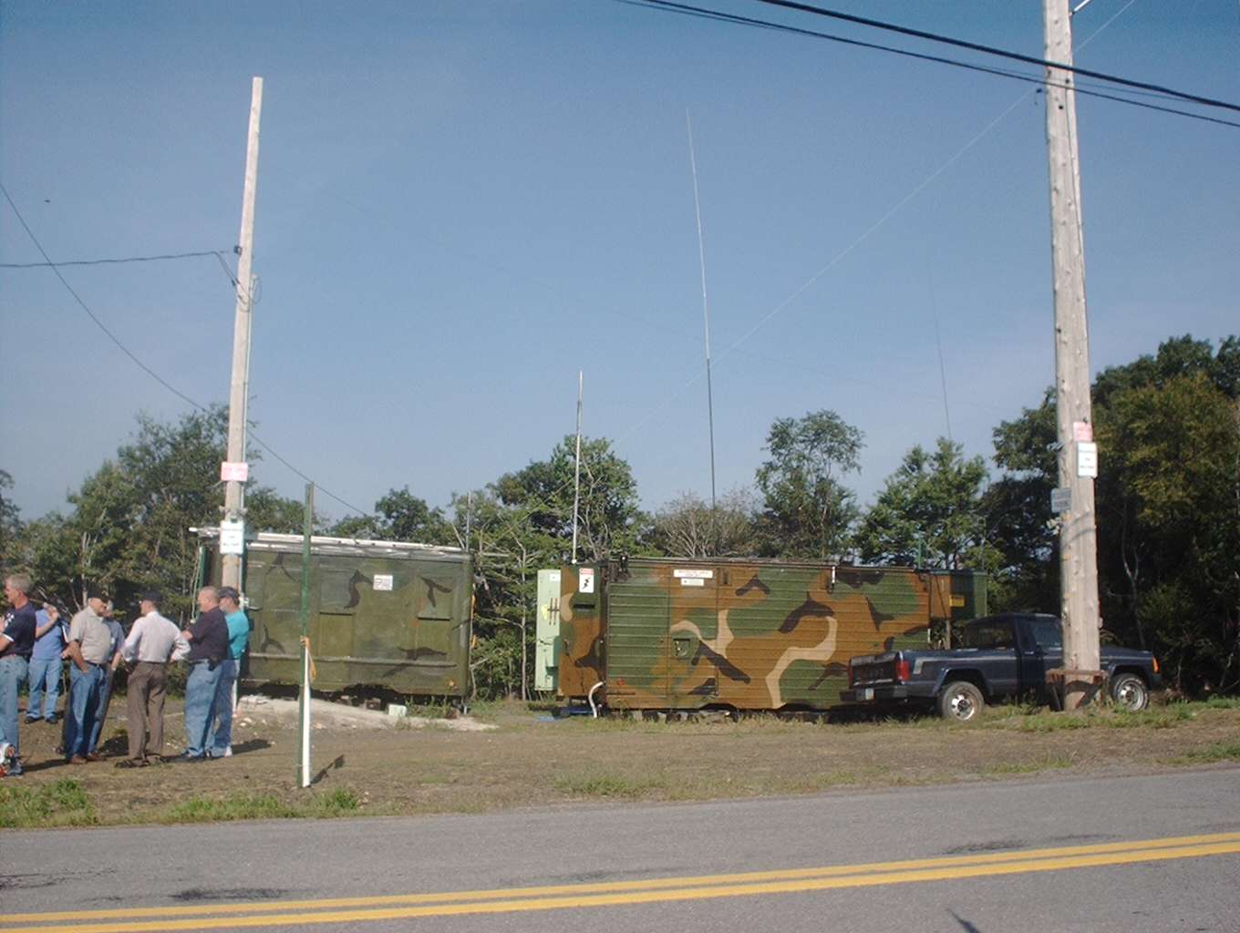
Communications trailers at Site One photos courtesy W3GHO

Just a reminder that Operation Holidays is just around the corner. Beginning in November anyone is encouraged to contact a MARS member and send a message to “any service person” and help let them know we care and appreciate their service for our great country and that they are away during the Thanksgiving and Christmas holidays. Army MARS Proud Professional and Ready.
--Jerry AAR3GF/W3GHO

Radio Amateurs of Corry Nets

Tuesdays – 10 Meters – 28.330 USB 8 p.m.
Thursdays – 2 Meters – 147.090 Repeater 8 p.m.
(NO PL is Needed to check into this net)

ARRL Petitions for
New 60-Meter Amateur Band

ARRL Bulletin 28

A petition filed this week by the ARRL could result in a new high-frequency band for US amateurs. The ARRL has asked the FCC to allocate 5.250 to 5.400 MHz to the Amateur Service on a domestic (US-only), secondary basis.

The League told the FCC that the new band would aid emergency communication activities by filling a ''propagation gap'' between 80 and 40 meters. ''There are times on certain paths when a frequency in the 80-meter band is too low, and a frequency in the 40-meter band is too high for reliable ionospheric propagation,'' the ARRL said in its petition. The ARRL said the propagation gap can hamper communication between the US and the Caribbean during a hurricane or severe weather emergency.

The ARRL Board of Directors approved the proposal at its July 20-21 meeting. The FCC has not yet invited public comments on the petition. Even if the petition finds favor with the FCC, it's likely to be several years before the new band actually becomes available.

As proposed by the ARRL, amateurs General class and higher would be permitted to operate phone, data, image and RTTY on the new band running maximum authorized power. No mode-specific subbands were proposed.

The ARRL said a new 150-kHz allocation at 5 MHz also could relieve substantial over-crowding that periodically occurs on 80 and 40. If the new band is approved, hams would have to avoid interfering with--and accept interference from--current occupants of the spectrum, as they already do on 30 meters. The band 5.250 to 5.450 MHz now is allocated to Fixed and Mobile services on a co-primary basis in all three ITU regions.

The ARRL's petition cites the success of the League's WA2XSY experimental operation in the 60-meter band, carried out since 1999, which confirmed the communication reliability of 60 meters.

''An amateur allocation in this band would improve the Amateur Service's already exemplary record of providing emergency communications during natural disasters when even modern communications systems typically fail,'' the ARRL concluded.

A copy of the ARRL petition is available on the ARRL Web site, http://www.arrl.org/ announce/regulatory/5MHz

Guess Who . . .
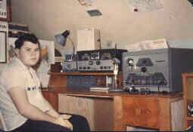

Here is a picture of ”the good old times—1950’s.” As you can see, his transmitter is the battleship Heath DX-100 AM/CW rig running a pair of 6146’s in the final It ran 100 watts on 160-M through 10-M (including the 11-M band). His receiver was a Halicrafters SX-99 and he used a Q-multiplier to sharpen his bandpass. He has not been as active in late because of health problems. Known as a DX’er, he is presently running a Kenwood TS-950. If you think you know him, turn to page 7 to confirm it.

FOR SALE: Rack Cabinets. Four 6-foot, one 4½ -foot, one 10-inch, one 14-inch. These cabinets have been in storage for some time now and I need the space they are occupying. Make offer. WA3HDK@arrl.net or (814)739-2206.

FOR SALE: TWO 8-foot roll up garage doors with hardware. WA3HDK@arrl.net or (814)739-2206.

WANTED: You can have your add run in an issue of the newsletter. Submit copy to WA3HDK@arrl.net or (814)739-2206. There is no cost to club members.
___________________________________________________
Club Membership Additions:

Ned Warren, KB3CZE
114 Mason’s Mobile City
Warren, PA 16365
(814) 7239796
FCC INVITES COMMENTS ON
ARRL'S 60-METER PETITION

ARRL Bulletin 33

The FCC has begun accepting comments on the ARRL's petition seeking the allocation of 5.250 to 5.400 MHz to the Amateur Service on a domestic (US-only), secondary basis. The Commission put the proposal on public notice this week and assigned a rulemaking number, RM-10209, to the proceeding.

Interested parties may comment on the proposal via the Internet or e-mail using the FCC's Electronic Comment Filing System (EFCS), information on which can be found at http://www.fcc.gov/e-file/ecfs.html . Those commenting should reference ''RM-10209'' in their postings. Even if the FCC eventually Okays the petition, it's likely to be several years before the new band actually becomes available.

In its petition, the ARRL told the FCC that the new band would aid emergency communication activities by filling a ''propagation gap'' between 80 and 40 meters, particularly for emergency communications during hurricanes and severe weather emergencies. The ARRL also said a new 150-kHz allocation at 5 MHz also could relieve substantial overcrowding that periodically occurs on 80 and 40.

The ARRL has proposed that General class and higher amateurs be permitted to operate CW, phone, data, image and RTTY on the new band running maximum authorized power. No mode-specific subbands were proposed. If allocated to the Amateur Service on a secondary basis, hams would have to avoid interfering with--and accept interference from--current occupants of the spectrum, as they already do on 30 meters.

The ARRL said that its successful WA2XSY experimental operation between 1999 and this year demonstrates that amateur stations can coexist with current users and that the band is very suitable for US-to-Caribbean paths.

Answer to GUESS WHO

The young lad in the picture is none other than Bob Myers, K3HWL. Although he lives in the Meadville area, he contrubites to the newsletter regularly.
Lower Amateur Radio Vanity Fee

ARRL Bulletin 27

The FCC says the fee for a new or renewed Amateur Radio vanity call sign will drop to $12 on September 10. Applications received on or after that date will be subject to the new fee. The current vanity call sign fee is $14.

The FCC proposed the lower fee last March in a Notice of Proposed Rulemaking for the Assessment and Collection of Regulatory Fees for FY 2001. The FCC has estimated that 8000 applicants will apply for vanity call signs in the current fiscal year.

Earlier this year, the FCC also put paper and electronic vanity call sign applications on an equal footing in terms of processing priority. The FCC used to give priority to electronic applications for vanity call signs.

FCC rules stipulate refunds for applicants who inadvertently overpay a regulatory fee. Applicants who determine that they overpaid a vanity fee may request a refund in writing. Requests seeking a ''Vanity Fee Overpayment Refund'' go to FCC, 1270 Fairfield Rd, Gettysburg PA 17325-7245. Refund requests should indicate the date of application, the total fee paid, and the total refund owed.

For more information, visit the FCC Amateur Radio Web page, http://www.fcc.gov/wtb/ amateur/ VanityCS.html.

Letters to the editor

I have moved to New York State.
My new E-Mail address is: k3cko@odyssey.net

My mailing addrtess is Robert E. Swarm
P. O. Box 69
Homer, NY 13077-0069

W3BZJ SUFFERS LIGHTENING DAMAGE

Mac, W3BZJ’s station suffered damage from a recent electrical storm. His computer, HF rig, power supply, and 2-meter rig were rendered unusable. He is back on the air with borrowed equipment. He is presently awaiting insurance adjustment. He wishes to thank those hams who have generously supplied standby equipment. Mac is the net manager for both the 10- and 2-meter nets.
PREZ SEZ . . .

I have been participating in an 80 meter net Saturday mornings. Here of late the communications have been less reliable, fading in and out and severe interference (QRM). We have switched (QSY) to 40 meters but find the band very crowded. These problems have lead the ARRL to petition to the FCC for a 60 meter band to provide more reliable emergency communications. The request is for an allocation of 5.250 to 5.400 MHz on a secondary basis, meaning the band would be shared with other users. It is proposed that general class or higher would be required to use the band.

There is an extract from a recent ARRL letter about this 60 meter petition: “Interested parties may comment on the proposal via the Internet or e-mail using the FCC's Electronic Comment Filing System (EFCS), information on which can be found at http://www.fcc.gov/e-file/ecfs.html

Those commenting should reference ''RM-10209'' in their postings. Even if the FCC eventually okays the petition, it's likely to be several years before the new band actually becomes available.” I would encourage you in sharing your comments.

It would be great to get another band. A 60 meter band would require changes to equipment and antennas. Change with the right attitude can be exciting. There are many changes--advancements, that have occurred in recent years--Satellite, PSK, computer controlled rigs, DSP and the list goes on. This is a young and advancing field, a great and exciting hobby. Great to be involved in it with you.

The summer is flying by; it is difficult to believe that school is about to start again. Our club meetings have been flying by also. There has been a lot of focus this summer on administrative stuff. The last few meeting have focused on trying to get the new by-laws in place. Hopefully this process will become less intense and we can begin to focus on other things. Let us know what you would like to do as a club. Your ideas are welcome and needed.

The club has had several successful projects recently, the Corry Airport Fly-In Breakfast and the Titusville parade. I would like to thank all those that provided the leadership to make it happen and those that supported the projects by their participation.

Ham radio is fun, let us all do our best to ensure everyone has a fun experience. Thank you all for all you do and in behalf of myself and my fellow officers we thank you for your support. 73’s
--Ralph, N3LXG
___________________________________________

INTERESTING PLACES
TO VISIT.

The Lowband Monitor. A newsletter dedicated to the 160/80/40m dxer:: http://www.qth.com/lowband/
Meteor Scatter. http://www.qsl.net/dk3xt/
Gladiator Verticals. 160m and 80m verticals used for the VK0IR Heard Island Dxpedition: http:// ww. primenet.com/~bmyers
PA3CQR's Grayline Program. Software that will calculate sunrise/sunset at your qth: http://www. iri.tudelft.nl/~geurink/grayline.htm
Tips and Techniques for Low Band Dxing. John Devoldere's book on 160/80/40 dxing. Probably the most definitive book ever published on low band dxing.: http://www.arrl.org.catalog/f-antennas. phtml#4661
Dxing on the Edge Jeff Briggs, K1ZM's, book about Dxing the Top band 160m:. http://www.arrl.org/ catalog/6354

http://www.nutrition.gov/home/indes.php3
http://www.k1dwu.net/ham-links/
http://ac6v.com/index.htm
http://www.alinco.com
http://www.epeervoices.com/index.html
http://www.k1dwu.net/
http://www.delphion.com/
--From Bob, K3HWL
___________________________________________________

Membership additions:

Will Cook, KD3II
44850 Old Route 77
Spartansburg, PA 16434
(814)654-7776

Harold Cole, WD4OOX
336 Essex St.
Corry, PA 16407
(814) 664-4233

Titusville Parade

Radio Amateurs of Corry again furnished support communications for the annual Oil Days Parade in Titusville. A total of eight club members and two guests met at McDonald’s at 10:00 on Saturday August 18 to prepare for the day. Mike, N3GCY served as event chairman and supplied us with a map of the parade route.

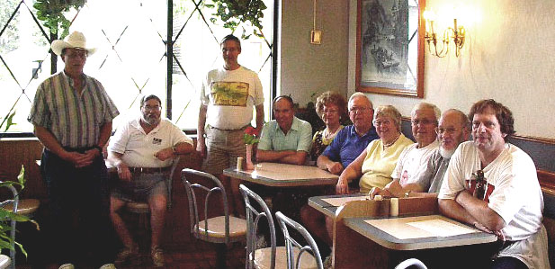
Photo courtesy of Bob, K3SBU

The parade was somewhat smaller than usual due to the absence of the Shriners, who had previous commitments. Never the less there were some 112 units in the parade.

The following members participated: Mike N3GCY, Jerry W3GHO; Bob K3SBU; Ann N3VHV; Hugh N3MBR; Frank KE3PD; Bob WA3HDK and Ed N3XBA. We enjoyed a first-rate parade and, I am happy to report that we had no incidents to mar the event. That is the best part of the whole day. However we could have used two or three more stations.

I am told that next year someone else will chair the parade. Too bad, as Sharon does a superb job in that position. Mike, too has said that he would like to see someone else (from our club) chair the com-munications part. He has done a fine job of co-ordinating our participation as communicators. I am sure that whoever does the job will continue to have the support of our members.

Following the parade, as is our custom, we met at KFC to replenish our bodies and also to critique the day’s events. The parade sponsors contributed a nice amount, which went into our treasury. Thanks to all of you who helped.
--Bob, WA3HDK
___________________________________________

From the Editor’s Desk

Well, another busy quarter has passed. A lot of good things and a few bad things went with it. First the bad news. Mac, W3BZJ was unfortunate enough to have a lightening strike wipe out a lot of equipment. He is in the process of moving his station from an upstairs room to a room on the ground floor. We will have the story with some pictures in a future issue. Mac has served our club very well as Net Manager for our nets. He has never missed making sure that a net control was on hand for each net. When you see him, why not give him an ‘ata boy.’

While on the subject of nets, I would be remiss if I didn’t tell you how lonely the nets have been during the summer. Last Thursday, however, we hosted the second largest net this year. Hopefully as the bad weather falls upon us, you will find your way back to the local nets.

Club meeting attendance has been down also over the summer months. If you can find the time to attend our meetings you can get your information first-hand. A lot of misinformation has serfaced this summer.

We are planning to get the next issue out by the first of December with details of the Christmas Party. It is to be held Saturday December 8. Plan to be there!

John Lis, N3MKV will be editing the Christmas issue. Please give him your cooperation.
--Bob WA3HDK
___________________________________________

SUMMER PICNIC

Members and guests met Saturday, June 9 at Mead Park’s Red Top Pavilion for our annual Picnic. The party numbered twenty-three. The planning for the outing was under the direction of Norma, W3CG. Her able assistants were Debbie, N2MQ; and Joanna, N3WNS. They had placed table cloths on the tables, and started a fire in the fireplace by the time I arrived.

We had time to visit and renew some old friendships before we sat down to dinner. Jerry, W3GHO returned thanks, and the feast began! We were blessed with perfect weather and lingered to visit. While not as large a turnout as usual, all had a pleasant time. We Thank Norma and her crew for the effort (continued on page 10)

Summer Picnic (Story on previous page)

SUMMER PICNIC

WA3HDK photo
Kneeling: Paul and Richard II (N3YPT’s harmonics), N3YPT, W3GHO, N3OCL, and WB3BLN.

Standing: Evelyn (W3GHO’s xyl), N3LXG, WB3BZJ, KB3EMH, Agnes (W3BZJ’s xyl) WB3AYW, Barb (WB3AYW’s xyl), N3MLX, Elaine (N3MLX’ xyl), KC2AUS, N2MQ, N3UBZ and Frank (grandchild), Nancy (N3UBZ’s xyl) and W3CG.

_{The} RADIO AMATEURS OF CORRY

P. O. Box 362
Corry, PA 16407

This newsletter is published quarterly

Editor, Robert E. Bair, W3HDK (739-2206)
Editor, John Lis, N3NVK (825-5565)
Staff: Jerry Owens, W3GHO

Submit material for the next issue on/or
before NOVEMBER 15 . Next issue is December 1

<<<<<E-mail articles to hdk@erie.net>>>>>

Club Officers--
President, Ralph Miller, N3LXG (489-0242)
Vice President, Daniel Fargo, KB3EMH (663-5170)
Secretary, Jerry Owens, W3GHO (664-7502)
Treasurer, Mike Dziubkowski N3GCY (664-7189)

