THE RADIO AMATEURS OF CORRY

VOLUME 8 No. 2 JUNE 2001

Radio Enthusiasts Ham It Up

[From the Dayton Daily News: 05.20.2001]
28,000 expected to attend Hamvention at Hara Arena
By Christopher Montgomery
Dayton Daily News
TROTWOOD | It’s 7:30 a.m., and under a layer of thick fog, a city of tarps and trailers comes to life in Hara Arena’s parking lot. Vendors still groggy with sleep unload their wares and quietly sip their morning coffee.
The scene is altogether different outside the parking lot gates. A crowd is gathering by the entrance, with only two security guards standing in the way. Five minutes before 8 the crowd starts getting restless. People shift from foot to foot and stand on their toes to check the front of the line.
Ten minutes later, isolated shouts of, “Come on!” and “Let’s rush the gates!” break the silence. With tension building, word finally comes through: Let the hams in.
The crush of visitors pouring into the open-air flea market Friday marked the beginning of the 50th annual Hamvention — the world’s largest gathering of amateur radio enthusiasts. More than 28,000 people from all 50 states and numerous foreign countries are expected this weekend to peruse the booths of 1,200 outdoor vendors and 250 larger indoor vendors. The event is sponsored and organized by the Dayton Amateur Radio Association. Even incessant rain like Friday’s can’t deter ham-radio devotees, according to one outdoor vendor, Larry Campbell, who was featuring a Furuno waterproof radio during one of the downpours.
“The Hamvention is an institution,” said Campbell,41, an electrical engineer at Ohio State University. “A little rain isn’t going to scare anyone off.” Campbell — who is selling radios and supplies with friends from Arizona, Louisiana and Michigan — said he buys booth space every year simply because he enjoys his hobby.
“I’ve spent about $1,000 to get here and sold $30 worth of equipment so far,” he said. “I’m not in it for

the money. I do it for the social aspects, the time I get to spend with people I only see once a year.”
The Hamvention is, indeed, a social event unlike any other. Hams with their names and call letters — W9RS Richard, N7PA Phil — emblazoned on their hats stroll by tables full of transverters, tranceivers and coax cables. They talk into handsets and headsets to fellow hams. Stand still for a moment, and all you can hear are floating voices, static and Morse-code blips.
The colorful, quirky atmosphere shouldn’t obscure the fact, however, that the three-day event means big business for the Miami Valley, said Hamvention spokesman Steve Cartwright.
“Last year alone, Hamvention brought $7 to $8 million into the area,” Cartwright said. “That covers everything from Life Savers to Starvin’ Marvin to the Hilton.
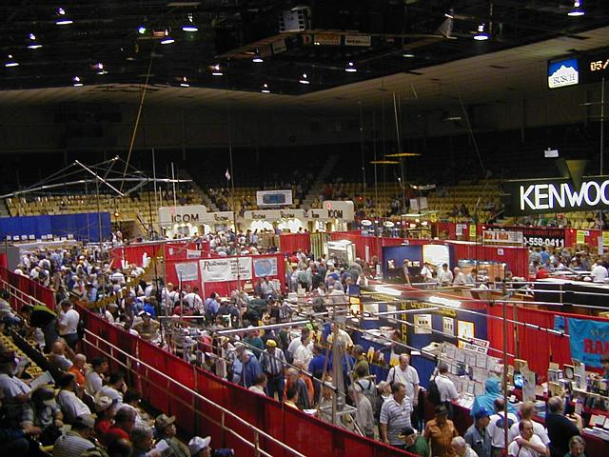
“We really benefit from the large geographic reach of ham radio. I would venture to say that, though we’re not the biggest event in town, we bring in the most international guests.”
What are the secrets to Hamvention’s success? Excellent organization and size, said Bill Caldwell, 41, who traveled to Dayton from Cedar Rapids, Iowa.

“I’m chairman of a hamfest back home, and it probably has one-fiftieth the draw. I dream of it being this big
(Continued on page 2)

2001 Hamvention® Rumor Answered

The week of Hamvention was busy with show preparation. A “rumor” was allegedly printed in a Chicago newspaper. The show was “uphill” after that.
The Hamvention Committee spent the weekend reassuring our vendors and attendees that HARA has not been sold, that Hamvention’s contract had not been “bought out” and that we would be back next year, at HARA, just like always.
HARA management issued a formal statement on Sunday restating those facts.
In summary - HARA has not been sold, HARA will not be razed and that Hamvention would return in 2002.

___________________________________________
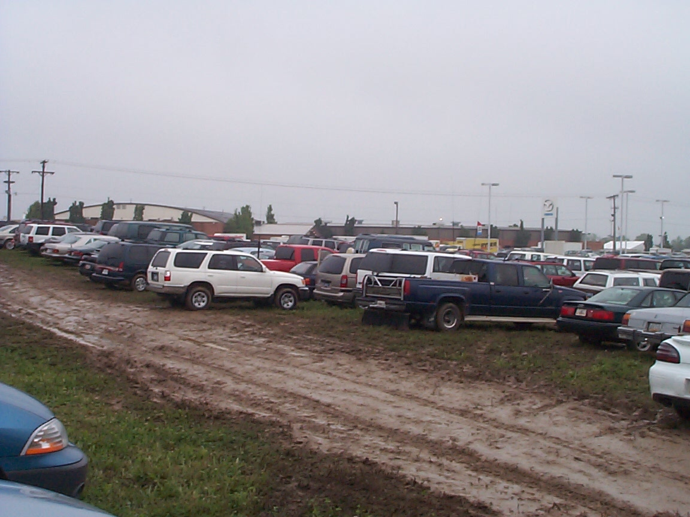

Nor Rain, Nor Flood, Nor Thunder. Nor Lightning, Nor Mud Hams still make the Trek to Hamvention 2001. (Photo Courtesy N3MLX)
___________________________________________

RADIO AMATEURS OF CORRY
MARCH 13 2001 MINUTES

The meeting was called to order at 7:30 P.M. by President N3LXG with Vice President KB3EMH and Secretary W3GHO present. Also there were 8 members present.
The minutes of the February 2001 meeting were read and approved.
President N3LXG thanked Leonard WB3AYW for the fine job as chairman of the fund raising breakfast the VFW in February there was plenty of food and good comments.
President N3LXG announced several VE sessions and Hamfests in the near future. The matter of the Club annual report and web page listing with the ARRL was discussed and the Secretary W3GHO was instructed to make the report and corrections to the ARRL web page. The matter of interference from the Pittsburgh, PA 147.09 repeater was discussed the consensus being they should be asked to install PL through their repeater trustee and WPA repeater council, Secretary W3GHO was instructed to do just that.

The subject of Equipment insurance was again approached and noted that there had been no receipt of renewal from the insurance broker and the current policy would expire on April 1st. Frank KE3PD stated that the ARRL sponsored equipment insurance was a much better deal and cited the prompt payment of a claim by the Franklin Club recently.

There was a motion to have Secretary W3GHO contact the current insurance broker in a timely manner and do what was necessary to renew the current policy to keep it in effect until we can change over to the ARRL sponsored equipment coverage. Motion carried.
Frank KE3PD said he would research information for the ARRL policy with serial numbers model numbers and other equipment information needed to initiate new coverage and forward same to the club secretary.
Treasurer Mike N3GCY arrived and gave the Financial Report showing receipts of $490.00 disbursements of $11.49. Checking balance of $2267.91 and Savings balance of $1139.50.
By-law committee reported that the by-laws were now complete and after e-mail and proof reading by all concerned would be printed and distributed.
Tower trailer project committee report showed nothing had been done yet.
Breakfast Committee. Leonard WB3AYW reported a good turnout for the workers and the breakfast was a success financially also.
Social Committee Chairperson Norma W3CG reported reservations had been made at the American Legion Post 365 in Corry for the 2001 Christmas party on December 8^{th.}
There was a motion to move the Christmas party back to the Dutch Treat in Spartansburg for 2001. This motion was defeated.
(continued on page 3)
Repeater Committee chairman Jim WT3O submitted a written report that was read by President N3LXG listing the maintenance and repair work that had been done on the repeaters and stating his policy regarding the use of the W3YXE call for the combined field day activity and that he only wants the club call used for Corry club communications.
Field day committee reports that Union City wireless club has approved the joint field day for 2001.
President N3LXG asked Secretary W3GHO to research when the club records were lost and where they might possible be. It was suggested former secretary Patty Sarver would be a good place to start.
Old Business: Mike N3GCY reported the club had insurance on the club owned equipment but did not have any liability insurance of any kind. The current equipment insurance will expire on 31 march 01.
Secretary W3GHO was instructed to attempt to obtain a renewal application and keep the present policy in force by regular motion by N3XBA. Second by WB3AYW.
Also it was the consensus of the members present that we should pursue a new policy with the ARRL insurance carrier. Frank KE3PD agreed to send an equipment list to the secretary in order to proceed with the ARRL insurance.
New Business: There was a motion to deny a request by the Civil Air Patrol for tower space on the Club repeater tower because of a stipulation in the agreement with the Hopkins family stating that only the Radio Amateurs of Corry would use the Building and tower site. By Frank KE3PD second by Bob WA3HDK.
Instead of a 50-50 fund-raiser, a drawing was held for a two meter antenna building project using a converted TV antenna and was won by N3XBA.
Motion to adjourn by Frank KE3PD Seconded by BOB WA3HDK
The Program for the evening was by Bob WA3HDK who set up his laptop computer and logged into the FCC universal license site to assist members who had not received their ULS registration number from the FCC.
Jerry W3GHO, Secretary
Radio Amateurs of Corry
___________________________________________

JUNE 12 CLUB MEETING -- 7:30 p.m. Corry ARC
JULY 10 CLUB MEETING -- 7:30 p.m. Corry ARC
AUG. 14 CLUB MEETING -- 7:30 p.m. Corry ARC
SEP. 11 CLUB MEETING -- 7:30 p.m. Corry ARC
RADIO AMATEURS OF CORRY
APRIL 17, 2001 Minutes
Due to the absence of President N3LXG the Meeting was called to order by Vice President Dan KB3EMH with Secretary W3GHO and 6 members present at 7:30PM.
The Minutes of the March 2001 meeting were read and approved. Motion by WA3HDK seconded by N3MLX.
KB3EMH then read the Calendar of coming events including Club Picnic, Field days, Titusville Parade and Jamboree on the Air.
There were no correspondence or bills to be read.
Treasurer N3GCY was not present so there was no financial report.
There was a discussion of who made the motion at the February meeting regarding joining with the Union City wireless Club for the 2001 Field days.
The Minutes were amended to show that the motion was made by two Members in Good standing N3XBA and WA3HDK.
Committee Reports: A written report was submitted by Jim WT3O saying the Repeater Committee had placed the Club 70 CM repeater back on the air. Frank KE3PD and others were indicated as helpers in the project.
It was also reported that the NW PA repeater council dues had not been paid for 2001. Secretary W3GHO stated that no bill had ever been received from the Council so nothing had been paid.
Old Business: Tower painting project is still on hold for better weather.
The address for the Radio Amateurs of Corry web site was announced by John N3NKV to be www.qsl.net/w3yxe

Secretary W3GHO reported the Equipment Insurance had been paid in the amount of $94.91. Also, that Frank KE3PD had forwarded the Model and Serial number of the equipment at the repeater site he also sent a list of all other equipment including hard-line and antenna’s. The matter of changing over to ARRL insurance carrier was held over until next meeting.

Vice President Dan KB3EMH reported on his findings with the liability insurance quest. He said that it would cost approximately $350.00 for $1,000,000 of liability insurance.

There was a motion to purchase $1,000,000 of liability insurance per occurrence and $2,000,000 cap by WA3HDK Seconded by N3OCL (continued on p 4)
A discussion followed regarding the agreement for the use of the repeater site tower and building and it was decided to keep searching for the papers with former secretary Patty Wotus a possibility.

New Business: The site for the 2001 field day is the Maynard farm on the old Lincolnville Road, Union City. N3XBA to coordinate with Corry Club on Field day activities and use of W3YXE call sign. He said there would be a picnic supper on Saturday night. WA3HDK said he would download and print the Field day rules, log sheets and dupe sheets.
Motion to adjourn by W3GHO second by WA3HDK
50-50 won by W3GHO
Jerry W3GHO, Secretary
Radio Amateurs of Corry
_______________________________________________________________________________

RADIO AMATEURS OF CORRY
MAY 8 2001 Minutes

The Meeting was called to order by President Ralph N3LXG at 7:30PM with Secretary Jerry W3GHO and 7 members in attendance. Treasurer N3GCY Mike was absent.

The minutes of the April meeting were read and after one correction approved.

Coming Events including Picnic on June 9th and Field Days on June 23/24 were announced by N3LXG, he also gave the date for the next VE exam in Erie.

Correspondence was read from the Chairman of the 147.09 North Hills repeater committee in reply from the W3YXE/R repeater Committee regarding the request for them to PL their machine, the answer was negative, also the Handi-ham newsletter was passed around.

There were no bills submitted for payment.

There was no Treasure’s Report due to the absence of N3GCY.

CommitteeReports:
By-law Committee did not meet, nothing to report.
Social Committee Chairperson Norma W3CG reported the Picnic would be held on June 9th at the Elks Pavilion in Mead Park, members to bring a dish to pass, table service and meat to bar-be-q. The club will furnish the Soda Pop for drinks.

Frank KE3PD reported on behalf of the repeater committee that a new receiver crystal had been installed in the 440 repeater but still losing the audio part of the time, he also said the 2-meter repeater was operating well and the battery water was stable.

The painting of the tower was discussed and the Repeater Committee was asked to contact someone with proper insurance to paint it for us.

Bob WA3HDK said the Newsletter would be edited by John N3NKV for this issue and would be out by June 1st.

Vice President KB3EMH has sent Insurance application to the ARRL but nothing has been received back yet.

Secretary W3GHO reported he had picked up the pouch of club records from former Secretary Patty Sarver and shared them with the members present and will place them in the file for safe keeping.

President N3LXG stated we still need to have a copy of the Land use agreement for the repeater site with the Hopkins family, it was understood that only one copy is known to exist.

New Business: After discussion there was a motion by KE3PD to switch to the ARRL equipment insurance plan, Secretary is to submit the forms. Second by WB3AYW.

Field days will be chaired by N3XBA from the Union City Wireless Club, WA3HDK has printed out the Rules, Log and dupe sheets from the ARRL web site.

There was a discussion about the Club registering at the Erie County Courthouse as a non-profit organization, the matter was shelved for further investigation.

There was a motion by WB3AYW to purchase a small portable file case to store Club records in, the file is to be placed in the basement of the Red Cross building seconded by KE3PD.

Door Prizes of a volt-ohm-meter and Breezeshooters hamfest ticket were donated by President N3LXG and won by Jerry KC2AUS and Rob N3OCL.

There was a motion by KE3PD and seconded by WB3AYW to have regular Club meetings all summer. Motion carried.

The meeting was adjourned at 8:45 PM

Jerry W3GHO, Secretary
Radio Amateurs of Corry
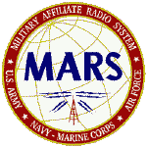MEN FROM MARS
May 5th and 6th are dates that will be remembered for a long time by the PA Army MARS Members here in Western PA because the Annual PA MARSCON (MARS Conference) was held here in Corry at the Masonic Hall. The last time a MARSCON was held in this area was in 1969 at the Armed Forces Reserve Center in Erie. The Local Committee put together a program for the Sunday meeting that filled the time with talks on Emergency Communications, message handling through the MMCS (Mars message system) on both HF and VHF packet repeaters, a hands on demo of computer hardware and installing sound boards and hard drives. A complete Packet BBS was set up and running with overhead projector with connection to a laptop system in the meeting room.

Also the new digital mode PSK31 (Phrase shift keying 31 Hz wide) was demonstrated. The MARSCON was also part social affair with an informal meeting Saturday evening and Sunday dinner get to gather at Country Foods between morning and afternoon sessions.
Members commuted from all parts of the state to attend but one of the best parts was the local members did not have a 5 or 6 hour drive to return home.
In other matters the three MARS (Army, Navy and Air Force) services were represented at the Dayton Hamvention again this year, early reports indicate much interest in the recruiting and overall mission of MARS.
A coming event is the NECON (National Emergency Communications Net) 01 June 2001 in which all Army MARS members can participate. Members check in to nets in the normal way and net control stations is asked to send an e-mail to FEMA.gov and then to check into a net on the FEMA frequency of 5.211mhz which some amateurs operators might be interested in listening to also.

I would like to wish all a fine summer and hope each one enjoys some of the summer operation activities.
Jerry AAR3GF/W3GHO
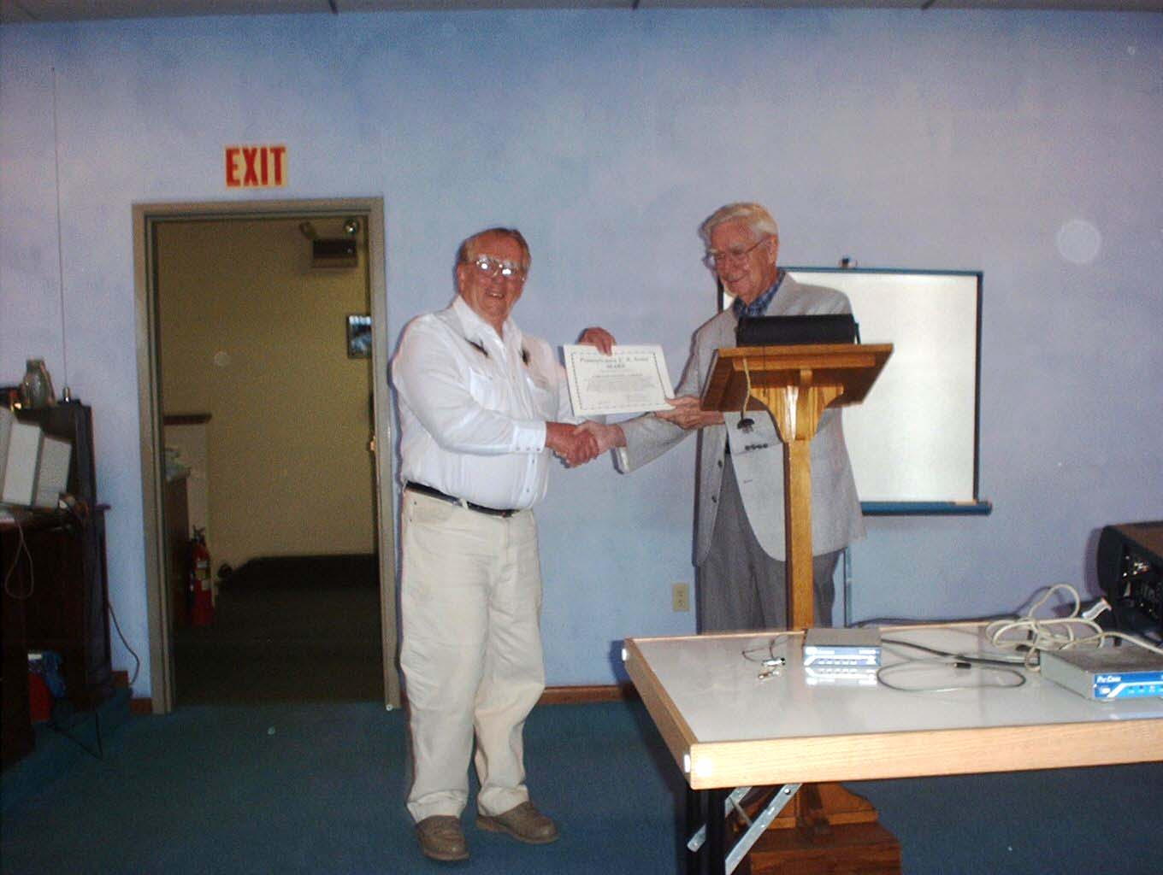

Jerry AAR3GF receives certificate for “most improved participation” from State MARS Director, Roger Colvin, AAA3APA.

Dick Perkins, AAT3IA gave a seminar on packet communication.

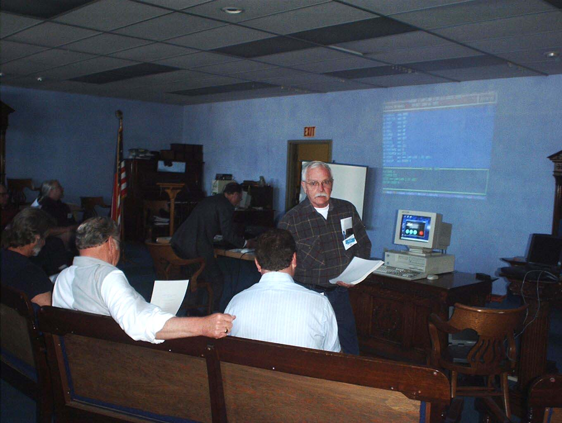

Annual Picnic
Meade Park , Red Top Pavilion
Saturday June 9
12:30 p.m.

Bring your meats to Grill, place setting, and a dish to pass. The club will provide soft drink beverages and charcoal. Members, prospective members and their guests are welcome.

UPCOMING EVENTS:

Hamfests
June 1-3
Atlantic Division Convention
Rochester ARA
http://www.rochesterhamfest.org

June 3rd
Breezeshooters ARC
http://www.breezeshooters.net

July 8th
North Hills ARC
http://nharc.pgh.pa.us
July 15th
Genesee Radio Amateurs
http://www.gramradio.org

August 5th
Western New York Section Convention
Lancaster ARC
http://hamgate1.sunyerie.edu/~larc

August 19th
Warren ARA
http://www.onecom.net/wara

September 9th
Western Pennsylvania Section Convention
Butler County ARA
http://members.fortunecity.com/w3udx/

September 23rd
Hamfest Association of Cleveland
http://www.hac.org

Radio Amateurs of Corry EVENTS:

JUNE 9 - ANNUAL PICNIC AT MEADE PARK- Red Top Pavilion- Bring your meats to Grill, place setting, and a dish to pass. The club will provide the beverages and charcoal.

JUNE 23/24 FIELD DAYS WITH UNION CITY CLUB – Maynard Farm located on Old Lincolnville Road.

JULY 15 FLY-IN BREAKFAST - Corry Airport***

AUG. 18 TITUSVILLE PARADE COMMUNICATIONS ***

***No information about these events has been received as of press time
Repeater Signal Propagation
By Ray Abraczinskas, W8HVG
May 17, 2001

Location, location, location. In real estate, that is the primary concern. But what other factors affect the capability of a repeater? Did you ever wonder why your local repeater coverage is as good or bad as it is? Sometimes the reasons are not too obvious.

Why can certain repeaters always be heard consistently further than other repeaters operating in the same area? How can repeaters be heard behind hills? Why does a repeater sometimes “interfere” with another on the same frequency, but only in certain locations? How can a repeater not be heard 30 to 50 miles away but can be heard, full-quieting, 60 to 150 miles away? These are interesting questions, especially in Michigan where all of the above situations can and do occur. These same factors will apply to almost any repeater anywhere, however.
Five Basic Influences
There are five variables responsible for these phenomena: propagation effects—terrain and meteorological, radiated power, antenna height, gain patterns and directivity, and receiver sensitivity.

Changes in any one—or any combinations—of the five variables can and do have a significant impact on repeater signal propagation. There are other factors such as antenna polarization and ambient noise effects, but they can be controlled, by design, for a fixed set of conditions. Voice repeater antennas are almost always vertically polarized, but unfortunately so is most ambient RF noise, adversely affecting receiver sensitivity.
Terrain Effects Michigan’s hills and ridges—moraines created by ancient glaciers, gentle slopes and flat land, vary in altitude from 750-1500 feet. Signal strength can be high, even behind hills. This is due to the knife-edge effect, diffraction. The radio wave is slowed down—bent—and essentially scattered, as it strikes the top of the hills and mountains. These terrain-boundary propagation effects can account for signals being received behind hills, on higher sloping terrain or across the lake. However, based upon my 34 years of repeater operation experience, I believe that meteorological conditions play the greater role in VHF/UHF signal propagation. From spring through fall the bands tend to be “hotter” longer than expected, with some exceptional band openings occurring in the mornings and evenings. In mid-winter, when even Michigan can warm up for a few days, band openings occur to surrounding states and beyond.
Meteorological Effects
The Great Lakes that surround Michigan have a significant influence on VHF/UHF propagation within the state. A “merging and changing weather effect” is caused by the interaction of cold air from the north, warm dry air from the west, and warm moist air from the south. These weather patterns also influence tropospheric ducting and enhancement. Distant repeaters or stations tend to drop out, get noisy or not be heard until sundown. This unique propagation is one of the reasons why the Michigan Area Repeater Council and other surrounding state councils agreed—years ago—to coordinate repeaters within a 120-mile radius. But still, repeater signals can easily propagate more than 120 miles, and they often do [See any recent edition of The ARRL Handbook for an extensive explanation of propagation phenomena].
Radiated Power-Maximize!
Hams generally agree that greater radiated power, can result in a stronger received signal. Radiated power depends on many things—the transmitter, power amplifier, duplexer losses, connectors and coax feedline losses and the antenna gain or loss. Antenna gain is influenced by the antenna’s location on the tower and by nearby metallic objects. Some repeater operators fail to appreciate this fact when measuring or analyzing their antenna gain pattern.
Most amateur repeaters in Michigan run 10-50 W output. Several repeaters, however, are running 100-300 W. It may be for a particular reason, such as to achieve greater coverage or just because they have the capability. Even though the FCC rules say to run only enough power to facilitate the desired communication, some hams must think this doesn’t apply to their repeaters. They are only interested in increasing their range, especially during non-enhanced conditions.
Antenna Height
If one has “efficiently maximized” power to the antenna, antenna height is the next significant factor in improving signal strength. Generally speaking, “the higher the better” is true, but there can be a point of diminishing returns. If the antenna is too high, the antenna’s vertical gain pattern is compressed or squashed into a narrow beam. The VHF/UHF signal transmitted by such an extremely high antenna—having a narrow vertical beam width—can skip over receivers located a few miles away, but will be heard 100 miles away. A local ham, using an HT, may not be able to get into the repeater, or his signal may be noisy.

Gain Patterns and Directivity
Antenna gain patterns—or directivity—effects are probably the most significant factors in the design of an amateur repeater, but are given the least attention. Radiation patterns in the horizontal and vertical plane can vary with frequency. It’s somewhat hard to predict patterns and it’s also hard to measure them accurately, especially if the antenna is side-mounted on a tower. Antenna spacing, location relative to the tower face, tower legs and other antennas all affect the antenna pattern. These factors usually create unwanted lobes in the pattern. Some antenna manufacturers provide radiation patterns for their antennas, showing the effect of different tower mounting configurations. But they are not always accurate because they are merely an approximation of a particular installation. If the antenna is on the top of a high-rise building, other nearby antennas or metallic objects can affect the antenna radiation pattern.
Rain and ice can alter the radiation pattern further. Even reflections from airplanes flying near the repeater can significantly affect the signal—by reflecting it—albeit for only a few moments. It’s possible for pattern effects to produce another 3 to 6 dB gain, or loss, thereby doubling or quadrupling—or reducing—the radiated power in certain directions. All hams should know that antenna gain is directivity. It’s like love and marriage. You can’t have one without the other!

Receiver Sensitivity There is no question that radios today are more sensitive than radios of several years ago. Solid-state devices have lower noise-levels and higher gain than the components they replace. Sometimes, just by changing his VHF or UHF radio receiver or adding a receiver preamp, a ham will hear repeaters he never heard before. The results can be so startling that he may think it’s a new repeater or that the repeater owner increased the repeater power considerably. Progress occurs in different ways!
- Courtesy ARRL Web Site

Editor’s Comments:
I would like to thank all who submitted articles for this issue. I am always looking for different articles. If you come across an interesting web site or have an article for me, drop me a line via e-mail. 73 N3NKV John John3nkv@hotmail.com

ARRL EXECUTIVE COMMITTEE REVIEWS PRELIMINARY 5 MHz BAND PETITION

The ARRL Executive Committee has reviewed a preliminary draft Petition for Rule Making seeking a new US ham band in the vicinity of 5 MHz. Experimental operation at 5 MHz under a license issued to the ARRL has been going on since 1999. Participants in the ARRL WA2XSY experimental operation have established that an allocation at 5 MHz could improve emergency communication capabilities by filling the gap between 80 and 40 meters. On a motion from Southwestern Division Director Fried Heyn, WA6WZO, the EC agreed that the petition should seek a domestic secondary amateur allocation around 5 MHz with a bandwidth of 150 kHz. Executive Committee members will review the completed draft petition before it’s filed with the FCC, possibly before the next ARRL Board meeting in July. An amateur allocation in the vicinity of 5 MHz long has been an objective of the International Amateur Radio Union. The IARU’s Administrative Council has approved a goal of “a narrow allocation, even on a shared basis in the vicinity of 5 MHz.” Winning an allocation at 5 MHz—even on a domestic basis—could take several years. Securing an international allocation will be more difficult and take even longer. Consideration of an allocation at 5 MHz is not on the agenda for WRC-03 nor on the preliminary agenda for WRC-05/06. A review of FCC-related issues dominated the May 5 Executive Committee session in Dallas. In other matters, the Executive Committee was told that an FCC Notice of Proposed Rule Making still is expected soon in response to the ARRL’s petition, RM-9404, seeking Amateur Radio access to the low-frequency spectrum. Filed in late 1998, the ARRL petition asks the FCC to establish LF allocations in the vicinity of 136 kHz and between 160 and 190 kHz. ARRL General Counsel Chris Imlay, W3KD, also told the Committee that the ARRL’s Application for Review that seeks to clarify the FCC’s PRB-1 limited preemption policy with respect to amateur antennas is pending before the full Commission. The ARRL wants the full Commission to review—and reverse—an FCC staff decision declining to extend PRB-1 coverage to include CC&Rs—covenants, conditions and restrictions. The EC agreed to request an en banc presentation to the full FCC this fall, after new Commission appointees have been seated. The Committee also was told that favorable FCC action is anticipated on a petition seeking to upgrade Amateur Radio’s status from secondary to primary at 2400 to 2402 MHz. The ARRL recently renewed a longstanding request that the FCC elevate Amateur Radio from secondary to primary at 2300 to 2305 MHz. The minutes of the ARRL Executive Committee meeting in Dallas are available on the ARRL Web site, http://www.arrl.org/announce/ec_minutes_466.html.
-Courtesy ARRL

DID YOU KNOW?

ORIGIN OF DX
DX is allegedly an early telephone term for distant exchange. It is also defined in Funk & Wagnall’s as Distance.

ORIGIN OF ELMER

Not many reports on this but had a report that early Army rifle instructors were called “Elmers”.
From Ken and Mary
I believe that the term “Elmer” is a fairly new one. It has only been widely used for perhaps the last twenty years. I recall reading of its origin in QST or other ham magazine sometime no earlier than the late ‘70s. It refers to a specific ham whose first name was Elmer, who was a mentor of novices in a ham club somewhere in the USA.

ORIGIN OF MAYDAY
Opinions from the Internet
Why do ships and aircraft in trouble use “mayday” as their call for help? This comes from the French word m’aidez - meaning “help me” - and is pronounced “mayday.” (Note: not exactly.... it’s pronounced “med-ay”, but close enough)

ORIGIN OF DE
Opinions From The Internet
Does anyone know how and why the “de” is included whenever the first name is used. ....as in “73 de Yab”. I know “de” is Dutch for “the”, but maybe that has nothing to do with it.
Close...’de’ is Spanish for ‘from.’ Ham shorthand. 73 from Yab. An artifact of CW usage.
All wrong, “de” comes from the French!!!!!!! language and has the translation to “from” and “of” in the English language.—odo
(Continued on page 9)
_______________________________________________

Your classified ad can be published in the newsletter free
ORIGIN OF CQ
Opinions From The Internet
Let’s turn to page 4 of Baarslag’s Famous Sea Rescues (formerly titled: SOS To The Rescue): “By 1904 a number of ships in the trans-Atlantic trade were equipped with wireless telegraphy. The British operators were nearly all landline telegraphers
who had left railroad or post-office keys to go to sea in the newly opened field. They brought along with them not only their Morse code but also many of their telegraphic abbreviations and signals. One was the general call - CQ, which had been used to attract attention of all operators along a wire. It preceded the time signal in the morning at 10 o’clock and also all notices of general importance. CQ went to sea and became a general call to all ships.”
A couple paragraphs later, “Early in 1904 the Marconi Company, realizing the desirability of some universal distress signal, filled the need by issuing the following general order: “It has been brought to our notice that the call ‘CQ’ (All Stations) while being satisfactory
for general purposes, does not sufficiently express the urgency required in a signal of distress. Therefore, on and after the 1st of February, 1904, the call to be given by ships in distess, or in any way requiring assistance, shall be ‘CQD.’ “ “
To me, this implies that prior to 1 Feb 1904, some ship did use CQ as a distress call, and possibly her calls for help didn’t draw the needed attention. (This was before the twice-per-hour Silent Periods were created - 600m was pure bedlam, and a CQ would have gone unheeded.)

ORIGIN OF 73
Via Louise Ramsey Moreau, W3WRE and Charles A. Wimer KC8EHA
The following is from Louise Ramsey Moreau, W3WRE:
“The traditional expression “73” goes right back to the beginning of the landline telegraph days. It is found in some of the earliest editions of the numerical codes, each with a different definition, but each with the same idea in mind - it indicated that the end, or signature, was coming up. But there are no data to prove that any of these were used.
“The first authentic use of 73 is in the publication, The National Telegraphic Review and Operators’ Guide, first published in April 1857. At that time, 73 meant “My love to you!” Succeeding issues of this publication continued to use this definition of the term. Curiously enough, some of the other numerals used then had the same definition as they have now,
but within a short time, the use of 73 began to change.
“In the National Telegraph Convention, the numeral was changed from the Valentine-type sentiment to a vague sign of fraternalism. Here, 73 was a greeting, a friendly “word” between operators and it was so used on all wires.
“In 1859, the Western Union Company set up the standard “92 Code.” A list of numerals from one to 92 was compiled to indicate a series of prepared phrases for use by the operators on the wires. Here, in the 92 Code, 73 changes from a fraternal sign to a very flowery “accept my compliments, ”which was in keeping with the florid language of that era.
“Over the years from 1859 to 1900, the many manuals of telegraphy show variations of this meaning. Dodge’s The Telegraph Instructor shows it merely as “compliments.” The Twentieth Century Manual of Railways and Commercial Telegraphy defines it two ways, one listing as “my compliments to you”; but in the glossary of abbreviations it is merely “compliments.” Theodore A. Edison’s Telegraphy Self-Taught shows a return of “accept my compliments.” By 1908, however, a later edition of the Dodge Manual gives us today’s definition of “best regards” with a backward look at the older meaning in another part of the work where it also lists it as “compliments.”
“Best regards” has remained ever since as the “put-it-down-in-black-and-white” meaning of 73 but it has acquired overtones of much warmer meaning. Today, amateurs use it more in the manner that James Reid had intended that it be used - a “friendly word between operators.”

Radio Amateurs of Corry Nets

Tuesdays – 10 Meters – 28.330 USB 8 p.m.

Thursdays – 2 Meters – 147.090 Repeater –
(PL is turned off for net operations)

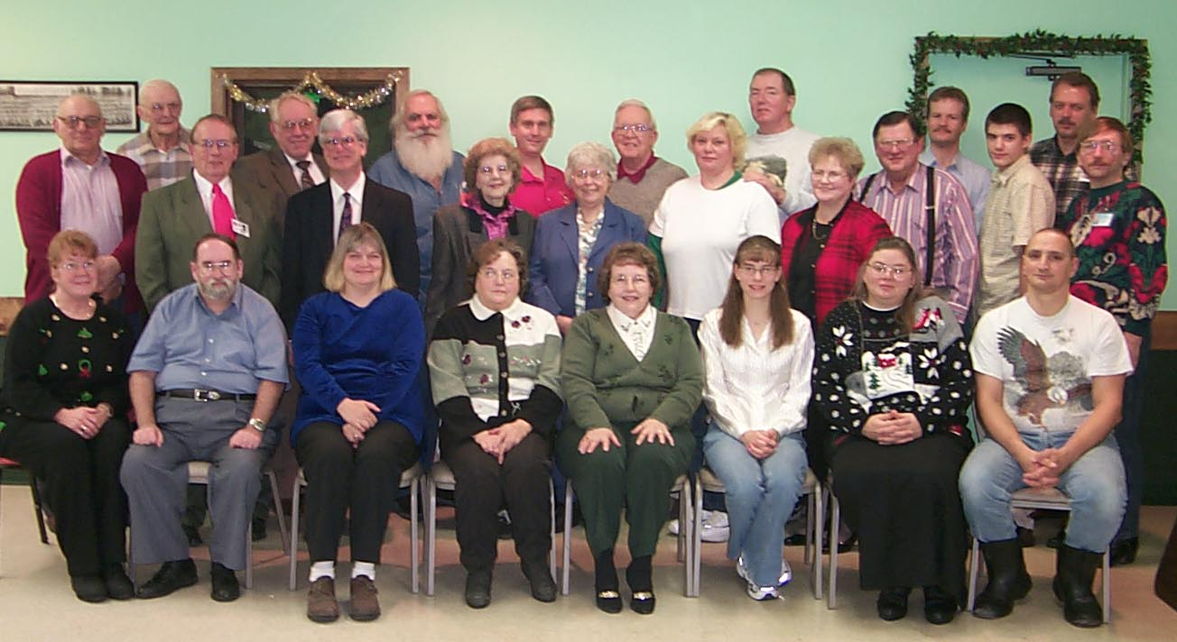

Because of space considerations in the last issue we were not able to show the group shot taken at this year’s Christmas Party. So . . . here it is! Photo by WA3HDK

_{The} RADIO AMATEURS OF CORRY
P. O. Box 362
Corry, PA 16407

This newsletter is published quarterly

Editor, Robert E. Bair, W3HDK (739-2206)
Staff: John Lis, N3NKV, Co-Editor
Jerry Owens, W3GHO

Submit material for the next issue on/or before
August 25 . Next issue is published September 11
<<<<<E-mail articles to wa3hdk@arrl.net>>>>>

Club meetings are on the second Tuesday of each
month at the American Red Cross Building in Corry.

Club Officers--
President, Ralph Miller, N3LXG (489-0242)
Vice President, Dan Fargo, KB3EMH (663-5170)
Secretary, Jerry Owens, W3GHO (664-7502)
Treasurer, Mike Dziubkowski N3GCY (664-7189)

