 TheRADIO AMATEURS OF CORRY
Volume 7 No. 4 December 2000

CHRISTMAS PARTY

This year the annual Christmas Party was held December 9, at the American Legion. It was a departure from the Dutch Treat Restaurant where the Party has been held for the last several years. The choice, it seems, was a good one. The parking was close and ample. The banquet room was spacious; and the food was good.

The menu included stuffed pork chop or stuffed chicken breast, mashed potatoes and gravy, and corn, a tossed salad and rolls, and coffee. There was no alternative drink served but water was available.

After dinner, Ron, KF3DJ, served as the master of ceremonies. A public address system, provided by Evelyn and Jerry Owens made it easy for all to hear the speakers. Mike, N3GCY, gave a report of the state of the club’s finances. Jerry, W3GHO reported on the highlights of the year, recalling some of the highlights of the past year. We had two after-dinner speakers—Quentin McCray, W3AHH, told of his service at Pearl Harbor on December 7, 1941. Our incoming President, Ralph Miller, N3LXG, told of his involvement in ham radio and of his aspirations for the upcoming year. A plaque was awarded to Dick Drace, K3AQR for his support. Since he was not in attendance, it was mailed to him. Mac, W3BZJ received certificates for meeting every 2-meter and 10-meter net this year. A 50-50 drawing was held with our incoming vice president, Dan, the winner. Each year, we draw names of those people attending the regular club meetings and award the winner a gift certificate for dinner at a local restaurant. This year’s winner was Quentin, W3AHH.
The Christmas Party Program Committee consisted of Norma, W3CG; Debbie, N2MQ; Joanna, N3WNS; and Rob, N3OCL. Like usual, they did a super job. After the speakers concluded, the committee awarded the door prizes. Every one in attendance got at least two door prizes. Rob made 10 very nice cutting boards. Norma and her committee really do an excellent job in this respect.
No plans have been made for next year’s Christmas party as of this date, but, I for one, think it would be hard to eclipse this year’s one. Thanks to all who helped to make this year’s party a good one and to all who attended.
-Bob, WA3HDK

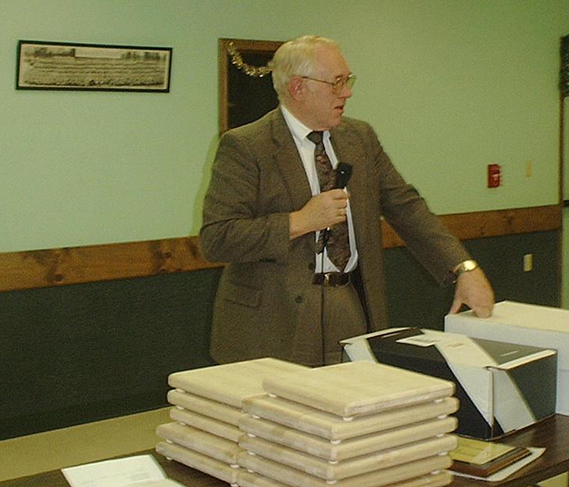

President-elect Ralph Miller, N3LXQ, addressed members at the annual Christmas party. The objects in the foreground are cutting boards door prizes furnished by Rob, N3OCL

NEW OFFICERS FOR 2001

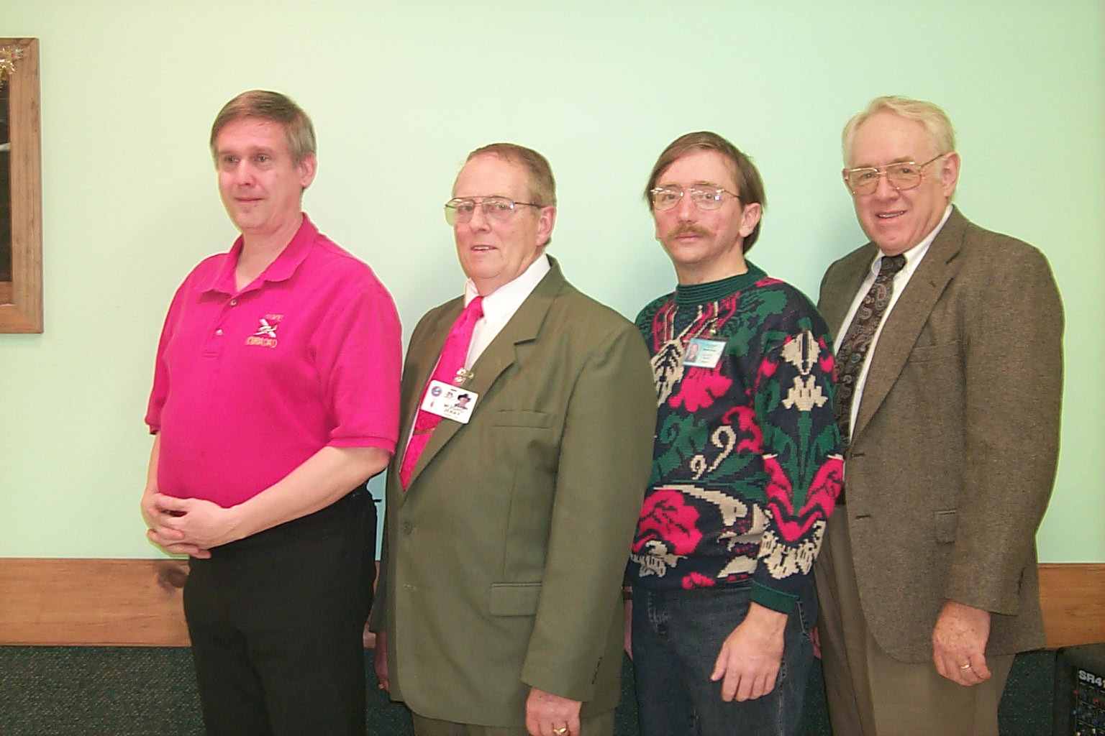
L – R: Treasurer, Mike, N3GCY; Secretary, Jerry, W3GHO; Vice President, Dan, N3EMH and President, Ralph, N3LXQ

President’s Corner
As your new president, on behalf of the newly elected officers, I thank you for the vote of confidence.
The officers for year 2001 are:
President Ralph N3LXG
Vice President Dan KB3EMH
Secretary Jerry W3GHO
Treasurer Mike N3GCY

We look forward to the opportunity to serve in the coming year. I’m new at this and have a lot to learn. I’ll thank you in advance for your suggestions, participation and patience. I would like to share with you a portion of a QST editorial from the May 2000 by David Sumner K1ZZ entitled “Real Hams”. “We all know how one becomes an amateur radio licensee. You study, you pass a test, and you get piece of paper from the FCC. Do that, and you are a ham. Being a real ham is different. It isn’t about being licensed - it is more than that - it is how you feel about radio, and how you act on those feelings. Getting the license is not the end of the road. For a real ham it is just the beginning of the adventure. Being a real ham means having a love for radio and for what can be accomplished with radio to benefit others. It means being able to appreciate the magic of a crystal set and the wonder of cutting-edge technology, equally and at the same time. It means working with others to share your love of radio to perform a service or to achieve a goal. In short, it isn’t the license that makes you a real ham. This is what you do with it. Heading a list of things we can - and should - do are emergency and public service communications. Regular participation may not be for everyone, but every ham should know the basics and should be able to get on the air when normal communications are disrupted. Isn’t this the least we can offer in exchange for the array of privileges we enjoy? If you are a real ham, what are you waiting for?”
I have a love of radio and look forward to growing to become a “real ham”. I’m excited about the possibilities.

We wish you and your family the best this holiday season.
73s
Ralph Miller,
N3LXG

Lost?

Have you moved or changed your E-mail provider? If you have, we have probably lost touch with you. We periodically E-mail announcements to those club members and a few other interested parties who have E-mail addresses. Some of those mailings have been returned as “undeliverable.” Off the top of my head, two addresses have been refused lately. They are: Ron Ploss and Guy Williams. If you have not been receiving these announcements, please E-mail me at WA3HDK@arrl.net. If you do not want to receive the announcements, also E-mail me and tell me that. A simple “unsubscribe” in the subject line will do it.

While I have your attention, let me ask you to also check your mailing label. If there is an error on the label, please call it to my attention. In the next addition there will be a roster of members. We want to have it as correct as possible.

-Bob, WA3HDK

Spring Computer Auction Fundraiser benefiting Radio Amateurs of Corry and
Union City Wireless Association
February 10th –
Wattsburg Hose Company Social Hall
8 a.m. to 1 p.m.

Web Sites to Check Out!

http://sort.tripod.com
The Southern Ontario Repeater Team is working with I-Phone and linking up repeater all across the world. Depending on conditions, they can be heard locally on 147.180+ in London.

http://www.javaradio.com
A real time Icom receiver that you can program and listen to over the web.

RADIO AMATEURS OF CORRY
SEPTEMBER 3, 2000 MINUTES

The Meeting was called to order by President WB3AYW with the following officers present, Secretary W3GHO and Treasurer N3GCY, there were 12 members also in attendance. The minutes of the August meeting were read and approved by regular motion. The Treasurer’s report was read and accepted.

Old Business:
Norma W3CG initiated a discussion concerning the resignation of the Kitchen Manager at the Corry American Legion Post and expressed concern that our reservation would not be honored for the December 9th Radio Amateurs of Corry Annual Christmas Party. A confirmation of the above date was to be made and reported back at the October meeting.

New Business:
Ron KF3DJ introduced Scott AK3R to the members and he was welcomed and reminded to come back often. Scott has recently moved back in the NW PA Area and is looking forward to renewing old acquaintances.
Frank KE3PD reported that the repeater tower needs painting real bad because it has lots of rust, he also reported that Will KD3II had been doing a fine job keeping the grass mowed and the repeater site well maintained by also cutting some of the brush that had grown too close. Frank also reported that the repeater to transmit on 224.060 Mhz was almost ready to go on the air.
Bob WA3HDK stated he was looking for more help for the Boy Scout Jamboree on the Air to be held on October 21,2000 he also is attempting to recruit a Chairperson for the event.
Mike N3GCY gave a report on the Communications support that the Radio Amateurs to the Titusville Parade held on August 19th .
A motion was made by Bob WA3HDK to donate $25.00 to Mead Park for the use of the Red Top Pavilion for both the Club Summer Picnic and Field Day. Moved and Seconded.
The 50-50 was won by Dave WX3E.
Motion to adjourn was made by Mac W3BZJ and Seconded by WA3HDK.
Submitted by,
Jerry W3GHO
Secretary

RADIO AMATEURS OF CORRY
OCTOBER 10, 2000 MINUTES

Due to the absence of the President and Vice President the Meeting was called to order by Secretary W3GHO and in accordance with Robert’s Rules of Order Ralph, N3LXG was elected Temporary chairman to conduct the meeting. Officers Present were Jerry W3GHO and Mike N3GCY also there were 9 members in attendance.
The minutes of the September meeting were read and accepted. The treasurer’s report was read and approved by regular motion.

Committee reports:
Bob WA3HDK reported that the 4th quarter newsletter would be edited by John N3NKV who requests that the writers of the regular columns e-mail their work to him for publication. He stated his e-mail address is johnn3nkv@hotmail.com and he will accept any articles at that address.
Norma W3CG reporting as Chairperson for the Christmas party said she is taking reservations for this years event to be held at 6:30 PM on December 9th at the American Legion Post on Sciota St. Corry, PA

Old Business:
A discussion was held concerning the painting of the Repeater Tower the consensus was to wait until spring of 2001. WA3HDK reported a chairman was still needed for the Boy Scout Jamboree on the Air to be held on October 21st beginning at 9:00 AM, Bob reported that a large group of scouts was expected this year.

New Business:
Mike N3GCY reported that he had a request from the Corry High School Music Department for several operators to help with communications during the Winds of Autumn band competition from 3:30 PM until 10:30 PM on October 21st. Mike will attend an organizational meeting on October 16th and report back on the details before the 21st. Mike N3GCY also reported that the Titusville parade committee had made a nice donation to the Radio Amateurs of Corry for helping with Parade Communications.
After discussion a motion was made to give an award at this years Christmas party to Dick K3AQR for his long time support of the Club awards program. Motion Carried.
WA3HDK submitted a bill for $35.59 to cover newsletter costs. Regularly moved and seconded to pay the bill.
Ralph indicated that he was donating a set of Extra Class code tapes to the Club to be used for members to upgrade.
The floor was then opened for Nominations for Officers for 2001 Nominated were :
Ralph N3LXG for President, Dan Fargo KB3EMH for Vice President ,Jerry W3GHO for Secretary and Mike N3GCY for Treasurer. Chairman Ralph N3LXG appointed a committee of W3CG,WA3HDK and W3GHO to suggest additional persons to run for office.
A thank you card was read from Bob and Marlene Bair for the flowers sent in memory of Marlene’s Mom Mrs. Maxine Althof.
The 50-50 was won by N3LXG who donated it back to the Club...Thanks Ralph followed by a motion to adjourn….Carried.
The Program for the evening was presented by Craig K3PLV who used a computer/projector to describe his recent Dxpedition to Jersey Island in the English Channel off the coast of France. He also had a sample of the many thousands of QSL cards that were received from all over the world to pass around. I was a very interesting presentation and enjoying by all.. Thanks Craig.
Respectfully Submitted,
Jerry W3GHO
Secretary

RADIO AMATEURS OF CORRY
NOVEMBER 14, 2000 MINUTES

Due to the absence of the President and Vice President and in accordance with Robert’s rules of Order the meeting was called to order by W3GHO Secretary when N3LXG Ralph was elected temporary Chair for the November, 2000 meeting. Ralph N3LXG then welcomed the Members and visitor to the meeting and thanked all for the good attendance. The roll call of officers revealed that W3GHO Secretary was present along with 13 members and one visitor.
The Minutes of the October meeting were read and after corrections approved. There were no correspondence or bills to submit for payment.

Committee Reports:
WA3HDK reminded all members that the 2001 dues are now payable and must be paid to remain on the mailing list for the newsletter.
WA3HDK also reported on the Boy Scout Jamboree on the Air (JOTA) held on October 21st indicating there were 35 to 40 scouts that operated the Amateur radio equipment talking to other scouts under the supervision of a control operator. He reported that operation started around 9:30 AM and ran until the campfire session started when things were packed up. The amateur radio station was one of several displays that were at the Elgin Park with the scouts moving from one to the other at specified intervals. The Scouts had plenty of food and drink for WA3HDK, W3BZJ and W3GHO who were on hand to oversee the radio operation.
Ralph N3LXG passed out copies of the club membership list that he had assembled by call and by name. W3CG Norma reported that she needs reservations for the Christmas Party because the legion needs to know how much food to prepare, she requested a post card reminder be sent to the club members to remind them of the event. Bill KL7KI volunteered to call the members instead of mailing a card, the offer was accepted.
New Business:
After discussion a motion was passed to cancel the December meeting and have a short business session at the Christmas Party if needed. Ralph N3LXG reported that Chautauqua & Erie Telephone Company that he works for, had donated some surplus computer equipment to the Corry and Union City Club which is stored in W7RVY’s garage at this time. There was a discussion of an offer from the Union City Wireless Association to work together with the Radio Amateurs of Corry and hold an auction of the surplus computer equipment and invite the members to bring “stuff” to be sold with the clubs to get a fee for selling. WX3E is to contact the Wattsburg Fire Company Officers and set up a date to use the social hall possibly in February 2001….The event will called Radio/Computer Rendezvous.
N3GCY Mike, Club Treasurer arrived and read his report which was accepted.
Bill KL7KI initiated a discussion concerning a club project to build a crank-up tower and beam on a trailer to be used for field day, JOTA and emergencies etc. WA3HDK then made a motion seconded by Bill W7RVY to make this a club project for 2001.
Election of Officers was then held for 2001 with the following results:
President Ralph N3LXG
Vice-President Dan KB3EMH
Secretary Jerry W3GHO
Treasurer Mike N3GCY.

Norma W3CG asked the Treasurer and Secretary to prepare an annual report to be given at the Christmas Party.
Ralph N3LXG gave the members a short BIOS of his Family, work and amateur radio activities, he also said he was looking forward to working with the Club for 2001, he then read a QST Editorial from the May issue which he agreed with, about what makes a “real “ham operator.
The 50-50 was won by Norma W3CG, followed by a motion to adjourn.
Submitted by,
Jerry W3GHO
Secretary.

HAMFESTS
Jan 27, 2001 — Lockport ARA
http://lara.hamgate.net

Feb 4, 2001 — Winterfest 2001
Northern Ohio ARS

Feb 18, 2001 — Greater Buffalo Winter Hamfest
Lancaster ARC
http://hamgate1.sunyerie.edu/~larc

Feb 25, 2001 — Wireless Association of South Hills
http://www.washarc.org/washfesty2k.htm

Feb 25, 2001 — Cuyahoga Falls ARC

Mar 25, 2001 — Lake County ARA
http://hamradio.org/lcara

Mar 25, 2001 — Two Rivers ARC
http://www.qsl.net/w3oc/hamfest.htm

Apr 29, 2001 — Twenty Over Nine Radio Club (Youngstown)

SWAP AND SHOP

I have many Radio Related Parts & Books For Sale. Some of the books date back to the 20s and 30s. Some of them would be “collectibles” Contact w3bzj@juno.com

I have for sale a disassembled 40 foot aluminum tower for $40.00 and a 19 element Cushcraft 2 meter boomer for SSB with the back reflector. Joe N3MLX – 814-825-5565 or via e-mail –n3mlx@adelphia.net

SAN FRANCISCO HAM LOSES ALL BUT HF CW PRIVILEGES FOR TWO YEARS
San Francisco amateur licensee Danny Kenwood, WA6CNQ, has again come in for FCC enforcement action. In an unusual enforcement twist, the FCC has modified Kenwood's General ticket to prohibit all amateur operation but HF Morse for a period of two years. Kenwood lost his VHF and UHF privileges for 90 days in October 1999 following allegations of profanity, obscenity, and deliberate interference directed at users of the K7IJ Grizzly Peak repeater and of failure to properly identify. Last spring, the FCC issued a Warning Notice to Kenwood on the basis of reports from the K7IJ repeater system control operator that the repeater had to be shut down due to Kenwood's alleged "interference and harassment to other operators on the repeater system." According to a December 5 letter to Kenwood from FCC Special Counsel for Amateur Radio Enforcement Riley Hollingsworth, Kenwood voluntarily agreed to the HF CW-only modification, which begins November 30 and continues through November 2002. The prohibition extends to Kenwood's operation of any other amateur station as well as to operation of his own station by himself or anyone else. Hollingsworth told Kenwood that if he violates FCC rules or the terms of the agreement, the FCC will initiate revocation and suspension proceedings against Kenwood and could also levy a fine.
-ARRL

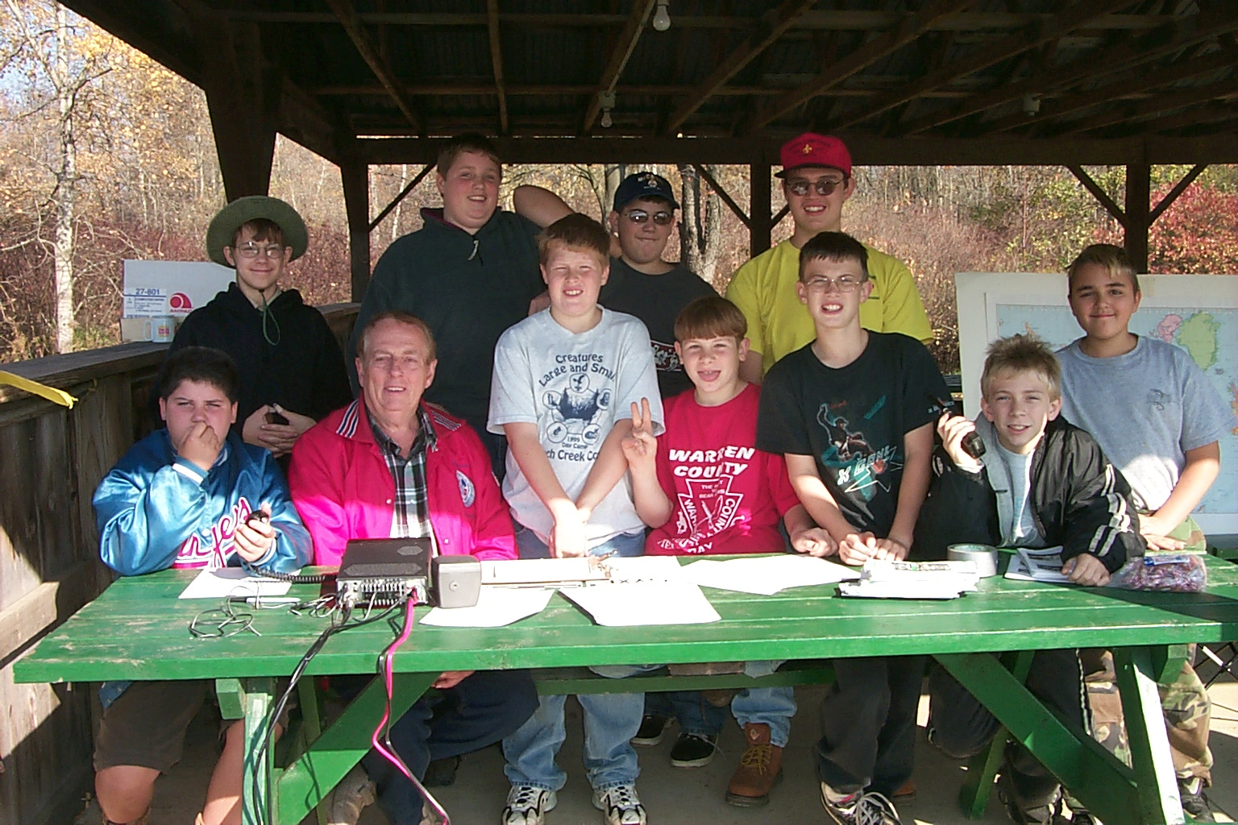

JAMBOREE ON THE AIR 2000
Every year since 1994, the Radio Amateurs of Corry have participated in the annual Jamboree on the Air (JOTA). The first chairperson of that first JOTA was Bob Swarm, K3CKO. Bob prepared maps and visual aids, which are still being used. Bob’s experience in Scouting spans all the way back to his childhood and he had kept relatively active since.
I have participated in four of these annual events myself and am here to tell you that it is a gratifying activity. Well, almost always that is. That first year with Bob was kind of windy and cold. The next year the same thing. I was ready to find a more pleasant way to spend a Saturday! However for the next four years, the weather was warm and pleasant. Those are the years I tend to remember. This year the weather was beautiful, the fall foliage in its peak as troops from Corry (Troops 89 and 85), Union City (Troop 3), Edinboro (Troop 176), Harborcreek (Troop 115), Erie (Troop 113), and Tionesta (Troop 82) participated. Jerry Owens, W3GHO and I arrived at the Elgin Park shortly before 9 a.m. Unpacking the equipment from the Dell computer box that I use to store my “emergency” rig took a few minutes. First, the radio equipment was sent up on a picnic table at the edge of the picnic pavilion. The 12-volt automotive battery that powers the Alinco DX 100 and a battery charger was next. The long wire tuner was tied to one of the legs on the picnic shelter and the ground post was pounded into the ground. The ground and antenna wires were next. The scouts helped Jerry play the antenna wire out and attach its free end to the lanyard of the flagpole. The antenna was hoisted and we were ready to roll.
We were ready to give it a try. Ten meters sounded good. There was a CQ. We decided to answer . . .”OK1VAM this is W3YXE” The contact was brief—he was just looking for contacts. His name was John. But we did exchange 5 by 9 signal reports and, being DX ignorant, I had to ask what part of the world he was from. “The Czech Republic,” came the reply. “Good day and good Dxing” And he was gone!.
It was perhaps another twenty minutes until the scouts gathered. The next few contacts were on 15-meters. In fact, we made just three more contacts in the next three hours. But they were long ones—one of them was almost an hour and a half. The rig didn’t sit idle for long. The scouts did most of the talking after they observed operating and received some instructions.

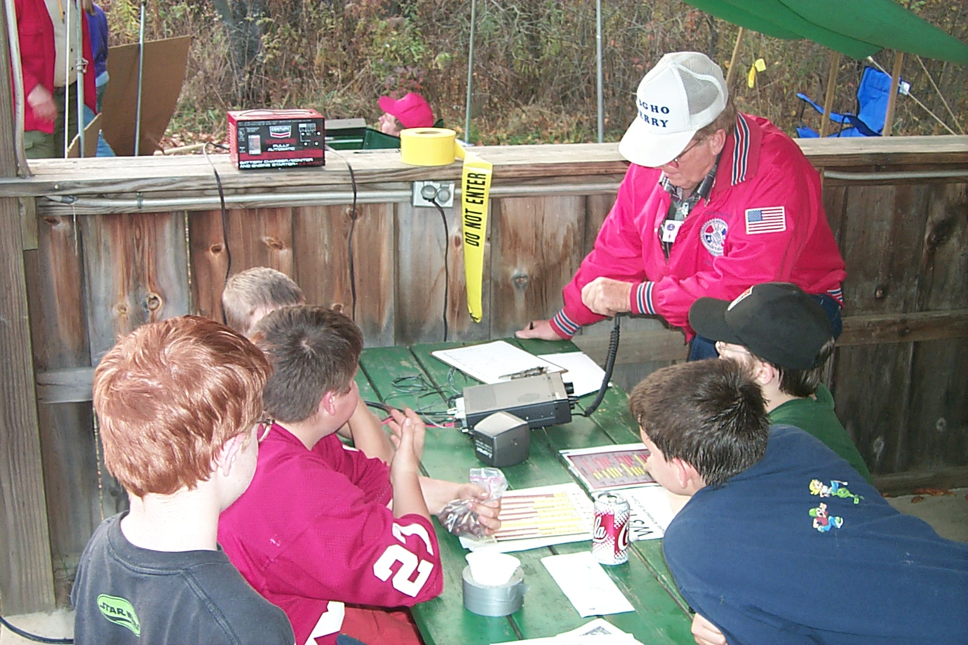Some of the boys had quite an attack of mike fright. Others had a real affinity for it.

Each of the troops had invited us to lunch which was prepared in their mess tent. Jerry and I took turns at it. Soon it was getting dark when we took down the antenna and packed things away. We were invited to join in the evening activities around the campfire, but we respectfully declined because it had been a long day. There will still be another feed put on by the scouts—an awards banquet at the Conelway Elementary School.
If you haven’t visited a JOTA site, plan on doing so next year. It is always in October. If you think you would enjoy working with the scouts, plan on helping out next year. It would be really nice if two or three (or more) of you could represent ham radio for the scouts.
-Bob, WA3HDK

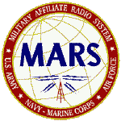

MEN FROM MARS
Happy Birthday MARS! That’s right, the combined Army, Air Force Navy/Marine MARS system has just celebrated its 75th birthday on November 26th , 2000. Part of the big event was the mother of all nets that had over 500 stations checking in. Amazing all participants with an orderly check-in procedure by call sign areas including Hawaii and Puerto Rico. The net was called to order by the Central Area Command Station AAA9A at 9:00 PM Local time and it was 9:50 PM before this writer was able to join when NCS called for 3rd area Army Stations, the end came at 12:27 AM local time.
On November 25, 1925, the Army Amateur Radio System (AARS) was initiated by a few dedicated pioneers and visionaries in the United States Army Signal Corps led by Captain Thomas C. Rives. His original intention was to enlist the talents of volunteer Amateur Radio Operators as a source to train soldiers in the new technology of radio as well as pursuing radio research and development to improve radio equipment with the Army. History reflects their efforts were very successful.
The Military Affiliate Radio System (MARS) as we know it today has grown in all the Armed Services worldwide. MARS relies on civilian and military MARS members to be available in case of emergency or disaster to provide communications support to disaster relief agencies. At such times, they need all of the support MARS can provide. Amateur Radio collectively with MARS has made its mark in Communications history. Each year provides new evidence of the important role Amateur Radio with MARS plays in the service to our country and to the military and their families.
The MARS system is again promoting and participating in “Operation Holiday 2000” this operation encourages stations to send a large volume of message traffic to service personal. The general public is invited via posters and flyers as well as announcements on amateur and MARS nets and ads in newspapers to contact a local MARS operator who would be identified in the information. Feel free to contact me or any of the Local MARS operators to send a Holiday message free of charge to a Service person you may know.
I close this issue of Men from MARS with a sad note to report the passing of AAA9PR/N4ZCF Lori Matthew, she was the Army MARS public relations Coordinator for all of the USA. Lori and her late husband began operation holidays that I mentioned earlier in this article, it was designed especially for those stationed overseas to let them know that the American people care for them. Her boss was Chief Army MARS Bob Sutton who said of her, she was the ideal exemplar of the Army MARS motto,” Proud Professional and Ready” I would like to take this opportunity to wish all, a Merry Christmas and Happy New Year 2001 and 73’.
− Jerry AAR3GF/W3GHO

First ARISS school QSO a success!
It was a historic moment for Amateur Radio. Some 200 youngsters, teachers, parents, and news media representatives were on hand at Luther Burbank Elementary School near Chicago December 21 to witness the first successful Amateur Radio on the International Space Station school contact. Several pupils plus one teacher got to chat with Space Station Alpha Commander William ''Shep'' Shepherd, KD5GSL, via ham radio. Earlier attempts by the school on December 19 were unsuccessful, despite the extensive technical preparations. On December 21, however, Shepherd, using the special NA1SS call sign, came right back to a call from veteran SAREX/ARISS mentor Charlie Sufana, AJ9N, at the school. Sufana and his ARISS team had spent the better part of two weeks setting up gear and antennas for the scheduled contact. Antenna setup was hampered by repeated snowstorms and frigid temperatures, but the efforts paid off. ''I'm happy that we were able to pull it off,'' Sufana said. ''The kids were bouncing off the walls.'' During the 10-minute pass, 14 first through eighth graders plus science and math teacher Rita Wright got a chance to pose questions about life aboard Space Station Alpha to Shepherd. Shepherd said he especially enjoyed being able to float around in the space station. He said the crew is keeping detailed logs about life on the space station, and that the crew was enjoying taking pictures of Earth from space, ''because you can see things that you can't see from the ground.'' Shepherd also explained that about 90 percent of water in the air inside the space station is recovered and reused. At the conclusion of the successful contact, the grateful crowd applauded loudly and offered up a hearty ''thank you!'' and ''73!'' to Shepherd and his Russian crewmates. Shepherd said he was looking forward to future school contacts. Another two dozen schools are under consideration for ARISS school contacts. Schools in Virginia and New York are tentatively scheduled for contacts next month. More information about requesting dedicated contacts is available on the ARISS web pages, http://ariss.gsfc.nasa.gov/.
-ARRL

The Automated Radio Station

The age of automation is here. Most factories are highly automated nowadays. Robots spot weld automobile frames and automatic assembly machines create and package everything from hypodermic needles to Thomas' waffles automatically with almost no human intervention. What about our hobby, Amateur Radio?
Yes, even Amateur radio is being automated. There are a number of “Logging” programs on the market that can be loaded onto a computer that are capable of taking charge of all functions of station operation short of ordering a ham sandwich and coffee from the XYL (I’m working on that). Two of these programs, LOG-EQF and LOGGER, I have used with my station and have found they save much time and effort. All that is needed is a computer running Windows 95 or greater and one to four serial output ports depending on how elaborate you want to get. There are currently on the market four serial port boards that can have each port strapped to any port number and IRQ desired.
My favorite program is LOG-EQF written by N3EQF. I have LOG-EQF set up with COM2 connected to my radio. I can choose a frequency and mode with my radio controls and that frequency and mode are automatically transferred to LOG-EQF. OR, I can type a frequency and mode into my log and it is automatically transfers to my radio. Log EQF is capable of controlling any modern radio that is equipped for external control. Com4 of my computer is connected to my KPC-3 Plus TNC and is used to connect to a packet cluster in Northern New Jersey. DX spots from the packet cluster can be displayed in a packet terminal screen by pressing F8 or on a dedicated DX spot screen by pressing F9. If I see a DX station I would like to work I can double click on his call and his call, frequency, and mode are automatically entered into my log. In addition, the frequency and mode are sent to my transceiver and the rig changes to that band and frequency, ready to operate. Also in addition, LOG-EQF looks up the call sign on my Buckmaster CD disk and enters the country prefix, grid, CQ zone, IOTA number, and county if he is a United States station, into my log. The stations latitude and Longitude are also retrieved from the CD disk and a beam heading from my station to the DX is calculated and automatically sent to the beam rotor via COM7 of my computer I do not at this time have a beam hooked up to my HYGAIN rotor but if I did, the beam would automatically turn to the DX station and I would hear him on the speaker. There is also an antenna switch function to be used if you are using phased vertical arrays or other antenna systems requiring external switching. LPT2 of my computer is hooked up to the transceiver auxiliary port through a simple isolation interface and allows my sound card to transmit RTTY or PSK31 to the transceiver. If the DX is a CW station, I can switch to a full CW keyer complete with eight pre recordable macro’s and setable keying speed by pressing <ALT> <K>. For example, If I see
“WORK HQ5CL on 28.355MHZ” pop up on the bottom of my log screen, I can double click his call, or press F11 if he is the latest DX spot, and his call; Frequency; and mode will be sent to my transceiver, The beam will rotate to 175 degrees, and all of his station data will be entered into my log book. I note that he is 5,153 miles south of me in Chile and it is 12:24 PM where he lives. All I have to do is key the mike and give him a shout. When I am done chatting with him, I can print a QSL label and an address label by pressing <ALT> <L>. Then I press F1 and the entire QSO is logged.
In addition to automating the entire setup LOG-EQF can sort and print the logbook on any field. It also keeps track of my progress toward the DXCC; WAS; WAZ; VUCC - VHF/UHF century club; County hunters; TEN-TEN; IOTA; and WPX awards. The keys <ALT> <N> brings up a note pad that you can use to store comments about each QSO for future reference. The keys <ALT> <T> will set an ID timer that will beep every 10 minutes. The keys <ALT> <4> will allow you to switch between two rigs, each with it’s own setup, if you are rich enough to have them. The keys <ALT> <F10> brings up a radio memory page where you can store your most used frequencies. Selecting one of these commands your radio to that frequency and mode. The keys <ALT> <F11> sends you to the GOLIST where you can retrieve the latest QSL information on DX stations.
The program “LOGGER” by K4CY does all of the above mentioned functions and has in addition, a conversion calculator window that will convert English to metric and metric to English; a Greyline window that will show you a map of the world with daylight and night shown; a TELNET window that will allow you to connect to a DX cluster via your modem; a Satellite window that will track any amateur satellite and show when it comes into your window of acquisition; a PSK31 operating window that interfaces directly with the log; and a Calendar window where you can set sched’s such as “Oct 25 1200Z CQWW DX Contest Phone”. A warning will pop up and a buzzer sound at that date and time. While logger has more bells and whistles, I use it strictly for PSK31 as in interfaces very well with the ZAKZNAKA beta 14 program by the same author. I still prefer LOG-EQF as my automatic log for Phone, CW, and especially contesting due to it’s ease of use. LOG-EQF can be set up to automatically log any of the major contests in the world and will keep track of points and multipliers and cut your dupe’s to nothing. It will output the results to printer or file in the new CABRILLO format or as a text file. I wrapped up my score and report for the Pennsylvania QSO party in less than 15 minutes. LOG-EQF can be obtained from www.itis.net/eqf/ for $49.95. An evaluation copy is also available for free download but does not contain all features. LOGGER is available for download from www.geocities.com/kc4elo. registration for this product is free at this time.
There are a number of other logging programs such as NA; CT; K3CP; Writelog; etc. which do some or most of the functions of LOGGER or LOG-EQF. I have not played with them but I am sure they are updated regularly and will eventually do all the radio station functions. It’s your choice. Which one do you like best? Whichever one you choose, you are sure to enjoy it and take advantage of the time it saves you to work more of your favorite hobby. Yes, automation is here to stay.....Even in Ham Radio.

-Bob, K3CKO

FCC OPENS DOOR TO INCREASED TEST FEES FOR 2001

The FCC has suspended its regulatory limit on the reimbursement fee for Amateur Radio examinations, and the ARRL VEC says a new $10 test fee will go into effect January 1. An FCC Public Notice released December 4 explained that the Commission did not plan to announce a maximum reimbursement fee for 2001 since the requirement to do so no longer appears in the Communications Act. For now, the FCC says, it will suspend enforcement of the fee provision, §97.527(b), which continues to appear in the FCC rules. Some, if not all, of the nation's other Volunteer Examiner Coordinators are expected to follow suit, although at least one VEC charges no test fee whatsoever. ARRL VEC Manager Bart Jahnke, W9JJ, says the ARRL VEC's current fee of $6.65 was based on the provision in the Communications Act, adopted in 1984, that established a $4 cap on reimbursement of out-of-pocket costs with an annual adjustment based on the Consumer Price Index. The new, higher fee reflects the fact that the ARRL VEC is doing more of the work on behalf of the FCC than was originally envisioned when the provision was included in the Communications Act. That effort includes data entry for all new and upgrade license applications once done by FCC staffers. ARRL VEC volunteer examiners will continue to charge applicants $6.65 through the end of 2000.
-ARRL

Radio Amateurs of Corry Nets

Tuesdays – 10 Meters – 28.330 USB 8 p.m.

Thursdays – 2 Meters – 147.090 Repeater –
NO PL is Needed

2001 APPLICATION FOR MEMBERSHIP IN THE RADIO AMATEURS OF CORRY 2001

Name_______________________________________________ Call______________ License_____
Address_____________________________________________ Phone Number_________________
City___________________________ State_______ ZIP____________ ARRL Member (yes / no)
e-mail address_______________________________

We maintain a list of member's favorite interests in the Club data base. If you care to, tell us some of the things you like to do. This could be radio or non-radio related. (some of the ones we have received include: computer, gardening, antennas, skywarn, traffic nets, woodcarver, etc.)

Interests:__________________________________________________________________________________

Mail along with $5 dues for 2001 to:
RADIO AMATEURS OF CORRY
P. O. Box 362

Corry PA 16407

==================================tear here======================================

_{The} RADIO AMATEURS OF CORRY
P. O. Box 362
Corry, PA 16407

This newsletter is published quarterly

Editor, Robert E. Bair, W3HDK (739-2206)
Staff: John Lis, N3NKV, Assistant Editor
Jerry Owens, W3GHO
Ron Rieff, KF3DJ

Submit material for the next issue on/or before
FEBRUARY 28. Next issue is March 13, 2001.

<<<<<E-mail articles to wa3hdk@arrl.net>>>>>

Club meetings are on the second Tuesday of each
month at the American Red Cross Building in Corry.

Club Officers--
President, Ralph Miller, N3LXG (489-0242)
Vice President, Dan Fargo, KB3EMH (663-5170)
Secretary, Jerry Ownes, W3GHO (664-7502)
Treasurer, Mike Dziubkowski N3GCY (664-7189)

