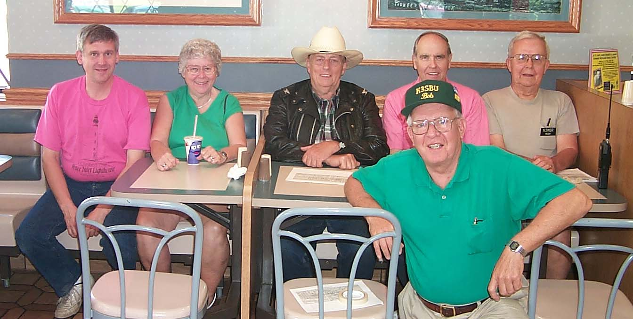
The 2000 Oil Festival communications team. Seated left-to-right are: Parade Chairman, Mike, N3GCY; Anne, N3VHV; Jerry, W3GHO; Frank, KE3PD; and Hugh, N3MBR. In foreground: Bob, KESBU. Photo by Bob,WA3HDK.

_{The} RADIO AMATEURS OF CORRY
P. O. Box 362
Corry, PA 16407

This newsletter is published quarterly

Editor, Robert E. Bair, W3HDK (739-2206)
Staff: John Lis, N3NKV, Assistant Editor
Jerry Owens, W3GHO
Ron Rieff, KF3DJ

Submit material for the next issue on/or before
November 18. Next issue is August 8.

<<<<<E-mail articles to wa3hdk@arrl.net>>>>>

Club meetings are on the second Tuesday of each
month at the American Red Cross Building in Corry.

Club Officers--
President, Leonard Shick WB3AYW (438-7199
Vice President, Jim Adams, WT3O (664-8140)
Secretary, Jerry Ownes, W3GHO (664-7502)
Treasurer, Mike Dziubkowski N3GCY (664-7189)

