  TheRADIO AMATEURS OF CORRY

VOLUME 5 No. 1 MARCH 1999
Confessions of a DXer
by Dick Drace, K3AQR

I know that all of you have had more than enough of confessions and the like in the last few months but I really must come clean and admit that I am an incurable DXer. Go ahead and laugh, but have you spent $30.00 to get one QSL card? I have. I’m really ashamed of it and while I realize it borders on indecent, squanderous behavior and runs contrary to the behavior of most normal people I really don’t think that it rises to the level of high crimes and mis-demeanors and my license should not be revoked.

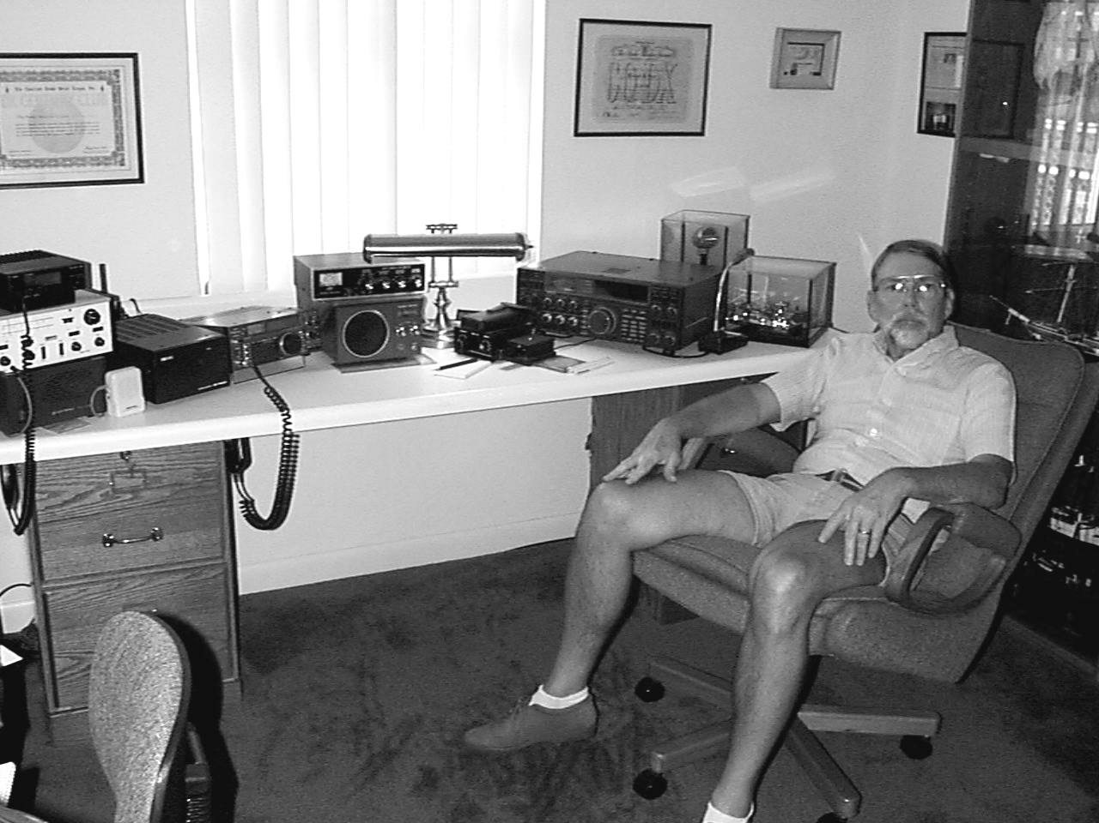How does this type of shameful behavior begin you ask? Well, it starts in one’s youth. It was in the mid-fifties when I got interested in ham radio. Back in those days there was basically AM and CW. SSB was some kind of “Donald Duck” sounding com-munications which kind of hung out on one end of the phone band. Well, through the constant bombardment of CW signals during visits to W3DUB’s ham shack, I got bitten severely by the “bug” and got licensed. I was and always have been an avid CW operator. (I had a high squeaky voice in my teens which, hasn’t changed much, and I was constantly getting referred to by the “old men” as a YL on the AM bands.)

My family lived on a rather narrow lot on Mead Avenue. It only really allowed for a dipole facing North and South. It wasn’t very high, either. Those were the days when the Sun Spots were pretty cool as the cycle was quite low. During my Novice days I worked hundreds of stateside stations on CW. However, the first signs of my affliction started then. Occasionally I would snare a W6 or W7 or maybe even a VE5 or VE6. I remember how my pulse would race. Much like it did that day my Novice ticket came and I worked my “Elmer” Duard May, W3DUB who lived no more than a few hundred feet South of my QTH.

Those were the beginnings! The next step was my constant rereading of an advertisement in QST for a “low cost vertical antenna which would allow even the most meager station to work all kinds of foreign stations known as DX.” It was only $19.95 plus ship-ping!! By that time the Sun Spot cycle was picking up. Of course I didn’t really know what the Sun Spot Cycle was.

One day, quite by accident, while try-ing to load my old WRL Globe Chief on 15 meters CW, (I never could work much other than 40 meters because of TVI--those old rigs were great on transmitting harmonics all over the place!) I stumbled on a CQ call from G3ACG. His signal was quite weak. I quickly looked in my prefix guide to see where he was located and when I realized he was in England I started to shake. I answered his CQ almost in an uncopyable fashion. He promptly came back to me. He gave me a 559. Now I wasn’t used to reports as poor as that because I only worked
Continued on page 2

“loud” stations on 40, but I thought that wasn’t too bad considering where he was located!! I gave him a 589 which was a lie, but I thought I might like to have his QSL and I didn’t want to offend him! As naive as I was I even got this poor guy to give me his mailing address. That took quite a while because I wasn’t used to the way foreign addresses are composed and the names were to say the least “foreign” to me!

Well, that did it! Next step was to figure out how to get successfully on 15 meters without TVI!! To make a long story a little shorter I bought that vertical for $19.95 plus shipping. I expected great things coming in the mail. As it turned out it was two pieces of aluminum tubing, two hose clamps (not even stainless steel), one 3” by 3” diameter air wound coil about 4” long and an alligator clip! Oh, yes, and very vague sheet of instructions!! I could have bought this stuff at Lester Lopus’ Western Auto for a lot less than $10!

The logistics of setting this thing up evaded me totally. I finally rigged a way to hook it to the side of the back porch. I insulated the radiator from the building and got it as far away as possible. I calculated from the handbook what I felt should be a good radiator length. The ground braid went to a stake driven in the ground. Try as I might I could not get this thing to load properly and needless to say the TVI was horrendous!!

Every Saturday morning back in those days (by now I had upgraded and could work AM with my screen modulator and Globe Chief) just about every ham in the area would get on 75 phone and talk in break-in fashion for an hour or so. It was there that I learned of W3BZJ’s prowess with vertical antennas. Now I had known Mac from the RAC, but we never talked much--at least then--about antennas! Well, anyhow, I enlisted Mac to take a look at my vertical one day when I caught him delivering our mail. He didn’t laugh! That is one thing I have always admired about Mac. His understanding of the other guys feelings!! He did suggest the addition of some radials, and made some other suggestions like grid dipping the coil and antenna assembly to get it somewhere near resonance. Well, after a lot of fiddling around and many tests with Mac on the air I got it to load very well. In all honesty I never did cure the TVI! I was now on my way to catching the elusive DX on 15 meters CW. My addiction, (compulsion, or whatever you want to call it) only got worse and worse over the years. I graduated to a Tri-band beam. Later in Florida I had a crank-up tower and a 4 element tri-bander. My conquests got better and better. (A lot had to do with the Sun Spots, too!!) I can’t begin to tell you how much I have spent in antennas, audio and bandpass filters, and the inevitable postage for procuring those QSL cards! It is down right immoral!

Many years have transpired between Corry, PA and the crank-up tower in FL. There has been many QTH’s and many different operating conditions. However, whenever there was a rig, there was that relentless desire to listen for DX. It is insidious!! It just never lets you go!!

Finally in Florida with the advent of another Sun Spot Cycle, a crank-up tower, and a four element beam, there came the ultimate level of DXing. I had worked and confirmed over 300 countries.

It was in Tennessee that reality and desire of another kind bit us. Only after retiring from “the farm” as I call it, and moving to what I hope will be my final QTH in Florida, did that terrible moral lapse occur once again.

I have been working Jim, WT3O on CW for the last 2 or 3 years, I guess. Quite recently the DX activity has started to pick up on the HF bands. I got that burning desire in my fingertips to start working more and more CW. I listened on SSB, too. By now I’m quite comfortable in that mode also, but CW is my love. Anyhow it hit hard and fast. I worked three new countries in quick succession. That was all it took and I was “off the wagon” again big time!!

Then I saw her. She had everything anyone could want. She had dual VFO’s, RIT, XIT, iambic keyer, DX spot button, DSP, and--well I could go on and on. I knew it was the ultimate CW DX rig for me! And in my price range, too.

Now it is getting worse all of the time. Every morning I check the DX Spots on the “DX Summit” on the internet--even before I get coffee. I have put off mowing the lawn to work DX and I’m sure the flower beds will suffer! Only reprieve might be whenwe get into our thunder storm season. I might actually get back to domestic chores!!
Don’t judge me too harshly! I really can’t control myself!! Perhaps a simple censure would be in order but please don’t take my license away!!

Seriously, ain’t ham radio great!! It has been with me for over 40 years and I still come back to it. All of you have different interests. The technology is far above me now but I can see that the various facets of ham radio will continue on. All of us succumb to some aspect of the hobby. Maybe not as fanatically as me, though!! Have fun!! Enjoy a great hobby and most of all, enjoy the camaraderie of a really good club. Only after you have tried to break into the ranks of the really large socially oriented clubs in the larger cities, like I have, will you realize what you have right there in Corry, PA. Use it. Make it a better club by your participation. Your interests all vary into different areas, but they are all in the same hobby Amateur Radio. 73’s and gud DX!!!!
--Dick Drace K3AQR

RADIO AMATEURS OF CORRY
Minutes
January 5, 1999

Meeting opened at 7:30 p.m. with Bob WA3HDK presiding. Other officers present were Leonard WB3AYW, Vice President; Mike N3GCY; Treasurer; and Jim WT3O, Secretary.

Committee reports

Repeater Committee:
Bob WA3HKD said the repeater building looked very nice with new paint job and rain gutters. A big thank you to Will KD3II who spent several days working up there. Also Bob wants to purchase a commercial pre-amp for the repeater. While he was up there he put a lamp under the 440 repeater to keep it warm.

Awards Committee:
Bob WA3HDK said he is resigning as Chair of the awards committee but he will still do the printing etc.

Old Business.
The by-laws were discussed. A motion was made by Jerry W3GHO to mail out copies to all members who don't have e-mail to get everyone's opinion on what changes should be made, and seconded by Leonard, WB3AYW.

New Business
Bob is looking for volunteers for the Picnic and Field Day chairpersons. If no one does, he will appoint someone. Ed N3XBA volunteered for Red Cross representative. W3GHO Jerry volunteered for the Audit Committee and is looking for 2 others. We need a volunteer to check into the net from the Red Cross using the radio there. Mike N3GCY gave the Treasurer’s report and volunteered to get the styrofoam cups and coffee for the Red Cross. Bob WA3HDK turned in a bill for $55.00 for the last newsletter. We got a notice to register our nets with the ARRL. A motion was made to adjourn by Mike N3GCY and seconded by Craig K3PLV. Meeting was closed at 8:45 p.m. Winner of the 50/50 was WT3O for $5.
Respectfully submitted,
James Adams, WT3O
_________________________________________________________

RADIO AMATEURS OF CORRY
Minutes
February 5, 1999

Meeting opened at 7:30 with Bob WA3HDK presiding. Other officers present were Vice President Leonard Shick, WB3AYW; Jim Adams, WT3O Secretary.

No Treasurer’s report. Mike, N3GCY, had to be out of town and couldn't make the meeting. Minutes were read and accepted.

Committee Reports

Awards Committee:
Bob wants and award committee to meet and select a new Chair to head up the committee.

Program Committee:
Chairman Craig K3PLV suggested some tapes to watch. They cost $12.50 each and last about an hour and a half.

Newsletter Committee: Bob WA3HDK wants some help with articles for the newsletter.

Audit Committee: No report.
Old Business:
Need Committee chairpersons for Picnic, Field Day and J.O.T.A. Bob N3LBI will chair Field Day. Look for chairman for Picnic and J.O.T.A.
(Continued on page 4)
Red Cross radio to be used next Thursday for the net.
Repeater pre-amp brought up to be used on the .09 repeater. We need it tuned and ready to go. Motions to buy it was made by Leonard WB3AYW and seconded by Mac W3BZJ. Passed unanimously.

New Business:
Leonard, WB3AYW made a motion to send a letter to the STARS .09 repeater group in Buffalo saying we had no objection to the closer-than-normal spacing restriction by the repeater council and waive our right to block the re-coordination of the machine, provided that the STARS repeater become tone guarded 100 percent of the time. Craig, K3PLV seconded it. Motion passed.

John Silvis inquired of President WA3HDK, if the club could provide communications in event of a Y2K emergency. He reassured John that we could provide emergency communications for any emergency problem.

50/50 winner was Richard N3YPT.

Motion to adjourn was made by Leonard WB3AYW and seconded by Richard N3YPT. Meeting adjourned at 8:25 local time.
Respectfully submitted,
James Adams, WT3O
_________________________________________________

A friend is someone we turn to
When our spirits need a lift,
A friend is someone we treasure
For our friendship is a gift,
A friend is someone who fills our lives
With Beauty, Joy, and Grace
And makes the world we live in
A Better and Happier Place.

--Submitted by Dave, WX3E
_______________________________________________________________

TECH AMERICA is advertising the ALINCO DJ-190TD 2M handheld with free nicads and charger for $99.95. A Tech America catalog is available at Radio Shack stores.

NEW ALINCO 10M FM RIG ANNOUNCED

Alinco is proud to announce the DR-M03SX. The DR-M03SX is a 10 Meter FM 10w mobile radio with 100 memories, CTCSS encode std. (decode opt.), Adjustable repeater offsets, and DTMF Microphone. The band is starting to really open, and this small performer is ready to take on what 10m FM can dish out. It’s smaller than a standard 2m mobile and fits into the confined spaces often found in newer cars. Our Suggested retail price is $259.95. Check with your local authorized Alinco dealer for your price on the DR-M03SX. Get ready for 10 meter adventure with the DR-M03SX!
_________________________________________________

THE GOOD OLD DAYS

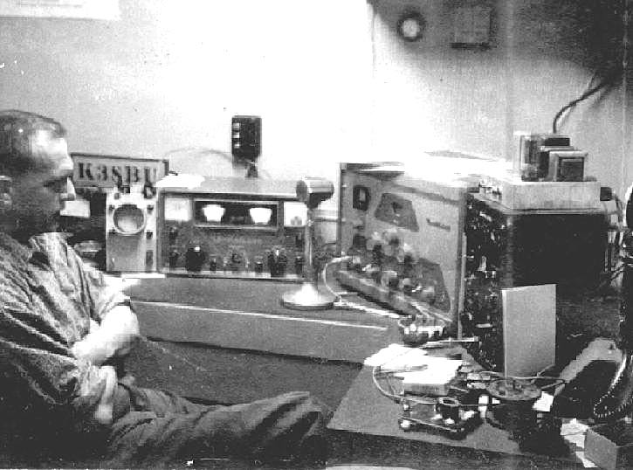

Pictured above is Robert Dziubkowski, K3SBU. The picture was taken in the mid 1960's. Bob has been an amatuer radio operator for 38 years. He originally got his license in 1961. He is not the only ham in the family. His wife Anne, N3VHV, got her license in 1995 and his son Mike, N3GCY, got his license in 1982.
1929

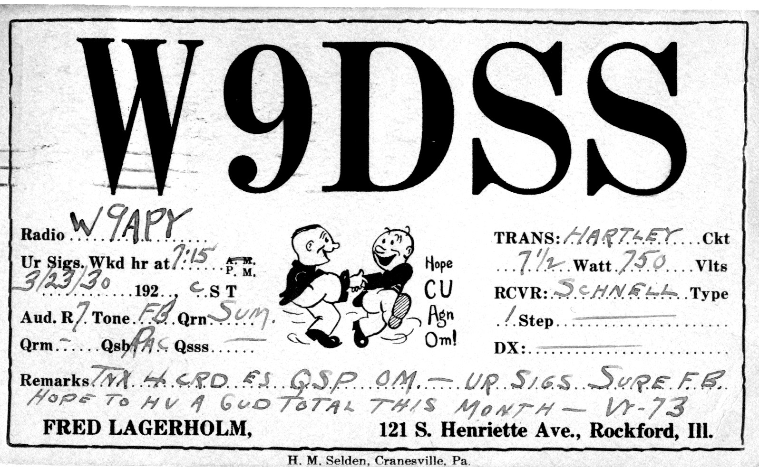

This 1929 QSL addressed to Q? J. Hinds was submitted by Quentin McCray, W3AHH. It was mailed from Rockford IL with 1-cents postage.
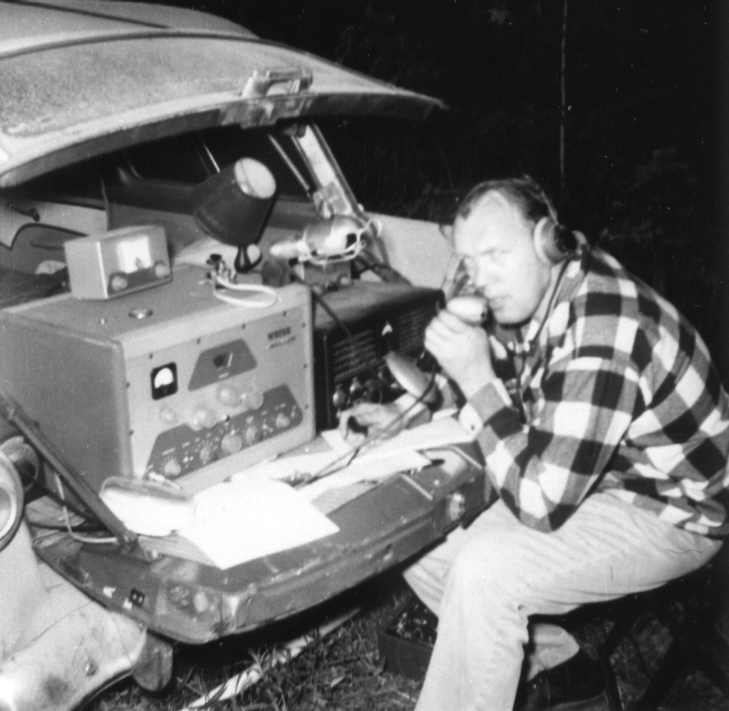

Here’s an old field day picture submitted by Jim, WT3O. Nobody around here knows who the ham is. Any of you old-timers know who the operator is? Please send replies to me, WA3HDK or to Jim. For what it is worth, the boat anchor is a Heath DX-100 AM/CW transmitter using 6146 finals and the receiver is a National. The meter on top of the transmitter is a Heath Q-multiplier—a regenerative IF signal-peaker. It worked quite well on CW but was only so-so on AM.

AN INTERESTING QSO--
A LOOK AT HAMMING IT UP
By Ron Reiff KB3BYP

Sometimes it isn’t who we find to talk to, it’s where we find them. I was on 17 meters last summer. Back then the band would open to the far east around 9 or so at night. This particular night, I heard a JA station call CQ. I knew it was Japan, and snapped to it fast. I banged the base of my SM8 desk mike and called the guy. To my amazement, he not only answered me, but asked me to tell him where I was, give him a signal report, and my name. I figured I’d just get a KB3BYP five over nine and nothing more.

He was a nice 5-9 plus. I told him the rest of the details. He came back with a similar report for me, and told me he was in MARA Japan. He was running a Yaesu FT1000 MP with a 200 foot rotatable tower, and two multi-element 17 meter beams. “So, what are you running, Ron?” was the next question. I told him the truth, “an Icom IC 735, with a hundred watts into a Antron 99 vertical.” It was the first time I heard a Japanese guy lose his cool! “You ARE NOT!” he exclaimed. “Sorry to disappoint you,” I said. “It’s what I have. You can ask anyone who knows me!” All I could say to him was, “Well sometimes you don’t need a lot to get a long way on this band.”

I figure he had about 10 grand or more tied up in his stuff, I might have 3% of that! I love this hobby!
--Ron, KB3BYP

FIELD DAY SET FOR JUNE 26-27

Field Day will be held again this year at Mead Park’s Red Top Pavilion. I have been unable to get anyone to commit to chairing the event. If you are interested in operating field day, perhaps you would be interested in chairing the activity. Because of time constraints, I have taken the liberty of reserving the park site. If I must continue making preparations, it will probably be a one-transmitter site. I can supply the transceiver in the form of an Alinco DX-70. Since it is my transceiver, I will insist on a “no food or drink” area around the equipment and also a “no smoking” area. We will be shooting for a high score, so I will be looking for two-person teams to man the rig for no more than a three hour stint. By the end of three hours you will need a break. We will need extra help during set-up and tear-down times. Visitors will be welcome—the more the merrier.

I will see that a field-day package gets ordered from ARRL headquarters. I haven’t tried to contact anyone about operating, because I am still under the delusion that someone would like to run the field day to suit themselves and will volunteer to chair the event. If that doesn’t happen, I will be looking for two person teams to sign up for the hours they will operate.

If you can help—or if you will chair the program, please get in touch. Use the roster attached to this issue to find address and /or phone number.
--Bob, WA3HDK

147.09 REPEATER GETS PREAMP

We have installed a Hamtronics LNG-144 GaAs FET preamplifier on the receiver up at the repeater site. The preamp has a 22 db gain and a low noise figure of .7db. The results of the $75 amplifier seem to justify the cost. If you haven’t tried the machine from the fringes you may be pleasantly surprised by the results.
SUMMER PICNIC IS JUNE 19

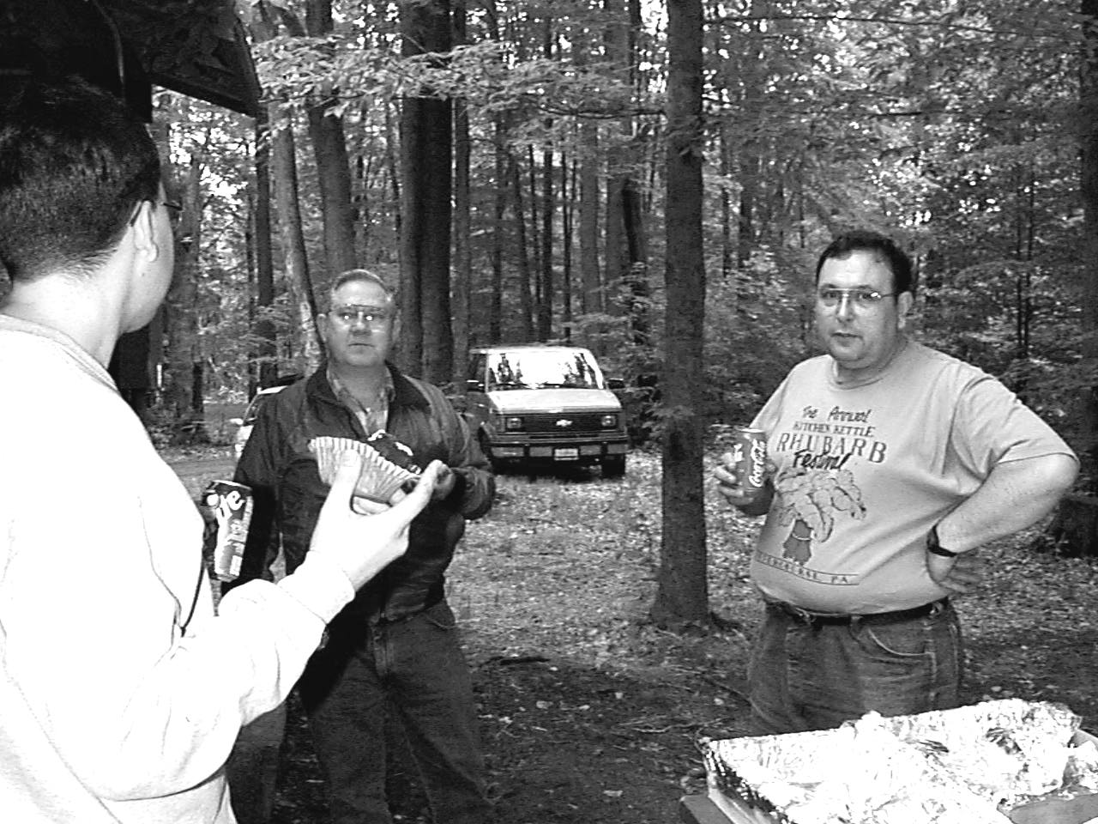

Every year our club sponsors a summer picnic. Everybody brings a dish to pass and we all share the booty. We have some mighty fine cooks among our member families and the spread is well worth the time.

We will have a charcoal fire going, so bring anything you wish to grill. Also bring along your tableware and paper plates and anything you wish to drink. We usually sit down about 1:00.

So far I have not been able to get anyone to chair this event either. I am hoping to have one of you come forth and accept the challenge.

There will be complete details in the next issue of the newsletter which will be distributed at the June club meeting and mailed shortly thereafter to those of you who are unable to attend the business meeting.
_________________________________________________

BYLAWS REVISION NEARING COMPLETION

Committee chairman Mike, N3GCY met recently with me to review the printing of the proposed bylaws. Sometime after the newsletter is printed, I will be printing the proposed revisions and a cover letter to accompany them. The material will then be distributed to all those who can be contacted personally (to avoid large postage costs) and then finally be mailed to those who cannot personally pick up a copy. The e-mail list has been ruled out because some of you cannot receive any other than straight text. The document contains shaded (gray) text and bold text to show what is proposed to be deleted and what is proposed for addition and I am afraid that e-mail will not show that.

You will then have a minimum of ten days to mail back any comments and suggestions for the committee to review. The committee will then review the returned correspondence. If no changes are indicated, the next issue of the newsletter will contain a ballot for you to mark your acceptance or rejection. A deadline for receiving the ballots will be set and by the July meeting we will vote to accept or reject the proposed bylaws.

We thank the committee for their efforts in this matter. The committee consists of Mike Dziubkowski, N3GCY; Ed Kulesa, N3XBA; and Norma Vanderhoff, W3CG.
___________________________________________________

CLASSIFIED ADS

FOR SALE: ICOM 706. HF, 6M, 2M. with MB62 mobile mount, CR502 TCXO crystal, OPC581 separation cable, FL223 1.9 kHz SSB filter, Outbacker Jr. 75-10M antenna, K400 Diamond Trunk-lid mount with 18 feet of RG-316. Package price $750. Frank, KE3PD (814) 663-0754.

FOR SALE: Seven (7) HamSticks HF Antennas. 80M - 40M - 20M - 17M - 12M - 10M - 6M with Inducdti-match. package price $80. Frank, KE3PD (814) 663-0754

FOR SALE: Texas Instruments MICRO LASER PRO 600 Laser Printer. 600 dpi. Commercial quality. Serial/Parallel input. 14 meg internal memory. Power step processor upgrade. All books and manuals, software for Mac and PC. This is the printer used to print this newsletter. Can demonstrate. Am replacing with color laser. $750. Will consider trade. Bob, WA3HDK. (814) 739-2206. hdk@erie.net

FOR SALE: Epson Color Stylus ink jet printer. 720 dpi. Software and manuals. Ink jet color refill kit. Some coated paper included. Can demonstrate. $100. Bob, WA3HDK. (814) 739-2206. hdk@erie.net.

2M net meets Thursdays at 8 p.m. on 147.09 repeater PL is not needed. We also hold a 10 M net on Tuesdays at 8 p.m. on 28.330 Khz. (technicians with hf can xmit here) Come join us.

VFW BREAKFASTS ARE
SIGNIFICANT FUNDRAISER

The December 20th breakfast sponsored by the Radio Amateurs of Corry and the VFW of Corry proved to be the best one yet in terms of revenue. Ever since Jim Adams, WT30, arranged for the first breakfast, we have looked upon these events to provide significant operating funds for the club. Leonard, WB3AYW, has served well as the committee chairman for the past couple of years.

On the Sundays that we have scheduled them, approximately ten club members, in two shifts, man the kitchen and serve hundreds of all-you-can-eat meals. The first shift meets at 6 a.m. to get things going. At 9 a.m. the second shift takes over and by noon, the kitchen is cleaned, the dining room is polished and the refuse deposited in the dumpster.

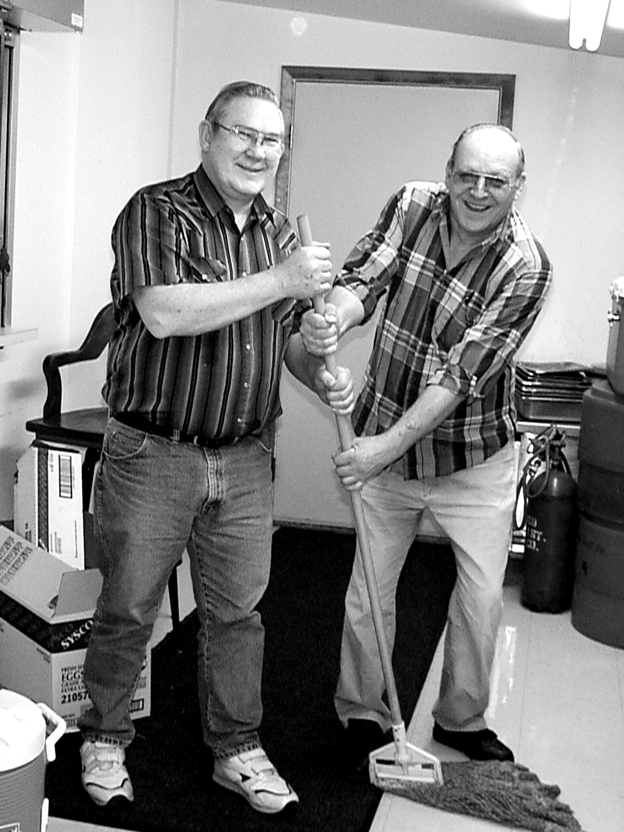

THE OLD AND THE NEW. Outgoing Breakfast Committee Chairman Leonard WB3AYW and new Chairman Jim WT3O fight for control of the mop during the clean-up of the kitchen at our last breakfast party.

Behind the scenes, and before the breakfast, posters are made and distributed. Announcements are made on the local radio station. Sometimes an advertisement is made in the newspaper.

Quite a few members get involved in this endeavor. Over time, the following have helped us to one degree or another: Jim WT30, Bob WA3HDK, Ron KB3BYP, Hal WDROOX, Will KD3II, Frank KE3PD, Mike N3GCY, Bob N3LBI, Jerry W3GHO, Tom K3KI, Leonard WB3AYW, Richard N3YPT, Gary N3WNP, Patty N3XFQ, Bob K3CKO, Evelyn XYL of WT3O, and Barb XYL of WB3AYW. I don’t think I missed anyone, but if I did, I’ll take this opportunity to apologize. To all of you who participated, my warmest thanks and, in the capacity of president of our club, a sincere thanks for your help.

The next breakfast is scheduled for April 11. Wouldn’t you like to be a part of this successful activity? At the request to be relieved as chairman, WB3AYW has been replaced by Jim, WT3O. I know Jim is looking for people to help. Please contact Jim if you can serve on either the early (6 - 9 a.m.) or late (9 - 12 noon). His phone number and e-mail address is on the roster which is included in this issue.
--Bob WA3HDK
_________________________________________________________

CORRY FD TO HOLD FIELD DAY
Late word has it that the Corry Fire Department will hold a field day on Sunday, June 27. They have requested that the Radio Amateurs of Corry provide some communications for them. We think they will want 7 or 8 operators with hand held radios. We have discussed this among our officers and believe that it will be possible to supply the operators and equipment even though the ARRL field day is that weekend. For those of you who do not operate field day, this should be a piece of cake. For the few of you who operate field day, you may want to schedule your operation on Saturday and keep Sunday open for the Fire Department activity. We still have ample time to plan for the activities. If you know you can help, please contact Jim, WT3O or me, WA3HDK.
_________________________________________________

prez sez
Boy, the first quarter of 1999 sure whizzed by. Here it is the first of March already. Lots of things are going on or coming up.

The membership is just about the same as last year with a total of 67. We have the honor of numbering 15 ham families on our membership roll. Our members have varied interests and operate many modes. It is a pleasure to be counted among such a talented group.

Attendance at our monthly meeting is down some with only about ten hams attending. This is less than 20% of our membership. I think we should be doing better than that! Won’t you try to make it to our club meetings? We meet the first Tuesday of every month at the American Red Cross Building, 134 E. Main Street at 7:00 p.m. (the meeting actually starts at 7:30).

We’re doing our best to have many, varied activities for you to participate in. I do hope you will find time to participate in at least some of them. For the first time that I can remember, we have two potential conflicts. The first one is on field day weekend, where the Corry Fire Department is requesting communication support for their field day. I think we should be able to handle that request. The second conflict is for the JOTA (Boy Scout) field day. It seems that the Corry group and the Beaverdam group both want our services. I will provide
(Continued on page 8)
the rig for one of them. We need someone else to step forward and supply the other one. Think you could do it? Contact me if you can.
(continued on page 8)
In other news, I have submitted our ARRL affiliation via the internet. Our percentage of club members is slightly below the required 50 percent required by the league for affiliation, but we’re hoping that the League will maintain our association. If you are a League member and “ARL” does not appear on your line near the left side of the roster, please contact me immediately. We do our best to keep records up-to-date but sometimes we slip up. Same goes for any other error you might find in our roster.

We are making plans for a tour of the new WWCB facilities sometime after field day. I’ll have more information in the newsletter next quarter.

Some of you can make some suggestions for programs you would like to have during the coming year. I ask you to help our Program Chairman, Craig Hill, K3VLP, by suggesting what kind of activity programs you would like

Check out our club’s web page which was created by John, N3NKV. Although it is still not finished—he’s waiting on some more pictures from me—I think you will be more than pleased with it. The address: http//www.qsl.net/n3nkv
(Continued on next column)

_{The} RADIO AMATEURS OF CORRY
P. O. Box 362
Corry, PA 16407

This newsletter is published quarterly

Editor, Robert E. Bair, WA3HDK (739-2206)

Submit material for the next issue on/or
before May 15. Next issue is June 1

Club Officers--
President, Robert E. Bair, WA3HDK (739-2206)
Vice President, Leonard Shick, WB3AYW (438-7199)
Secretary, James Adams, WT3O (664-8140)
Treasurer, Mike Dziubkowski, N3GCY (664-7189)
We need volunteers to put the Red Cross 2M station on the air once a month during the 2M net. It would be nice if that station would be net control. For security purposes, I would like to see you pick a buddy to sit with you and perhaps keep the log.

Finally, I need help with the newsletter. Can’t some of you write about your activities—like Dick, K3AQR or Ron, KB3BYP did in this issue. Don’t be overly concerned about grammar, punctuation or spelling. I’ll take care of that. 73’s—I’m running out of space.
--Bob, WA3HDK
__________________________________________________________

March 14 - Conneaut Hamfest. Talk-in 147.39
March 28 - Madison OH Hamfest. Talk-in 147.21
April 4 - Easter
April 6 - CLUB MEETING
April 11 - VFW Breakfast fund raiser
April 18 - Two Rivers Hamfest (Pgh) w3oc@nb.net
April 25 - Canfield OH Hamfest
May 4 - CLUB MEETING
May 14 -16 Dayton Hamfest (the granddaddy of em all)
May 31 - Memorial Day
June 1 - CLUB MEETING
June 4 - 6 Rochester Hamfest
June 13 - Goodyear Hamfest, Akron OH
June 19 - SUMMER PICNIC, Mead Park, Red Top
June 26 - 27 FIELD DAY, Mead Park, Red Top Pavilion
June 27 - CORRY FIRE DEPT FIELD DAY, details later

