 TheRADIO AMATEURS OF CORRY
VOLUME 4 No. 4 DECEMBER 1998

MEMBERSHIP DRIVE BEGINS NOW

Don’t look now, but it is time to renew your membership to the club. Dues are just $5 for individuals and you can include licensed members of your immediate family for only $2.50 more. Thus a ham and his spouse (or child) can both belong to the club for $7.50.

What do you get for your money? First of all, you get voting privileges allowing you to have a say in the way our club operates. You also join in keeping our two repeaters on the air. Add a subscription to the newsletter and you have a winning combination! Oh, yes, and the newsletter will have the club roster in the March issue. Only club members get this information.

The back page of this newsletter has an application form. Please fill it out and either bring it to the club meeting the next time you come or mail it to the club address which is on the page with your name label in this issue. It is quite helpful to us to have that form. IF YOU HAVE NO CHANGES IN THE DATA YOU NEED ONLY TO FILL YOUR CALLSIGN IN THE BLANK. However, please do include the data for your ARRL affiliation and your e-mail address if you have one.

VFW FUNDRAISER BREAKFAST SCHEDULED FOR SUNDAY DECEMBER 20

Breakfast chairman Leonard WB3AYW is still looking for a few good men (or women) to serve in the kitchen for this activity. The work is scheduled in shifts of approximately 3 hours each. Volunteers are needed for each shift. Please notify Leonard at 438-7199 if you are able to help. This really is an easy way to help support the club. Please volunteer!
YARD SALE WAS SUCCESS

We held two fund raising yard sales this year. The first one found the weather overcast with intermittent showers. Nevertheless, it was decided to setup shop. Leonard WB3AYW, Jim WT3O and xyl Evelyn, Richard N3YPT and his xyl, and Bob WA3HDK met in Richard’s front yard at 8 a.m. We got the tables all set up and it started to rain, at first it looked like it may not last and then it really let loose we had to hurry to get everything covered. So we gave up and chose a rain date on September 26th.

The weather cooperated on Saturday, September 26 with very sunny, very warm and muggy conditions. That day was just perfect. We set everything up about 8:00 a.m. and the customers started coming in droves. The site proved to be a good, high traffic, one. We were very busy all day. Lots of sunshine and lots of activity. By mid afternoon, traffic slowed and the weather found us hiding in the shadow cast by the house. When we decided to call it quits about 3 p.m., some articles were packed away and stored for next year’s sale and the clothing, which was pretty well picked over, was taken to the Salvation Army deposit box in the plaza.

It was the most successful yard sale so far. So our thanks goes out to those who helped us and those who donated to the yard sale. We want to especially thank Richard N3YPT for allowing us to use his front yard, Jim’s daughter who served as contact person for collecting a very large donation of clothing and Jim WT30 and Leonard WB3AYW for furnishing transportation to pick up the donation.
______________________________________

RAC meets at 7:30 p.m. on the first Tuesday of each month at the Corry Red Cross building. Join us!!!

RAC PROVIDES COMMUNICATIONS FOR FINDLEY LAKE 10K RACE

The Findley Lake 10-K race was held on September 19 this year. The weather was great that day (better than other years). Seven club members met at the fire hall at 8:30 a.m. We met with the fire chief and received our assignments. Maps of the route were provided by Bob, WA3HDK. Hal, WD4OOX took position at the two mile marker. Ed N3KGD was at mile marker three; Jim WT3O at mile four; Lee WA3HJC at mile five; Richard at mile six, and Jerry W3GHO at the grandstand.

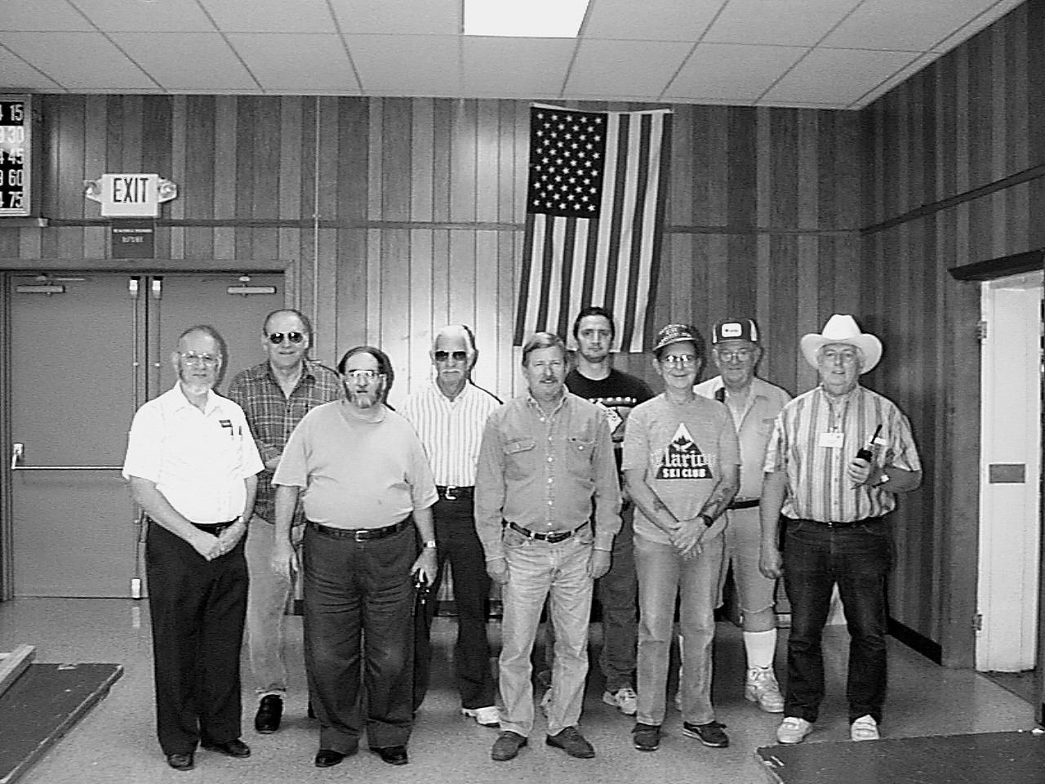
Members of the communications team were: Front row, WA3HDK, Bob; WA3HJC, Lee; K3KI, Tom; N3KGD, Ed; and W3GHO, Jerry. Rear row: WT3O, Jim; KD4OOX, Hal; N3YPT, Richard; and K3CKO, Bob.

Bob WA3HDK was elected to be net control. His station was in front of the fire hall near the fire chief. This year we were permitted to assign an operator to the lead and the trailing vehicles. Bob K3CKO was assigned to the trailing vehicle and Tom K3KI rode in the lead vehicle with the fire chief's wife. She was very impressed with the way we conducted our traffic. I'm sure the chief heard all about it.

We used tactical call signs. They are quick to use and allow for shorter transmissions. In order to meet FCC ID rules, net control asked for stations to identify themselves every 10 minutes.

The whole event went off very well without any incidents and when we returned to the fire station we were all thanked by the fire chief and the other volunteers at the station. Not to be forgotten was the pizza we enjoyed before we all started home. Thanks to all of you that helped.

We received a letter from the coordinators of the10K race thanking us for our participation. The letter speaks for itself--here is the text of the letter:

--Jim Adams WT3O

"Thanks Helpers" You can take a bow for a job well done. Thanks to our sponsors being a part of the volunteers we have had another successful 10K race. It was such a beautiful day everyone enjoyed beautiful Findley Lake as they made their way around the village. We were able to give each the fire company and the Mina Town Youth Recreation fund a check for $750. Again, from the committee and all the benefactors, we want you to know we appreciate your participation. (signed) Kay Cooper
FOR SALE: Azden PES-7500H 6M FM transceiver. 50 watts high power, 10 watts low power. CTCSS encode. Ned Warren KB3CZE. (814) 723-6983.

FOR SALE: Icom IC-24AT dual band handheld. 5 watts high power, 1.5 watts low power. CTCSS encode/decode. Modified for MARS (transmit/receive 138-174 Mhz) BP-82 low power battery pack, BP84S (7.2v, 1400ma) battery & wall charger, BP-85S (12v, 800ma) battery & wall charger. All manuals and documentation included. Good condition, but some scratches and marks. Original cost over $750. Asking $175 obo. Bob WA3HDK (814) 739-2206

FOR SALE: I'm getting the "bug" to get a new piece of gear after several years but the XYL says I can't "collect" my older equipment anymore!! So, my trustworthy old friend must go. ICOM Model 735 with AC power supply, mobile bracket, DC Power cord, and mike, all in excellent condition with manuals and boxes, $725.00. Also, complete Hustler mobile system for 15 and 20 meters. Consists of bumper mount with quick disconnect, radiator for 15 and 20 each consisting of separate quick disconnect, fold over mast, spring (below coil), and loading coil, $100.00. U-pay shipping. Dick Drace, K3AQR. Phone: 941-294-8385. e-mail: rdrace@juno.com If anyone buys any of this equipment as a result of this ad in the RAC Newsletter, I will contribute 10% of the sale to the club.

FOR SALE: 50ft. Rohn Tower. Good condition. Call for a price. Jim WT3O 814-664-8140
__________________________________________________________

We made a lot of points this year on field day 98- read about it in the Q.S.T. --Jim WT3O
Radio Amateurs of Corry
Minutes
September 1, 1998

The meeting was started at 7:30, with Leonard Shick, President, residing. Other officers present were Mike Dzuibkowski treasure and James Adams temporary Secretary. Those absent were Gerry Owens, Vice President.

OLD BUSINESS:
Mike, N3GCY questioned the minutes of last meeting in August that stated he and Leonard were present and they were not. Minutes were corrected. Treasure Mike gave report of expenses which were $12.62 electric bill and $50.30 for the newsletter.

A report of the yard sale was given which was held at Richard's N3YPT. It was rained out and a new date was set at September 26th at Richard's QTH. A starting time was agreed on of 6:00 am. Leonard WB3AYW suggested he will get together with Mac and Terry McCray to make arrangements for the JOTA coming up in November. Leonard said he will call Ron N3KLN to see if he can borrow his rig for the event. Mike N3GCY discussed the bylaws with the members present. It was decided that voting on the by-laws was to be done on January 5th at the Christmas Party. A motion was made by N3XBA Ed and seconded by Bob WA3HDK that mail-in votes must be in by December 30th, 1998.

NEW BUSINESS:
The Duard May Committee was discussed. New members of that committee were W3BZJ Mac and W3AHH Quentin with Bob WA3HDK as chairman. The Annual 50/50 tickets were discussed and are to be distributed by the members. Club members will be notified by telephone that tickets are available and will be distributed by Mike N3GCY and the drawing will be held on December 5th at the Christmas Party at the Dutch Treat restaurant. Also door prizes will be bought for Xmas party by Mike. The menu for the Xmas party will be Swiss Steak and Turkey. A motion to adjourn was made by Bob K3CKO and seconded by Ed N3XBA at 9:12 p.m. The 50/50 was won by yours truly and turned in to the club. These minutes submitted on October 6, 1998.

Respectfully submitted,
James Adams WT3O, Acting Secretary
______________________________________________

RADIO AMATURES OF CORRY
Minutes
October 6, 1998

The meeting was called to order at 7:30 by Mike, N3GCY. Officers present were Jim, WT3O, acting secretary. Officers absent were Leonard, WB3AYW and Jerry, W3GHO. Leonard’s mother is in the Pittsburgh Hospital.
The minutes were read by WT3O and accepted. Treasurer’s report was given by N3GCY. All bills paid. ($12.45 to Penelec). No Income to report.

COMMITEEE REPORTS
Awards Committee has not met yet. Nothing to report.

REPEATER COMMITTEE
WT3O gave report on maintenance to the repeater building. New gutters and new paint job. New electric service.

OLD BUSINESS
Terry McCray (in charge of Boy Scouts) says the council has canceled JOTA for this year. Bob Fuller, N3LBI, committee chairman has been notified.

Bob, WA3HDK, has submitted a bill for newsletter of $47.04 to the treasurer.

50/50 tickets were discussed and distributed by Mike, N3GCY. Mike is to notify members that were not in attendance about the tickets.

Bylaws are to be finalized at the November meeting.

A report was given on the yard sale that was held at Richard, N3YPT’s QTH. It was very successful but poor turnout of members willing to help.

Bob, WA3HDK mentioned that we need to check out the 147.09 repeater with a signal generator to see why the receive is so poor.

The Christmas Party was discussed. The party will be at the Dutch Treat Restaurant in Spartansburg again this year on Saturday December 5. Time is set for 6:30 p.m. Price for the dinner is $10.95 and that includes the tip. Door prizes will be picked up by Mike, N3GCY. He will also be the master of ceremonies.

A motion to adjourn was made by Ed, N3XBA and seconded by Craig, K3PLV. Meeting adjourned at 21:10 local time.

Respectfully submitted
James Adams, Acting Secretary.
______________________________________________

RADIO AMATEURS OF CORRY
Minutes
November 3, l998

Meeting called to order by President Leonard Shick, WB3AYW. Officers present were, President WB3AYW, Vice President Jerry W3GHO, Temporary Secretary Jim WT3O. Officers absent was Mike W3GCY.

Minutes were read by WT3O. Jerry W3GHO made a motion to accept the minutes as read and Bob N3LBI seconded it.
(continued on next page)
November Minutes continued

COMMITTEE REPORTS
The awards committee has not met yet. A report was sent to Dick K3AQR on the members of the awards committee.

All members attending the Christmas party are to notify Bob WA3HDK for reservations. All reservations are to be in one week before Christmas party.

NEW BUSINESS
We discussed the repeater condition and we will try to get a crew to go up and check it out before the weather gets bad.

Voting for officers: Nominations and voting were done at this meeting. New Officers are President Bob WA3HDK, Vice President Leonard WB3AYW, Treasure Mike N3GCY, and Secretary Jim WT3O.

OLD BUSINESS
Bob says he needs help with the newsletter. We discussed a replacement for the Red Cross Representative. N3XBA volunteered but we only had 2 months to go before we get new representative for 1999 so N3LBI made a motion to hold off until we can talk with Danielle. Bob WA3HDK seconded it and it was carried.

NEW BUSINESS
We discussed the testing of the 2 meter rig at the red cross during a net on Thursday night. Bob WA3HDK suggested Craig Hill K3PLV program chairman, he agreed.

Bob N3LBI made a motion to adjourn. Seconded by Jerry W3GHO at 8:40 p.m. local time. Matt KB3CAT was the 50/50 winner
Respectfully submitted
James Adams, Acting Secretary.
______________________________________________

RAC ELECTS NEW OFFICERS

The following officers were elected at November’s regular business meeting:
President: Robert Bair, WA3HDK
Vice President: Leonard Shick, WB3AYW
Treasurer: Mike Dziubkowski, N3GCY
Secretary: Jim Adams, WT3O
______________________________________________

The SIX SHOOTERS group has a breakfast/swapmeet once a month in the North East area. The last one was at 8 a.m. on Sunday, December 6 at the Harvest Inn at Route 89 at the I-90 exit. Bob Fuller, N3LBI invites any of you to attend the next one. Call him at 898-1115 to find out when the next breakfast will be. If you have your eyes open at 8 a.m. you really ought to check this one out!
______________________________________________

Are your dues paid? The next issue of the newsletter will not be mailed to non-members.
PUT YOUR ANTENNA ON A BALANCED DIET

I like open wire feeders, but you cannot just hook your transceiver to a hunk of open wire (or ladder line) and expect it to be happy. For that, you need some kind of tuner. The tuner doesn’t change the antenna and feedline into some kind of super antenna—it just makes the transceiver think that it is hooked up to the “perfect” antenna.
The tuner that I use is an adaptation of the one described by AG6K, Richard L. Measurers, in the February 1990 QST magazine. I built the tuner in breadboard fashion, but it would have been much easier to use if the two coils could be ganged so that both could be controlled with one knob. Both coils must have the same number of turns in the circuit. There seems to 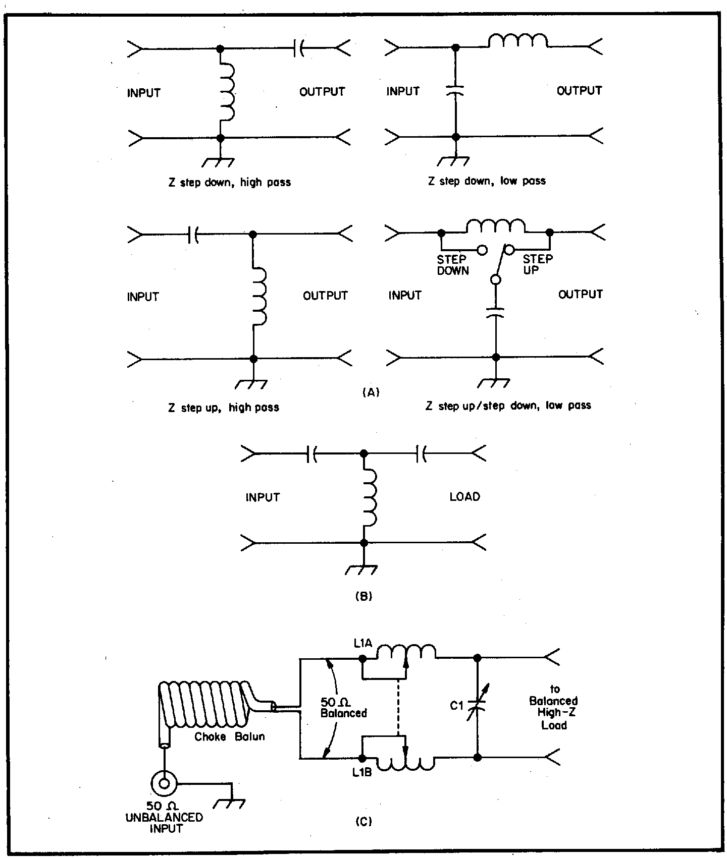
Fig 1—At A, the four basic L-network configurations. At B the unbalanced-T network. At C, the balanced-L network, fed by a choke balun made of coaxial cable wound on a plastic-pipe form.
--Reprinted with permission from February 1990 QST; copyright ARRL.

be no loss compared to the regularly used unbalanced tuner with a balun. In fact, there seems to be a slight gain instead. This type of tuner makes for less radiation from the feed line, thereby making the antenna directivity more dependable.
(continued on next page)
PUT ANTENNA ON BALANCED --continued

This tuner is very satisfactory on any type of twin line if proper twin line installation precautions are used. This tuner is not satisfactory (at least for me) for use on unbalanced (coax) line. The circuit show at the bottom of figure 1 is the one that I used. The one in figure 2 is the same except the motor drive is not needed because the best place to put the tuner is at the operating position between the transceiver and the feed line. By mounting it at this position, you tune the entire antenna circuit. For a fuller explanation of this approach, see ANTENNA REFLECTIONS by Maxwell, W2DU.

Balanced line, especially ladder line, has very low loss even with a high swr. I use over 100 feet of it with very good results. If properly tuned, the current will be very nearly the same in each leg of the feed line. The parallel connected variable capacitor should have a maximum of about 365 pfd and a second one could be switched in parallel if needed. It must be possible to switch the variable capacitor to either side of the second inductor. If the capacitor is switched to the antenna side of the inductor, it will step up the load impedance. When the capacitor is switched to the transceiver side, it will step down the impedance.

It should be noted where the balun is placed and how it is made. Rule one is that the balun is used on the transceiver. Rule two is that the balun is made of coax. It is made by winding about 31 feet of close-spaced 50 ohm coax on a 5-inch diameter plastic form. This makes a 1:1 balun which puts less “strain” on the balun doing away with the chance of saturation of the core. Saturation causes distortion. Since the balun always sees 50 ohms, placing the balun in this position works well for any type of tuner or antenna.
--Mac W3BZJ

Editor’s note: If you do not have your copy of the February 1990 QST and want to read the article, you may borrow my copy.

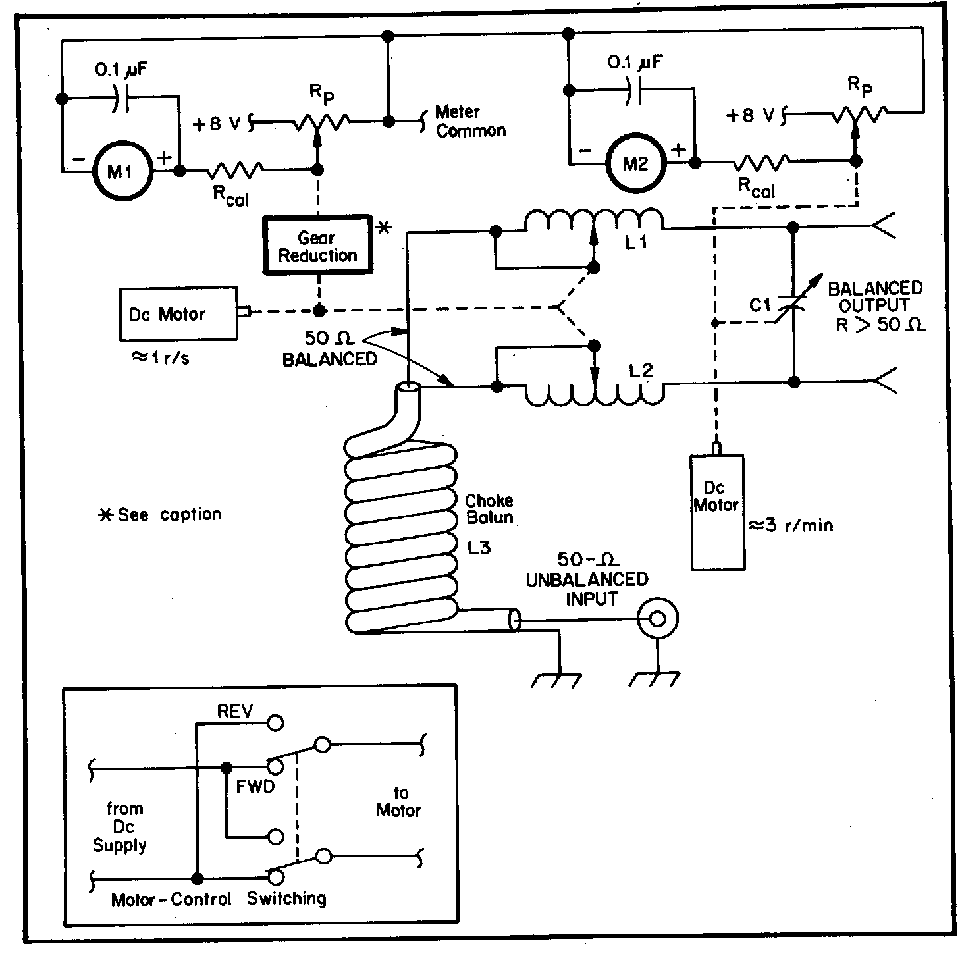
Fig 2—Schematic of a basic remote-controlled scheme for the balanced antenna tuner. A control cable with at least seven conductors is required for this arrangement; the meter-common and motor-common leads must not be connected together. Conductors are needed for: (1) approximately +8 V regulated; (2) meter common; (3) motor common; (40 capacitor-drive motor; (5) inductor-drive motor; (6) capacitor-position-indicator meter; (7) inductor-position-indicator meter. Each motor is controlled by a DPDT monetary-contact toggle switch (see insert). If the tuner is to be used for loads of less than 50phms, a relay and additional control lines must be added to the circuit to switch the variable capacitor from the output to the input side of the L-network.
--Reprinted with permission from February 1990 QST; copyright ARRL.

__________________________________________________________

The Federal Communications Commission has warned owners of antenna structures to comply strictly with FCC antenna tower lighting and marking rules. The warning follows a recent nighttime incident in Texas where a helicopter ambulance nearly hit an unlighted radio tower.
___________________________________________

R. L. Drake Company has announced it no longer will provide factory service for most of its older amateur radio and marine equipment. The list includes much--but not all--of the popular 4-Line equipment.
___________________________________________

The repeater committee reports that the repeater is doing better now since the last tune-up. The receiver was set on frequency and the preamp removed because of a sensitivity problem.

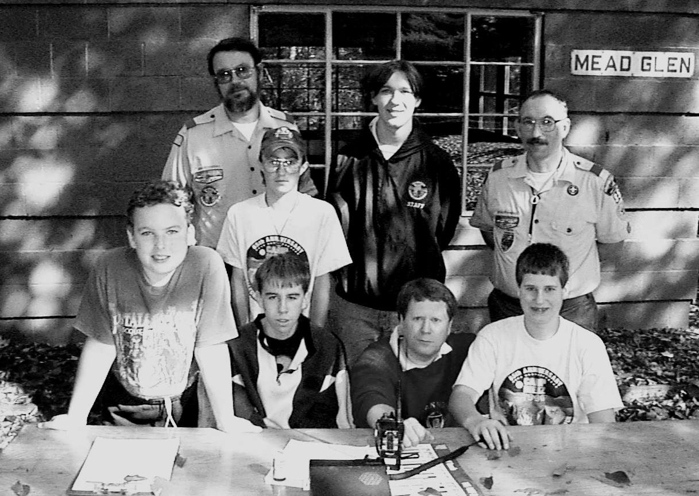
Front Row (l-r): Shawn Pelc, Mike McClenahan, leader Bruce Burr, Dan Burr, Rear: leader Norm Shrader, Ryan Emerson, Zach Shrader, leader Bob Pelc.

TROOP 85 PARTICIPATES
IN JOTA 1998

The combined Boy Scout council represented by Terry McCray called off the JOTA participation this year. That’s why I was a little surprised when Bruce, K3JVO called a couple of days before the scheduled event and asked if we could set up a station for troop 85. I called around to see if any other club member could participate. K3CKO said he would come over and spend some time. Although he did not operate, he did use my digital camera to get some shots of the event.

I had just purchased a used Alinco DX70 HF transceiver at the Erie hamfest and this would be a good time to see how good the rig was. Saturday, October 17, the weather just about the finest fall day that anyone could want.

I arrived at the Mead Glenn site in Mead Park and enlisted the aid of the scouts to throw a rope over a tree limb. A 50-foot hank of antenna wire was tied to the rope and promptly hoisted about 25 feet into the air. The antenna was connected to the Alinco EDX-2 long wire antenna tuner and the tuner was grounded to a 5-foot ground rod which I was only able to get about half way into the ground.

After the 12-volt automobile battery, and a battery charger was tied across it, we connected the power and turned on the rig. Ten meters was good. Ditto for seventeen meters. Twenty meters sounded good also. Forty meters wasn’t too bad and of course, seventy-five didn’t even exist. So much for testing. Now the real operations began.
I decided that seventeen meters sounded best and soon we were talking to Grover, KM5HB, 70 miles north of Dallas. All five scouts got in on that one. In fact most of our contacts lasted the better part of a half hour. Conditions were great!

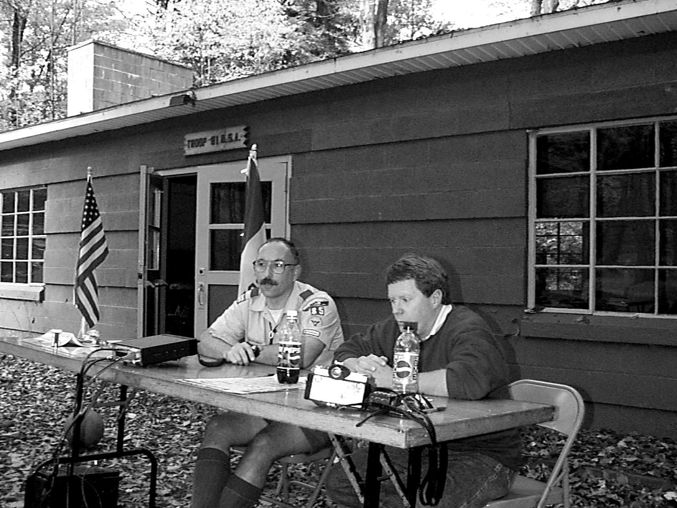

During the course of the afternoon we talked to stations in several states including K2BAR, N5WF, N2 CJ, K3PSP, AC5IC, W7TEN, K3AE, and KA1FGL.

When we tried 20 meters, we began a QSO with I3VKW in Italy. But as sometimes is the case the big guns jumped on the frequency and we lost him. Still not bad for 100 watts and a 50-foot hank of wire only 20 feet in the air!

Not to be beaten, we called 6Y5MV in Jamaica. Our scouts talked to their scouts for better than half an hour. Don was an excellent host as he had scout after scout talk to our boys. Next was Tom in Albuquerque and Richard, W7TEN in Olympia, Washington. PA3BRJ, Hugo, in the Netherlands was also a gracious operator having his scouts talk for more than a half hour with ours. DF5MR closed out our twenty meter operations with another long QSO.

As the shadows lengthened, we switched to forty meters. There we worked WB8KPE and John, KB3CIR. John doesn’t have HF privileges, so he worked under the guidance of Bill.

At this point we were all getting tired, so we decided to call it a day. It was enjoyable and rewarding—that day in the woods! Kind of a mini field day. When next October rolls around, volunteer to help with JOTA 1999.
--Bob WA3HDK.
PREZ SEZ

Well, I guess I’m jumping the gun a little as my term does not start until the January meeting. But the lead time to get articles into print is at least three months and I do want to get this column going again.

Lead time is something that has been in short supply lately. Right now we should be thinking summer picnic, field day, and any other activity that will come up in March through June of 1999.

Of course, it takes warm bodies to do all this planning. We haven’t had an abundance of volunteers to work on these activities. Unless we discuss it in our December meeting, I will be looking for volunteers to chair committees for doing the initial planning for the picnic and for field day. This planning should be in place by the deadline date for the next newsletter. That date is March 15. If it is not done by then, there will be no newsletter coverage until after the event, and that doesn’t encourage participation. Perhaps you can think of other activities that need to be addressed. If you do, we need your input and suggestions. Give me a call if you want to discuss anything at all about the club. Remember it is your club and you deserve to be heard. Can’t promise that everything you want will happen, but lets discuss it. The final action must be acted upon at a regular club meeting. We operate on the democratic principle that the majority rules.

It’s time to renew your membership in the club. Our membership year is the calendar year. An application blank is printed at the end of this newsletter. Won’t you please fill it in and return to our post office box address ASAP. The next issue of the newsletter will contain the 1999 club roster.

And, speaking of the roster, please make sure that your correct e-mail address is on file with me. I have started sending late-breaking information on e-mail. Two mailings have been made so far. If you have an e-mail address and did not receive a mailing from me, please send a blank message to me at hdk@erie.net. When I receive your message I will add your name to our mailing list. E-mail from Skip N3YGQ and Joann N3YEU Carr has been returned. If you know what happened to this couple, please forward their new address to me.

Another fund raiser VFW Breakfast is coming up on Sunday, December 20th. Committee chairman for that event is Leonard Shick, WB3AYW. There is a couple of things that you could do which would be appreciated. One, call Leonard and volunteer to help serve breakfast. We work in two shifts of about 3 hours each. Leonard still needs help for each shift. His phone number is 438-7199. If you cannot help in the kitchen, perhaps you would want to partake of the breakfast. It is served buffet style and is quite a bargain for the price of $4.

I look forward to the new year. Please help me make it a successful one for the club. We need your help and no one should ever be afraid to speak his piece. Get started now to share your knowledge and expertise for the good of all amateurs. Remember, unless you make your wants known, nobody will know what you want from your club. Also, show up at the club meetings on the first Tuesday of each month at the Red Cross building on Main Street.
--Bob WA3HDK
______________________________________________

CHRISTMAS PARTY 1989

The Christmas party this year was one of the best yet. The weather was warm—no cold and snowy conditions made getting from the car to the restaurant a pleasure. The crowd filled the banquet room at the Dutch Treat. Before the meal, which consisted of Swiss steak, turkey, mashed potatoes, and green beans, we were treated to a couple of Christmas carols by a group of town folks. Then Santa and Mrs. Claus, in the person of Mr. And Mrs. Carlos Shambaugh, made an appearance and wished all of us a Happy Christmas! This was a nice surprise to the program committee, too.

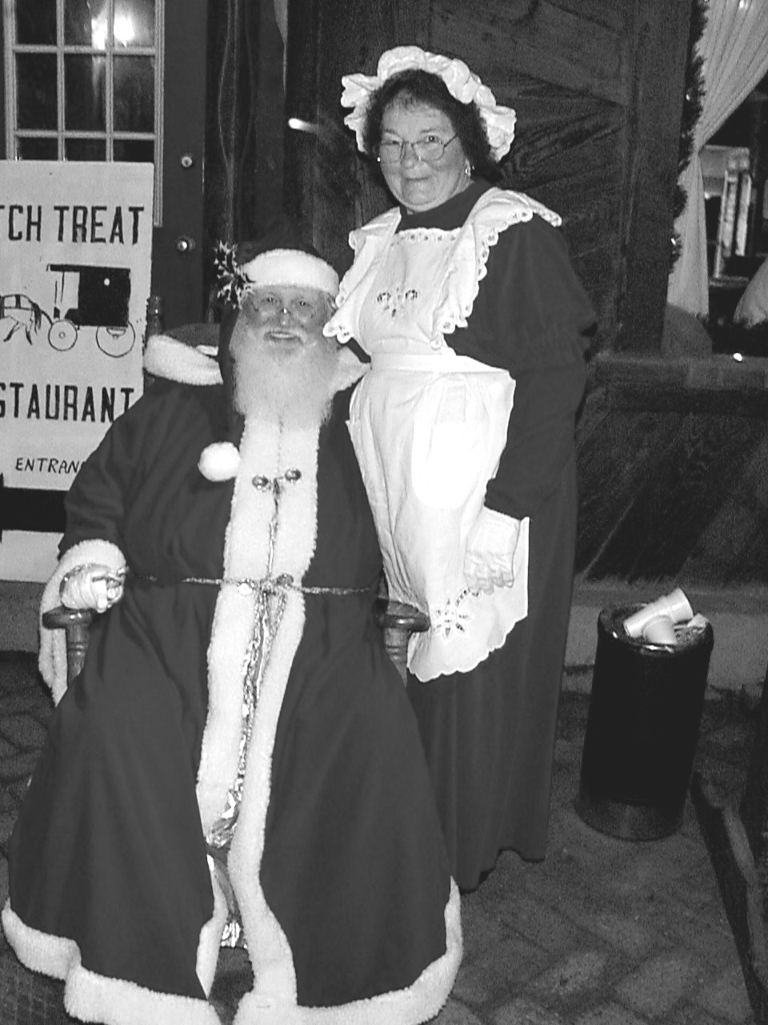

(continued on next page)
CHRISTMAS PARTY 1998 --continued

The featured speaker on the program was K3SBU, Bob Dziubkowski. With the help of his son, Mike N3GCY and xyl Ann N3VXV, he gave a video account of his recent trip to Hawaii. There was a follow up question and answer period. Following the presentation, Jim Adams, WT3O was definitely surprised to receive the annual RAC/Duard May Award. N3UBZ, Arnold received a certificate for being present at all the ten-meter nets of 1998. N3UBZ was again called to the fore along with WT30, Jim and W3BZJ, Francis for having perfect attendance on the two-meter net.

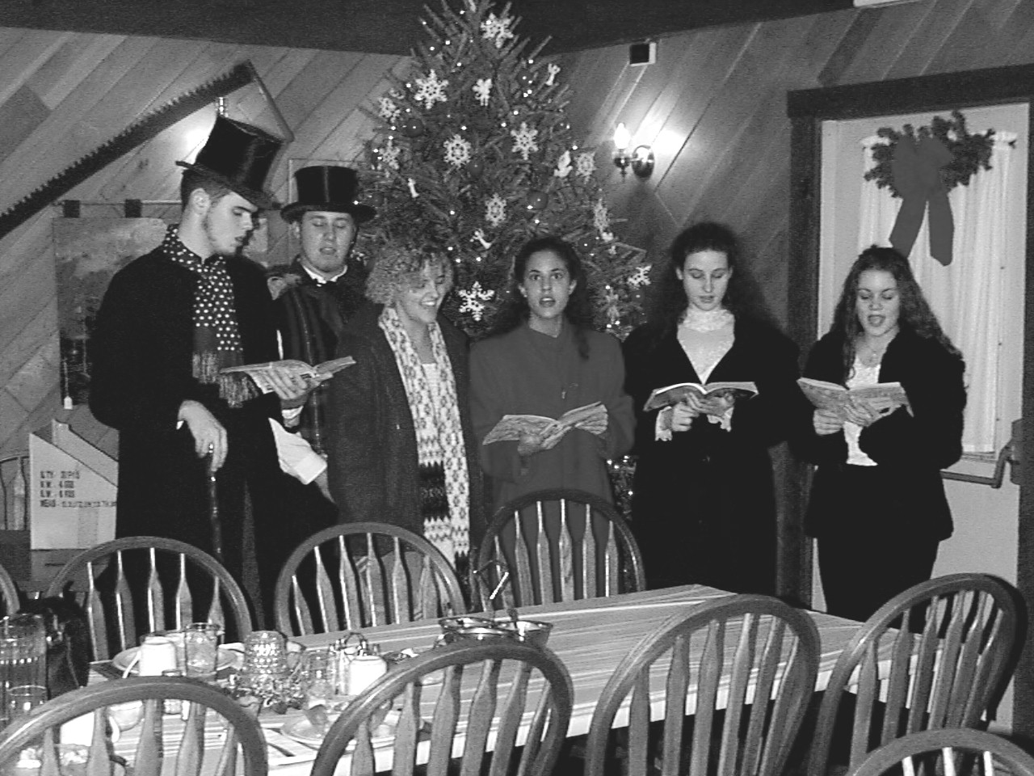
The Village Carolers paid us a surprise visit.

Everyone found a nice Christmas figurine on the table. We need to point out that Evelyn Adams (xyl of Jim) and Mike Dziubkowski did the shopping and wrapping of the prizes. On behalf of the club, I want to say thanks to both of you.

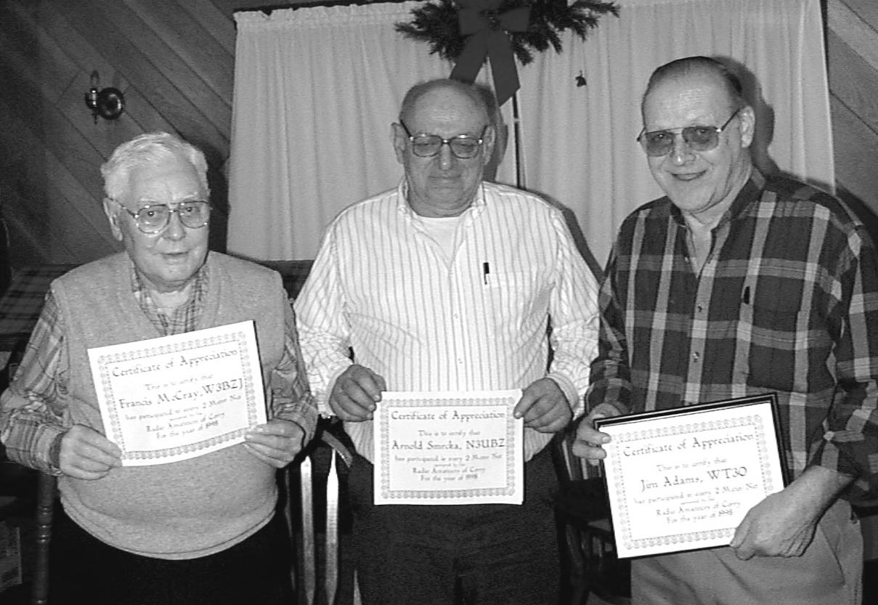Recognized for perfect net attendance: (l - r) Francis “Mac” McCray, W3BZJ; Arnold Smrcka, N3UBZ; and Jim Adams, WT3O.
If you missed the 1998 Christmas party, you missed a good one. Plan now to attend the 1999 Christmas party next December 11th. That’s the second Saturday in December at the Dutch Treat Restaurant.
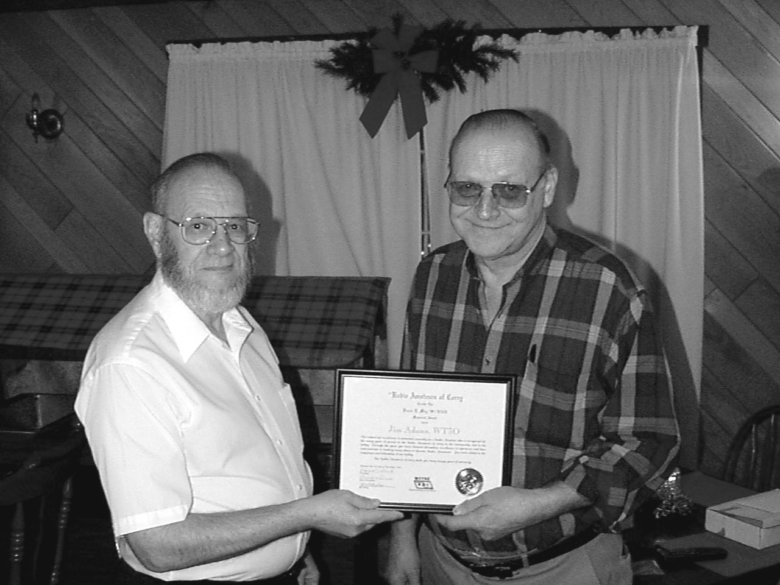
WA3HDK presents the Duard May Award to Jim Adams, WT30

COMMING EVENTS

December 20
VFW fundraiser breakfast. 8 -11 a.m. 1151 Mead Avenue. All you can eat. $4

December 31-January 1
Straight Key Night

January 2-3
RTTY Roundup

January 23-24
VHF Sweepstakes

February 13
Hamfest - Chautauqua County Radio Amateurs, Westfield, NY Eric Kroon, N2PCQ 239 Maple Ave., Cassadaga, NY 14718 716-595-3220 Fax: 716-595-8186 E-mail: EKroon@NetSync.Net

March 14
Hamfest - Conneaut ARC, Conneaut, OH Jack Marttila, KA8TUU 697 Broad St., Conneaut, OH 44030 440-593-3353

March 28
Hamfest - Lake County ARA, Madison, OH Roxanne 10418 Briar Hill, Kirtland, OH 44094 440-256-0320

March 20
Absolute deadline for submission of articles to the newsletter. Have your article in early, if possible.

