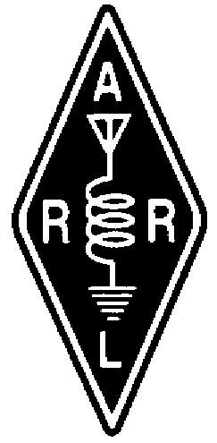  TheRADIO AMATEURS OF CORRY  
VOLUME 4 No. 1 MARCH 1997
QUINTIN McCRAY IS RECEPIENT OF DUARD MAY AWARD

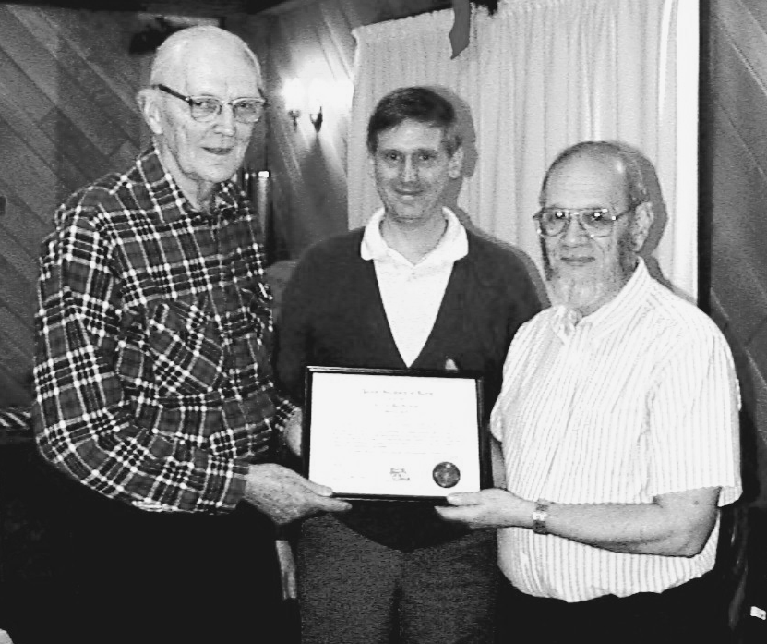

W3AHH, Quentin McCray was presented with the Duard May award at this years's Christmas party at the Dutch Treat Restaurant in Spartansburg The award was presented by Bob, WA3HDK on behalf of the Club. Shown above are Quentin, W3AHH, Masster of ceremony, Mike, N3GCY and Bob, WA3HDK. Quentin is well know in the area not only for his ham radio activities but also as a Pearl Harbour survivor. See more pictures of the Christmas party, elsewhere in this issue.

The Radio Amateurs of Corry recently donated a 2 meter amateur transceiver to the local Red Cross. Dave Marriot of the Corry Red Cross is shown here accepting an Icom IC-2000H ham radio from Leonard Shick, President of the Radio Amateurs of Corry. The radio has been installed in the operating position in the Red Cross building. It will be used in case of any emergency that may happen in the Corry and outlying areas. There are many ways this unit can be used. It can be used for FM Voice communications. Also it could be used in digital contacts with mobile units using lap top computers. This will make all communications much better during an emergency. The two meter 10-element beam was installed on the roof the the chapter house a couple of years ago. The Radio Amateurs of Corry have been serving the area since 1955.

73 Mike {n3gcy@tbscc.com}

