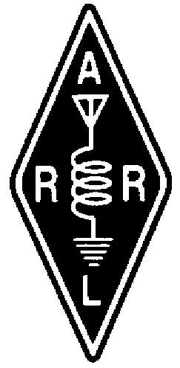 RADIO AMATEURS OF CORRY
VOLUME 2, No. 3 SEPTEMBER 1996

__________________________________________________________________________________________________________________________________________

Announcing 1996 JOTA

Looking for some high adventure to break the monotony of everyday life? Been thinking of embarking on a second childhood? Need a weekend away from the XYL and harmonics? Well here's your chance! A weekend of high adventure with the Boy Scouts Of America as we operate the 1996 Jamboree-on-The-Air.

Having been involved with both Boy Scouts and Ham Radio I know that Ham operators are nothing more than overgrown boys. If we didn't share that same thrill of adventure that drives Boy Scouts to seek high adventure, we would have never gotten into this hobby to start with. I also know that we never get over the quest for adventure. It is with us from cradle to grave.

So what is JOTA? (JOTA is an acronym for Jamboree On The Air.) It seems that Boy Scouts, like Ham Operators, like to get together in bunches to swap stories and find out how the other guy does it. They get together in District Camperees of a couple
hundred scouts twice a year, they gather at national Jamborees in groups of twenty to thirty thousand once a year, and they gather at a World Jamboree with as many as 400,000 Scouts once a year. If you have ever attended one of these jamborees you know that the primary purpose of going to a jamboree is to exercise your jaw muscles. Ham Radio operators have long been recognized as the worlds greatest experts in this fine art, so it is only natural that Boy Scouts and Ham Operators should get together once a year for an all out ratchet jaw weekend. JOTA is an annual event in which Boy Scouts and Girl Scouts (yes I said Girl Scouts) from all over the world speak to each other by means of amateur radio. Scouting experiences are exchanged and ideas are shared via radio waves. Since 1958 when the first Jamboree-on-the-Air was held, millions of Scouts have met each other through this event. Many contacts made during JOTA have resulted in pen pals and links between Scout troops that have lasted many years.

JOTA is held the third weekend in October. JOTA 1996 will take place Saturday October 19, from 0001 hours local time, through Sunday October 20, at 2359 hours local time, although some activity continues over from Friday to Monday to take advantage of long distance DX time differences. Licensed Amateur Radio operators operate stations in accordance with their national standards and instruct Scouts in enough rules, procedures, and Ham Radio jargon so that they can make contacts and exchange information over radio waves.

Stations should call "CQ Jamboree." or answer stations doing so. Any authorized frequency may be used however it is suggested that stations use the agreed World Scout frequencies and nearby frequencies in order to avoid congestion. These frequencies are:

BAND SSB (PHONE) CW

80M 3.740/3.940 Mhz 3.590 Mhz
40M 7.090-(7.290 in IT Region 2) 7.030 Mhz
20M 14.290 Mhz 14.070 Mhz
17M 18.140 Mhz 18.080 Mhz
15M 21.360 Mhz 21.140 Mhz
12M 24.960 Mhz 24.910 Mhz
10M 28.990/28.350 Mhz 28.190 Mhz

JOTA is not a contest. The idea is not to work as many stations as possible in a weekend but to make quality contacts that are both fun and a learning experience for the Scouts (and Ham Operators). Each station, club or group is asked to send their logs to their national JOTA Organizer who in turn sends them to the World Scout Bureau for publication in the World JOTA Report which is published in March. Each club/Scout troop participating in JOTA is asked to design and make QSL cards commemorating the special event. These can be sent to all stations worked including non Scout stations. There are Certificates of Participation available, free to all participants and pocket patches available for $2.50 each. See K3CKO or Terry McCray to order.

Come on RAC members, lets have some fun and make this year's JOTA one to remember. Contact K3CKO to volunteer your station and time. This could be bigger and better than Field day or the PA QSO party. Just think, 24 hours of operation without the pressure of big contests. Hey... .sign me up right now!!
--Bob Swarm, K3CKO

_______________________________________________________________

LETTERS TO THE EDITOR

Dear RAC members,

It was nice to see a good turnout at our picnic this summer and Field Day as well. Glad everyone had a good time at both events And a special thanks to all who helped with the yard sale. It was a real success!

I experienced some trouble with my HF rig this summer. Thanks to Frank, KE3PD who recommended that I send it to Denver Amateur Radio in Stenens, PA. They did a good job repairing my rig at what I thought was a reasonable price. So, if you have problems you may want to try them. Their advertisement appears in QST and CQ magazines.

Hope to see all of you at future meetings and at the JOTA on October 19.
73
sgd/ Jim Adams, WT3O

FIELD DAY '96 REPORT

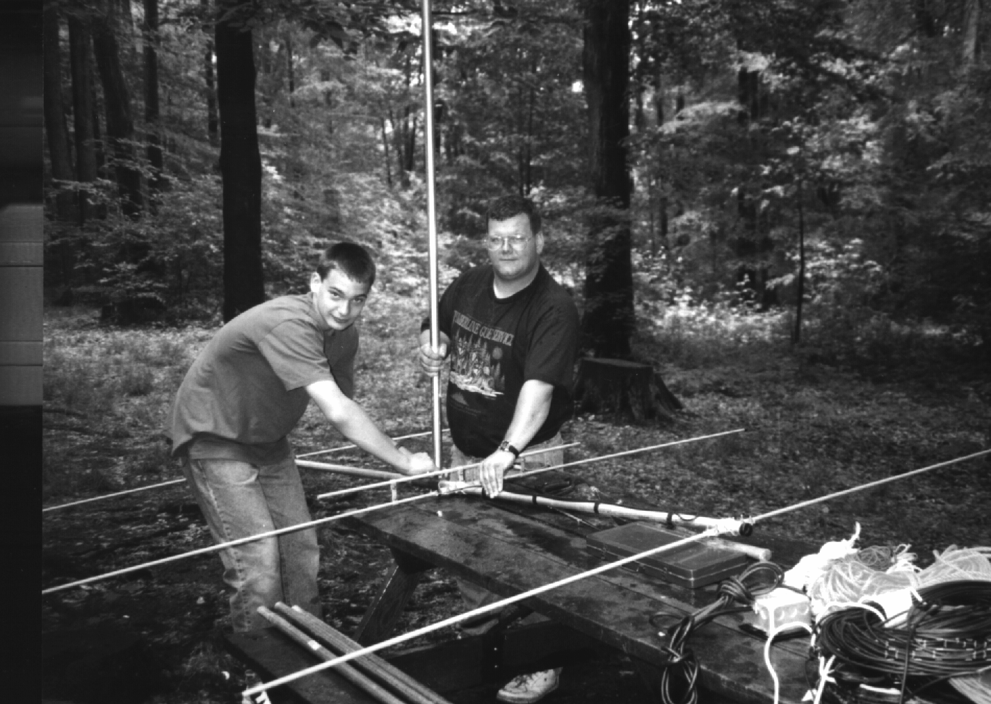

Mat, N3XFW and Don, N3TYF assemble the six meter beam used during Field Day

Thanks to all who participated in Field Day '96. The Radio Amateurs of Corry amassed over 1,000 points during the contest. Despite some last-minute changes, all worked out well. Most importantly, Corry is now a better place to live because we now have an experienced team ready to response to any local disaster. People who have operated a radio all night long, set up generators and antennas, and coordinated among ourselves an emergency response plan.

The top operators were WT3O, WA3HJC, KE3YN AND WX3E. Jim worked some 44 people on 20M CW, lee worked 42 people on 40M CW, and Greg and Dave worked some 45 people on SSB.

Now let's get geared up for the PA QSO Party on October 12 and 13. This is also a HF contest promoting phone and CW contacts with the 67 counties of Pennsylvania and ARRL Sections. Maybe W3YXE can sponsor a station this year???
--Lee, WA3HJC
_______________________________________________________________

An XYL Speaks. . .AKA Packet Queen

Faster than a speeding bulletin; able to leap long distance in a single byte; it's....packet! You may not think packet is your cup of tea but ya gotta give it a try. I didn't think I'd like it and now my hubby calls me the "Packet Queen." It is too much fun. We have cards from all around the world. Countries we rarely heard of. When is the last time the Azores came up in a conversation? We have also had QSL exchanges with South Africa, Australia, England, Italy, Spain, and Germany. I could go on and on. We've also received QSL's from the states. Some of these have become good friends through the computer.

All you need to get started is a computer at a reasonable price and a TNC (Terminal Node Controller) and you are about ready to get into the best hobby!

When you get into the BBS (Bulletin Board System), there's sales, recipes, info and all kinds of neat stuff. Once you're set up, you don't have to spend a dime, except postage if you want to exchange QSL cards. Let's put it this way. If I can run packet then anyone can run packet. You don't have to be a computer whiz to do it. Anyone who is interested can just get in touch. Another good one to contact is Bob WA3HDK. We had to ask him zillions of questions when we started and we still bug him occasionally. (he may say frequently, ha....ha.) Another good one to contact is Bob K3CKO. He gave us a hand with commands. He's been into packet quite awhile. Between the two Bob's and any help N3WNP and I can offer, you should be all set for packet. There's lots of packet people in Corry so you wouldn't be lost starting out. Now that I've written my article guess I'll get back to the packet and maybe even some housework. It's fun (packet, that is). . .try it. We love that packet racket.
--Patty, N3XFQ
_______________________________________________________________
W3GC ATTENDS YLRL CONVENTION

The Young Ladies Radio League (YLRL) Convention, held in July at the Omni Hotel in Albany, New York, was a full four days of fun. The variety of program subjects covered many different aspects of Amateur Radio, with emphasis on scholarships, contesting, friendships, which includes international, Girl Scouts, and satellite operation.

Guest speaker at the Grand Banquet was Steve Mendelsohn WA2DHF, ARRL Vice President. His talk centered on possible loss of the 2 and 3/4 meter bands, concentrating on the need of all Amateur Radio licensed operators and clubs to continue a heavy paper trail in a try to hold these bands. Mendelsohn stressed the lack of ARRL support by many Technicians, feeling that they did not understand that the support of everyone is necessary to be successful in an uphill fight, and Technicians would be severely harmed at the loss of these bands.

One day of the Convention was spent with a bus tour in visiting ARRL and W1AW. Souvenirs were plentiful and some operating was done under the W1AW banner.

At the Convention, a Special Event station was operated from the 15th floor, with 80, 40, 20 and 10 meters being active bands. Contacts were frequently made with operators at the Atlanta Olympics.

It was interesting to have James Drake W5EF of Albuquerque, NM. at our banquet table. Drake designed the radar system which caused bombs to explode at a specific altitude. Nancy Hall KC4IYD of North Olmsted, Ohio, who is an employee of NASA, and also Vice President of YLRL, was also a very interesting speaker.

My traveling companion, Deborah Nelson KB2WOM of Jamestown, NY. and I came home with numerous prizes and mementos of the occasion, and hope to attend the 1999 Convention which will be held on the West Coast.
--Norma W3CG
_______________________________________________________________
The 147.90 repeater has changed PL from 123Hz to186.2Hz
RAC MEMBERSHIP MEETING
AUGUST 6, 1996
CORRY RED CROSS BLDG.

The meeting was called to order at 7:30 P.M. by President Frank Cutshaw KE3PD. All officers and 21 members were present. Minutes of the last meeting and Treasury report were accepted as read by Norma W3CG.

ACKNOWLEDGMENT
A card of thanks was received from Red Cross Manager, Danielle Smith, for replacement of coax on the Red Cross CB antenna. Volunteers were W3AHH, WA3HDK, W3BZJ, WT3O, and W3AGF.

Thank-You cards are to be sent to Danny Gobbels at Penelec for furnishing guy wire and clamps, and to Dave Marriott of Jamestown Electric for the ground clamps.

Leonard WB3AYW served as Net Control, relief operator for 6 1/2 hours at New Bethlehem during the recent floods in Jefferson County.

Bob K3CK0 was visited recently by bicycle traveler David Haas NlOSL of Lancaster, NH., who made an overnight stay at the Sciota Campgrounds.

Bob Swarm K3CKO upgraded to General in July
Arnold Smrcka N3UBZ upgraded to Amateur Extra on August 3rd.

NEWSLETTER
Bob Bair WA3HDK announced an August 15 deadline for material to be submitted. Don Swarm N3TYF and Larry Sperry N3WRA sold ads which covered costs of the next newsletter. Suggested by Don N3TYF that newsletter be placed at Corry Public Library. More pictures for the newsletter are always welcome.

OLD BUSINESS
Registration taken for volunteers to help Mike N3GCY with the Titusville Parade on August 17.

Dick Drace K3AQR letter of W3DUB Award to be reviewed at September meeting.

APPOINTMENTS
JOTA Chairman - Don N3TYF and CO-Chairman Bob K3CKO.

1996 Year End 50/50 Ticket Chairman - Jim WT3O.

1996 Year End Dinner Arrangements - Will KD3II.

REPEATER
Larry WA3PGL resigned from committee to return to Florida.

Cecil W3AGF acquired guy wire for tower and can borrow tools for installation if the project is completed before his return to Florida on August 26.

Bob WA3HDK is in charge of work arrangements, estimated as a 3 hour job.

Will KD3II announced that land at the repeater site has been sold by the owners.

Jim WT3O announced that the 440 is in repair shop, getting tuned up.

Bob WA3HDK and Jerry AB3X mowed the grass and cleaned up the repeater site.

NEW BUSINESS
Jim WT3O displayed an artistic cup inscribed with club call sign, to denote any interest in ordering. Price quote was $20.00, if used to reinforce the club treasury.

Suggested by Frank KE3PD that we participate in Penndot Program in clean up of highway litter, selecting an area of Rte 6, which would assure exposure of club name on a highway sign.

Bob WA3HDK suggested a new vote on Christmas Dinner menu choice, between the 2 meat dinner of turkey/roast beef, the original choice, being replaced with Swiss Steak. KD3II to check with restaurant of possible change and cost.

CLUB FUNDS
Checking account - $569.89
Savings account - $931.99

Refreshments were provided by Don N3TYF. 50/50 - $20.00 One half won by Frank KE3PD and donated to club.

Motion to adjourn - Bob N3LBI, 2nd by WB3AYW.

Submitted by Norma W3CG, Sec/Treas.

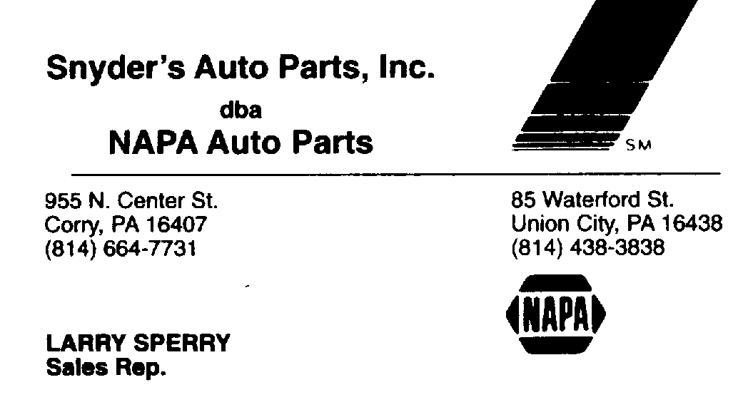
THE CLASSIFIEDS

FOR SALE: Alliance U110 Rotor. Rebuilt with 60- feet HD rotor cable and 6-foot HD aluminum mast. includes mounting plate to use for horizontal/vertical antennas. Excellent condition. $70. (814) 663-0754. Frank Cutshaw KE3PD

FOR SALE OR TRADE: UT-50S 6-Meter module for KENWOOD TS 741A or TS 742. New January 1996. Trade for UT-220S 220 Mhz module or sell for $250. (814) 6630754. Frank Cutshaw KE3PD

THE INTERNET

I want to share with you what I did one afternoon. I started by checking in with Mark Foley KC5FJV. Mark is a member of a multi-national ham radio club in Okinawa. Next, I jumped over to Ithaca college, to look though their library. Then checked into the ARRL Headquarters, and downloaded information about JOTA. Then I checked out the weather radar from Cleveland. I wanted to look up some calls, so I jumped over to the QRZ data base. and later I listened to a ham radio talk show by Len Winkler, KC5FJV. I did all this in one afternoon and never left my chair. How, you ask? . . . by the internet, that's how.

Armed with a computer and a modem I surfed around the world. I surf the net almost every night, and never get tired of it. The Internet is a global network of computers that communicate using a common language. It's similar to the international telephone system--no one owns or controls the whole thing, but it is connected in a way that makes it work like one big network.

The web lets you jump or "hyperlink" from one web site to another. Web sites are like books and each site has at least one webpage--like pages of a book, and most web sites have many pages. Pages can contain new, pictures, movies, sounds or just about anything.

When you hook up to your local web server you have access to websites all over the world; there are no additional long-distance charges. The world wide web (WWW) is changing the way we communicate. There are about 40 million people on the web and it is growing faster than any other form of communication. Hope to see you on the web!
--N3TYF, a web crawler.

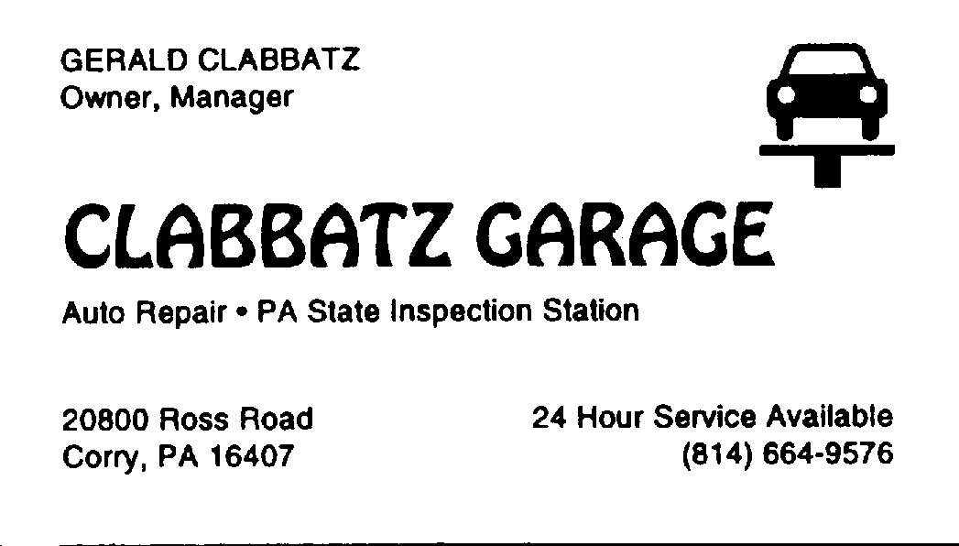
RAC COMMUNICATES FOR THE
TITUSVILLE OIL FESTIVAL '96 PARADE

The Radio Amateurs of Corry were well received at the parade as we did the radio communications for this annual event. I want to thank all the amateur radio operators who participated in this event, including the co-operation from the parade committee and participants, and a good job done by all.

Thanks to the following amateurs radio operators who helped with communications: WA3HDK (Bob of Union City, PA, as net control); W3AGF (Cecil of Port Orange, FL); K3SBU (Bob of Erie, PA); N3VHV (Anne of Erie, PA); W3BZJ (Mac of Elgin, PA); N3MBR (Hugh of Rocky Grove, PA); N3QCR (Mary of Rocky Grove, PA); WT3O (Jim of Corry, PA) and myself N3GCY (Mike of Corry, PA).

Several things happened today at the parade in which the radio operators were able to correct. First, right from the start, I began my day at the horse staging area, getting there to find out, that somebody had forgot to send the judges or for that matter, to send anybody to the staging area. The problem was corrected. During the parade, the amateur radio operators were also able to initiate two 9-1-1 calls, due to minor injuries. The radio operators also aided in the set-up, and control of the flow of the parade.
73 Mike (N3GCY)
_______________________________________________________________

ALASKAN HAM FAMILY
BIKES THRU STATES

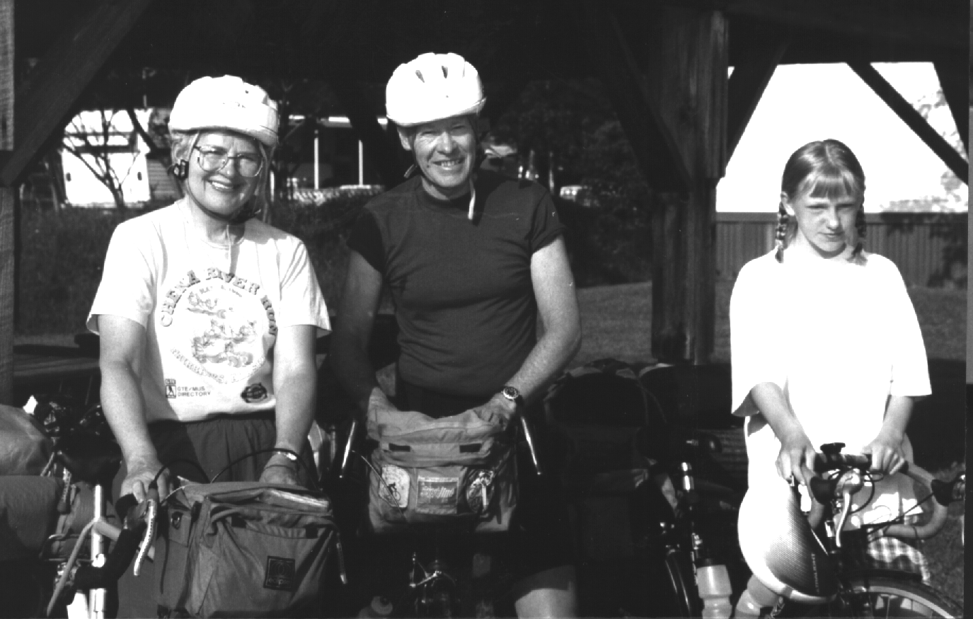

An Alaskan ham family recently toured through Corry on their way coast to coast through the US. The unusual thing about the tour, though, was that they were "pedal powered." Dave DeVoe, WL7CRD, his wife Carol, WL7CRE of Fairbanks, were accompanied by their granddaughter, Gina Baker.

I met the DeVoes after they checked into our Thursday 2M net. They camped overnite at the Harecreek campgrounds. Since they were tenting, I took their handheld and recharged the batteries overnite. The following morning I got up way before my heart got started and accompanied them through the boro, ate breakfast with them along the way, and bid them ado on route 77 near AB3X's QTH. Later they met Bernie Fuller, N3EFN somewhere near Cambridge Springs.

The pair was licensed only in January and were enjoying their newly acquired privileges. The couple have three daughters, who are all married, and three granddaughters. They live in a remote area near Fairbanks that has no phone and no electricity.

This is not their first experience with bike touring, but it is their longest one. They once toured from Colorado to Oregon. They also toured western Europe prior to 1976. Dave points out that you really get to know the country when you pedal thorough it. Best wishes Dave, Carol and Gina.
AB3X WINS DUARD MAY AWARD

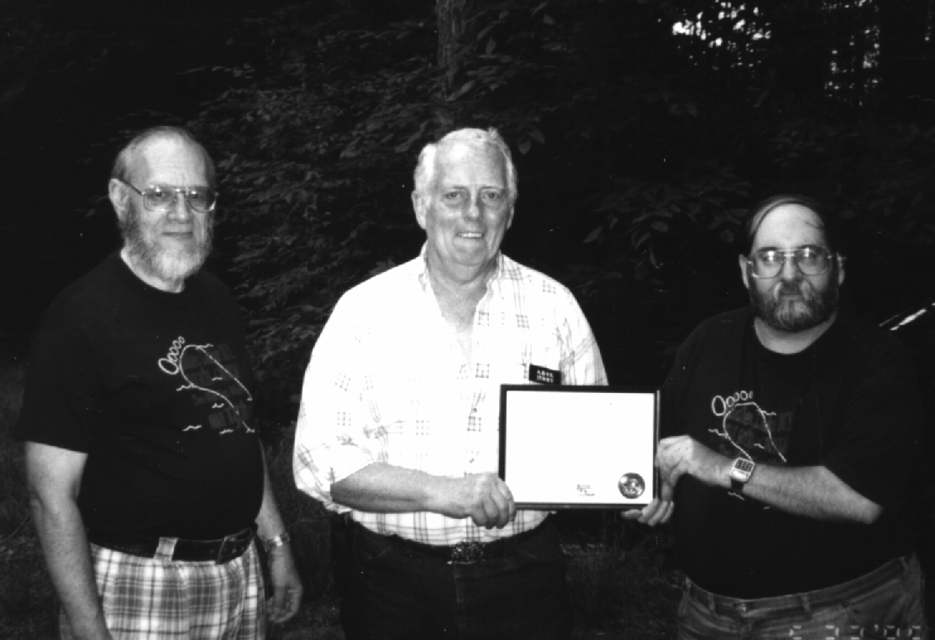
Vice President Bob WA3HDK looks on as FD Chairman Lee WA3HJC presents the Duard May Award to Jerry AB3X

A short presentation ceremony at the RAC 1996 Field day site surprised Jerry Owens, AB3X with the presentation of the Duard May Award.

Jerry was first licensed in 1959 and was extremely active in club activities. He is a member and past officer of the QCWA. He has also held office in the RAC. He has two grown children--Larry and Sue--and 6 grandchildren. Jerry was employed by Corry-Jamestown before they closed. He is presently employed by Troyer Potato Products as a truck driver.

The Duard May Award is funded by Dick Drace, K3AQR as a memorial and tribute to his elmer and long-time friend. The criteria for selection as set out by the sponsor of the award is: The recipient should be a current and long-standing member of the club who has made significant contributions to the club and to the ham community. The selection committee is chosen from the club roster and consistent of knowledgeable and informed individuals. This selection committee, which was appointed by president Frank Cutshaw, KE3PD consisted of Ron Munn, N8BQG; John Payer, KA3WUM; Bruce Burr, KA3JVO; Bob Bair, WA3HDK and Craig Hill, K3PLV.

Starting this year, the award will be given at the annual Christmas party.


PRESIDENT'S CORNER

Here we are to September already and that word "FALL." Anyway, we can look forward to next summer already!

Thanks for the nice turnouts for our summer meetings, field day, Findley Lake foot races, and Titusville parade. Welcome to our new members. Congratulations to all of those of you who upgraded. Thanks, too to those of you who are about to participate in the Boy Scout JOTA coming up in October.

We all are facing some rough times in amateur radio with the big maneuvers going on by many firms to get more frequencies for paging, satellites and business bands. Keep up your letters to our governing agencies, to let them know you are aware of what's going on.

So, to all, lets have a big season We need your help to have programs for future meetings, and we need people to assist in programs to our new members, don't be afraid to get involved. You are just as much a part of the club as anyone is.

Thanks for asking about the XYL, Dorothy. She should be on the mend by the time this newsletter gets out. She appreciates your concern. . . . 73's
--Frank, KE3PD.

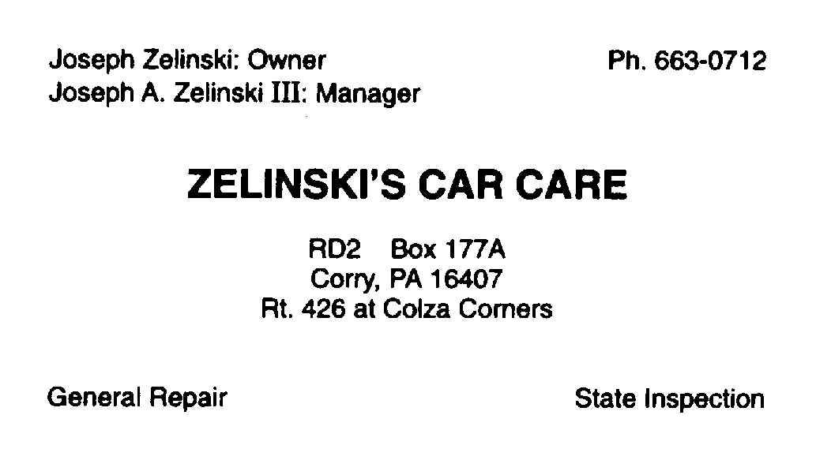
EDITOR'S TID BITS

On Saturday, August 24, volunteers replaced the lower set of guy wires at the repeater site. Materials for the party were donated by local businesses. Jerry Owens, AB3X and Hal Cole, WD4OOX performed the climbing duties. The ground crew consisted of Jim Adams, WT3O: Don Swarm , N3TYF; Mike Dziubkowski, N3GCY; Lee Robinson, WA3HJC; Cecil Messinger, W3AGF; Leonard Shick, WB3AYW and Bob Bair, WA3HDK.
* * *
The 444.80 repeater was off the air for a few weeks due to a failure of the audio/squelch board. It will be back on the air by the time this issue is published. We are sorry for the outage--but this happens once in a while. Murphy never takes a holiday!
* * *
(Continued on page 6)
The 147.09 repeater suffered an outage on Monday, August 26. Early that morning the squelch opened and the repeater timed out. It was after nineteen hundred hours before WA3HDK and N3UBZ could make the trip to the repeater site and effect repairs.


* * *
Volunteers replaced the coax on the Red Cross CB radio in early August. For some unknown reason someone cut the cable and
the station had been of the air for some time. The crew making the repairs included Quentin McCray, W3AHH: Cecil Messsinger W3AGF; Jim Adams, WT3O and Bob Bair, WA3HDK. Red Cross representative, Danielle sent a thank you card (which was entered into the minutes) to the club.
* * *

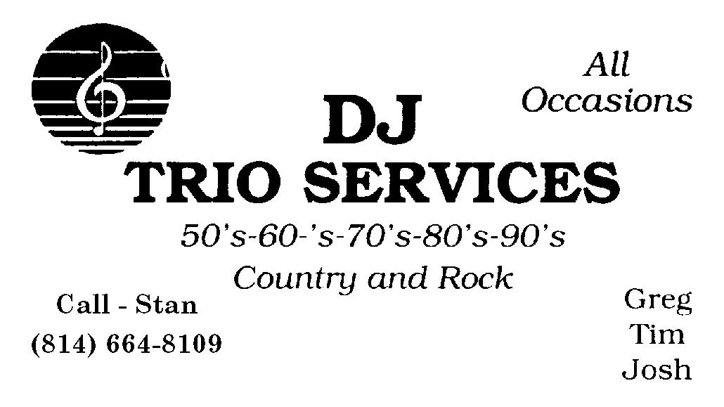

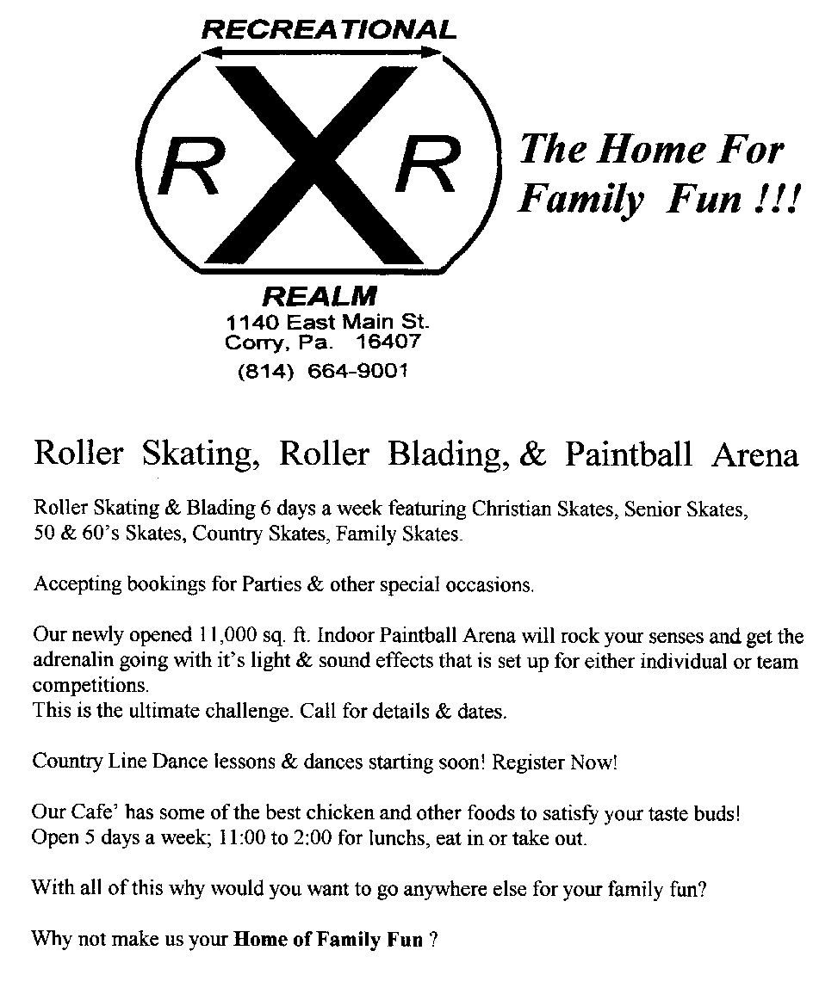

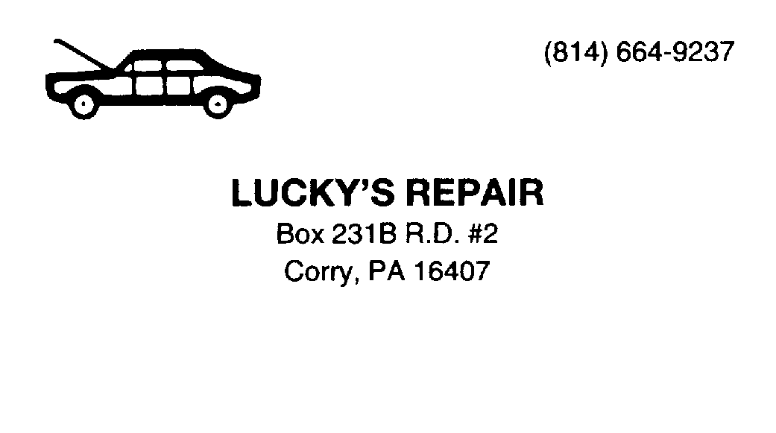

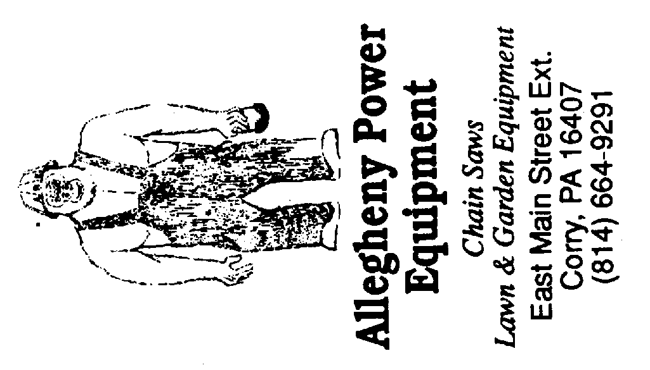

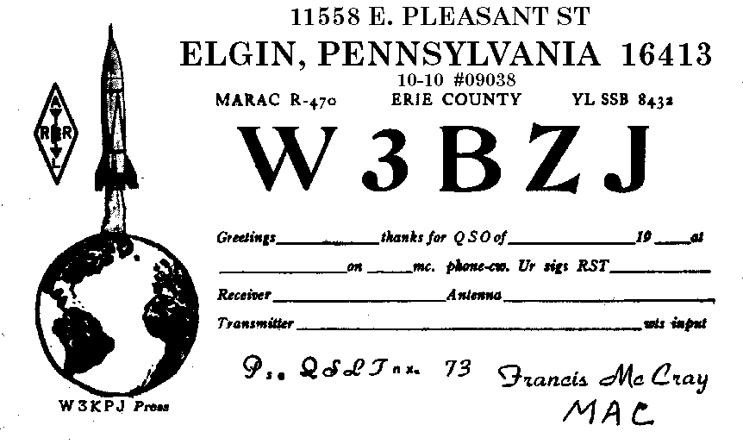
QUENTIN MC CRAY, W3AHH

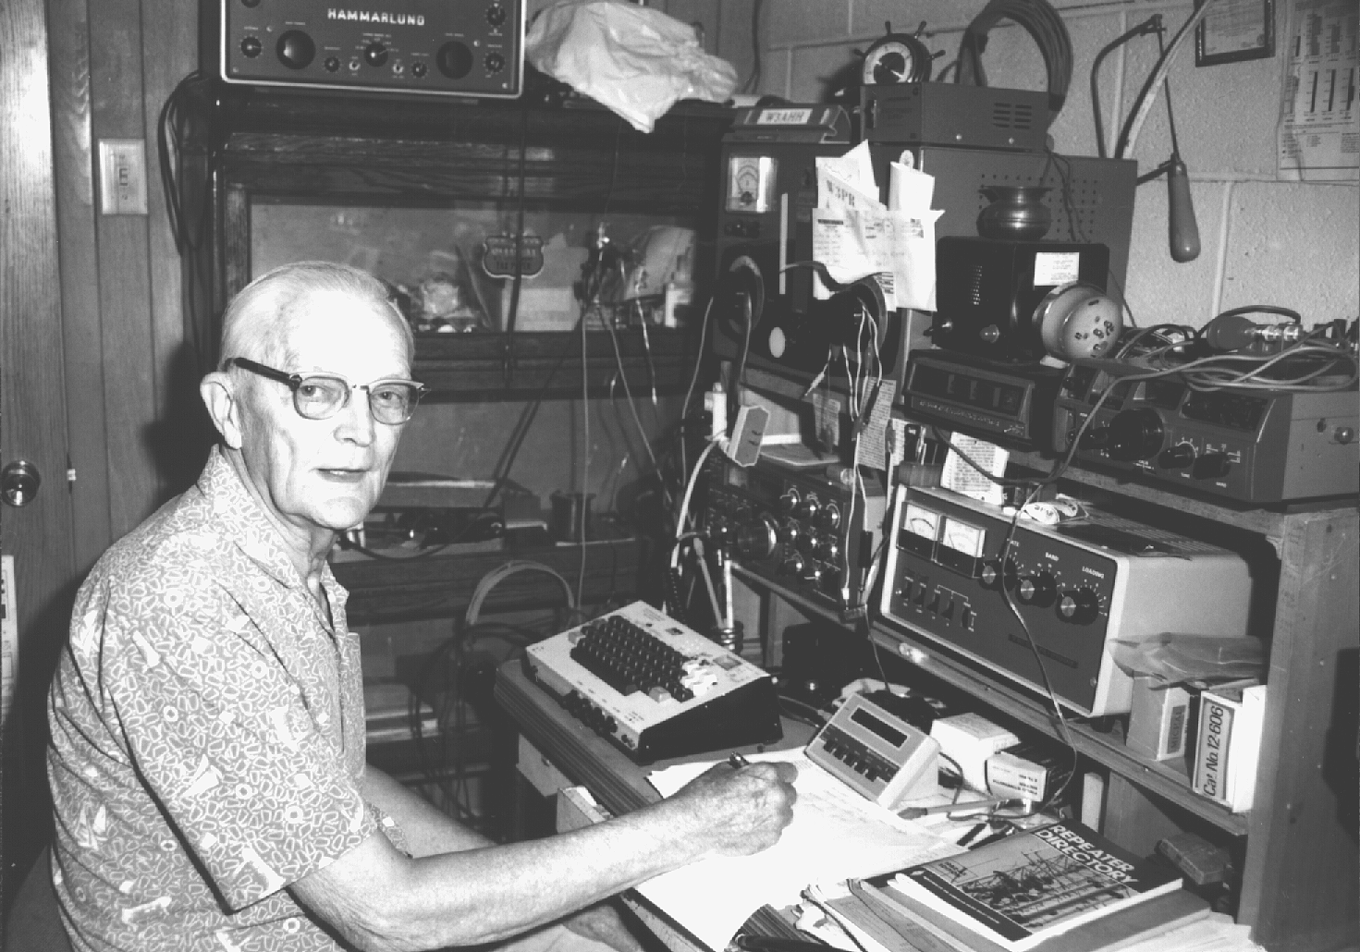

A club member since the early 1950's, Quentin McCray, W3AHH. is one of the old timers in our hobby. His gentle manner and willingness to help have made him stand tall in our eyes. And stand tall he is--all 6 feet 3 inches of him.

Quentin has worked in many fields of endeavor. His first job was as a drill press and punch press operator at Precision Products Company. One of his remembrances of that job was that the floor around the machines was covered with sawdust so that the tobacco chewers could spit on the floor.

Remembering the stories his uncle told about his experiences in WWI convinced Quentin that he should join the U. S. Navy. That was in 1941. That decision caused him to be in Pearl Harbor that fateful day when the Japs bombed the installation. He was radioman on the U.S.S. Sumner. The Sumner was a coast and geodetic survey ship that surveyed and made nautical charts of the 31 islands in the Pacific which were at that time uncharted or had obsolete charts. During the war, some of the Sumner's duties included blasting wider access entrance channels. Often they would follow the mariens into such places as Guadalcanal, Tarawa, and Iwo Jima.

After the war Quentin attended Oregon State and Penn State Colleges. He also worked as a Western Union operator and Manager. Two of the interesting jobs he held was at the U. S. Weather Bureau as an Observer, and as a radio operator at Civil Aeronautics Administration installation at Pescadero, California.

The C. A. A. installation covered 232 acres on a hill top overlooking the Pacific Ocean. There short-wave signals from Hawaii were converted to FM and relayed to the SanFrancisco airport. When the Eisenhower administration cut back on jobs, he was transferred to a job installing new radio equipment in airport control towers in the eastern U. S. He says that he got tired of sleeping in motels and eating in restaurants and returned to Corry where he went into business with his father-in-law raising turkeys.

He got a job with Raymond Spring Company where he worked over the years as a painter, trucker, tool crib man, assistant metallurgist, estimator and inspector. He retired from Raymond's and took up the hobby of flying ultralight aircraft.

Quentin lives east of Corry with Bertha his wife of 47 years. The couple have six children and nine grandchildren. His pristine grounds has room for a nice vegetable garden and a blueberry patch from which he sells to the public. He says the crop this year has not been good.

His shack, in the basement, is small but it is jam packed with goodies. Some of the equipment you find there is a Kenwood TS 530S transceiver for 10M through 80M, a YAESU FL 2100B power amplifier and a Johnson Viking antenna tuner. He uses an inverted vee antenna for 80M/40M and a vertical antenna for 10M/15M/20M. On 2M he uses an ICOM IC-290A and a beam antenna. He also has a YAESU FT-7 transceiver and an old 23 channel CB radio. You will also find an MFJ Super Keyboard and a KANATRONICS Mini-Reader on his desk.

Quentin has been licensed since 1950. His first call, from Arizona, was W7SVR. At one time, he also held a MARS license. His favorite band is 10M (although the sunspot cycle has diminished its use) and he likes CW. The WPA CW traffic net on 3.585 Mhz is one of his favorite hangouts.

He is a member of the American Red Cross where he serves as liaison for the club. He is also a life member of the VFW.

The Radio Amateurs of Corry salute you, Quentin, and wish you many more years of happy hamming.

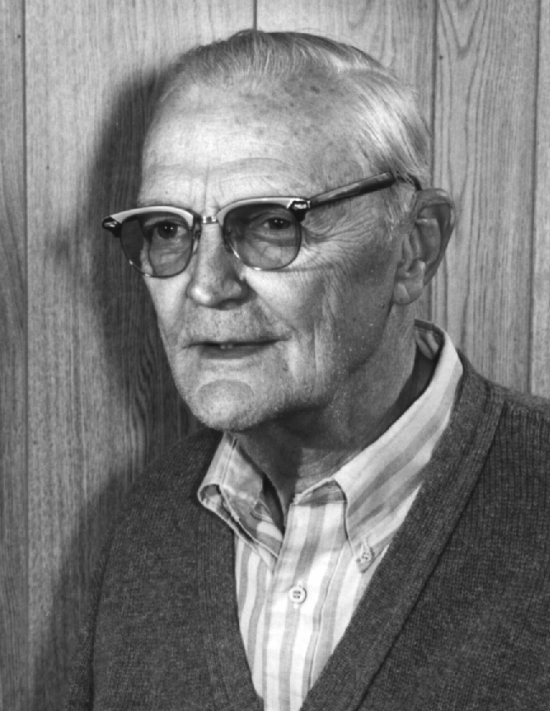

This page for two meter band plan--supplied by N3GCY

REPEATER CODES YOU CAN USE

Three control codes you may want to remember for the 2M repeater are:
*01 turns the PL OFF
*21 turns the PL ON
Press the 1 key to reset the timer
(your signal must be strong enough
to capture the timed-out signal)

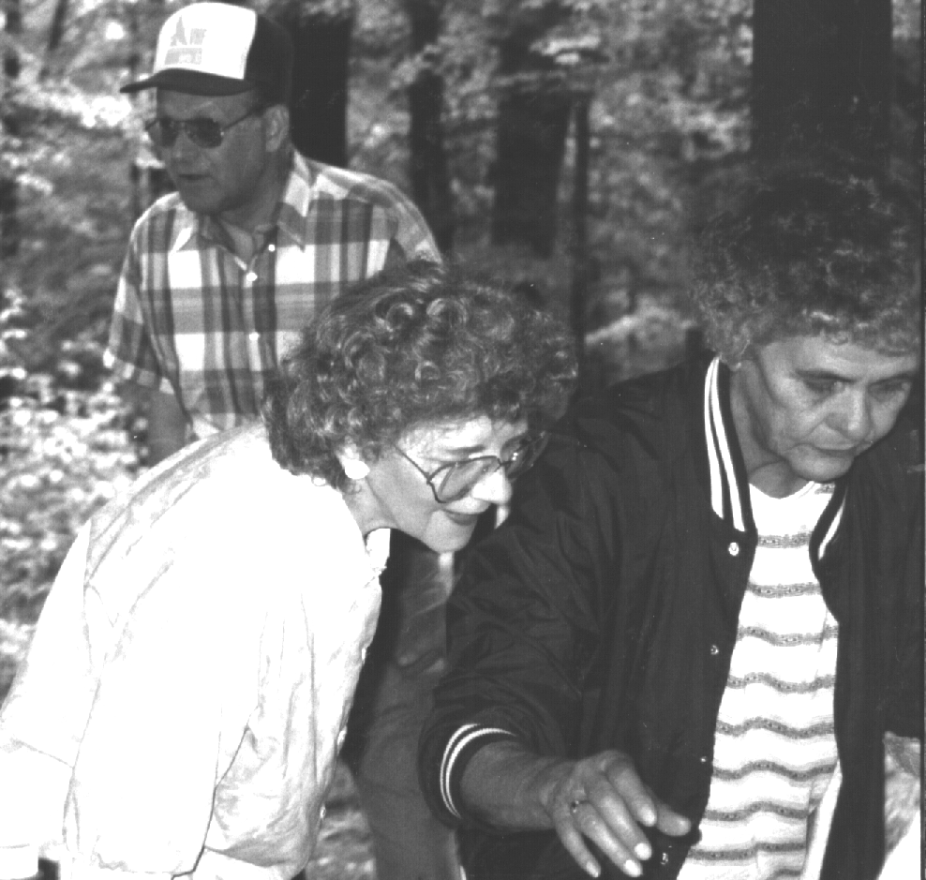
Summer Picnic goers are Norma, Q3CG, Doris (XYL of KD3II). WT3O in the background

RAC NET STATISTICS

I have been keeping track of the check-ins on both local nets. I'll bring the full print out to the Christmas Party and pass it around so that you can compare your activity with that of others. In the meantime, here is a summary of what the computer has to say:

10M net 2M net
Number of nets this year 30 37
Total number of check-ins 221 501
Largest net size 15 20
Smallest net size 3 3
Average net size 7.4 13.5
Perfect attendance N3UBZ N3UBZ
W3BZJ

The 10M net meets Tuesdays (except on Club Meeting Nites) on 28.330 Mhz at 20:00 hours local time. The 2M net meets on Thursdays on the 149.09 repeater (no PL tones necessary) at 20:00 hours local time. Why don't you plan to join us for the nets. You are more than welcome!

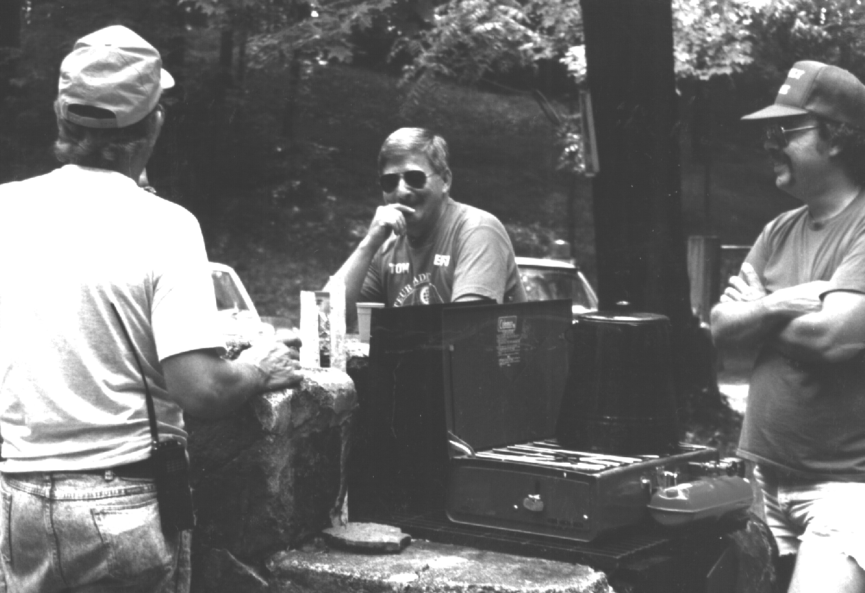
Field Day. Tom, AA3G and Mike, M3MLY. Photo by KD3II
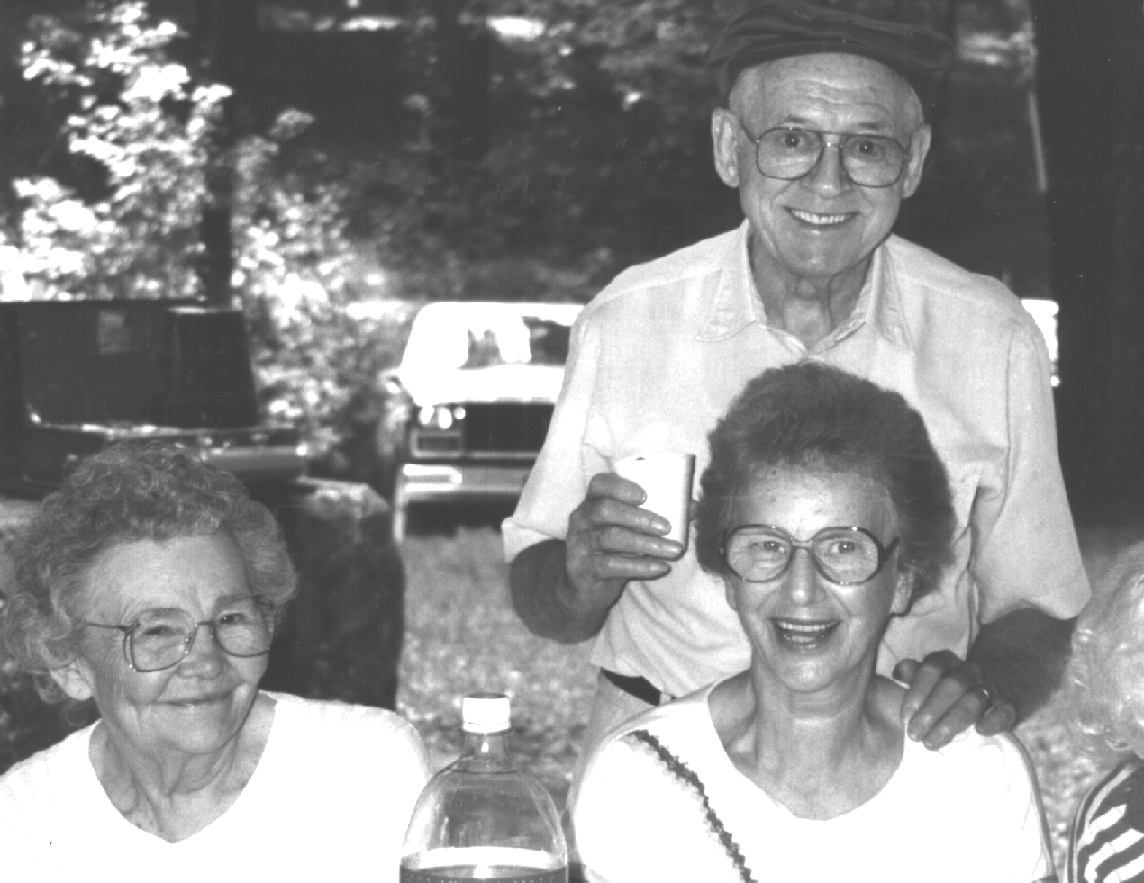
More Summer picnic. Agnes (xyl of W3BZJ), Cecil W3AGF and XYLGerta KD3II photo

Tid-Bits (continued from page 6)
The club is again conducting a 50-50 drawing to be pulled at the Christmas Party on December 9. If you can sell any of the tickets, please contact Jim Adams, WT3O. The drawing is a significant source of income for us. Last year's activity netted us nearly $150. High salesman last year was Leonard, WB3AYW.
* * *
The Christmas Party is scheduled for Monday December 9 at the Dutch Treat Restaurant in Spartansburg. The menu will be Swiss Steak and Turkey. Cost is $10.50 which includes your beverage , desert and tip. The restaurant is on the "main drag" in the center of town . You can't miss it. Call any of the club officers or party chairman, Will Cook, KD3II to confirm your attendance. (We need to give them an estimate of how many are attending.) We can handle a small error in reporting this number so those of you procrastinators who just didn't get around to calling can still sneak in.

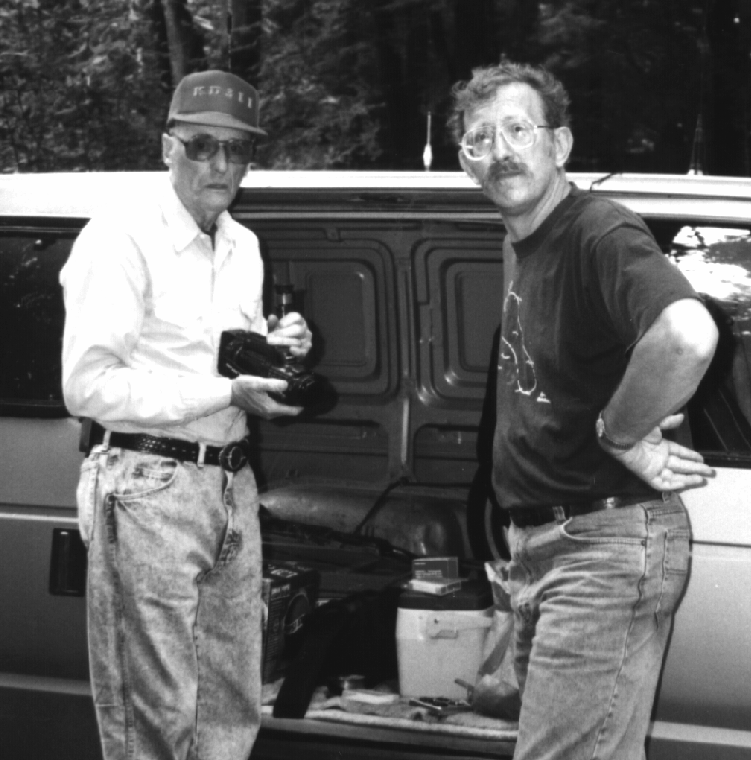
Will Cook, KD3II and Ron Ploss, N3KLN at the picnic Photo by W3CG

* * *
By the time this newsletter reaches you, Dorothy Cutshaw, wife of president Frank Cutshaw, KE3PD should be recuperating at home from surgery performed at Roswell Cancer Center. Get well soon Dorothy!

The RADIO AMATEURS OF CORRY
P. O. Box 362
Corry, PA 16407

This newsletter is published quarterly

Editor, Robert E. Bair, W3HDK
Staff--Don Swarm, N3TYF
Jim Adams, WT30

Submit material for the next issue on/or
before November 16. Next issue is Dec. 9

Coming Attractions:

Oct. 12-13 PA QSO Party
Oct 19 JOTA at Elgin Park
Nov. 3 Breakfast Fund-raiser at
VFW (help is needed)
Nov. 16 Deadline for articles for next
newsletter
Dec. 9 Christmas Banquet 6:30 p.m.
at Dutch Treat - Spartansburg

Club Officers--
President: Frank Cutshaw, KE3PD (663-0754)
Vice President: Bob Bair, WA3HDK (739-2206)
Sec./Treas.: Norma Vanderhoff, W3CG (665-9124)

