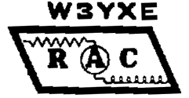
 RADIO AMATEURS OF CORRY
VOLUME 2, No.2 JUNE 1996

I ENJOY DXING
By Craig Hill K3PLV

I have been licensed since 1960. DXing had always held a fascination for me, but I never really got serious about it. I put up a log periodic, distributed by Sommer, around 1987. In 1989 the DX bug infected me. At that time, I interfaced my computer to my main transceiver (a Kenwood TS-440S), and began to keep records of the DX stations I had contacts with. I found that DXing had changed quite a bit since my early days of amateur radio. There were now DX nets in which the net control brought stations on frequency, then took a list, and the DX stations would work the list stations in turn. I found countries that once were extremely rare were now reasonably common place. By 1990, I was close to 300 countries worked, and most of these were with 100 watts, although I had an old Heath SB-220 amplifier when pileups got
thick and heavy. __________________________________________________________________________________________________________________

I also found that some of the rarer DX only seemed to be in the amateur extra band segments, especially on CW. Although I said I would never upgrade after the ARRL forced incentive licensing, I swallowed my pride and took the test. When I had worked all of the DX available without waiting for a DX-pedition to show up, I decided to work at least 100 DXCC countries on every band that I operate. Although I always thought it would be extremely difficult to work DX on 80 meters, I found that by using an inverted vee at a top height of 30 feet, it was possible to work the 100 countries that I wanted without much difficulty. In 1994, I began to think about 160 meters and put up one half of an inverted vee at 30 feet using the tower as the other half. I found it to be a challenge, as my amplifier would not go down to 160, and my antenna was very minimal. However, it was possible, and in two seasons I am up to 51 countries worked and am in the process of building a one band amplifier for next season.

I am now up to 319 countries worked and 318 confirmed on the current list, along with a number of deleted countries. I have worked 200 or more countries on all bands except 80 and 160 meters. I do not use the DX nets, but, I do not look down my nose at those who do. I bought a Yaesu FT-900 transceiver for my main station and recently (middle of January) an Icom IC-706 that I put in my truck. For those who think it is hard to work DX, I have worked about 30 countries running mobile on my way home from work (25 minute drive), mostly on 20 meters. I also do some satellite operation (mostly RS-12), and have worked many European, African, and South American stations using this satellite. I also have plans to use the IC-706 to work through RS-15 in the future. If any of this interests you, give it a try. You will soon learn many operating techniques to work new ones. Also the sunspot cycle has nowhere to go but up, so conditions will be getting better and better. Try it and see if the DX bug bites you also. 73
___________________________________________

REMEMBER THE TUESDAY 2-METER NET AT
8:00 P.M--147.09 REPEATER 123 PL

MANY NEW HAMS IN SW ERIE COUNTY
Over the past few months, several new ham licenses have been earned by local folks. If you hear the newcomers on the repeater, it would be friendly to say hello and welcome them into the ham fraternity. Here is the list of those I know about: Thanks to Norma, W3CG and Gary, N3WNP for most of the information.
KB3BNC Beth N3XFQ Patty
N3WNB Tim N3XFR Marion
N3WNP Gary N3XFS Cory
N3WNQ Jim N3XFT Gayle
N3WNS Joanna N3XFV Russell
N3WRS Joe N3XFW Matt
N3WXM Ed N3XFX Greg
N3WXN Denise N3XGA Hope
N3XBA Ed
_______________________________________________________________________________________________________________________________

"QSL OK VIA BURO"
by Bob Swarm N3UDR

Last Saturday I hung up my first batch of DX QSL cards on the ham shack wall. It sure looked good to look up and see FR's, DL's, LU's ON's and XE's decorating my walls. These were my first returns after a year of working CW on 40 and 15 meters and SSB on 10 meters. I've sent out over one hundred QSL's to stations outside the United States in the last year. Only one of them, to my friend Cecil in Capetown, South Africa, was sent direct. Since the only way to get mail to overseas locations nowadays is via airmail, the South African card cost me 60 cents. I checked at the post office and found it would cost 60 cents for postage to Europe and South America too. Now let me see, if I remember right, 60 cents times over 100 cards is more than $60 and that's not counting the cost of envelopes and the wear and tear of addressing them. A ham who likes to work DX could soon go broke, especially if he or she were to start operating in the real DX world of the 30, 20, and 17 meter bands where you can rack up 30 or more DX contacts on a
(Continued On Page 2)
weekend, and more in contests. Well, relax. There is a way to keep the cost of postage from eating up the saving you have squirreled away to buy that new Ten-Tec.
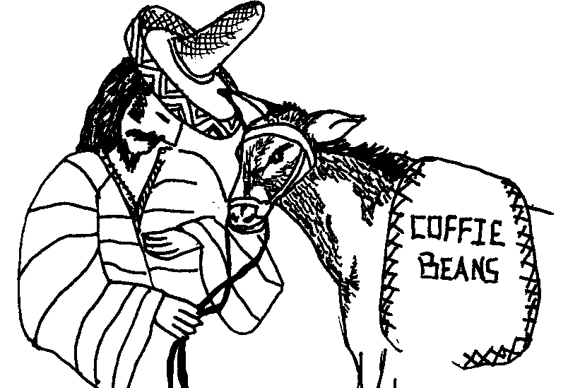

I kept hearing the phrase "QSL OK VIA BURO" sent near the end of almost all DX QSO's. The phrase was used by both US and foreign stations. This is also true of most foreign countries. I am a member of the ARRL and know that we have an outgoing QSL bureau available to all members. I dug out my introductory packet from the ARRL and read up on it. It sounded great, but was rather vague on how to go about using the service. One day someone told me K3HWL, Bob, in Titusville was a big time DX buff. I didn't waste much time getting in touch with him. Being a good Elmer and a FB Ham, he led me step-by-step through the procedure of using both the outgoing and incoming services. Here is what I learned:

Outgoing Service

1. Presort your DX QSL cards alphabetically by call-sign prefix (AP, C6, DL, F, JA, and so on). Addresses are not necessary. Do not use separators such as slips of paper, paper clips, rubber bands or envelopes between countries.

2. Enclose the address label (or a Xerox copy of the label) from your latest issue of QST. A copy of your ARRL membership card will also do.

3. Enclose payment of $3.00 per each pound or portion thereof. Approximately 150 cards weigh one pound. A package of ten cards or less costs only $1.00. This is the way to go for the casual or beginning DX operator as it gets your cards into circulation quicker than waiting until you accumulate 150 cards. Pay by check or money order and write your call on the check.

4. Include only the cards, check, and address label in the package. Wrap the package securely and address it to the ARRL Outgoing QSL Service, 225 Main Street, Newington CT 06111.

There are about twenty countries that are not served by the bureau. to get a list of these, request form MCS-235 from the ARRL.

Incoming Service

Most countries have outgoing bureaus that operate much like the ARRL Outgoing Service. Cards are packaged and shipped bulk to incoming QSL bureaus in the appropriate countries. Most DX QSL's are sent directly to the incoming bureau for the individual call districts in the United States. In other words cards to W3 K3, A3, or N3 will be shipped from the country of origin directly to the third district call area incoming QSL bureau which is the Pennsylvania DX Association in York Haven, PA. AR
To claim your QSLs, send two or three 5 x 71/2 or 6 x 9 inch self addressed, stamped envelopes (SASE) with you call printed neatly in the upper left hand corner of the envelope to the following address:

The Pennsylvania DX Association
PO Box 100
York Haven, PA 17370-0100

A suggested way to send envelopes is to affix a first class postage stamp to the envelope and clip extra postage to the envelope. Then if you receive more than one ounce of cards, they may be sent in a single package.

Good cooperation between the DXer and the bureau is important to ensure a smooth flow of cards. Remember that the people working in the bureau are volunteers. They provide you with a valuable service. With this in mind, pay close attention to the following DOs and DONT's:

DO

1. Do keep self addressed stamped envelopes as described above on file at the bureau.

2. Do send the bureau enough postage to cover envelopes on file and take care of any postage increases.

3. Do respond quickly to any bureau requests for SASEs, stamps or money. Unclaimed card backlogs are the bureau's biggest problem.

4. Do notify the bureau of any changes in call sign or address. send SASEs with new call sign and address as soon as possible.

5. Do include a SASE with any information request to the bureau.

6. Notify the bureau in writing if you don't want your cards.

DON'T

1. Don't send domestic (US to US) cards to the bureau.

2. Don't expect DX cards to arrive for several months after the contact. Some countries only mail out cards once a year. Overseas mail is very slow.

3. Don't send your outgoing DX QSL cards to the incoming bureau. Send them to the ARRL as described above.

4. Don't send SASEs to your portable bureau. In other words, when operating as AA3XX/4, send the SASEs to the three call area bureau.

5. Don't send SASEs to the ARRL outgoing service.

6. Don't send SASEs larger than 6 x 9 inches. They require extra postage and do not fit in the incoming bureaus file drawers.

Now that you know how to handle DX QSL cards, go ahead and have a ball working all the DX you can get. 73
AMTRAK MOBILE
By Bill Young W7RVY

It has always been a hope of mine to do some real different mobiling. I have been mobile on six meter AM and on HF SSB mobile. I have had 2 meters on my own boat, been aeronautical mobile in a small plane during a search for a lost child, and on both small and large commercial aircraft. I have even been mobile in a hot air balloon, but until a few years ago I had not been mobile on a train.

About 12 years ago I traveled by train from Flagstaff, Arizona to Seattle Washington. I took along a hand held and made a grand total of one contact while passing through Oakland California. And the guy didn't believe I was on a train!

I just returned from a train trip to Washington state, and, of course, I took along a handheld with extra batteries. This time, I made some real neat contacts including one with real life and death implications. Here is how it worked.

Early in the morning of the second day of my trip, I had been trying to sleep spread out on two seats. My success was mixed. About 5:30 in the morning, I looked out the window at the passing landscape. I couldn't see much as there was a blizzard in progress. The wind was blowing snow across the tracks and the near-by interstate which goes across North Dakota. Suddenly, the train slowed to a stop, and the already subdued light dimmed even more with only the emergency lights working. The sound of the air conditioning stopped and it was very quiet.

Being aware of a car full of sleeping passengers, and a blizzard outside, I thought maybe a little outside help would be in order just about now. I turned on my HT and started looking for a repeater. Finding one which came in pretty strongly, I called CQ and indicated I needed help. I was answered immediately by a man near Fargo North Dakota who was on his way home after driving a truck all night.

I told him where I was, and that the train was stopped, and the power was off. He told me he knew about where we were, and that he would stand by 'til I determined if we needed help.

The Train Master came through the car quietly, using a special key that opened the doors of the car which usually work electrically. Upon telling him I had a man in Fargo on the air, he said to keep him on for a while in case they couldn't get things going. If he needed to do so, my ham friend could contact those who could help the train. My friend said OK, and promised he would wait for my call.

About 20 minutes later, the train master and the conductor came to tell me that they had things under control, but that the train would be about 3 hours late into Grand Forks. He asked if my friend could call Amtrak and inform them of the delay. The voice on the other side of the radio said he would make the call. He then said 73 and went inside because all this time he was in his truck in the driveway of his house.

For all those who don't know it, ham radio did it again. We were there, and we helped out--at least a little--to ease the minds of those waiting for the train in Grand Forks.

The moral of the story is, "never go anywhere without your handheld and a good battery."
PACKET RADIO IN THE EYES OF A NEWCOMER
By Gary Sarver N3WNP-

I recently acquired a PK-232 packet terminal node controller (TNC). I had only seen packet once before this, so I knew it was going to be an adventure for me.
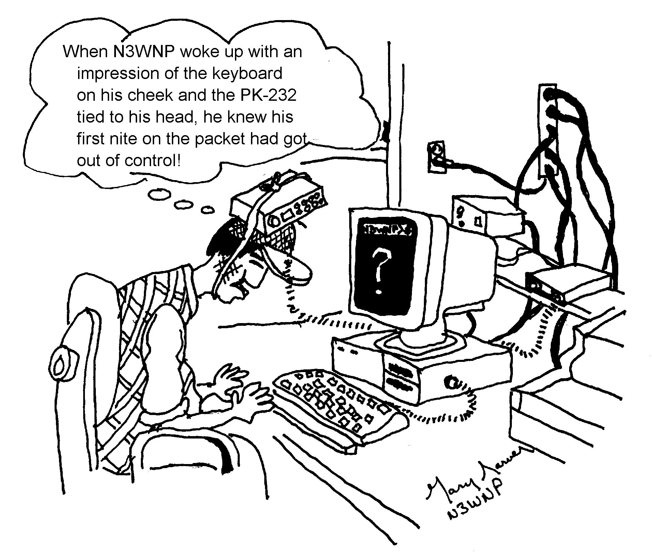
I guess the first week or so was the roughest. Learning all those commands and set-ups was a challenge. Reading the boards was fun. A few simple basics was plenty at first. Soon I was to embark on something I only heard about--packet contacts. I thought well maybe I would get a few contacts and that would be nice, so I sent out a CQ. The response was phenomenal to say the least. Every day I get some messages. Be very prepared when you send out a CQ.

Like anything; its a learning process but the rewards are priceless! I thank all those who have helped me learn something about packet and guided me through some of the rough areas. Thanks to those who are patient, kind and understanding to the new ham.

And so in closing, I'm sending this article to WA3HDK's packet mailbox. Instantly it was received in the newsletter editor's system. No stamps, no hand delivery--it's there! Packet radio, a wonderful new world. I love it!
_________________________________________________________________________________________________________________________________

AN XYL SPEAKS . . .AGAIN
by Patty Sarver N3XFQ

Welcome to all new hams . . .We're proud to have our licenses, thankful to pass the test. We still have the jitters--a tad--when it comes to talking on the radio but we'll get over that. We still have a lot to learn too, but we've only been into amateur radio for a short time. I have a tendency to get either long winded or tongue tied. There seems to be no middle ground.--I recall my hubby's first contact with W3TO very well. N3WNP sat on our deck (no enclosure) in the dead of winter with his portable Radio Shack 2 meter with rubber duckie. He froze his bum off, but for a man who loves radio as passionately as Gary does, it was worth it. Since then he stays indoors and runs his 2 meter Radio shack mobile, Ringo Ranger II antenna and a PK 232 for
(Continued on Page 4)
packet. He had a hand with that one from the "pacman" himself, Bob WA3HDK Bair. Lately N3TYF Don Swarm has been giving N3WNP a few lessons. Thanks to both! Now Gary is just trying to keep up with all his QSL's. The farthest contacts he has made so far are Washington State and Manitoba, Canada. He's having a ball with it. There are so many areas of interest in amateur radio. I'm sure all the new hams will find their niche. Could any of us have imagined even a couple years ago we'd be talking on 2 meters? I'm going to buy some letters and numbers and put "N3WNP" and "N3XFQ" on the front of our trailer right by our address. Sometime I have to get serious about taking the dreaded code. There is a general class license just waiting to be had! The tech test was a breeze. The novice exam was a little tricky. Wasn't this supposed to be the other way around?? Thanks to my hero, Gordon West for making it simple for me. I'll definitely be using his book to study for general. I was thinking (it can happen) there are a few things in life I would like to accomplish before I hit the QTH on the other side:

1. Get N3WNP to admit that I'm right about 90% of the time.

2. Have a little N3WNP running around, God willing of course.

3. Paint a few hundred statues. It's Sooooo relaxing and when the work is finished it is a feeling that is very satisfying. Nothing like it, not even radio. Sorry Gordy.

4. Get general class license and pass 13 wpm code. It may take an eternity to pass code!

5. Live long enough to see N3WNP bring home my statue of St. Francis of Assisi. We have enough antennas. Gorton West is great but Francis is one of my real heroes. If there ever is a little Sarver his middle name is Francis.

6. Gary finally gets my call sign down pat.

7. N3WNP and I take that honeymoon to South Dakota. We were going to visit St. Joseph's Indian School out in South Dakota after we got hitched in King sport, Tennessee. We had just enough gas to make it back to Corry. Lucky we made it back at all. It cost us more than we figured (how everything goes) and we traveled with no spare tire.

8. Gary gets the computer of his dreams and I get my own radio. Then you can run packet all you want dear.

9. Gary gets the big one and doesn't have to fabricate a story or keep playing bass tournament on the computer.

10. Convince N3XFR and N3XGA they can take over the control point--at least for one day.

11. I spend my last day on earth bumble free and Gary can't believe it.

That's about a wrap. "Nobody gets to live life backward. Look ahead--that's where your future lies." to quote Ann Landers. Hope all your dreams come true and you accomplish all you desire. 73's to all, congrads to all the new hams--our friends especially--and all newcomers generally. "That's the story on that." Bob Bair--thanks Bob, you were my first QSO! 88's to N3WNP de N3XFQ.
The Sky Is Falling! ...Or Is It?
by Bruce Burr, KA3JVO

Ever since the devastating tornado of May 31, 1985, many local residents become anxious when the skies turn dark in the spring and summer. The lusty crash of thunder still sends some folks diving under their beds. The sky is falling! . . . or is it?

Because we live in an area that has volatile weather, we need to have sufficient information about these storms. But unlike Chicken Little, we really don't need to panic. Let's look at the statistics. Although tornadoes can occur any time of the year, the most active storm period in Pennsylvania is from May through July. In an average year, our state has two tornadoes for every 10,000 square miles, or nearly ten every season. Each year tornadoes kill about 2 people in Pennsylvania. Oddly enough more people are killed by flash floods and lightning than by tornadoes. Just the same, how can you be best prepared for severe weather and what should you look for?

First, be aware of the conditions which may cause severe weather to occur. Generally, when cold air from Canada and warm Gulf air collide, thunderstorms will occur. Be more vigilant during these extreme changes in temperature. Although some of these thunderstorms may be severe, remember that not all of them will be strong enough to have damaging effects. There are several good sources of information besides the morning weather report.

♦ The Weather Channel (19) provides both forecast details and severe weather bulletins.

♦ The Erie television stations display a "weather box" and run "crawlers" of information about storms during regular programming.

♦ Many radio stations participate in the Emergency Broadcast System and air appropriate information about severe weather events.

♦ The National Weather Service transmits weather data and severe weather statements on 162.40. You can program this into most scanners or 2 Meter radios.

♦ My most useful source of weather information is a tone-alert weather radio. Although I can listen to routine meteorological information broadcast on 162.40, the radio emits a siren-like yowl when the NWS issues a severe weather bulletin. So, for the most part, I can ignore the weather radio until it tells me that it's time to pay attention.

♦ You can monitor the Skywarn Net on 146.61. Often you can learn the location of severe weather events by listening to information being relayed by Skywarn Observers. They will pass on details about wind speed, hail size, rainfall rate, and the location of storm cells. Remember, this is a directed net. Don't break in unless you have something very important to report to the net control.

♦ Local Skywarn information is relayed to Cleveland NWS on 6 Meters. You can probably monitor this information and
(Continued on Page 5)
Cleveland's responses on 52.680. Again, this is a directed net and you should not break in.

What does it mean when the National Weather Service does issue a severe weather statement? A Watch means that conditions may be right for a particular event to happen. Remain alert. Monitor the weather and the various information sources. However, a Warning means that the event is happening in your area RIGHT NOW! This means you should be ready to seek shelter at a moment's notice. By the time you hear your local tornado siren, you should be in your shelter. Other signs to look for are:

♦ High winds. The winds that come from the leading edge of the storm (not the tornado itself--it will be closer to the trailing edge of the storm) can reach speeds of 50 to 100+ mph.

♦ Heavy rain. Rainfall may exceed 1 inch/hour.

♦ Large Hail. This could be 1/2 inch in diameter or larger.

♦ Observable cloud formations. Look for lowering of the main cloud body; wall clouds, funnel clouds, and tornadoes. Be aware that organized rotation or circular movement of these clouds can also be an indicator of storm strength and threat potential.

It's a good idea to have a pre-planned place to seek shelter from a storm. If you have a basement, go there. Although some people may tell you that the west wall is the safest place, it is best to get as much protection over your head as possible. Try to get under a sturdy workbench or set of steps. It may be a good idea to keep a flashlight, drinking water, and supply of your prescription medications in your shelter area. If you don't have a basement, go to the innermost room on your ground floor. This is usually a bathroom. Forget trying to open your windows before the storm. You'll just be wasting time. Get as far away from windows as possible. Most people are killed by flying debris.

If you are in a car or mobile home in the path of a tornado, exit them quickly. Move into any kind of ditch or depression in the ground. Get as low as possible and HANG ON! People in mobile homes and automobiles are at the highest risk for injury or death.

During this storm season we all need to be alert to the possibility of severe weather. Although you shouldn't worry needlessly, don't be unprepared either. Gather enough information from these sources to make wise decisions. Be ready to take shelter quickly and calmly when necessary.
______________________________________________________________________________________

DEAR R.A.C. MEMBERS:

The coordinator of the Findley Lake 10K walk asked me to say thanks to all who helped on Saturday May 11th. It wasn't a nice day but it was very gratifying to be able to partake in their event. Hope to see you at field day.
--73 Jim WT3O
RAC MINUTES
HELD AT CORRY RED CROSS
April 2, 1996

The meeting was called to order at 7:30 P.M. by President Frank Cutshaw KE3PD, with 16 members present.

Roll Call of Officers - all present.

Reading of the minutes of the last meeting and Treasurer's report were given by Norma W3CG.

Motion by Bill W7RVY, seconded by Lee WA3HJC to accept as read. Carried.

Old Business / New Business

Announced that picnic would be held on June 15 at Red Top Pavilion in Mead Park. Motion by Mac W3BZJ, seconded by Quentin W3AHH, that time be set for 12 noon. Carried.

Announced that license plate key chains had arrived, were delivered to those present who had ordered them and $2.50 collected for each. Total order was $45.00

Buckmaster Publishers of Hamcall CD ROM offer - A group club photo and 10 individual photos were requested in exchange for a free CD. Bob WA3HDK and Mike N3GCY volunteered to bring cameras to the May meeting and Bill W7RVY offered to develop the pictures. Bob WA3HDK volunteered to make consent forms on the computer.

Committee Reports

Repeater - meeting announced to be held next week.

Newsletter - Bob WA3HDK requested that a staff meeting be held on Wednesday, May 1, with May 15 to be the deadline for articles to be submitted.

Announcements

♦ Field Day Chairman - Lee WA3HJC.

♦ Picnic Chairman - Willis KD3II.

♦ Program Chairman - Bill W7RVY requested to be relieved of duty.

♦ Titusville Parade Chairman - Mike N3GCY and volunteers are requested for Saturday, August 17.

♦ Breakfast Chairman for June 9 at VFW - Leonard WB3AYW. Volunteers for 6 A.M. - N3WNP, KE3PD, WD400X, KD3lI, N3TYF, W3CG. Volunteers for 9 A.M. - N3WNP, KE3PD, WA3HDK, N3GCY, WT30.

♦ May Meeting Refreshment Chairman - Gary N3WNP.

♦ Findley Lake 10K Race - request by Kay Cooper for club to furnish communications on Saturday, May 11, with arrival time to be 8:30 A.M. at the latest, and Race to commence at 9 A.M. Jim WT30 to organize. Volunteers - W3BZJ,
(Continued on page 6)
KE3PD, WA3HDK, WB3AYW, N3TYF, N3WNP, N3GCY, W3CG, with W3AHH, WA3HJC and WD4OOX as possibilities.

♦ May Meeting Program - Rick Cutter WA3MKT of North East to be solicited by Leonard WB3AYW.

♦ Union City test session announced by Rob N3OCL. To be held on Thursday, April 11, at 7 P.M., in the Art Room of Union City Elementary School on Route 8. Raffle tickets are being sold with a choice of a Radio Shack 2M HT or 19" color TV, with the drawing to be held at the test site.

50/50 - $8.50, won by Don N3TYF

Motion to adjourn - Bill W7RVY - 8:15 P.M.

--Norma Vanderhoff W3CG, Sec/Treas
___________________________________________

146.70 IMPROVES ANTENNA SYSTEM
By Rob Jocobs N3OCL

On Sunday, May 5, a new antenna was reinstalled on the tower for the 146.70 Union City repeater. Doug, N3BDJ from Seneca and Roger, N3UDQ from North East along with other ground helpers participated in the installation. The Union City group wishes to give a special thanks to Doug and Roger for their help and donations towards the antenna project.

The new antenna is a Sinclair Channel Master installed approximately 185 feet up the WCTL Tower in Arbuckle. The repeater is now using 7/8-inch 75 Ohm hardline in place of the RG-9913 which was previously used. No changes were made to the repeater itself. Field testing has shown that the new antenna has made a significant difference in coverage for the repeater.

An exploratory repeater coverage net was held on Sunday evening at 7:30 to determine how well the repeater's coverage improved. In addition to local check-ins, a station from New Castle was heard. On Monday, May 6, a station from Ontario was worked.

Areas in the boro of Union City previously unworkable by handhelds is now fully covered. All of the Erie area is now accessible by mobiles which will be a great asset to those who wish to communicate with amateurs in Erie.

UCWA wishes to thank the following helpers who showed up to help in the antenna installation: Dave WX3E, Bob N3UDR, Matt N3XFW, Don N3TYF, Rob N3OCL and Joe N3WRS. Special thanks to a new member of the Club, Jim Edwards of Union City who was the other climber. Jim is currently studying for his Technician license.

The Union City Wireless Association will be making equipment changes to the repeater in the near future. When these changes are made, the PL will change from 123 Hz to 186.2 Hz. The repeater committee has chosen to make the 146.70 repeater a full-time PL repeater after the proposed equipment changes are made.
RAC MINUTES
CORRY RED CROSS BLDG.
May 7, 1996

The meeting was called to order at 7:30 P.M. by President Frank KE3PD with all officers and 26 members present. Business was temporarily suspended for a program presentation "Direct Digital Synthesis", by Rick Cutter WA3MKT of North East.

This was followed by a group picture taken by Bob Bair WA3HDK, who had also taken individual pictures earlier in the evening.

The business meeting took place at 8:45 P.M. The Secretary/Treasury report by Norma W3CG was accepted as read, with motion by Bill W7RVY, seconded by Mac W3BZJ , and carried.

Old Business

WA3HDK The newsletter is to be distributed at the June meeting. More pictures are welcome and deadline is May 15. Twenty-three pictures were taken for Buck Master Publisher and 7 more are needed.

KE3PD No report on Fly-In Breakfast, in regard to providing the communications.

WT3O Findley Lake 10K Race, scheduled for 9 A.M. on May 11. Volunteers are Bob Swarm N3UDR Bruce Burr KA3JVO, Don Swarm N3TYF, Francis McCray W3BZJ, Harold Cole WD4OOX, Gary Sarver N3WNP, Mike Dziubkowski N3GCY, Lee Robinson WA3HJC, Norma Vanderhoff W3CG, Frank Cutshaw KE3PD, and Bob Bair WA3HDK.

KE3PD Yard sale date is to be determined at June meeting.

KE3PD Program Chairman is needed.

Committee Reports

Repeater by KD3II - Some new guy wire and clamps are needed on the tower. The transistorized 440 repeater purchased from WB3AYW is now on the air, battery powered and running 26 watts into the transmission line.

W Pa. Repeater Council meeting by WA3HDK.

June Refreshments by WA3HDK - Patty N3XFQ and Gary Sarver N3WNP to serve.

An appreciation gift certificate of $20.00 for the Erie Waterfall Restaurant was presented to Rick Cutter WA3MKT for his excellent electronic presentation and demonstration.

Present was new member Russ Campbell KA3WNL of Franklin, Pa.. which brings our total membership to 68.

50/50 - $12.50 and won by Norma W3CG.

Motion to adjourn by WB3AYW. 9:18 P.M.

--Norma Vanderhoff W3CG, Sec/Treas.

_________________________________________________________________________________________________________________________
THE CLASSIFIEDS

FOR SALE: ICOM IC720 HF transceiver with PS20 power supply. Includes APPLE II+ computer with Microtronics RTTY interface. Dick WB3ETW. 868-9788.
_______________________________________________________________________________________________________________________________FOR SALE OR TRADE: APPLE IIC clone with green screen 12 inch monitor and some software. Bob WA3HDK. 739-2206.
_______________________________________________________________________________________________________________________________
FOR SALE. BSR Compact Disk Player (CD Music). Excellent Condition. Replaced with multi-disk player. Bob WA3HDK 739-2206.
_______________________________________________________________________________________________________________________________
FOR SALE. 50+ feet BELDEN 9913 coax with PL259's on each end, $20; ASTRON RS-12M power supply with meter, $65; 6-Meter HAMSTICK antenna 3/8-24 thread, $6; CUSHCRAFT AR-6 Ringo 6-Meter vertical (3 months old), $40; MIRAGE KP-1/6M GaSaFET preamp for 6-Meters FM/SSB, $95; Frank KE3PD 663-0754
_______________________________________________________________________________________________________________________________
FOR SALE. Lew McCoy book on antennas, $8; Five sets ARRL and Gordon West Morse Code Tapes 5 thru 22 wam, $10; RADIO SHACK 12 volt, 1.75 amp power supply catalog #22-127, $15; ICE Model 474 AC Surge Protector And Filter, New $45: COBRA Trap Shooter Radar Detector, $10. Frank KE3PD 663-0754
______________________________________________________________________________________

FIELD DAY IS JUNE 22-23
By Lee WA3HJC
Field Day Chairman

START TIME 1800 UTC SATURDAY, JUNE 22
END TIME 2100 UTC SUNDAY JUNE 23
LOCATION ELGIN COMMUNITY PARK

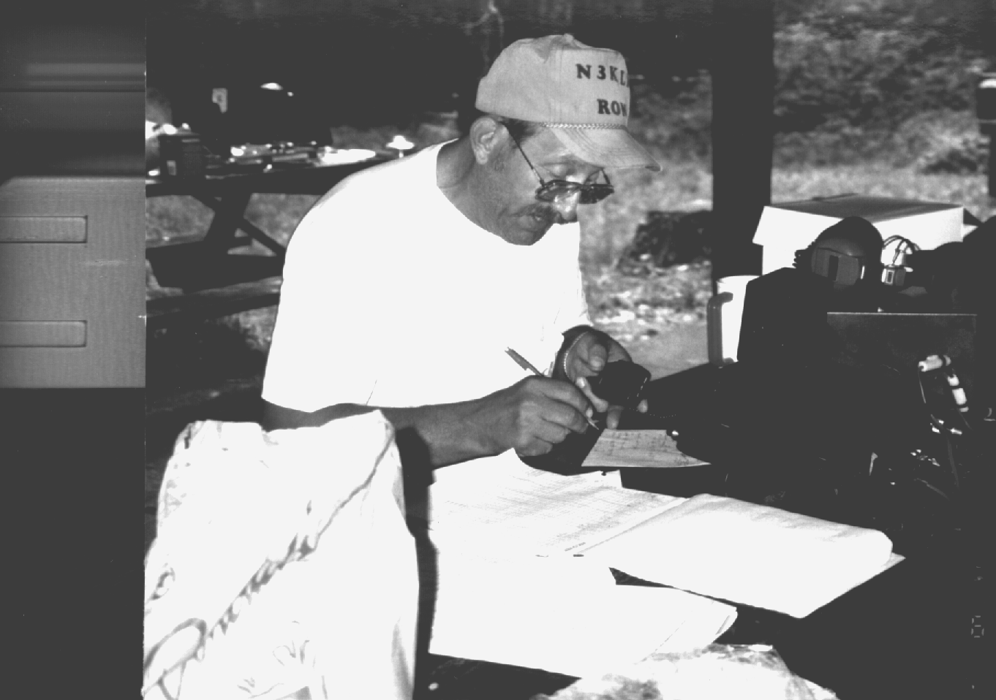

WANTED

Would you give $5 to help keep this newsletter coming regularly?
If you will contribute, we will put a boxed advertisement like
this one in our next issue. You can even include pictures, your QSL
card, or other art work in your ad. If you don't have any art work,
we will put our standard "COMPLIMENTS OF . . ." display ad
like we have in past issues. If you have any questions call Bob
WA3HDK at (814) 739-2206.
CQ FIELD DAY CQ FIELD DAY CQ FIELD DAY CQ FIELD DAY CQ FIELD DAY DE W3YXE W3YXE W3YXE. Ron, N3LKN operating voice at the 1995 Field Day. Photo by W3CG

Are you ready for the single most exciting Amateur Radio event of the year !!!! FIELD DAY !!!!!

We will begin setting up the antennas at 12 noon on Saturday and will serve lunch just before the contest starts at 2 PM. This year we will be operating on 80, 40, and 20, Meters for sure and 15 and 10 meters if band conditions allow. We also be using 6 meters and adding 2 meter CW/SSB this year. They still do not allow Field Day operations on the new WARC bands.

For the newcomers to Amateur Radio, Field Day was started as an emergency exercise simulating a widespread disaster when normal communications and electrical power are down and cannot be restored for over 24 hours. Within that 24 hour period we set up a " mock" command post in the field running as many amateur bands and modes on emergency generators as possible. Each Amateur Radio Operator is then encouraged to improve their operating skills and contact as many other amateur stations as possible in the same time period.

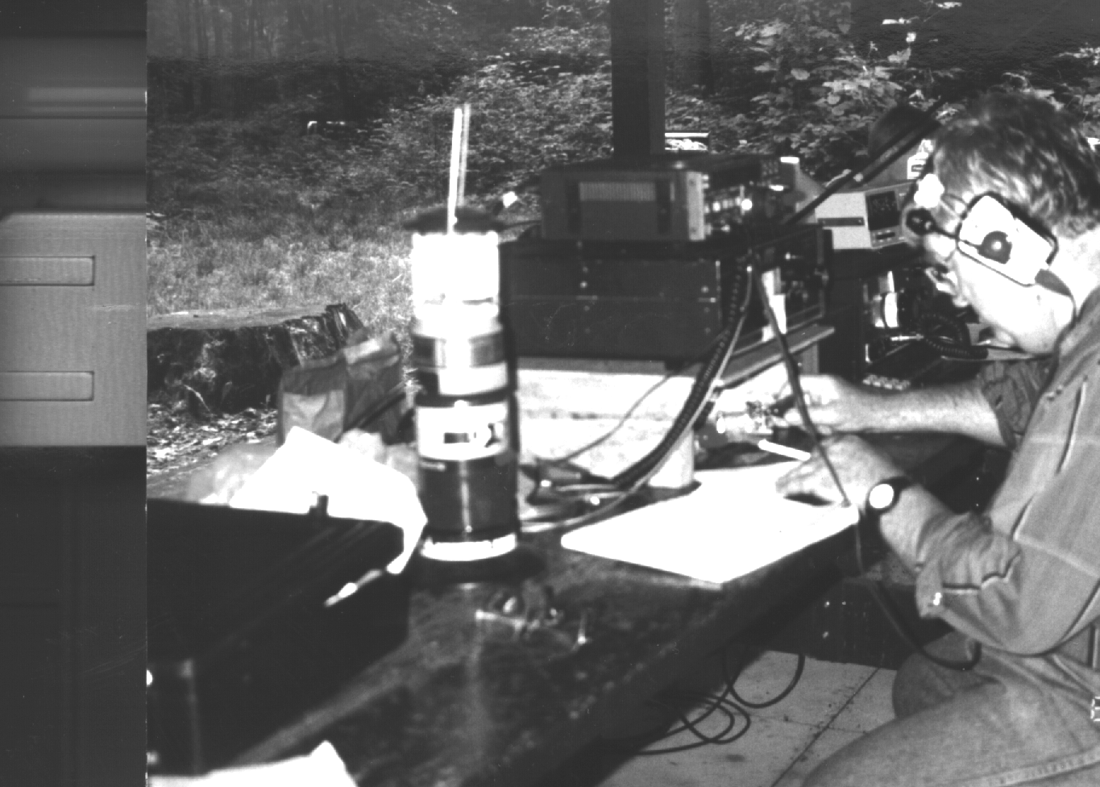
N3UDR Bob Swarm rackes 'em up at last year's field day. Photo by W3CG

Two important notes this year. First the new location at the Elgin Community Park will allow us to "spread out " our antennas over a greater area, thus lowering the amount of QRM from the other rigs at the site. Secondly, we will be setting up a schedule of operators for a two hour shifts. In the past, it seems as if we had lots of help at one time and little or no help at other times. When you do arrive to operate you can use CW/SSB or any mode you like on the band you chose to work. Again this year we will need the greatest amount of help at noon Saturday for the initial antenna set up and 5 PM Sunday for antenna tear down.

The Corry club would like to invite all our friends at the Union City Wireless Society and those visiting the area to join us this year at the Elgin Community Park. Remember . . .Saturday June 22 and Sunday June 23. See you there! 73

Editor's Note: Call Lee WA3HJC to sign up or if you have any questions. Let's make this the best field day yet.

ARRL PRAISES LOCAL VEC TEAM
by Norma Vanderhoff W3CG

The RAC boasts three volunteer examiners among its membership. Headed by Norma Vanderhoff, W3CG, the team also includes Tom Piotrowski, AA3GJ and Dave Wellman, WX3E. The VE Team holds test sessions from novice through Extra on the first Saturday of each month at 8 a.m. at Villa Marie Center, 2551 West 12 Street in Erie.

Radio Association of Erie president Cliff Craft, N3BZL, returned from the Western Pennsylvania A.R.R.L. President's Conference with accolades for the Erie Volunteer Examiner team, lead by VA Coordinator Norma Vanderhoff; W3CG. Both Section Manager Bill Edgar, N3LLR and Atlantic Division Vice Director Bernie Fuller, N3EFN, said that the Erie VE team is the "finest they have seen." This is high praise, and the area is lucky to have the excellent VE team we do.

The team has held a regularly schedule since February 1935. Two annual hamfest exams that we also conduct are at the Radio Association of Erie and the Conneaut Radio Club hamfests.
_______________________________________________________________

NEW MEMBERS

The following names have been added to our roster since it was printed in the last issue. Take a little time right now to add them to your copy. (You do save old issues, don't you?) On the line with the telephone number, the additional information is: Class of license, ARL = American Relay League member, and Interests. Where there are no interests given or the member is not a member of ARRL, the information will be blank.

Craig Hill K3PLV
9801 Mark Road
Erie, PA 16509
(814) 825-3438 E ARL DX

Robert L. Dziubkowski K3SBU
4004 Cooper Road
Erie, PA 16510
(814) 899-2107 G ARL

Russ Campbell KA3WNL
1235 Chestnut Street
Franklin, PA 16323-1434
(814) 432-4139 ARL
___________________________________________

TID-BITS
By BobWA3HDK

The hamfest season is upon us. I finally, after 30 years as a ham, got to Dayton. It was big. Didn't get to see everything even though I spent the entire three days there. Got some answers to questions I had been saving up--some I liked, some I didn't. Will I go back? Maybe.--Maybe once is enough! If you have never been there and like hamfests, you should give it a try. If you do go, be prepared to walk a lot. Take some kind of carrier (backpack or cart) because you must depend on shuttle bus service to get your goodies back to your car. You can't park anywhere near the place! But enough of the Hamvention. If you must hear more, talk to someone who was there.

Before we put this issue to bed, I want to thank all of you who submitted articles. You make the newsletter! I only got one handwritten article this time. Several came via packet, a couple on disk, and some were typewritten pages. Every one of these modes make my job as editor a lot easier. It's the handwritten ones that take time. I'm not complaining, mind you. I'll take any contribution, no matter how it is submitted. Again, thanks to every one of you who contributed.

As long as I am in the "thankful" mode, let me thank Leonard, WB3AYW, for the donation of a solid state 440 repeater to replace the tube-type one we were running. Will, KD3II, contributed the xtals for that rig. I'll try to have more about this in the next issue.

And, speaking of contributions, we may soon be able to change the PL on 147.09 to the Repeater Council guidelines of 186.2 Hz. I found what I think is the correct PL reeds for our repeater while at Dayton. WA3HJC, Lee and I will stand the cost of this change. We can discuss this at the club meeting tonight and take our directions from there. I'll keep you informed.

This is the very last article to be prepared for the newsletter. I try to fill any blank space with TID BITS. There wasn't too much room this time so I had to make the type a little smaller.

Finally, I want to invite you to suggest the type of article you want to see in this newsletter. If you have any ideas for articles please let me know. One of the best ways to decide editorial content is to have a brainstorming meeting. If you would serve, say so.
I need your nominations for the "RAC SALUTES" article. I was going to put a nomination form in the newsletter, but I ran out of room. Who do you want to see an article about???

Is the information on your mailing label correct? Just above and to the right of your name there is a "96" indicating that you are a member of RAC for the current year. To the right of that number may be an "ARL" or an "ARLL." This indicates that you have told us that you are a member or life member of the American Radio Relay League. These are critical keys on which we search the list. Please notify WA3HDK (739-2206) if we do not have you listed as ARL and you are a member of ARRL. Same if we have you listed as a member but you are not. I have lengthened some of the fields for the next printing so names that are run together this time should not be next time. Anything else wrong???? Tell me--Bob WA3HDK.
________________________________________________________

PRESIDENT'S CORNER
By Frank Cutshaw KE3PD

QRU, QRU QRU. Welcome to all of present, new and future RAC members.

Well, Dayton Hamvention is over and The Breezeshooters Butler Hamfest and Rochester will soon be here with field day plus the RAC picnic, too. It's been a long two months.

I want to thank all of you who have responded to the projects we have done. To you who helped with the Findley Lake 10 K race, to the committees--field day, picnic, etc. thanks! Our club is what its members make it. We can only offer what our members are willing and able to do. Your input and active participation is what makes RAC hum!

Our dues of $5 per year is very low compared to the 12- 15- or even 20-dollars charged by other clubs. We think we stretch them a long way by making them pay for the cost of the repeater, the insurance, the newsletter and some other miscellaneous expenses. With your participation and teamwork we, the club, can be a fine group to be part of.

Finally I wish to extend a welcome to all the new ticket holders coming into the amateur family!! We invite you to be a part of our club.
RAC SALUTES

KENNETH KIRCH, K3ENA

This month's personality is Kenny Kirch, K3ENA. Many of you haven't met Kenny. Since 1990 he has been a resident in Corry Manor suffering from an Alzheimer's-like disease.

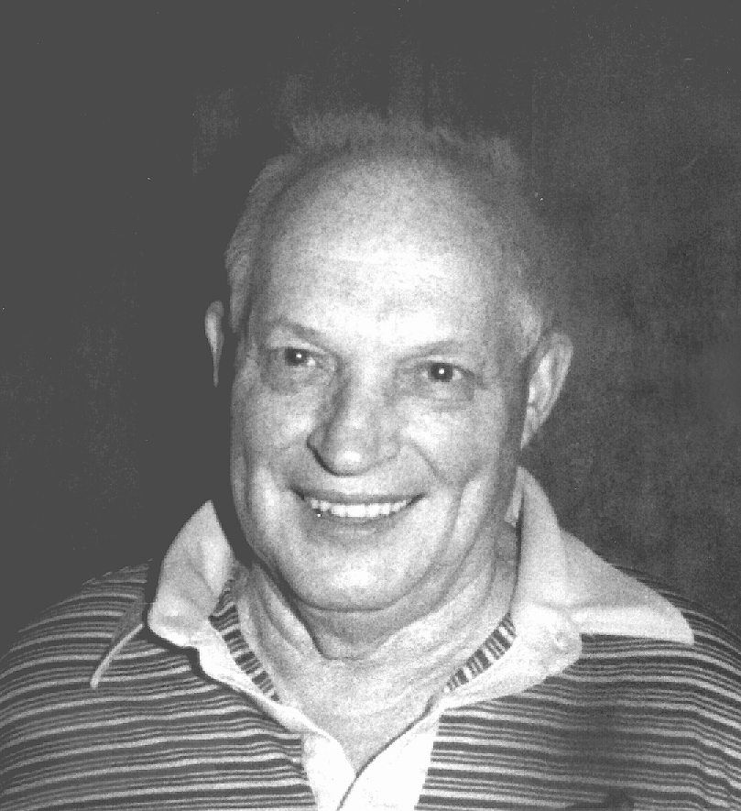

Kenny married Emeline Drake on May 1, 1940. Kenny and Emeline have three children, 13 grandchildren and 15 great-grandchildren. For most of their married life the couple lived on Turnpike road, not far from Beaver Dam. Kenny and Emeline were members of the Wayne Valley United Methodist Church, where he was bus driver and Sunday school teacher. She is currently a member of the Corry Christian Missionary Alliance Church. Emeline now lives in a new home on Buffalo Road which her son-in-law built for her and Kenny. While she is quite comfortable there, she misses her husband greatly and visits him as often as she can.

One of his first jobs was driving tractor trailer truck for Western Express. He later operated an auto repair shop from this Turnpike Road address. There he did general repairs, inspections, etc. One of the lines of vehicles he specialized in was the Volkswagen. Seemed like he always had one of them around. He later took a job with Corry Jamestown. Because of some health reasons, Kenny left the shop and took a position in the office.

In those early days, CJ had three plants. Plant number 1 was over Meerhoff's Furniture (where Montgomery Wards catalog store is). Kenny asked for, and was granted permission to establish a ham radio station on the premises. His station consisted of a home brew transmitter coupled with an ARC-5 command receiver. His antenna was on the roof of the building. It was from that station that Kenny spent his lunch hours checking into MARS nets. These were the days when Charlie Slocum, W3AGD; Wilber Sorensen, W3IAS; (now K4ICE); Gene Hasbrook K3ELJ and Gene Gruber (W3NFX/W3JIO) frequented the MARS circuits. In 1962, when the CJ office staff moved into the new "Glass House" on route 6 east of Corry, he again asked for and was granted permission to move the radio shack to that location.

In 1985, Kenny retired from Corry Jamestown where he worked in the mailroom and drove executives and guests to and from the airports. He also served as tour-guide for visitors when they visited the plant. Part of his job was to deliver the mail to various locations throughout the plant. Jerry, AB3X, tells of Kenny stopping by his work station and talking "radio." Kenny didn't do much QSLing and Jerry used to bring his cards for Kenny to look at and then place in the mail.

He loved traveling. Many times he described this trip or that to me. He had a dream to visit all of the state capitals. And while he did make it to most of the capitals east of the Mississippi, he never did make it to all of them. He used to tell me about his motorcycle, too. He became interested in and took pride in his (mostly flower) gardening, and after he retired, spent many hours in his garden.

Kenny was licensed in the early 1950's. I met him as a result of my activity in Army MARS (Military Affiliate Radio System). He was quite active in MARS, meeting at least two nets per day. He had multiple stations set up at home. Most of the equipment he used was military issue. He had several ART-13s (Collins aircraft auto-tune transmitter), a BC-1335 10-meter mobile, BC-221 Freq Meter, a BC-610 high power transmitter and a 4 cylinder, 5-kw power generator. He had two or more of just about everything in his shack. He ran RTTY with a Model 19 teleprinter. He also had Model 14's repreforators and Model 15's. In subsequent years, he acquired a Central Electronics 20A SSB xmitter and current (for then) 2-meter gear which included a Kenwood TR-2500 handheld and a Kenwood TR-7400A.

I doubt if Kenny would recognize you as a ham operator if you were to visit him, but maybe you can say hello to Emeline when you see her. She'll probably be at the Club picnic on June 15 at Red Top pavilion at Mead Park.

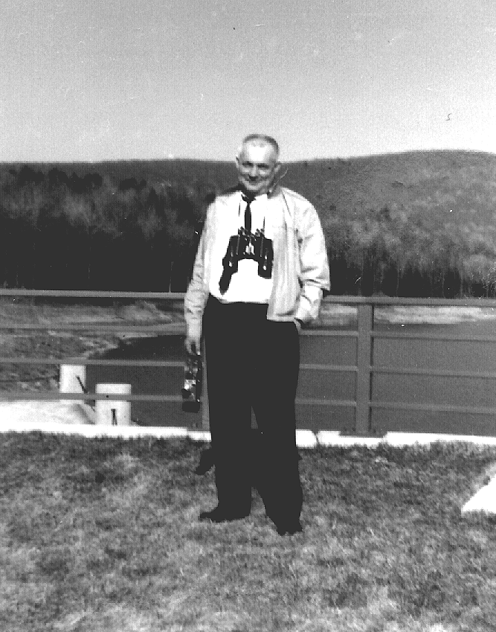

Do you have a friend who is not a member of the Radio Amateurs of Corry? How about passing along this application for membership to him/her.

1996 APPLICATION FOR MEMBERSHIP IN THE RADIO AMATEURS OF CORRY 1996
Name_______________________________________________ Call______________
Address_____________________________________________ Phone Number_________________
City___________________________ State_______ ZIP____________ ARRL Member (yes / no)

We maintain a list of member's favorite interests in the Club data base. If you care to, tell us some of the things you like to do. This could be radio or non-radio related. (some of the ones we have received include: computer, gardening, antennas, sky-warn, traffic nets, woodcarver, etc.)

Interests:_______________________________________________________________________________________________________________

Mail along with $5 dues for 1996 to:
RADIO AMATURES OF CORRY
Norma Vanderhoff W3CG
P.O.Box 362
Corry PA 16407

The RADIO AMATEURS OF CORRY
P. O. Box 362
Corry, PA 16407

Coming Atractions:

June 9 (Breakfast fundraiser
canceled by VFW) Tentatively
rescheduled for Nov 3 or Jan 5
June 8 Possible date for Yard Sale
Confirm at regular club meeting
June 15 Club Picnic
Red Top Pavilian 13:00 hrs
June 15 Deadline for articles
for September Newsletter
June 22-23 Field Day - Elgin Park
July 17 Titusville Parade
August 18 Warren OH hamfest

