The
 RADIO AMATEURS OF CORRY
VOLUME 2, No.1 MARCH 1996

A NEW HAM'S COMMENTS
by Gary, N3WNP

As you know, there are many new hams added to the roster, with more to come. I'm a new ham myself. I've only been in the door a short time, but its been long enough to know help is right around the corner at any given time.

As a new ham mistakes, albeit small ones, are made. The input of fellow operators has been a tremendous help getting over various problems. It is the experience of these seasoned hams that has guided us new hams through a "period of adjustment."
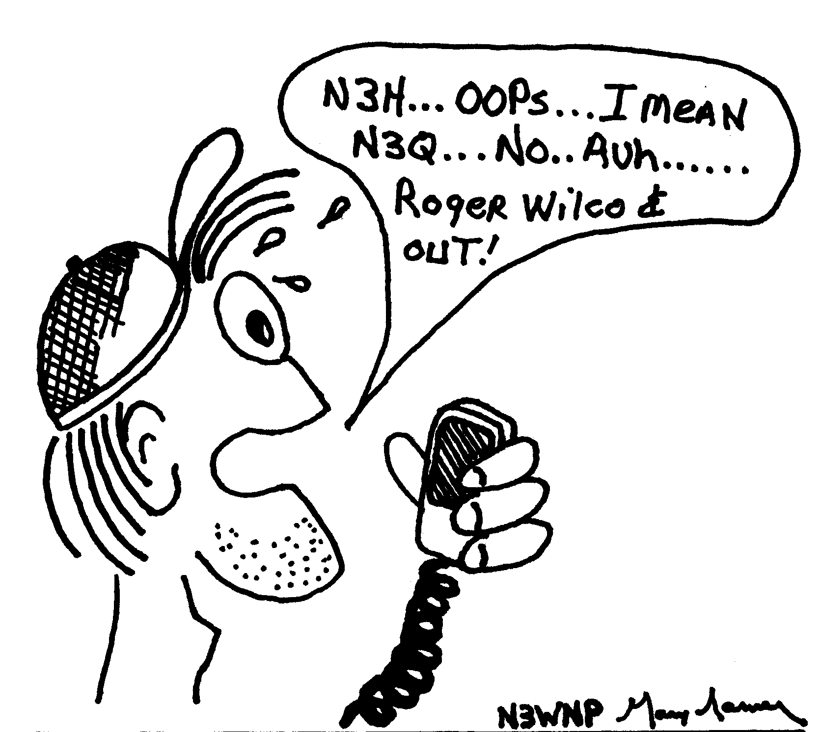

It is more than their experience though. They must remember how it was when they first started out and the assistance they received.

We new hams appreciate your help, fellowship, experience and patience. The extension of your knowledge to us is for the betterment of the whole amateur radio world. From all of us, Thank You!

Duard E. May Amateur of the Year Award
Is sponsored by Dick Drace, K3AQR

The Duard E. May Award of Excellence is presented annually to the local Radio Amateur recognized for their many years of service to the Radio Amateurs of Corry, to the community and to the hobby. Through these years of activity this individual has fostered fellowship and operating excellence, and been

instrumental in leading many others to become Radio Amateurs. They have added to the enjoyment and fellowship of the hobby by those who have had the privilege of association with them through club affiliation or on the air.

The RAC are currently working to find the one amateur most deserving of the Duard E. May, W3DUB, Memorial Award for 1996.

The award winner for 1995 was Francis McCray, W3BZJ. As you can see we need someone with pretty impressive qualifications to add to our annual list next to W3BZJ's name.

If you know of someone that deserves this award, please give their name and qualifications to either: Ron Munn N8BQG, John Payer KA3WUM, Craig Hill K3PLV, Bruce Burr KA3JVO, or Bob Bair WA3HDK.
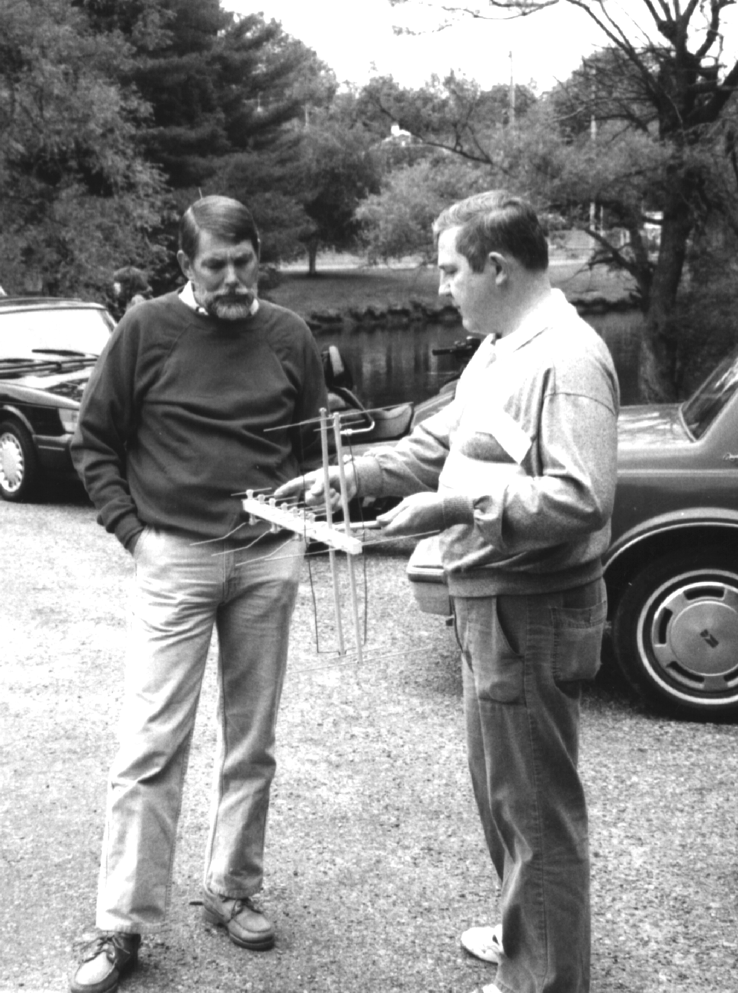
Dick Drace, K3AQR and Leonard Shick, WB3AYW discuss one of Leonard's antenna designs at a recent picnic in Mead Park. Dick is sponsoring the Duard May Award which is given to a RAC ham each year. Photo by Will, KD3II
FOR SALE: Heathkit SB-200 amp. 80-10 m with rebuilt power supply and new finals. I am original owner. looks good, works great. manual included. $300.00 local. Hustler 4-BTV vertical antenna. Works good and in fine condx. perfect antenna. if you have limited lot size. $70.00 local. All is up and working, you can come to my QTH and see it work. will deliver half way. contact K3HWL on 2m or via WA3ZCA BBS and leave message. Letters to: Robert E. Myers, RD1 Box 143G, Titusville, Pa. 16354-9772.
___________________________________________________

FOR SALE: 2 CD ROM internal drives for IBM-type computers with interface cards, installation instructions and MICROSOFT CD ROM extensions. (used in very good condition) $45 each. New CREATIVE (Sound Blaster) brand external CD ROM DRIVES WITH 16 bit Sound Blaster card and packaged software, $135. Bob WA3HDK 739-2206 or via WA3ZCA bbs.
___________________________________________________

FOR SALE. 2-meter mobile. Choice of YAESU 212RH or ICOM IC229H; 10-meter, 4-element beam; 10-meter PALOMAR 60 power amplifier; 11-meter SSB KRACO KCB2340 transceiver. Will KD3II 654-7776.
___________________________________________________

FOR SALE: Vibroplex Brass Racer automatic keyer. Also, Icom IC-229H 2 meter mobile transceiver with touch-tone mike in mint condition. Jim WT3O 664-8140.
__________________________________________________

Compliments of

Radio Association of Waterford

Tom Piotrowski, AA3GJ
Leonard Shick, WB3AYW

PRESIDENT'S CORNER Frank, KE3PD

It is with great pleasure, as President of the Radio Amateurs of Corry club, to report on the progress and growth of our fine club.

We are planning activities which will benefit our members and others. The activities will require the work, ideas and participation of project managers, committees, and you. Some things such as field day, the picnic and net operations are not new to you. But, we need to provide net control operator training, refreshment and snack variations and other activities. We could use more guest speakers at our meetings who could expound on various functions in our area.

Being a committee leader, a helper, or a club officer presents a challenge to each and every one of us. It takes you and I and everyone to make our club a success. Let's promote our club to others, bring guests and remember the club is YOU.
________________________________________________________

REPEATER CONTROL CODES YOU SHOULD KNOW:

• The PL frequency for W3YXE 147.09/.69 is 123 cps

• The PL tones can be turned off by touching *01 and can be turned back on by touching *21. Please return the repeater to the state you found it.

• A touchtone "1" can reset the time-out timer. If your signal is strong enough to capture the offending signal, you can restore the timed-out signal

RAC ROSTER
RAC ROSTER
RAC ROSTER
MINUTES FROM RAC MEMBERSHIP MEETING
HELD AT RED CROSS ON JANUARY 2, 1996

The meeting was called to order at 7:22 P.M. by President KE3PD with 23 present. Ten new-comers were present and joining the club were Stanley Ingram N3WNA, Marian Ingram, Tim Ingram N3WNB, Joshua Ingram, Gary Sarver N3WNP, Shawn Cobb N3WMY, and Larry Sperry. Visitors present were Patricia Sarver, Greg Ingram, and Hope Allen.

Minutes of the November meeting and December Club Dinner, plus Treasurer's report were given by Norma W3CG. Motion to accept as read by WT30, seconded by W3AHH. Carried.

New Business

• Motion by WT3O that someone check into automatic payment of Penelec from checking account. Seconded by WB3AYW. Carried.

• Requested by WT3O that WA3HDK update and make additional copies of repeater brochure.

• WT3O requested that WA3HDK make and mail a certificate to Dick Drace K3AQR.

• W3CG requested that one also be presented to N3KLN, Field Day Chairman, since it was omitted in error in December when certificates were presented.

• Motion by WT3O to supply money for another newsletter. Seconded by Mike N3GCY. Carried.

• Motion by Bruce KA3JVO that club officers have permission to spend up to $50.00 per month without approval of the membership, for club maintenance. Seconded by N3TY. Carried.

• In reply to questions of repeater concerns, KE3PD stated that the Repeater Committee would handle this.

• WA3HDK announced an interest in liability insurance and will send for a price quote.

• WA3HDK announced that the former 147.60/09 repeater had been removed from the air and the cans were now at his home for return to Don Baxtrum N3DB. WB3AYW volunteered to return.

• WT3O announced that Harold WD4OOX would house the 146.13/73 repeater with use of his tower.

• KE3PD appointed a new repeater committee - Control Operators Will KD3II, Bob WA3HDK, Leonard WB3AYW, Jim WT3O and Frank KE3PD.

• Net Controls for Thursday 8 P.M. Net on 147.69/09: 1st week - KA3JVO, 2nd week - WT3O, 3rd week - KE3PD, 4th week - WA3HDK to take temporarily.

• Net Controls for Tuesday 8 F.M. Net on 10M - tabled until next month.

• Refreshment Committee - WA3HDK to organize monthly volunteers. N3GCY for February.

• WA3HDK requested $6.00 for postage.

• KE3PD expounded on possible future club programs: Announced that Field Day would be held at Elgin Park and a donation is mandatory.

• KE3PD announced that club Post Office box is #362.
• WT3O announced that members may view the repeater site in limits of four at one time.

Communications

• Thank-You card from Ron Ploss N3KLN family.

• ARRL Field Forum

• A Thank-You card was signed by all present and to be presented to VFW.

50/50 - won by Marian Ingram - $10.50

Motion to adjourn by W3AHH. 8:30 P.M.

Norma W3CG, Sec/Treas.

Compliments of

WA1YJZ
Rich Durning
MINUTES FROM RADIO AMATEURS OF CORRY
RED CROSS BUILDING ON FEBRUARY 6, 1996

The meeting was called to order at 7:30 P.M. by Frank Cutshaw KE3PD, President, with 21 present. Roll Call of Officers - all present. Reading of the Minutes of the last meeting and Treasurer's report by Norma W3CG. Motion to accept as read by Bill Young W7RVY, seconded by Ron Munn N8BQG. Carried.

Committee Reports

• Repeater - Will KD3II, Bob WA3HDK, Leonard WB3AYW.

• Newsletter - WA3HDK. Deadline for articles to be submitted is February 15. Newsletter to consist of 4 pages of roster, leaving 5 pages for submitted material. To be assembled at membership meeting if needed.

• Net Roster - Bob WA3HDK.

• Pa. Repeater Council meeting on January 21 - Bob WA3HDK. Next meeting to be held on April 21, with place to be announced. Report on file.

Appointments

• Field Day Chairman - deferred until next meeting.

• Net Manager - Jim WT3O.

• Project Manager - Mike N3GCY.

• Program Chairman - Bill W7RVY, and may select help as required.

• Breakfast Chairman for June 9, 1996, at VFW Leonard WB3AYW.
Continued On Page 8
• Awards Committee - school teachers, Ron Munn N8BQD, John Payer KA3WUM, Bruce Burr KA3JVO, Craig Hill K3PLV, and Bob Bair WA3HDK.

Communications

• A Thank-You from Rick Cutter WA3MKT and an offer to provide 2 demonstrations for the club. Topics to be Direct Digital Frequency Synthesis - The JulieBoard and Controller and A 40 Meter QRP CW Transceiver - A New "Breed" Radio.

• A Thank-You and notice from W. Pa Section Manager Bernie Fuller N3EFN of his appointment as Vice Director, Atlantic Division.

• A Thank-You and notice from District Emergency Coordinator Bill Edgar N3LLR of his appointment to W. Pa. Section Manager.

• Hamfest Notices from Mansfield, Ohio for February 11, and Lake County, Painesville, Ohio on March 24.

• QUA-RAE Newsletter from Radio Association of Erie.

• Guidelines for Duard May W3DUB Award from Dick Drace K3AQR.

• Interest and Closed Account statement from Corry Savings Bank.

• Offer from Geniac Technologies, Inc. of Florida to sell license plate key tags for club profit

New Business

• Bill Thomas KL7KI extended an invitation to hold Field Day at their location at Spring Creek, with some equipment, tower, antennas and a 10 K generator being available. Jim WT3O to check on canceling reservation at Elgin Park.

• Don N3TYF announced that classes for Novice and Technician are being sponsored by the Union City Wireless Society. Classes will be held at Union City Elementary School and commence on February 8.

• Three boxes of goodies were brought by Bill KL7KI, with magazines to be given away and balance to be taken home by Frank KE3PD and decision to be made as to a raffle or hamfest sale.

• KL7KI announced that he has extra equipment at home, mentioning a Kantronics still in the box which he may donate to the club if they are progressive.

• Jim WT3O announced that he had received a request for a contribution to FAR Scholarships.

• Bill W7RVY expressed a willingness to help with club projects when needed.

50/50 - $13.00 won by Bob WA3HDK.

Program was provided by Bill KL7KI, a video of wild animals in Alaska - Moose Molly and twin babies and a mama bear and twin cubs - pictured at home in the back yard of KL7KI at their former home in Alaska.

Adjournment - 8:35 P.M.

Norma W3CG, Sec./Treas.

________________________________________________________
The Radio Amateurs of Corry meet the first Tuesday of each month at 7:00 p.m. in the American Red Cross Building, 134 E. Main Street, Corry, PA
AN XYL SPEAKS...
HUBBY SAYS, DOES SHE EVER!

This is the XYL of N3WNP sending congrads to all the new hams, including N3WNP. Gary passed his exam in December. He was very proud to receive his call letters and license. I have to be honest--I'm probably prouder of him than he is of himself.

Gary comes by his love of radio naturally. His father, Gary L. Sarver Sr. was in CB back when it was licensed and regulated by the FCC. Gary Jr. decided to get into CB himself the day we spotted a Sears Road Talker at a garage sale. It cost us $10 and worked remarkably well. It should have come with a warning (who's read "The Monkey's Paw" by 0. Henry?)

Two years and innumerable radios, mikes and antennas later we were seriously talking about getting out of CB, ASAP! We wanted to get into Amateur Radio.

My own father had a saying when I was growing up and it has stuck with me all my life. He couldn't say it often enough: "if you don't have something nice to say about someone don't say anything at all. "I won't say anything about CB.) Gary loved radio and HAM had to be the answer! We knew very little except that you had to take a test. We had tons of questions and we weren't even sure where to get the answers. Where did one take this test? Who gave it? Could anyone take it? If you passed the test, then what?

We heard about a HAM operator named Jim Adams and went to see him. It was kind of like the Scarecrow and Dorothy going to see the Wizard of Oz. We were perfect strangers yet Jim made us feel most welcome. He told Gary as much as he possibly could. I know to this day it was WT3O (I always think of C3PO when I hear his call) who sparked the flame to make Gary DETERMINED to get into Amateur Radio! (TU Jim). Next, Gary called Norma (W3CG). Then he headed to Radio Shack and bought Gordon West's No-Code Book. Coincidentally Stanley Ingram and his family were seriously talking about going into HAM too. Stanley started a study group, had Gary over and they hit the book for weeks. Stan really encouraged Gary and the group. He went out of his way to help and took everyone to Erie for the exam. Gary passed! It was exciting but even that was topped when his call letters and license arrived. He's really enjoyed 2 meters and all the people he has met and talked to. It's been a wonderful experience for BOTH of us (unlike another hobby I won't mention). Now N3WNP is pursuing packet and satellites and Morse Code.

Continued on Page 9
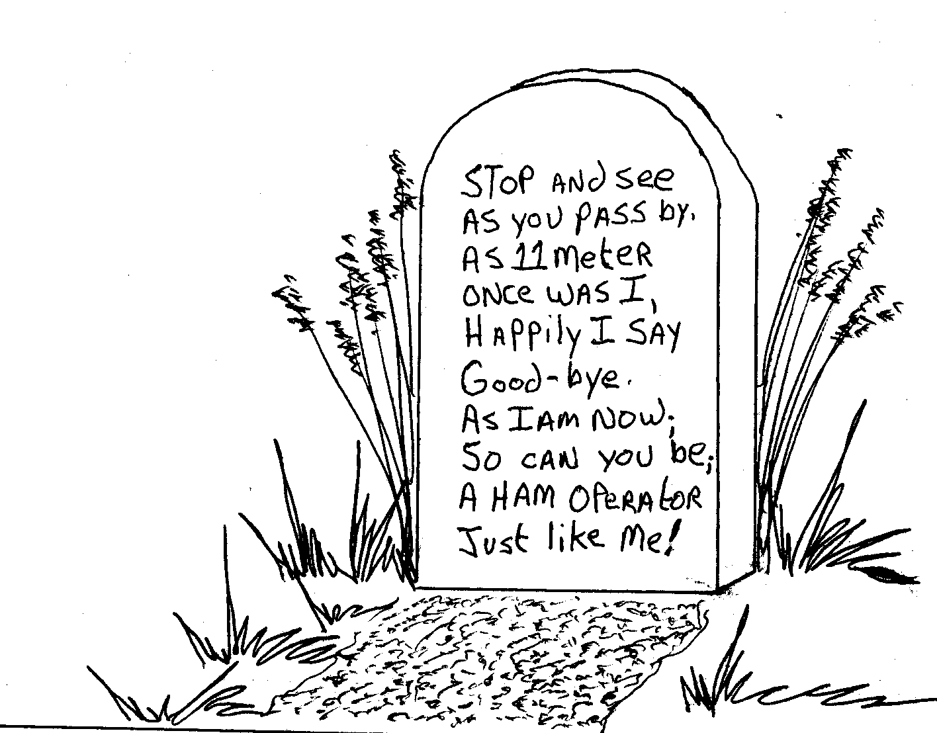
Sending a SASE to Canada? Attach 52 cents in stamps.--Source ECARS Monitor --WT3O.
Little did we know--back when we didn't know anything--that there were so many areas of interest to pursue in HAM radio.

So KUDOS and 73's to the following: WT3O--I can't say enough about him. Jim's what ham is all about. WA3HDK--Bob "the packet man" Bair has sparked Gary's interest in packet and computer. Besides Bob has answered Gary's zillions of questions patiently, helped many a time and always has pleasant conversation to offer (unlike another hobby I won't mention again). In fact I believe WT3O and WA3HDK were N3WNP's first contacts on 2 meters!

The Ingram family--Stan (N3WNA), Tim (N3WNB), Josh (N3WRU) for encouragement, help, fun and everything else. Much Thanks to N3WNA's wife Marian who provided many sandwiches, pots of coffee and hospitality deluxe. To W3CG, for much info; and to all the other HAMS who have made this a rewarding experience. AND TO N3WNP--my 'bestest' friend in the whole wide world--88's

P. S. Honey, I used to have this reoccurring dream about tossing something over a cliff. Any clue what it could have been?
--Patricia Sarver
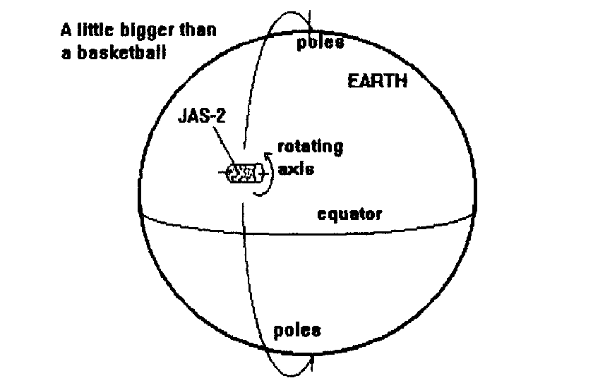JAS-2 SATELLITE SCHEDULED TO LANCH
by Gary W3WNP

For those who missed the February issue of QST, there is a lot of information on a new ham satellite that will be launched this year. It is replacing Oscar-20 who's days are very limited now. Oscar-20 has been failing a long time ago with SSB and CW the only ones working now. Even those modes are now failing. The new satellite, named JAS-2, is scheduled to launch in September or August on an H-2 rocket.

JAS-2 features a linear transponder for SSB and CW communications. The uplink passband is 145.90 Mhz to 146.00 Mhz with a downlink passband from 435.80 Mhz to 435.90 Mhz--Just like FO-20. The designers are considering a rotating schedule for the satellite. The anticipated orbit will be polar with an apogee of 1500 Km and a perigee of 800 Km. The satellite is a little larger that a basketball.
OUTGOING PRESIDENT'S MESSAGE

Compliments of

AB3X
Jerry Owens

Dear RAC Members,

Just a few words of thanks to all for your support during my three years as president of our fine club.

We have accomplished many seemingly impossible tasks and without all of your help it could not have been possible.

I hope you will continue to work with the new officers and keep the club active as you have in the past years. (especially Field Day)!

I believe the founders of our club would be very proud of the progress we have made and I am looking forward to the future projects that lie ahead of us.

73 de WT3O Jim Adams

VE EXAM DATES

Compliments of

WA3HJC
The Huge Junque Collector

Lee Robinson

Lee Robinson, WA3HJC, wants to remind all of you that VE Exams are given twice each month in Erie. Below is the schedule submitted by him via packet. (Those of you who work packet might like to consider submitting material for the next quarterly edition of The Radio Amateurs of Corry Newsletter. Address correspondence to WA3HDK @ WA3ZCA.#WPA.PA.USA.NOAM.)

MONTH VILLA GANNON
________________________________________________________

MARCH 2 16
APRIL 6 20
MAY 4 18
JUNE 1 15
JULY 6 20
AUGUST 3 17
________________________________________________________

Start Time at Villa Exams 8:00 am
Start Time at Gannon Exams 12:30 am

Contact Persons ..........Villa .............W3CG Norma .......665-9124
Contact Persons ......... Gannon ....... K3ED John .......... 734-4260
________________________________________________________
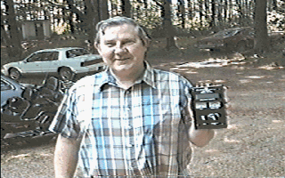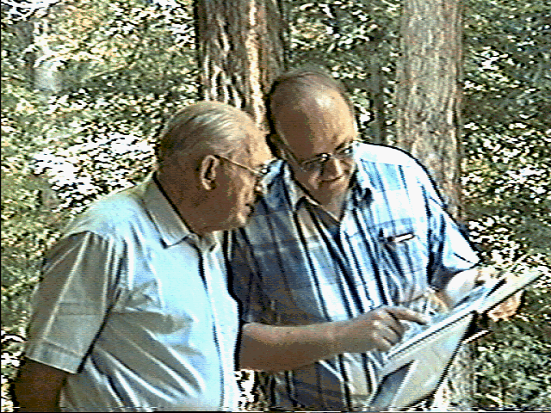

Scenes from the summer picnic. On the left, Leonard WB3AYW shows off his MFJ antenna analyzer. On the right, Jim WT3O and Cecil W3AGF work over the club's scrap book.--Photos by Will KD3II
THE LAST WORD by Bob WA3HDK

We're pleased to present you with the third Radio Amateurs of Corry Newsletter. Like usual, it's been fun putting the issue together. Inside we hope you will find some informative and entertaining reading.

On pages 3-6 you will find the 1996 roster of club members. On the first sheet, members are listed alphabetically by LAST NAME. On the second sheet, by CALL. The information is pretty straight forward, but I'd like to call your attention to the "ARRL" column where ARLL indicates a life membership. The "LI" column indicates the class of license. Please check to see if yours is listed correctly. The "Mem" column indicates the latest year you were a member. In the "Interests" column I have listed some of the things you said you were interested in. Please check your listing carefully and report any errors to me. (You can get my address and phone number from the roster. I know you will want to keep the entire issue of this newsletter--but if you don't, at least tear out the membership roster and keep it for your use during the coming year.

There are four "display" ads from members who made financial contributions to this issue. If you would like to contribute to publication costs, you can "buy" an ad for $5. Of course, you can have a larger ad for more green stamps. We will also use your original art work if you want something more "dressy." See me if you would like to offset our printing costs.

The Union City Wireless Association wants to remind you that their Licensing Classes will end on April 11 and that VEC exams

_______________________________________________________
BELOW: Scenes from the 1995 Christmas party and the 1995 Summer picnic. Clockwise from upper left (1) Mike N3GCY was master of ceremonies, Jerry AB3X in foreground: (2) Jim WT3O and XYL Evelyn: (3) Frank KE3PD and Leonard WB3AYW; (4) Quintin W3AHH; (5) Harold WD4OOX, Bob WA3HDK and Rich WA1YJZ; (6) Cliff KE3SM.
l be given that night. As I understand it, walk-ins are OK, but it might be prudent to call Rob N3OCL just in case. Rob also said that they are planning to give away a subscription to CQ Magazine and CQ VHF Magazine as well as a quarter-wave mag mount 2m antenna at the final session. Also planned, is the drawing for their 50-50 raffle of a 2m Radio Shack HT (or 19" color TV).

Norma W3CG wants me to remind you all that VEC exams will also be given at the Conneaut hamfest on March 10.

A couple of corrections and or additions are in order. The story about the Duard May award on page one was submitted by Ron N8BQG. Sorry, Ron . . .that one just slipped by me.! Also the membership of Craig Hill K3PLV came too late to be included in the roster. That makes our numbers come up to 67. I missed one committee on the back page of "call" sort of the roster. The Western Pennsylvania Repeater Council representatives are Mike N3GCY and Bob WA3HDK. The June 9 fund raiser breakfast at the VFW didn't get emphasized in this newsletter. We had a good time at the last one, but we can use some more help. Won't you give a Sunday morning to help keep us financially solvent?

There wasn't enough room to print our pictures the size I would have liked to have them. But I thought you would enjoy them no matter how small they had to be. If you have pictures that would be of interest, please submit them to me. They will be returned. The Ham Personality article would not fit in this month because of the rosters. Look for it in the next issue.

We want you all to feel you have a place in the club. You can influence the direction we take by attending the monthly meetings, taking part in the activities, and volunteering your expertise. If something is not the way you would like it, bring it up to the officers or at a club meeting. Finding things to do at the club meetings is always difficult. If you can suggest any activities, please tell your officers about it. 'Till next time, 73's

The RADIO AMATEURS OF CORRY
P. O. Box 362
Corry, PA 16407
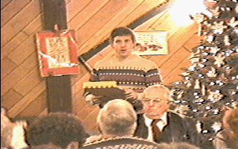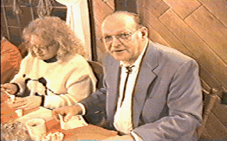

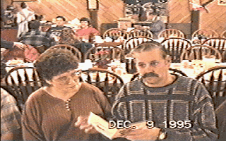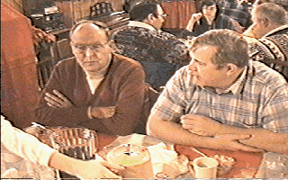

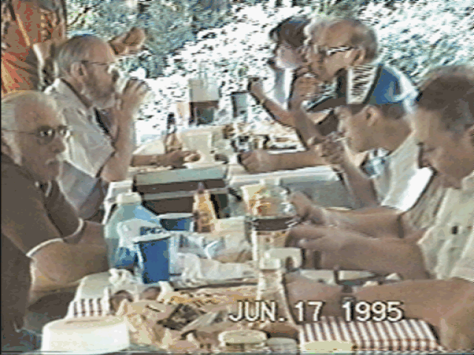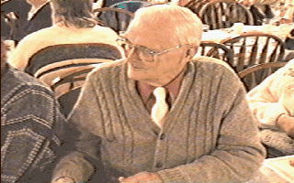

--Photos From Videotape By KD3II

