_____________________________________________________________________________________________________________________________________
The
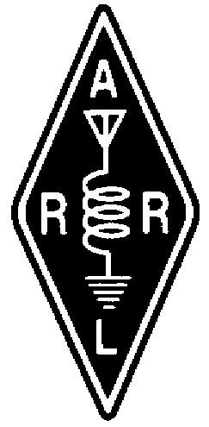 RADIO AMATEURS OF CORRY
________________________________________________________________________________________________________________________________________
VOLUME 1, No.2 OCTOBER 1995
_

TECHNICIAN PLUS OFFERS
EXCITING ENTRY-LEVEL HAMMING
By Bob, N3UDR

It's four o'clock in the afternoon on a warm summer afternoon. Just a good time to be in the ham shack after two hours of mowing the lawn. You take a sip of iced tea and carefully turn the main tuning knob across the 15 meter novice band. The portion of the band around 21.120 Mhz has become one of your favorite afternoon haunts.

There! A weak signal, about 8 words per minute, and quite readable. He's calling CQ. You wait with bated breath. . . . CQ CQ DE PY2WDM PY2WDM AR K. Ha! A DX station for sure! A quick check of the DXCC list on the wall shows he is in Brazil. It's time to rock and roll baby! You reach for the paddles and answer his call using the same speed as he was using. Signing with your call followed by KN, you wait for what seems like an eternity though it is only a few seconds. Where is he at? Nothing but silence on the band! Then ...N3UDR N3UDR DE PY2WDM PY2WDM R R THANKS FOR THE CALL - MY NAME IS MARCO - I AM IN CAMPINAS, BRAZIL. UR SIG IS 569 HERE . . . The rest is history.

Twenty minutes later you glance at the log book entry before heading to the kitchen to see what's for dinner. There it is, the last entry on the page. PY2WDM Campinas, Brazil. Name is Marco. Age is 38. He is a school teacher. Later this evening you will fill out a QSL card for Marco. It will go with a batch of QSL card going to the ARRL QSL bureau for overseas delivery. In about six months you will receive a QSL card from Marco. You will pin it up on the station wall in the most conspicuous space still available, and each time you look up at it you will remember the thrill of the moment you first heard your call sign coming back from Brazil.

Such memories don't go away. I still remember many of them from the winter of 1957 when as a new novice I waited with bated breath for the hoped for answer from across the miles . . . DL4XH . . . LA1TV. . . 5A5TO . . . XE3JJN. I also remember the K4/MM call operating maritime mobile from the USS Billfish, a submarine in the north Atlantic. His QSL card gave his QTH in degrees latitude and longitude instead of a city. I remember Thurmgard Dudek, a seven year old YL in Rostok, Germany. Ah, the memories. The memory of the times on the NOVICE CW bands far outweigh those of the phone bands.

I managed to let my call expire a few years ago. Now, a few years before retirement, it is time to pick up where I left off. Well, not quite where I left off. The code speed has dropped off and the old equipment is long gone. But, being one who could never turn down a dare, I went down to Gannon and took the TECH - HF test without any preparation. I Passed! Now what to do! I didn't even own a rig! Ham's are always willing to help and by the time my ticket arrived in the mail I had an old antique EICO 720 restored and a couple crystals ground for both 40 meters and 15 meters. The antenna wasn't much as I lived in a Millcreek trailer court at the time. It was made of Radio shack #30 white hook-up wire, and was almost invisible in the winter landscape. The RG-8X coax feed line wound it's way up a small maple tree. My first contact was N2IFG, Keith, in Webster, NY. Keith was 84 years old and was operating his grandson's station.

Over the next seven months I have worked 412 stations on the CW bands. I have worked stations in 43 of the 52 states. I have worked 4 of the Canadian provinces. I have worked Puerto Rico, Mexico, Venezuela, Paraguay, Brazil, Argentina, Portugal, Spain, and the Netherlands. Not bad for the bottom of the sun spot cycle! In a couple of years when the bands start to come alive again, the fun will really begin. I have somewhere upwards of 200 QSL cards in page protectors in a notebook. The large map over my operating table bristles with pins and my atlas is getting dog eared from looking up QTH's

So if you are thinking of going for a ham license, or you presently have a TECH - NO CODE call, stop and consider doing the 5 word per minute thing. Even if you never upgrade again in your life, you will not have missed the thrill of copying a rare DX station in an almost forgotten language . . . the language of the International Morse Code. See you further down the Log, or as the say in CW, 73 ES CUAGN -- SK N3UDR
___________________________________________
THE CLASSIFIEDS

For Sale. Mirage B-23G 2-meter amplifier with built-in pre-amp. Brand New. Asking $150. Phone (814) 432-3412. Larry K3HJQ
___________________________________________________

TID-BITS
By Bob, WA3HDK

Here are a couple of useful Control Codes that you need to be aware of: (1) You can reset the time out timer on the 147.09/.69 repeater (if your signal can capture the long-winded offender) by sending a DTFM "1." This same technique can be used instead of dropping the carrier to reset the timer. (2) Since we have been unable to gain access to the OLD repeater site to unplug the old repeater, it sometimes comes on (usually after a power outage). Should you hear it on the air, please touch tone it "OFF" by sending the DTFM sequence "*602*."

* * *

Thanks to Norma, W3CG, for pointing out that the RADIO AMATEURS OF CORRY club was founded forty years ago. I haven't got all the details yet, but it looks like it would make a good project for some of you historians out there to pick up. Tell you what--if you will write the story, I will set in to print How 'bout it, any takers??

* * *

The WESTERN PENNSYLVANIA REPEATER COUNCIL FREQUENCY COORDINATING COMMITTEE strongly suggests that repeaters in the northwestern quadrant utilizing PL use 186.2Hz. A reproduction of their map is shown below.
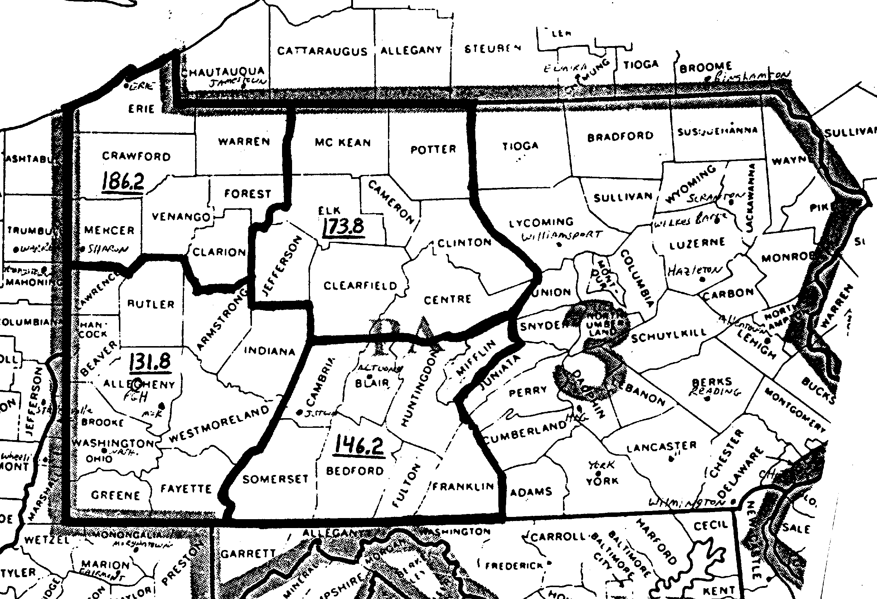

* * *

I want to take some time to thank those who made financial contributions so that we could publish this issue. A couple of you made really sizable contributions. I won't embarrass you by saying which ones, but thanks to those of you who contributed $20 and $10. A couple more made $5 contributions. I don't suppose you know it, but it takes about $50 to publish one issue--actually it is probably more when you stop to think about it. Postage alone is 32 cents and my supplies cost nearly 5 cents per page. We mail to sixty-six addresses so, if I miss the deadline and cannot deliver some issues at the club meetings, the costs go up about $10. There ain't no such thing as a free lunch!

HAVE YOU CHECK THE EXPIRATION DATE ON YOUR LICENSE

* * *

I have received a packet message from John, N3NKV revealing the results of some of his research for a term paper he is working on. John is a student majoring in communications art at Clarion U. Being a typical ham he looked into the heights of the TV towers on upper Peach Street. To save space, I have tabulated the stats.

STATION HAAT* HAG** HAS***
WICU 1,000 789 2,167
WJET 955 780 2,090
WSEE 938 750 2,090
WQLN 880 717 2,017
WFXP 500 350 1,667
________________
*HAAT = Height above average terrain,
**HAG = Height above ground
***HAS = Height above sea level

* * *

CLUB TO CO-SPONSOR BREAKFAST BUFFET AS A FUND RAISER

VFW OFFERS UNIQUE FUND-RAISING
OPPORTUNITY TO RAC

The VFW is offering a unique opportunity for our club to earn some money. As a part of their community service program, they are allowing non profit organizations to share the profits from their breakfast buffets. We are required to buss tables and provide some kitchen services--mostly KP type work.

We are going to need about 14 volunteers to help by serving a four-hour shift. There will be two shifts--One from 6:00 am to 10:00 am, and the other shift will run from 10:00 am to 2:30 pm.

We have contracted to serve the buffet on Sunday, December 3, 1995. The location is the VFW hall on Meade Avenue. Although the breakfast begins at 8:00 am, we need to have our crew on duty at 6:00. We hope you will call Jim at 664-8140 and volunteer your services. Let Jim know which shift you can handle. One runs from 6 am thru 10 am and the other starts at 10 am and ends about 2:30 pm.

If you can't help serve, why not consider eating breakfast there on December 3. The menu will be eggs, toast, home fries, pancakes, ham, sausage, French toast, pastries and many other items. It is an all-you-can-eat deal.

EXTENDED COLLINEAR
FOR THE VHF AND UHF BANDS
By Leonard WB3AYW

Ready to save money in ham radio? Try home brewing antennas.
Depending on the size and construction techniques chosen, it's possible to build vertical or horizontal collinear in as little as two hours, or at most, one day. The cost is low, and gain can be increased by adding more elements, one set at a time, to the array. Support can be a rope attached to a tower or tree. With only moderate variation in gain and pattern, the VSWR will be low across the band.

The antenna illustrated in figure 1 is a 1/2 wave J, from the VHF Handbook on Antennas, 1975 by Green Publishing, Inc., page 17.

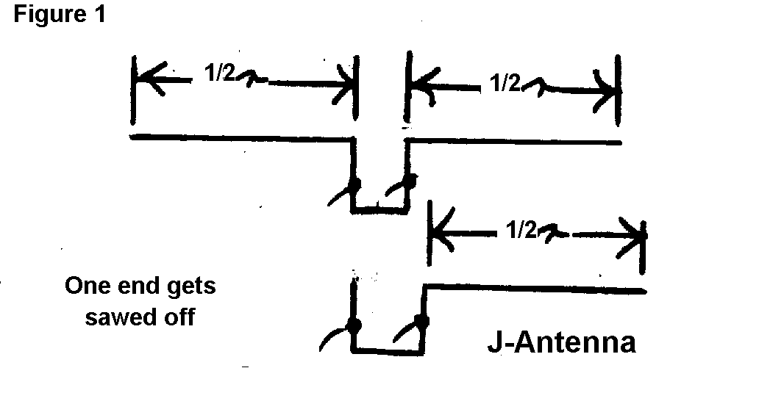

By changing the 1/2 wave section to 5/8 wave, (See Fig. 2) the gain can be increased. The feed point is changed only by a minor amount, with a gain in performance.
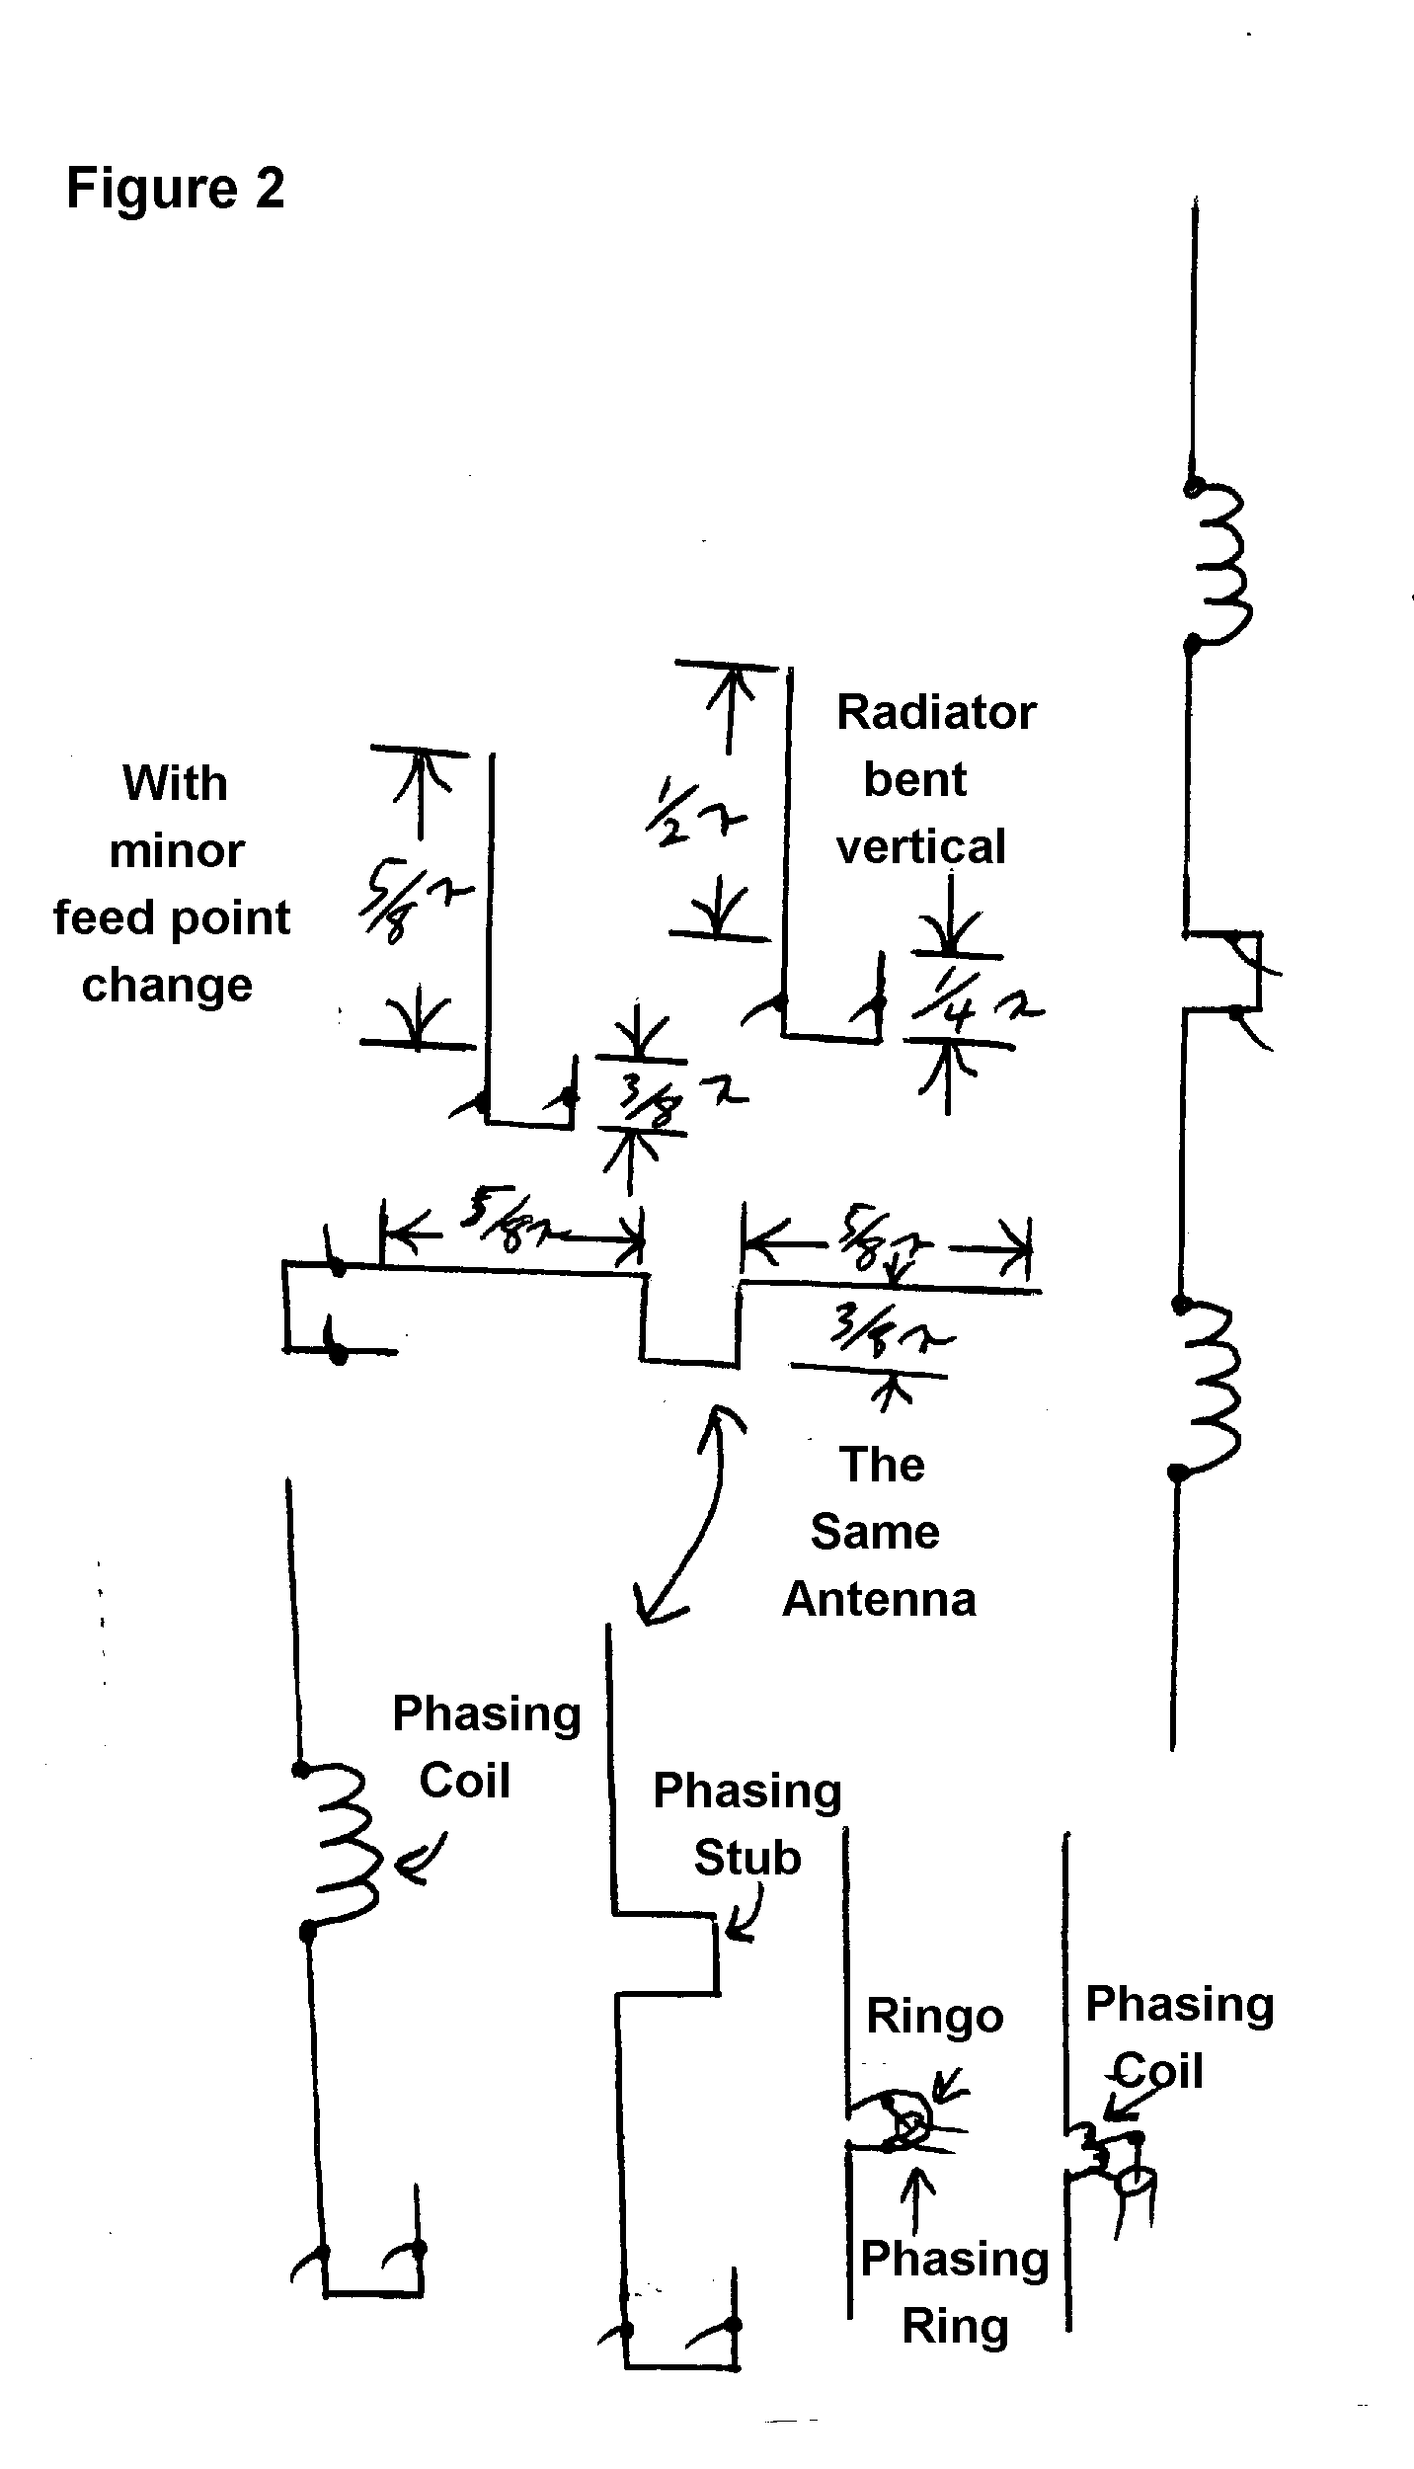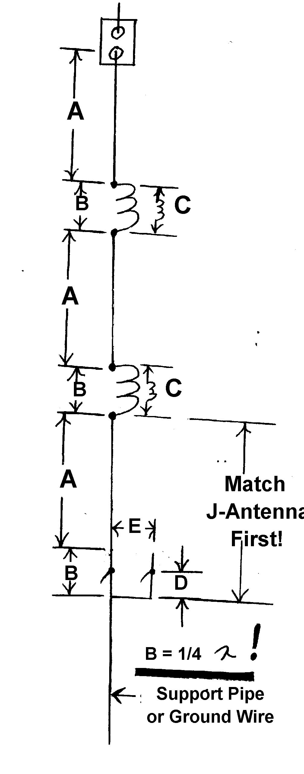
For use on two meters, the antenna is made from #12 stranded copper wire for the radiators Te loading coils (see Fig. 3) are #16 or #18 solid wire.The jumpers are made from wire that is braided, so it can flex if necessary.

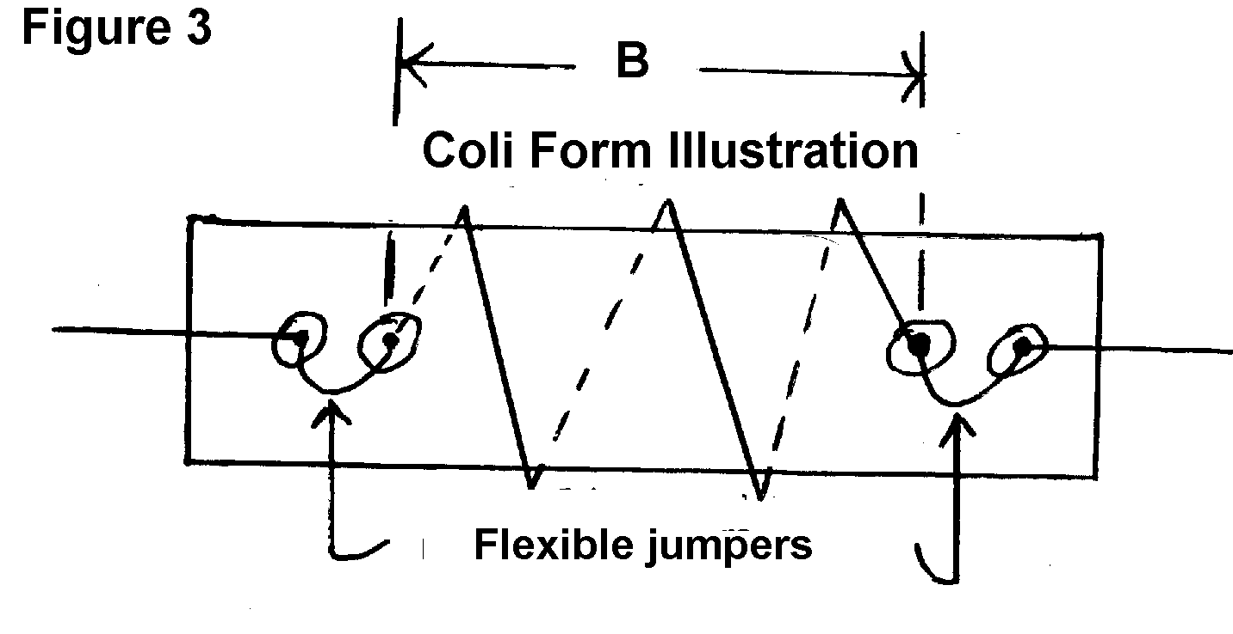
446 coil form diameter = 1/2"
146 Mhz coil form diameter = 3/4" to 1
52 Mhz coil form diameter = 1" to 2"
The length of wire (C) for the phasing coil which is spaced out to dimension (B) is determined by the formula, C=1 wavelength +B-A.

The antenna is fed with coax and the VSWR is 1.2:1 over the entire FM section of the band, at the transmitter. The phasing coils (see Fig. 3) are wound on fiberglass tubing, so the support will have little effect on the loading coils. PVC will vary the tuning with each coil, and the performance will vary also.

Assemble the J-antenna and tune it by sliding the feed point for the lowest VSWR; then add one coil and 5/8 wave section at a time. Adjust by shorting out one turn at a time to raise the band center (In effect to shorten the array), if necessary.

To make an antenna for other frequencies, use the formula (for the coils) one wavelength plus the coil physical length minus the 5/8 wave length. This is the wire wound on the coil form. This antenna could be self supporting, by using aluminum tubing and a solid fiberglass coil form. The antenna must be straight (in line), so the pattern does not deteriorate. The gain will decrease; if the antenna is not straight.

Other dimensions in inches:
446 146 52
A 15 3/8 48 1341/2
B 6 19 53
C 17 53 148
D 1 3 8 1/2
E 1/4 1/2 1 1/4
_________
Reference VHF Handbook 1975, Green Publishing, Inc. Page 17, figure #1. and (H.R. - 1986 page 95 and 97 by WB3AYW)

* * *

BOB, N3UDR IS SPORTING AN NEW AEA PK232 MBX. An old-time RTTY operator, Bob is enjoying the "new" digital revolution.

* * *

MAC, W3BJZ FINALLY HAS THE NEW WARAC BANDS on his cubicle quad. He had a little scare after putting the antenna in the air when his rotor failed. KD3II, AB3X, KE3PD, and WA3HDK asssisted in replacing the failed unit.

Compliments of

WB3AYW
REPEATER

146.31/.91 Union City, PA

COUNTY HUNTERS USE MARAC
(MOBILE AMATEUR RADIO AWARDS CLUB)
By Mac, W3BZJ

This club offers many awards for working counties that are given out as mobiles travel across the country. Mobiles sometimes stop on a county line and give out 2 counties at a time. It is lots of fun to listen to them and, when a county is given out that you need you can give him/her a call and send and receive a report thereby confirming the contact. You do not have to be a member to join in on the fun but it is more enjoyable if you have a membership so that you can send for awards when you have enough contacts. Some of the many awards that can be earned are for counties worked; being net control; going mobile yourself; and many more. There are several nets on different bands but the most popular is 14.336 Khz.

There are over 3000 counties in the 50 states but you do not have to work all of them to start getting awards. Some stations have worked them all and started over as many as 3 or 4 times so there is no end to it if wish to keep on. You have to send cards to get the contact confirmed but the cards can be ordered from the bureau or any of several other printers. The cards have room for 8 or 9 contacts but you must have only the contacts for one station on a card. You may send as many cards at a time as you wish. The cards are sent to the bureau which sorts them and sends them to the mobile. A special postage rate is charged because several cards are sent at a time to the mobile for signing (which validates them) and several are returned to you at one time. The present mailing rate will be given to you when you send for the informational packet. Membership includes a monthly magazine called "The County Line Road Runner." The dues are $16 per year to ship the magazine via 3rd class mail, or $19 per year for 1st class. Your cards are always sent 1st class. To get the membership packet send a business size SASE with 55 cents postage to:
MARAC
P.O.B. 2561
Universal City, Texas 78148-2651

The membership package will include information on net frequencies, net operation guides, computer logging, QSL procedures, and Mobile Reply Cards.
Radio Amateurs of Corry Mark 40th Anniversary

Here are some notes given to me by Norma, W3CG, concerning the origins of our club. They are in the form submitted and we don't claim that it makes slick reading. Instead, here are some notes:

First meeting January 18, 1955

First Officers
President, Charles Slocum W3AGD
Vice. President, Cecil Messenger W3AGF
Secretary, David Hubertz W4FRK (not original call)
Treasurer, Jay Patton (now lives in California). W3AHH said he was called Jay
Trustees
Dick Williams W3AGP 1 year
Bob Barto WN3AWV 2 years
Quentin McCray W3AHH 3 years

Code and theory classes were held twice a year at CorryHigh School, hours 7 P.M. to 11 P.M.
First class terminated in June and second in December
Field Day was held in 1958 and possibly from 1955 on

M. Harold Sexton W3YXE of Union City died May 19, 1958 and his call sign was applied for by the club on May 21, 1958. Second choice was K3RAC.

MARS affiliation was requested on July 15, 1957. (the club is no longer affiliated)

110 people were present at the Club/MARS picnic on June 4, 1959.

Club Station listed as of June 25, 1958

Club dues were $2.25 May 23, 1961 Treas. balance was $31.04

UNION CITY AMATEURS FORM CLUB
By Bill, W7RVY

Something different and exciting happened in Union City last month. On September 14, 1995, a new and long-needed radio club came into being.

The "Union City Wireless Association" was formed by a group of some fifteen hams meeting in the living room of W7RVY. The group went over a set of "draft" bylaws, making changes,

Continued on page 5
adding, and subtracting, and coming up with a short, but workable platform for the operation of the new club.

Prior to the discussion and adoption of bylaws, a thorough presentation of the history, present condition and future of the 146.70 repeater was given. Ideas and suggestions were heard as to what those present wanted or expected from the machine.

Some of the plans were to get the machine up as soon as possible, put the patch back on, add a 440 repeater to the complex and the possibility of a ten meter outlet, as well as better coverage for users.

The UCWA. came into being with some assets in equipment, and cash. All of the assets were gathered up over time by the area hams. There was a GE Master repeater, a Regency 440 repeater, a 2 meter duplexer, various antennas and cabinetry, a power supply, spare parts for the GE, and some $270.00 in cash. The site, on the WCTL tower and transmitter building, is of very great value also, as is the goodwill of all of the Union City community.

Prior to the forming of the UCWA., the hams had ordered a repeater from Florida, and were working on getting funding to pay for it. With donations and dues to the club, along with a fund raiser--selling cotton candy at the U C Homecoming parade--sufficient money was raised to pay for the new repeater, (a Motorola Mocom), and leave some $70.00 in the brand new UCWA checking account.

The 146.70 machine is back up and running. We are looking to the installation of the 440 machine, and the patch is on 2 meters. All-in-all, the Union City Wireless Association is off to a good start.

* * *

Your newsletter is being published because these people made monetary contributions to this issue:

WT3O W3BZJ KD3II N3UDR
WX3E N3UBZ WA3HDK N3NNX
WA3PGL W3AHH WB3AYW

My personal thanks for the help, fellows. If you would like to see regular issues of this newsletter, please consider helping to finance it.

PRESIDENT'S CORNER

RAC BREAKFAST BUFFET
SUNDAY DECEMBER 3, 1995
VFW HALL
MEADE AVENUE NEAR RT 6
SERVING 8:00 a.m. till 2:00 p.m.
$5

By Jim, WT3O

Here it is Fall already! How time flies. I hope everyone had a nice summer. Our club activities went very well. The Findley Lake 10-K was very well attended as well as the picnic and Field Day. Our service was very much appreciated at the Titusville parade.

Also we have had a record number of check-ins on the Tuesday 10-meter net and on the Thursday 2-meter net. This all proves that our club is doing well and all are still interested in our club.

I am trying to line up some speakers for our future meetings and hope you all can attend. There are always lots of interesting things to discuss and it gives us a chance to visit.

If anyone has any projects they are working on please bring them to a meeting and show us what you are doing.

Please mark October 21 on your calendar as that is the day we demonstrate ham radio to the Boy Scouts out at Elgin Field. Please stop in and see what a good time can be had by showing our hobby to the future operators of tomorrow. Hope to see you at the JOTA (Jamboree On The Air).

If anyone has any items for the October 28th yard sale, please drop them off at my house. The date is tentative and may need to be changed due to weather.

I would like to thank all the members of the Radio Amateurs of Corry for your support of our club.

73's Jim, WT3O, President

NEXRAD . . . Good News.. Bad News
by Bruce,KA3JVO

Because I recently submitted a letter to the Department of Commerce about the possible degradation of services caused by the removal of the Erie office of the National Weather Service, I was sent a beautifully bound copy of a study done by the National Research Council.

The study was titled An Assessment of NEXRAD Coverage and Associated Weather Services. The National Research Council considered public opinion to the modernization of the National Weather Service. A team of 35 people, mostly NWS weather persons, evaluated these collected comments and data about the new NEXRAD radar installations.

The pre-NEXRAD radar network consisted of 128 different sites concentrated mainly in central and eastern United States. Few of these sites had Doppler capability. Many of these sites were only in operation during severe weather conditions.

The good news is that the NEXRAD network, when complete, will consist of 138 high-tech radars. They will provide coverage for nearly all the central and eastern United States. NEXRAD's Doppler coverage will provide increased short-term forecasting of thunderstorms, macrobursts, wind shear, and mesocyclones that are often associated with tornadoes. The new network will be capable of detecting "tall" storms of at least 26,000 feet anywhere in the United States. This is a significant improvement over pre-NEXRAD capabilities.

And now the bad news. We, in this small area of Northwestern Pennsylvania, will not benefit from the increased NEXRAD radar coverage. With the removal of the Erie radar we are now 153 miles from the closest NEXRAD site. Only five other sites in the United States are more distant from the nearest NEXRAD since removal of their local radar.

The Conclusions and Recommendations section of the report it states:

"Despite the fact that NEXRAD provides overall network superiority, in areas where the old radar site is relatively distant from the replacement NEXRAD, there may be some degradation in coverage. These areas of concern include parts of Alabama, Indiana, North Dakota, Tennessee, and northwestern Pennsylvania."

The report further defines the specific concerns about the Erie area:

"This area has a region-specific, low-altitude weather phenomenon (lake-effect snow) that is difficult to detect with NEXRADs located at Cleveland, Ohio; Buffalo, New York; and Pittsburgh, Pennsylvania. The pre-NEXRAD radar in this region was able to detect lake-effect snow within approximately 110 km of the existing radar site. Other locally occurring low-altitude phenomena that may have degraded radar-detection coverage include mini-supercells and macrobursts. These last two occurrences are associated with severe thunderstorms and tornadoes".

Unfortunately, our area seems to be in a "black hole" of sorts where those three nearest NEXRADS can't quite see at the limits of their coverage.

The final effects of this study are yet undetermined. The bottom line is that Public Law 102-567 prohibits degradation of service. The Secretary of the Department of Commerce will submit his report to Congress by late fall 1995. This report may include adjustments to ensure that there is no degradation of weather services for the areas of concern. Unless changes are made to the current modernization program, our local area will not see any improvements to our weather services. As things stand now, we will have poorer service than we did before NEXRAD. I will let you know more on this after I receive the Secretary s report.
RAC Minutes
September 5, 1995
Red Cross Bldg.

The meeting was called to order by Jim Adams WT30 at 7:30 P.M.

Seventeen members, including Larry Barton WA3PGL, who now resides in Florida, were present and one visitor, Denver Baker KC5EXZ of West Point, Mississippi.

Roll Call of Officers--Vice President, Ron Ploss N3KLN absent.

The minutes of the last meeting and Treasurers report were accepted as read, by Norma Vanderhof W3CG.

Bills
Penelec $16.73
Duard May W3DUB Award $10.75

Income
1996 dues from Larry Barton WA3PGL $5.00

Donations
$10.00 from W3BZJ toward cost of newsletter to be published
$15.00 from WT3O for glider donated by KD3II and sold.
$7.50 from KE3PD, winner of the evening's 50/50

Communications
From W. Pa. Repeater Council, confirmation of frequency coordination of 444.800 Mhz repeater.
QSL from N3JZK of Valdosta, GA. for October 1994 JOTA QS0. Request from Boy Scout Leader, Terry McCray for radio communications for JOTA on October 21.
Thank-You from Findley Lake, NY officers for providing communications on May 13.
From Kenwood, Newsletter and discount coupons.
From Butler Hamfest flyer and free $5.00 ticket for September 10, for publicity received.
From ARRL, RAC President's Handbook.
Receipt from W. Pa. Council.

Announcements
KE3PD and N3GCY gave an Amateur Radio presentation for Corry Rotary Club.
Boy Scouts Jamboree On The Air (JOTA) to be held October 21.
Terry McCray offered to check out availability of Elgin Park for Field Day 1996.
WT30 ordered 1,000 50/50 tickets printed without numbers for use to be unlimited.
W3AHH, for Red Cross Board, announced that radio operators were requested for a simulated disaster drill. Date to be announced later.
Rumor of Corry CB Club folding and Treasury balance donated to charity.
WA3HDK announced that cost of newsletter to be about $50.00 and funds were still $20.00 short.
N3UDR suggested a possible interest in presenting programs such as the Erie Forum holds.
WT30 announced that KA3RDA donated a lawn mower to be sold, questioning if it should be held for mowing repeater site. KE3PD recommended selling it to reinforce the Treasury.
W3BZJ announced that he has a couple of boxes of goodies for the yard sale.
WT30 announced that Paul Gerbracht W3QPP offered a QCWA speaker for a future meeting.
KD3II announced that the stand-by battery for repeater is in fine shape, and we now have a battery charger. Building has been insulated and air movement improved. Temperature running from 70o-82o and Cecil W3AGF provided ground wire and improved grounding system.

Drawing Winners
50/50 Frank KE3PD
Butler Hamfest ticket Rob N3OCL

Motion to adjourn by W3AHH - 9 P.M.

Respectfully submitted
by Norma Vanderhoff W3CG, Sec./Treas.

RAC MINUTES
OCTOBER 3, 1995
RED CROSS BLDG.

The meeting was called to order by WT3O Jim Adams, at 7:30 P.M. with 16 present.
Roll Call of Officers - V. President N3KLN Ron Ploss absent.
Minutes of the last meeting and Treasurer's report were accepted as read.

Announcements
By W3AHH Quentin, a Red Cross Disaster Drill, involving Emergency Management Agency and Corry Fire Dept., will be held on October 5, commencing at 6:30 P.M. W3AHH will be in charge of communications and volunteers are requested.
N3KLN was having a hernia operation today at Hamot Medical Center, and would appreciate help in a couple of weeks, to erect a 2M antenna on a TV mast.
JOTA communications will be provided on October 21. W3BZJ will furnish a rig, KE3PD will provide a Half- Square 20M antenna, N3UDR volunteered to help and more volunteers are needed. To be at Elgin Park.
Club yard sale will be held on Saturday, October 28, at the QTH of WT3O.
Advised by Terry McCray that Elgin Park will be available on June 22, 1996 for Field Day. A donation will be appreciated to offset expenses. WT3O to secure the date.
WA3HDK announced that the club newsletter is nearly done and will be mailed to all members. Funding is complete with a possible $5.00 on the plus side.
WX3E announced that the Union City 146.10/70 repeater is back on the air, and problem had been located in the hardline. For those not having PL, their touch-tone pad can turn PL off. Operators should turn the PL back on when done.
A meeting will be held at the home of W7RVY on October 12, at 7 P.M.
WT3O requested volunteers to serve as net control for the Thursday 8:00 P.M. net on 147.69/09.

Dates
October 14 & 15 - Pa. QS0 Party
October 21 - JOTA Program and Fort Venango Mike and Key Club auction at Seneca.
December 9 - RAC Holiday Dinner at Dutch Treat Restaurant at Spartansburg - 6:30 P.M.

Suggestion by KA3JV0 of checking with VFW of a club sponsored pancake breakfast. W3AHH volunteered to check this out.
Motion by KA3JVO that W3AHH be authorized to secure a firm date if it falls before the next meeting. Seconded by W7RVY. Carried.
N3GCY reported that 10 radio operators provided communications for the Titusville Parade and the Parade Committee expressed their appreciation.
Nominating Committee for November Club election suggested by KD3II. Appointed were W3AHH, WA3HDK, and KD3II.
Motion by KD3II to give PL access code to club members. Seconded by KE3PD. Carried.
WB3AYW furnished a drawing of a 2M gain vertical Butternut antenna to those present.

Bills
$44.52 Office Products Unlimited for printing of 1000 50/50 tickets.
$16.21 Penelec

Income
$25.00 from lawnmower, donated by KA3RDA and purchased by KD3II.
$25.00 donation toward electric bills from WA3HJC.
$07.50 from 50/50 drawing.
$67.50 dues collected for 1996.

50/50 - $7.50 won by WX3E

Coffee and donuts were available throughout the meeting.

Adjournment - 9 P.M.

Submitted by Norma Vanderhoff W3CG, Sec/Treas.
* * *
CONGRATULATIONS TO ARNOLD, N3UBZ ON UPGRADING AGAIN! HE IS NOW A GENERAL.
RAC SALUTES
Jim Adams - WT3O

You can't be involved in ham radio in northwestern Pennsylvania for very long before you hear the call WT3O. That call belongs to Corryite Jim Adams. Jim 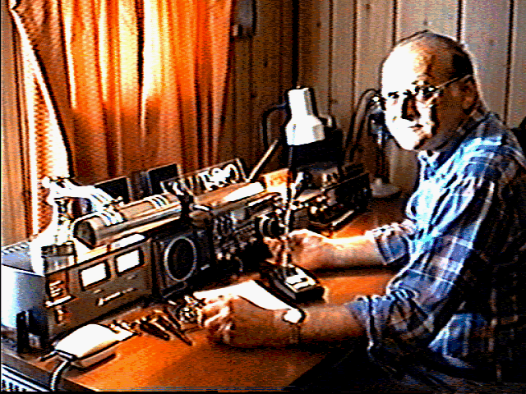
was born 57 years ago in Corry. He married Evelyn Burkett. They have two daughters and a son. He's been a Grandpa three times over. Jim retired 8 years ago as a truck driver for Consolidated Freight Lines. He piloted the big rigs for 29 years.

Jim was first licensed in 1975 as a novice with the call WN3ZYR. His first station consisted of a Hallicrafter's HR30 receiver and a Knight CW-only transmitter. Some of the other calls he has held through the years are WA3ZYR, KA3OSG, and N3KFX. He has held his present call, WT3O, since 1991.
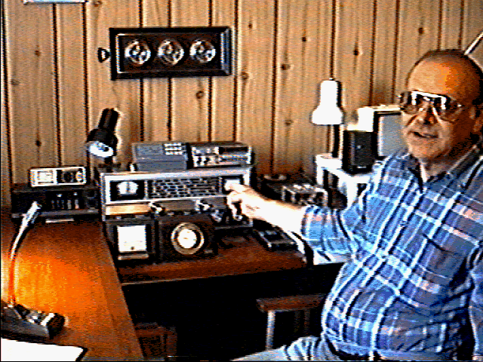
When you walk into Jim's shack you come face-to-face with an impressive array of fine equipment. There is an Icom IC751A to handle HF, an Icom IC2410H for UHF/VHF, and a Radio Shack HTX100 for 10-meters. All of this is powered by an Astron dual meter power supply. An MFJ 949E Antenna tuner has the job of keeping his HF transmitter happy. Also prominent on his desk is his squeeze paddle keyer and a couple of microphones. His Yesau FT530 dual band hand held is never far away.

The ell-shaped desk on his right holds his ancillary gear. There is a Uniden BC210 scanner, a Hallicrafters HR-30, his weather station, several rotor control boxes, and a Radio Shack color computer.

Outside, you look up to see a TA33 triband beam for 10- 15- and 20-meters, a trap dipole for 160-meters, and an inverted vee for 80- and 40-meters. Stacked 11-element beams are used on 2-meters and stacked 440-Mhz beams designed and built by Leonard WB3AYW are on another rotor.

Jim has worked all states, but has not attempted to get a certificate. His favorite modes are CW HF operation, and FM voice operation on VHF and UHF. He says with a grin that his longest contact was to a station in Newcastle, Australia.
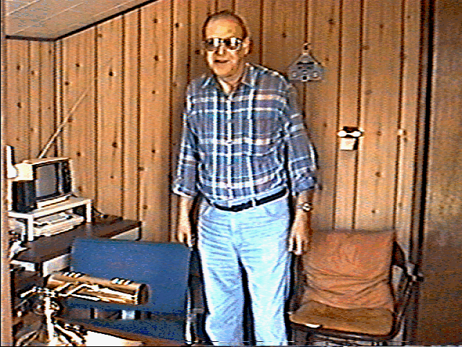
He has been president of our club for three years and is responsible in part for the growth we have been experiencing during that time. He has put in endless hours on our improved repeater, coordinated the work with the Boy Scouts, the parades and the fly-in. He is also a member of the VEC team, ECARS; Army MARS, and ARRL.

Photos from videotape by WA3HDK

Coming Events

October 14-15
PA QSO PARTY
October 21
JOTA (Elgin Park)
Simulated Emergency Test (see September QST, page 65)
Fort Venango Mike & Key Auction
October 28
RAC Yard Sale (WT3O's QTH)
November 4
ARRL Sweepstakes (CW)
November 7
RAC Elections (Regular Club Meeting)
November 11
Simulated Emergency Test (Local)
November 18
ARRL Sweepstakes (Phone)
(October QST, page 125)

The RADIO AMATEURS OF CORRY
Meet the first Tuesday of each month at
The AMERICAN RED CROSS BUILDING
134 E Main Street, Corry PA at 7:30 pm

December 3
RAC Sponsored Smortgasbord (VFW)
Your Help is Needed
December 9
RAC Christmas Party (Dutch Pantry)
January 7
Hiram Percy Maxim 127
June 22-23
Field Day
September 14
RAE Hamfest (Erie)
September 15
Butler Hamfest
Every Tuesday
10-meter Net 8:00 pm - 28.33 Mhz
Except first week of each month when the regular Club Meeting is held
Every Thursday
Two Meter Net 8:00 pm - 147.09/.69

