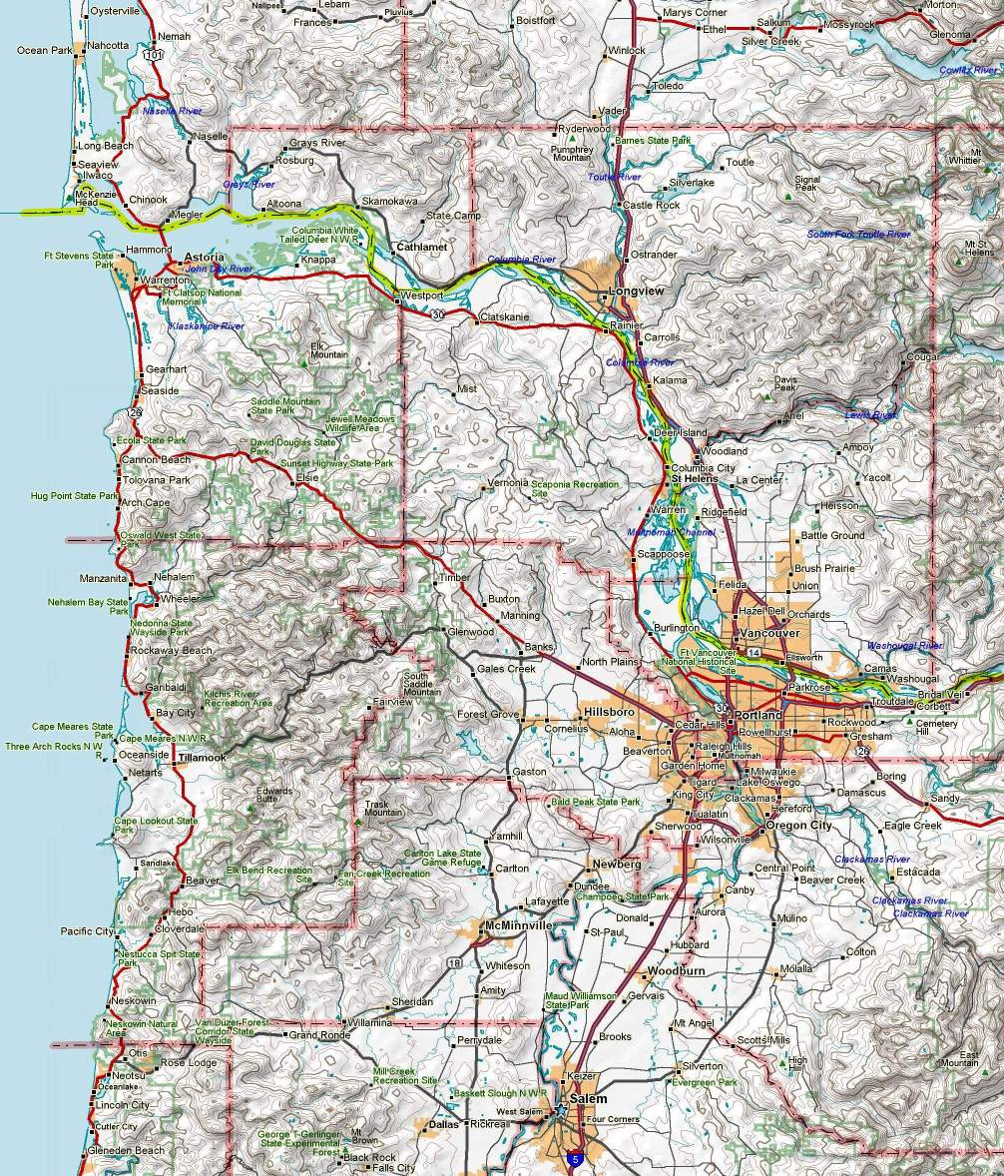
RMS Freq Location Node Freq Node Freq Node Freq Digi Freq
K7GA-10 145.63 Cathlamet NICOLI 145.63 CEDAR 145.63 ARESWC 145.63 W7BU-5 144.96
W7BU-10 144.96 Warrenton JAY 144.96 KELSO 145.09 WSTPLK 144.93
N7AST-10 144.93 Clatsop EOC AST 144.93 PARET 441.50 CEDAR 144.93
IQICMS 145.63 Portland TILLMK 145.03 FG1 145.63 DMASCS 144.95

KB7EOC-10 144.95 Tillamook BVRTN2 145.05 MTHOOD 145.05 HEBO 145.03
W7GC-12 441.50 Hebo PARC 144.91 HCKNSN 145.63 WESCOM 144.93
K7TRP-10 145.05 Beaverton GOBLE 144.91 NM7R-8 145.63 NM7R-9 144.96 NM7R-10 <bridge>
W7AEP-10 144.95 Albany LYONS (1) 144.95

Packet Stations Portland
April 2010 de nm7r v3.0
JAY
NM7R-9
NM7R-10
W7BU-10
W7BU-5
CEDAR
HCKNSN
DMASCS
GOBLE
KELSO
BVRTN2
MTHOOD
HEBO
TILLMK
PARET
VRNONA
WSTPLK
WESCOM
K7RTP-10
W7GC-12
KB7EOC-10
KD7SRE-11
N7AST-10
AST
ARESWC
W0RLI-2
LYONS
W7AEP-10
PARC
FG1
NICOLI
K7GA-10
IQICMS

