**LKD 13 Room Pix**   
Shot 1, shows scale and overall layout, Shot 2 shows scale with candid humans in room.   
Left side is most used most w/2 meter radio and 220MHz. Right side is 10m, monitor and 6 meter. Power supplies are on shelf top. Radios mounted under shelf.   
Note conduit.  
Shot 1

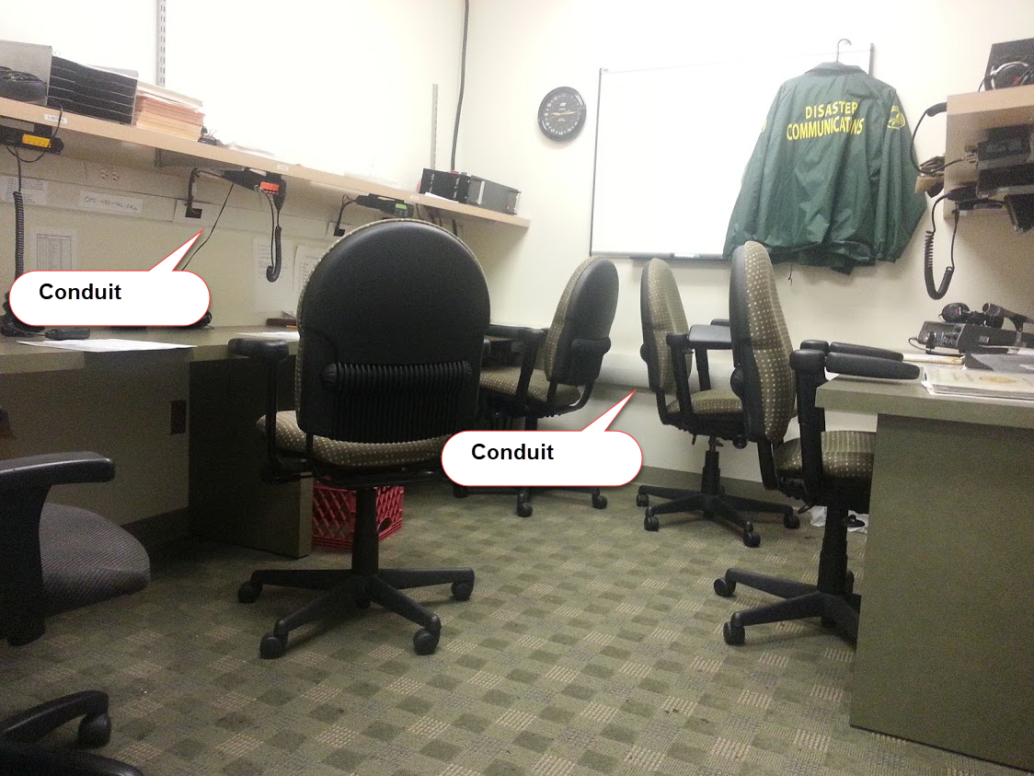

Shot 2, candid to simply show scale

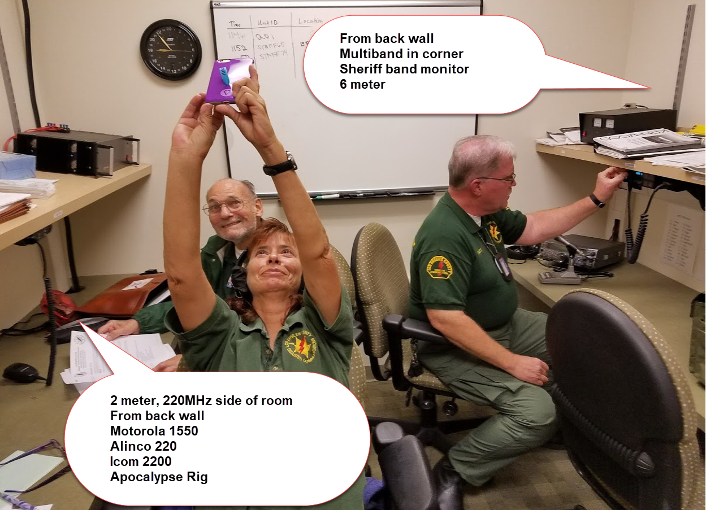

Shot 3 – This is the side we work most Mondays. Laptop typically sits on table top for 2000 NBEMS net acoustic coupling.

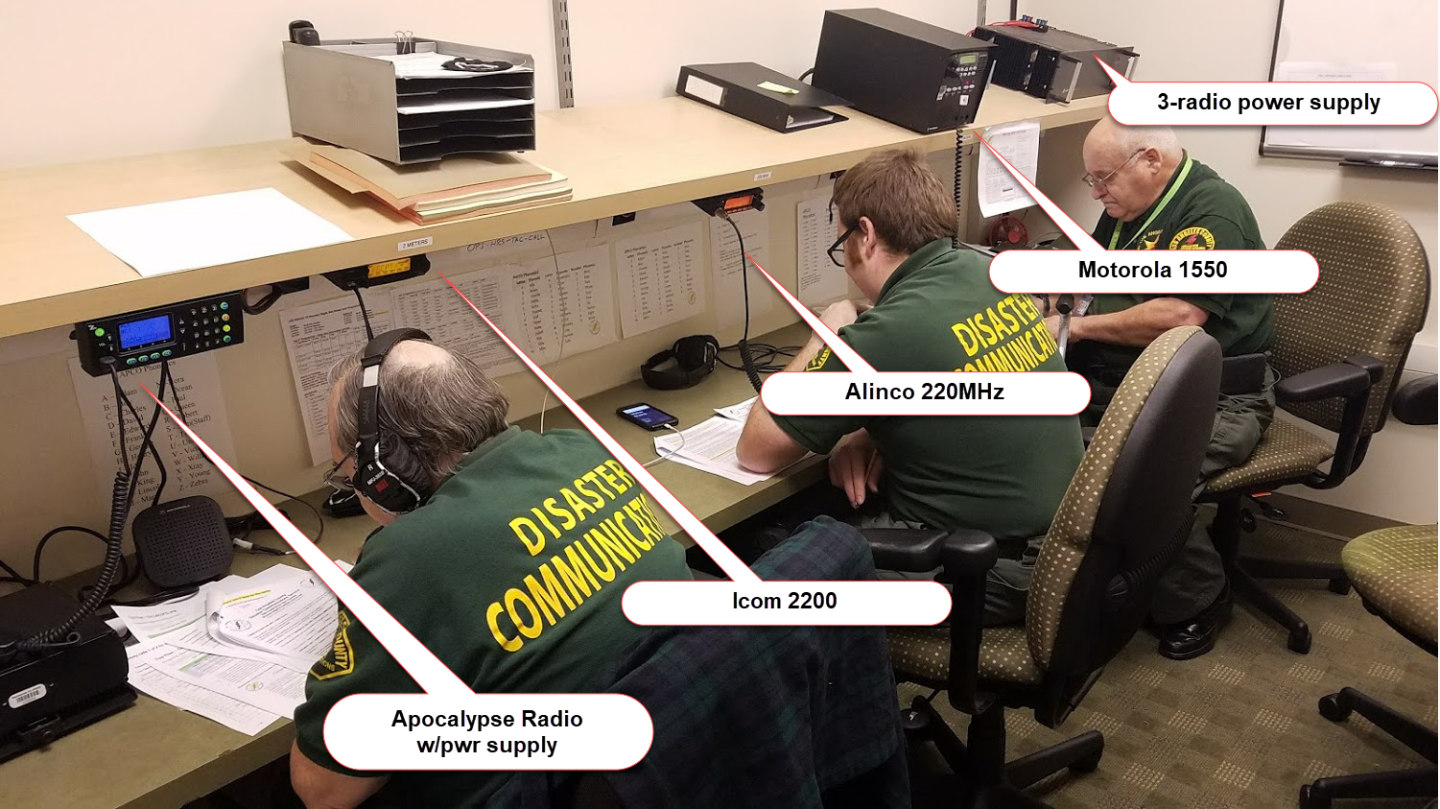

Shot 4, right side, not operated a lot.

