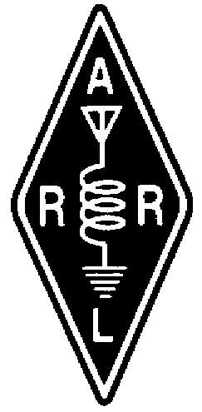  TheRADIO AMATEURS OF CORRY

VOLUME 8 No. 4 DECEMBER 2001

Come ring in the start of the Christmas Season with your Ham Radio Friends!

THE RADIO AMATEURS OF CORRY


The annual Christmas Party of the Radio Amateurs of Corry will be held Saturday, December 8 at the American Legion of Corry, 1360 Sciota Road. Dinner will be served at 6:30.

The cost, including tax and gratuity, is $8.25 per person. It is to be a buffet with three entrees--Baked Ham, Cabbage Rolls and Stuffed Pork Chop,--Mashed Potatoes and Gravy, Baby Carrots, and a Salad Bar. Coffee and Tea will be available. Desert is Ice Cream.

So that the Cooks can determine how much to prepare, we need your reservations as soon as possible. Please indicate if you plan to attend, and how many will be in your party. It is not necessary to prepay as you will be expected to pay the night of the dinner.
Notify Norma, W3CG, of your intentions BEFORE December 1st via e-mail W3CG@tblscc.com or telephone 665-9124

As of Christmas Day, only 143 Days until the Dayton Hamvention!

Twas a Ham Operator's
Night Before Christmas

Twas the night before Christmas, when all through the night, We Amateurs sent messages, with the speed of light.

The stockings were hung by the ham rigs with care, In hopes a new dual-bander, soon would be there.
And Ma with her HT, and I with my set, Had just settled down for a long winter’s net.
Here and there are the books that we need, Books that we’re crazy if we don’t read.
Books equal to motherhood, and apple pie, Like Uncle Wayne, they Never Say Die!
When out in the street there arose such a clatter, I sprang to the window to see what was the matter.
When what to my wondering eyes should see, But a plain gray van, with a license plate: “F C C”.
With a little old driver so lively and quick, I knew as my heart sank, it was not St. Nick.
He knocked at the door, no chimney to help,
Said “I’m from the government, I’ll have those cookies & milk.”
Now I thought to myself, “What a sticky wicket”, With laser sharp eyes he was examining my ‘ticket’.
He tested the radios, one by one,
I held my breath, and tried not to run.
Now Yaesu, now Kenwood, now Ten-Tec and Icom, On Comet, on Cushcraft, on Azden and Den-Tron,
To the top of the tower, to the end of the beam, Now dash away, dash away, signals SO CLEAN!!
After testing my setup, and laughing so gay, Not “HUMBUG” said he, but “Your rigs are OK”.
Then he was away like a flash, no question or fee, By then, he was just like Santa Claus to me.

And..I heard him exclaim ‘ere he drove out of sight,
"73's TO ALL, AND TO ALL A GOOD NIGHT!"

JOTA 2001 IS A SUCCESS!
By Jerry Owens, W3GHO

Success is a good way to describe the participation of members of the Radio Amateurs of Corry and local Boy Scouts in the 2001 Jamboree on the Air (JOTA). The weather proved to be delightful with a cool but sunny start at 9:00AM when the setup of equipment and erection of antennas began, but by midday we had shed our jackets and enjoyed the warm October sun. The amateur radio operators were asked to join the opening Flag ceremony and W3GHO played the bugle, rendering the “call to colors”.
The Radio Amateurs of Corry had been asked at the annual awards dinner by Scoutmaster Terry McCray in February of this year to participate in JOTA again for 2001. Terry indicated many of the boys look forward each year to talking to other scouts across the country and in other parts of the world.
Before the scouts arrived at the radio site, they worked on an emergency preparedness exercise which when completed earned them a merit badge by working in teams and finding an injured person in the woods, giving proper treatment and transporting back to the fire company ambulance which included a ride to the fire station.
There were two complete HF stations operating one on SSB manned by Hal WD4OOX, Dan KB3EMH and Jerry W3GHO and the other on psk-31 operated by Bob K3CKO. During the course of the day Mac W3BZJ, Lee WA3HJC and Jim Froncek KA3RDA and his son stopped by to operate for part of the event. The scouts were sent to the site in groups of 4 or 5 as they finished the other activity. Many contacts were made near and far such as the Battleship New Jersey special event station, K9BSA Boy Scout headquarters in Illinois, K1BSA in Maine and several scout stations like the one we were operating in Elgin Park. The scouts took turns passing the mike around the group and talking to boys on the other end doing the same thing. They talked about their ages, troop number how many merit badges they had and where they were located. Bob K3CKO demonstrated how computers and ham radio worked together as many of the scouts even had their own e-mail address.
The day ended with a nice supper and fellowship around the campfire with a vesper service conducted by local clergy. The flag was retired with taps played by W3GHO.We have been asked to participate again in 2002 so lets plan to make this worthwhile activity a part of the club’s activities using W3YXE for the new year.

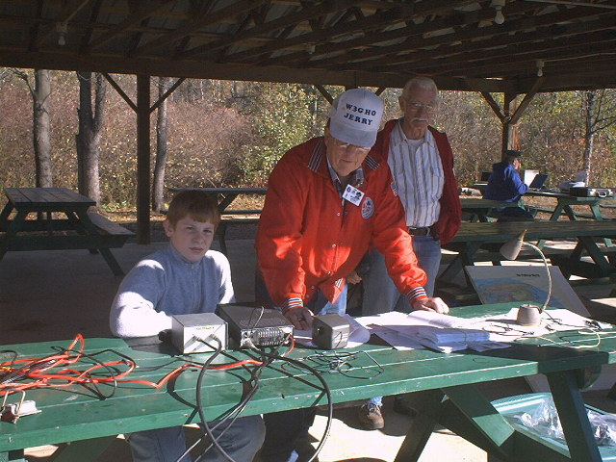

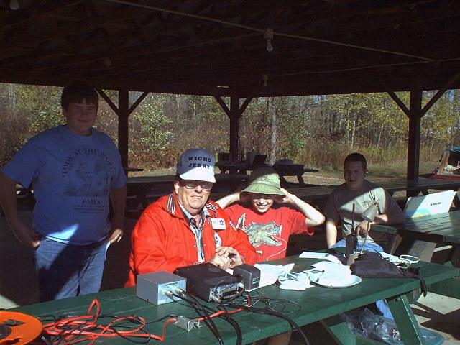

Editors Note: More Pictures will be available soon at the RAC Web Site!

http://www.qsl.net/w3yxe
************************************
Radio Amateurs of Corry

September 2001 Minutes
After checking the sign in book it was determined that there was not a quorum present as called for in the club by-laws, but Vice-President Dan KB3MH held an informational meeting instead.
There were 7 members present including two officers, Vice-President Dan KB3EMH and Secretary Jerry W3GHO.
The informational meeting began with the reading of the August 2001 minutes.
The JOTA event in October, Breakfast in November and Christmas Party were the activities scheduled for the rest of the year 2001.
Bob WA3HDK agreed to chair the JOTA again this year and he stated that K3CKO Bob was planning on attending and bringing a complete PSK-31 station.
Dan KB3EMH agreed to be in charge of the November breakfast and asked for more help to work at the VFW on the 18th both shifts.
Norma W3CG has been working on the menu for the Christmas party and asked for suggestions from the members present, it was agreed that the menu would be Baked Ham, stuffed pork chops, salad bar, mashed potatoes and gravy, baby carrots and crème demit ice-cream. Norma is to check on the additional cost for having third meat of cabbage rolls. Beverage to be coffee and tea.
Correspondence: Notice of Club Presidents conference from John N3MSE WPA SM on September 29th, President Ralph and Vice President Dan plan to attend and a notice from ARRL regarding the Club keeping $15.00 per new member dues.
Committee reports: Leonard WB3AYW reported for the repeater committee that the Repeater batteries had been checked and have been working fine since the weather has cooled down.
No by-law Committee report due to absence of Mike N3GCY.
The tower trailer project appears to be dead with nothing done in 10 months not even a plan or prices.
Tower base painting project, nothing done paint is locked up tight.
Members present via Non-motion that Club meeting minutes should be sent to all members and non-members on the e-mail list.
Bank signature cards are in and will be signed and returned to the bank.
There was a discussion about holding code and theory classes for prospective new hams but no interest was shown to proceed, it was noted that the Union City Wireless Association plans to have classes this fall and we could refer people over there.

Jerry W3GHO won the 50-50

We agreed to adjourn at 8:25PM

Jerry Owens W3GHO
Secretary
Radio Amateurs of Corry

Radio Amateurs of Corry

October 9th 2001 Minutes
President Ralph N3LXG called the meeting to order at 7:30 PM with Other Officers Vice president Dan KB3EMH and Jerry W3GHO Secretary present. Also there were eight other members in attendance.
The minutes of the non-meeting held in September were read for information only since there had been no quorum for an official meeting.
One piece of Correspondence was presented from the Handi-hams, which was passed around for members to read.
Bills were read from Bob WA3HDK in the amount of $33.18 for newsletter expenses and Jerry W3GHO in the amount of $8.47 for the new port-a-file. So moved they be paid.
Treasurer Mike N3GCY was absent so there was no treasurer’s report.
Committee reports: It was reported the by-law committee had made some progress but very slow going with 2 short meetings taking place during the summer.
W3CG Norma reported the menu for the Christmas party is now complete with the price to be $8.25 which includes tax and gratuities, she asked Bob WA3HDK to e-mail to all on the regular list, members without e-mail will have the newsletter in a timely manner before the December 8th party. WA3HDK will print the net attendance awards. There was a motion by WA3HDK and seconded by W7RVY to spend up to $75.00 for party expenses including a award plaque.
Breakfast Committee Chair Dan KB3EMH said he is getting a kitchen crew for the November 18th fund raising event but still needs help for the 2nd shift.
JOTA Chair WA3HDK indicated there would be 2 rigs operating on October 20th one on voice and one on PSK31 but needs more help for the event.
There was no repeater committee report.
Old Business: Jerry W3GHO reported the wood tower guard has been painted after finally receiving a key to the repeater building and the key had been returned to WA3HDK.
There was a motion to send the Club meeting minutes out by e-mail to all on the mailing list ASAP after each meeting. Carried.
Jerry W3GHO reported the new port-a-file had been purchased, filled with the old club records that could be located and placed in the basement storage shelf in the Red Cross building where the meetings are held.
New Business: Motion to raise the Club dues to $10.00 for 2002 by WB3AYW, there was no second but a discussion was held regarding club finances and a motion was then made and seconded to keep the dues at the present $5.00 level for 2002 carried.
Motion made and seconded to cancel regular December meeting, and any business for December to handled at the Christmas party in brief manner, carried.
Motion by WB3AYW and seconded by W3CG to nominate the present officers to serve in the year 2002 with the floor to be open for further nominations at the November meeting before the elections.
W3BZJ has asked to be relived of the Net manager’s job for both the 10 meter net on Tuesday night and the 2-meter net on Thursday night. Vice President Dan KB3EMH accepted the manager job for the 2-meter net on Thursday.
Motion made and seconded to suspend the operation of the 10-meter net after January 1st 2002 if a net manager/NCS volunteer is not found, carried
The new net manager for the 2-meter net will be conducting simplex tests on the 147.09 output freq of the repeater and needs the control code to turn off the repeater briefly for the tests. Dan will ask the repeater committee for the necessary codes.
W3CG reported attending the September meeting held by the ARRL SM John Rodgers and informed the members present that the FCC had lowered the Vanity fee to $12.00 and N3YEA had been appointed WPA emergency coordinator.

Motion to adjourn by W7RVY and seconded by WX3E at 8:25PM
The 50-50 was won by W7RVY.
Jerry W3GHO
Secretary
Radio Amateurs of Corry.

Radio Amateurs of Corry

November 13, 2001 Minutes

President Ralph N3LXG called the meeting to order, other officers present were Vice President Dan KB3EMH and Secretary Jerry W3GHO and six members were also in attendance.

The minutes of the October 2001 meeting were read and approved.

The calendar review showed the November 18th breakfast and the Annual Christmas party on December 8th.

Mike N3GCY arrived and gave the treasurers report.
Committee reports: President Ralph N3LXG asked By-Law committee chairman Mike N3GCY to turn over the by-law drafts to the new chairman Dan KB3EMH. The committee is to meet soon and then the officers will review the changes so that the proposals can be presented to and voted on by the general membership early in 2002.

Norma W3CG reported on the Christmas party committee activities saying that we will meet at 6:30PM on December 8th and the cost will be $8.25. Reservations are now being accepted.

Breakfast Committee Chairman Dan KB3EMH reported the first shift is fully manned but still needs 2 more helpers for the second shift from 9:00a.m. till Noon.

The Repeater Committee report was given by WB3AYW Leonard who said the batteries had been checked and the repeater building had been inspected for winter and appears to be ready for winter. Painting of the tower base guard was looking good.

2-meter net manager Dan KB3EMH reported that he had asked for the control codes from the club trustee so he could turn off the repeater for the simplex tests on the repeater output frequency of 147.09 but the Club station trustee had refused to give him the codes.

There was a discussion on holding the simplex tests on 146.52 to 146.58 but the consensus was that if the repeater went off most operators would still be listening to 147.09 Mhz. And that the simplex tests should indeed be conducted on the repeater output frequency.

After some discussion a motion was passed to amend the preamble of the net call-up with the statement ”If for any reason the repeater goes down, communications will continue on 147.09 simplex” Motion by KB3EMH and second by WA3HDK.

Old Business:

Ralph N3LXG stated the he was still looking for a net manager for the 10 meter net on Tuesdays and if a person is not found for the job the net will suspend operation as of January 1st, 2002.

New Business:

The floor was opened for nominations of officers for 2002. There were no new nominations so a motion was made to keep the officers the same for 2002 as for 2001 carried. The secretary was then instructed to cast a unanimous ballot.

A check in the amount of $50.00 was received from Bill and Judy Thomas KL7KI which was a donation in appreciation of the antenna party at the Thomas QTH by several club members earlier this year.

There was a question regarding why the club insurance had not been changed to the ARRL policy. The secretary was instructed to apply to the ARRL in a timely manner in the early spring to insure there would be no lapse in coverage beginning May 1st, 2002.

A discussion followed concerning who the club should send memorial flowers to. Members were asked to think it over and a policy will be set at the January 2001 meeting.

A drawing for a butane powered soldering iron was held with the winner being Leonard WB3AYW.

A motion to adjourn at 8:45PM was made by Leonard WB3AYW and seconded by Debbie N2MQ.

Jerry W3GHO
Secretary
Radio Amateurs of Corry

The Highest Elevations
in Erie County

- Mertz Corners – 1850 Feet ASL
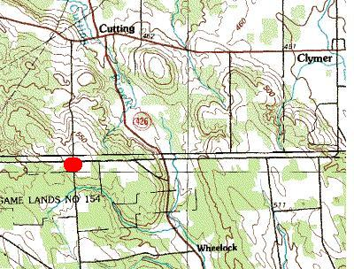
- Five Points – 1836 Feet ASL
- Carter Heights Golf Course 1800 Feet ASL
- Ridge West of Wattsburg – 1795
- Dowd Hill – 1730

*Information courtesy USGS GNIS Database

N3MLX Satellite Station
Hits the Air
By Joe Lis N3MLX

The satellite bug hit me this past May at the Dayton Hamvention when I bought a new Icom 910 H from AES during their “rain” sale. At the Breezeshooters Hamfest, I was looking for some satellite equipment, but had no luck. One Sunday morning I was at a Six-Shooter breakfast at Meeder’s Restaurant in Ripley and I talked to Bob W3BBO and asked if he knew of anyone who had any satellite equipment for sale. He said that he had a whole setup and was interested in selling it. Thus begins a new frontier at the N3MLX QTH.

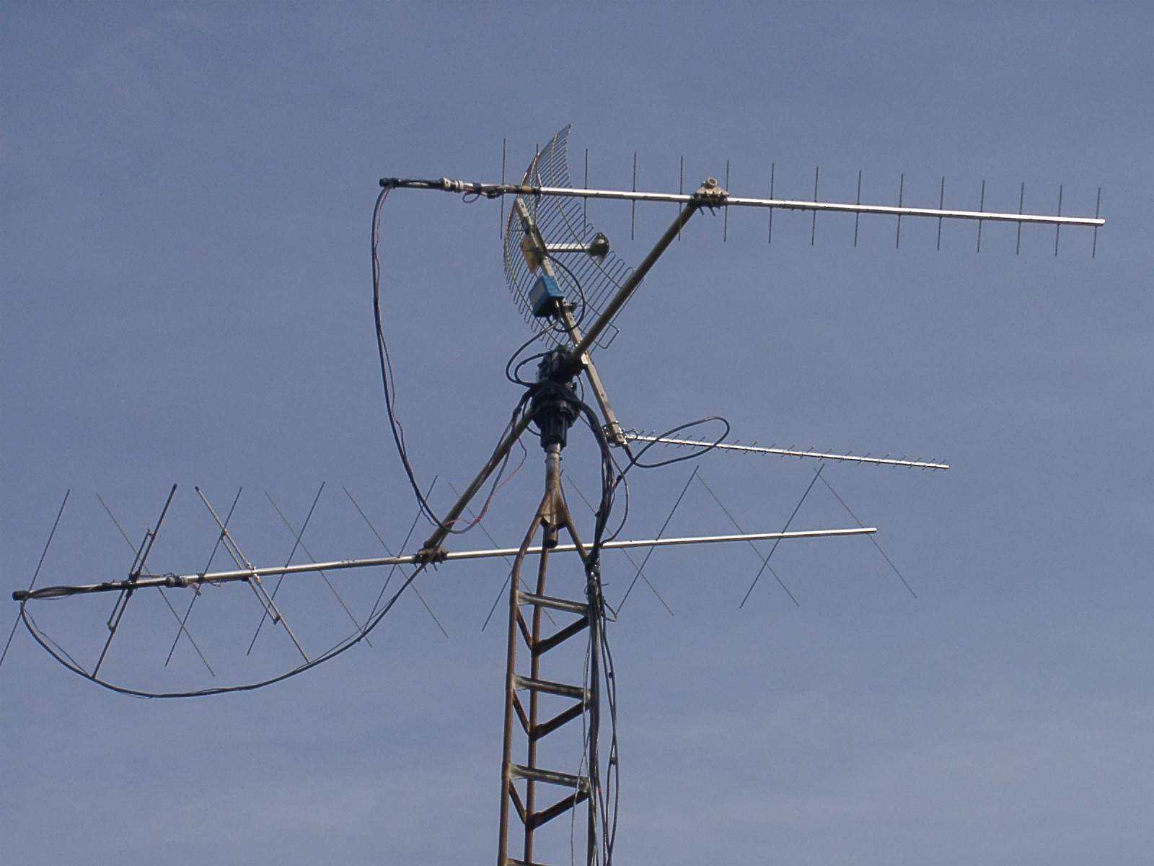

The preliminary equipment for the satellite station consisted of a 16 element cross-polarized beam for 144 Mhz, a 30 element cross-polarized beam for 435 Mhz, a Yaesu azimuth/elevation rotor, and a 2.4 Ghz antenna and 2.4 Ghz downconverter.

The next project was to get this array up in the air. Luckily, our old satellite dish pole came in handy. We attached a spare tower we had to the pole. At the 23 foot level, there is a hinge that allows the array to be lowered so that work can be done on the roof. A 75-pound sandbag placed at the bottom of the tower acts as a counter-balance for the system of antennas.

After getting the array setup, my first contacts were EA1IW from Spain, W3NBJ from Baltimore, K6CCC from grid DM14 in California, and PY1DGV in grid GG87 in Rio DeJaniero, Brazil.

Since my first contacts, I have done a lot of tweaking to the system such as adding a 1.2 Ghz module and 3 DSP modules to the Icom 910H, a RF protector to stop RF from going through the downconverter, the NOVA satellite tracking program that keeps track of satellite using the most up to date keplarian units from the internet, and the Kansas Tracker which interfaces with the Yaesu rotor to track satellites with accuracy to .20 degrees. With the original equipment I had, it was very hard to hear, tune, and track satellites all at the same time.

Satellite QSOs are quote interesting and I have received slow-scan tv on a couple of them showing pictures of ham shacks and antenna designs. My favorite satellites to work are AO40, AO10, and AO27.

Resources recommend for Reading:
The Radio Amateur’s Satellite Handbook by the ARRL
The OSCAR Satellite Report online at http://www.hampubs.com
AMSAT news and AMSAT Journal– http://www.amsat.org
(I prefer the OSCAR Satellite Report over the AMSAT news and Journal)

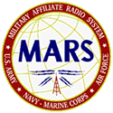

MEN FROM MARS
NOVERMBER 2001

Greeting to all Army MARS members and prospective members, this sure is a busy time of the year for the mission of MARS (Military Affiliate Radio System) but now that America is at war there are many more troops deployed now than in several years.
The phone patch stations are asked to submit weekly reports on overseas phone patch activity which are forwarded to Chief Army MARS and from what I understand are quite busy. Arnold AAT3JG/N3UBZ is the only authorized MARS phone patch station in this area and he along with several others here in PA are being asked to monitor as much as possible around the clock during this time of high alert. Stations in the operational areas are in different time zones and may call anytime they have a free minute.

Operation holidays is now in full swing with messages of greetings, encouragement and morale being accepted by any Army MARS member, if you do not have the address of a deployed service person, messages can be sent to “Any Service Person” and will be forwarded to a lonely and deserving solder.

This year MARS grams are being accepted for and sent to patients in Veterans Hospitals across the country again if you don’t know a Veteran in a VA hospital you can show your support and concern by sending messages to “Any Hospitalized Veteran” and help greet some person who has served their country and now needs some cheering up.

I would like to wish all readers of this article a Happy Holiday season and ask you to contact any local MARS member for sending a MARS gram. God Bless America…..
Army MARS – Proud, Professional, and Ready.

Jerry Owens
AAR3GF/W3GHO
PA Army MARS NW PA

NiCad and Gel Cell Care for Dummies
by Len Gelfand, VE3LGZ

(Courtesy Ottawa Valley Mobile Radio Club Newsletter – The Rambler)

CHARGING NICADS
Avoid overcharging. This practice is probably the most common battery killer.
As often as convenient, discharge the NiCad fully before charging to minimize the chance of overcharging, and, as some experts claim, a memory problem. Avoid recharging the NiCad after every partial discharge. NiCads, (unlike gel cells) aren’t harmed by being left in a partly discharged state. Avoid the temptation to continue charging a NiCad that doesn’t reach the fully charged voltage in the recommended time. It has one or more defective cells. You will only succeed in overcharging and killing the remaining good cells.
Instead, open the battery case (often difficult) and replace the bad cell(s). The replacements should be charged to the approximate state of charge of the other cells. This will postpone having to buy a new battery.

Use an intelligent charger
The best NiCad charging method is to use an intelligent charger like the one Bill Wilson, VE3NR, showed us at homebrew night a few years ago, or the many described in ARRL Handbooks and Amateur Radio periodicals. These chargers stop charging when they sense the small decrease in voltage that occurs when a charging NiCad is fully charged. The next best NiCad battery charging method is to use a constant current power supply. If you have one, you probably don’t need instructions. But if you are a beginner and decide to get one, here is what you do. Divide the Ah rating of your NiCad by 10. Set your constant current (constant Ampere) supply to this value. If the NiCad is fully discharged, charge for 14 hours, then stop. For example, many batteries for Amateur Radio handhelds with AA cells inside have a rating of 600 mAh. Set your constant current power supply for 60 mA (600 divided by 10) and charge for 14 hours.
The original power supply and battery pack of the ubiquitous HTX-202 charges this way.

Timing is everything
Why do you charge for 14 hours rather than 10? To fully charge a NiCad, you need to put about 40-60% more electricity into it than it will give out. If the NiCad is only partly discharged, you will have to guess the amount of charge (electricity) used and reduce the charging time proportionally. At this slow charging rate of 1/10 of the NiCad’s capacity, you won’t harm the NiCad by charging a couple of hours more than necessary. You can shorten the charging time by increasing the charging current but this requires greater vigilance and more knowledge. If you are a beginner, don’t try it without help.

Check the manufacturer’s instructions
If you don’t have an intelligent charger, or a constant current power supply, follow the charging instructions of the manufacturer. But if the instructions say you can leave the battery on charge continuously, be skeptical. Most chargers will overcharge and damage the battery if it is left on charge much longer than the recommended time. The safest tactic is to charge the battery for the length of time stated in the instructions and then stop charging.
If you don’t have the manufacturer’s instructions, or if you want to use a power supply made for another device, here is what has to be done. First, make sure the power supply delivers direct current (DC). It will have a label stating the input voltage that should be 115 V 60 Hz., and the output voltage and current. Don’t worry about the output numbers. Just make sure the output is DC. If it has no label, the output will have to be checked with a voltmeter. If the output is AC, the unit is not usable for battery charging.
Second, connect the power supply, through a meter to measure amperes (ammeter), to the battery that isn’t fully discharged and has all its cells OK. Make this connection only long enough to get a reading on the meter. The positive wire from the power supply must be connected to the positive of the battery and the negative to the battery’s negative. Making the correct connection will require some fiddling because of the variety of connectors and polarities. It’s easy to damage the power supply, battery, and meter. Get help if you aren’t certain that you can do it correctly.
Third, divide the Ah rating of the battery by the amperes shown on the meter in the previous step. Multiply this value by 1.4. This is the number of hours you should charge the battery. If it is less than 10 hours, get advice from someone knowledgeable before you use this power supply as a charger. Faster charging increases the chance of damaging the battery.

Reminder From the FCC
to those using the Digital Modes
Be sure to identify properly when operating digital modes: The ARRL reminds operators who are active on the digital modes, including RTTY, PSK31, packet, PACTOR and AMTOR, to identify properly in accordance with FCC Part 97 rules (§97.119). The rules require a station (except space or telecommand stations) to transmit its assigned call sign on its transmitting frequency at the end of each communication and at least every 10 minutes during a communication. Part 97 also states: "No station may transmit unidentified communications or signals, or transmit as the station call sign any call sign not authorized to the station." Amateurs monitoring unidentified or otherwise suspicious digital transmissions should report details to FCC Special Counsel for Amateur Radio Enforcement Riley Hollingsworth. Recordings of such transmissions also are invited.
- Courtesy ARRL Web
The following addresses are being removed from our mailing list because the mail is being returned as undeliverable:
KB3CZE@nwestpa.net and fulltime297@webtv.net.
If you know KB3CZE or W3AGI, please let them know that the mail is being rejected by their respective isp.

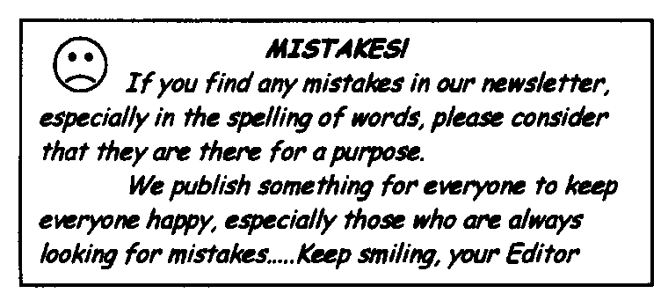
Courtesy Anchorage Amateur Radio Club – Thanks to Bill Thomas KL7KI

2002 APPLICATION FOR MEMBERSHIP IN THE RADIO AMATEURS OF CORRY 2002

Name_______________________________________________ Call______________ License_____

Address_____________________________________________ Phone Number_________________

City___________________________ State_______ ZIP____________ ARRL Member (yes / no)

e-mail address_______________________________ personal web site address:_______________________

We maintain a list of member's favorite interests in the Club database. If you care to, tell us some of the things you like to do. This could be radio or non-radio related. (some of the ones we have received include: computer, gardening, antennas, skywarn, traffic nets, woodcarver, etc.)

Interests:__________________________________________________________________________________

Mail along with $5 dues for 2001 to:

RADIO AMATEURS OF CORRY
P. O. Box 362
Corry PA 16407

==================================tear here========================================

The RADIO AMATEURS OF CORRY
P. O. Box 362
Corry, PA 16407

This newsletter is published quarterly

Editor, Robert E. Bair W3HDK (739-2206)
Staff: John Lis, N3NKV, Assistant Editor
Jerry Owens, W3GHO, Reporter

Submit material for the next issue on/or before
FEBRUARY 28. Next issue is March 13, 2001.

<<<<<E-mail articles to wa3hdk@arrl.net>>>>>

Club meetings are on the second Tuesday of each
Month at 7:30 p.m. at the American Red Cross Building
in Corry.

Club Officers--
President, Ralph Miller, N3LXG (489-0242)
Vice President, Dan Fargo, KB3EMH (663-5170)
Secretary, Jerry Ownes, W3GHO (664-7502)
Treasurer, Mike Dziubkowski N3GCY (664-7189)

