 TheRADIO AMATEURS OF CORRY
VOLUME 5 No. 2 JUNE 1999

INTERESTING QSO’S
A LOOK AT HAMMING IT UP

To me, there’s nothing more satisfying than being the first to talk to someone, especially if it’s CW. If it’s a QRP station, that’s a real bonus. In November of ‘98, I was about to call it quits when I heard a signal, just barely out of the mud. WA3ENK was in State College, and running QRP. Rod was excited, he had just finished building the rig, and wanted to see if it worked! He built the rig to give to his son for Christmas.

Conditions changed rapidly, and Rod faded out on me before I got an answer about whether or not his son had seen him build it.

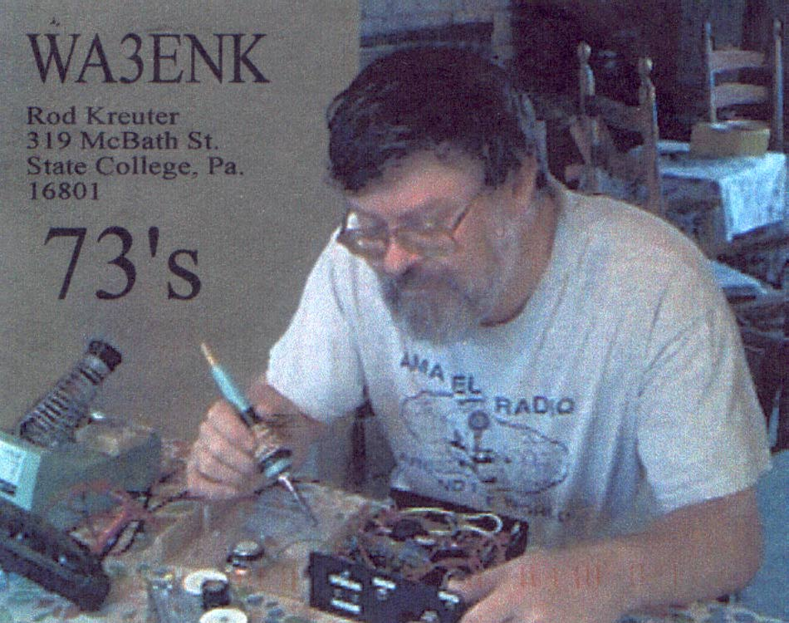

When the QSL showed up, it didn’t seem to matter. There he was! A picture of Rod building the rig right on the card. Maybe this contact wasn’t very far, but it was still a blast, and one of these days I’ll run into Rod at a Hamfest and get a chance to find out if his son did in fact watch him built it. Maybe his son took the picture! I love this Hobby!
- Ron Reiff, KB3BYP

I Haven't Lost My Mind, It's Backed Up On Disk Somewhere!

WWCB PROJECT NEARLY FINISHED

I heard that during WWII when anything went wrong the thing to do, was to blame the GREMLINS from the KREMLIN. I'm sure the Russians had some similar statement. In radio, there are no Gremlins, but Murphy used to be a disc jockey! WWCB has had a series of Murphy's Law reminders since the beginning of the summer in 1997. That's when a sudden "downburst" caused tower number 2 to literally snap in half. Since then, we have been working on replacing the towers. The project really got off to ground this spring. Headed up by Dave Popovich, the project first was to simply prepare the site for tower re-errection. It seemed every other day some other new stumbling block forced delays to clearing the land, leveling things up, even being forced to move a 20-foot high embankment back over 60 yards!

As of this date, a planned open house for us "ham types" has been rescheduled three times now due to the delays in getting our back-up gear moved, the old building torn down, and a friendly visit from the folks in Buffalo. Our projected early summer date has proven to be more "ambitious" than we thought. Because of the nature of this BEAST, I have been forced to hold off setting a summer date for an open house.

There are still so many details to work out that it is impossible to guess about a date that would be good for us to invade WWCBville, and get a good look at the new transmitter building, the new towers, the phaser and some other extraordinary broadcasting stuff out there.

Bob had asked me to set a date, and it looks like I won't be able to do it at this time. If you would like a tour of the new WWCB plant, and a gander at our new production studio (very cool), I'm going to have to ask you to "Stay tuned" and we will pass the word on as best we can. I know I speak for everyone when I tell you that we're very excited about "showing" off Corry's new radio station. As I said, we'll keep you up-to-date through the usual "channels"!
--Ron Smith, KB3BYP

RADIO AMATEURS OF CORRY
Minutes
March 2, 1999

Meeting opened at 7:30 with Bob, W3HDK presiding. Other officers present were Vice President Leonard WB3AYW, Treasurer Mike, N3GCY, Secretary Jim, WT3O. The previous minutes of the February meeting were read and one correction was made as to who was in charge of the 1999 Christmas Party. The Treasurer’s report was given by Mike, N3GCY.

Committee reports:
The Christmas Party Committee has set a date for the second Saturday of December at the Dutch Treat.

The Repeater Committee Report was given by Bob, WA3HDK. He reported that he installed the new pre-amp on the repeater and said the repeater needs more adjustments. To be discussed at a later date. Also it was mentioned by Mac, W3BZJ that we need to give recognition to Will, KD3II for all the he has done up at the repeater site.

Picnic Committee: No report was given

Breakfast Committee: Chairman Jim, WT3O reports we need more volunteers to help with the breakfast. Volunteers so far are Leonard WB3AYW, Ron KB3BYP, Hal WD400X, Richard N3YPT, for first shift and second shift Bob WA3HDK, Jerry W3GHO, Mike N3GCY, Jim WT3O, and a few maybes.

Audit report: Lee WA3HJC volunteered to help Jerry W3GHO with the audit report on next Saturday February 6th at 1 o'clock.

Old business: We discussed the need to recognize John N3NKV for his good work with the new radio club web site. We also discussed different ideas for John to make the web site more interesting.

We have received member dues from 6 more members.

A motion was made by Lee WA3HJC and seconded by Leonard WB3AYW to pay the bills.

There was no letter sent to the S.T.A.R.S. giving them permission to re-coordinate the 147.090 repeater
in Buffalo.
A letter was sent out concerning the by-laws and will be discussed at the March meeting.

No report given by the Field Day Committee.

New Business: The Corry Fire Dept. sent a representative to our meeting to discuss there field day activity on June 27th. He said they will need approximately 14 volunteers to help. This will be in two shifts--one starting at 8 a.m. till noon and one from noon till closing of the activities. We need to discuss the times the volunteers will be needed for this event. This is the first time our club has been asked to help the Fire Department.

Jerry W3GHO suggested we need some vests to identify our selves during this event. He said he would check with Trusted Name to see how much vests would cost and give us a report at the March meeting.

It was discussed that the club pay the cost of video tapes ordered for viewing during future meetings. The motion for them was made by Norma W3CG and seconded by Leonard WB3AYW and the motion was carried.

A motion to adjourn was made by Jerry W3GHO and seconded by Leonard WB3AYW at 8:43 local time

Respectfully submitted,
Jim Adams, WT3O, Secretary

___________________________________________________________________

RADIO AMATEURS OF CORRY
Minutes
April 6, 1999

Meeting opened at 7:30 with Bob, WA3HDK presiding. Other officers present were Len WB3AYW, Vice President; Mike, N3CGY Treasurer; and Jim, WT3O Secretary.

The March minutes were read and accepted. The Treasurers report was read. The March Electric bill was double and was discussed by the membership.
(Continued on page 3)

He who hesitates is not only lost but miles from the next exit.

April 6 Minutes (continued from page 2)

Old Business:

Bills for Hamtronics and the repeater council were turned in for payment. A new lock set was installed on the repeater building.

The newsletter committee brought up that we need someone to help with the newsletter and maybe to take over in the future. Bob wants to publish the newsletter early so we can get out the information on the summer club activities.

Ron Ploss has volunteered to be field day chairman. Ron will provide the generator and a radio. Also Bob and Len will donate their radio to be operated during field day.

The fireman field day was discussed. We need help. Ned KB3CZE volunteered to help and also bring his firemans radio. Plans were discussed and anyone wanting to help contact me or one of the officers.

The Titusville parade will be held third Saturday. in August and Mike is in charge. He also needs help with this project.

New Business:

Life membership was discussed. We agreed to give life membership at 20 times the regular dues to be voted on later. We also discussed moving the meetings at the Red Cross to the second Tuesday of the month. Quentin will check with Daniel to see if we can hold the meetings at the Red Cross on that day. This will be voted on later.

We discussed that in the future audits of the books we need 3 people on the audit committee. This was voted on and passed.

Bob wants someone to take the net at the Red Cross next Thursday to test the emergency rig there.

The 50/50 was won by Len WB3AYW and turned back to the club. Quentin, W3AHH made a motion to close and was seconded by Ed KB3CZE. The meeting closed at 8:30.

Respectfully submitted,
James Adams, WT3O, Secretary

Corrections:

The last newsletter had a few proofreading errors. Guess you can blame it on my poor eyesight. On page one, the word sounding was hyphenated. On the second page of the roster, there was an “I” added to WT3O’s call and in the roster, the call of K3HJQ was not purged from the list. (He was a 1998 member). On page 10, I left an “A” out of my own call, and omitted a parentheses after WT3O’s phone number. Finally, the call letters of the Corry radio station is WWCB, not WCCB which is a station at Clarion University of PA. If I had a co-editor, maybe we could get it right!

___________________________________________________________________

Membership additions:

Please add the following to your membership roster which was in last month’s newsletter. (You did save it, didn’t you?) I apologize to Ed Kulesa, N3XBA for omitting his call sign from the membership roster. His information is tabulated along with the new members list.

Edward M.. Kulesa, N3XBA (Technician)
P. O. Box 305
Union City, PA 16438
(814) 438-3262

ARRL Member
Leonard J. Migliaccio, N3XSR (Technician)
263 Worth Street
Corry, PA 16407
(814) 663-4661

Corry A. Migliaccio, N3XFS (Technician)
263 Worth Street
Corry, PA 16407
(814) 663-4661

James Adams, Jr. KC2FBP
- O. Box 94
Ashville, NY 14710
(no telephone)
_____________________________________________

For Sale: 1982 Holiday Alumalite 32’Motorhome. Chevy 454, auto transmission, 54K miles. $8500 OBO. Bob, WA3HDK. (814) 739-2206. Also have three overhead garage doors with track—cheap.
Firemens Field Day:

This year, June 27 marks the first time for the annual Firemen Field Day. Its also the first time that we have been asked to give our assistance. We should feel quite proud that they have asked us to help.

They will need 2 shifts of 5 to 7 hams with either handhelds or mobile rigs. The first shift to start around 8:00 am and finish around 12:30. The second shift to come in at 12:30 to about 5:00.

We don't know how well this will work as it's the first time for us all. Also I understand there will be refreshments provided for us. So would you please call me or Bob if you can help. We already have a few volunteers but we need more. Thank you.

PS. Remember that this is what our club is all about
--Jim WT3O

_____________________________________________

VFW Breakfast:

Well we did it again! We out performed ourselves. The last breakfast we sponsored at the VFW in December was on we thought could not be exceeded. Well to our surprise we had a better one this time. Even the VFW was impressed. All of us in the kitchen were extremely busy.

So the BIG thank you goes out again to all of those who are so good about helping with these projects to keep our club healthy, especially those who drove a long way to get here. Also to the six shooters group who came to patronize our project. The next one is to be held in February of 2000, so mark that on your calendar.
Jim WT3O
_____________________________________________

AH, SPRING

Spring has sprung
The grass is riz
I wonder where the boidies is

The boids is on the wing
Now aint that absoid
I always thought the wing was on the boid
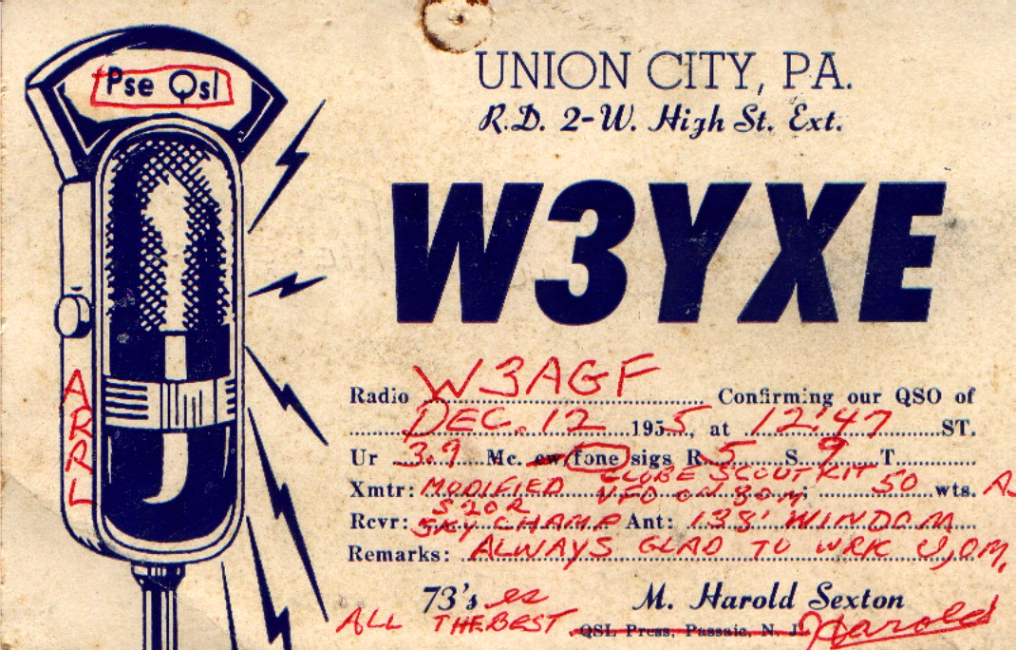

This 1955 QSL Card was forwarded by Cecil, W3AGF along with his correspondence. A note on the back says “This is my prize. From Harold S. -- he showed me the first ‘ham’ license I ever saw. That was before 1955.

Letters to the Editor

Dear Bob and the rest of the RAC,

I am sending a few snapshots as I am not gaining in the health department and don’t expect to make it to Corry in the summer of 1999.

I am on aerosol inhalers which are supposed to last six hours. I now get less than four and am loosing ground. It seems that my days are numbered—a smaller number than I would like to have it, believe me!

I would like to leave a verse of scripture with you—John 14:6. “Jesus saith unto him, (speaking to Thomas) I am the way and the life. No man cometh unto the Father but by me.” This is the only way to Heaven—right in a nut shell as they say.

I suppose I should leave it at that, but I have a few more sheets of this paper. Will write more if I can think of anything.
For now, As ever,
(s) Cecil W3AGF
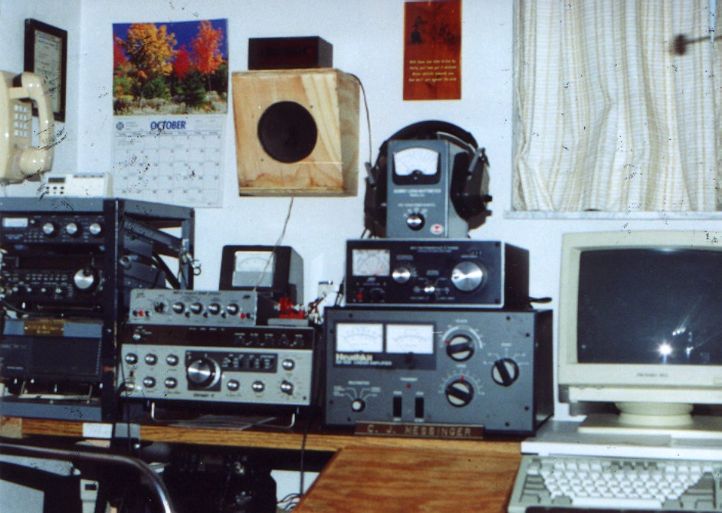
This is a picture of Cecil’s current shack
FLY-IN IS SUNDAY JUNE 13

In Memory of

Dorothy E. Cutshaw
(XYL of KE3PD)

1931 -1999

RAC TO HAVE COMMUNICATIONS TEAM ON HAND

The Corry Fly-In Breakfast Committee has formally asked us for help. As last year, the amateurs are being asked to work with airport officials to provide ultra high quality communications. We might even get to talk to a few mobiles this year. Set for June 13th, rumors of a summer without a fly-in breakfast were just that, rumors. We just received a news release that tells the whole story about the 1999 event. Not only is the fly-in set for sure for the 13th, the plans are to accommodate those who miss much of it because of religious commitments. This year the fly-in is being extended from 8 a.m. to 1 p.m.

The 6th annual Hubert S. Vaughn Memorial Fly-in Breakfast is sponsored by the Corry Area Chamber of Commerce, the Corry Rotary Club and the Kiwanis Club of Corry. Proceeds from the breakfast are used to provide a $500 scholarship to a Corry High School student planning to attend college or a technical school. This year we will award our 6th scholarship.

Persons attending will get an opportunity to see a wide variety of home built, factory built, antique and classic aircraft and possibly a retired military warbird or two. Peak hours for aircraft arrivals are 9 a.m. till 11 a.m. The committee has issued a special invitation to air bear to come and visit the children and a stat med-evac medical helicopter is planning to attend.

Over 65 aircraft attended last year’s breakfast and over 600 Breakfasts were served. The public is invited to attend and enjoy a delicious breakfast. Cost of the breakfast is $ 5.00 for adults and $ 3.00 for those over 65 and under 10.

This event is held rain or shine, so if the weather is inclement we still need the support of the public to be able to continue to provide the scholarship.

Chairman for the event is Mike, N3GCY. In a telephone conversation with him, he indicates that he is planning to set up an information booth. The booth will have a rig or two set up—HF, VHF, and/or UHF. If the arrangements can be made, there may be an ATV station set up. There will be some pamphlets to pass out and lots of volunteers to man the station. Call Mike at 664-7189 if you can help.

SUMMER PICNIC IS
SATURDAY JUNE 19

Red Top Pavilion in Mead Park is again the site of our annual picnic. Once each year some of the best cooks set out some really good eatin.’ You don’t want to miss this one!

You and your guests are invited to partake. Here’s what to expect. We will begin assembling at the site around noon. Someone always gets a charcoal fire going in the barbecue pit. You can cook your own burger, steak, or hot dog until it is just perfect. Bring a dish (entree or dessert) to share with everyone, your own place settings, and any additional meat or drink that you would like. In the past the club had sometimes provided beverages, but the last time I said that in print, nobody made any effort to do that. So, bring your own and play it safe. Along about one o’clock we will sit down to eat and share tall stories. Like so many activities, there has not been much planning. (Boy, I sure would like to have the plans made before the newsletter goes to press!) The only thing I do know is that the casseroles supplied by everyone are worth the trip. See you there!
_____________________________________________

RADIO AMATEURS OF CORRY
Minutes
April 6, 1999

Meeting was brought to order at 7:30 by President Bob WA3HDK officers present were Vice President Leonard WB3AYW,Treasuer Mike N3GCY, and Secretary Jim WT3O and there were 13 members present. Minutes of the April meeting were read (there was no treasurer’s report given).
(Continued on page 6)

April Minutes (continued from page 5)

Committee Reports:
Repeater Committee: Secretary, WT3O brought up the electric bill that was doubled in January. Mike N3GCY was going to check with Penelec to see if they could put a monitor on the electric meter.

Picnic committee: There was no report on this.

Field Day Committee: Chairman Ron Ploss N3KLN was at work and no reports were available.

Breakfast Committee: report was given by WT3O and he reported the most successful one on record and thanked those who took the time to help.

Other Reports: The Breezeshooters hamfest coming up in June was discussed.

President Bob said he is looking for a volunteer to run the Red Cross radio on a net to test it out." No one volunteered to do it.

Old Business:
The voting on the by-laws is to be done in July. There were more additions to the by-laws. One was to change the time of the month to hold our meetings also life memberships was brought up. A motion was made by Leonard WB3AYW and seconded by Mike N3GCY that the life membership would be 20 times the annual dues. It was voted on and passed by the membership.

Also a motion was made by ED, N3XBA for the club to buy pop for field day and was seconded by Frank KE3PD. The motion was carried.

The firemen’s Field Day on June 27th was discussed. We are still looking for arm bands or vests to identify us and Mike and Frank said they will check when they go to Dayton to see if they can get any information on them. WT3O will check with Fox to see what they have to offer.

New Business:
Frank, KE3PD asked for permission to install a 220 repeater up at the 147.090 site. He will install a folded dipole antenna system for the repeater. The motion was made by Frank KE3PD and seconded by Mike N3GCY and the motion was passed by the membership with the stipulation that there will be no interference to the other repeaters.
WT3O made a motion to donate $50.00 to the Red Cross for the benefit of those who suffered the disaster in Oklahoma City and it was seconded by Frank KE3PD. The motion was carried by the members.

We have no information on the fly-in at the airport at this time. This was tabled to be discussed at the June meeting.

The 50/50 was won by Richard N3YPT. A motion was made by Bob K3SBU to adjourn and was seconded by Craig K3PLV. Meeting ended at 8:38.

After the meeting Craig, K3PLV presented a movie on the pioneer days of over seas amateur transmissions and the trials and tribulation of how it was done. The movie as very interesting. Thanks Craig.
_____________________________________________

PREZ SEZ

June, July and August are busy times. Not only do we have many family obligations, but the amateur radio calendar is full, too. For instance, June 4, 5, and 6 is the Rochester hamfest. June 13 is the Corry Fly-in Breakfast. The picnic is June 19 and Field Day is June 26 and 27. Also on June 27 is the Corry Fire Department’s competition. The Titusville parade is August 21. All of these activities have requested ham radio support. The local ham radio ranks will be spread very thin at this one.

Getting volunteers is hard to do. Usually the same half dozen people show up to lend a hand. The job is sometimes harder because advanced planning is not too well done. Sometimes new hams need to be groomed and made to feel welcome. Whatever the case, we depend on all of you to make an effort to work for the good of the fraternity. If you are not one of those who volunteer, take that first step and volunteer for some of these activities. If you do not know who to contact, call me or make a query on one of our nets. Try participating in our activities. If you are an ‘old-timer’ to our club, make a special effort to make the ‘new-comer’ welcome at our activities.

I’m afraid that I am beginning to sound like a broken record, but I must again stress the need for better planning of club activities. When a chairperson is appointed to an activity, one of the requirements of his/her office should be to pre-plan the event so that as many people as possible can participate. Everyone should have a chance to lend his hand if they want. Everybody should be notified of the upcoming event—preferably via the newsletter, but also by personal invitation where possible. We’re communicators, for gosh sakes—let’s act the part.

We’re including a ballot in this issue for you to voice your opinion about the proposed changes to our bylaws. You will notice that it is printed on the back of the address part of the masthead page. In order for your ballot to be valid, you should return the half-page containing the ballot with your mailing label on the reverse side. To insure a better return rate, I have included a self-addressed envelope. This required that we cut the pages to eight.

The Field Day coverage in this issue is quite abbreviated. There is no information available at press time. I’ll try to have information on the nets and there will be a discussion at tonight’s meeting, but that is the best I can offer now.

Have a good summer. I’ll meet you back here in the September issue. --Bob, WA3HDK
ATLANTIC DIVISION HAMFEST CALENDAR

OFFICIAL BALLOT

- Shall we amend the by-laws of the Radio Amateurs of Corry as set forth in the mailing made to all members? If you vote yes, the changes outlined in color on the mailing will become our new bylaws. If you vote no, the old by-laws will be retained.
YES
NO

The following changes have been suggested to the committee and are presented here for your vote.

- Shall we amend the by-laws to specify the meeting night to be the second Tuesday of the month?
YES
NO

- Shall there be a provision in the by-laws for a life membership which will be 20 times the current membership dues? The moneys will be invested so as not to deplete the fund.
YES
NO

- Shall we specify that the audit committee shall consist of 3 members in good standing selected by the president?
YES
NO
+ indicates ARRL Hamfest

JUN 4-6 + Rochester Hamfest - Rochester, NY
Atlantic Division / NY State Convention
JUN 6 + Breezeshooters - Butler, PA
JUN 12 + Columbia-Montour ARC - Bloomsburg, PA
EPA Section Convention
JUN 12 + Skyline ARC - Cortland, NY
JUN 20 + Frederick ARC - Frederick, MD
JUL 3 + Murgas ARC - Wilkes-Barre, PA
JUL 4 + Harrisburg RAC - Bressler, PA
JUL 10 + Genesee Radio Amateurs - Batavia, NY
JUL 11 + Mid-Atlantic ARC/ alley Forge - Kimberton,PA
JUL 11 + North Hills ARC - Pittsburgh, PA
JUL 17 + Jonestown Mountain RA - Beach Haven, PA
JUL 17 + Utica ARC - Frankfort, NY
JUL 25 + BRATS - Timonium, MD
AUG 7 Juniata Valley ARC - near Lewistown, PA
AUG 7 Auburn ARA - Weedsport, NY
AUG 14 + Rome RC - Westmoreland, NY
AUG 15 + Greater Buffalo Hamfest - Depew, NY
AUG 15 + Jersey Shore ARS - Bayville, NJ
AUG 15 York Ham and Computer Swap Fest - York, PA
AUG 21 + Fingerlakes / Tompkins Co. ARC - Ithaca, NY
SEP 11 + RA of Erie - Erie, PA
SEP 12 + Butler Co. ARA - Butler, PA
SEP 12 Kent Co. ARC - Felton, DE
SEP 18 + Buffalo Hamfest - Hamburg, NY
WNY Section Convention
Updated May 20, 1999
JUNE IS AMATEUR RADIO
AWARENESS MONTH IN PA

Governor Ridge has proclaimed June as AMATEUR RADIO AWARENESS MONTH in Pennyslvania. In his proclomation, he noted the 25,000 licensed hams in the state who provide service during times of natural disasters, local emergencies, and at public events.

The full text of the proclomation can be viewed via the ARRL Atlantic Division web page, http://www.bfdin.com/atlantic/index.htm.
______________________________________________________

FAVORITE INTERNET SITES

It has been suggested that we publish a column each issue listing some ‘neat’ internet sights. I’m willing to do this but I am going to depend on your submitting the material. To get you started, here are a couple of my favorites.

Http://www.aesham.com/index2.html Amateur Electronics Supply site. Check out prices. Other links.
Http://www.amradiotrader.com/ Electronic ver-sionof their classified magazine. Other links

_{The} RADIO AMATEURS OF CORRY
P. O. Box 362
Corry, PA 16407

This newsletter is published quarterly

Editor, Robert E. Bair, W3HDK (739-2206)
Staff:-- Jim Adams, WT30
Ron Rief, KB3BYP

Submit material for the next issue on/or
before August 15. Next issue is September 6.

Club Officers--
President, Bob Bair (739-2206)
Vice President, Leonard Shick (438-7199)
Secretary, Jim Adams (664-8140)
Treasurer, Mike Dziubkowski N3GCY (664-7189)

QUICK TAKES
Arnold N3UBZ, is experimenting with the new digital mode, PSK31. It is a very narrow rtty-like packet system that interfaces to your sound card. No other tnc is needed. I watched his screen as the signals faded into oblivion and the thing still copied the signal with near perfect results. It doesn’t seem to be as fast as other modes, but this may have been due to the sending station’s slow typing rate. Look for details on the system May 1999 issue of QST.
____________________________________________________________

Vanity update: The FCC in Gettysburg reports it has processed vanity call sign applications received through May 7. On May 26, the FCC issued 187 grants. Another 269 applications landed in the work-in-process (WIPs) stack. The FCC received 1431 vanity applications during the month of April, 1276 of them electronically filed.--FCC
______________________________________________________

Call for articles. We are always looking for material for the newsletter. If you have a favorite activity, consider writing a short article about it. Submit via internet, packet, on disk, or even handwritten text is acceptable.

