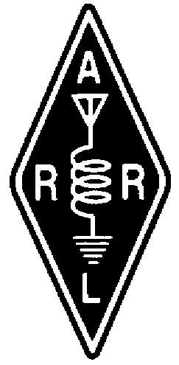 tHERADIO AMATEURS OF CORRY
VOLUME 2, No.4 DECEMBER 1996

______

THIS MAY BE YOUR LAST ISSUE!!!
by Bob WA3HDK
How often we see that on catalogs from the various firms that haven't received orders from us recently. Most of the time the catalogs just keep coming . . . every week or two! But that won't happen to your club newsletter. If you haven't renewed your membership to the Radio Amateurs of Corry, you definitely will not get the next newsletter. We sure would like to send copies to each of the thousand or so hams in the local area, but we simply cannot afford to do that. Each issue you get in the mail costs the club about 73 cents. If you get your issue at the club meeting, you save us 23 cents for postage. That means that almost $3 of your $5 membership contribution goes for the newsletter. The remaining couple dollars is used mostly for the operation and maintenance of the two repeaters we operate.

I'm not complaining, mind you, or asking for the dues to be increased. We are doing quite well with what income we have and member contributions are fantastic when (or if) we have a crisis. I, for one, am proud that we have the lowest dues of any club around. And our two repeaters serve as well as those in high dues clubs.

But, I digress. Take a look at your mailing label. It has two important bits of additional information that may interest you. To the upper right of the label, is your membership year status. If a "97" appears here you will get the next issue. If a "96" is there you will not get the next issue. Immediately to the right of the membership year you may see the letters "ARL" or "ARLL." The first code means that you are a member of the ARRL and that helps us to qualify for the ARRL affiliated club status. The "ARLL" flag means that you are a life member of the ARRL.

If there is any information on the label that is incorrect, please let me know via the post office box or on air so that I may correct it in our database.

And finally, there are some newsletters that do not get delivered because we do not have your current address. Please remember that if your address changes, the post office may not forward your newsletter. Don't take a chance of missing anything!! Check your label now and notify us of any error you may find.

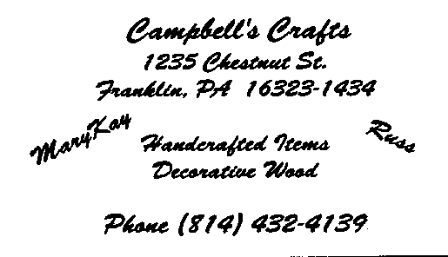
_____________________________________________________________________________________________________________________________

Ancient Mary, alive or dead?

You ask, who uses AM, other than CB'ers? Well there are many local hams that are still active on the "Ancient Mary" mode! It is one of those modes that is still used frequently on 160 meters and 80 meters in the HF bands. Listen in on those Bands and you may be pleasantly surprised. Hold on! What about other bands? Well, you might catch someone on 40 meters on occasion. Well, what about VHF? Ah! the secret is out! Locally there are two rather active Nets on VHF. There's the 6 Meter AM net on Wednesdays at 7:00 P.M. at 50.400 Mhz. There have been check-ins on the net as far away as Alabama! Let's not forget 2-Meters! There's an active net in the area on 144.450 Mhz. We get hams from all over the area who check into this one! They are mostly in the Erie area, however we do get check-ins from as far away as the Buffalo area, and Detroit area and many from Westfield, Ripley, and even Jamestown areas.

You ask, "What do I need to get involved with the AM mode on these frequencies?" It mostly depends on the size of your Amateur Radio funds, or "mad money"! We had a case of one ham in Erie who got on 6-meter AM using a Heathkit "lunch box", for $2.00 from a yard sale, a borrowed crystal, and a home made Dipole antenna! With 2 to 3 watts of power, he reaches from Lake City to Westfield! The other extreme is an Icom 706 for $1250.00 and up! Your choice!

Used Heathkit, Gonset, Hallicrafters, Polycomm, Utica, or even home made gear can be used. Check under the tables and in the boxes at hamfests. You may find a treasure for $5.00 to $10.00 that only needs a little TLC, a crystal, and an antenna. Tranceivers in excellent working order sell for $30.00 to $100.00+ depending on condition and accessories, microphone, VFO, etc. Transverters from Hamtronics, Ten-Tec, Down East Microwave, and others, can be used with HF or other gear that has AM capability. Oh, by the way, the preferred antenna polarization is Horizontal! 73, and happy AM-ing!
--Bob, N3LBI

I NEVER MET HERVEY, BUT....

When I first started on packet, all I knew was that you had to type "X-WA3ZCA" to connect. It never occurred to me that WA3ZCA was a person. It just worked. Then I found out that this WA3ZCA was what was known as a sysop. It was funny. Every time I made an error, the sysop got in touch. I came to relate the word sysop with Cyclops.. . . imagining this man with one eye glued to a screen waiting for mistakes to appear. Whenever a message came back and it was from WA3ZCA it was oh no-not another one from the "dreaded Cyclops." What did I do now? Finally I learned that this remote and God-like sysop had a name--Hervey! I also learned that Hervey took his role as sysop to heart and he was only trying to help. He once said he was trying to run the best BBS. I tried other BBS systems. Fact is, his was the best. Hervey was probably the kind of person who tried to do the best he could do at any job. Maybe I was overly sensitive. I learned a lot from Hervey. In fact it came to where I would send Hervey a message asking for his assistance and he was no longer the "oh no, the dreaded sysop." Hervey and I had one short lived falling out. I commented on Clinton and it wasn't positive. Another quality I found out about Hervey was that he was passionate about his politics. Me too. So we had a little exchange. We finally agreed to disagree. Nothing more was said about the matter. Then one night I was listening to the radio and someone mentioned his name was Hervey. I knew it had to be him! How many people have the name Hervey. A skywarn net was coming up so we only spoke briefly. A "hi, how are you and talk to you later" type of QSO.

Weeks later Hervey tried to connect direct on packet. I had no idea what to do and botched it up. He tried again a few weeks later and we connected direct. It was so cute. He was typing "Yoo hoo" and all kinds of things to get my attention. By now I knew what to do and we had one terrific conversation on packet. It was JUST a conversation and Hervey turned out to be a real nice guy. He arranged to meet with my hubby at the Erie Hamfest. He described himself. I knew Gary could never miss him. I pictured Hervey-a limber tree with a ball cap and the letters WA3ZCA. He would tower over everyone. Unfortunately Gary didn't get the pleasure.

So for you Hervey, WA3ZCA, I have to say I never met you but I wish I had. I know that when I read "welcome to the BBS and have fun" you meant it. You weren't the dreaded Cyclops. You were a man who intended to do the job well and felt passionately about what was important to you. TNXS. de N3XFQ@WA3ZCA.#NWPA.PA --Patty Sarver
PRESIDENT'S CORNER
73's
HERVEY E. WASHBURN, JR.
1925 -1996

Well, 1996 is gone and a Happy New Year to all our members and families. Time sure flies by but we had a good year with each monthly meeting having a good turnout. The breakfasts at the VFW have been quite successful. 1996 has been a good membership year, too with a roster of 85 members.

Many thanks to everyone for serving on committees, participating in the nets, and the many donations of time and money, and for the fellowship we have shared throughout the year.

Let's welcome the new officers--WB3AYW, President: W3GHO, Vice president: KE3PD, Secretary; and N3GCY, Treasurer. And, of course, thanks to the outgoing officers who have faithfully served this past year.

Remember the club meetings each first Tuesday of the month. Our club is what you, the members, put into it. Your attendance and contributions of talent and ideas determine the direction of the club. Make sure that you make known what you want the club to be.

I've enjoyed the past year very much and a special thanks goes out to all of you who offered the prayers and well wishes for Dorothy. 73's
--Frank Cutshaw, KE3PD
_______________________________________________________________________________________________________

LETTERS TO THE EDITOR

Dear Bob,

We are getting well settled into winter here, with snow on the ground and below zero temps last week. But it was up close to freezing today and I rode my mountain bike up our neighborhood mountain, taking my HT along in a fanny pack. Carol had our mobile two-bander (just purchased at a hamfest about a month ago) at home. We checked both rigs out on a couple of simplex freq's. I called from three different places enroute, one of which was out of sight. We look forward to more simplex uses for the radios.

I thought you might like to see another ham radio newsletter--one that has part of the story of our trip in it.

If you sent us a copy of the Corry hams' newsletter with your story about us, we don't have it--either misplaced or never got here. We'd enjoy having a copy.

By next summer, we hope to be truly mobile, either in a car or on a bike, with our rigs. Remote PTT's, ear mikes, and antennas are high on the list of "mobile" equipment needed.

That "bump" mentioned in the article was not the reason ;my HT wouldn't make our local repeater squelch. It was because the PL tone had been erased somehow. We are learning. Hope to meet again someday. 73's

--Dave (WL7CRD) and Carol (WL7CRE) DeVoe
LETTERS TO THE EDITOR, CONTINUED

Howdy everyone;

As you all know, the bbs has been down. Fortunately, it's back up again. Our sympathy goes out to the family of Hervey (WA3ZCA) who died a short while ago. When we first started in packet we made plenty of mistakes. Sysop Hervey would send me strong messages about my mistakes. I was to the point of getting very upset.

We then decided to ask questions so as not to make so many more mistakes. With the answers that Hervey gave us came an understanding of why he came on so strong. He took his job (his hobby) very seriously. After weeks of questions and answers we became good friends and we typed to each other on a regular basis. We even made arrangements to meet at the Erie Hamfest.

I went . . . but to my disappointment, I did not meet Hervey. Little did I know that he had been hospitalized a few days before.

I still have all the papers that were printed off back and forth. It's tough to lose a friend who was a part of our lives for too short of time. Thank you Hervey for teaching me, showing me, and most of all being, a friend!
--Gary N3WNP

BEST WISHES FOR THE NEW YEAR

WT30
Jim Adams
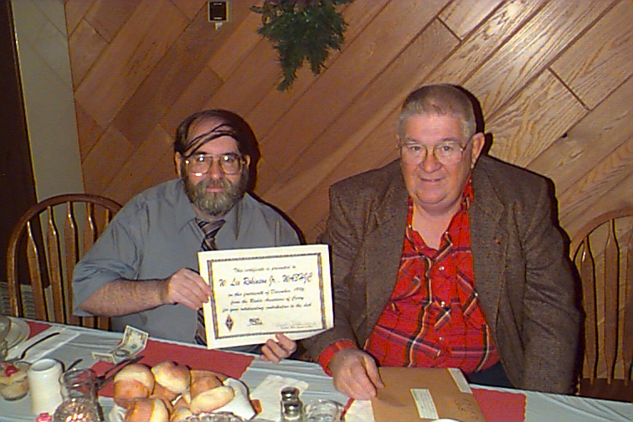

Lee Robinson, WA3HJC with certificate he received for chairing Field Day and Bob Swarm K3CKO (ex N3UDR) who also received a certificate for his chairing the Boy Scout JOTA activity.

N3UBZ MEETS EVERY RAC NET IN 1996

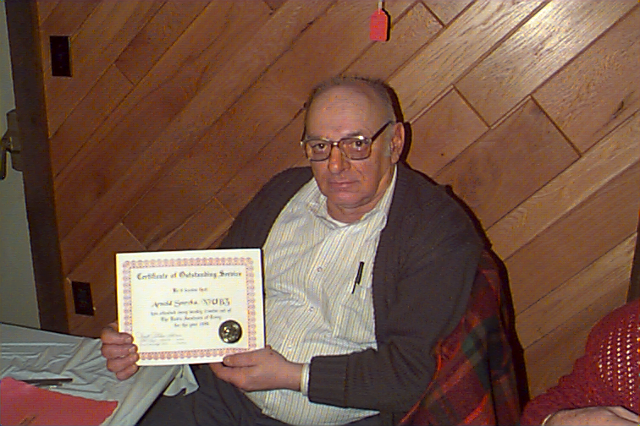

Arnold Smrcka, N3UBZ has the distinction of being the only one to meet all of the 10- and 2-meter nets since the formal keeping of the roster began in December of 1995. He was presented with a Certificate of his achievement at the 1996 Christmas Party. Arnold is also active on the MARS frequencies where he is often net control station. A ham for only a year, he now sports an extra class license. Our hats are off to you!!
___________________________________________________

W3CG ATTENDS PA QSO PARTY SYMPOSIUM

The Pennsylvania QSO Party Dinner/Symposium which followed on the evening of the RAE Hamfest, was held at Erie Best Western Restaurant, with Chris Robson KB3A serving as Master of Ceremonies Guests of Honor were ARRL Atlantic Division Director Kay Craigie WT3P, Vice Director Bernie Fuller N3EFN, and Western Area Section Manager Bill Edgar N3LLR. Club representatives were present from numerous counties in Pennsylvania, and it was fun to be able to put a face with the call signs that become familiar to us during the QSO Party.

The PA QSO Party is sponsored by the Nittany Amateur Radio Club of State College, and many of the various awards are sponsored by some of the participating clubs.

Doug Maddox W3HDH, Chairman of the event, invited suggestions and reported on changes which will be made, commencing with this year. The W3YA Special Event Station will be circulated around the state, and this year, will be handled by the Delaware Lehigh ARC at Wind Gap, Pa., using their club call W3OK.

The fun event is held on a weekend, each October, and scoring for QSO points is 2 points for CW QSOs on 80 and 160 meters and one point for CW contacts on other bands, and SSB/FM QSOs. Mobile operators are helpful in helping us gain counties where operators are scarce, and are masters at finding locations where two or three counties join.
___________________________________________________

FOR SALE: Radio Shack HTX-404 handheld transceiver and ICOM 229H 50-watt mobile rig. Will, KD3II. 654-7776
RAC MEMBERSHIP MEETING
SEPTEMBER 3, 1996
CORRY RED CROSS BLDG.

The meeting was called to order at 7:30 P.M., with Vice President Bob Bair WA3HDK presiding. Twenty two members were present.

Roll Call of Officers -- absent, Frank Cutshaw KE3PD.

Motion made by Bill Young W7RVY, seconded by Mike Dziubkowski N3GCY and carried, to accept the minutes as printed in the September Newsletter.

REPORTS

WA3HDK- New club member is David Haas N10SL of Lancaster, N.H.

WT3O- Picnic reservation has been made for June 15, 1997, at Stennett Pavilion, Meade Park.

WA3HDK- Christmas Party will be held at Dutch Treat Restaurant, Spartansburg, on December 14. Family style dinner with menu of Swiss Steak and Turkey will be served at 6:30 P.M. Cost of $10.50 includes tax and gratuity. Mike Dziubkowski N3GCY appointed Master of Ceremonies. Norma W3CG will assist.

N3GCY- Titusville Parade communication volunteers were Bob Bair WA3HDK, who served as Net Control, Cecil Messenger W3AGF, Bob Dziubkowski K3SBU, Ann Dziubkowski N3VHV, Francis McCray W3BZJ, Hugh Householder N3MBR, Mary Householder N3QCR, Jim Adams WT3O, and Mike Dziubkowski N3GCY, Chairman of Parade communications.

N3TYF & K3CKO - JOTA, scheduled for October 19 & 20, will be held at Elgin Park. Volunteers are requested for operators and equipment. QSL cards and Certificates will be supplied to the operators and QSLs will also be furnished to the Boy Scouts for their use. Food for radio operators will be furnished by the Scouts.

WT3O- VFW Breakfast date is November 3, and volunteers to sign up with Leonard Shick WB3AYW.

WT3O- 50/50 tickets to be sold are available from Jim Adams WT3O.

N3TYF - Tower guy wire job is done. Volunteers were Harold Cole WD4OOX, Gerry Owens AB3X, Jim Adams WT3O, Don Swarm N3TYF, Mike Dziubkowski N3GCY, Lee Robinson WA3HJC, Cecil Messenger W3AGF, Leonard Shick WB3AYW, and Bob Bair WA3HDK.

N3TYF & W7RVY - Radio Classes will be sponsored by the Union City Wireless A.R. Society. Classes for Novice and Technician will commence on Thursday, September 12, at 7 P.M., with exams to follow, scheduled for November 14, at 7 P.M.
N3QCR- Emergency Volunteer Vests may be ordered from Mary Householder N3QCR. Cost is $19.00 for the general model and call signs will be additional. Vest modeled by Hugh Householder N3MBR.

WT3O- 440 repeater parts have been obtained and repair is to follow. Assurance given by former tower owners, Hopkins, that continued tower use has been granted for as long as the club has need of it. Requested that Radio Shack scanner, $149.95 on sale for $99.95 plus tax, be purchased for Mr. and Mrs. Floyd Hopkins.

K3SBU- offered used scanner and offer rejected.

WT3O- requested that a new Award Committee be appointed.

WA3HDK- NEWSLETTER - Mike Dziubkowski N3GCY volunteered to be on staff. Bob Swarm K3CK0 to write the personality items. Gerald Owens AB3X to write MARS. Public Library to be added to mailing list, and copy to be left for Red Cross. Jim Adams WT3O suggested that a different name be given to newsletter, and membership interest centered on leaving as it is. Space offered for inclusion of Union City Wireless A.R. Society news. 80 copies of September issue were printed. Printing cost - $55.72 mailing cost of 46 - $14.72.

MEMBERSHIP ACTION
Motion by Bob Swarm K3CKO, 2nd by Francis McCray W3BZJ, to purchase scanner for Mr and Mrs Floyd Hopkins. Carried.

Motion by Leonard Shick WB3AYW, 2nd by Russ Campbell KA3WNL, to keep the same Awards Committee. Carried.

DRAWINGS - Ticket for Butler Hamfest donated by Hamfest Committee, was won by Bob Fuller N3LBI. 5O/50, won by Quentin McCray W3AHH, and $11.00 donated toward newsletter.

TREASURY REPORT
Savings Account $973.70
Checking Account $457.35

Adjournment - Motion by Bill Young W7RVY, 2nd by Mike N3GCY 8:30 P.M.

--Submitted by Norma Vanderhoff W3CG, Sec/Treas
___________________________________________________
RAC MEMBERSHIP MEETING
OCTOBER 1, 1996
CORRY RED CROSS BUILDING

Meeting called to order by Frank KE3PD at 7:30 p.m.

Motion to accept minutes by Bob Fuller, N3LBI; seconded by Leonard Shick, WB3AYW

OLD BUSINESS

Bob Bair, WA3HDK, sold two 50/50 tickets at Butler Hamfest, One new membership which Norma, W3CG, is aware of. Thank you for flowers was acknowledged.
Gary Sarver, W3NPW, presented a certificate of appreciation to WA3HDK for his help to various club members in setting up the computers, packet, etc. Signed by club members present at meeting.

Leonard Shick, WB3AYW, asked for volunteers for the November 3 VFW breakfast.

Will Cook, KD3II hopes to have a written agreement concerning the tower from present property owners. Hopkins' are enjoying their new scanner. Will programmed and set it up for them. It works well at their location.

Bob Swarm, K3CKO on JOTA. Bob has two large maps; USA and World to put up push-pins in to designate contracts. Bob has QSL cards created for the event (by Bob and N3GCY will print them on his printer) Bob explained that 2 stations will operate . He asked for volunteers.

Frank Cutshaw, KE3PD, Check received for $10 from Dick Drace for the next issue of the newsletter.

Jim Adams, WT3O had fliers of information for the PA QSO PARTY on October 12 and 13 and distributed them to interested members.

Rob Jacobs, N3OCL, announced the National Weather Service will give Skywarn training at the Union City Elementary School on October 10 at 6:30 p.m. There is a $1 donation to cover the cost of the materials. An ARES presentation will also take place.

Dave Wellman, WX3E, asked if the club would like to continue the 146.70 repeater to link during Thursday's nets. Mac, W3BZJ made motion to do so, seconded by Leonard, WB3AYW. Passed. Net Control will announce the link in the preamble.

Dave Wellman, WX3E, announced that the 146.70 now has autopatch and 911. Key up, Dial 911. Use # to drop the patch.

Bob Swarm, K3CKO announced a meeting on October 5 at 9:00 a.m. to finalize JOTA arrangements.

Jim Adams, WT3O, suggested a scavenger hunt for the club this winter when things slow down after the holidays. This will be brought up next meeting to appoint a committee and set a date.
Mike Dzibkowski, N3GCY moved to discuss at next meeting, creation of a set of by-laws. The present ones can not be found. Seconded by Bob, K3CKO. Carried.

Bob Fuller, N3LBI picked his own ticket in the 50/50 (club is suspicious!) Club takes in $8.

Bob Fuller, N3LBI, moved to adjourn. Seconded by Will, KD3II. Adjournment at 8:30 p.m.

--Submitted by Bruce, KA3JVO, Acting Secretary
_______________________________________________________________

Don't forget the two nets sponsored by the club
Tuesdays, 8p.m. - 28.330 Mhz
Thursdays; 8p.m. - 147.09 RPT
RAC MEMBERSHIP MEETING
NOVEMBER 5, 1996
CORRY RED CROSS BLDG.

The meeting was called to order at 7:30 P.M. by President Frank KE3PD, with all officers and 21 members present. Reading of the minutes of the last meeting and Treasury Report by Norma W3CG, and approved as read. Checking Account Balance $475.52 Savings Account Balance $975.50.

REPORTS

KE3PD VFW check of $150.00 was received for November 3rd RAC Breakfast.

K3CKO JOTA - 38 stations contacted, including 2 DX. Postage cost to QSL was $10.80. Paper and printing donated by K3CKO.

WB3AYW VFW RAC Breakfast is scheduled for January 5, 1997, with April 27 date available for an additional booking, if so desired.

KE3PD Membership meeting will be held December 3, and Christmas Party will be held at Spartansburg Dutch Treat Restaurant on December 14, at 6:30 P.M.

WT3O 440 repeater is ready for pick-up on November 6, with repair charge of $75.00.

WA3HDK Newsletter deadline for submitting material is November 15.

WT3O 50/50 tickets - 150 left to be sold.

WA3HDK W PA Repeater Council meeting attended. Election of officers was conducted and RAC dues of $10.00 now due for 1997.

W3BZJ Radio Repairman was listed in Want Ads of Erie Sunday Times.

KA3DNP - Herv Washburn WA3ZCA of Guys Mills in Erie Vets Hospital and condition very serious.

WT3O Requested $20.00 club donation for Tina Stanbro, whose 2 children died in a house fire caused by children playing with a cigarette lighter. Also requested a second donation by passing a hat. Hat collection - $48.00.

APPROVED MEMBERSHIP ACTION

Motion by Bob WA3HDK, 2nd by Mac W3BZJ, for $10.00 reimbursement to K3CKO for JOTA expense.

Motion by Len WB3AYW, 2nd by Bill W7RVY, to send all members a notice for Christmas Party.

Motion by Len WB3AYW, 2nd by Mac W3BZJ, to pay $75.00 repeater repair charge.
Motion by Bob K3CKO, 2nd by Gary N3WNP, to donate $20.00 to Stanbro. $48.00 collection plus $20.00 club funds - $68.00 total.

Vote of thanks to Bob WA3HDK for RAC newsletter.

50/50. $12.00 won by Arnold N3UBZ and donated to club.
Christmas Party reservations to date - 28.

Accepted Nominations For Office.

ELECTED FOR 1997

President Leonard Shick WB3AYW
Vice President Gerald Owens W3GHO
Secretary Frank Cutshaw KE3PD
Treasurer Michael Dziubkowski N3GCY

Motion to adjourn - Bill W7RVY, 2nd Bob N3LBI 8:45 P.M.

-- Submitted by Norma W3CG, Sec/Treas.

________________________________________________________

RAC MEMBERSHIP MEETING
December 3, 1996
CORRY RED CROSS BLDG.

The meeting was called to order at 7:30 PM by President Frank KE3PD. All officers and 13 members were present. Secretary and Treasurer's report given by Norma W3CG, and accepted as read.

NEW BUSINESS

Leonard WB3AYW was appointed Chairman of the VFW Breakfast to be held on January 5th. Breakfast charge to drop from $5.00 to $4.00, as set by the VFW.

Selection of by-law Committee to update the by-laws to be made. Tabled.

Request by Jim WT3O for certificate of appreciation be made and presented to VFW.

Request by Jim WT30 that 50/50 winnings at Christmas Party be presented by check.

Request by Jim WT3O that monthly 1997 50/50 ticket stubs be collected for an annual drawing with $25.00 to be awarded.

Request by Jim WT30 that a stand-by antenna for the 2M repeater be purchased. Tabled.

Request by Bob WA3HDK that membership forms be printed.

APPROVED MEMBERSHIP ACTION

Appreciation certificate for VFW to be printed and framed by Bob WA3HDK. Motion made by Len WB3AYW, seconded by Mac W3BZJ.
All 1997 50/50 ticket stubs to be held for an annual drawing, and winner to be presented with $25.00 Motion made by Leonard WB3AYW, seconded by Russ KA3WNL.

REPORTS

N3GCY -$50.00 donation was received from Titusville Parade Committee.

WA3HDK -An SWL group in Wisconsin sent a Field Day report and requested a QSL. Bikers sent newsletter and requested one in return. Award Committee will meet on December 8th. Ron N8BQG Chairman.

KA3DNP -Packet Node/Bulletin Board maintained by Herv Washburn WA3ZCA at Guys Mills, has been moved to QTH of Mike Hall N3QQH at Meadville, in Kennedy Hill area. Antenna is expected to be up soon.

WT3O -Guy wire covers for repeater site were donated and are to be installed. Committee to tend to plywood purchase for base of tower. Both repeaters are running on 12V batteries. 50/50 left to sell, and some unaccounted for at present. Sales over $400 mark and expectation is for close to $500.00. Marian N3XFR and Leonard WB3AYW are highest in sales.

50/50 winner of the evening - Leonard WB3AYW - $6.50

Checking Account balance - $600.81
Savings Account balance - $977.31

Adjournment 8:33 P.M.

--Submitted by Norma W3CG, Sec/Treas.

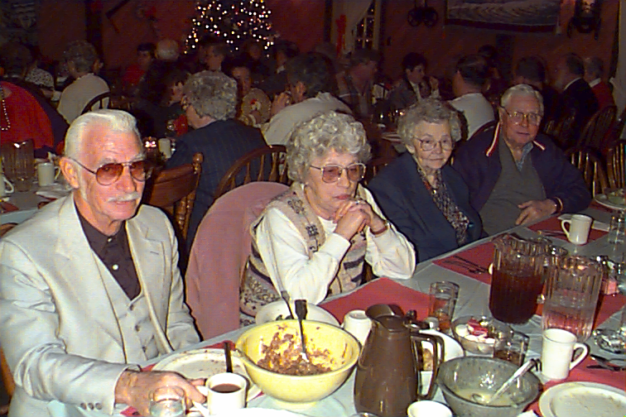

Harold Cole, WD4OOX and XYL Betty share a table with Agnes and Francis (Mac) McCray at the 1996 Christmas Party. If you missed this one, you should be kicking yourself now. The family-style dinner included swiss steak and turkey with all the trimmings. . . .um um good!!
_______________________________________________________________

The next issue of the newsletter will contain the 1997 Membership Roster. Only 1997 members will be listed. Make sure you are on it. Join today before you forget it . . . again!!!
RAC Salutes . . .
Francis McCray, W3BZJ

This month we feature Francis McCray, W3BZJ, as amateur operator of the month. Those of us who know Francis know him as "Mac". In fact the name "Mac" has become synonymous with Amateur Radio in Corry, Union City and the surrounding communities. There are few amateur operators who have enjoyed the hobby as much , or explored the hobby as much as Mac. Mac also believes in sharing this great hobby. He has been an excellent "Elmer". Many of us in the community owe our start in amateur Radio to Mac. In 1957 when I first met Mac, he lived with his wife Agnes and their daughter Linda Lee on a small farm in Elgin where he still lives today. That small farm never raised cattle or produced a large crop of potatoes or corn. It did, however always produce a fine crop of antennas. I was studying the code for the novice license at the time and my neighbor Al, K3ACF, took me down to meet Mac. Al said "You can always find Mac's place. Just look for the antennas."

You might say Mac graduated from High School into Ham Radio. He got his first license in 1930. At that time this part of Pennsylvania was part of the eighth call area and Mac was issued the call W8CDZ. At that time he operated a Hartley oscillator on CW and listened with a two tube regenerative receiver. Most of his contacts were with Walter Aur in Corry. Mac recalls that he did a lot more listening than transmitting at that time. There were ham's starting to use "voice modulation" instead of CW at that time. Mac equipped his Hartley with a carbon microphone connected to a few turns of wire coupled to the Hartley oscillator coil, which was how the first rigs were modulated. There was an old saying that said: "You can tell a ham radio operator by the RF burns on his lips". Mac braved the RF burns and went on the air with his "Voice modulated" rig. He finally made one contact with it in Cocranton, Pa. which at that time was pretty good DX. Anyone who knows Mac's love of talking into a microphone knows that Mac was hooked on Ham Radio right then and there. Most ham radio operation at that time was still done with CW and that just didn't suit Mac's style so he didn't renew that license.

When western Pennsylvania became part of the 3rd call area Mac again gave amateur radio a second try and was issued the call W3AFH. Again, CW was a chore and at that age, Mac could find lots of other ways to exercise his vocal chords, such as flirting with young teachers. Again he didn't renew the license.

Radio made great strides during the second world war. By the time it was over, voice communication by AM phone was a common mode of communication. Mac still remembered the time when he talked through the radio waves with a ham in Cocranton. There were also a number of other hams in the Corry area at that time. He decided to give it another try. In April, 1955 Mac was issued the call WN3BZJ. He went on the air with a Heath AT-1 with an 807 tube in the final and a National NC100 receiver. Though he was crystal controlled and on CW, The bands were full of AM voice. This inspired Mac to keep on practicing and he finally mastered the 13 words per minute.

With a new General Class ticket in his pocket, Mac acquired a World Radio Laboratories Globe Chief 90. This rig, with its 6L6 final ran a whopping big 50 watts on AM and 90 on CW. Mac screwed the microphone connector on and threw the transmit switch . . . The term "Rag Chew" had come to the Corry area.

Mac's next rig was an ART-13 Military surplus transmitter with an 813 in the final and modulated with an 811A. This transmitter ran about 250 watts AM. This is the transmitter that you always see in the old movies in the back seat of a jeep behind the drivers seat. Remember, the Platoon leader always stood in the mud and leaned against the antenna on the back of the jeep to call in an artillery barrage. I always wondered how he did that without getting burned when he keyed up? Maybe Mac can tell us some time.

When the whole world shut down their AM rigs and went to Single Sideband, Mac retired the ART-13 and the old National NC100 and bought a brand new Swan 500CX which he still has today as a back up to his Kenwood TS-430. He also has an old Midland 2 meter transceiver and a new Realistic HTX-212 for the 2 meter nets.

Mac likes people, He likes to visit with them in person as well as on the air. He likes to talk about any subject they have in mind to talk about. But over the years I have noticed that if the subject is left up to Mac, it will most often gravitate toward antennas, feeding systems, and propagation. As I mentioned before, Mac always had an antenna farm, and there are few designs of antenna that have not at one time or the other

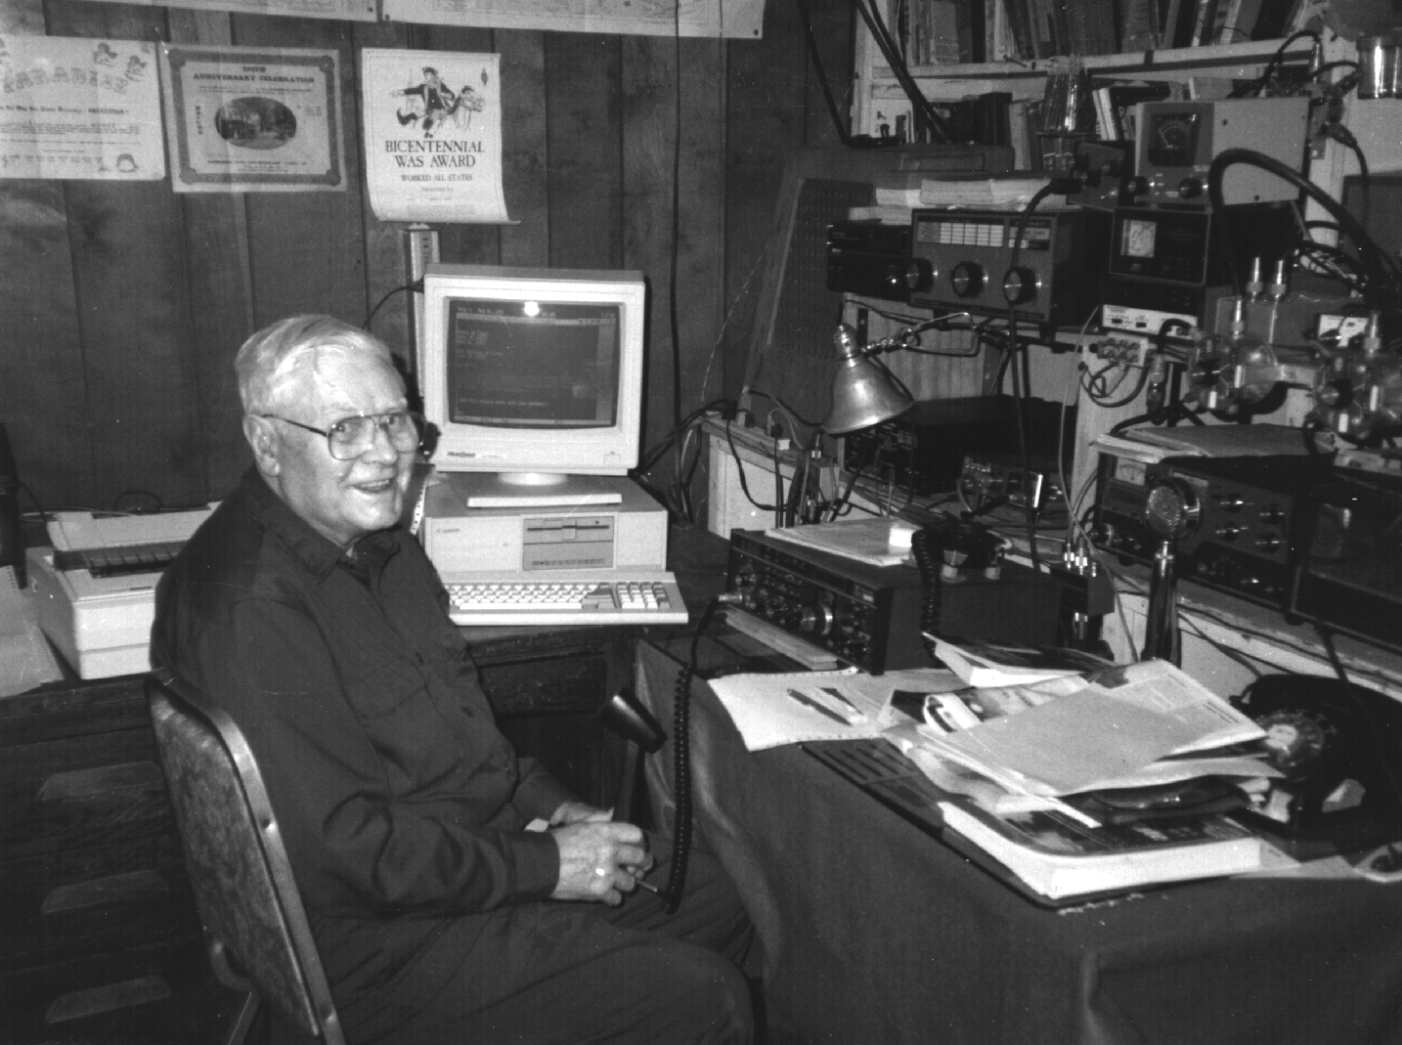

graced his back yard. I'm not sure how all of those antennas reacted with each other and the surrounding ecology, but I have noticed that woodchucks refuse to live there and deer will not take a shortcut through Mac's yard. One thing I do know is that
the signals get out. There are not very many parts of the world that Mac has not worked, and with 100 watts or less. He tells of working Baffin Island near the North Pole, and of working both Australia and New Zealand. He tells of working India with an 800 foot long wire which stretched from his shack to a tree on the adjacent farm which belonged to his mother. He tells of working several Japanese stations, one after the other. Mac says his best all around antenna was a Guy Wire Pyramid Antenna which was like a bow tie with the center lifted up to 50 feet and a second one at right angles to the first except at 40 feet. His favored DX antenna however has always been the cubical Quad. Mac's present antenna farm boasts a Cubical Quad for 20, 17, 15, and 10 meters; Inverted vee's on 80 and 40; a 48 foot base loaded vertical mounted at ground level with radials 42 radials for 75, 40, and 20 meters; a Butternut HF6V-X vertical for 80, 40, 30, 20, 15, and 10 meters; an 11 element 2 meter beam. and a 2 meter J-pole antenna on the chimney.

Mac was active in MARS for a number of years, ran Phone patch traffic to Quito, Ecuador for a local minister, Kept a regular sked. with Larry, K3HJQ, when he was stationed on Grand Turk Island, operated in the Post Office Net for years, operated Boy Scout JOTA for the last three years, and is still active on the Wednesday 20 meter net to Florida, the County Hunter net and most of the local nets.

Mac was never big on certificates and wall paper but he did get a WAS award and has over 2000 counties confirmed with mobile operators, and might have the cards for a DXCC although he never checked.

W3BZJ is a Ham's Ham and an asset to the Amateur Radio community.
--Bob Swarm, K3CKO
___________________________________________________

CHRISTMAS PARTY 1996

The Christmas Party was held at Dutch Treat in Spartansburg, on Saturday, December 14. Dinner was served family style, at 6:30 P.M. with a Swiss Steak and Turkey menu. The 48 in attendance came from Corry, Union City, Erie, Cambridge Springs, Franklin, Titusville, Spring Creek, Jamestown, and Spartansburg. Michael Dziubkowski N3GCY served as Master of Ceremonies.

Two certificates were presented for a perfect check-in record on the 2-M and l0-M Nets, which are held weekly throughout the year. Recipient of each was Arnold Smrcka N3UBZ. Arnold was the only one to meet every net. Additional certificates were awarded for "outstanding contributions to the club.". These were presented to Robert Bair WA3HDK, for the newsletter, Leonard Shick WB3AYW, for the VFW breakfasts, Lee Robinson WA3HJC, for Field Day, Jim Adams WT3O, for fund raising, and Bob Swarm K3CKO for Boy Scout JOTA.

Lindsey Ingram N3WAF and Joanna Rater N3WNS received awards for being the youngest hams. At age 12, the two YLs are both General Class operators. Awards were also presented to Michael Dziubkowski N3GCY as M.C. and to Leonard Shick WB3AYW for highest 50/50 ticket sales.

Numerous donated prizes were also presented to the winners. Our thanks goes out to all who worked to obtain the prizes, but we wish to send special thanks to Evelyn Adams (XYL of WT3O) for her outstanding contribution. Winner of the 50/50 drawing of $245.00 was Jackie Snyder of Union City.

The Duard May W3DUB annual award which is sponsored by Dick Drace, K3AQR of Winter Haven, Florida, was presented to Norma Vanderhoff W3CG. Honorable mention belongs to our Award Committee, which is composed of a special group of people, namely educators, some current and some retired. They are Chairman, Ronald Munn N8BQG, Robert Bair WA3HDK, John Payer KA3WUM, Bruce Burr KA3JVO, and Craig Hill K3PLV. We would be remised if we did not mention that a newer member is also eligible to belong to this committee, and this is Paul Vamos KA3DNP. We are very fortunate to have such a unique committee for the size of our club and with any luck the committee will remain permanent as long as they are willing to serve.

A very enjoyable time was had by all and the food was plentiful and tasty. You owe it to yourself to be at next year's celebration. See you there!
--Norma W3CG
_______________________________________________________________

NORMA VANDERHOFF, W3CG RECEIVES AWARD

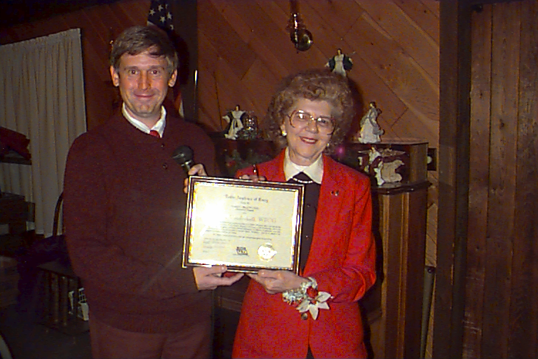

Norma, W3CG, was presented with this year's Duart May Award by Master of Ceremonies, Mike, N3GCY. The award is presented to an amateur each year who has demonstrated service to her club and community. Norma has not only served as our Secretary/Treasurer but is also liaison of the VEC team. She also holds membership in several other local ham clubs and is the author of the ham radio column that appears each Sunday in the Erie Times-News. She is an ARRL member and holds the post of Assistant Director, Atlantic Division. Norma also serves the ARRL in the position of Public Information Coordinator. She is a member of the Young Ladies Radio League and Treasurer of the Alton Division of the Morse Telegraph Club. Norma has been a member of the Radio Amateurs of Corry since 1968.

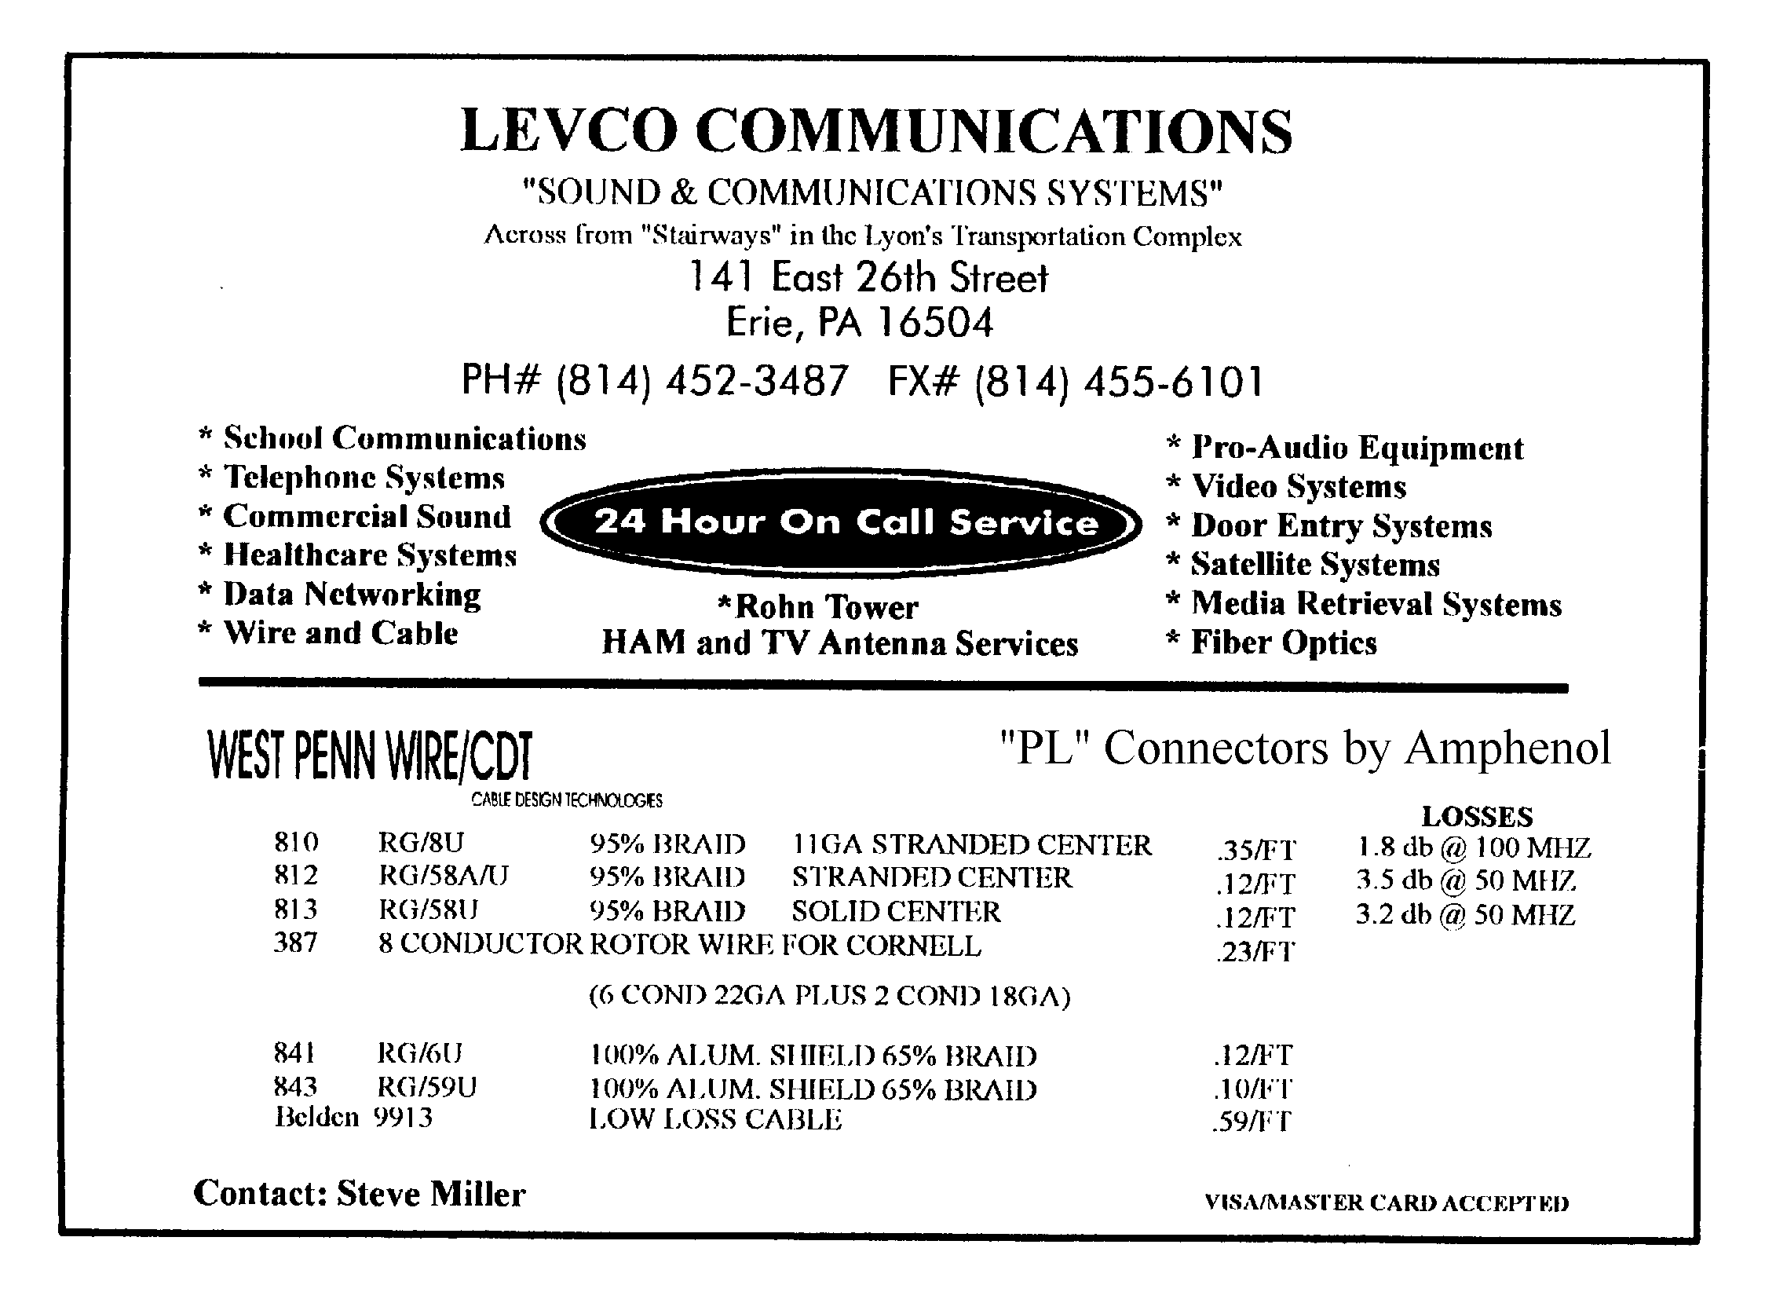

____________________________________
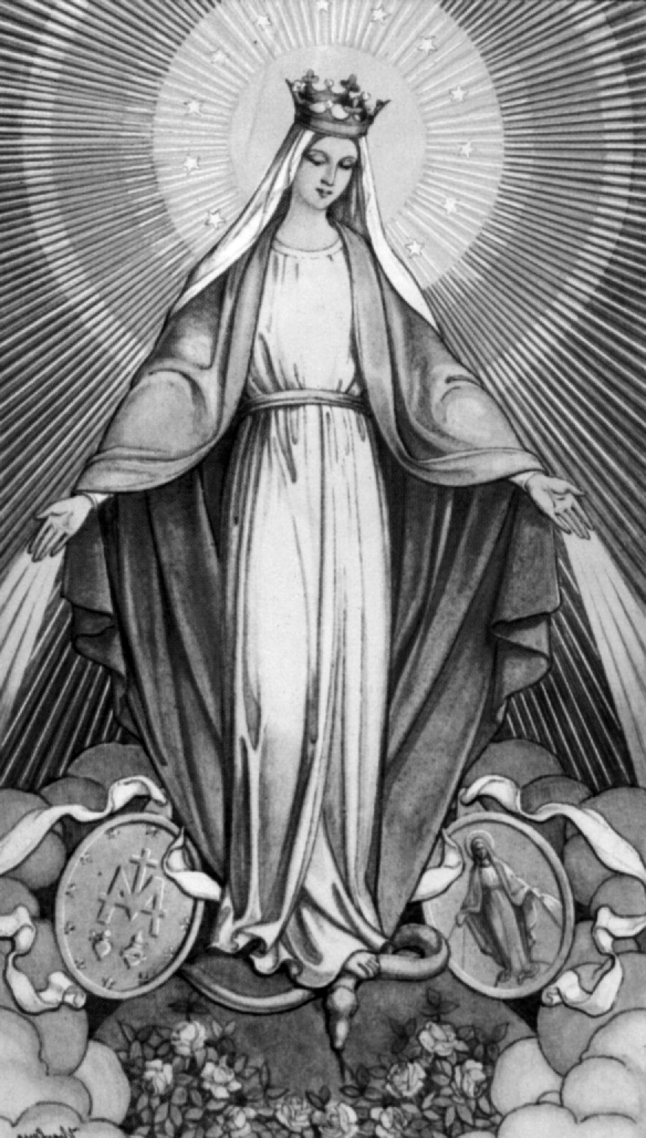
Sacred Images
Religious Statues

Will Also Refurbish

Patricia Sarver (N3FXQ)
316 Seminole Avenue
Corry, PA 16407

(814) 665-8012
______________________________________________________________________________________

Dear RAC Members,

1996 was a very good year for our club. We had lots of public service work, a great field day and a very successful JOTA. Thanks to all of those who took the time to help and let's make 1997 an even better year!

Also, I can't forget to mention the Christmas Party. The turnout was great. A very enjoyable evening for all those who attended. 73 es HAPPY NEW YEAR.
--(Signed) Jim, WT3O

HOW TO SUBMIT ARTICLES FOR PUBLICATION

This newsletter is good because our members submit good material to be printed. Let's be truthful . . . If nobody bothered to write articles, the paper would be boring.

If you haven't submitted anything, why don't you consider doing so. The paper is published quarterly on the last day of the month. The next issue will go to press on or around March 15. We have never refused to publish any material submitted. It's kinda' fun to see your name in print.

I will accept material in almost any form, but I prefer it be in some digital mode. (That keeps me from retyping it.) In order of preference, the most desirable is as a plain text (ascii) file on any floppy disk format. Packet is quite suitable, too. Address your packet message to WA3HDK @ N3QQH.#WPA.PA.USA.NA. Or, transmit it directly to my mailbox which operates 24 hours a day every day on 145.69 Mhz . The call sign is WA3HDK-2. If you can't use any of these digital modes, the next favored mode is typewritten. Since I scan those documents into the computer, it is important that the ribbon is in reasonably good shape. (carbon ribbon is best) And finally, if none of the above will work for you, a hand-written page will do. Please be sure what you send is readable . . . I don't see as well as I used to. However you cut it, get your article in there and tell us about yourself or your favorite subject.
--Bob, WA3HDK

NEWSLETTERS ARE MAILED ONLY TO MEMBERS. DON'T MISS THE NEXT ISSUE!

1997 APPLICATION FOR MEMBERSHIP IN THE RADIO AMATEURS OF CORRY 1997

Name_______________________________________________ Call______________
Address_____________________________________________ Phone Number_(___)____________
City___________________________ State_______ ZIP____________ ARRL Member (yes / no)

We maintain a list of member's favorite interests in the Club data base. If you care to, tell us some of the things you like to do. This could be radio or non-radio related. (some of the ones we have received include: computer, gardening, antennas, sky-warn, traffic nets, woodcarver, etc.)

Interests:_________________________________________________________________________________________________

________________________________________________________________________________________________________

Dues for licensed hams in the same immediate family are half-priced. i.e. $2.50 each. (Only one newsletter mailed to each family.)

Mail along with $5 dues for 1997 to:
RADIO AMATEURS OF CORRY
P.O.Box 362
Corry PA 16407

MEMBERSHIP ROSTER INCLUDED IN NEXT NEWSLETTER. BE SURE TO BE INCLUDED.
JOIN TODAY

The RADIO AMATEURS OF CORRY
P. O. Box 362
Corry, PA 16407

This newsletter is published quarterly

Editor, Robert E. Bair, W3HDK (739-2206)
Staff:-- Bob Swarm, K3CKO
Jim Adams, WT30
Gary Sarver, N3WNP
Patty Sarver, N3FXQ

Submit material for the next issue on/or
before March 18. Next issue is April 1

Coming Attractions:
Feb. 9 - Latrobe (PA) Hamfest
Feb. 15 - Harrisburg (PA) Hamfest
Feb. 23 - Cuyahoga Falls (OH) Hamfest
Feb. 23 - South Hills (PA) Hamfest
Mar. 16 - York (PA) Hamfest
Mar. 23 - Madison (OH) Hamfest

Club Officers--
President, Leonard Shick WB3AYW (438-7199)
Vice President, Jerry Owens,W3GHO (664-7502)
Sececretary, Frank Cutshaw, KE3PD (663-0754)
Treasurer, Mike Dziubkowski, N3GCY (664-7189

