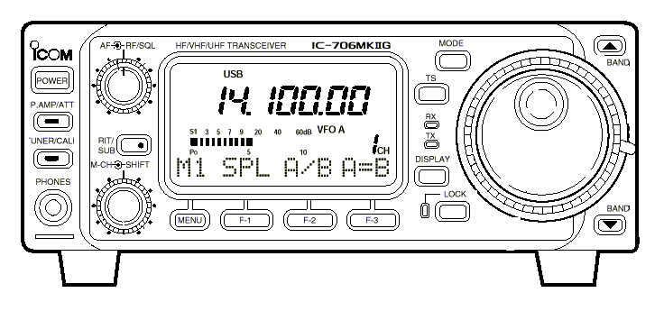

To Radio | Date (yy-mm-dd) | UTC | MHz | RST | Mode
E-QSO |  | Transceiver : iCOM IC-706 Mk II G  Antenna: Diamond CP-6 Vertical  Tnx nice QSO |  | 599 | E
Conforming our QSO
Prashant Koli, 601,Chandraganga
Near Fly Over,Mulund (East)
73! Pat
Mumbai-400081 INDIA
Grid Locator MK69LE ITU 41 CQ 22 E-mail vu2cbu@hotmail.com http://www.qsl.net/vu2cbu

