HP8640B IMPROVED LOCK RANGE

The HP8640B is a great generator. It combines the low phase noise of a cavity oscillator and the stability of a crystal oscillator. This is accomplished by using a low bandwidth PLL to lock the cavity to the crystal. As the cavity drifts with temperature, the PLL varies the tuning voltage fed to Varacter diodes to keep the cavity in tune. As designed, the PLL can keep the cavity locked over only a few kHz worth of drift. If you turn the unit on from a cold start and put it in lock mode, it will probably drift out of lock by the time it warms up. In fact the unit will maintain lock over only a fraction of a turn of the front panel fine tuning knob. When I first got my unit working, I noticed this limited lock range and thought something was still wrong with it. I scoured the manuals and made some voltage measurements and found everything worked as described in the manual. The Counter lock board was able to put out a range of +/- 5 Volts centered around +10 Volts. Beyond that, an error sensor decides there is an error. This +/- 5 Volt signal travels through the Phase lock loop filter (located on the FM Shaping card) and is applied to the cavity Varacter. At the output of the loop filter the tuning voltage is centered around -16 Volts and has a range of only about +/- 1 Volt. I thought this was odd. I simulated the circuit in PSPICE and found that my unit was working as per the design on the schematic and the way the manual describes. Apparently the 98640 is designed with a limited lock range.

But while perusing the loop filter circuit, I noticed VR1, a 6.2 Volt Zener diode that seemed to be used as part of the voltage level shifter to shift the 10 Volts control voltage to -16. But during the testing my unit I saw there was only 0.7 Volts across the Zener diode. Was something wrong with my unit? But this is also what the simulation said is correct, so there was nothing broken in my unit. I looked at the schematic again and saw that the Zener diode was placed backwards from what I would have expected. I thought about what would happen if I reversed it. Would I be able to increase the range of the tuning voltage? Checking in the simulation I found yes, if I also change the connection of the Varacter bias pot. To make a long story short, I tried the change shown in the accompanying schematics and pictures, and low and behold the lock range was increased by about 3.5x. The unit now holds lock for at least +/- 1 full turn of the fine tuning knob. I also checked the phase noise performance and found it to be as good as before in the x1 display mode. In the x10 display mode there is some phase jitter, but that has always been the case. I looks like the design was really intended to use the lock feature only in the x1 mode. Per HP the lock node doesn't even work at all in x100 mode.

The connection of Zener VR1 in the original circuit is very odd. The diode was forward biased like a standard diode and had only 0.7 Volts across it. HP could have used a regular diode there instead of a Zener. With the modified circuit, with the Zener reversed, the Zener is now operating as a Zener with 6.2 Volts drop across it. I can't help but wonder what were the intentions of the original designer.

In any case, I am very happy with this change, it is very simple to make and needs no new parts!

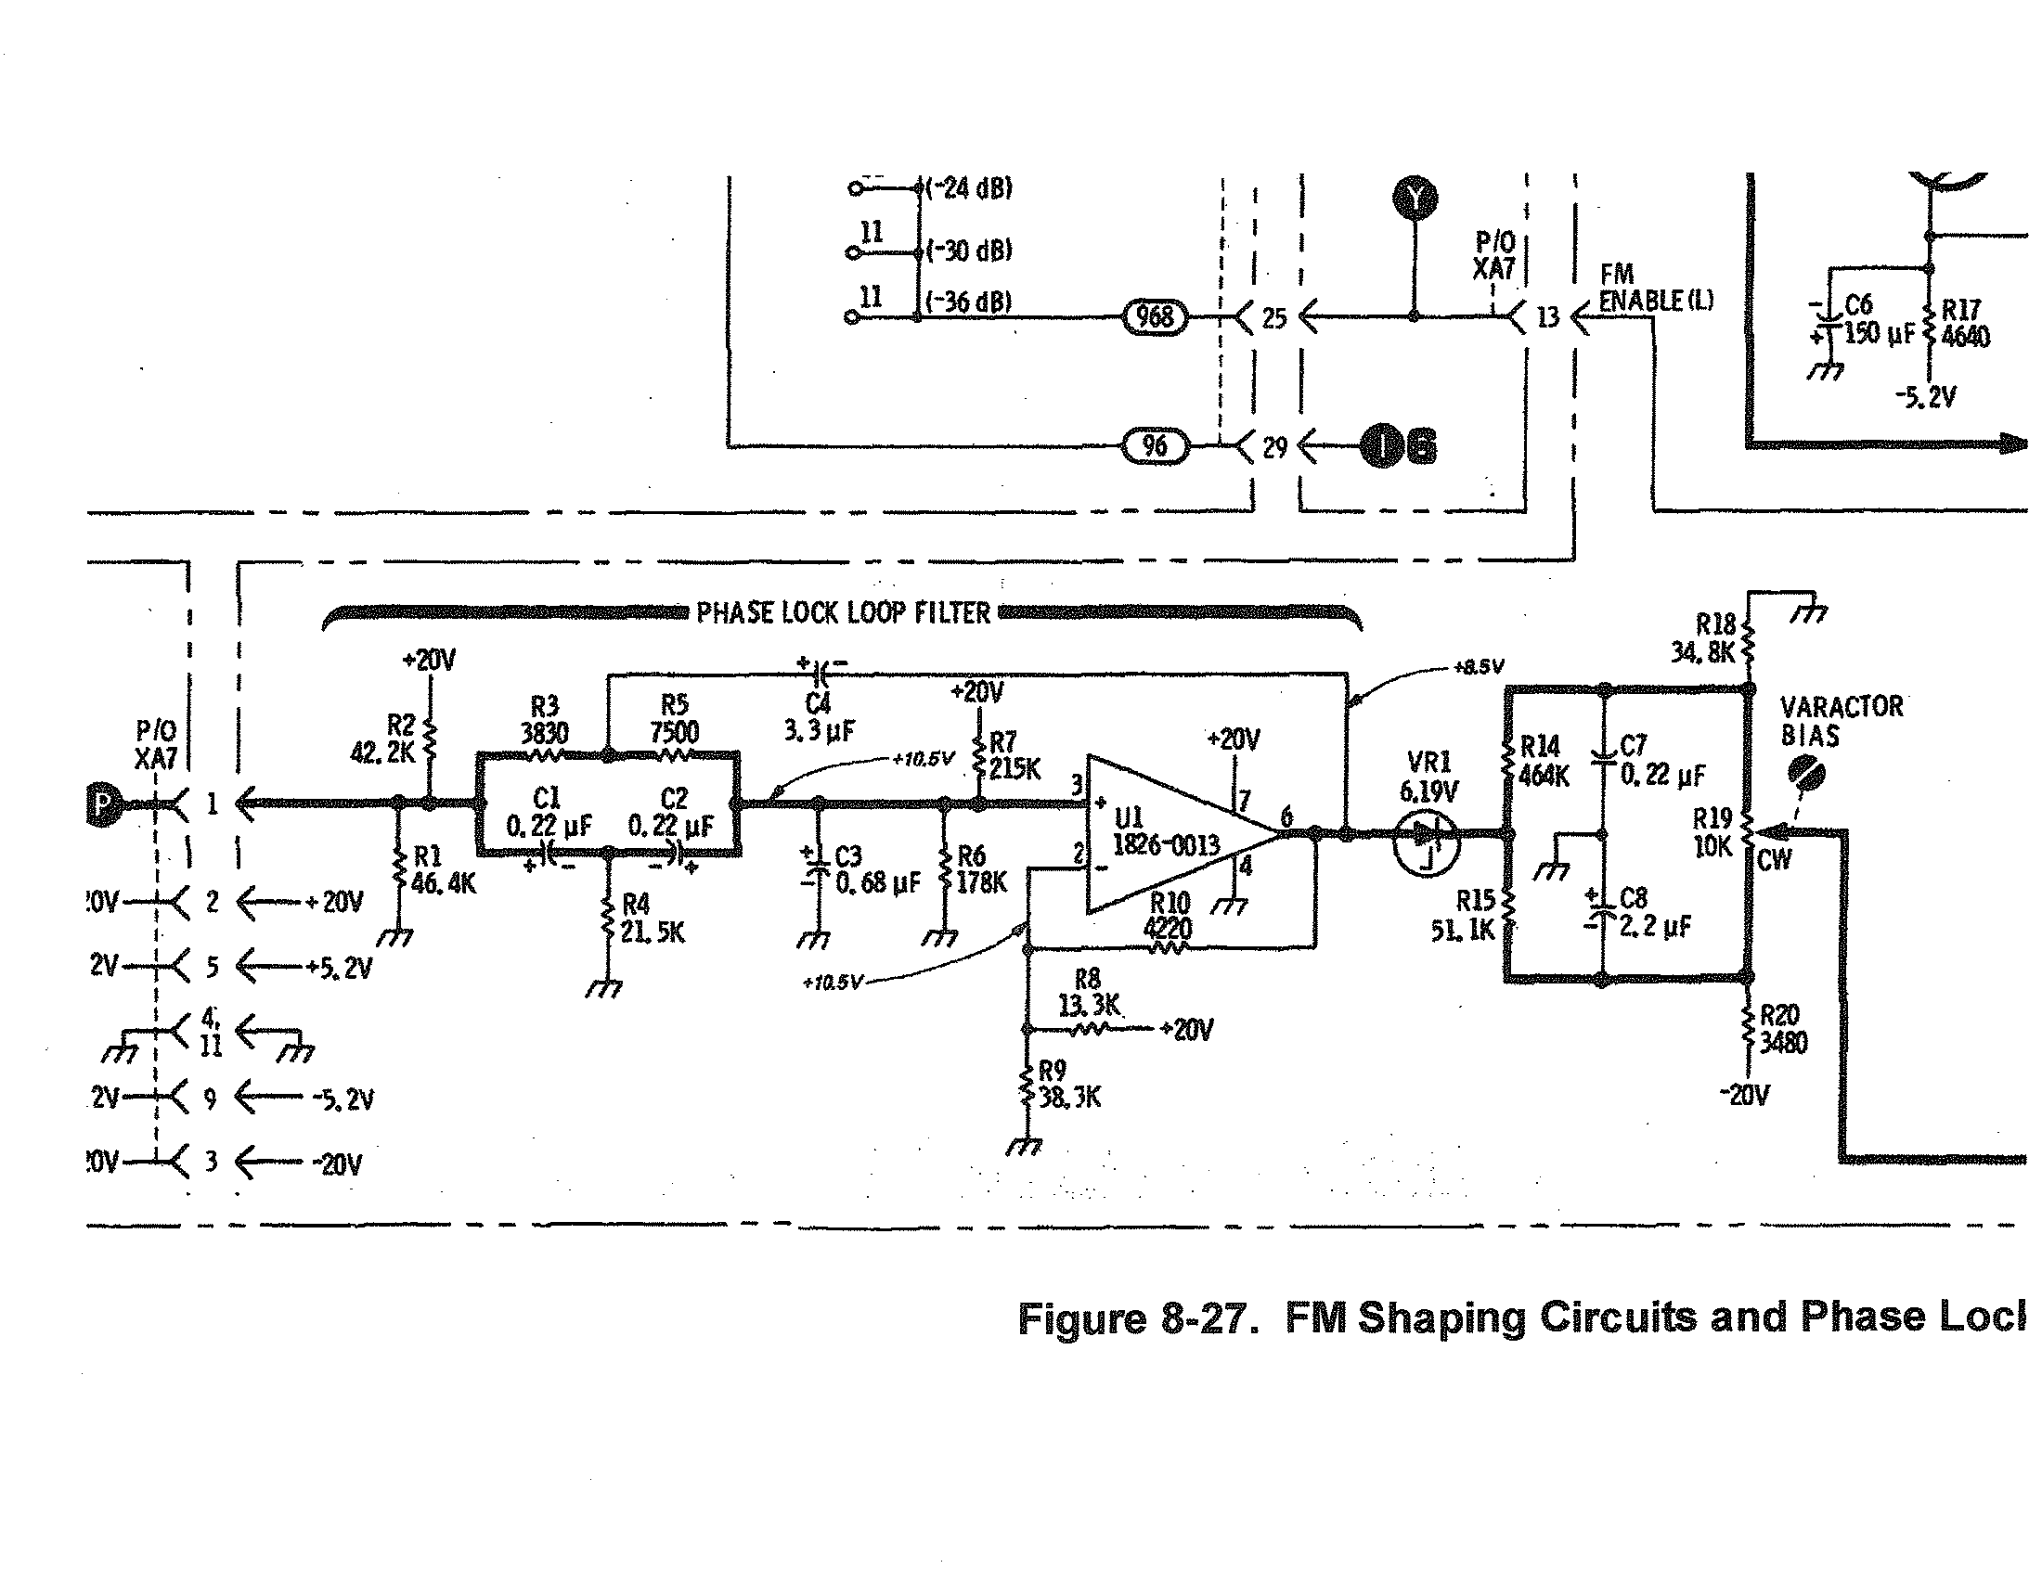
PHASE LOCK LOOP FILTER BEFORE MODIFICATION
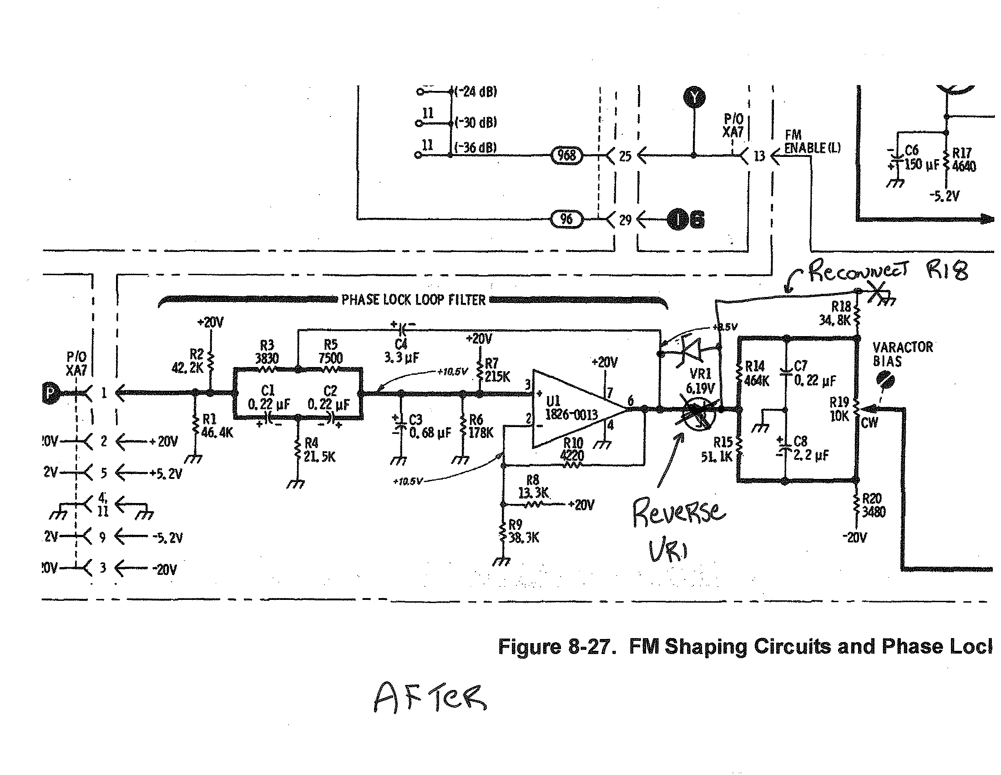

PHASE LOCK LOOP FILTER AFTER MODIFICATION
Reverse VR1
Reconnect the ground side of R18 to Anode of VR1 so R18 is in parallel with R34.

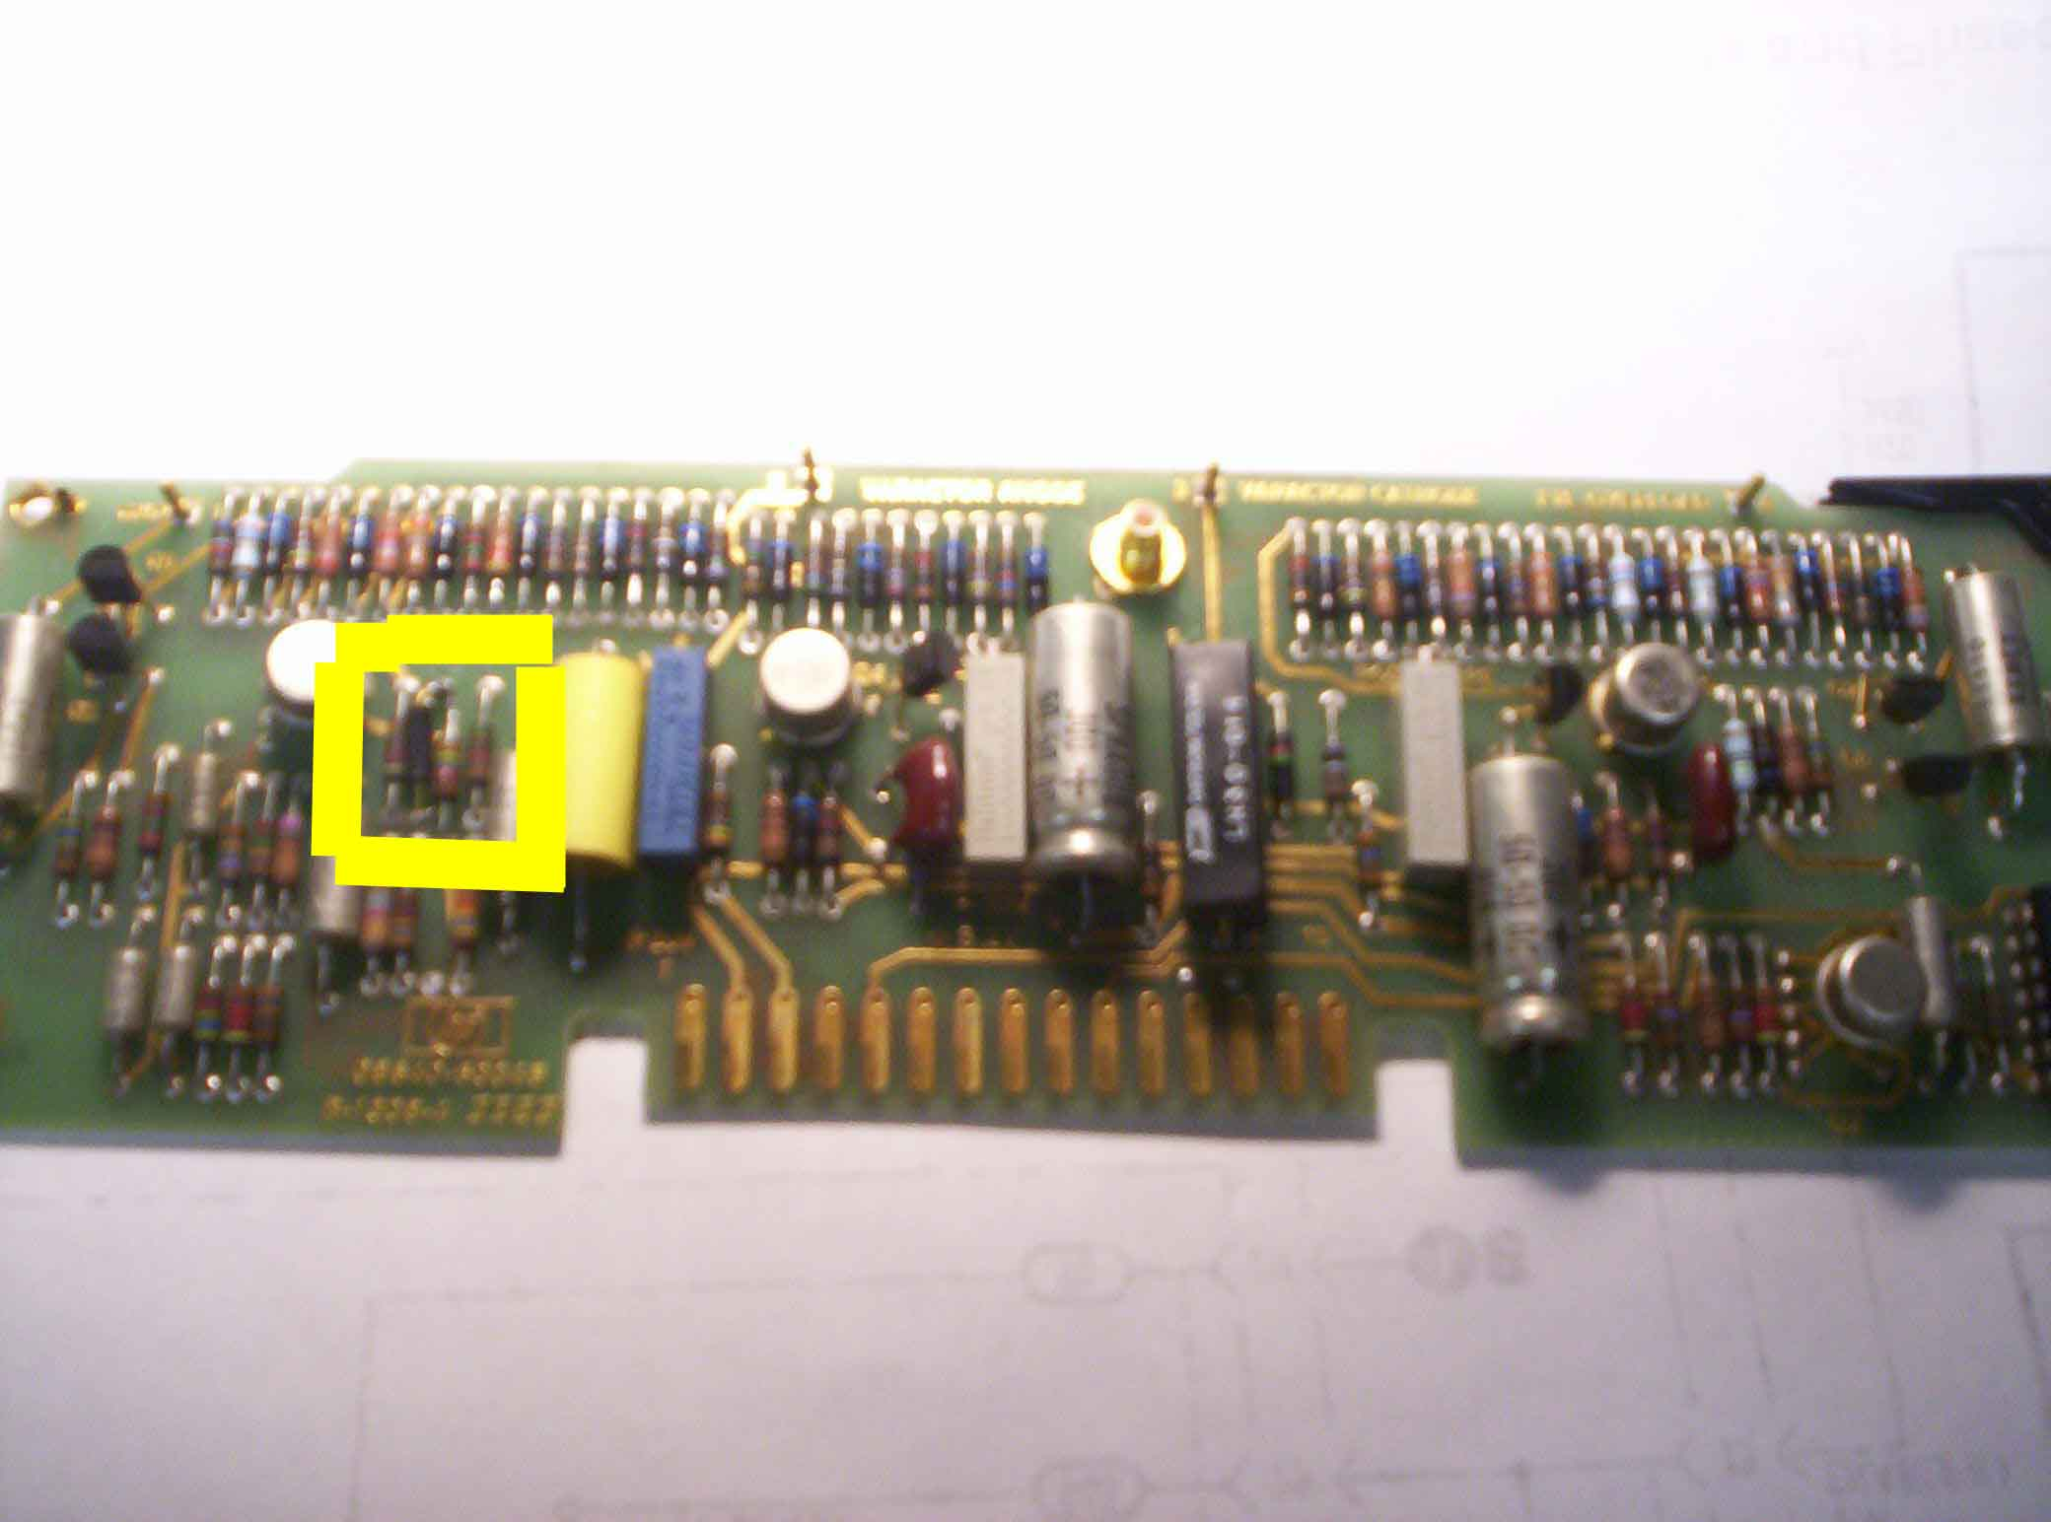

Zener diode VR1 and R18 located here on FM Shaping Card

If your unit is the version that has a mini-coax attached to the FM Shaping Card, be careful when removing the card so as not to yank on the cable.

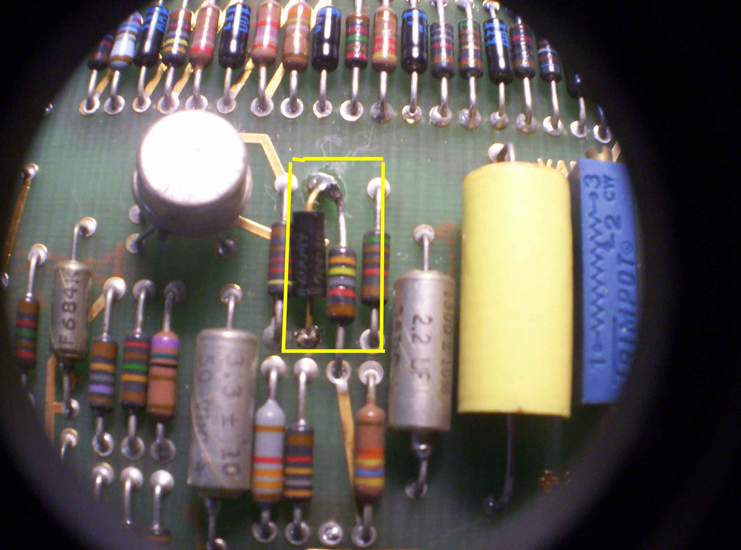

VR1 removed and re-installed in the reverse direction. Anode is now UP.
R18 34.8K unsoldered from the lower ground pad and rotated up 180 degrees and soldered to what is now the anode side of VR1.

That's IT! Enjoy!

Mark Kolber
WB2WHC
January 2009

