**NodeMCU started on 13 Oct 2014**

- **Hong** committed the first file of nodemcu-firmware to GitHub.

- **Huang R** committed the gerber file of an ESP8266 board

- **Tuan PM** ported MQTT client library from Contiki to the **ESP8266** **SoC** [ **System on Chip** ] platform

- **Devsaurus** ported the u8glib to the NodeMCU

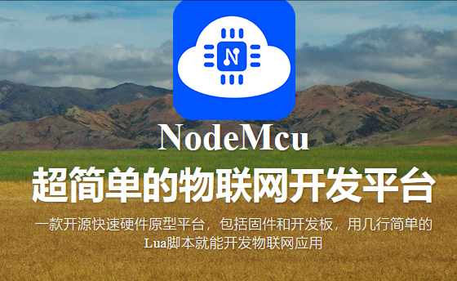

**What is I2C**

The **Inter-Integrated Circuit bus** (IIC or **I2C bus**) is a synchronous, multi-master/multi-slave, packet switched serial data bus. It is widely used for low-speed communications in digital systems on board and off board.

<https://www.realdigital.org/doc/6da47099f4ada78618d85b3d68613ac8>

