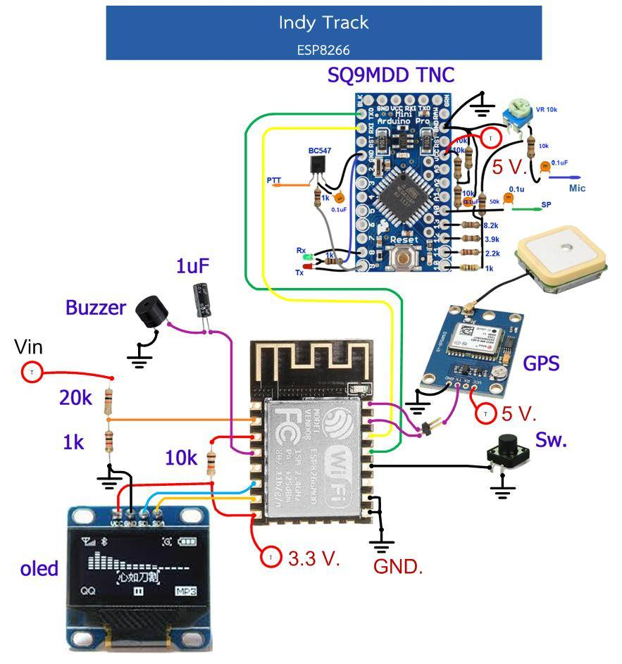

1. Activate the SABTrack V2 box as normal and turn on the mobile phone to search for SSID WiFi signal. Will find the SSID according to the call center that has been set up, such as E24KHS-9 or SABGATE_Config To connect Go in And enter the password 123456789



2. When the WiFi status says that it is connected status ... Open a web browser such as Chrome.

Coming up and entering IP 192.168.4.1, you'll find the settings page.



3. Each topic will display the topic name And settings that are currently used and used in the machine



4. Enter the desired value in the space and press the SAVE button. *** Note: The value can be recorded only for 1 topic at a time ***

5. Explanation of meaning of each topic

Mycall: call signals from amateur radio and numbers that specify different types of stations such as

-0 Main station stationed at home

-1 general station, DIGI signal repeater, mobile, weather monitor, others

-2 general stations, DIGI signal repeater, mobile, weather monitor, others

-3 general stations, DIGI signal repeater, mobile, weather monitor, others

-4 general stations, DIGI signal repeater, mobile, weather monitor, others

-5 stations from other networks (Dstar, Iphones, Androids, Blackberry's etc

-6 special activity stations, Satellite ops, camping or 6 meters, etc -7 stations from mobile radio Or various temporary stations -8 station aboard or alternate mobile station -9 car stations or main mobile stations -10 stations in the internet network, internet, Igates, echolink, winlink, AVRS, APRN, etc -11 air stations, balloons, aircraft, spacecraft, etc -12 stations that can be controlled by APRStt, DTMF, RFID, devices, one-way trackers *, etc -13 Weather stations -14 Trucks or vehicles with drivers at all times -15 general stations, DIGI signal repeater, mobile, weather monitor, others

**Profile1**

Symbols and texts That you want to show results According to work pattern 1 Such as: I am HAM RADIO / Is the table showing symbol no. 1 > Is a saloon car symbol I am HAM RADIO is the text that I want to display. Eye



Table 1 shows characters instead of the desired image.

**Profile2**

Symbols and texts That you want to show results According to work pattern 2

For example \ PStop

\ Is to choose to use Table 2

P is a P shaped in a blue square Show the parking symbol

Stop is the text to be displayed. Explanation

eye





Table 2 shows characters instead of the desired image.

Path is the path to sending the data out. In the radio frequency And want to be able to be transmitted as far Can go out at any signal repeater station For example, WIDE1-1 means that it needs to be forwarded 1 more time "WIDE1-1, WIDE2-1 means want to be sent for 2 more times

Fast KM / Hr is the maximum speed. (Kilometers / hour) that you want to Use operation in style 1. For example 80

Fast rate is the time value (seconds) that is required for data transmission.

For example 45

*** Fast KM / Hr and Fast rate will work together **

example

Fast KM / Hr is set to 80, meaning 80 km / h.

Fast rate set to 45 means 45 seconds

The feature is that when we move at a speed of 80 km / h and up, the device will send a signal every 45.

second

But if using a speed less than 80 km / h, the device will Calculate the amount of time that is appropriate for the signal.

According to the following equation

Calculated time value (seconds) = ([Fast KM / Hr] / current speed) x [Fastrate] Assume that currently moving at a speed of 40 km / h Substitution in the equation Calculated time value (seconds) = (80/40) x 45 Calculated time value (seconds) = 90 seconds

Example 2 Assume that currently moving at a speed of 20 km / h Substitution in the equation Calculated time value (seconds) = (80/20) x 45 Calculated time value (seconds) = 180 seconds

This method of operation will ensure that the signal transmission is consistent and changes according to the speed of movement.

- We will estimate the approximate value From how can we set that the settings are appropriate?

Things to keep in mind are Do not set the device to send signals. Too much frequency and more than necessary because it will cause

Other stations do not have the timing to signal. Because the frequency is not available ...

- How much is appropriate? Normally, should be set with the calculation. Movement beyond 500 meters and then gradually transmitted 1 signal or better, 1 kilometer or more, send 1 signal Calculation method Suppose that Fast KM / Hr is set to 80, meaning 80 km / h. Fast rate set to 45 means 45 seconds

Distance = time x speed Distance = 45 seconds x 80 km / hr *** Convert units to hours as well **** Distance = (45/3600) x 80km / h *** 3600 is from 60x60 60 seconds to 1 minute 60 minutes to 1 hour **** Distance = 1 kilometer In conclusion, if set Fast KM / Hr is set to 80, meaning 80 km / h. Fast rate set to 45 means 45 seconds The device will send a signal every 45 seconds or every 1 kilometer.

Slow Km / hr is the lowest speed value. That will change the work to the second style For example 1 Means when the movement speed is less than 1 km / h Change the operation to the second format.

Slow rate is the time value (seconds) in the signal when working in the second pattern. For example 600 Meaning the device will send a signal every 600 seconds ****** Slow km / Hr and slow rate will work together ***

TNC rate is the speed of data communication with TNC.

GPS rate is the speed of data communication with GPS.