Two Yagi antennas for 162 MHz AIS reception

Introduction

Shown here are two different antenna models designed with AIS reception in mind. I have yet to build either model, but I’m fairly confident that, if constructed within reasonable tolerances, they will work as modeled. I’ve used NEC2 modelling software, which has been shown to provide an accurate representation of gain and pattern, and a fairly good estimation of input impedance.

The first antenna is a 3 element HF design by Orr. It has a 50 ohm feed point, moderate gain and a good front-to-back ratio. It also has a fairly good bandwidth. You could either feed it in the center using 50 ohm coax by splitting the driven element in half, or use a folded dipole with a ½ wave coaxial balun.

The 2nd antenna, designed by DK7ZB, has a lot more gain, a considerable narrower beamwidth and has a 28 ohm impedance, which requires a special matching section. You can find more info on the 28 ohm DK7ZB match on Martin’s website at: http://www.qsl.net/dk7zb/dk7zb-match.htm. This antenna would be a better choice for someone who lives a bit further from the seacoast, or wants to chase DX on AIS. It has a boomlength of slightly less than 10 feet.

The element lengths for both antennas are based on 5 mm diameter elements and are valid for free space only! This means that if you want to use a metallic boom, you will have to lengthen all the elements somewhat. If you use a wooden boom, then the freespace dimensions are fine. More on this later.

AIS signals are vertically-polarized, so you should mount these antennas vertically, using a non-conductive mast.

3 element Yagi

 | Boom spacing | Element length | Element diameter
Reflector | 0 mm | 963 mm | 5 mm
Driven element | 335 mm | 880 mm | 5 mm
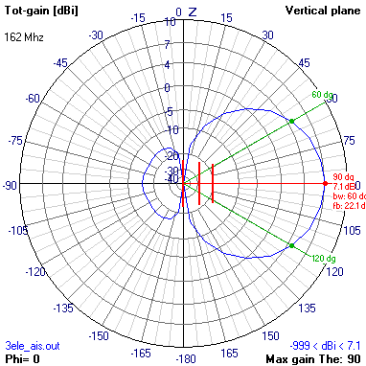  1st director | 605 mm | 792 mm | 5 mm

As you can see, this antenna has about 7 dB gain over an isotropic radiator and a pretty good front-to-back ratio. If you want to use thinner copper wire, (say around 12 AWG) for the elements, I would lengthen all the elements by approximately 10 mm each.

Here’s the NEC2 input file, if you want to play with the design. I used 4NEC2 by Arie, which is shareware.

CM Orr 3 element yagi scaled for 162 MHz
CM 9 = reflector , 2 = driven , 5 = reflector
CE
GW 9 11 0.00000 0.000000 0.48150 0.00000 0.00000 -0.48150 0.00250
GW 2 11 0.33500 0.000000 0.44000 0.33500 0.00000 -0.44000 0.00250
GW 5 11 0.60500 0.000000 0.39600 0.60500 0.00000 -0.39600 0.00250
GE 0
LD 5 9 1 13 5.8001E7
LD 5 2 1 13 5.8001E7
LD 5 5 1 13 5.8001E7
FR 0 1 0 0 1.62E+02 0.00E+00 0.00E+00 0.00E+00 0.00E+00 0.00E+00
EX 0 2 6 01 1.00E+00 0.00E+00 0.00E+00 0.00E+00 0.00E+00 0.00E+00
RP 0 37 37 1000 -90 0 10 10
PQ -1
PT -1
'FR 0 20 0 0 162 1
XQ
EN

7 element Yagi

 | Boom spacing | Element length | Element diameter
Reflector | 0 mm | 907 mm | 5 mm
Driven element | 285 mm | 866 mm | 5 mm
1st reflector | 530 mm | 851 mm | 5 mm
2nd reflector | 1020 mm | 830 mm | 5 mm
3rd reflector | 1627 mm | 813 mm | 5 mm
4th reflector | 2330 mm | 815 mm | 5 mm
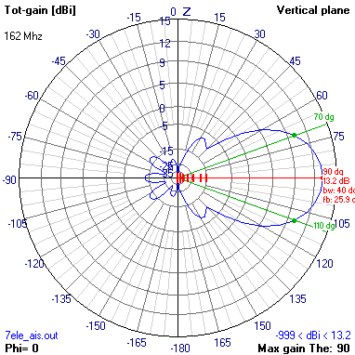  5th reflector | 2905 mm | 802 mm | 5 mm

As you can see, this yagi has about 13.2 dB gain over an isotropic radiator, and a very good front-to-back ratio. Here’s the NEC2 input file.

CE
GW 1 11 0.00000 0.000000 0.45350 0.00000 0.00000 -0.45350 0.00250
GW 2 11 0.28500 0.000000 0.43300 0.28500 0.00000 -0.43300 0.00250
GW 3 11 0.53000 0.000000 0.42550 0.53000 0.00000 -0.42550 0.00250
GW 4 11 1.02000 0.000000 0.41500 1.02000 0.00000 -0.41500 0.00250
GW 5 11 1.62700 0.000000 0.40650 1.62700 0.00000 -0.40650 0.00250
GW 6 11 2.33000 0.000000 0.40750 2.33000 0.00000 -0.40750 0.00250
GW 7 11 2.90500 0.000000 0.40100 2.90500 0.00000 -0.40100 0.00250
GE 0
LD 5 1 1 13 5.8001E7
LD 5 2 1 13 5.8001E7
LD 5 3 1 13 5.8001E7
LD 5 4 1 13 5.8001E7
LD 5 5 1 13 5.8001E7
LD 5 6 1 13 5.8001E7
LD 5 7 1 13 5.8001E7
FR 0 1 0 0 1.62E+02 0.00E+00 0.00E+00 0.00E+00 0.00E+00 0.00E+00
EX 0 2 6 01 1.00E+00 0.00E+00 0.00E+00 0.00E+00 0.00E+00 0.00E+00
RP 0 74 37 1000 -90 0 5 10
PQ -1
PT -1
'FR 0 20 0 0 162 1
XQ
EN

A note about metallic booms

NEC2 doesn’t really take into account the effect of metallic booms, which make the elements ‘appear’ electrically shorter. According to DL6WU’s table that appears in one ARRL publication, mounting these elements in full electrical contact with a metallic boom of 25 mm diamter will like make the elements act as if approximately 9 mm shorter than the free space dimensions, so lengthen all the elements by 9 mm. If you mount the elements through the boom but electrically insulated, you should half this element correction to 4.5 mm. If the elements are mounted 1 element diameter away from the metallic boom, or through a wood or fibreglass boom, then the freespace dimensions should work fine. There’s more info on this effect on G3SEK’s website at: http://www.ifwtech.co.uk/g3sek/diy-yagi/#BoomCorr

This article is a work in progress, so let me know if you find any typos, omissions or glaring errors.

73 de va3rr
www.qsl.net/va3rr

