Sterling Park Amateur Radio Club (SPARC)

2012 Field Day

21 June 2012

1.  SPARC will operate a Class 4A amateur radio station on Field Day from Park View High School.  
    (4 transmitters (CW, 2xPhone, Phone/CW/RTTY) plus extra VHF/UHF transmitter and HF Phone GOTA transmitter).  
  
2.  The station schedule is:  
  
   22 Jun 12   Friday           7:00 PM Local: Antenna set-up preparation   
   23 Jun 12   Saturday     10:00 AM Local: Station set-up (in so far as possible, do not park on field)  
   23 Jun 10   Saturday       2:00 PM Local (1800 UTC): Radio operations begin  
   23 Jun 10   Saturday       6:00 PM Local: Education session - party with food and drink  
   24 Jun 10   Sunday        2:00 PM Local (1800 UTC): Radio operations end  
   24 Jun 10   Sunday        2:00 PM Local: Station take-down starts  
  
3.  There will be six radio stations as follows:

| **Equipment** | **HF CW** | **HF CW/SSB** | **HF SSB** | **10M SSB** | **Digital / RTTY  Demo Station** | **HF GOTA (Bonus Station)** | **VHF  (Bonus Station)** |
| --- | --- | --- | --- | --- | --- | --- | --- |
| Call Sign | K4NVA | K4NVA | K4NVA | K4NVA | K4NVA | NQ4K | K4NVA |
| Tent | Kevin Pop-Up | Kevin Pop-Up | Club Tent #1 (Gordon, K4NVA) | 10m/VHF Tent | 10M/VHF Tent | Club Tent #1  (Gordon, K4NVA) | Van (Ray, KD4RSL) |
| Table | 6-ft table (Don, K7CS) | 5-ft table (Gordon, NQ4K) | 6-ft table (Gordon-NQ4K) | Table (Jim, KF4PQL) | Table (Gordon, NQ4K) | 6-ft table (Gordon-NQ4K) | (Ray, KD4RSL) |
| Radio | IC-756 (Don-K7CS) | (Don, K7CS) | ICOM 756 (Dick -W2YE) | FT-100 (Jim, KF4PQL) | FT-840 (Kevin, W4KLS) | Something (Gordon, NQ4K) | (Ray, KD4RSL) |
| Antenna Tuner | Manual Tuner (Don, K7CS) | (Don, K7CS) | n/a | (Jim, KF4PQL) | W/ Artificial Grd (Kevin, W4KLS) | (Gordon, NQ4K) | (Ray, KD4RSL) |
| Transmission Line | See Below | See Below | See Below | (Jim, KF4PQL) | See Below | See Below | (Ray, KD4RSL) |
| Antenna | See below diagram | See below diagram | See below diagram | See below diagram | See below diagram | See below diagram | (Ray, KD4RSL) |
| Logging | Networked computer (Don, K7CS) | Networked computer (Dick, W2YE). | Networked computer (Eric, AJ4LN) | Networked Computer. (Jim (KF4PQL) | Laptop (Kevin, W4KLS) w/ MMTTY for RTTY operation. | Stand-alone computer (Gordon, NQ4K) | Standalone. |
| Power Strip | (Don, K7CS) | (Don, K7CS) | (Gordon, NQ4K) | (Jim, KF4PQL) | (Kevin, W4KLS) |  | (Ray, KD4RSL) |
| Lamps (for night) | Bruce, KJ4MFF |  | Jim, AF4MO |  |  | Gordon, NQ4K |  |

4.  Other Equipment  
  
   a.  Ropes for hauling Antennas: Dick, W2YE; Don, K7CS;   
  
   b.  Folding Chairs:   Everybody (need lots of chairs);   
  
   c.  Transmission Line: Don, K7CS; Kevin, W4KLS; Russ, W3RST; Bill, WF1L  
  
   d.  Logging software: N1MM on Networked and Stand-alone computers. - Coordinator: Eric, AAJ4LN.  
        Networked computers linked by wire. Networking equipment and cables provided by Eric, AJ4LN.  
  
   e.  GOTA operator sign-in sheets, paper dup sheets, logging sheets, certificates: Gordon, K4NVA  
  
   f. HF filters for transmission lines (80m 40m, 20m 15m): Dick, W2YE   
  
   g. Computer screen shields: Jim, AF4MO  
  
5.  Additional Points

a. (3 x 100 pts) 100% Emergency Power:  Generator and Distribution Line: Russ, W3RST  
  
   b. (100 pts) Media Publicity:  Jim, AF4MO, coordinates with Loudoun Times.  
  
   c. (100 pts) Public Location:  Jim, KF4PQL, coordinates with Park View High School as field location.  
  
   d. (100 pts) Public Information Table: John, KK4AHY, sets up Table with Banner, pamphlets, etc.  
  
   e. (100 pts) Message Origination to Section Manager: Bill, KJ4VTH, sends formal message (w/assistance from

Bill, WF1L.  
  
   f. (10 messages x 10 pts = 100 pts) Message Handling: Bill, KJ4VTH, sends 10 messages (w/assistance from Bill, WF1L.  
  
   g. (100 pts) Satellite QSO:  Ray, KD4RSL and Mark, KI4OBT  
  
   h. (100 pts) Alternate Power:  Ray, KD4RSL, will operate with solar panel charged battery

for minimum of 5 QSO at VHF station.  
  
   i. (100 pts) W1AW Bulletin:  Dick, W2YE will copy field day bulletin.  
  
   j. (100 pts) Educational Activity Bonus: Kevin, W4KLS, RMS Express software demo.             
  
   k. (100 pts) Site Visitation by elected Government Official:  Jim, KF4PQL.  
  
   l. (100 pts) Site Visitation by a Representative of an Agency: Kevin, W4KLS  
  
   m.  (1000 pts) GOTA Station:    
            For each GOTA operator, every  20 QSOs gets 20 points up to 100 points.   
            Additional GOTA operators for up to 500 Points total.  
            Full-Time GOTA Coach doubles points (GOTA Coach: Gordon, NQ4K; and Linda, K4LDT)  
  
   n.  (50 pts) Web submission: Dick, W2YE  
  
   o.  (20 pts x 5 per youth = 100 pts max) Youth Participation:  Jim, AF4MO, will coordinate with scouts.  
  
6.  Club Party - Mark, KI4OBT will organize.  
   a. Drinks:  Everyone brings some drinks (in cooler or not) and puts them in QRM Tent.  
   b. Food:  Request $5 donation from attendees. SPARC treasury will pay for remainder.

Food run at 5:00 PM. Probably subs from Joe's, chips, etc.  
   c. All sit around, eat, drink, and talk.  Station operators remain on radios.

7.  Field Day Layout

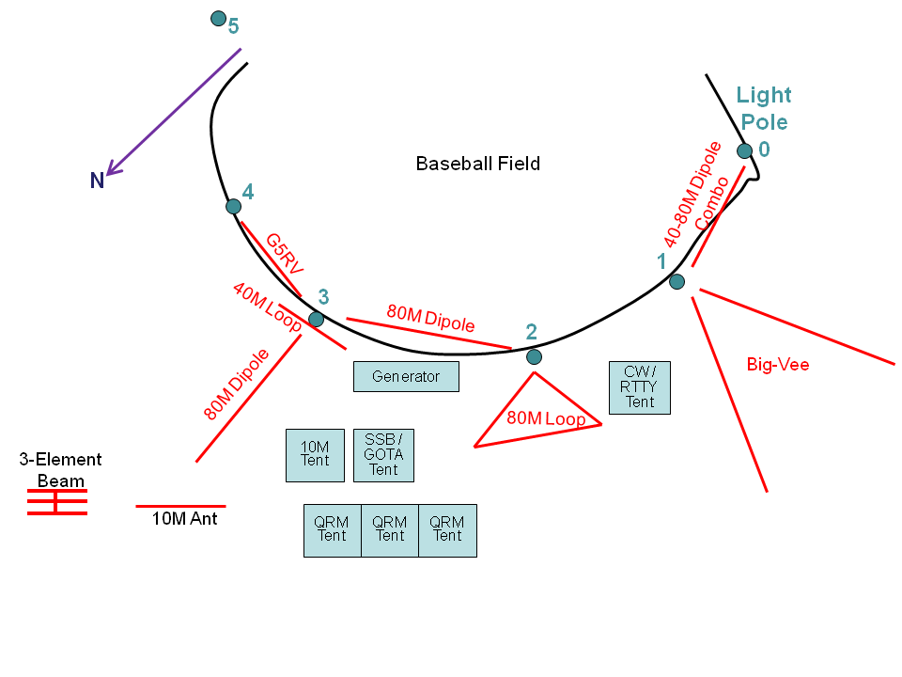  
8. QRM Tents  
A place for all to sit and talk when not operating the radios.    
Three tents if possible.  Gordon, NQ4K; Paul, K4PDF; Don, KC4RCG; Skip, KJ4LBB).   
Several tables. All should bring chairs.   
    
9.  Operator Schedule  
This is a best estimate in an attempt to keep someone on the radios at all times. Operators and times will change based upon who is ready and willing to operate at any given time. If you feel like operating for a while, please either take over an unoccupied radio or ask the current operator if they would like to take a break. All times are subject to friendly negotiation.

|  |  |  |  |  |  |  |
| --- | --- | --- | --- | --- | --- | --- |
| **Date/Time (local)** | **HF CW** | **HF SSB** | **HF CW/RTTY/SSB** | **HF GOTA** | **10M SSB** | **VHF** |
| **Saturday** |  |  |  |  |  |  |
| 1400 - 1500 | DDTJ | John, KK4AHY | Kevin, W4KLS |  | Jim, KF4PQL | Ray, KD4RSL |
| 1500 - 1600 | DDTJ | John, KK4AHY | Kevin, W4KLS |  | Jim, KF4PQL | Ray, KD4RSL |
| 1600 - 1700 | DDTJ | John, KK4AHY |  |  | Jim, KF4PQL | Ray, KD4RSL |
| 1700 - 1800 | DDTJ | Bill, AF4LL |  | Cedric, WA2FTV | Jim, KF4PQL | Ray, KD4RSL |
| 1800 - 1900 | DDTJ | Bill, AF4LL |  | Cedric, WA2FTV | Jim, KF4PQL | Ray, KD4RSL |
| 1900 - 2000 | DDTJ | Bill, AF4LL |  | Don, KC4RCG | Jim, KF4PQL | Ray, KD4RSL |
| 2000 - 2100 | DDTJ | Eric, AJ4LN |  | Don, KC4RCG | Jim, KF4PQL | Ray, KD4RSL |
| 2100 - 2200 | DDTJ | Eric, AJ4LN |  | Don, KC4RCG | Jim, KF4PQL | Ray, KD4RSL |
| 2200 - 2300 | DDTJ | Jim, AF4MO | Gordon, NQ4K | Don, KC4RCG |  |  |
| 2300 - 2400 | DDTJ | Jim, AF4MO | Gordon, NQ4K |  |  |  |
| **Sunday** |  |  |  |  |  |  |
| 2400 - 0100 | DDTJ | Jim, AF4MO | Gordon, NQ4K |  |  |  |
| 0100 - 0200 | DDTJ | Jim, AF4MO | Gordon, NQ4K |  |  |  |
| 0200 - 0300 | DDTJ | Jim, AF4MO | Gordon, NQ4K |  |  |  |
| 0300 - 0400 | DDTJ | Jim, AF4MO | Gordon, NQ4K |  |  |  |
| 0400 - 0500 | DDTJ | Jim, AF4MO | Gordon, NQ4K |  |  | Ray, KD4RSL |
| 0500 - 0600 | DDTJ | Jim, AF4MO | Gordon, NQ4K |  |  | Ray, KD4RSL |
| 0600 - 0700 | DDTJ | Mark, KI4OBT |  | Skip, KJ4LBB |  | Ray, KD4RSL |
| 0700 - 0800 | DDTJ | Mark, KI4OBT |  | Skip, KJ4LBB |  | Ray, KD4RSL |
| 0800 - 0900 | DDTJ | Linda, K4LDT |  | Skip, KJ4LBB |  | Ray, KD4RSL |
| 0900 - 1000 | DDTJ | Linda, K4LDT |  |  |  | Ray, KD4RSL |
| 1000 - 1100 | DDTJ | Linda, K4LDT |  |  | Jim, KF4PQL | Ray, KD4RSL |
| 1100 - 1200 | DDTJ | John, KK4AHY |  |  | Jim, KF4PQL | Ray, KD4RSL |
| 1200 - 1300 | DDTJ | John, KK4AHY |  |  | Jim, KF4PQL | Ray, KD4RSL |
| 1300 - 1400 | DDTJ | John, KK4AHY |  |  | Jim, KF4PQL | Ray, KD4RSL |

DDTJ – Don, Dick, Tom, and Jim. TBD

Anyone free to sit at 10M and VHF station at any time.