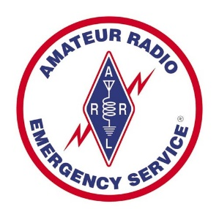
SANTA FE AMATEUR RADIO EMERGENCY SERVICES (SFARES)
REGISTRATION PAGE
NAME:
CALL SIGN:
ADDRESS:
CITY, STATE, ZIP CODE:
EMAIL ADDRESS:
HOME PHONE NUMBER:
WORK PHONE NUMBER:
CELL PHONE NUMBER:
LICENSE CLASS:

You can give the completed registration page to LV West (W0WLV) at any SFARES monthly meeting (site information is on the SFARES main website page) or email it to him at lvwest@gmail.com.

