An illustrated guide to understanding the Double Cross Antenna (DCA) for APT reception

The information in this article is so fundamental that it is probably unnecessary to actually display it But, in an effort to be thorough, the following information is offered to those curious about how the DCA works.

Half Wave Dipole ---
A dipole has a free space radiation pattern as shown in figures 1, 2 and 3. The dipole is linearly polarized, with distinct nulls toward their ends, and a maximum orthogonal to their axis

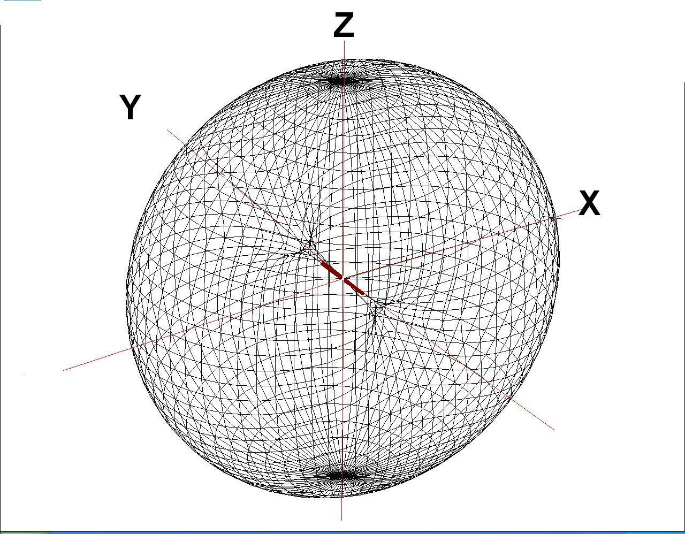
FIGURE 1 Horizontal Dipole radiation pattern.

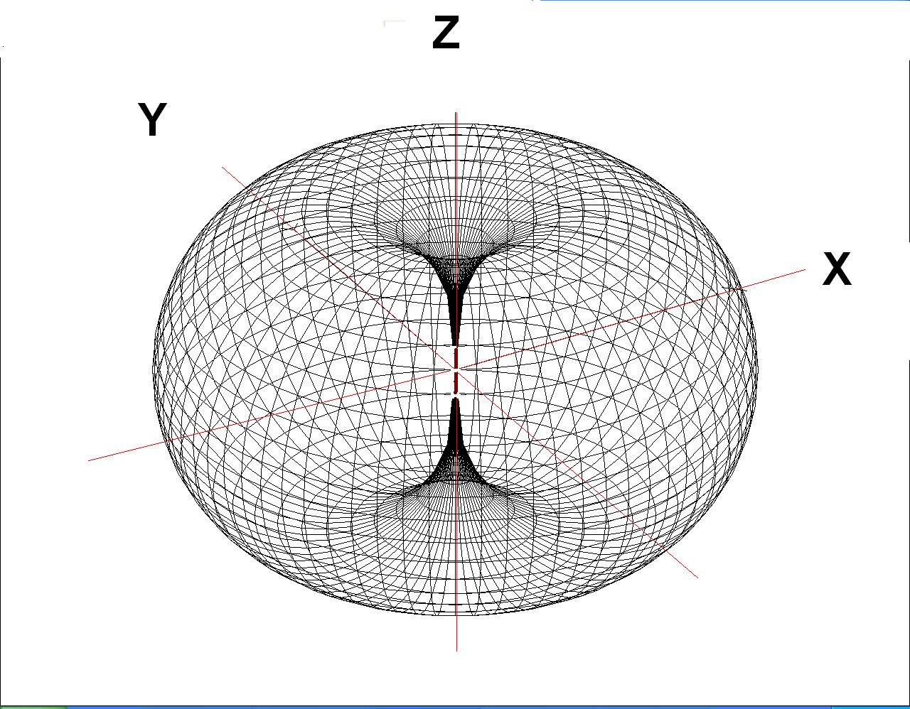

FIGURE 2 Vertical Dipole radiation pattern.

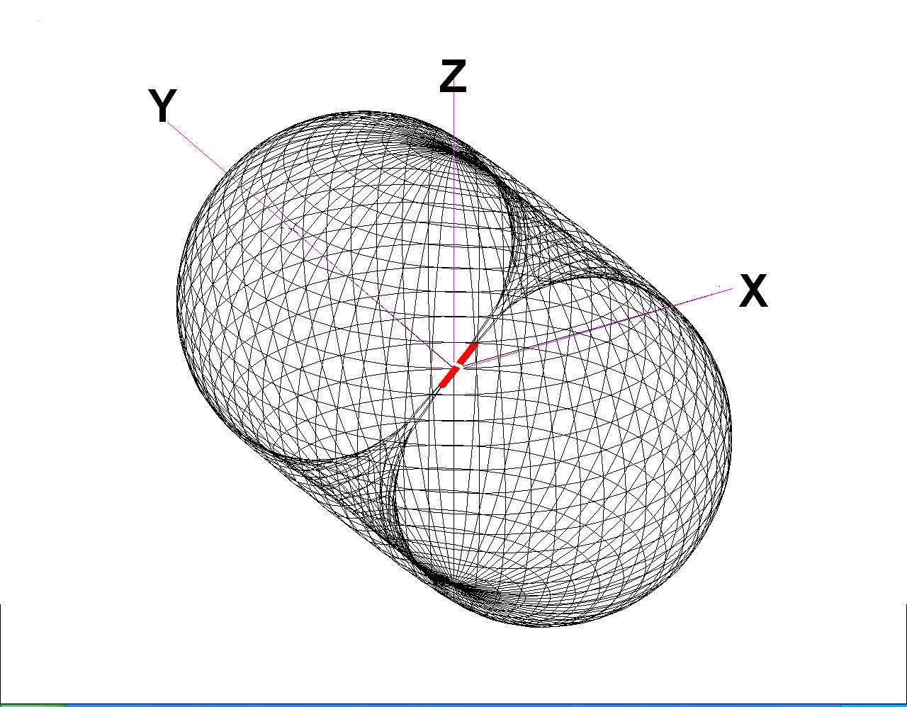

FIGURE 3 Diagonal Dipole radiation pattern.

Circular Polarization ---

Figure 4 (from Wikipedia) is an attempt to display how two linearly polarized signals can be added to produce a circularly polarized signal. Consider two radiators at the same frequency. One linear signal is at right angles to the other linear signal and with a phase difference of 90 degrees relative to each other.
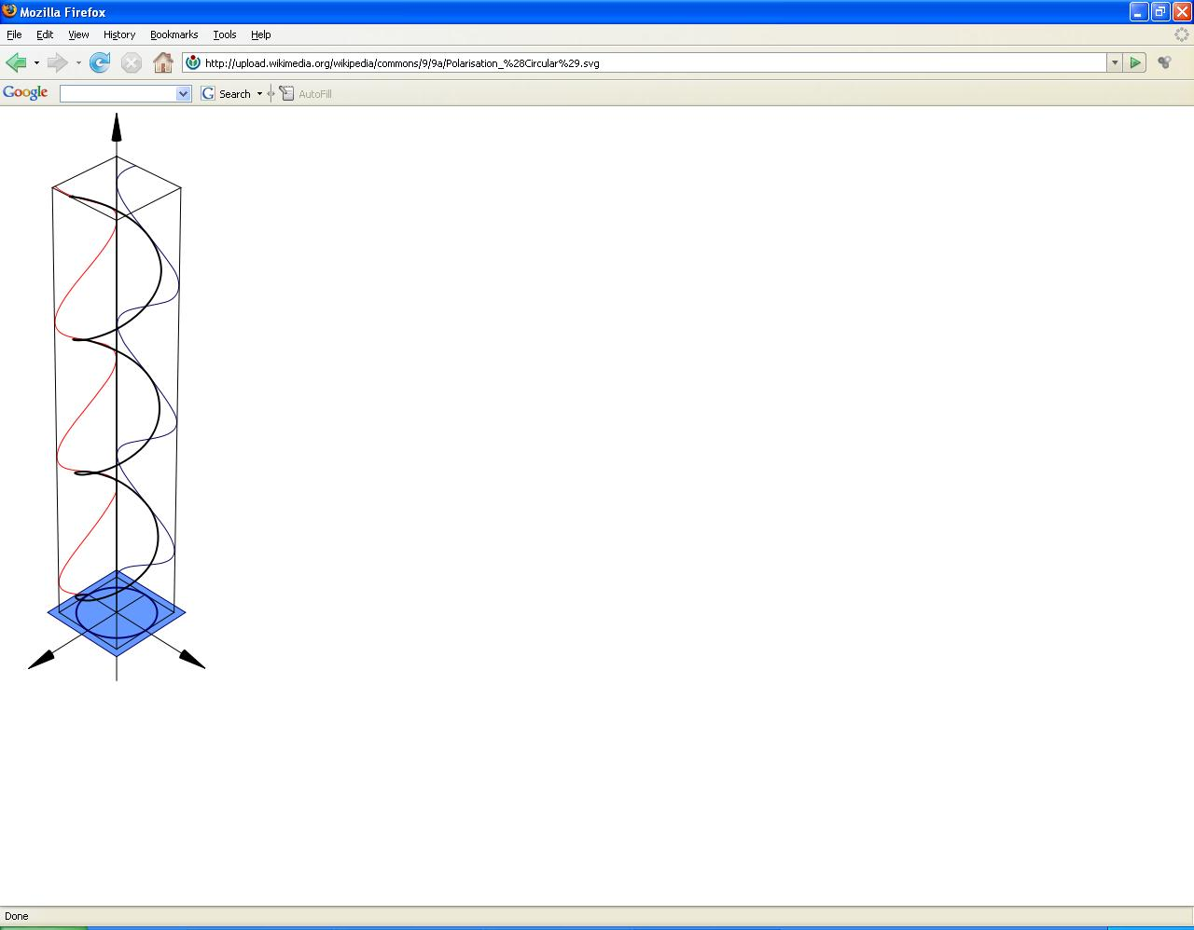

Figure 4 illustrates how two linearly polarized signals can produce one circularly polarized signal, using two dipoles.

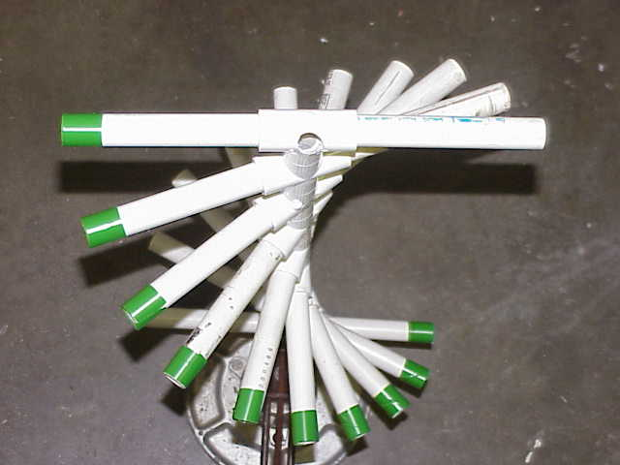

FIGURE 5 RHCP

Figure 5 is an attempt to illustrate how a RHCP signal might look as it progresses away from the viewer. Figure 6 illustrates LHCP

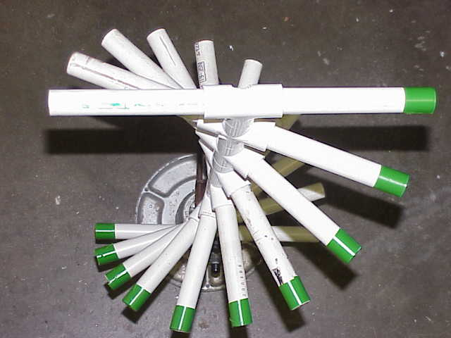

FIGURE 6 LHCP

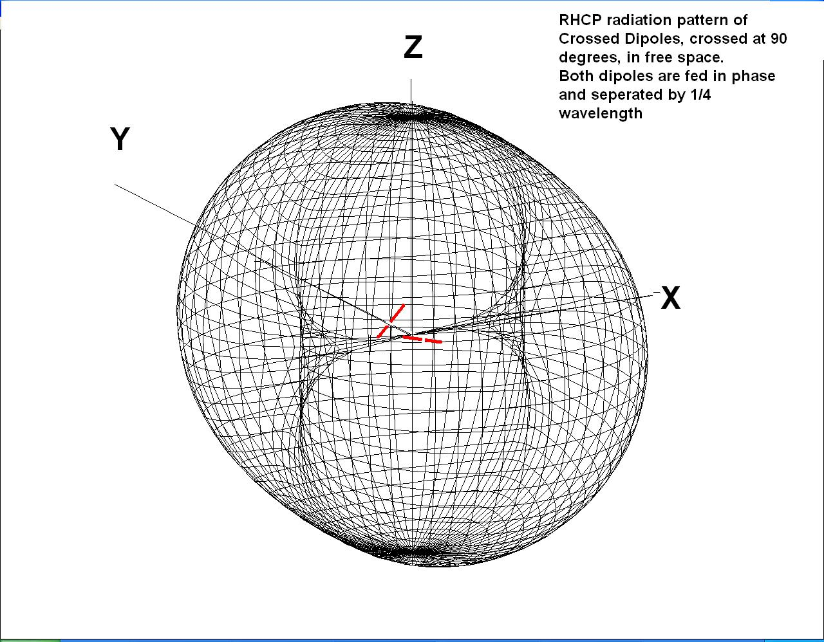

FIGURE 7 Circularly polarized signal generated by two linearly polarized dipoles.

The radiation from these two dipoles is circularly polarized along the Y direction. It degrades to linear polarization as viewed from any other direction. This degradation changes from circular thru elliptical to linear at the X axis and Z axis.

Two dipoles crossed at 90 degrees, spaced ¼ wave apart and fed in phase can generate the pattern in figure 7. Obviously, the location of the nulls can be made to occur at any direction by twisting or turning the two dipoles. The null locations can also be made to occur either toward the X axis or the Z axis by adjusting the POLARITY of the dipoles.

When the two dipoles are Polarized as shown in figure 8, the pattern will be as shown in figure 7

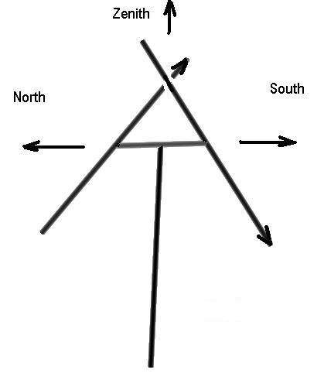

FIGURE 8 Two dipoles spaced ¼ wave and fed in phase with their polarity shown by the arrows.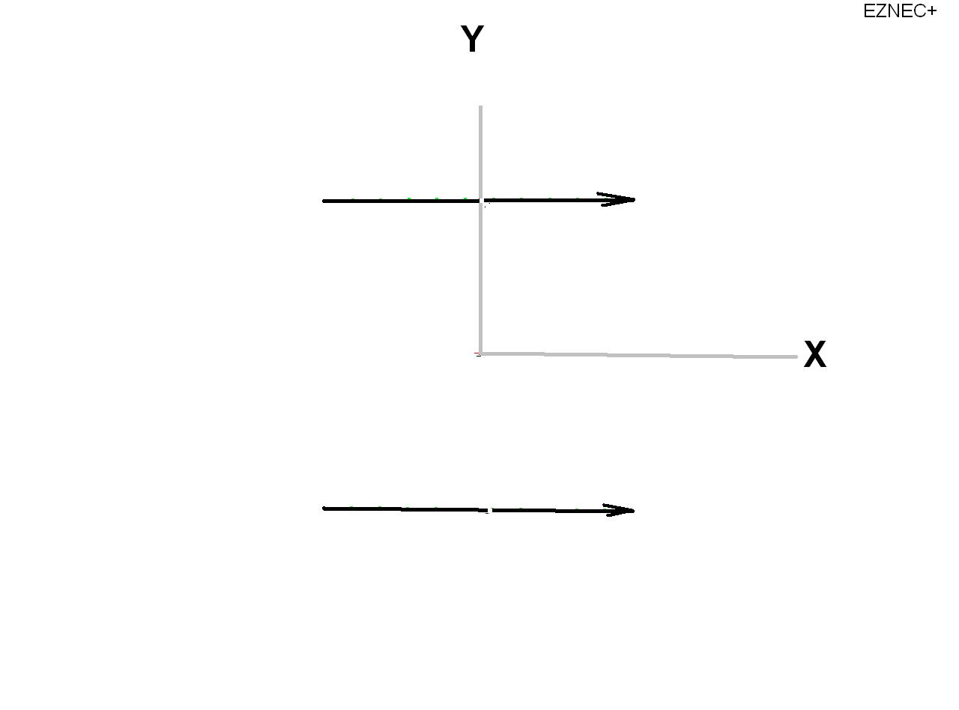FIGURE 9 Two dipoles spaced ¼ wave as viewed from above.

When viewed from above, the two dipoles are seen as two foreshortened radiators, IN phase.

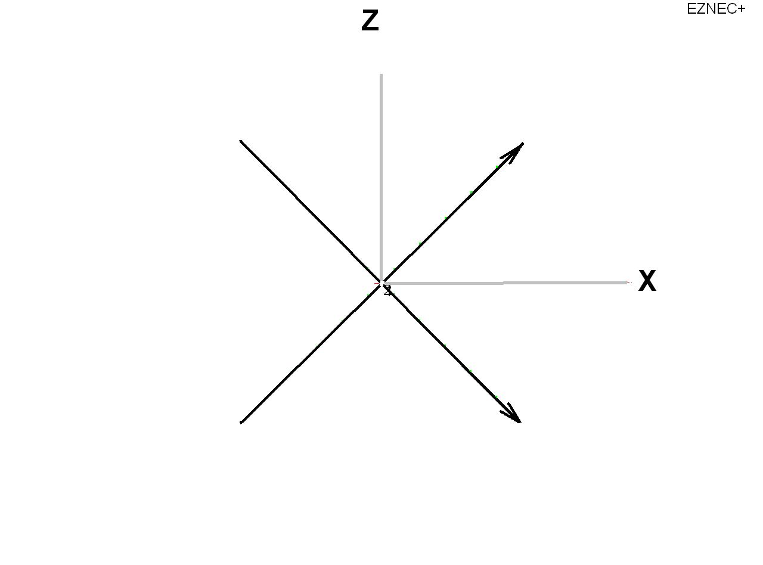
FIGURE 10 Two dipoles spaced ¼ wave as viewed ‘end on’.

When viewed from along the Y axis, the two dipoles are seen as ideal half wave radiators for RHCP.

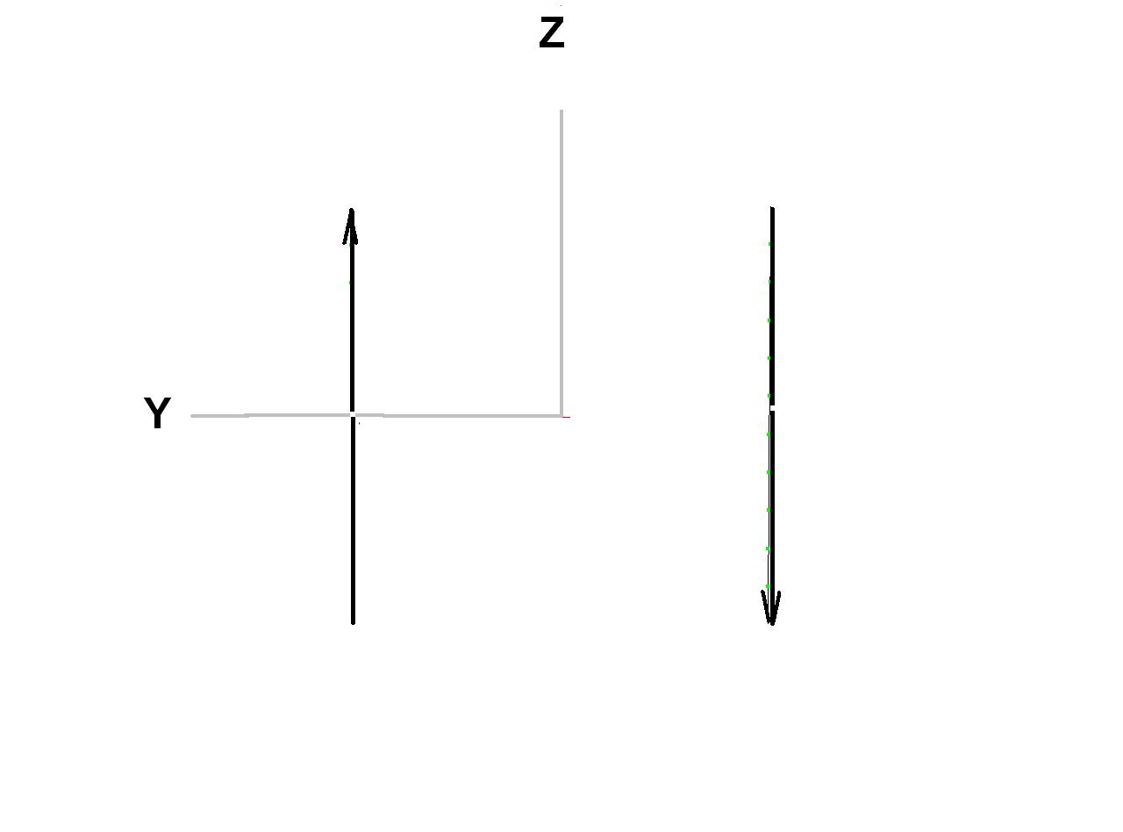
FIGURE 11 Two dipoles spaced ¼ wave as viewed from the side.

As seen from the side, along the X axis, the two dipoles are parallel and out of phase, which results in them canceling each other out.

It is expected that the readers will benefit from seeing that the two dipoles, when separated by ¼ wave and fed in phase will radiate a linearly polarized signal toward Zenith and will have a null to the side. But, if the dipoles are not mounted as shown in Figure 8, the pattern will also be “other than shown”.

Since the objective of this antenna development is to receive signals from Polar Orbiting Earth Satellites, it is important to recognize that the satellite signal is nearly 20 times stronger when the satellite is overhead that when it is at the horizon. That means that it is advantageous to tilt the dipoles slightly upward so their projected length is lessened and their radiation is lessened upward, where it is less needed.

The input impedance of the half wave dipole in free space is around 72 ohms. But, when two dipoles are spaced ¼ wave and fed in phase, and crossed at 60 degrees, their impedance is about 50 ohms each.

When tilted (30 degrees each) the pattern upward is slightly improved for our application, and the impedance can be easily be used with 50 ohm systems. But, the circularity of the polarization is degraded. The amount of degradation is indicated by the Excel plot figure 12.

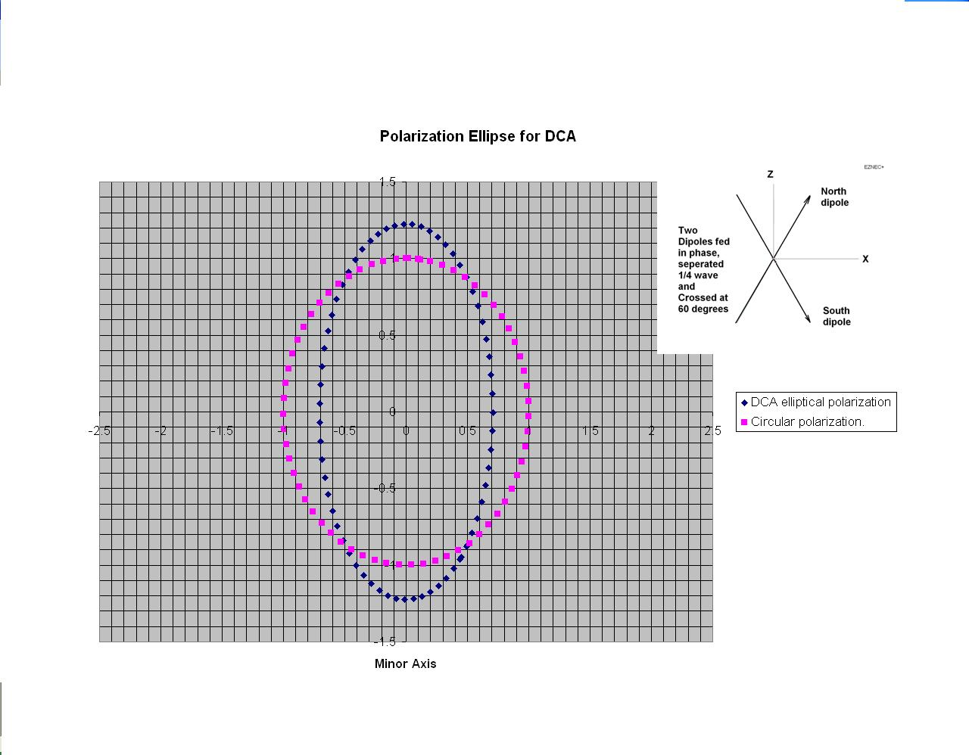
FIGURE 12 Polarization Ellipse for dipoles crossed at 60 degrees, compared with Circular Polarization.

The Double Cross

Two “Cross” antennas can be nested together, and properly fed to produce a radiation pattern that is appropriate for reception of signals from Polar Orbiting Earth Satellites.

When the two pairs of Crossed dipoles are mounted together as shown in figure 13, they will produce a free space radiation pattern as shown in figure 14

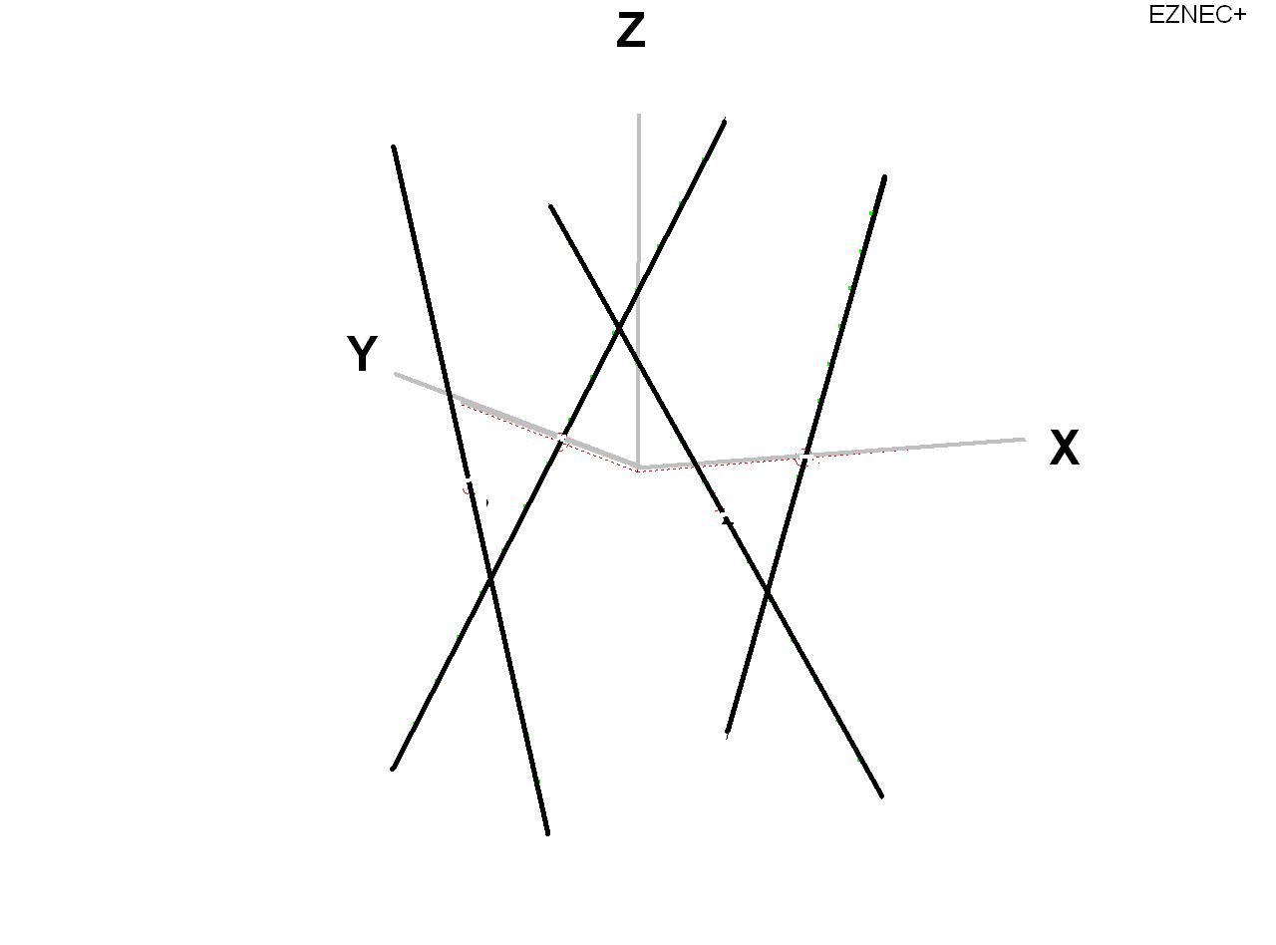

FIGURE 13 Four dipoles spaced ¼ wave apart and tilted 30 degrees from vertical.

The tilt is expected to lessen the sensitivity toward zenith, so more may be realized at the horizon where it is more beneficial. Another benefit from tilting the dipoles 30 degrees from vertical is the individual dipole impedance is very nearly 50 ohms +/-j zero when the dipoles cross at 60 degrees and are fed in phase with this ¼ wave spacing.

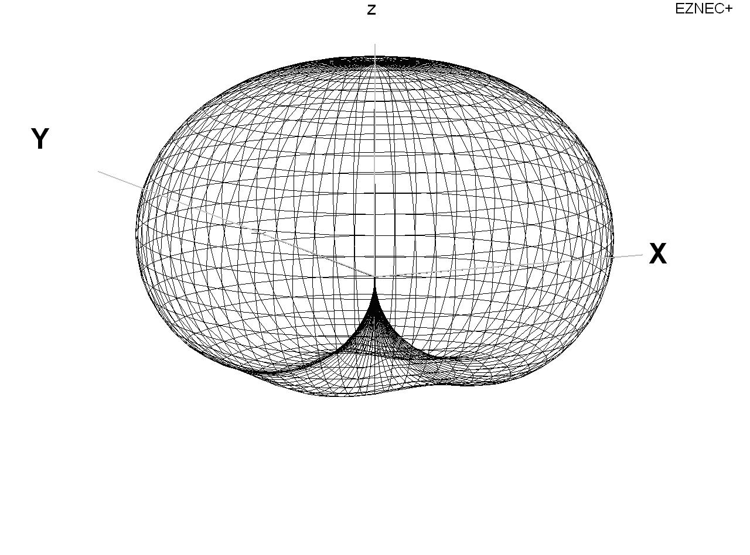

FIGURE 14 Free space radiation pattern of the antenna in figure 13, when properly fed.

In order to achieve the desired pattern as shown in figure 14, the four dipoles must be fed in a particular way so that the radiation from each dipole combines with the others properly.

It aids the reader to identify each dipole with the compass headings so the proper dipole will be connected with the corresponding proper polarity and phase. The finished antenna has no need to be oriented according to the marking. It just helps to give each dipole a name while describing how it must be fed.
Lets name the dipole that crosses the plus Y axis the North dipole. That makes the plus X axis crossing dipole the East dipole.

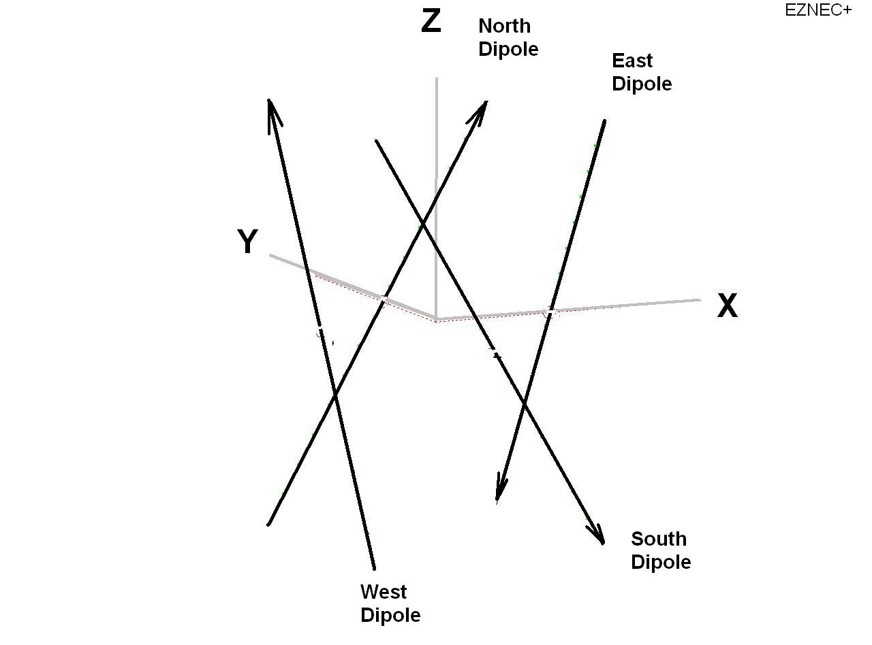
FIGURE 15 DCA antenna showing polarity of dipoles

The arrow tips are intended to indicate the direction of current flow of opposite dipoles. The feed harness must be connected so the North dipole and the South dipole are fed in phase and the upper half of the North dipole is polarized the same as the lower half of the South dipole. The East and West dipoles are fed the same way, but are fed 90 degrees later than the North and South.

The phasing and polarity might be easier to understand if the antenna is viewed from angles where it is relatively simple to analyze.
Figure 16 shows the antenna as viewed from the South

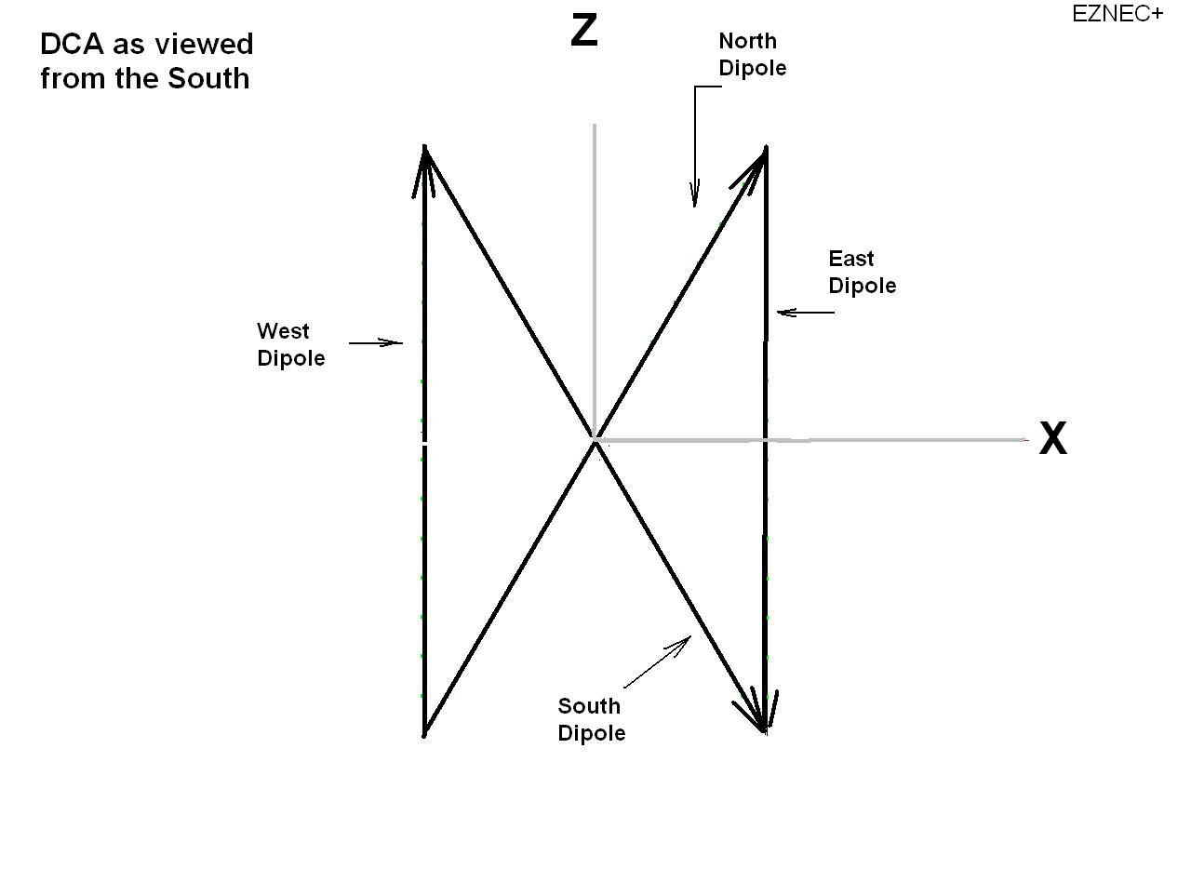
FIGURE 16 DCA as viewed from the South

From this location, which is the horizon, it can be seen that the North – South dipoles cross at 60 degrees, and will generate good Elliptical Polarization in this direction. The East – West dipoles are seen to be polarized opposite from each other thereby canceling any radiation from them, to this direction.

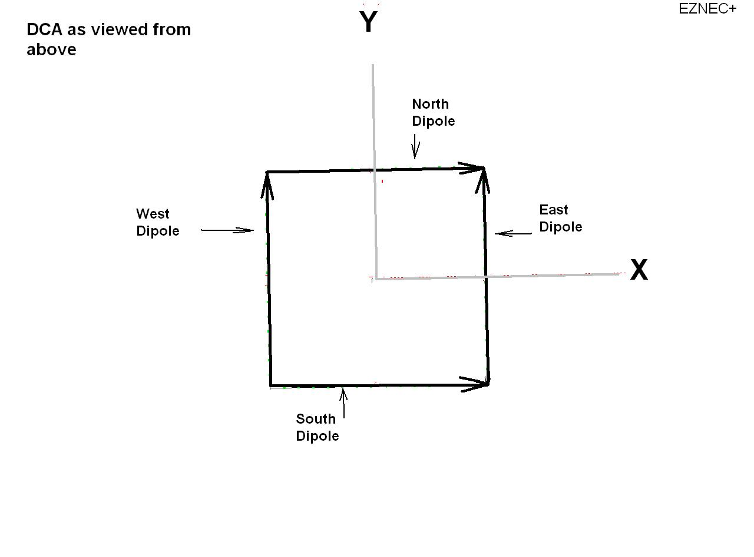

FIGURE 17 DCA as viewed from above.

When the antenna is viewed from above it can be seen that the North dipole is polarized the same as the South dipole. And, since those two dipoles are fed in phase, their signals add. The East and West dipoles are also adding. And, when the East – West dipoles are fed 90 degrees later than the North – South, they combine to generate excellent RHCP toward zenith.

When a DCA is mounted 10 meters above a real, ground, it’s radiation pattern, as predicted by EZNEC is shown in FIGURE 18

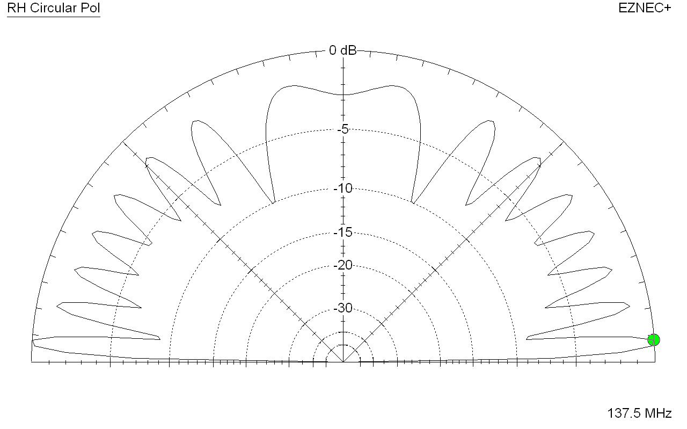
FIGURE 18 computer modeled elevation plane pattern of a DCA at 10 meter above ground.

A measured elevation plane pattern of a DCA mounted at about 10 meter above ground is shown in FIGURE 19.

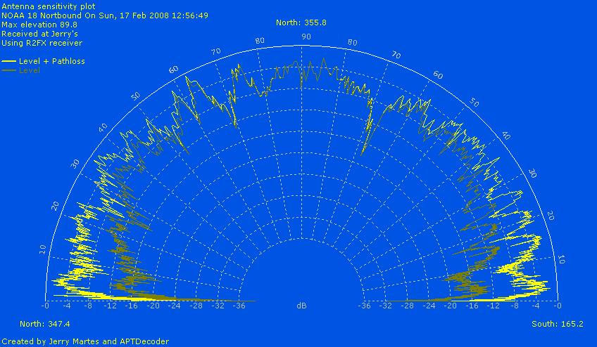

FIGURE 19 measured elevation plane pattern of the DCA at 10 meters above ground and 5 meters above roof top

Little correlation between figures 18 and 19 is obvious. It is likely that the local roof tops and trees obscure pattern minimums.
For reference, the image recorded while the pattern of FIGURE 19 was being recorded is shown in FIGURE 20.

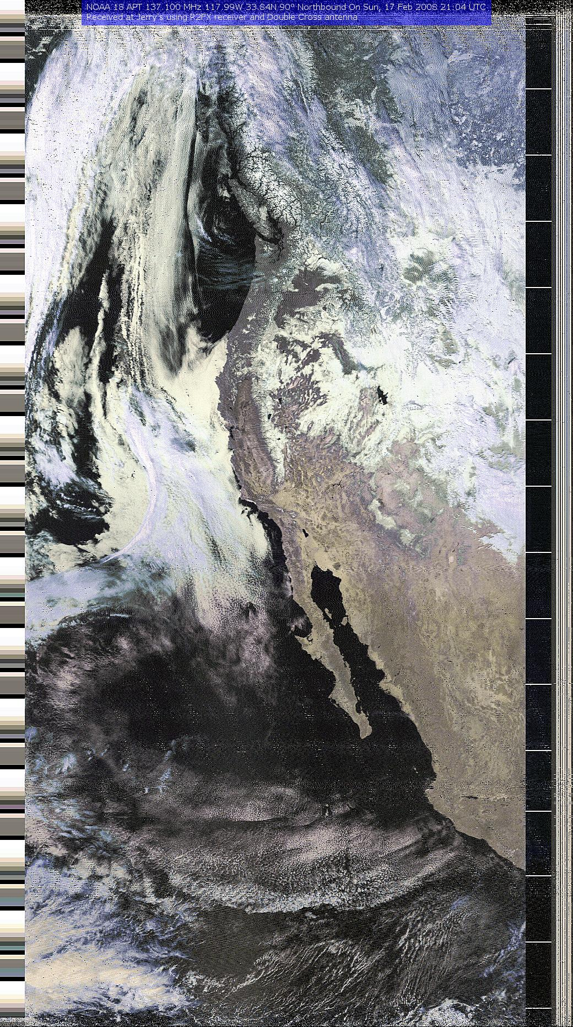

FIGURE 20 Image recorded with the DCA mounted above the roof top.

Figure 21 shows a picture of the DCA as mounted when the above pattern and image was recorded .

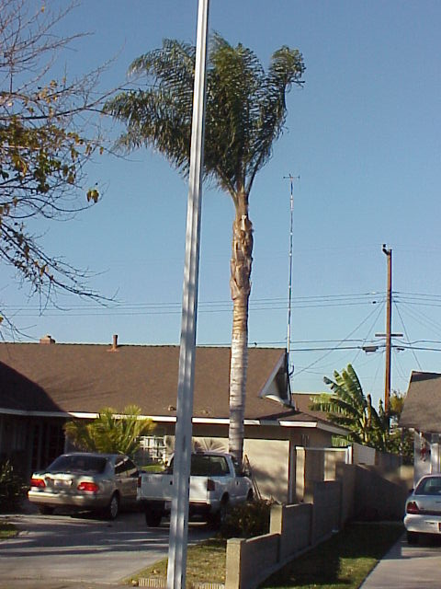

FIGURE 21 DCA mounted at about 10 meters above ground.

This information and data is believed to be correct and accurate. But, if there are any errors or unclear information, please contact Jerry Martes to point out where corrections and/or additions are needed.

