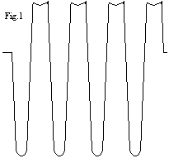
MODULATION PROBLEM
Symptom: Crappie Audio
1. - When doing alignment audio output is low, lots of distortion. It makes you look for AGC problem, don't get fooled! It is an Audio Amp problem.
Solution:
Use O-Scope and a Signal Generator producing about 3uV or S3 on radio meter, 30% modulation. With Scope on Pin 4 of TA-7222AP if the Sign Wave looks Good, then move the scope to Pin 9, low and behold, the signal now looks like fig.1 above.
Change C-176 between Pin 9 & Pin 10 to cure the problem.

COBRA 148 GTL ALIGNMENT
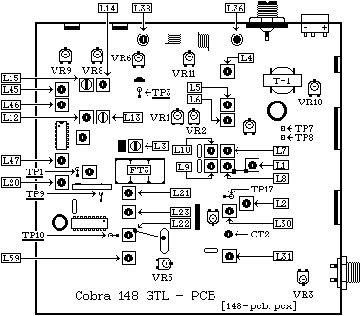

ALIGNMENT SYNTHESIZER

Input of Freq. Counter To TP-13 (IC-1 Pin 8)
CH-19 -------------------------------- Check for 10.240Mhz.
Input of Scope To TP-10
CH-19 AM ------ Adjust L-21 for Maximum RF (3-4vPP Typical)
Input of DC Meter To TP-9
CH-40 AM
Adjust L-19 for 3.2 Volts DC - 2.2 Volts DC on CH-1
Input of Scope To TP-1
CH-19 AM -------- Adjust L-20 for Max RF (190 MvPP Typical)
Input of Frequency Counter To TP-1
CH-1 AM ----------- Adjust L-23 for 34.7650 Mhz. +/- 20 Hz.
CH-1 USB ---------- Adjust L-59 for 34.7665 Mhz. +/- 20 Hz.
CH-1 LSB ---------- Adjust L-22 for 34.7635 Mhz. +/- 20 Hz.
Input of Frequency Counter To TP-10
CH-1 AM -------------------------------- Check for .790Mhz.
Input of Frequency Counter To TP-3
CH-19 USB ------- Adjust CT-2 for 7.8015 Mhz. +5 Hz. -0 Hz.
CH-19 LSB ------- Adjust L-30 for 7.7985 Mhz. +0 Hz. -5 Hz.
CH-19 AM XMT - Disconnect TP-7, TP-8 and transmit, Adjust L-31 for 7.8000 Mhz. +/- 5 Hz.
Input of Frequency Counter To TP-15 (FET-1 Gate 1)
CH-19 AM ----------------------------- Check for 7.3450Mhz.
Input of Frequency Counter To Antenna Input
CH-1 AM ------------------------ Adjust VR-5 for 26.965Mhz.
RECEIVER ALIGNMENT
Set output of Sig Generator to 27.186 Mhz.
Ch. 19, USB ------- Adjust L-14, L-12, L-10, L-9, L-8, L-7
for Max. output at speaker
Set output of Sig Generator to 27.185 Mhz.
Ch. 19, AM - Adjust L-15, L-13, L-3 for Max. output.
Set output of Sig Generator to 27.185 Mhz. Ch. 19, AM - Adjust L-6, L-5, L-4 for Max. output at speaker
NOISE BLANKER ALIGNMENT
Set output of signal generator to 27.185 AM, 1000 Hz. @ 30% modulation.
Input of O-Scope to TP-17, (D-2 Cathode) Inject a 100pps, 1uSec. pulse width signal at antenna input. Switch noise blanker ON
Adjust - L-1, L-2 for a Maximum while maintaining wave form Symmetry
RECEIVER ADJUSTMENTS
Set output of signal generator to 27.185 AM, 1000 Hz. @ 30% modulation.
Output level 1000 uV.
Set Squelch Maximum
Adjust VR-3 so that squelch just breaks.
Set output of signal generator to 27.185 AM, 1000 Hz. @ 30% modulation.
Output level 100 uV.
Adjust VR-1 for s9 on signal meter.
Set output of signal generator to 27.186 USB, 1000 Hz. @ 30% modulation.
Output level 100 uV.
Adjust VR-2 for s9 on signal meter.
TRANSMITTER ALIGNMENT
Input of RF wattmeter to antenna input
Ch. 19 AM
Adjust L-47, L-48, L-46, L-45, L-38 for maximum output
NOTE: Do not touch L-36 (TVI filter), factory adjustment is O.K.
TRANSMITTER ADJUSTMENTS
Input of RF wattmeter to antenna input, no Modulation. Ch. 19 USB, Dynamike MINIMUM
Adjust VR-4 for MINIMUM RF output.
Input of RF wattmeter to antenna input, no Modulation.
Ch. 19 USB, Dynamike MINIMUM
Insert a DC AMP meter at TP-8 (Violet wire)
Adjust VR-9 for 25 mA.
Insert a DC AMP meter at TP-7 (Green wire)
Adjust VR-8 for 50 mA.
Input of RF wattmeter to antenna input,
Inject a two-tone 500 mV signal at mic input, Dynamike MAXIMUM Ch. 19 USB
Adjust VR-11 for 11.0 watts PEP RF output maximum.
Input of RF wattmeter to antenna input Ch. 19 AM, Dynamike MAXIMUM Adjust VR-10 (AM carrier) to 3-4 watts RF output
Input of RF wattmeter to antenna input
Ch. 19 AM
Adjust VR-6 So that it agrees with your output meter.

COBRA 148 GTL SLIDE

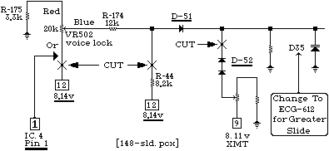
1. --- Remove R-44, R-175 & D-52.
2. --- Install jumper where you removed R-175.
3. --- Move orange wire on Clarifier to Pin 1 of IC-4
4. --- Jump R-174 or clarifier WILL NOT center up.
NOTE : L-23 (AM), L-59 (USB), L-22 (LSB), will have to be readjusted for center slot on Clarifier control - some units slide more than others.
NOTE ALSO: if you change D-35 to a ECG-612, the stock clarifier will be sensitive and hard to control so, you will have to change VR-502 to a 10 turn pot.
After doing this you MUST re-tune L-23, L-59 and L-22. See my tune-up section {above} on the Cobra 148 GTL.
It would be a good idea to let the radio settle out for a few days in the ON position then re-tune it again.

THE FOLLOWING IS A (NO-NO) AND IS FOR YOUR INFORMATION ONLY. This data is all over the net, and the only thing that is correct is item #3 below and it too is not necessary if you change the "stock varactor" to an ECG 612, in most radios that this mod applies to, Cobra 148 GTL, Cobra 142 GTL, President Washington (MB8719) ect. ECG-612 "will" in most cases, expand the slide a whole 10 kHz or one channel.
------------------------------------------------------------
"WANT MORE SLIDE?"
"1. Remove D51 and put in a jumper."
"2. Install a "super-diode" in place of the stock varactor D35."
"3. Or, add a 4.7uh to 10uh choke to the banded-end of the stock varactor."
------------------------------------------------------------
COMMENTS::
#1 above is a NO, NO, D-51 is there for a purpose.
#2 above is outdated, (what's a super diode)? I'll tell you, it's a special diode that was supplied by an outfit that is no longer in business, therefor, the information is useless as printed.
#3 above is OK to do and does work but it is hard to get the clarifier to center up.

