HF-150
Manufactured by Loewe Electronics Ltd., Bentley Bridge, Chesterfield Road, Matlock Derbyshire DE4 5LE.
Around 1991, the British manufacturer Lowe, which took an unconventional path to shortwave reception without frills with its devices, came up with the compact HF-150. Around 1987, Lowe had made his debut as a developer of shortwave receivers with his uncompromising HF-125, a few years later the more compact HF-150 appeared, in which certain additional tasks could only be mastered in the form of additional devices.
Battery-operated, the HF-150 is a high-performance travel receiver, with the additional devices it becomes a useful station receiver.
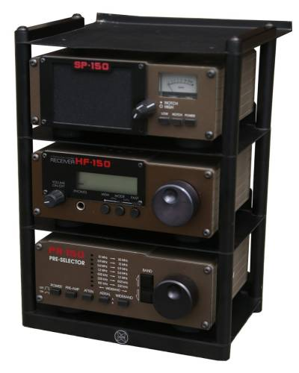

Specifications
- Principle: Doppelsuperhet, ZF 45 MHz / 455 kHz
- Operating modes: A1, USB/LSB, AM (A3), synchronous demodulator
- Frequency range: 30 kHz - 30 MHz
- Frequency display: Digital display, 1 kHz
- Frequency memory: 60
- Signal strength indicator: without
- Signal processing: synchronous demodulator
- Equipment:
- Sensitivity: AM (A3) 1 μV / Selectivity: 2.6/4.1 and 6.5/10.2 (nominal 7) kHz (-6/-60 dB)

Power supply
- Mains operation: (12 V resp. 10 - 15V), 300 mA) with external power supply 220 V
- Battery / battery operation: 12 V resp. 8 x 1.5 V accumulators (UM-3)

Battery / Battery Operation
History:
In the early days of radiotelegraphy, accumulators and batteries were almost the only usable source of voltage, especially if a device was to be used outside the home.
The ancient appliances are supplied by heating accumulators for tube heating, usually high currents with voltages of 6.3 volts are required. Furthermore, the tubes require different anode voltages, which could be obtained from anode batteries, battery- or mains-powered converters or "mains anodes".
In the classic mains-operated tube devices of the forties to sixties, mains transformers with a heating and an anode voltage winding with corresponding rectifiers are used. For the portable devices of the mentioned period, heating batteries (often AA 1.5 volts) and anode batteries (special formats, often 51 and 103 volts) were usually used.
The transistor devices from the seventies are battery-operated and usually require standard batteries, the rechargeable accumulators, which are also often used, supply a lower voltage with AA 1.2 V per cell, so that in individual cases it must be clarified whether a device with AA 1.2 V accumulators works instead of batteries in the battery compartment and provides the optimal reception performance.

Dimensions
- 185 x 80 x 175 mm, weight 1.3 kg (with accumulators 1.5 kg)

Accessories
- Preselector PR-150
- Speaker / S-Meter SP-150, for correct display a modification of the HF-150 is necessary.
- Rack
- KPAD-1 frequency input keyboard
- Accessory Kit AK-150 with a telescopic antenna, a carrying strap with integrated antenna function and eight AA accumulators or batteries.
- Computer - Interface IF-150

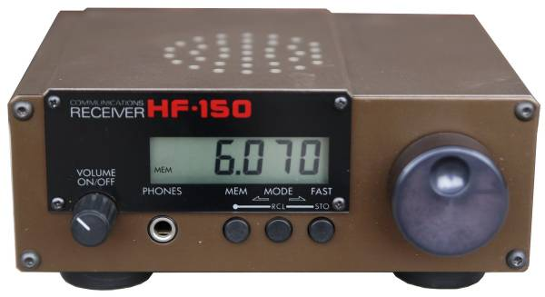

Controls
The receiver can either be operated as a standalone travel receiver (with eight
batteries or rechargeable batteries inserted, it can even be operated independently of the mains) or with a preselector and a loudspeaker as additional devices in a rack as a station receiver.
The receiver itself is built into a milled aluminum housing. The front panel looks spartan with five controls. The LCD display, which unfortunately has no backlight, is located in a black area, the combined main switch / volume control on the left, three pushbuttons under the display and the tuning button on the right.

As already mentioned:
The device is switched on with the volume control, you should hear a noise in the loudspeaker, the receiver jumps to the last set frequency shortly after switching on. If headphones are plugged into the headphone socket, the built-in loudspeaker, which radiates upwards, is muted.
The frequency can now be set with the large tuning knob. Pressing the right button FAST switches the tuning steps to 100 kHz in order to "move to" the desired band more quickly. The next time you press FAST you are back to fine tuning, in AM mode 60 Hz and SSB modes 8 Hz tuning step size.
Pressing the middle button MODE displays the active operating mode, with the right resp. The left button can be used to switch back and forth between the different operating modes. Letter codes indicate the operating mode:
- A: AM wide, 7 kHz filter
- On: AM narrow, 2.5 kHz filter
- ASd: AM synchronous demodulator, dual side band, 7 kHz
- ASF: AM synchronous demodulator, 7 kHz, high fidelity
- ASL: AM synchronous demodulator, lower sideband 2.5 kHz
- ASu: AM synchronous demodulator, upper sideband 2.5 kHz
- LSb: SSB LSB (Lower side band)
- USB: SSB USB (upper side band)
When the MEM button is pressed, the receiver goes into memory mode, indicated by a small mark on the display under MEM. Now, when turning the tuning knob, the various memories are called up, the device stores 60 frequencies by pressing MEM and then STO(re).

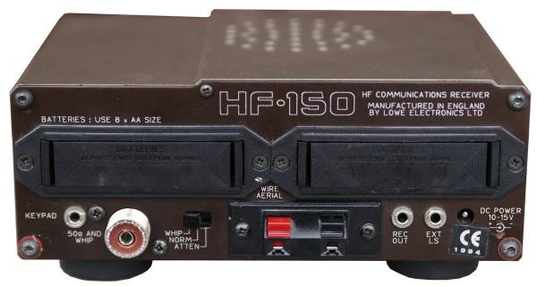
There are more elements on the back than on the front. Four AA UM-3 batteries or rechargeable batteries can be inserted into both battery compartments for battery operation. The inserted batteries are charged when the device is supplied with 12 V DC and is switched off.
If there are normal batteries in the battery compartments, the device must not be powered by 12 V or the mains adapter - the batteries cannot be recharged and may explode. For mains operation, remove the batteries or loosen the battery holders from the latched position by pressing sideways and pulling them out a little.

A modification is recommended to be executed. Put the battery holder connections is series and also the 120 Ohm resistors is series en change the connections of the mains switch into only on / off function.

On the back are the connections for a 50 ohm coaxial cable and clamps for a (long) wire antenna, the sensitivity can be switched: in the WHIP position (rod antenna) a preamplifier is activated and a telescopic antenna on an SO 239 connector or similar can be connected. Since the device tends to overload without pre-selection, the ATTEN attenuator must be activated at high signal levels.
The connections for the external frequency input keyboard, a line out and a loudspeaker output and the 12 V direct voltage connection (centre - positive, 5.1/2.1 mm low voltage connection) are also found here.
Also a RS232 unit can be connected for directly control from programs at the Personal Computer.
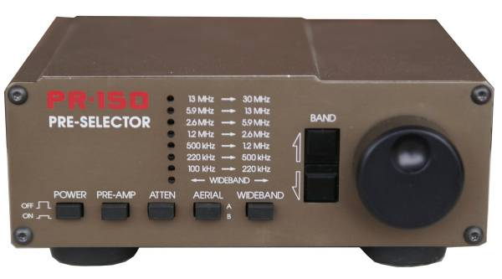

PR-150
Since the front end of the HF-150 is designed without pre-selection, the signal only goes through a 30 MHz low-pass filter in the input stage, the large signal behavior on long antennas is not optimal: a preselector must be used to improve the large signal behavior. For this purpose, Lowe had the PR-150 active preselector in the same format on offer.
If the signal situation is unproblematic, it can be bypassed in the WIDEBAND position. The band pass corresponding to the frequency can be selected with the UP/DOWN buttons and tuned to the signal maximum with the tuning knob. A preamplifier and attenuator that can be switched from the front panel is also integrated in the preselector, and two different antennas (A: unbalanced; B: symmetrical dipole antenna) can be switched.

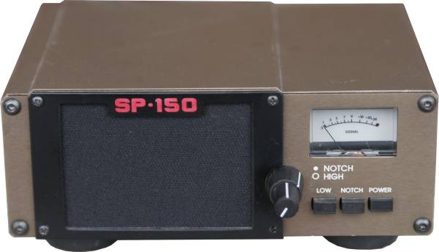

SP-150
With the SP-150, an external loudspeaker was available, which is equipped with an adjustable notch filter and a low-pass filter, the heights can be variably limited to improve intelligibility. In addition, a red backlit S-Meter is integrated into the SP-150; for activation, a trace must be interrupted on the base board of the HF-150, as described in the manual.

Technical principle
The receiver is designed as a double super with a high-lying first intermediate frequency of 45 MHz, at the front end a low-pass cuts all frequencies above 30 MHz, but preselection is only possible with the manually operated PR-150 preselector, which massively improves the large signal characteristics.

Placement
The device is semiconductor-mounted.

Technical documentation
Technical documents are available on the http://www.qls.net/pe2jeb,

