[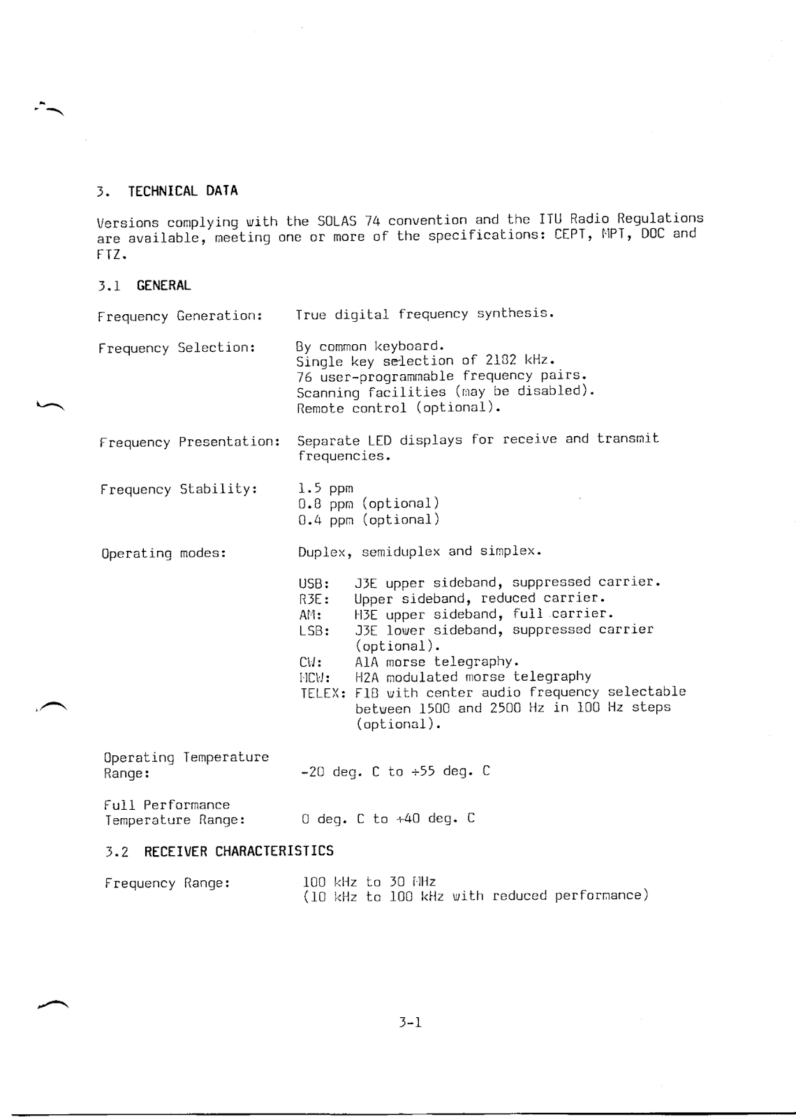](https://4.bp.blogspot.com/-DHensrrDZrg/Wx0w_4hXADI/AAAAAAAAxVc/ZJ-ztFwi0AMY7K2RpE5tVCjSfPfOw9iSgCLcBGAs/s1600/TRP+8750D_Sayfa_011.png)

[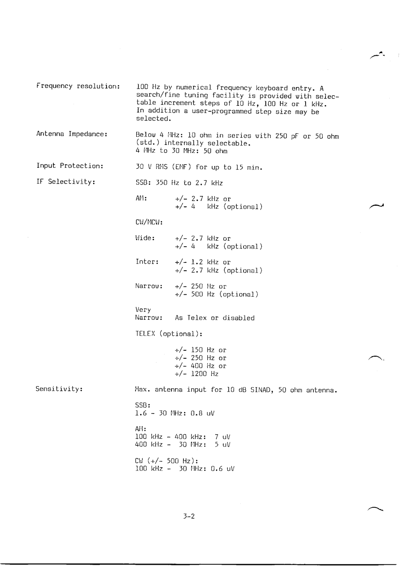](https://3.bp.blogspot.com/-HtgPLKj-1J8/Wx0xADpHyVI/AAAAAAAAxVg/DG9DvWDIQMEQB42vqLvYIFawWQrV-tvmgCLcBGAs/s1600/TRP+8750D_Sayfa_012.png)

[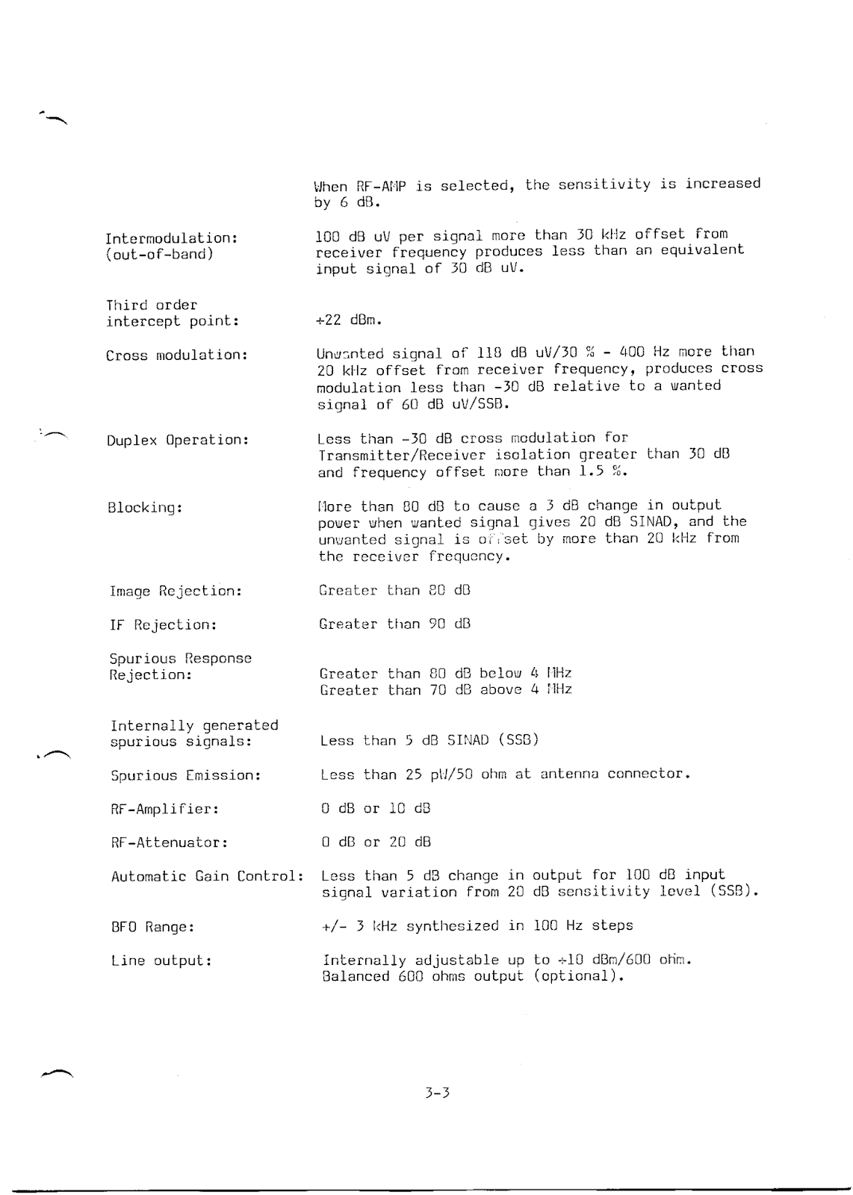](https://4.bp.blogspot.com/-HhfJF1sSgkc/Wx0xAvkO2hI/AAAAAAAAxVk/PHAleEYtJ54roBEHAjrrzXO1GHzD1cy0ACLcBGAs/s1600/TRP+8750D_Sayfa_013.png)

[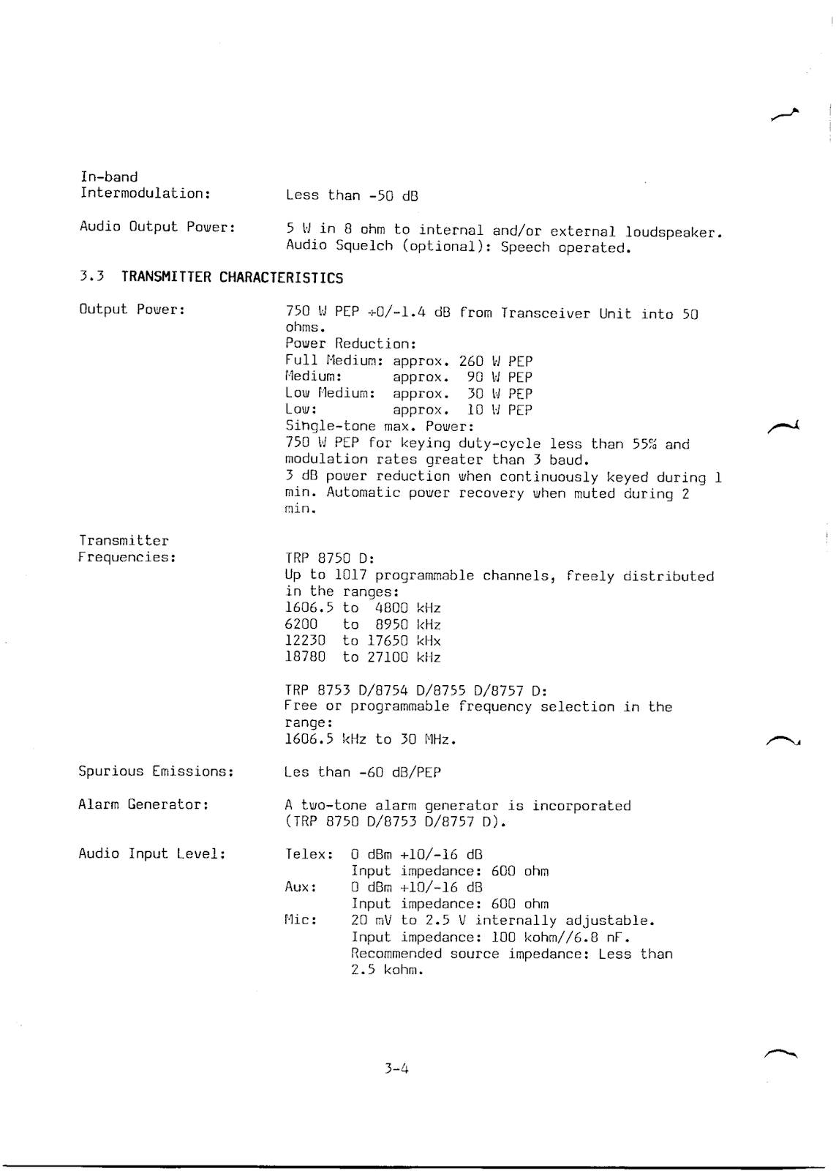](https://1.bp.blogspot.com/-FiLUjRUVPQw/Wx0xBCPjoMI/AAAAAAAAxVo/9EjSflepNB8K_jI1PdEGJQUd2xc9lCgswCLcBGAs/s1600/TRP+8750D_Sayfa_014.png)

[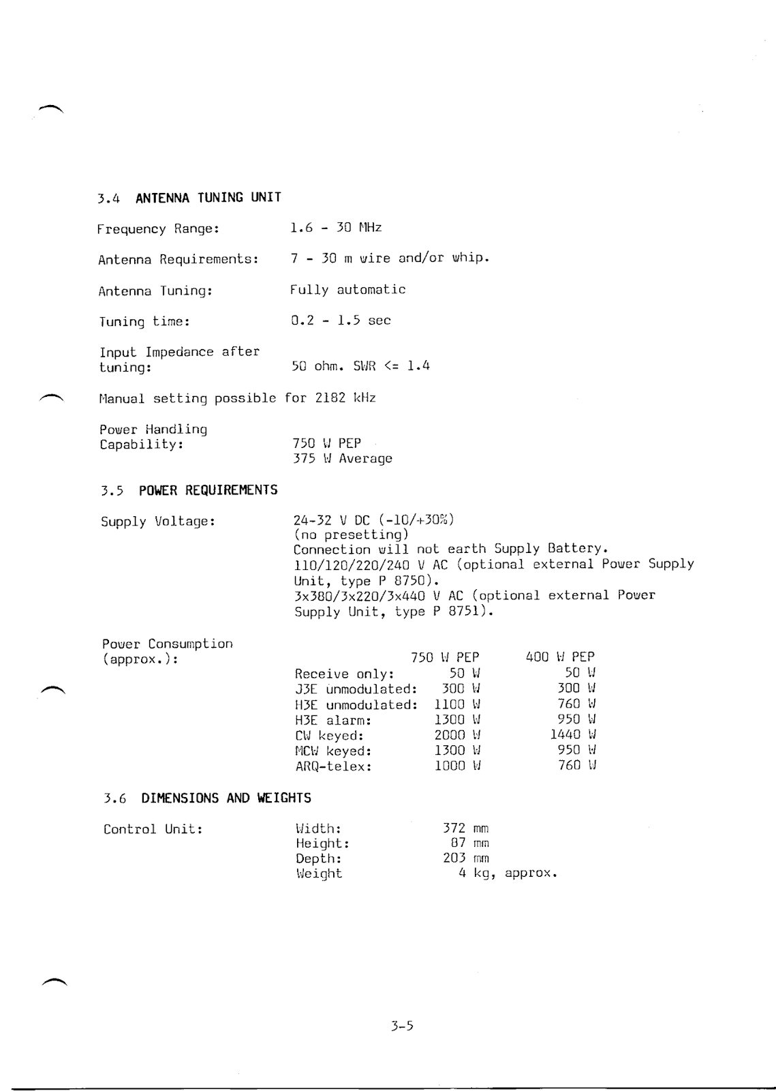](https://3.bp.blogspot.com/-dM2VFAlOk5k/Wx0xBuHkHPI/AAAAAAAAxVs/AW8AAUtkSdgdkHz9lfN3kF-KfKRe7MiowCLcBGAs/s1600/TRP+8750D_Sayfa_015.png)

[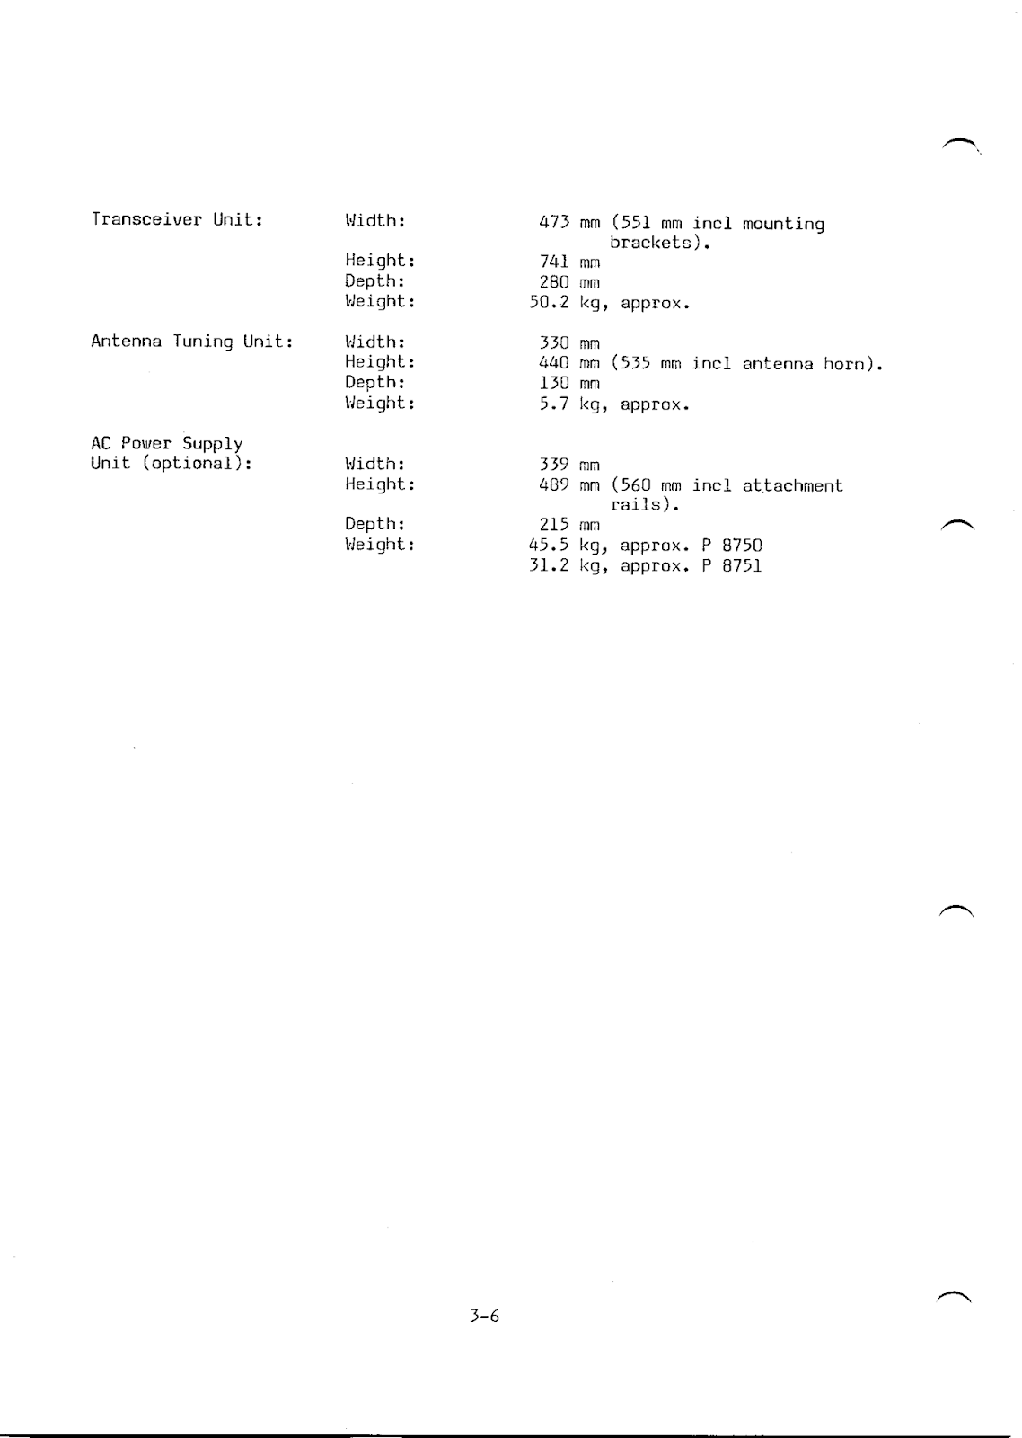](https://3.bp.blogspot.com/-dnLoeeUVEHU/Wx0xBzuqGcI/AAAAAAAAxVw/r9Ol0OnPwPAY-iaQWh6reRggZMJe1nU9wCLcBGAs/s1600/TRP+8750D_Sayfa_016.png)