[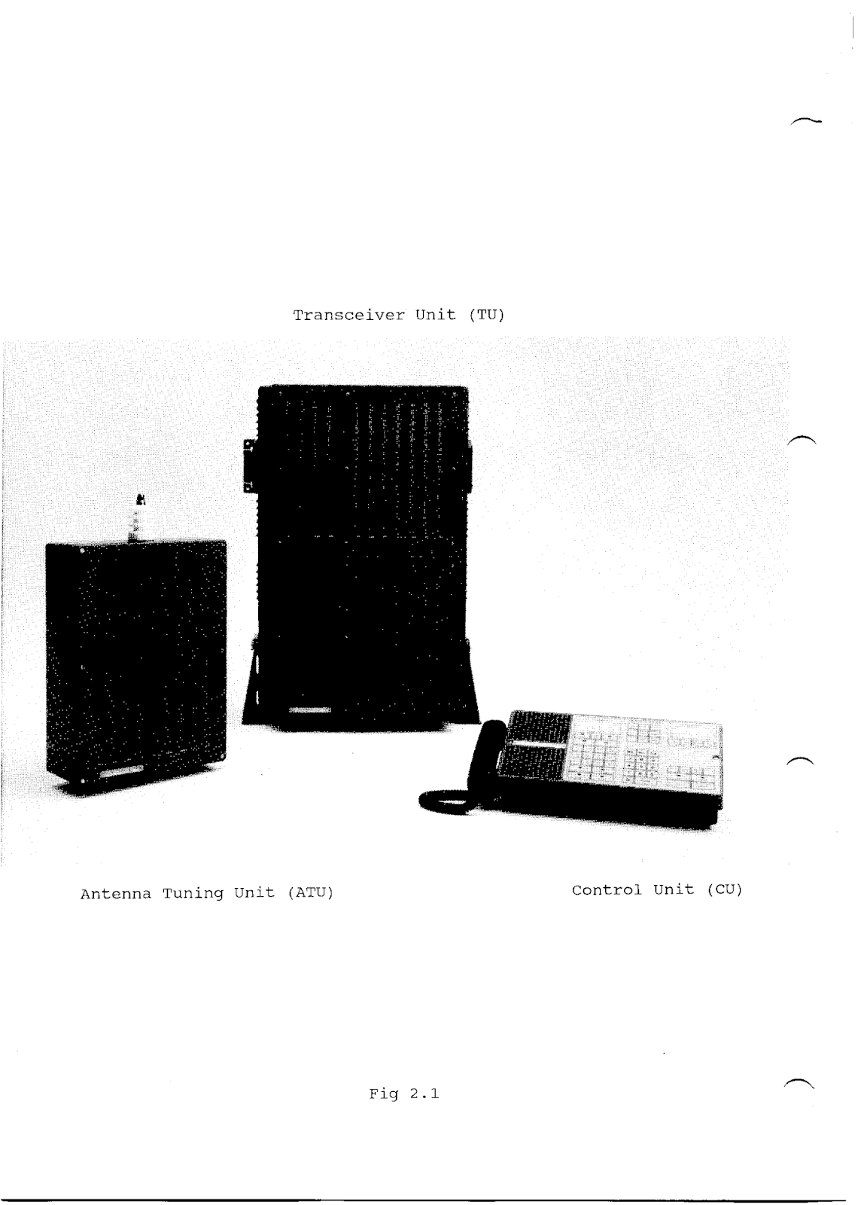](https://4.bp.blogspot.com/-lwjWmDHFx_o/Wx0w-9OJPlI/AAAAAAAAxVM/Vqjg8cOaf3I3jGR0PH_wE54ApkFBIoeBgCLcBGAs/s1600/TRP+8750D_Sayfa_006.png)

[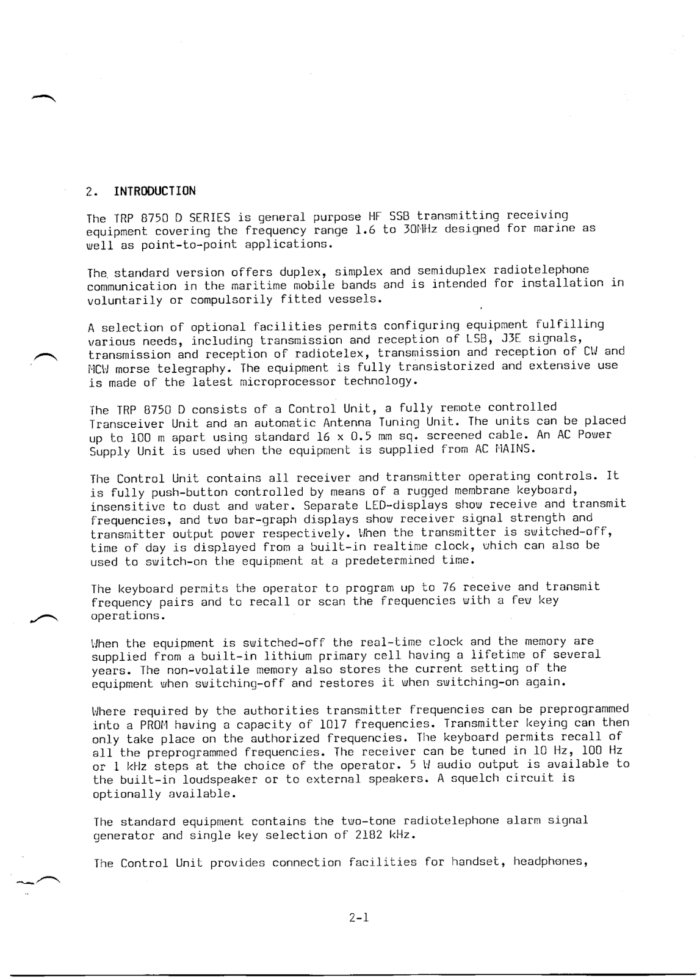](https://4.bp.blogspot.com/-yK-noDleUqg/Wx0w-7f0hiI/AAAAAAAAxVI/htP_n9poJE8ZP-ma_j1QiFrxsb1hC5fmQCLcBGAs/s1600/TRP+8750D_Sayfa_007.png)

[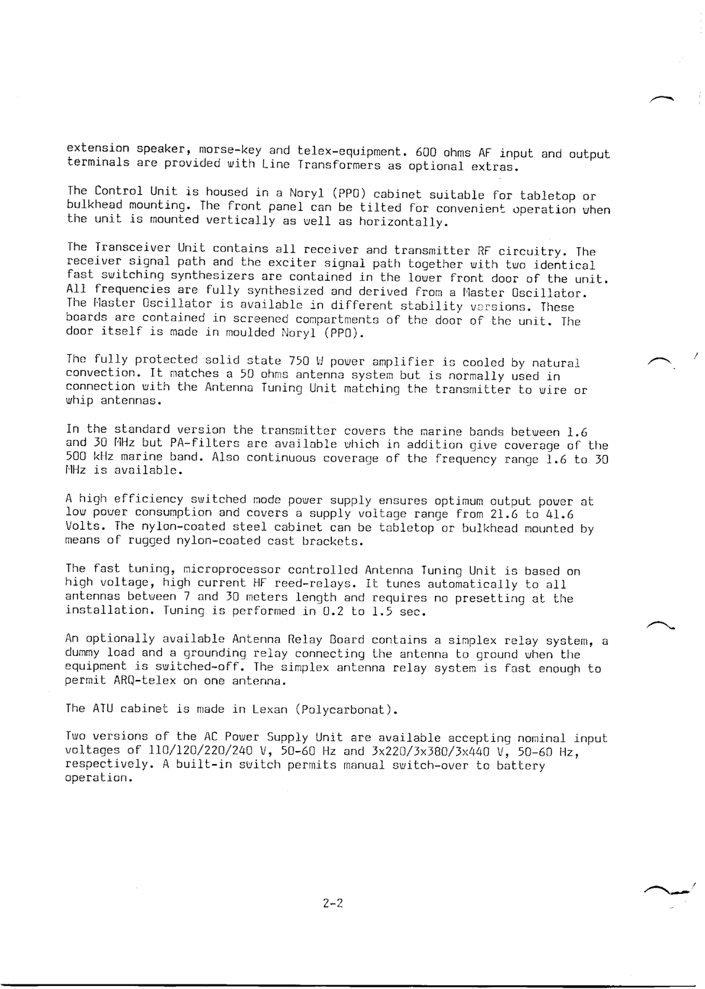](https://2.bp.blogspot.com/-Ma6ZZf366Do/Wx0w_Mz1s0I/AAAAAAAAxVQ/bBy0rB63-YoSPYAB5hus0v6fNUbNwScSACLcBGAs/s1600/TRP+8750D_Sayfa_008.png)

[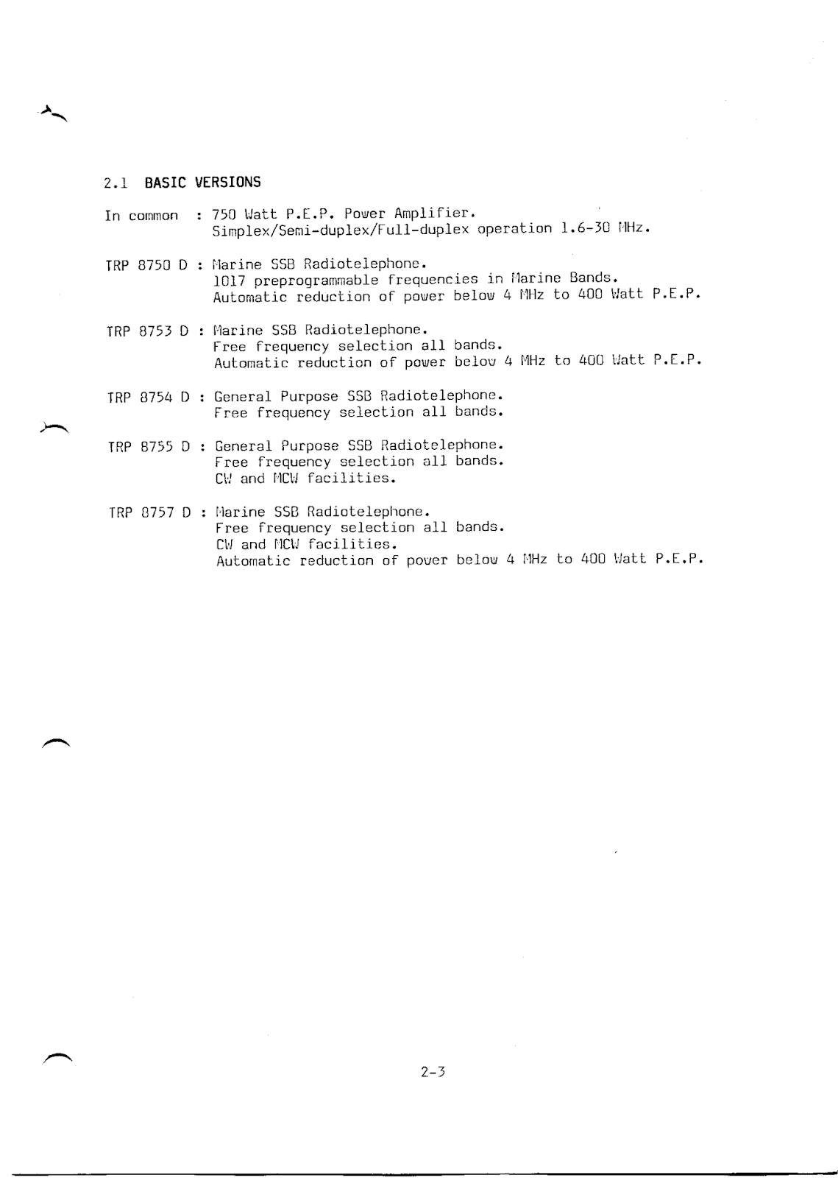](https://1.bp.blogspot.com/-fj0NyHZAbP0/Wx0w_nOvzfI/AAAAAAAAxVY/b0pZKKfcBIET8ejNt5Q3gqHCQjTOebmlgCLcBGAs/s1600/TRP+8750D_Sayfa_009.png)