

E 5002 INSTRUCTION MANUAL

Skandinavisk Teleindustri Skanti A/S
34, Kirke Vaerlgsevej - DK 3500 Vaerlose – Denmark

PHONE. + 45 2 48 25 44 . CABLE: SKANTIRADIO, COPENHAGEN
TELEX: 37292 SKANTI DK .
E 5002
INSTRUCTION MANUAL
CONTENTS
1. INTRODUCTI0N | 1 - 1
2. OPERATING INSTRUCTIONS | 2 - 1
2.1. Tuning to a Frequency  2.2. Operating Controls and their Functions  2.3. Filter Cleaning | 2 - 1  2 - 1  2 - 3
3. INSTALLATION

3.1. Programming of Memory 303, General  3.2. Ordering Programmed PROMs  3.3. Instruction for use of Programming Unit 241  3.4. Remote Control | 3 - 1  3 - 3  3 - 8  3 - 14
4. TECHNICAL DATA

5. TECENICAL DESCRIPTION

5.1. Mechanical  5.2. Circuit Description, General  5.3. Circuit Summary, Signal Path E 5002  5.4. Circuit Summary, Frequency Synthesizer E 5002  5.5. Circuit Description, Exciter E 5002 | 5 - 1  5 - 1  5 - 1  5 - 2  5 - 4
6. SIIMPLE SERVICE

6.1. Incorrect Operation  6.2. Battery  6.3. Checking the Antenna Tuning  6.4. Using the CRICK SWITCH  6.5. Replacement of Fuses | 6 - 1  6 - 1  6 - 1  6 - 1  6 - 2
7. REPAIR AND ALIGNMENT | 7 - 1
7.1. Introduction  7.2. Cross Slot Screws  7.3. Locating Subunits and Components  7.4. Locating Faults  7.5. Test Points  7.6. AC Voltages  7.7. DC Voltages  7.8. Adjustments | 7 - 1  7 - 1  7 - 1  7 - 1  7 - 1  7 - 1  7 - 2  7 - 2

7.9. | 244 | Realignment of 1.4 MHz Exciter | 7-2
7.10 | 302 | Realignment of RF Translator | 7-4
7.11 | 234 | Realignment of Control Circuit and Tone Generators | 7-5
7.12 | 208 | Realignment of Loop Translator | 7-6
7.13 | 209 | realignment of VC01 and VC02 | 7-7
7.14 | 210 | Realignment of VC03 | 7-8
7.15 | 240 | Realignment of Master Oscillator | 7-8

8. PARTS LISTS AND CIRCUIT DIAGRAMS | 8-1
8.1. Numbering | 8-1
8.2. Switches | 8-1
8.3. Terminals | 8-1
8.4. Voltages | 8-1
8.5. Test Points | 8-1
8.6. Symbol Explanation | 8-4
8.7. Abbreviations | 8-5
8.8. Parts Lists
8.8. Diagrams

LIST OF ILLUSTRATIONS

Front panel and operating controls | 1 - 1
PROM-types whi.ch can be installed | 3 - 1
Remote Control Interface | 3 - 15
PROM programming work sheets | 3 - 17
Function table for M234 IC5 | 7 - 10
Function table for 302 IC5-IC9 | 7 - 11
Function table for 303 IC16 | 7 - 16
Location of circuit boards E 5002 | 8 -

LIST 0F DIAGRAMS
Block Diagram, Signal Path
Block Diagram, Frequency Synthesizer
Block Diagram, Frequency Selection
Keying Circuit, Simplified Diagrams
300 | E 5002 Wiring Diagram, | 301 | Motherboard
244 | 1.4 MHz Exciter
302 | RF Translator
M234 | Control Circuit and Tone Generators
207 | Frequency Divider
208 | Loop Translator
209 | VCO1 and VC02
210 | VC03
240 | Master Oscillator
303 | Display and Keyboard
241 | Programming Unit
T 5002 Cabinet Wiring
Terminal Strip A

1. Introduction
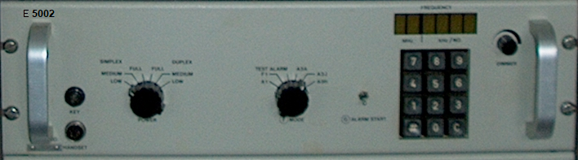
  - The E 5002 exciter is designed for use in conjunction with the T 5000, T 5001 or T 5002 transmitter power amplifier and the P 5000 (THC) or P 5001 (AC) power packs. It can also be used in conjunction with other transmitter power amplifiers and power packs where the necessary interface is available.

The exciter is fully synthesized for operation in the frequency range 400 KHz to 29.9999 MHz in 100 Hz steps and contains a memory for up to 32 discrete channels which can be freely distrisuted over the entire frequency range.

The exciter is designed for transmitting of F1, A1, A2H and upper sideband A3H, A3J and A3A signals (optionally upper and lower sideband A3H, A3J and A3A signals).

The dimensions match a standard 19-inch rack and the exciter is intended for mounting in the cabinet with the T 5002 transmitter. When so mounted, the exciter and transmitter together with the receiver and the transmitter power pack constitute the TRP 5002 SSB general purpose radiotelephone.

As we are constantly processing the experience gained during the production and operation of our equipment, it is possible for minor modifications to occur relative to the information given in this instruction manual. Wherever practicable, however, any corrections will be listed on a correction sheet at the back of the front cover of this manual.

This manual describes the exciter E 5002 in conjunction with the T 5002, P 5000 or P 5001 and a receiver of the R 5000 series.

1 – 1
2. Operating Instructions
2.1. Distress 0peration on 2182 KHz (valid for TRP 5002 with T 5000 only)
Set controls as follows:
A SUPPLY to TRANSMIT
B BAND to 2182 KHz
D VOLUME clockwise
E SENSITIVITY fully clockwise
F MODE to TRANSMIT ALARM
G Press and release ALARM START
The alarm signal is now transmitted for approx. 45 seconds and nay be monitored in the
handset earpiece. When the alarm signal ceases, depress handset key and, speaking clearly into microphone, transmit distress message.
If it is required to repeat the alarm signal transmission, it is only necessary to press and release the ALARM START push button again.
An alarm signal transmission may be interrupted at any time by turning the MODE Switch to A3H.
NOTE: In the TRANSMIT ALARM mode on 2182 KHz the power output of the transmitter is automatically set to FULL POWER SIMPLEX independent of the setting of the POWER switch.
2.2. Tuning to 2182 KHz (valid for TRP 5002 with T 5000 only)
1. Set SUPPLY switch to TRANSMIT.
30 seconds after switching on the transmitter is ready for operation.
2. Set BAND switch to 2182 KHz.
The band-indicator lamp will show constant light indicating that 2182 KHz is selected. The FREQUENCY display will show frequency no. zero for approx. 1 see. followed by a display of 2182.0 KHz.
3. Press TUNE button and adjust TUNING control for maximum deflection on ANTENNA CURRENT meter.
The tuning range on 2182 KHz is reduced 8o that power is tran8- mitted even when the TUNING control is not adjusted.

The transmitter is now ready for operation.

NOTE: The type of service used on 2182 KHz is A3H, simplex. This mode is automatically selected when the BAND switch is set to 2182 KHz, and the MODE switch .can therefore be set to any position except TEST Alarm. The equipment will also work in the simplex mode even if the POWER switch in a DUPLEX position.
2 - 1
2.3. Tuning to a Frequency

- Set SUPPLY switch to TRANSMIT.
30 seconds after switching on the transmitter is ready for operation.

- Turn DIMMER control fully clockwise.

- If the display does not show zero, clear display using C key of keyboard.

- Select the desired frequency with the keyboard or look up the desired frequency in frequency chart and read frequency No. and key frequency No. into keyboard. If a frequency No. is chosen it will be displayed for approx. 1 sec. followed by display of the actual frequency.

- Set BAND switch to position indicated by flashing band indicator lamp. If no flashing occurs the BAND 8uitch is already correctly set.

- Press TUNE button and adjust TUNING control for maximum clef lection on ANTENNA CURRENT meter.

- Select desired type of service with CODE and POWER Switches. Transmitter is now ready for operation.

2.4. Operating Controls and their Function

2.4.1. The SUPPLY switch has four positions:
OFF Receiver and transmitter are switched off.

RECEIVE ONLY Power Pack is Started up and supplies poser to receiver (and grid bias to transmitter output valves) Remote speaker of receiver is connected to receiver Output.

STAND BY Power Pack supplies power to receiver, exciter, band indicator and filaments of transmitter output valves. Remote speaker of receiver is connected to receiver Output.

TRANSMIT Transmitter can be keyed. Remote speaker of receiver is disconnected.

NOTE: A built-in delay circuit protects the output valves of the transmitter from being keyed for the first 30 sec. after switching from OFF or RECEIVE ONLY to STAND BY or TRANSMIT.

2.4.2. The POWER switch has six positions:

LOW PORER Transmitter is keyed from handset key, morse key or telex equipment
SIMPLEX depending on mode of operation. Receiver is muted while transmitting. Transmitter can be driven to approx. 1/20 to full output power.
2 - 2
MEDIUM POWER As above, but transmitter can be driven to approx.
SIMPLEX 1/4 of full output power.

FULL POWER As above, but transmitter can be driven to full power.
SIMPLEX Not to be used for A1 transmission below 4 MHz.

FULL POWER Transmitter is keyed constantly ill the F1, A3A, A3J and A3H modes.
DUPLEX Receiver is on, but built-in speaker is disconnected. In the A2H and Al modes the operation is simplex independent of the setting of the POWER switch. Transmitter can be driven to full output power. Not to be used for Al transmission below 4 MHz.

MEDIUM POWER As above. but transmitter can be driven to approx.
DUPLEX 1/4 of full output power.

LOW POWER As above, but transmitter can be driven to approx.
DUPLEX. 1/20 of full output power.

2.4.3. The MODE switch has six positions (eight on E 5002 for T 5000):

A2H Transmission of modulated radiotelegraphy. Only the morse key input is open.

A1 Transmission of un modulated radiotelegraphy. Only the morse key input is open (Reduce poker to medium or low power for frequencies below 4 MHz).

F1 Transmission of telex. Only the telex inputs are open.

A3A Transmission of Single sideband signal with reduced carrier. The transmitter can be keyed from the handset key or 6y setting the POWER switch to DUPI.EX.

A3J As above, but carrier Suppressed. As above, but full carrier.

(TEST ALARM) The built-in two tone alarm generator is connected to the receiver AF amplifier. Transmitter cannot be keyed.

(TRANSMIT ALARM) The tow-tone alarm generator is connected to the receiver AF amplifier and the alarm generator is ready for transmission of an alarm signal. The mode is A3H as above.

NOTE: Using pre-programmed frequencies, note that the frequency might be programmed A3H simplex, and this is overriding the POWER and MODE switch setting.
2.4.4. The keyboard is used for frequency selection.
The key marked “ # “ is used for choosing between direct or programmed frequency Selection.
2 - 3
When the key is in its outer position, free frequency selection mode is selected. The frequency is keyed-in on the keyboard and the frequency is shown on the display. When the key is in its inner position the pre-programmed frequency mode is selected. The programmed frequencies are listed in the frequency chart. Each frequency is supplied with a number which is keyed into the keyboard. The keyed-in frequency number is shown in the display with a "no." sign in front for approx. 1 sec. after which the actual frequency is displayed. If a frequency number is cancelled the display will be blanked except the "10 MHz" digit and the "1 MHz" digit.

2.4.5. The DIMER controls the intensity of the display.

2.4.6. The LSB/USE switch (optional selects the sideband to be transmitted (lower sideband or upper sideband) of the modes A3H, A3A and A3J. In the modes A1, Fl and A2H the USB position must always be selected.

2.4.7. The ALARM START push-button on E 5002 for T 5000 is used to start the alarm generator after the MODE switch has been tuned to the TRANSMIT ALARM position. The push-button is depressed and released and the alarm signal will be transmitted for approx. 45 seconds.

The push-button is also used for starting the alarm generator in the TEST ALARM position.

2.4.8. The TUNING control is used for tuning the antenna circuit to maximum antenna current
indicated on the ANTENNA CURRENT meter.

2.4.9. The BAND switch has 16 positing.

2.4.10. A band indicator lamp at each position shows by flashing light where to set the BAND switch in accordance with the frequency selected. The light will extinguish when the BAND Switch is set at the correct position.

2.4.11. The 2182 KHz position on the BAND switch on T 5000 Selects frequency no. zero on the Exciter (normally programmed 2182.0 KHz Simplex A3H overriding the selected frequency and mode on the Excited. The band indicator lamp shows constant light indicating that 2182 KHz is selected. The range of the TUNING control is reduced.

2.4.12. The TUNE push-button is used when tuning the antenna circuit. The transmitter is keyed and a tune signal is generated. During tuning the receiver is muted.

2.4.13. The CHECK SWITCH is normally inoperative. Pulling the switch knob out will switch the ANTENNA CURRENT meter to read the voltage or current selected with the Switch. When released, the knob will return to its original position.

2 - 4
3. Installation

3.1. Programming of the Memories on 303 General

3.1.1. The building block of the memory, located on printed circuit board 303 is the Programmable Read Only Memory, in short PROM. A PROM is not re-programmable because programming a bit position is like blowing a fuse.

3.1.2. On printed circuit board 303 8 PROMs can be mounted in separate sockets. Five PROMs are used for band information and three PROMs are used for storing frequency information.

3.1.3. The programming of the PROMs can be done in two ways.

The optional Programming Unit 241 can be used for this job as described in paragraph 3.3. But only the six TI - types shown table 3.1.1. can be programmed by means of printed circuit board 241.

The other way is to let the local PROM-distributor do the programming In this case all the
PROM-types shown in table 3.1.1. can be used.

Manufactured | Types
INTERSIL  INTERSIL  SIGNETICS  SIGNETICS | IM 5600  IM 5610  N 82 S 23  N 82 S 123
TI  TI  TI  TI  TI  TI | SN 54188  SN 54188 A  SN 54S188  SN74188  SN 74188 A  SN 74S188 | Only these PROM-types can be programmed by means of the optional programming unit 241.
Table 3.1.1.

3.1.4 The Band Information Memory controls the Band Indicator of the Transmitter Power Amplifier.

Each position of the transmitter power amplifier BAND switch Can be adjusted to any frequency, but once adjusted the frequency coverage of each band is limited.

In order to obtain a reasonable output power the ratio between the highest and lowest frequency within a band of the T 5002 should not exceed approx. 1: 1.2.

3 - 1

The table 3.1.2. suggest a subdivision of the frequency range
1.6 MHz - 30 MHz for the T 5002.

Transmitting frequency (MHz) | BAND |  | Transmitting frequency (MHz) | BAND
1.6 - 1.9  1.9 - 2.3  2.3 - 2.8  2.8 - 3.4  3.4 - 4.0  4.0 - 4.8  4.8 - 5.8  5.8 - 7.0 | K  L  M  N  O  P  Q  R |  | 7.0 - 8.4  8.4 - 10.0  10.0 - 12.0  12.0 - 14.4  14.4 - 16.9  16.9 - 20.3  20.3 - 25.0  25.0 - 30.0 | S  T  U  V  W  X  Y  Z

Table 3.1.2.

The band decoding memory runs in steps of 100 KHz.

NOTE: Then the exciter E 5002 is used on frequencies below 1600.0 KHz, the PROM 303 IC16 must be changed according to paragraph 3.2.13.

3.1.5. Information on the transmitting frequency of every frequency No. is Stored in the frequency memory. It is possible to store two more bits of information on each frequency No. ; one is determined for transmission of node A3H-simplex irrespective of the node Selected by the POWER and mode switches (e.g. distress frequency) , the other for auxiliary purpose via the remote control interface {e.g. change of bean direction) .

3.1.6. Programming frequency No. zero can be done in two ways.

If it is convenient that this frequency No. contains the information associated with an often used transmitting frequency.

On the other hand, if it is not desired to store any transmitting frequency information associated with frequency No. zero, this can be done by Programming the frequency 00000.0 KHz into The memory at frequency No. zero.

When the exciter is used in conjunction with the T 5000 transmitter power amplifier the frequency No. zero is selected when the band Switch on T 5000 is set in the 2182 position.

The Programming instructions for frequency No. zero do oat differ from the instructions concerning any other frequency No.

3.1.7. The easiest method of checking the programmed frequencies and band information when the PROMs have been mounted in their sockets is to connect a frequency counter to the output BNC socket, 301SK5, of the exciter. The output socket is the one carrying no colour code. It is normally connected to the transmitter power amplifier via a coaxial cable. - Unplug the cable and connect the counter to this socket.
3 - 2
The check is made with the SUPPLY switch in STAND BY. The frequency measured is the transmitter power amplifier.

3.2. Ordering programmed PROMs

3.2.I. To make it possible for the local PROM-distributor to do the Programming the customer Dust fill in a Word Pattern Sheet, Supplied by the distributor for each PROM to be programmed.

3.2.2. The frequency information programmed in the frequency memory PROHs is the transmitting frequency in BCO-code.

NOTE: When the exciter E 5002 is used on frequencies below 1600.0 KHz the PROM 303 IC16 must be changed according to paragraph 3.2.13.

Observe that the transmitting frequency ft is the carrier frequency in the modes A2H, A1, A3A, A3J END A3H. In the F1 mode ft is the assigned frequency output from the telex equipment is 1500 Hz. If the AF center frequency is 1700 Hz, subtract 200 Hz from the assigned frequency to obtain ft.

3.2.3. The input address of the PROMs corresponds directly to the frequency No,

3.2.4. Each of the five least Significant digits of the transmitting frequency ("1 MHz", ”100 KHz", "10 KHz". “1 KHz" and ''100 Hz") is encoded as follows:

Number | Code
0  1  2  3  4  5  6  7  8  9 | 0000  0001  0010  0011  0100  0101  0110  0111  1000  1001

Table 3.2.1.

3 - 3

3.2.5. The most significant digit of the transmitting frequency ("10 MHz") is encoded as follows:

Number | Code
0  1  2 | 00  01  10

Table 3.2.2.

3.2.6. If the transmission of the frequency No. concerned mist always be A3H simplex irrespective of the mode selected by the POWER and MODE switches the MODE-bit must be programmed "0''. Otherwise program the MODE-bit "1".

3.2.7. If it is desired to use the auxiliary information on the remote control interface Socket pin 28a (301-SK1-28a) this is programmed according to its use.

3.2.8. A self adhesive sticker marked A, B and C respectively should be placed on the package of each PROM indicating in which socket is to be mounted.

The Word Pattern Sheet on page 3-16 is at your disposal.

3.2.9. Example 1:

Assume that the frequency 14170.0 KHz is to be programmed at frequency No, 13.

According to paragraph 3.2.3. the input address is "13" ( 1 )
The auxiliary bit is set according to paragraph 3.2.7. for example to “1” ( 2 )
For free selection of MODE the MODE-bit is set according to
paragraph 3.2.6. for example to “1” ( 3 )

By use of table 3.7.2. and table 3.2.1. the associated codes can be found:

Digit | Number | Code
“ 10MHz ”  “ 1MHz “  “ 100KHz “  “ 10KHz “  “ 1KHz “  “ 100Hz “ | 1  4  1  7  0  0 | 01  1001  0001  0111  0000  0000 | ( 4 )  ( 5 )  ( 6 )  ( 7 )  ( 8 )  ( 9 )

3 - 4
The total amount of information is now to be arranged:

Input  Address | Aux.  bit | Mode  bit
Input  Address | Aux.  bit | Mode  bit | 10MHz | 1MHz | 100KHz | 10KHz | 1KHz | 100Hz
13 | 1 | 1 | 01 | 0100 | 0001 | 0111 | 0000 | 0000
 | 0 | 0 | 0 0 | 0 0 0 0 | 0 0 0 0 | 0 0 0 0 | 0 0 0 0 | 0 0 0 0
 | 7 | 6 | 5 4 | 3 2 1 0 | 7 6 5 4 | 3 2 1 0 | 7 6 5 4 | 3 2 1 0
 | Prom-C |  |  |  | Prom-B |  | Prom-A

Example 2:
Assume that the maritime radiotelephone call and distress frequency 2182.0 KHz is to be programmed at frequency No. 2 and the omni-directional antenna must be selected. On 2182.0 KHz the type of Service used is A3H-sinplex. Let us say that the omni-directional antenna is selected by a "0" on the auxiliary pin of the remote control interface.
From paragraph 3.2.3. we have the input address "2" According to paragraph 3.2.7. the aux. bit is set to "0" According to paragraph 3.2.6. the HODE bit is Set to "0"
By use of table 3.2.2. and table 3.2.1. the associated codes can be found :
Digit | Number | Code
“ 10MHz ”  “ 1MHz “  “ 100KHz “  “ 10KHz “  “ 1KHz “  “ 100Hz “ | 1  4  1  8  2  0 | 01  1001  0001  1000  0010  0000 | ( 4 )  ( 5 )  ( 6 )  ( 7 )  ( 8 )  ( 9 )

The total amount of information is now to be arranged:
( 1 ) | ( 2 ) | ( 3 ) | ( 4 ) | ( 5 ) | ( 6 ) | ( 7 ) | ( 8 ) | ( 9 )
Input  Address | Aux.  bit | Mode  bit
Input  Address | Aux.  bit | Mode  bit | 10MHz | 1MHz | 100KHz | 10KHz | 1KHz | 100Hz
13 | 1 | 1 | 01 | 0100 | 0001 | 0111 | 0000 | 0000
 | 0 | 0 | 0 0 | 0 0 0 0 | 0 0 0 0 | 0 0 0 0 | 0 0 0 0 | 0 0 0 0
 | 7 | 6 | 5 4 | 3 2 1 0 | 7 6 5 4 | 3 2 1 0 | 7 6 5 4 | 3 2 1 0
 | Prom-C |  |  |  | Prom-B |  | Prom-A

3 - 5
3.2.10. The information in the five band decoding memory PROMs is stores as follows:
Frequency in MHz  (both included) | PROM
0 – 6.3 | IC9
6.4 – 12.7 | IC8
12.8 – 19.1 | IC7
19.2 – 25.5 | IC6
25.6 – 31.9 | IC5
Table 3.2.3
Each input address covers 200 KHz. The four most significant bits cover the first 100 KHz and the four least Significant bits cover the next 100 KHz. In this way the bands can be changed every 100 KHz.
The band information codes for T 5000 / T 5001 / T 5002 are:

Band in  T 5001 / T 5002 | Code | Band in  T 5000
K | 1111 | Not be used
L | 0000 | A
M | 0001 | B
N | 0010 | C
O | 0011 | D
P | 0100 | E
Q | 0101 | F
R | 0110 | G
S | 0111 | H
T | 1000 | 4 MHz
U | 1001 | 6 MHz
V | 1010 | 8 MHz
W | 1011 | 12 MHz
X | 1100 | 16 MHz
Y | 1101 | 22 MHz
Z | 1110 | 25 MHz
Table 3.2.4.

3-6
From the function cables showing the standard Programming for 303 IC5 - 1C9 on
page 7 - 11 to 7 - 15 the input addresses and frequency coverage can be seen. The word pattern sheet on page 3 - 17 is at your disposal.
3.2.11. On the package of each PROM a self adhesive sticker should be placed indicating in which socket it is to be mounted. The stickers are marked 0 - 6.3, 6.4 - 12.7,
12.8 - 19.1, 19.2 - 25.5 and 25.6 - 31.9 corresponding to IC 9 to 5 respectively.
3.2.12. Example:
Assume that the frequency range from 1600.0 KHz to 1899.9 KHz is to be programmed for operation in band W of the T 5002.
From the table 3.2.4. the code for band W is read: "1011".
From the f unction table for 303 IC9 on page 7 - 11 we have the addresses to be changed:
1600.0 KHz -1699.9 KHz address 8 (low order byte)
1700.0 KHz -1799.9 KHz address 8 (high order byte)
1800.0 KHz -1899.9 KHz address 9 (low order byte).
The PROM must be programmed as shown below:
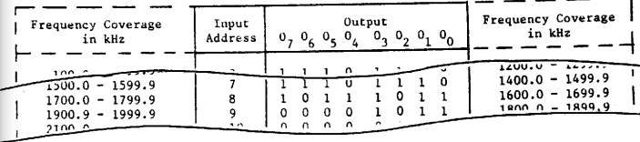
3.2.13. When transmitting on frequencies below 1600.0 KHz the key line in the exciter must be enabled. This is done by changing the band decoder PROM 303 IC16 labeled 382 239 7 into a PROM labeled 382 239 8. The difference between the two PROMs is the 07 bit in address 0. The function tables are shown on page 7 - 16 and page 7 - 17.
3.2.14. When the PROMs are to be installed in the Display and Keyboard 303 make sure that they are mounted correctly.
The three frequency memory PROMs are mounted on the back of the Display and Keyboard 303 in the sockets marked A, B and C. PROM A is mounted in the socket marked with an A, PROM 8 in socket a and PROM C in socket C.
The five band decoder memory PROMs are mounted in their appropriate sockets. The PROM marked 0 - 6.3 in the socket marked 0 - 6.3, the PROM 6.3 - 12.7 in the socket 6.3 - 12.7 etc.
The top mark of the PROM package is to be uppermost when the Display and Keyboard is mounted in its normal position.
The band decoder PROM is soldered onto the front of the Display and Keyboard 303 This is due to the fact that the PROM is usually only changed when the exciter is installed in conjunction with a transmitter.
3 - 7
3.3. Instruction for Use of Pro ramming Unit 241 when used in E 5002
3.3.1. A minor disadvantage associated with the use of the PROM as the memory building block is that a few per cent of the PROMs cannot be programmed in one or more bit positions due to tolerance problems in the manufacturing process. In this case the sections 3.3.14 and 3.3.31 describe what to do.
3.3.2 As a PROM is not reprogrammable the greatest care should be taken concerning the Programming procedure.
3.3.3. There are two ways of calculating the setting of the sliders on the PROGRAMMIMG UNIT 241 when programming the frequency memory PROMs, the hard way and the easy method.
If you do not have a Programming Slide-rule 342 244 31 at your disposal you must go the hard way described below.
3.3.4. Calculate the codes for the frequency information to be stored in the frequency memory PROMs according to the tables 3.3.1. and 3.3.2. (see paragraph 3.2.2.)
Desired frequency in MHz |  | Code for slider in 241
(“10 MHz”, “1MHz”) | Band |  |  | Mode | MHz
0  1  2  3  4  5  6  7  8  9  10  12  13  14  15  16  17  18  19  20  21  22  23  24  25  26  27  28  29 | 4 MHz  4 MHz  4 MHz  4 MHz  4 MHz  4 MHz  4 MHz  4 MHz  6MHz  6MHz  8MHz  8MHz  8MHz  8MHz  8MHz  8MHz  8MHz  12MHz  12MHz  16MHz  16MHz  16MHz  16MHz  16MHz  16MHz  16MHz  16MHz  22MHz  22MHz |  |  | RT  RT  RT  RT  RT  WT  WT  WT  WT  RT  RT  RT  RT  RT  WT  WT  WT  WT  RT  RT  RT  RT  RT  RT  WT  WT  WT  RT  RT | 5  4  3  -  5  4  3  -  5  4  3  -  5  4  3  -  5  4  5  4  3  -  5  4  3  1  -  5  4
Table 3.3.1. Calculating the codes for the two MHz digits.

3 - 8
Desired frequency  "100 KHz", "10 KHz", "I KHz", "100 Hz" | Code f or sliders on 241  "100 KHz", "10 KHz", "1 KHz",  "100 Hz"
0  1  2  3  4  5  6  7  8  9 | 9  8  7  6  5  4  3  2  1  0
Table 3.3.2. Calculating Codes for the four KHz digits and the
100 Hz digit.
3.3.5. Presuming you have the Programming Slide-rule 342 244 31, set the slides 1 on the slide-rule according to the desired frequency (see paragraph 3.2.2.) and from window 2 on the slide-rule you have the codes for the sliders on the programming unit 241.
3.3.6. In the three sockets on the programming unit 241 three un-programmed PROMs are inserted. The PROMs must be of the type which can be programmed by means of the programming unit 241 according to table 3.1.1.
3.3.7. Switch on the 241 by means of the On - OFF switch.
3.3.8. The sliders on the programming unit 241 are adjusted as obtained from paragraph 3.3.4. or paragraph 3.3.5. In the other window some holes appear, and these are the positions which must be programmed.
3.3.9. By means of the keyboard on the front panel the Frequency which is to be programmed is selected. The No. button “ # ” must be in its inner position and the frequency will only be displayed for approx. one second after being keyed-in
3.3.10. The Programming Pin is now placed in the extreme right hole in the window. The lamp of the red pushbutton will light as long as the programming pin does not have proper contact with the underlying socket-terminal or if this hole position has already been programmed.
3.3.11. Now activate the red pushbutton.
3.3.12. If the programming was successful, the lamp of the red pushbutton Will light and the -pin is moved to the next hole.
3.3.13. If the Programming was unsuccessful, the red pushbutton must be activated repeatedly until the lamp is lit.
3.3.14. If it turns out that it is impossible to program this hole position, the only thing to do is to cancel the frequency No. and then choose another frequency No. and start Programming all over again.

3 - 9
The cancelling is done by setting the sliders on the programming 241 as follows:
"BAND" = A, "MODE" = RT and "KHz" = 4111.1 and programming the holes in the window as per paragraph 3.3.10 to 3.3.13. Then the sliders are set to: ''BAND" = A, "MODE" = RT and "KHz" = 5222.2 and the holes in the window are programmed.
When a frequency No. installed in t:he frequency memory is cancelled the display will blank all the digits except the "10 MHz" digit and the "1 MHz" digit when the display after approx. one second of displaying frequency No. switches over to displaying the selected frequency.
3.3.15. If the transmission on the frequency No. concerned must always be A3H-simplex irrespective of the mode selected by the POWER and MODE switches, do not program the extreme left hole in the window.
3.3.16. If it is desired to use the auxiliary information on the remote control interface socket pin 28a (30l-SK1-28a) this is programmed to logic one by programming the hole "Enabling of a correctly programmed frequency No.". Otherwise the auxiliary information will be a logic zero. The programming is to be done after programming of the frequency information into the PROMs.
3.3.17. Concerning the Programming of frequency No. zero some considerations are to be made, refer to paragraph 3.1.6.
3.3.18. When the programming of the frequency No’s. has been accomplished the Programming unit is turned off, the programming pin is placed in its holding clips and the three PROMs are removed to the Display and Keyboard 303.
Take care that the PROMs are mounted in the correct way and in the correct sockets.
3.3.19. Programming procedure step by step.
1. By means of the programming slide-rule 342 244 31 the codes for the Programming unit 241 are found for each frequency No. to be pro
2. Mount three PROMs in the sockets on A (take care that they are correctly positioned).
3. Turn on the Programming unit.
4. Adjust the seven sliders according to step 1.
5. Select by means of the keyboard the frequency No. to be programmed.
6. Place the Programming pin in one of the holes in the window of the tool, beginning from the right. If this hole is un-programmed the lamp in the red pushbutton will extinguish.
7. Activate the red pushbutton. The lamp of the red pushbutton will now light if the Programming was successful. As long as there are un-programmed hole positions the steps 6 and 7 are repeated. 3-10

3 - 10
8. The extreme left hole is left un-programmed if it is desired that the frequency must be programmed A3H-simplex.
9. If the auxiliary bit is to be programmed insert the pin in the "Enable" hole position in the middle of the programming tool and program this hole position. This should finally be done before changing to a new frequency No.
10. If there are more frequency No’s to program revert to step 4, otherwise to step 12.
11. If there is a hole position which cannot be programmed, cancel the frequency No. and start from step 6. (refer to paragraph 3.3.14.).
12. Turn off the programming unit.
13. Place the programming pin in its holding clips.
14. Place a self adhesive sticker on the package of each PROM indicating in which socket (A, B or C) it is to be mounted on Display and Keyboard 303.
15. Move the three PROMs to 303. (Take care that they are mounted in the correct way and in the correct sockets).
3.3.20. The band decoder memory are programmed by means of the program
3.3.21. Obtain the PROM number, the addresses and the band information Codes as described in paragraph 3.2.10 and paragraph 3.2.12.
3.3. 22. Translate the most significant bit five bits ( 07, 06, 05, 03, 04 ) according to the table 3.3.3. and the least significant three bits ( 02, 01, 00 ) according to table 3.3.4.
The "x" in the "En” column of table 3.3.3. means that the hole position marked "Enabling of a correctly programmed frequency No." is to be programmed. The programming work sheet on page 3-17 is at your disposal.
3.3.23. In the socket C on the programming unit 421an un-programmed PROM is inserted. The PROM must by of the type which can be programmed by means of the programming unit 241 according table 3.1.1.
3.3.24. Switch on 241 by means of the ON-OFF switch.
3.3.25. The sliders on the Programming unit 241 are adjusted according to paragraph 3.3.22.
3.3.26 By means of the keyboard on the front panel the input address which is to be programmed is selected.
The No. button " # " must be in its inner position and the input address will only be displayed approx. one second after being keyed-in.
3.3.27. The programming pin is now placed in the right in the window. The lamp of the red pushbutton will light as long as the programming pin does not have proper contact with the underlying socket-terminal or if this hole position has already been programmed.

3-11
Band information codes |  |  |  |  | “Codes for 241
07 | 06 | 05 | 04 | 03 | “En | “”Band
0  0  0  0  0  0  0  0  0  0  0  0  0  0  0  0  1  1  1  1  1  1  1  1  1  1  1  1  1  1  1  1 | 0  0  0  0  0  0  0  0  1  1  1  1  1  1  1  1  0  0  0  0  0  0  0  0  1  1  1  1  1  1  1  1 | 0  0  0  0  1  1  1  1  0  0  0  0  1  1  1  1  0  0  0  0  1  1  1  1  0  0  0  0  1  1  1  1 | 0  0  1  1  0  0  1  1  0  0  1  1  0  0  1  1  0  0  1  1  0  0  1  1  0  0  1  1  0  0  1  1 | 0  1  0  1  0  1  0  1  0  1  0  1  0  1  0  1  0  1  0  1  0  1  0  1  0  1  0  1  0  1  0  1 | 0  0  0  0  0  0  0  0  0  0  0  0  0  0  0  0  X  X  X  X  X  X  X  X  X  X  X  X  X  X  X  X | A  B  C  D  E  F  G  H  4 MHz  6 MHz  8 MHz  12 MHz  16 MHz  22 MHz  25 MHz  MF  A  B  C  D  E  F  G  H  4 MHz  6 MHz  8 MHz  12 MHz  16 MHz  22 MHz  25 MHz  MF
Table 3.3.3.
Band infor-  mation codes |  |  | Codes for 241
 |  |  | “MODE” | 1 MHz | 100 KHz | 10 KHz | 1 KHz | 100 Hz
0 | 0 | 0
2 | 1 | 0
0  0  0  0  1  1  1  1 | 0  0  1  1  0  0  1  1 | 0  1  0  1  0  1  0  1 | RT  RT  RT  RT  RT  RT  RT  RT | 5  4  3  -  5  4  3  - | 9  9  9  9  9  9  9  9 | 9  9  9  9  9  9  9  9 | 9  9  9  9  9  9  9  9 | 9  9  9  9  9  9  9  9
Table 3.3.4.

3-12
3.3.28. Now activate the red pushbutton. 3.3.29. If the programming was successful the lamp of the red pushbutton will light and the pin is moved to the next hole.
3.3.30. If the programming was be activated repeatedly until the lamp is lit.
3.3.31. If it turns out that it is impossible to program this hole position, the only thing to do is to replace the defective PROM with a new one and start Programming all over again.
3.3.32. If the "En" column is "x" the hole in the middle of the unit marked "Enabling of a correctly programmed frequency" must be programmed too.
3.3.33. Programming procedure step by step.
1. Obtain the addresses and codes as described in paragraph 3.2.10. and paragraph 3.2.12. filling in the Programming work sheet on page 3-17.
2. Translate by means of table 3.3.3. and table 3.3.4. the codes to EA" -codes on the Programming work sheet.
3. Mount an un-programmed PROM in the socket C of the programming unit 44A. (Take care that it is correctly positioned).
4. Turn on the Programming unit.
5. Adjust the sliders according to the Programming work sheet.
6. Select by means of the keyboard the input address for the PROM.
7. Place the programming pin in one of the holes ill the window of the tool, beginning from the right.
8. Activate the red pushbutton.
The lamp of the red pushbutton will now light if the Programming was successful.
As long as there are un-programmed hole positions the steps 7and 8 are repeated.
If all hole positions in the window are programmed and the "Enable" bit is to be programmed go to step 9 otherwise to step 11.
If the lamp of the red pushbutton does not light, Step 8 is repeated until it lights.
If there is a hole position which cannot be programmed. go to Step 3 and start the Programming all over again.
9. Program the "Enable" hole position in the middle of the tool.
10. If there are more input addressed to be programmed. revert to Step 5.
11. Turn off the Programming unit.
12. Place the programming pin in its holding clips.
13. Place a self adhesive sticker on the package of the PROM indicating in which socket (0-6.3, 6.4-12.7, 12.8-19.1,19.2-25.5 or 25.6-31.9)
3-13

14. Move the PROM tog (Take care that it is mounted in the correct way and the correct socket).
3.4 Remote Control
3. 4.1. The remote control interface socket 301 SK1 (also used for the programming unit 241 is intended for a remote control interface board.
3.4.2. The remote control interface socket permits the remote control of: Digital selection of the 32 preprogrammed frequencies.
Digital selection of transmission node.
Digital selection of operation mode.
Digital selection of power level (full, medium or low).
Tow-tone alarm generator: Test and start functions.
Provision for transmission of a constant 1300 Hz tone (10 sec. timer not included in E 5002) after transmission of the alarm signal and / or transmission of the navigational warning signal (2200 Hz).
3.4.3. The remote control interface board is customer supply. Nevertheless an example of a remote control circuit is shown on page 3-15.
3.4.4. The power from the E 5002 for supplying the remote control interface board must not exceed:
20 rnA from the 15.7V Supply
30 rnA from the 7.5V supply when the E 5002 is supplied from the P 5000 or P 5001.

3-14
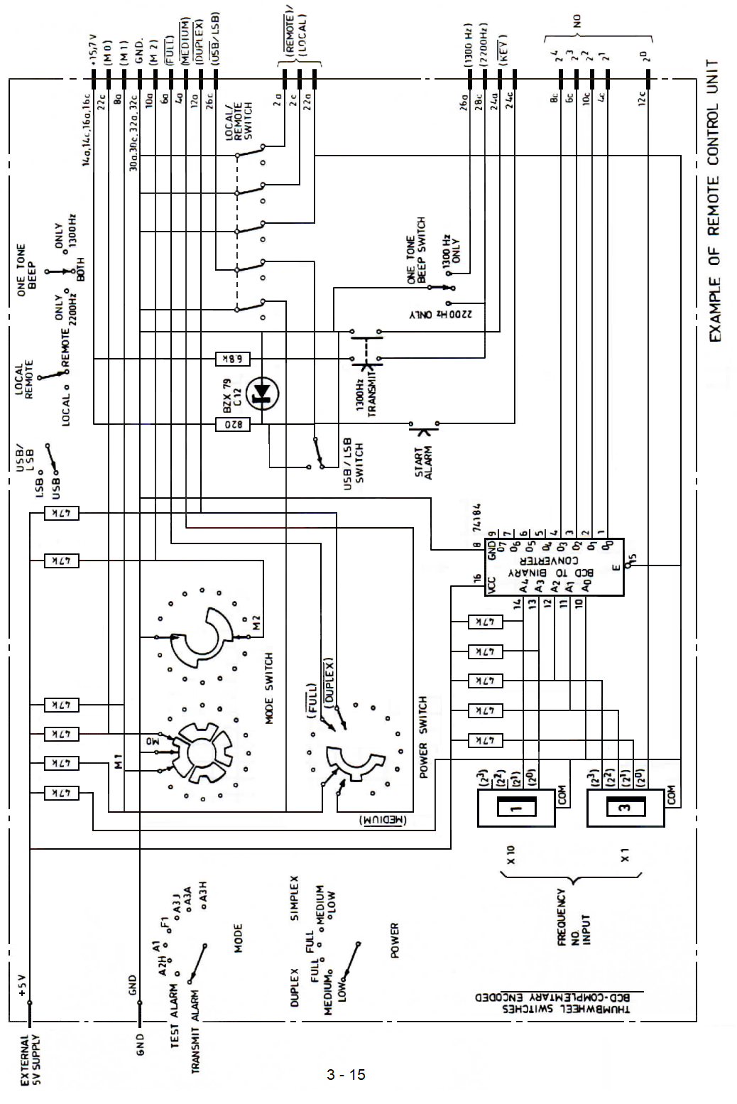
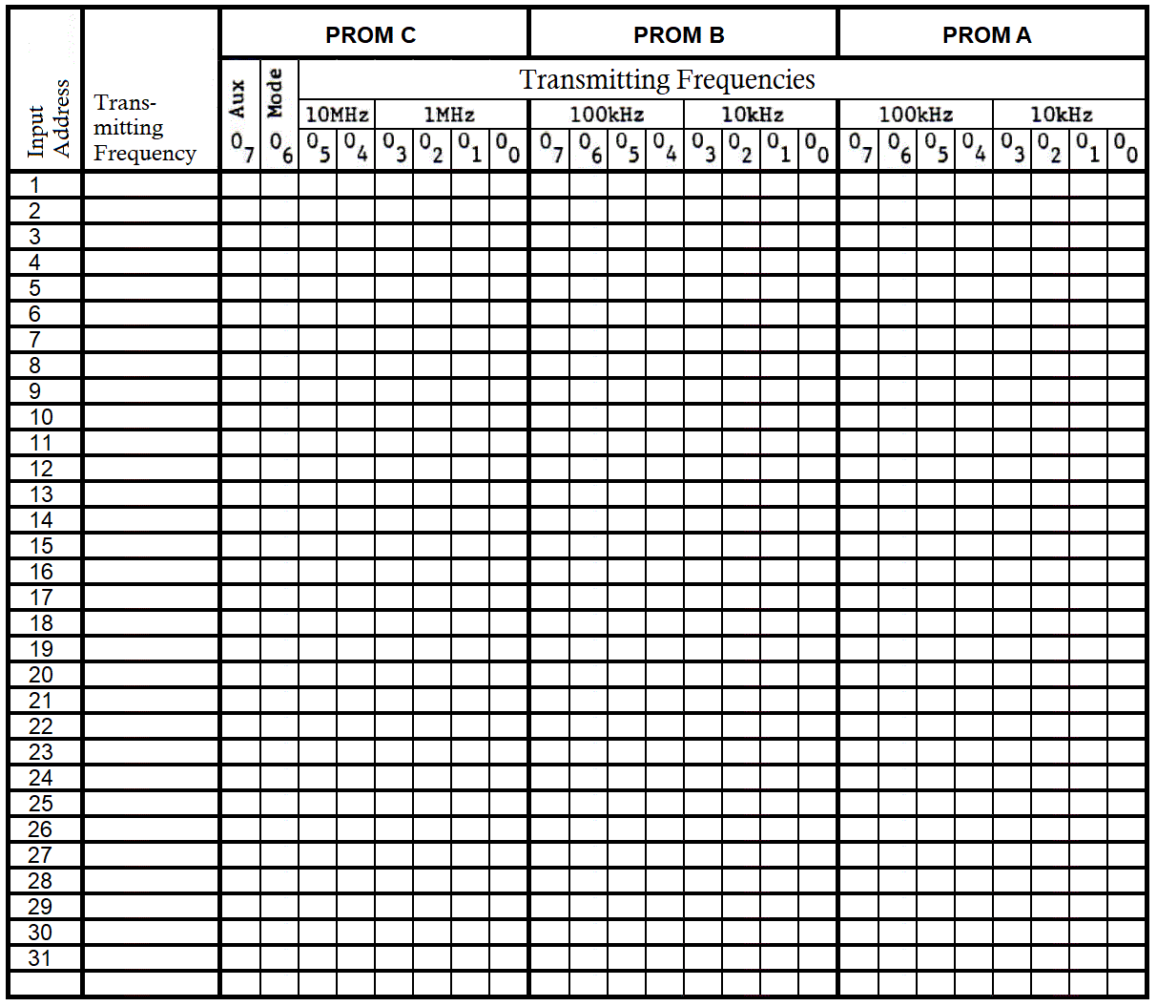

3 - 16
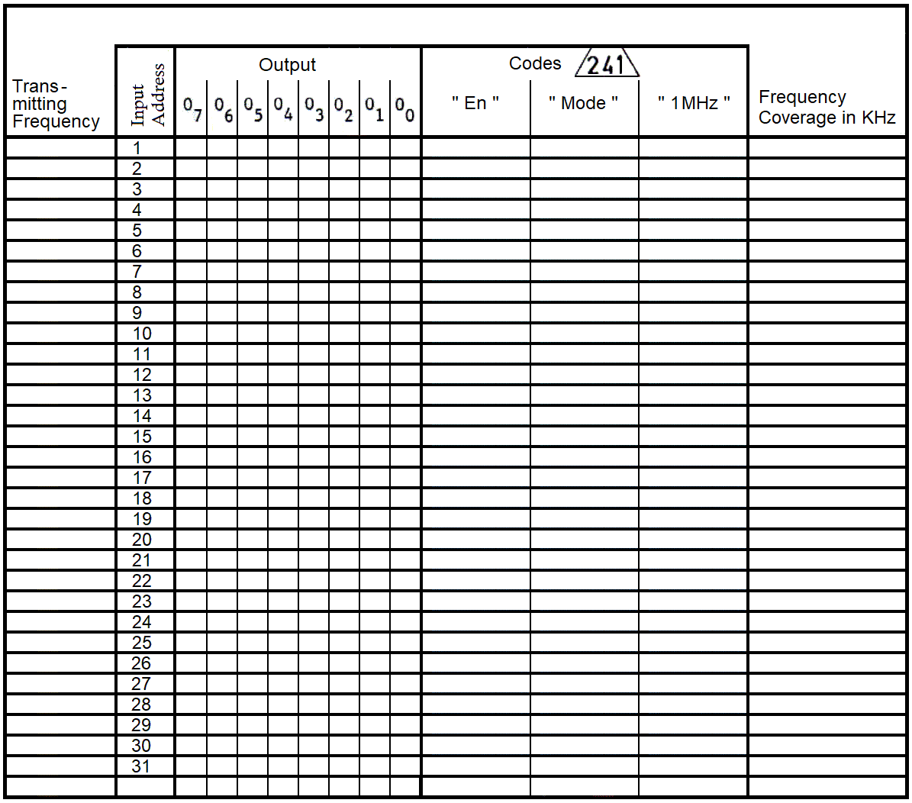

3 -17

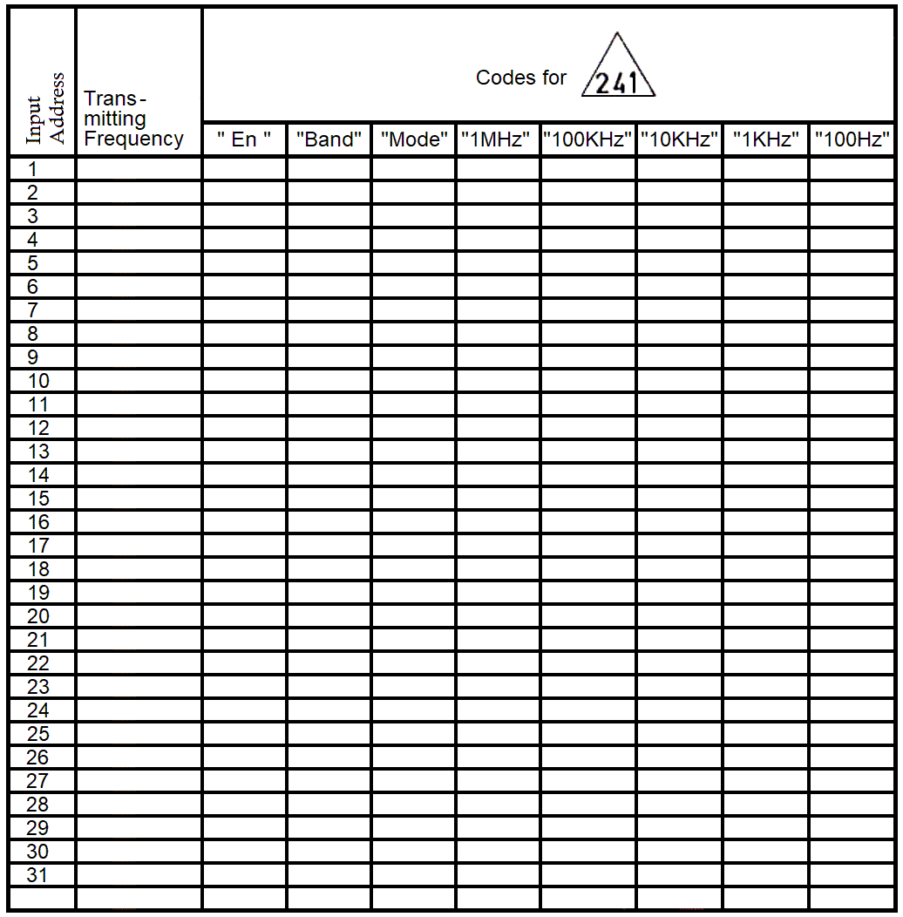

3 - 18

4. Technical data
Modes of 0peration
Duplex, semi duplex and simplex A3A, A3H, A3J and F1 (USE).
Option for LSB/USB
Semi duplex and simplex Al and A2H.
Power Output
Al, A2H, A3A and A3J: 2 - 3.5V pp in 50 ohms (adjustable)
F1: 1.6-2.7V pp in 50 ohms
Medium power: -6 dB
Low power: -13 dB
Frequency Range
405 kHz -29.9999 MHz
Semi continuous in 100 Hz steps.
Frequency Selection
a. Direct mode: Keyboard selection with fixed decimal point.
b. Programmed mode:
Keyboard of up to 32 preprogrammed frequencies (PROMs) Frequency No. shown on display for approx. 1 sec. after selection of No. Thereafter display of frequency.
Mode A3H/simplex may be pre-programmed.
c. Remote mode:
Selection of the 32 pre-programmed frequencies in binary code via 301 SK1
d. Distress frequency:
When the exciter is used in conjunction with T 5000 the band switch can select frequency No. zero which should be pre-programmed 2182.0 kHz -A3H/simplex.
Frequency Accuracy and Stability:
Depending on master oscillator (connected to 301 SK2) .
Accuracy: Less than 240 ppm/year.
Stability: ± 5 Hz in any t5 min. period.
Unwanted Radiation:
Unwanted Radiation 7.5 kHz or more off the assigned frequency: at least 43 dB (typical 50 dB) below the p.e.p. value.

4 - 1
Frequency Linearity:
+/- 1.5 dB over the frequency range 405 KHz -29.9999 MHz.
Modulation:
Modulation characteristic within 6 dB from 350 Hz to 2700 Hz.
AF Compression:
Output varies less t:hah 0.75 dB for a variation of input level from -10 dB to +10 dB relative to nominal input.
AF Inputs:
Carbon microphone: 200 ohms nominal 3V pp max. 9.5V pp Line input: 600 ohms nominal 0 dBm max. +10 dBm. Telex input: 600 ohms nominal 0 dBm max. +10 dEm.
Two Tone Alarm:
Included for remote control only.
Intermodulation:
Better than -43 dB (typical -46 dB) as per CCIR specification.
Noise and Hum Level:
More than 40 dB below full power p.e.p.
Remote Control Facility for Exciter:
Digital selection of the 32 preprogrammed frequencies.
Digital selection of transmission mode.
Digital selection of operation mode.
Digital selection of power level (full, medium or low).
Two-tone alarm generator: Test and start functions. Provision for transmission of a constant 1300 Hz tone (10 sec. timer not included) after the alarm signal and/or transmission of the navigational waning signal (2200 Hz)
The digital and other remote control information must be fed via 301SK1 and the digital interface (costumer supply) may be place in the space provided for the PCB 241 programming unit. PCB 241 may still be used for field programming.
Supply Voltage:
7.5V +/- 5% max 2.7A typical 1.9A
15.7V +/- 5% max 1.1A typical 0.9A
Environmental Conditions:
Complies with CEPT

4 - 2
Dimensions:
Height : 132.5 mm
Width : 482 mm
Depth into rack : 333 mm
Weight : 9.2 Kg approx.

4 - 3
5. Technical description
5.1. Mechanical
The exciter is built on a rugged zinc plated and passivated iron chassis.
The exciter contains five plug-in boards 207, 208, 209,210 and M234 and two boards in separate screened cans 2044 and 302 which became accessible after removal of the respective lids. Board mounted behind the front panel. This board and the motherboard 301 become accessible when the front panel is tilted forward. This is possible after removal of the two upper screws in each side fixing the front panel.
5.2. Circuit Description, General:
Each printed circuit board and also the chassis-mounted components have been allocated an identification number 207 and 303. The designation of a component or terminal includes this number as a prefix, e.g. 207R3 (resistor R3 on board 207, or 244-6 (terminal No. 6 on board 244).
For convenience in this section and on the circuit diagrams the prefix is omitted except where is a risk of ambiguity.
The circuit diagram is delivered into a wiring diagram on page 8 - showing the motherboard 301 and the interconnections between the printed circuit boards of which the exciter is composed and circuit diagrams of the individual circuit boards. The block diagrams on pages 8 - to page 8 - illustrates the operation of the exciter.
5.3 Circuit Summary, Signal Path E 5002
5.3.1. The signal path is contained on boards signal, having passed an input selector compressor, is converted to a 1.4 MHz double sideband Signal by mixing with a 1.4 MHz signal derived from the master oscillator. The upper sideband is removed in a crystal filter and the lower sideband is applied to an amplifier, the gain of which is set in accordance with the mode selected. At the output a 1.4 MHz Signal of appropriate level for carrier re-insertion is applied in the modes A3A and A3H.
5.3.2. The 1.4 MHz single side band signal is fed to the RF translator302.
When te signal enters 302 it passes the level setting circuit which allows the level to be set independent at each band. The 1.4 MHz lower side band signal is converted in the 1.4 to 38MHz mixer to a 38 MHz LSB signal by mixing with a 36.6 MHz signal from the 36.6 MHz VCO. The Signal is filtered in a crystal filter to remove undesired mixing products.
The signal is converted to a 0 – 30 MHz upper side band signal in the 38 to 0 – 30 MHz mixer by mixing the 38- 68 MHz signal from the synthesizer VCO3. The signal is then amplifiered and fed to 30 MHz low pass filter. Before the Signal is fed to the transmitter it passes the step attenuator controlled from the POWER switch.

5 - 1
5.3.3. In the A1, A3H and the TRRANSMIT ALARM modes the AF signal is supplied from the tone generators on board M234. The 1.5 KHz oscillator is used for generating the carrier frequencies in the modes Al and A2H. A 1.5 kHz shift command from the mode control circuit makes the synthesizer decrease its output frequency by 1.5 kHz in these codes which means that the output frequency of the exciter becomes the correct transmission frequency. The 2.2 kHz oscillator is in addition used for generating the sideband in the A2E code giving a modulation frequency of 700 Hz.
The KEYLINE output from the keying circuit to the power pack informs the HT converter to start when the line goes high. However, this is inhibited if an illegal frequency has been selected.
5.3.4. The 1.4 MHz reference frequency is normally supplied from the master oscillator of the R 500X receiver. However, if the receiver is not installed in the cabinet, master oscillator 240 is mounting in the exciter.
5.4. Circuit Sumamary, Frequency Synthesizer
This frequency synthesizer consists of two programmable phase locked loops (loop 1 and loop 2), the outputs of which are controlling a third (loop 3) from which the complete synthesized Signal is derived and fed to the 1st mixer in the signal path.
The output frequency of loop I is controlled by the 100 Hz, 1 kHz, and 10 KHz information according to the contents of the displays, provided that the receiving mode chosen is not A1. A2H or F1. If the A1, A2H or Fl mode is chosen the output frequency is decreased by 1.5 KHz. Loop 1 produces an output frequency is 999 steps from 20.000 " to 21.998 MHz is all modes but A1, A2H and Fl. In the A1, A2E and F1 modes it is from 19.970 MHz to 21.960 MHz. This frequency is divided by 200 and serves as a variable reference frequency for the Loop Translator.
Independent of the different receiving rode9 loop 2 is controlled by the 100 KHz, 1 MHz. and 10 MHz information according to the contents of the displays. The output frequency of this loop is variable from 3.70 MHz to 6.69 MHz in 299 steps and is fed to the mixer of the loop translator where it is subtracted from the synthesizer output frequency divided by 10 and is finally compared with the variable reference frequency to this loop by means of Phase / Freq. Detector 3. A Frequency Comparator ensures that the synthesizer output frequency divided by ten is higher than the output frequency of loop 2. If this was not the case, it could lead to stable, unlocked condition of loop 3.
The frequency synthesizer is locked to a I.4 rm2 signal derived from the TCXO so that the output frequency will exhibit exactly the same stability as specified for the TCXO.

5 - 2

Provided that the 3 loops are locked the following equations, where fvco1 is short for output frequency of VC01, will become valid:
Assumption: Transmitting frequency is (ab, cde.f KHz.
(fvco3 -10) - fvco2 = (fvco1 - 200).
(fvco3 - 10x (fvco2 + (fvco1 - 200)).
where
fvco1 = (20000 + (d e f) x2) KHz and
fvco2 = (3700 + (a b c) x10) KHz and
fvco3 = 38000.0 KHz + a b c d e f KHz.

5 - 3
5.5. Circuit Description, E 5002
5.5.1. 301 Motherboard
The motherboard contains the interconnection between the different units and the wiring. The motherboard also contains the plugs for the cabinet wiring and the voltage regulators: the 5V regulator. The 12V regulator supplying the output amplifier on 302 and the 12V regulator for the remaining circuits.
On the 301 motherboard the 10 divider for the VC03 loop is located.
5.5.2. 244 1.4 MHz Exciter
The AF input signals are connected to the compressor through an input Selector. The microphone and line inputs are open only if the terminals 4 and 8 are both HIGH. The telex AF input is open only if terminal 8 is LOW. The tone input is always open.
The gain of the compressor is controlled by means of the field effect transistor TR2, which functions as a variable emitter resistor for the left hand transistor in IC1. The control voltage is provided by a rectifier consisting of the pair of IC1 transistors to the right, which detect the sideband level at the output of the Crystal filter X1 (or X2). when terminal 4 is Low the compressor is off as the resistance of TR2 is kept at its maximum value.
The compressed audio signal and a 1.4 MHz signal from the carrier level regulator IC2 are fed to the balanced mixer IC3. The output is a 1.4 MHz double sideband suppressed carrier signal that is fed through crystal filter X1 (or X2) which removes the upper sideband (or the lover sideband) and suppresses the carrier still further.
The gain of the amplifier stages following the filter is controlled from terminals 13, 14 and 15 by inserting different emitter resistors. In the A3H-mode all terminals are high and the gain is determined by R76. Carrier re-insertion is performed by applying the 1.4 MHz signal from the carrier level regulator to TR7 via an attenuator controlled from the same terminals.
The filter shift is made by means of transistor TR4 controlled by the optional LSD/USE switch on the front panel or the remote control interface .
5.5.3. 302 RF Translator
The 1.4 MHz single sideband signal enters the RE translator through a 1.4 MHz filter. The load resistance of the filter is adjustable and can be set individually at each band by means of variable resistors. The signal is converted in the 1.4 to 38 MHz mixer IC1 to a 38 MHz signal by mixing the signal with the 36.6 MHz signal from the 36.6 MHz VCO. After removing the unwanted mixing products in a 38 MHz crystal filter the Signal is fed to the 38 to 0-30 MHz mixer.

5 - 4
The 38 to 0-30 MHz mixer 302 IC7 is a double balanced passive mixer converting the signal to the transmitting frequency by mixing it with the injection frequency from the VC03. The signal is amplified in TR5 before the image signal is removed in the 7th order low-pass filter. The desired signal is amplified is FULL power level in TR9.
Before the signal leaves the board, it passes the step attenuator controlled by the POWER switch setting or remote control interface. The attenuator is a modified T-attenuator attenuating 0dB, 6dB and approx. 12dB.
The reference frequency of 1.4 MHz is amplifiered in the buffer TR1 supplying the 1.4 MHz 244 and the 36.6 MHz VCO. The reference frequency is derived from the TCX0 in order to accomplish the necessary degree of frequency stability of the output signal from the voltage controlled oscillators
The 1.4 MHz reference frequency is divided by seven in the divider IC3 before it-as a 200 KHz signal -is fed to one of the input ports of the Phase Detector IC5. The output from the 36.6 MHz VC0 is buffered up through TR13, TR14, TR7 are half of IC6 before it is divided by 183 in the synchronous divider consisting of IC9 and IC8 and the other half of IC6 which acts as presetting control.
The output of the VC0 is amplitude regulated and fed to the 1.4 MHz to 38 MHz mixer IC1.
The selection of the variable resistor for the level setting is carried out by the band decoders IC2 and IC4 turning the diodes D1 to 1D17 (except D6) on and off.
5.5.4. A Control Circuit and Tone Generators
The mode control signals from the MODE switch, the A3H simplex signal from the frequency memory in E and the RE information from the transmitter power amplifier are the input signals to the programmable read only memory (PROM), IC5, of the Mode Selector. The PROM has been programmed to give at the output the desired control signals corresponding to the wanted mode.
The mode selector controls the input selector and the mode setting of the 1.4 MHz exciter 244 via de respective control leads. The 1.5 kHz SHIFT output tells. when HIGH, the synthesizer to decrease its frequency by I.5 kHz. In the Fl trade the anode voltage of the P.A. valves is lowered by nears of a relay in the poser pack controlled from transistor TR5. Automatic selection of FULL POWER is carried out by means of transistor TR4, when A3H simplex (terminal 14a Low) TRANSMIT ALARM (output 06 of IC5 LOW) are selected. The mode selector further controls the key selector.
Keying of the transmitter is only possible from the MORSE FEY input in the A2H and A1 modes, from the TELEX KEY input in the Fl mode, from the HANDSET KEY input in the A3A, A3J, A3H and transmit ALARM modes, and from the DUPLEX input in the F1, A3A, A3J, A3H or TRANSHT ALARM modes, provided A3H simplex is not selected as the DUPLEX input is then inhibited. Furthermore the information terminal 24a (WT) has to be in accordance with the mode Selected: HIGH at A2H, A1 and F1 LOW at A3A, A3J, A3H or TRANSMIT ALARM. This is done by connection to the 1500 Hz shift control output at terminal 20c.
5- 5
The keying signal ac IC2, pin 8 controls, via an inverter, transistor TR9, supplying +12V to the output amplifier circuit of the RF translator 302 and activating the keyline to the power pack. In SIMPLEX it supplies base current to TR8 controlling the muting of the receiver.
The two-tone alarm signal l generator incorporates the 45 sec. timer the 2Hz astable multi vibrator and the 2.2 kHz and 1.3 kHz oscillators. The 45 see. timer is enabled from the mode selector in TEST ALARM and TRANSMIT ALARM and can be started by pushing the ALARM START push-button that applies +12V to terminal 2c. Via the voltage divider R32 and R33 a keying signal is applied to the key selector. The 2Hz astable multi vibrator starts and supplies base current to TR6 and TR11 alternatively. The audio signal from the oscillators is, via the tone keyer, applied to the 1.4 MHz exciter 244 and, via the sidetone keyer, applied to the receiver audio amplifier.
In the A1 mode the 1.5 MHz oscillator is started. The audio signal is keyed in the sidetone keyer and the tone keyer which are both controlled from the morse key. Capacitor C8 and adjoining components at the gain control input of IC7 serve to shape the tone pulses correctly.
In the A2H mode the 2.2 kHz oscillator as well as the 1.5 kHz oscillator are on. R54 is connected to ground in IC4 thereby reducing the peak level of the audio signal at the tone keyer input to the same level as when only one tone is present. The sidetone keyer is connected to the 1.5 KHz oscillator only and TR12 is turned off by means of D24.
When the TUNE-button of the transmitter power amplifier is activated terminal l8c is LOW. A2H is selected by means of Dl Sad D3 the transmitter is keyed via IC2 pin 9, and the sidetone keyer is turned off by means of IC3 pin 1.
5.5.5. 207 Frequency Divider
There are three divider chains, their associated buffer amplifiers and two phase / freq. detectors located on this board.
The reference divider produces the 2 kHz reference frequency I or the phase / freq. detector 1 and the 10 kHz reference signal for the phase/ freq. detector 2 from a 1.4 MHz signal derived from the TCXO.
The variable divider chains are composed of programmable up-counters and their associated external gating logic. The dividing action is accomplished by presetting (programming) these counter which the data blocks corresponding to the contents in the displays at the end of each counting cycle. The data blocks contain the BCD 9' s complement code of the corresponding digit.
In the loop 1 divider chain the WT modes information (e.g. A1, A2H and F1) is used to control the associated external gating logic. In the WT modes this chain counts 15 clock pulses less than in any other rode before concluding a counting cycle. Thus the contents of the data blocks are independent of the mode.

5 - 6
The loop 2 divider chain counts independent of the receiving mode and adds by means of the external gating logic 370 extra clock cycles so what is determined by the three most important digits before concluding a counting cycle.
The outputs from the variable dividers are led to their respective phase/freq. detectors and are here compared to the fixed reference frequency. In case of a frequency difference the detector will produce a DC error voltage which will adjust the associated VCO to establish the wanted frequency equality.
5.5.6. 208 Loop Translator
This circuit board contains one half of loop 3, mainly the frequency comparator 200 divider, the loop 3 mixer, with its associated 1.5 MHz low pass filter and phase/freq. detector 3.
The VC01 output frequency is divided by 200 and fed as a variable reference frequency to one of the two input ports of phase / freq. detector 3. The output frequency of VCO3 divided by 10 is fed to the loop mixer whose other injection signal is derived from VCO2. The sum frequency from this mixing process is removed in a 13-order 1.5 MHz low-pass filter thus allowing only the difference frequency to pass on via the following buffer amplifier to the other port of phase/freq. detector 3. This detector is almost identical to the detectors mentioned in the description of board 207.
If the VCO2 output frequency is higher than the synthesizer output frequency divided by 10 at he beginning of an acquisition of loop 3 this loop will end in a stable, unlocked condition. To avoid these to two frequencies are compared. If the frequency of the VCO2 is the higher of the two mono stable multi vibrator IC13 is triggered by the latch following the two divider chains and via the phase / freq. detector 3 the frequency of VC03 is forced to rise thus pulling loop 3 out of this unwanted condition.
The output pulse from the detector is smoothed by means of a simple RC-filter before leaving this circuit board.
5.5.7. 209 VC01 and VC02
The loop filter and voltage controlled oscillator of both loop 1 arid loop 2 are located on this board.
Both of these filters are active 3rd order low pass types with all integrated function incorporated. The purpose of the loop filters is to remove the pulses from the output of the phage/freq. detector and allow only the DC-information to pass on to the vari-cap diodes of the voltage controlled oscillators. By use of the phase error adjustment potentiometer the phase error pulse width can be minimized. Once adjusted this it width will remain unchanged throughout the whole frequency range of the VCO, due to the use of an integrator in the loop filter. Both of the VCO's are amplitude regulated.
The selection of one of the three bands in which VCO2 is operating is carried out by means of a decoding circuit on 303.

5 - 7
5.5.8. 210 VCO3
This circuit board contains the loop 3 filter and the voltage controlled oscillator VC03.
The loop 3 filter consists of a low-pass filter and an integrator. The filter serves to remove the pulses of the phase / freq. detector output signal and allow only the DC information to pass on to the vari-cap diodes of VC03. By use of the phase error adjustment the phase error pulse width can be minimized, and once adjusted it will remain unchanged throughout the whole frequency range of VC03 due to the use of an integrator in the loop filter.
VCO3 consist of three voltage controlled oscillators VCO3-x, VCO3-y and VCO3-z, each covering a band of approximately 10 MHz. The band selection is carried out by means of a decoding circuit on 303.
The VCO3 output is amplitude regulated and serves as an injection to the 38 to 0 – 30 MHz mixer in the signal path.
5.5.9. 240 Master Oscillator (0ptional)
The oscillator itself is a Sealed unit containing a highly stable TCXO (temperature compensated crystal oscillator) at 11.2 MHz. The output signal of the TCXO is amplified in the transistors TR1 to TR3 and fed to the binary counter in which divides the input frequency by 8. The 1.4 MHz square wave signal is filtered ill a tuned circuit C6, T1, and the regulating sine have signal is fed to the output terminals.
TCXO's of two different manufactures may be used. In both cases crystal oscillator aging is very small (less than 10-6 per annum) and will be greatest during the first few years. Aging will normally cause an increase in frequency which in one case can be compensated for by introducing the connection indicated by the dotted line in the circuit diagram (this will reduce the by approx. 2x10-6) and in the other case by changing the factory Selected resistor. The resistor should be selected at 25°C ambient temperature to give a TCX0 output frequency offset from the nominal frequency (11.2 MHz) by the amount marked on the can.
Frequency adjustment should be carried out only if counter is available for control of the frequency. It must be ensured that the accuracy of the counter at the time of use is better than 10-7.
5.5.10. 303 Display and Keyboard
When a key is pressed or released some sort of bouncing effect will always appear before the key has settled. This bouncing is removed by means of the Key Bounce Eliminator consisting of IC45 and its associated external coxponent8. When a key has settled after being pressed, a read-pulse is produced at pin 12 of IC45 and the BCD code of the key number in question is produced by IC46 and IC47.
Dependant upon whether the number key “ # “ is in its inner or outer position the read-pulse is passed to the first register in the No. register stack IC42 or to the first register in the frequency digit register stack IC41. The BCD code is at hand on the input of both register stacks. The direction of the read-pulse from IC45 and the clear pulse from the clear key are

5 – 8
controlled by IC43 under control of the number key. The data blocks already stored in the register stack concerned are simultaneously shifted to the next register.
Two display modes are possible.
If the No. key S4 is open the outputs from the frequency digit register stack are enabled and the displays shows the contents of the frequency digit register stack, and the transistor TR7 turns on the decimal point of display IC40.
If the No. key S4 is closed the No. display timer IC51 guides the contents of the No. digit register stack to the displays IC32 and IC40. IC37 and half of IC33 are enabled to pass the information. By means of TR1 some Segments in the displays IC12 and IC13 are switched on together with the decimal point in IC23 forming the letters: "no." (short for frequency No.) .
After approx. one second the No. display timer runs out and the outputs of the frequency memory PROMs IC20, IC24 and IC34 are enabled and passed to t:he displays indicating the frequency stored in t:he frequency memory.
The diodes D20 and D21 enable the transmitter power amplifier T 5000 to select frequency No. zero when the band switch is set to distress frequency.
The frequency information is converted through the BCD to BCD 9’s complement converters IC11, IC3, IC2l, IC26, IC30 and IC49 to BCD 9's complement code supplying the frequency dividers 207 with the frequency information for the synthesizer.
At the same tine the three most significant digits, the ''10 MHz", "1 MHz" and "100 KHz" digits are decoded in the BCD to binary decoders In1, IC14 and IC15. The binary code controls the band information memory IC5, IC6, IC7. IC8. IC9 and the data selector IC2.
The band information memory PROMs contains the band information for the transmitter and the RF translator 302. The information is stored in 100 KHz steps. Each address in the PROM contains 2 steps - the least significant four bits the first information, the most significant four bits the next information controlled by the data selector IC2. The band information is split up on five PROMs: IC9 contains information between 0 KHz and 6300 kHz, IC8 the information between 6400 KHz and 12700 KHz, IC7: 12800 kHz - 19100 KHz. IC6: 19200 KHz -25500 KHz and IC5: 25600 KHz and up.
If the display indicates a frequency equal to or higher than 32 MHz the frequency digit register stack is cleared by means of IC11 pin 5. In the same way IC3 clears the stack if the frequency is equal to or greater than 30 MHz.
The input addresses for the frequency memory PROMs IC20, IC24 and IC34 are derived from the remote control interface in 301 SK1 or from the No. register stack IC36 and IC42 after code conversion in IC39.
If a frequency No. greater than 31 is keyed in, IC39 clears the No. register stack.
5.5.11. 241 Programming Unit ( optional)
The purpose of this printed circuit board is to make it possible to program manually the PROMs used as building blocks in the memories in the 303 Display and Keyboard.
5 - 9
The only types of PROMs which can be programmed by means of the programming unit are the TI - types shown in table 3.3.1.
Three PROMs together can contain the information of 32 different frequency No’s. The three PROMs are placed in SKI, SK2 and SK3. Their input word address is chosen by nears of the keyboard on the front panel, thus selecting one of the 32 possible words in each of the three PROMs.
A programmed output will be greater than 2V (HIGH), and an un-programmed output will be less than 0.8V (LOW).
Half of IC4 is always sensing the voltage level on pin 9 of SK1. If this voltage level is HIGH, pin 5 of IC4 will also become HIGH after the first positive transition of the clock pulse at pin 3, thus disabling IC2 and thereby IC6 and IC8 from being activated by the key S1. This is irrelevant in E 5002.
The outputs from the six mono stable multi vibrators IC2, IC6 and IC8 are combined by means of 4/6 IC5, 2/4 IC7 and 1/4 IC3 into three pulse-trains, one for the Vcc-pins, one for the enable pins of the three PROMs and lastly one for the transistor TR1. This transistor sinks the programming current from the PROM-output to which the programming pin is connected.
The three pulse-trains are show on the next page.
The two voltage levels of the vac-pins of the PROMs are stabilized by means of D3 and IC9.
In order to keep the PROMs as cool as possible which is very essential to obtain good programming results their Vcc supply line only receives a 5V pulse in 5 msec. out of 100 msec. during the period of time where no programming takes place. This pulsed operation is controlled by a clock-pulse generated by In opening and closing via 2/4 IC3 and 2/6 IC5, the transistor TR2. At the end of each 5 nsec period the logic levels of pin 9 of SKI and the programming pin are read into the two D - flip-flops of IC4; a High level, corresponding to a programmed bit location will make the associated lamp light.
When the key SK1 is activated and MON1 of IC2 is triggered, the clock generator IC1 is stopped. Once the programming pulse-trains have been accomplished the clock generator is allowed to start again after a delay of approximately 30 msec.
A delay circuit consisting of R7l, R72. C12 and D4 prevents the Vcc – programming pulse from being generated when the programming unit is first switched on. This prevent falsely generated signals to IC2. This is accomplished by tuning off TR2 via ¼ IC3 and 2/6 IC5 until all the voltage levels have stabilized.

5 - 10

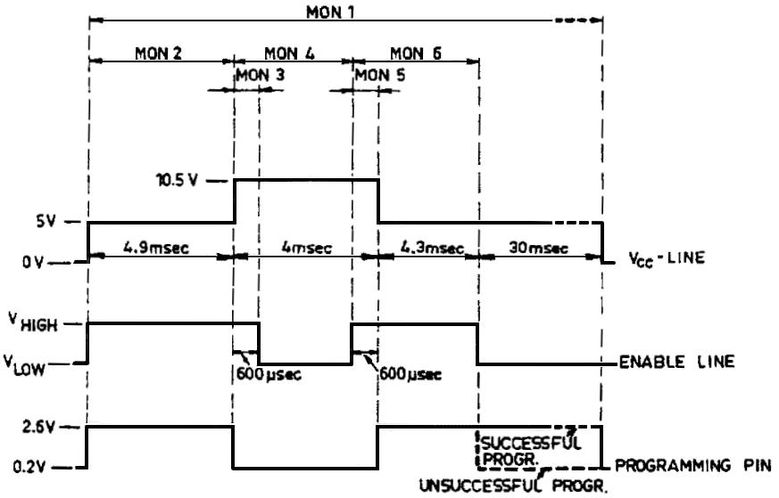

5- 11
6. Simple service
6.1. Incorrect 0peration
If the equipment is not functioning correctly, a check should be made that it is being operated properly. Go through the tuning procedure 2.I. if necessary.
6.2 Battery
The condition of the battery should be checked at frequent intervals. The battery must always be fully charged and should be tapped up frequently with distilled water (liquid should be 5 to 10 mm above the plates).
6.3 Checking the Antenna
Tuning the antenna tuning may be checked by adjusting the transmitter as described in section 2.3., preferably on one of the frequencies that was listed in the tuning chart when the equipment was installed.
Then set POWER switch to SIMPLEX, MEIDIUM and CHECK SWITCH to LEVEL. Pull the CHECK SWITCH knob out and press TUNE button. Note the meter reading.
Set PORER switch Co SIMPLEX, FULL and press TUNE button. Note ANTENNA CURRENT reading.
Compare the readings with the values listed in the tuning chart. If the two readings differ appreciably from the listed values and the transmitter is otherwise functioning normally, the fault can be expected to be in the antenna system or in the transmitter earth connection .
Accordingly the following check should be made.
Have any changes been node in antenna or earth connections since the installation was made?
Have any changes been made in the rigging or in the placement of the derricks, etc.?
Is leakage present on the antenna, possibly caused by moisture or dirt on the antenna insulators?
6.4. Using the CHECK SWITCH
The CHECK SWITCH is normally inoperative. Pulling the Switch knob out will switch the ANTENNA CURRENT meter to read the voltage or current selected with the switch. When released the knob it will return to its original position.
The meter reading in all positions except LEVEL is approx. 3 under normal conditions, i.e. transmitter adjusted as described in section 2.3.. POWER switch set to FULL and TUNE button pressed.

6 - 1
Position of  CHECK SWITCH | Check of | Deflection to 3 Corresponds to approx. | Actual deflection
VA | Anode DC voltage | 1700V | 2.4. to 3.5 dependent on supply voltage
V S1 | screen grid voltage of valve no. 1 | 300V
V S2 | screen grid voltage of valve no. 2 | 300V | 2.4 to 3.6 depen-dent on valve cha-racteristics
V G | control grid bias | -49V | 2.4 to 3.7 depen-dent on valve cha-racteristics
I 1 | cathode cur-rent of valve no.1 | 165 mA
I 2 | cathode cur-rent of valve no.2 | 165 mA
V D | supply volt- age to driver amplifier | 28V
Table 6.4.1.
6.5. Replacement of Fuses
All fuses, except the high tension fuse, are accessible on the front panel of the power pack. The high tension fuse becomes accessible when the power pack is pulled out.
NOTE: Set SUPPLY switch to OFF and open external supply voltage switch before opening the equipment and replacing fuses. Short circuit both ends of high tension fuse to chassis using an insulated tool before touching it.
Fuse ratings are given in table 6.5.1. and table 6.5.2. below. Fuses with marked ratings within 5 per cent of the ratings given must be used. Note that slow or fast blowing fuses must be used where specified.

6-2
Fuse Rating | Designation | Front Panel Fuses  (from left to right) | Symptom if fuse  is blown
1.6A fast | 260FS 5 | 7.5V to receiver | no light in display
1.6A fast | 260FS 6 | 15.7V to receiver  and exciter | no light in displays, negative deflection  on check SWITCH  position V G
3.15A fast | 260FS 3 | 7.5V to exciter | no light in displays
40A fast | 260FS 2 | 24V battery input  (LT and HT converters) | no light in displays
8A fast | 260FS 1 | 24V battery input  (RL, 1, filament  supply, blower) | no light in displays  no cabinet light
1.6A fast | 260FS 4 | 28V to driver in  T 5000 | no reading on CHECK  SWITCH position V D
0.5A fast | 260FS 8 | 600V screen grid  supply | no reading on CHECK  SWITCH positions V S1  and V S
0.5A HT | 260FS 7 | High tension fuse  1700V to anodes | no reading in CHECK SWITCH position V A
Fuse Rating, 24V THC Power Pack P 5000
Table 6.5.1.

6-3
Fuse Rating | Designation | Front Panel Fuses  (from left to right) | Symptom if fuse  is blown
1.6A fast | 265FS 3 | 7.5V to receiver | no light in display
1.6A fast | 265FS 7 | 15.7V to receiver  and exciter | no light in displays, negative deflection  on check SWITCH  position V G
3.15A fast | 265FS 3 | 7.5V to exciter | no light in displays
8 / 16A slow | 265FS 2 | Mains input | no light in displays  no cabinet light
8A fast | 265FS 8 | filament supply | No reading on CHECK  SWITCH positions I1 and I2
1.6A fast | 265FS 6 | 28V to driver in  T 5000 | No reading on CHECK  SWITCH positions V D
0.5A fast | 265FS 5 | 600V screen grid  supply | no reading on CHECK  SWITCH positions V S1  and V S2
0.5A HT | 265FS 4 | High tension fuse  1700V to anodes | no reading in CHECK SWITCH position V A
Fuse Rating, AC Power Pack P 5001
Table 6.5.2.

6 -4
7. REPAIR AND ALIGNMENT
7.1. Introduction
Repairs and adjustments on the equipment should be performed only by qualified technicians to whoa this chapter is addressed. Before attempting any repairs or adjustments, a study of Chapter 5, Technical Description, is recommended.
7.2. Cross-Slot Screws
The cross-slot screws used to secure the printed circuit boards are Pozidriv screws. A Pozidriv screwdriver No. 1 should be used in order to avoid damaging such screws.
7.3. Locating Subunits and Components
Locations of circuit boards in the equipment appear from the photographs on pages 8- to 8- . locations of components on each circuit board appear on the component location drawings against the respective circuit diagrams.
7.4. Locating Faults
Fault finding. as described in section 7.5. below, is aided by test points provided for the purpose of permitting rapid localization of faulty circuit boards on the basis of THC the measurements. Since not all types of faults can be traced by means of DC measurements, supplementary AC measurements with an oscilloscope nay be required; see section 7.6. To facilitate fault finding each individual circuit board typical voltages are listed on the circuit diagrams.
7.5. Test Points
Several circuit boards contain one or more test points. They are snail pin-type terminals, colour coded following the standard colour code in addition to being numbered. In the circuit diagrams are test points are marked TP 1, TP 2 etc., and typical voltages at the test points are listed there.
The terminals of the circuit boards may to a great extent also be regarded as test points. Typical voltages are therefore also listed against relevant terminals on the circuit diagrams.
If a voltage measured at a test point differs markedly from the listed value it is a fairly certain indication that the circuit board in question is faulty, assuming chat the voltages applied to the circuit board are the correct ones. This should likewise be checked.
7.6. AC Voltages
AC voltages listed in the circuit diagrams are typical voltages. Voltages specified are based on based requirement With an oscillator having an input impedance of 10 Mohms in parallel with 7 pF, and a sensitivity of the order of 50 mV / div and a frequency range of not less than DC -50 MHz.
AC voltage values measured in the signal path of the transmitter call be measured only if the transmitter is modulated with a two-tone signal. This can be done by pressing the TUNE button of the transmitter.

7 - 1

7.7. DC voltages DC voltages listed in the circuit diagrams are based on measurement with a 25 Kohms / Volt: multimeter. If a stated voltage is dependent or` the setting of a control this is also stated on the circuit diagrams. Typical logic levels (LOW/HIGH) are indicated in brackets.
7. 8. Adjustments The following sections describe alignment procedures for printed circuit boards that contain adjustable components. Bear in mind that no adjustments should be carried out unless there is a clear indication that it is really necessary. Moreover, adjustments should be carried out only by a qualified technician with the necessary equipment at his disposal.
When a unit or printed circuit board is replaced adjustments are in some cases necessary. These cases are listed in the table below.
Replacement of unit or board | Adjustment required of | Procedure given in
E 5002 | Level setting | Transmitter manual section 7.8.3.
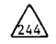 | 244-R15  Level setting | Transmitter manual section 7.8.3.
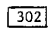 | Level setting | Transmitter manual section 7.8.3.
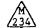 | 244-R15 | Section 7.9.2.
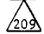 | 209-R13  209-R14 | section 7.13.3  section 7.9.2.
 | 210-RS | section 7.14.2
T 5000 / T 5001 /  T 5002 | Level setting | Transmitter manual section7.8.3.
7.9. Realignment of " MHz Exciter
Measuring equipment : Oscilloscope having a sensitivity better than 50mv/div. Input impedance 10 Mohm in parallel with 20 pF or less.
7.9.1. Realignment of 244R6, Microphone Sensitivity:
The microphone sensitivity potentiometer is normally fully clockwise, corresponding to full sensitivity. When the transmitter is installed where there is a high acoustic noise level it can be advantageous to reduce the sensitivity by tuning the potentiometer half or fully anti-clockwise. This has the effect of reducing the background noise coming lip in speech pauses. The compressor ensures that the transmitter is still fully modulated by the speech signal.

7 - 2

7.9.2. Realignment of 244 R15:
Control settings: SUPPLY switch: STAND BY.
1. Connect oscilloscope to test point 244 TP7.
2. Unsolder brown lead to terminal 244-4.
3. Set potentiometer 244 R15 to the middle of its range.
4. Press TUNE button and adjust Sensitivity of oscilloscope to give full screen peak to peak deflection.
5. Re-solder brown lead to terminal 244-4.
6. Press TUNE button and adjust 244 R15 to give exactly the same def lection on oscilloscope as before.
7.9.3. Realignment of 244 R44, Balance:
Control settings: SUPPLY switch: STAND BY
MODE switch: A3J
1. Connect oscilloscope to the hot end of 244 R61.
2. Adjust potentiometer 244 R44 for minimum deflection on oscilloscope.
7.9.4. Realignment of 244 R48, Carrier Level:
Control settings: SUPPLY switch: STAND BY.
Mode switch: A3H
1. Connect oscilloscope to 244 C44/244 L6.
2. Press TUNE button and adjust sensitivity of oscilloscope to give full screen peak to peak deflection.
3. Unsolder grey lead to 244-13.
4. Press TUNE button and deflection as before. terminal adjust 244 R48 to give exactly the same peak deflection as before.
5. Re-solder grey lead to terminal 244-13. Above procedure implies that 244 R15 is correctly adjusted (paragraph 7.9.2.).
7.9.5. Realignment of 244 T1:
Control settings: SUPPLY switch: STAND BY.
1. Connect oscilloscope to test 244 TP7
2. Press TUNE button and oscilloscope. Switch: STAND BY adjust 244 T1 for maximum deflection on oscilloscope.

7 - 3

7.9 .6. Realignment of 244 L6:
Control settings: SUPPLY switch: STAND BY
- Connect oscilloscope to 244 C44/ 244 L6
2. Connect a shorting strap across capacitor 303 C1.
3. Press TUNE button and adjust 244 L6 for maximum deflection on oscilloscope .
4. Remove shorting strap.
7.10. Realignment of RE Translator
Measuring equipment :
Oscilloscope having a sensitivity better than 50mv/div. Input impedance 10 Mohm in parallel with 20 pF or less. Frequency range up to 50 MHz.
Standard signal Generator covering 20-40 MHz and having a frequency accuracy better than 10-4 and an output of at least 3V in 50 ohms.
7.10.1. Realignment of 302 T1. 1.4 MHz input transformer:
Control settings: SUPPLY switch: STAND BY
1. Connect oscilloscope to 244 C44 / 244 L6.
2. Press TUNE button and adjust T1 for minimum deflection on the oscilloscope.
7.10.2. Realignment of 302 R18, balance of " to 38 MHz mixer:
Control settings: SUPPLY switch: STANDBY
MODE switch: A3J
POWER switch: DUPLEX
1. Connect oscilloscope to R45/R55.
2. Adjust R18 for minimum deflection on oscilloscope.
7.10.3. Realignment of 30 MHz Low Pass Filter:
Control Settings: SUPPLY switch: STAND BY
MODE switch: A3J
POWER switch : DUPLEX - FULL.
1. Connect oscilloscope to the BNC-socket 301 SK5 through a 50 ohms load.
2. Remove strap between terminals 302-3 and 302-4 and connect signal generator between terminals 302-3 and 302-5 (302-5 ground).
3. Detune the three circuits of the filter by turning the cores anti-clockwise.
4. Set signal generator to 52.5 MHz, approx. 2V.
5. Adjust L5 to minimum deflection on oscilloscope.
6. Set signal generator to 46.0 MHz. approx. 2V.
7. Adjust L4 to maximum deflection on oscilloscope.
7 - 4
8. Set signal generator to 28.0 MHz and an output giving approx. 1.5 Vpp on the oscilloscope.
9. Adjust L5 to maximum deflection on oscilloscope.
10. Remove signal generator and re-solder the scrap between terminals 302-3 and 302-4.
7.10.4. Realignment of 302 L6, 36.6 MHz VCO:
Control settings: SUPPLY switch: STAND BY
1. Connect oscilloscope to IC5 pin 3.
2. Adjust L6 to symmetry of the square wave (e.g. 50% duty cycle).
7.10.5. Realignment of 302 T2, 36.6 MHz Transformer.
Control settings: SUPPLY switch: STANTBY BY
MODE Switch: A3J.
1. Connect oscilloscope to IC1 pin 1 and ground at pin 13.
2. Adjust T2 for maximum deflection on oscilloscope.
7.10.6. Realignment of Level Setting Potentiometers
The level setting potentiometers control the RE drive voltage to the transmitter and is therefore described in the transmitter manual. (The T 5002 manual paragraph 7- ).
7 .11. 234 Realignment of Control A Circuit and Tone Generators
Measuring equipment:
Frequency Counter having an accuracy better than 10-4 and a sensitivity of at least .0.5V.
Extender Board 259
7.11.1. Realignment of M234 T1 and M234 T2:
Control settings: SUPPLY switch: STAND BY
mode switch: TEST ALARM.
1. Insert extender board.
2. Connect frequency counter between terminals M234-32c and M234-4c ground) .
3. Connect the adjustment terminal B marked 1 and 2 together.
4. Depress and release ALARM START pushbutton.
5. Adjust M234 T1 until counter reads 2200 Hz ± 1 Hz.
6. Remove connection referred to in point above.
7. Connect the terminals marked 2 and 3.
8. Depress and release ALARM START button.
9. Adjust M234 T2 until counter reads 1300 Hz ± 1 Hz.
10. Remove connection referred to in point 7 above.

7 - 5
7.11.2. Realignment of M234 T3:
Control settings: SUPPLY switch: STAND BY
MODE switch: A1
1. Insert extender board.
2. Connect frequency counter between terminals M234-32c and M234-4c (ground) D
3. Depress morse key or alternatively short circuit the terminals of the jack socket 300 SK2.
4. Adjust M234 T3 until counter reads 1500 Hz ± 1 Hz.
7.12. 208 Realignment of Loop Translator
Measuring Equipment :
Signal Generator covering the range 100 KHz to 10 MHz. Oscilloscope or RF Voltmeter having an input impedance greater than 10 Kohm and a sensitivity of at least 10 mv/div. Extension board 259
7.12.1 Realignment and Check of 1.5 MHz LP-filter:
Control settings: SUPPLY switch: STANTBY
Frequency selected: Greater than 5 MHz
1. Remove PCBs 209 and 210 from their sockets.
2. Adjust the cores of L2, L3, L4 and L5 until they are flush vi.th the top of the coil former.
3. Connect the signal generator to pin 12 of 208 IC4 through a 0.1 pF capacitor and common.
4. Connect the oscilloscope probe tip to the collector of 208 TR5 and the oscilloscope ground clip to common.
5. Adjust the signal generator to 20 mV rms.
6. Sweep the Signal generator from 60 KHz to 1.45 MHz; the voltage reading level on the oscilloscope must not change core than 1 dB. (Take care that the output level of the signal generator does not change during the sweep).
7. Readjust the signal generator until the signal level measured is decreased by 3 dB relative to the maximum signal level found under 5). The frequency should then tie between 1.5 MHz and 1.9 MHz.
8. Readjust the Signal generator until the signal level measured is decreased by 20 dB relative to the maximum signal found under 5). The frequency should then be between 1.8 MHz and 1.9 MHz.
7.12.2. Realignment of Transformer 208 T1:
Control settings: SUPPLY switch: STAND BY
1. Insert the PCB into its socket.
2. Select by means of the keyboard 29,900.0 MHz as the transmitting frequency.
3. Connect the oscilloscope probe tip is pin 1 of 208 IC4.
4. Adjust the transformer 208 T1 until the signal measured is approximately 2Vpp.
7 - 6
7.13. 209 Realignment of VCO1 and VC02
Measuring equipment:
Oscilloscope having an input impedance of 10 Mohms in parallel with 20 pF or less.
Frequency Counter having an accuracy better than 10-3 and a sensitive of at least 0.5V.
Extension Board 259.
7.13.1. Realignment of VC01:
Control settings: SUPPLY switch: STAND BY
1. Connect a shorting lead between terminal 209-32c and common.
2. Correct the frequency counter between 209-22c and common.
3. Adjust transformer 209 T1 until the counter reads 23.0 MHz.
4. Remove the shorting lead referred to in (1).
7.13.2. Realignment of VC02:
Control settings: SUPPLY switch: STAND BY
1. Connect shorting lead between terminal 209-2c and common.
2. Connect the frequency counter between 209-16c and common.
3. Select the (3.70 – 4.69) MHz VCO2 – band (a frequency between 100 kHz and 10 MHz as transmitting frequency.
4. Adjust transformer 209 T2 until the counter meter reads 5.0 MHz.
5. Select the (4.70 – 5.69) MHz VCO2 – band (a frequency between 10 MHz and the 20 MHz a transmitting frequency).
6. Adjust coil 209 L6 until the counter reads 6.1 MHz.
7. Select the (5.70 – 6.69) MHz VCO2 – band (a frequency between 20 MHz and the 30 MHz a transmitting frequency).
8. Adjust coil 209 L5 until the counter reads 7.1 MHz.
9. Remove the short circuit referred to in 1.
7.13.3. Realignment of Phase/Frequency Detector 1 Error Signal:
Control settings: SUPPI.Y switch: STAND BY
1. Connect the oscilloscope between 209-32c and common.
2. Adjust 209 R13 for minimum puls width.
7.13.4. Realignment of Phase / Frequency Detector 2 Error Signal:
Control settings: SUPPLY switch: STAND BY
Frequency Selected: Greater than 1MHz.
1. Connect the oscilloscope between 209-2c and comrnon.
2. Adjust 209 R14 for minimum pulse width.
7 - 7
7.14. 210 Realignment of VC03
Measuring equipment:
Oscilloscope having an input impedance of 10 Mohms in parallel with 20 pF or less.
Frequency Counter having an accuracy better than 10-3, a sensitivity of at least 1v and an upper frequency limit of at least 75 MHz.
Extension Board 259
7.14.1. Realignment of 210 C24, 210 C26, 210 C28, VC03:
Control settings: SUPPLY switch: STAND BY
1. Connect a shorting lead between terminal 210-6c and common.
2. Connect the frequency counter between 210-16c and common.
3. Select VC03-z. (a frequency between 100 KHz and 10 MHz as transmitting frequency).
4. Adjust 210 C24 until the counter reads 51.0 MHz.
5. Select VCO3-y (a frequency between 10 MHz and 20 MHz as transmitting frequency).
6. Adjust 210C26 until the counter reads 61.3 MHz.
7. Select VC03x (A frequency between 20 MHz and 30 MHz as transmitting frequency) .
8. Adjust 210 C28 until the counter reads 71.3 MHz.
9. Remove the shorting lead referred to in 1.
7.14.2. Realignment of 210 R5 Phase/Frequency Detector 3 Error Signal:
Control settings: SUPPLY switch: STAND BY
Frequency selected: Greater than 1 MHz.
1. Connect the oscilloscope between the junction of 208 R48 / 208 R49 and common.
2. Adjust 210 R5 for minimum pulse width.
7.14.3 240 Realignment of Master Oscillator
Measuring equipment : Oscilloscope having an input impedance of 10 Mohms in parallel with 20 pF or less. Frequency counter, accuracy better than 10-7.
7.15.1. Realignment of 240 T1,1.4 MHz coil:
Control settings: SUPPLY switch: STAND BY
1. Connect oscilloscope to terminals 240-2 and 240-3 (ground).
2. Adjust 240 T1 for maximum deflection on oscilloscope.

7 - 8

7.15.2a Realignment of TCX0 frequency (in case of an ITT TCXO):
Control settings: SUPPLY switch: STAND BY 1.
Connect the counter to In pin 1. 2. At approx. 25° C the frequency must be within ± 2 Hz of the nominal frequency 11.2 MHz ± the offset frequency (marked on the top of the metal case).
If the frequency is not within these limits, the value of the resistor R2 must be changed, generally with a lower value. A resistor can therefore normally be placed in parallel with R2.
7.15.2b Realignment of TCX0 frequency (in case of a Philips TCXO): Control settings: SUPPLY switch: STAND BY
1. Connect the counter to the IC1 pin 1.
2. If the frequency is higher than 11.200.0 MHz, the connection indicated by the dotted line in the circuit diagram must be introduced. (This will reduce the frequency by approx. 2 ppm).

7 - 9

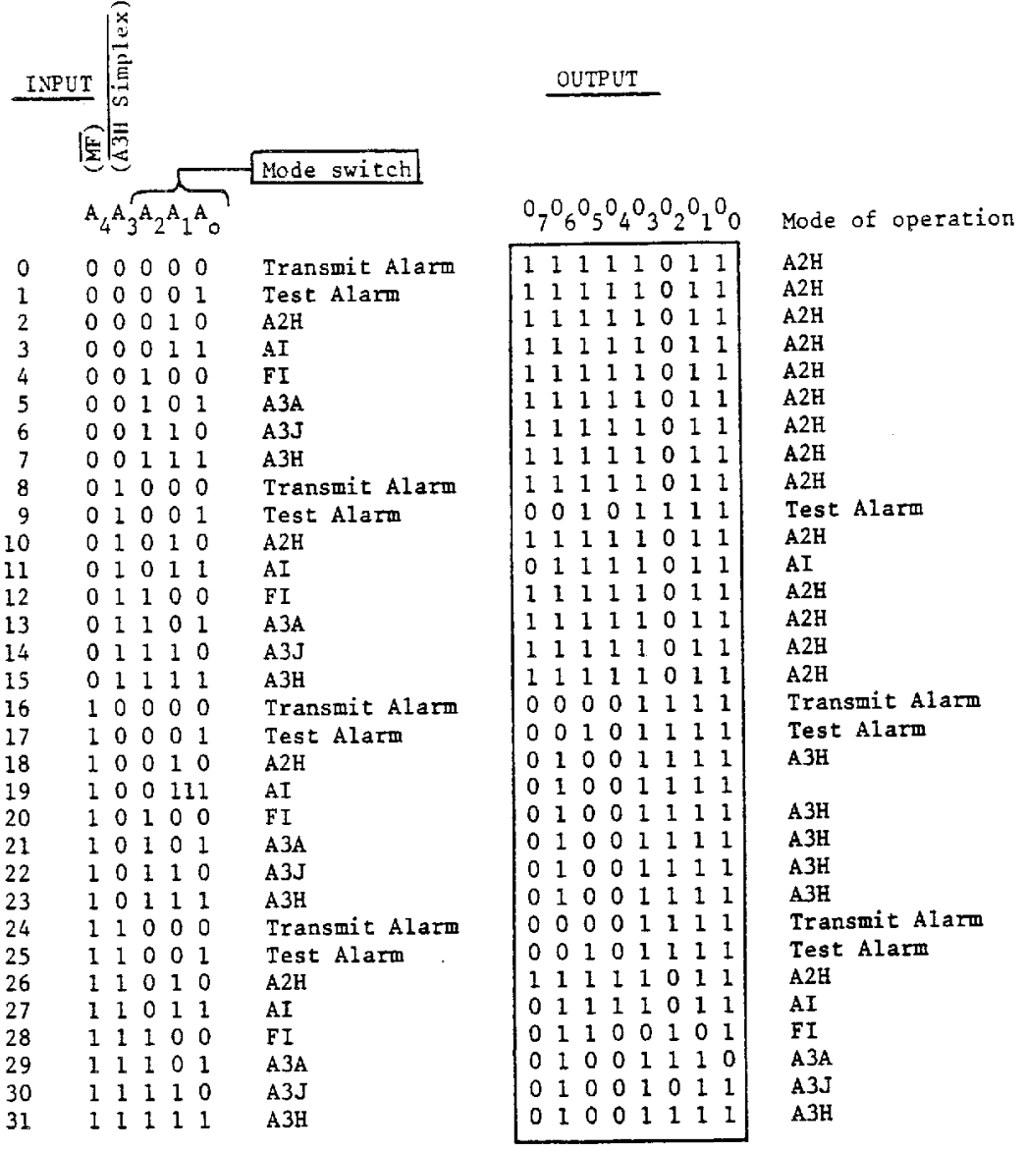
Function Table for M234M IC5
32 x bit Prom of Control Circuit and Test Generators M234
The MODES Transmit Alarm and Test Alarm are only accessible from the Remote Control Interface and from the frontpanel MODE Switch in conjunction with T 5000 and on request.

7 - 10
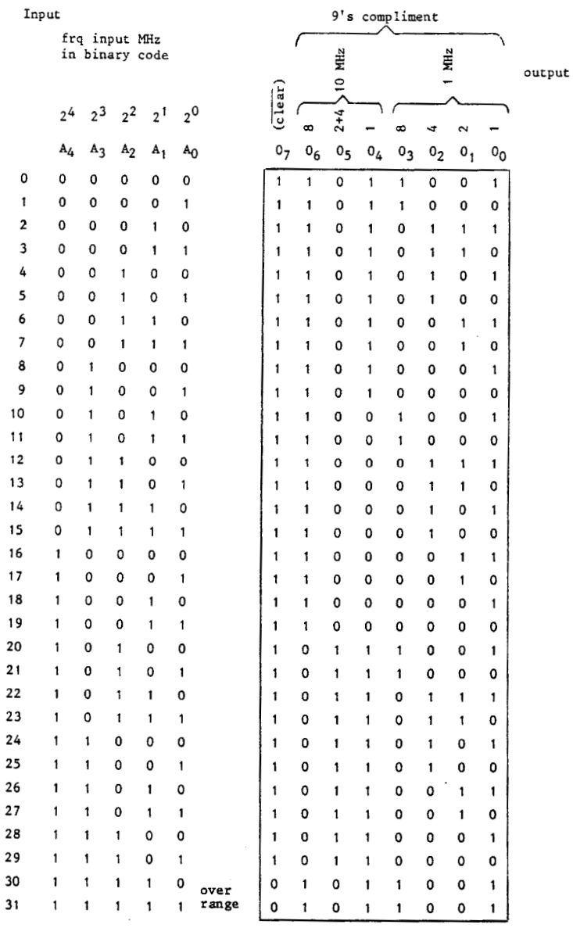
Function Table for 303 IC 3 (382 239 51)
32 I 8 bit Prom binary to 9'8 complement converter in Display and keyboard 303
7 - 11
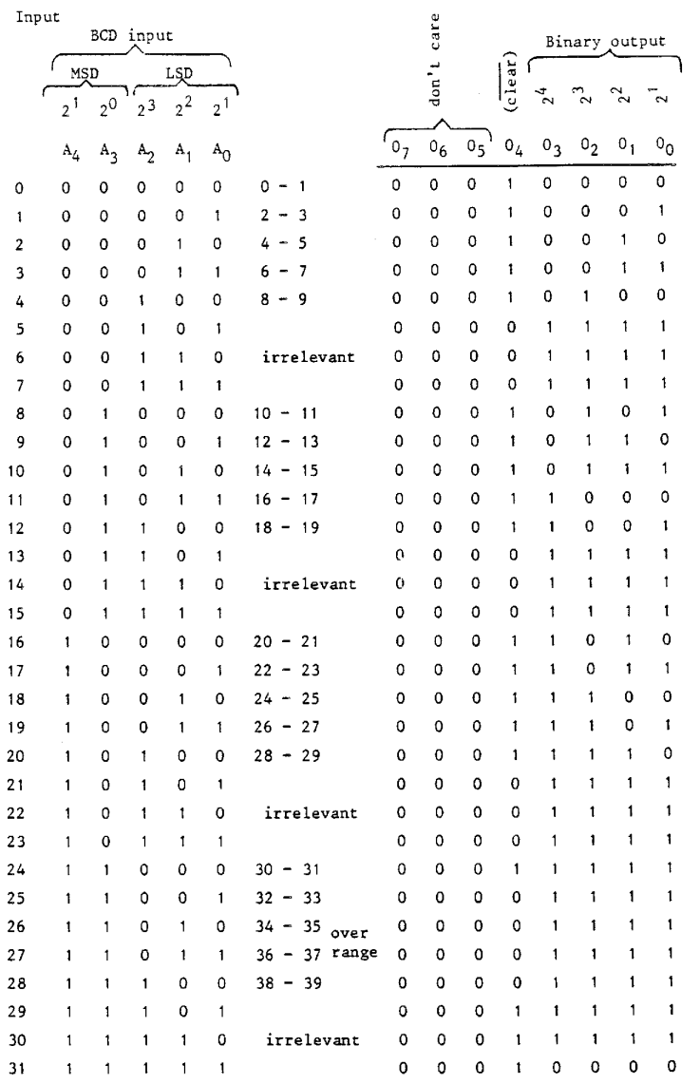
Function table for 303 IC 11 + 303 IC 39 (382 239 61)
32 x 8 bit Prom BCD to Binary Converter in Display and Keyboard 303
7 - 12
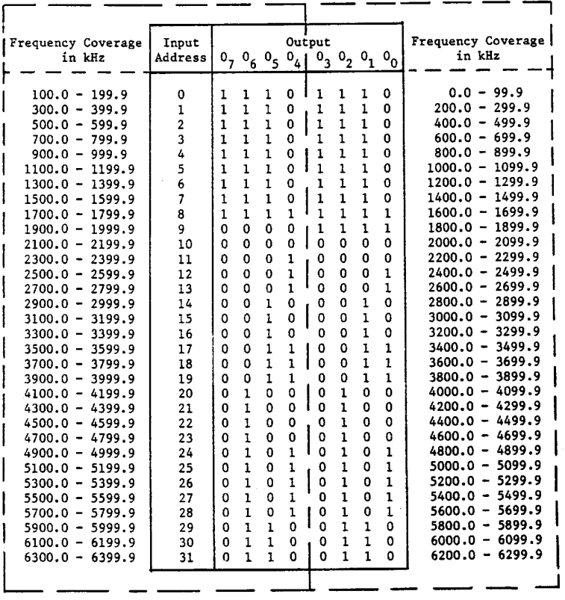
Function Table for 303 IC 9 Standard (382 246 21) 0 - 6.3
32 x 8 bit Prom of the Band Decoder Memory in Display and Keyboard 303 for T 5002.

7 - 13

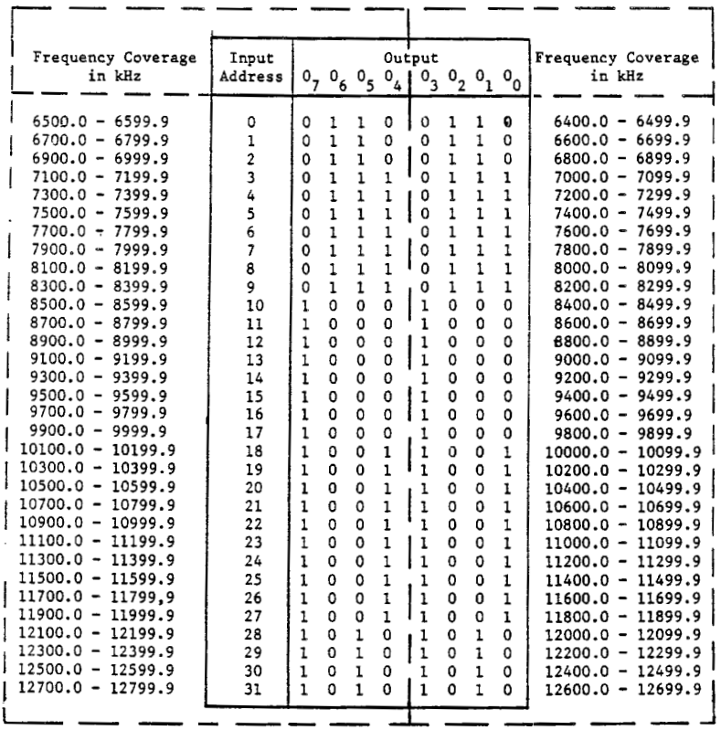
Function Table for 303 IC 8 Standard (382 246 31) 6.4 – 12.7
32 x 8 bit Prom of the Band Decoder Memory in Display and Keyboard 303 for T 5002.

7 - 14

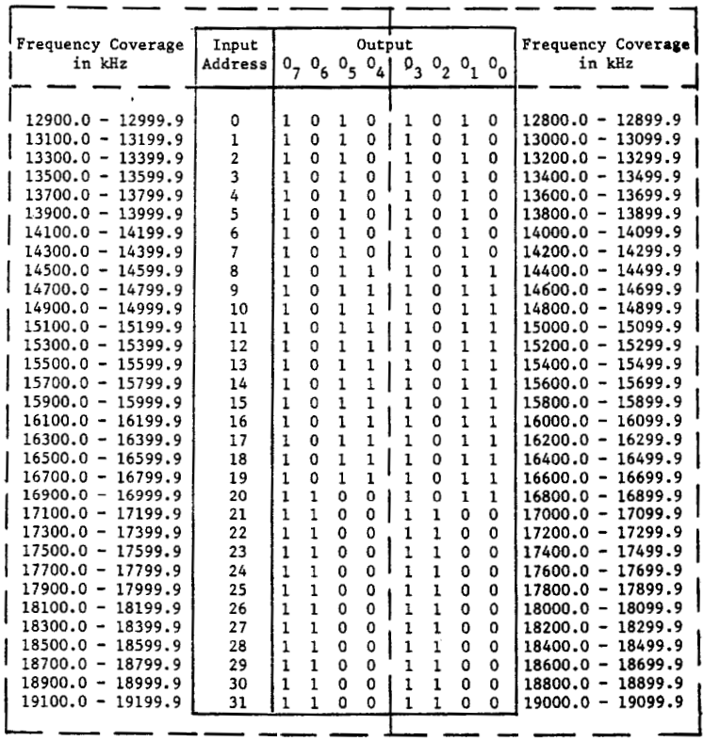
Function Table for 303 IC 7 Special (382 246 42) 12.8 - 19.1
32 x 8 bit Prom of the Band Decoder in Display and Keyboard 303.

7 - 15

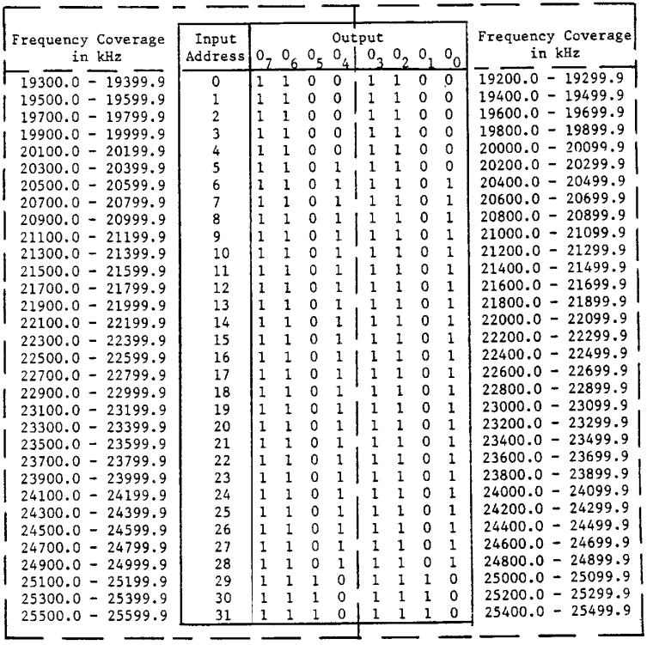
Function Table for 303 IC 6 Special (382 246 52) 19.2 - 25.5
32 x 8 bit Prom of the Band Decoder in Display and Keyboard 303.

7 - 16

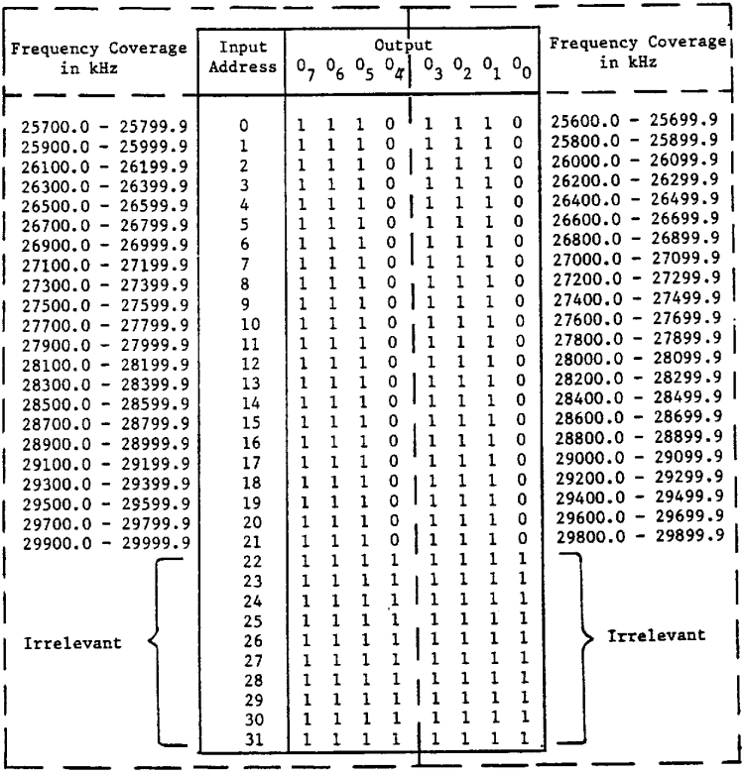
Function Table for 303 IC 5 Special (382 246 61) 25.6 - 31.9
32 x 8 bit Prom of the Band Decoder in Display and Keyboard 303.

7 - 17

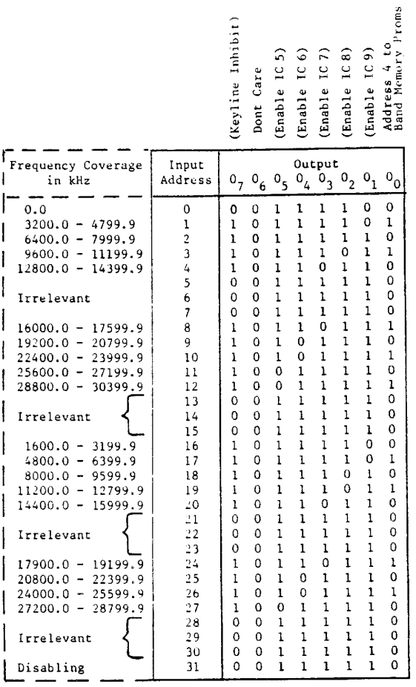
Function Table for 303 IC 16 Special (382 239 72) excl. MF
32 x 8 bit Prom of the Band Decoder in Display and Keyboard 303.
7 - 18

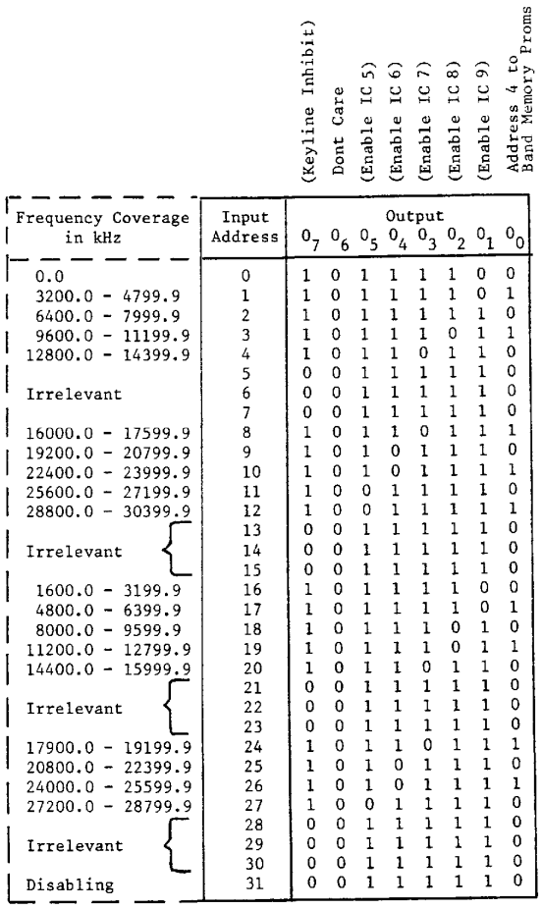
Function Table for 303 IC 16 Special (382 239 82) incl. MF
32 x 8 bit Prom of the Band Decoder in Display and Keyboard 303.
7 - 19

- PARTS LIST AND CIRCUIT
DIAGRAMS
8-1. Numbering
An identification number between 207 and 303 is assigned to each module. The designation of a component or terminal includes this number as a prefix - example: 207R3 (resistor R3 on module 207), or 207-12 (terminal No.12 on module. 207).
8.2. Switches
Switches with stops are shown in the extreme anti-clockwise position. the BAND switch is shown in the BAND K position.
Switch wafer No. 1 is the wafer nearest to the front panel, and the front side of a wafer is the side facing the front panel.
8.3 Terminals
Locations of terminals appear from the component location drawings. On the circuit diagrams, each terminal is identified by a number and in nose cases by all explanatory text. In addition to this, the number of the module and terminal to which the lead is connected is indicated (example: 244 -12). Where interconnections consist of coaxial cables only the number of the terminal is given to which the inner conductor of the cable is corrected.
8.4 Voltages
Typical DC voltages are indicated on the circuit diagrams next to the points to which they refer and are marked with a " V ''.
Typical logic levels are indicated in a bracket (LOW/HIGH) on the circuit diagrams next to the point to which they refer and are marked with a '' V ''.
Typical AC voltages are likewise indicated of the circuit diagrams. They are marked with "Vpp" or "mVpp`'. For measuring conditions See Chapter 7,
8.5 Test Points
Location of test points is shown on the component location drawings. Typical voltage ac each test point is indicated on the circuit diagram.
8.6. Symbol Explanation
8.6.1. Logic circuits:
A small circle at an external input means Chat the specific input is active LOW, i.e. it produces the desired function in conjunction with other inputs if its voltage is the lover of the two logic levels in the system; otherwise the specific input is HIGH.

8 - 1
A small circle at a clock input means that the outputs change on the HIGH to LOW clock transition.
A small circle at an output indicates that when the function designated is true the output is LOW. Inputs and outputs are labeled with mnemonic letters as described in table 8.6.1.
8.6.2. Logic Functions:
Logic functions are labeled with mnemonic letters in a bracket. An active LOW function is given a bar over the label. More logic functions may be connected by means of the principles of Boolean Algebra.
8.6.3. Arrows: A black arrow on a line indicates in which direction an AC - signal flows,
A white arrow on a line indicates in which direction the information of a DC signal flows. An exception from this rule is the supply lines and their connections, which are always indicated by a supply voltage level or its associated label.

Positive supply line: Example | 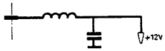
Negative supply line: Example | 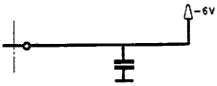
Connections to supply line: Example | 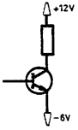

8 - 2

Label | Short for | Meaning
Ix | Input | Data Inputs to combinatorial circuits
J,K |  | Inputs to JK flip flops
Dx | Data | Inputs to D flip flops and latches
S,R | Set, Reset | Inputs to JK and D flip flops, latches, registers, and counters; R resets output to LOW; S sets output to HIGH
Px |  | Inputs to registers and counters
Ax | Address | Inputs used for selection of an input, output, data route, or memory location:
E | Enable
PE | Parallel Enable | Control input used to synchronously load information in parallel into a circuit
MR | Master Reset | Input which resets asynchronously all outputs to LOW, overriding all other inputs
CL | Clear | Input which resets outputs to LOW, but does not override all other inputs
CP | Clock Pulse output
CE, CEP, GET | Count Enable | Control inputs to counters
Ox | Output | Outputs of combinatorial circuits
Qx |  | Outputs of sequential circuits
TC | Terminal Count | (Output of a counter indicating 1111 for up binary counters, 1001 for up decimal counters, or 0000 for down counters) .
Table 8.6.1.

8 - 3

8.7. Abbreviations
A = ampere, amperes
C = capacitor
Car. = carbon
Cer. = ceramic
D = diode
F = farad
FS = fuse
H = henry
IC = integrated circuit
K = kilo or 10+3
L = coil, inductor
LS = loudspeaker
Lin. = linear
Log. = logarithmic
m = mille or 10-3
M = mega or 10+6
ME = instrument
MF = metal film
Mi = mica
MP = metalized paper
u = micro or 10-6
n = nano or 10-9
NPO = temperature coëfficient 0
N150 = temperature coëfficient -150
NTC = neg. temperature coëfficient
P = pico or 10-12
PL = connector (socket)
Polyes. = polyester
Polyst. = polystyrene
PTC = pos. temperature coëfficient
R = resistor
RN = resistor network
RL = relay
S = switch
SK = connector (socket)
SL = lamp
T = transformer
Tan = tantalum electrolytic capacitor
TR = transistor
V = working voltage DC or volts
VL… = valve
Vac. = working voltage AC
Var. = variable
Vpp = peak to peak voltage
Varicap = variable capacitance diode
ww = wire wound
W = watt, watts
W.alum. = wet aluminum electrolytic
X = crystal, crystal oscillator or crystal filter

8 – 4
