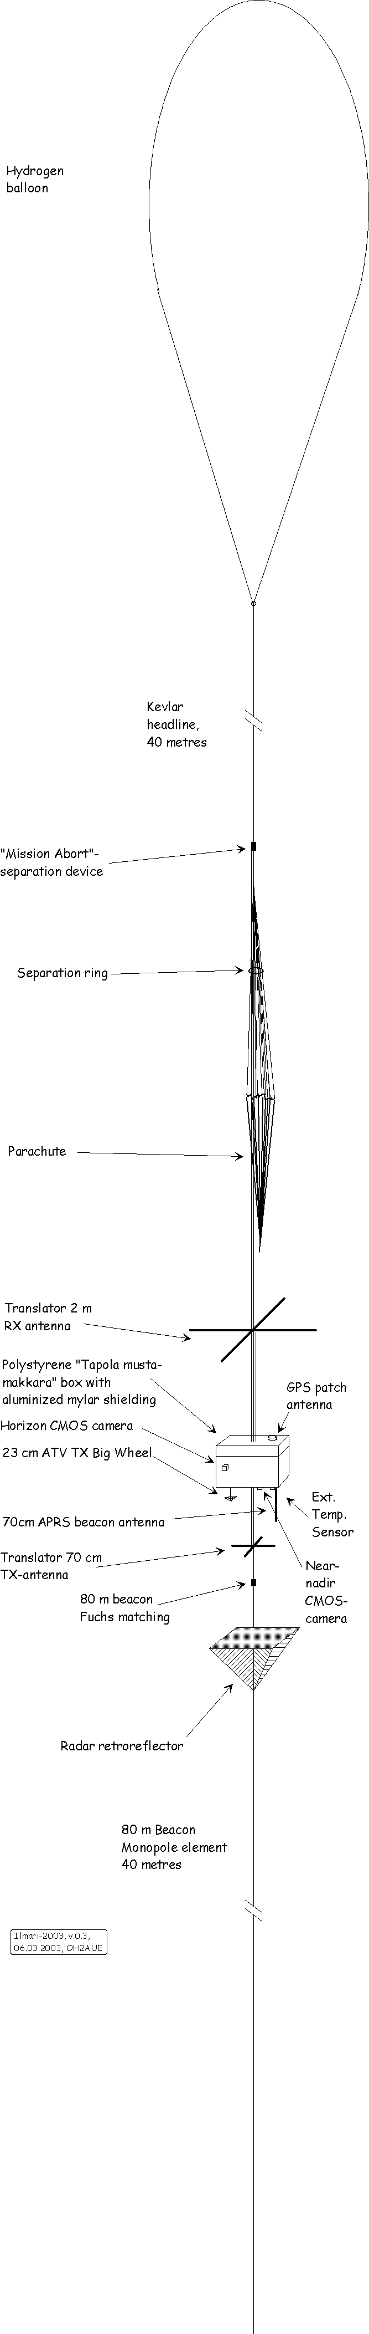

Ilmari-2003 Info Sheet

Ilmari-2003 is the latest Finnish Radio Transponder Balloon and is to be launched on it’s maiden flight in 2004. The payloads for this project are versatile and cover 23 cm live ATV video transmission with two switchable cameras, packet telemetry on 70 cm, CW telemetry on 80 m and a linear, high power transponder from 2 m to 70 cm allowing communication over a very large area using SSB/CW and SSB bandwidth digital modes like SSTV, PSK31, MT63, RTTY etc.

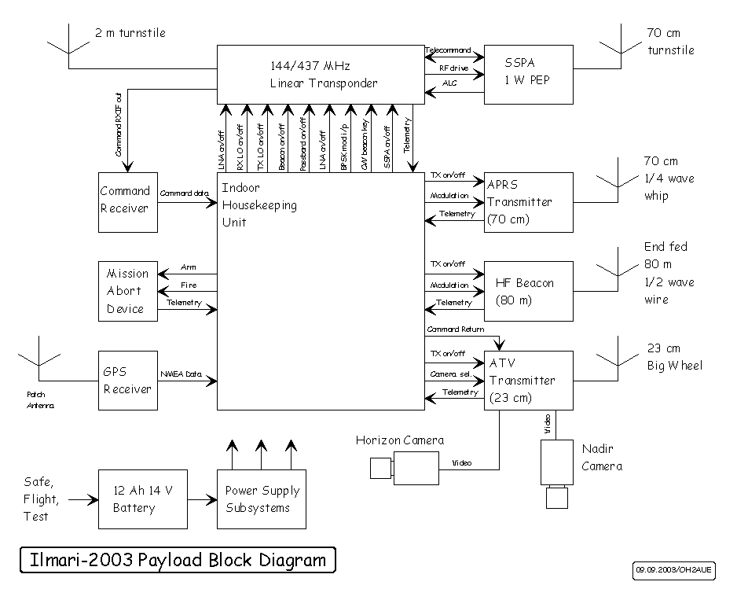

The Ilmari-2003 Balloon project will be the 20th in a long succession of transmitting amateur experiments in Finland with the first flight dating back to 1967. This latest Ilmari project is simultaneously an experimental platform and team effort targeting RATS-SAT, a Finnish Amateur Radio Satellite project and has been constructed by the RATS (Radio Amateur Technology Society) AMSAT-OH subdivision. AMSAT-OH participated in AO-40 by supplying the 10 GHz high power transmitter and carrying responsibility of RF payload testing during the various flight verification sessions. AMSAT-OH is currently also involved in AMSAT-DL Phase 3E and Phase 5A projects.

Michael Fletcher, OH2AUE & OH2FM,
Ilmari-2003 Payload Manager
Chairman of AMSAT-OH

