DRIACS-G2
EME Antenna Controller System (Generation 2)
Design by Hannes - OE5JFL, implementation by Alex - HB9DRI
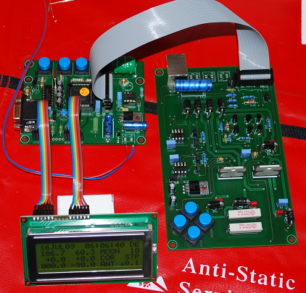
INTRODUCTION:
The present document is a detail description about how to test, install and interface the DRIACS-G2 to your antenna system, this document doesn't replace the original information publish by Hannes in: www.qsl.net/oe5jfl/ant_cont.htm
The DRIACS-G2 is the evolution of the original ACS (Antenna Control System) design by Hannes OE5JFL 13 years ago. A plethora of EME stations still using the G1 model with excellent results. This G2 controller has a lot of improvements respect to the G1 but essentially have the same philosophy: Tracking the moon (or other celestial bodies) without PC.
Hannes dedicate an invaluable time to develop and "clean" the Firmware and also to improve the hardware configuration, with the new Absolute encoders on the market, he develop a very flexible interface capable to read different kind of encoders, giving you the possibility to adjust the system to your necessities and capabilities. My contribution is only the implementation in a reduce number of controllers, I have no plans to have permanent stock, the materials are selected trying to deliver the better quality as possible, searching the better price BUT without scarifying quality, some components are imported direct from Germany, USA and Canada, other parts, like the PCB's are made in Ireland and few parts are located here in the electronic local market in Switzerland.
One of the big improvement is the chance to interface the new cheap series of MEGATRON Encoders, the MAB25 is an Absolute encoder capable to run up to 12bit resolution but with the software configuration is possible to configure the system to run in 10 and 11bits also.
Of course the results of the MAB25 are less impress than the well know A2-S-S from US digital but with a difference of more than 200.00 USD per encoder the MAB25 is something to evaluate and look. Previous results show a little thermal drift of only 0.2 degrees, this small difference could be compensated if the encoders are installed in a sealed box with some kind of insulation material and maybe and Oven system to try to keep the temperature constant around the encoder, this part will be released to you, the final investigator.
I hope you will enjoy your new device and soon you will adopt the DRIACS-G2 as an invaluable piece of hardware in your EME station.
73 de Alex, HB9DRI

MANIPULATION:
The DRIACS-G2 have sensitive CMOS devices, a carefully manipulation is a MUST, use anti-static techniques when you manipulate the controller without a box, in a very dry places (especially in winter when the relative humidity down below 40%) avoid any metal contact with the PCB's except ground.
DC POWER SUPPLY:
The controller runs from 9V to 13.8V DC without problems, variation in the DC voltage have only impact in how intense is the backlight on the display, R1 (47ohms) is calculated to dissipate 2 watts when 12 VDC is used, this resistor become hot when voltage go up more than 11 volts. A good compromise about backlight intensity and power dissipation in R1 is run the controller with 10 VDC, 9VDC will works but the stability of the voltage regulator 7805 could be compromise sometimes. Keep the ripple as low as possible and use a standard properly techniques to have a pure DC as possible. Run with batteries will be perfect but not necessary.
PACKING LIST:
Your controller KIT comes with the next elements:
-PCB1: Controller board where the Microprocessor is located
-PCB2: Interface Board where the Power control parts for the Encoders.
-PCB3: Splitter board where the encoders are connected
-1 Display board 20x4
-1 x 20pin flat cable to interconnect PCB1 and PCB2
-2 x 6pin flat cables to interconnect PCB1 and Display board
-2 8pins IC’s LTC485 (IC3 and IC4) (install only if you will use A2-S-S encoders)
-Firmware v1.0 uploaded (LAT/LON is configure in my QTH in HB9, you can change later)
WHAT IS NOT INCLUDED?
-Enclosure to install PCB1, PCB2 and Display board. Avoid plastic or wood boxes, use ONLY metal boxes to protect any possible RFI inside the controller.
-Encoders, if you order your KIT with MAB25 encoders you will receive a pair with the extra cost.
- 8 push buttons for chassis mount

DISPLAY BOARD AND PUSH BUTTONS MODIFICATION in PCB1 and PCB2:
If you see the OE5JFL homepage you will see nice photos of the controller, you can see how the Display board is attached to the controller board as a single unit with the 4 push buttons installed behind the microprocessor board, aligned below the display. This setup is very compact but offer additional complexity to install in a metal box, the square hole for the display board need to match perfect with the holes for the 4 push buttons. Additional the 4 push buttons are not for chassis mount, are simple surface mount buttons.
To give you more flexibility in the process to install all your PCB's inside your metal box I decide to de-attach the Display board from the PCB1 (Controller board) and connect the Display board and the controller board with 2 small 6pin flat cables, with this configuration you can install the Display board easy.
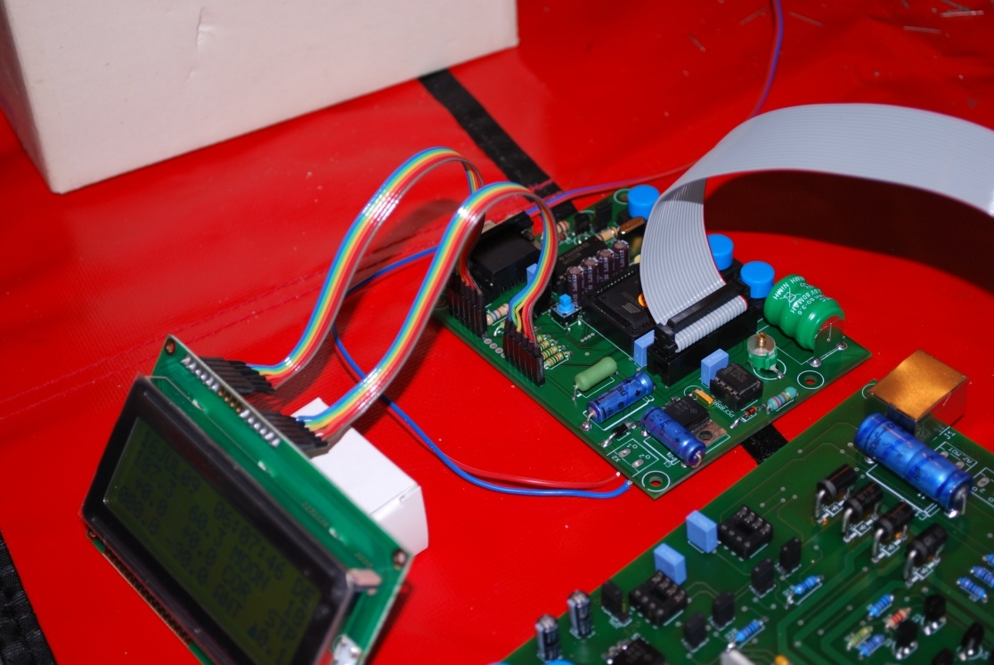
FIG1
Regarding the Push buttons I mounted reverse compare with the original design, means you can install the controller board in the bottom of your box with the component side looking to you and you will have access to the push buttons now located for the component side (in the original model the push buttons are located in the other side aligned with the display board.
The push buttons installed on the board are only used for the initial configuration or when you run the controller open without box, you must install 4 push buttons in your front panel (Shift, +, - and AUTO), the electric connection will be in parallel with the buttons on the PCB1.
The push buttons works closing the control pin to ground, you just install each push button in your front panel in parallel with the respective button in your board, for that you need to extend 4 control cables and 1 ground cable and that's all, it's very simple.
In the next FIG you can see the new button distribution (is inverted than the original design):
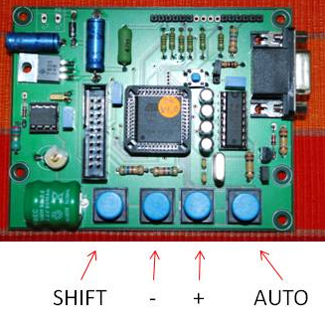
To have the other 4 push buttons (position control: UP, DOWN, LEFT and RIGHT to move the antenna manually) you need to add another 4 push buttons for chassis mount in your front panel and cabling this 4 buttons in the same way you did for PCB1 but now for PCB2 (interface board).
The display board need to be connected carefully one to one pin, means pin 1 in PCB1 need to be pin 1 in display board, pin2 on PCB1 need to be pin2 on display board and so on, any error here could damage the display board and/or the microprocessor board.
The 6 pins flat cables allow you to match the pin1 and pin16 then the rest of the connections are done automatic, the first flat cable connect pin1,2,3,4,5 and 6 from the PCB1 to pin1,2,3,4,5 and 6 on the display board in a one to one way, pins 7,8,9 and 10 ARE NOT USED, the second flat cable connect pin11,12,13,14,15 and 16 from the PCB1 to pin11,12,13,14,15 and 16 on the display board in a one to one way. For more details see FIG1 and you will understand easy how is done.

PCB3, THE SPLITTER BOARD
The splitter board is located as close as possible to your encoders, means to your antenna, you will connect your encoders to the splitter board using as short as possible cables and using ferrite to decouple any kind of possible RF magnetic field coming from your antenna.
The splitter board will be connected to your controller box via a normal UTP LEVEL 5 network cable or well know as a CAT5e network cable, the connector for that is the well know RJ45 used to interconnect computers into the network. You will identified this RJ45 connector on the PCB3 (splitter board) and PCB2 (interface board)
Depending of the encoders you decide to use you need to configure your PCB3, the explanations and diagrams about that are in the original documentation from Hannes OE5JFL. If you use MAB25 encoders you need only to install a jumper BUT is you use an A2-S-S encoder from US Digital you need to remove the jumper and install few resistors, Hannes explain this part really well in the original documentation.
ABOUT THE NETWORK CABLE TO INTERCONECT THE ANTENNA AND YOUR CONTROLLER BOX
This is a very sensitive topic, especially for the big amount of bad quality cables existing on the market.
Our initial test done separated in Austria and Switzerland show to Hannes and me more or less same results, it's possible to interface the PCB3 and your PCB2 in your controller box up to 50-meters of good quality UTP LEVEL 5 or CAT5e Network cable, we test up to 70 meters but after 60 meters the system start to exhibit some kind of inconsistence in the lecture of the encoders with some cables, with others not, for that reason we decide to declare the maximum distance were the encoders reads 100% of the time in 50 meters. This is for sure enough for us were the distance from the shack to the antenna is a critical part for the RF path
The quality of the cable have big impact on that, in a experiment Hannes declare an error in the lecture with only a 7 meter cable (apparently bad quality cable) and I already test a special version double shielded up to 85 meters without errors but this cable is rare and very expensive on the market. Avoid any cheap cable coming most of the time from some unknown producers, I cannot approve or not some producers but try use the best cable as possible. Ask the experts.
The problem here is the number of twist existing per meter, a network cable is organize internally by pairs and this pairs twist constantly giving you a level of impedance, the bad quality cables have bad quality control and techniques to be produced and cannot keep this twist ratio per meter constant, this cause a lot of reflexions and changing in the impedance of the cables affecting the encoders. Remember a good cable here is the key to interface your antenna without problems. To avoid problems limit your distance to 50 meters or go up by your own risk to have errors in the lecture.

CONFIGURE BOARDS, INTERCONECT AND TEST YOUR CONTROLLER:
DO NOT APPLY DC BEFORE YOU CONFIGURE YOUR BOARDS PROPERLY:
IF YOU USE MAB25 ENCODERS FOLLOW THIS CONFIGURATION:
1- In PCB1 (controller) JP1 and JP2 removed (this is normal operation position)
2- IN PCB2 (interface) JP5 voltage selector to 5 volts (12 volts are for A2-S-S encoders)
3- IN PCB2 (interface) JP1, JP2, JP3 and JP4 close.
4- IN PCB2 (interface) Remove IC3 and IC4 (you don't need this IC's with MAB25 encoders)
5-IN PCB2 (interface) if you use DC electric motors (max 36 volts 2 amps negative not grounded) JP6 and JP7 close, this is the PWM to soft-start and soft stop, if you are not using DC electric motors direct attached to the PCB2 and you planning to use external Relays to control the antenna start and stop based in other kind of rotor, electric motor or hydraulic system open JP6 and JP7, later you will find a diagram how to interface electric relays instead of direct DC motors to PCB2.
6- IN PCB3 (splitter) connect the encoders MAB25 and jumper according to the original documentation:
AZIMUTH interconnection MAB25 – Splitter board
Encoder MAB25 | PCB3 Splitter Board
VDD | + (5 vdc)
CS | 2
CLK | 0
DATA | 1
GND | - (minus)
PROG | NOT USED

ELEVATION interconnection MAB25 – Splitter board
Encoder MAB25 | PCB3 Splitter Board
VDD | + (5 vdc)
CS | 6
CLK | 4
DATA | 5
GND | - (minus)
PROG | NOT USED
YOUR SYSTEM IS READY
IF YOU USE A2-S-S US DIGITAL ENCODERS FOLLOW THIS CONFIGURATION:
1- In PCB1 (controller) JP1 and JP2 removed (this is normal operation position)
2- IN PCB2 (interface) JP5 voltage selector to 12 volts (5 volts are for MAB25 encoders)
3- IN PCB2 (interface) JP1, JP2, JP3, JP4 open
4- IN PCB2 (interface) Install IC3 and IC4
5-IN PCB2 (interface) if you use DC electric motors (max 36 volts 2 amps negative not grounded) JP6 and JP7 close, this is the PWM to soft-start and soft stop, if you are not using DC electric motors direct attached to the PCB2 and you planning to use external Relays to control the antenna start and stop based in other kind of rotor, electric motor or hydraulic system open JP6 and JP7, later you will find a diagram how to interface electric relays instead of direct DC motors to PCB2.
6- IN PCB3 (splitter) connect the encoders A2-S-S remove the jumper and install the respective resistors according to the original OE5JFL documentation.
YOUR SYSTEM IS READY

INTERCONNECTION AND TEST:
1- Connect your display board to the PCB1 following the instructions on page 3 and looking FIG1. DO NOT CONNECT OTHER BOARD, WE TEST FIRST ONLY THE CONTROLLER
2- Connect 10 volts DC to PCB1 DC connector, respect polarity.
Now your controller is running, you will see the date, time, moon position in HB9DRI QTH, correction in 0.0 degrees and antenna out of range: AZ 000.00 and EL -90.00 (this lecture is normal when PCB2 and encoders are not connected to the PCB1 Controller board.
3- Switch off your controller
4-Interconnect PCB1 and PCB2 with the 20pin flat cable, this cable can be installed only in one position like in the floppy disk drives or Hard disks, here no chance for errors.
5- After your PCB3 is configure and the encoders are connected to the splitter board use a CAT5e network cable to interconnect PCB2 and PCB3.
6- Turn on your controller board, after 2 sec. you will see moon position in HB9DRI QTH, correction in 0.0 (immediately you start show 10.0 but then got to 0.0) and you will see the ANT position, move your encoders slowly and the antenna position will change, now pres the AUTO button, you will see two symbols blinking right down on the display, this show to you in which direction the antenna is moving, the first symbol is refer to AZIMUTH and the second one to ELEVATION, try to move your encoder until the lecture of the ANT AZIMUTH match with the MOON AZIMUTH you will see how the symbol stop blinking and appears and asterisk *, your antenna controller is working.
7- To test the interface board you need to apply a DC voltage to CN2, this could be from 10 volts to 36 volts DC, I recommend apply 12 volts DC.
With your controller running in AUTO and the encoders reading a different position than the moon you will see the two symbols blinking in your display, now take your VOM in DC, and connect to CN1 (AZIMUTH) you will see 12 volts (or maybe only 11.98 VDC, voltage drop a little via the diodes) now move your AZIMUTH encoder trying to reach the moon position, you will see how DC voltage disappear from CN1 when the antenna position match with the moon position, means antenna stops, if you move the AZIMUTH encoder in the other direction the 12 volts will back to CN1 BUT inverse, means negative, because the interface is trying to move the DC motor in the opposite direction and for that need to inverse the polarity. Same test you can do with CN3 (ELEVATION), if you have this lectures your Interface is running.
A double check will be disable the AUTO tracking, connect your VOM in the AZ output and press one of the buttons in PCB2, you will see DC (approximately 11.98 VDC) now if you press the opposite movement you will see a negative value -11.98 VDC, same for elevation, in manual mode you will have DC output only when you press the respective button.
HOW TO INTERFACE PCB2 WITH EXTERNAL RELAYS, ROTORS OR HYDRAULIC SYSTEMS:
This was the most common question I receive regarding the controller interface (after how much cost the controller?), Hannes design a very flexible interface and is easy to adapt your existing system to this board. One of the main reason is not everybody is using DC motors to move the antenna; most of the times are AC electric motors and sometimes magnetic valves for hydraulic systems
The most common way to control the antenna movement is using Relays to turn on/off electric motors, despite if they are AC or DC, also to open or close valves in hydraulic system. We can use the PCB2 to commute Relays without changing nothing, the only reconfiguration will be disable JP6 and JP7 (the PWM soft start/stop routine)
We can use any kind of Relay with coils operated from 10 volts to 36 volts DC 2 amps max., let's say we want to use 12 VDC relays, follow the next interconnection graphic:
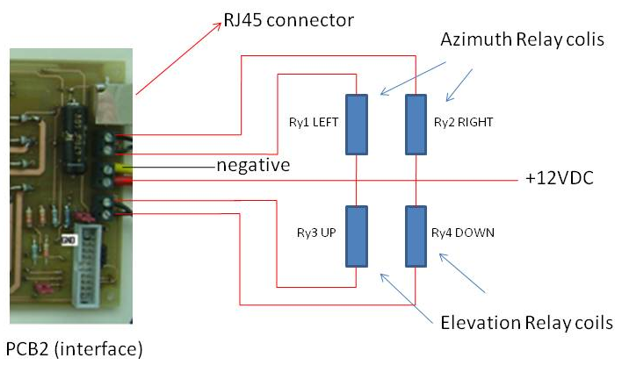
This is a simplified diagram, you MUST add an additional set of contacts per Relay to disable the coil of the opposite movement when one coil is activated, otherwise you become in short circuit and you can damage the PCB2. This means you need to avoid a situation where you press both movements at the same time, for example AZIMUT LEFT and RIGHT, any combination involving AZIMUTH and ELEVATION have no problem BUT per AXIS you can execute only one movement at the same time, your protection system need to disable the coil of Ry2 when the RY1 is activated and vice versa, in the same way you need to disable the coil of Ry4 when Ry3 is activated and vice versa, people can use Logic circuits with CMOS gates or simple passing the coil 12 VDC rail thru a set of contacts in the opposite relay with the idea when one relay is activated the additional set of contacts will "open" the 12VDC rail in the other relay stopping any kind of possible simultaneously activation, this protection system is a MUST.
CALIBRATING THE REAL TIME CLOCK
The controller board host the real time clock were the Date/Time and geographical coordinates are saved. The Real time clock has a 22pF trimmer to correct the difference in time. By default the trimmer is setup in a half capacity. You must run at least 48 hours your controller an register how many seconds you are off, the change the capacity approximately 1/8 of turn and wait another 48 hours, you will find the right position were the maximum deviation will be 1 second per year, enough stable for our application. Some body ask me why not update the time via internet? And the answer is very simple: we want a controller with no one single dependency of external connections like internet, calibrate the real time clock is time consuming but after is done is done, the onboard battery keep all the parameters inside the Real Time clock chip, the life time is minimum 5 years before replacement is needed

INTRODUCE YOUR QTH (OR DX) GEOGRAPHICAL POSITION (LON/LAT):
Follow the instructions of Hannes to change parameters in the controller, at the beginning is a little complicate to understand but after few minutes you will understand how to change the parameters easy, the controller are delivery with my QTH coordinates 7.6E / 46.9N.
The notation is degrees with decimal degrees, be carefully to calculate properly your location, for example for me LON is 7.5766E but I introduce 7.6E, 7.5E will be not correct because 7.57 is more close to 7.6 than to 7.5.

