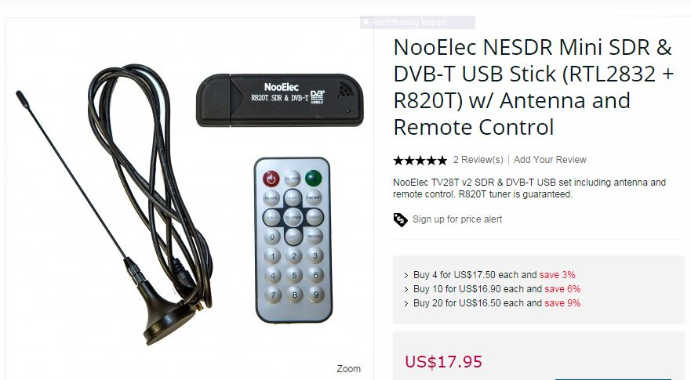

This custom NooElec SDR is a modified DVB-T USB dongle tuned for SDR usage, including upgraded crystal, capacitors and inductors compared to generic devices. Full compatibility with a large array of software packages, such as MATLAB®, HDSDR, SDR Touch, SDR#, Planeplotter--too many to list.

MathWorks® and NooElec™ have coordinated to bring MATLAB® support for our SDR receivers. The RTL-SDR radio support package enables you to design wireless receivers using real world signals. Using Communications System Toolbox™ in conjunction with an RTL-SDR USB radio, you can design and prototype systems that process real-time wireless signals in MATLAB® and Simulink®

Wireless engineers, students, and hobbyists can learn to receive and decode real-world radio signals using this low cost RTL-SDR hardware connected to your computer.

The perfect device for learning software defined radio, on the cheap. Amateur radio, ADS-B, police & fire scanning, trunking, satellite images--you name it, this little guy can probably do it. Outperforms many devices 10x its cost!

These units are based on the R820 (R820T) tuner IC made by Rafael Micro. As such, they have a frequency capability of approximately 25MHz-1750MHz, though this can vary somewhat from unit to unit. There is also an RTL2832 (RTL2832U) IC on board of course, which acts as the demodulator and USB interface.

The connector type on the antenna and USB board is MCX--male MCX on the antenna, female MCX on the SDR. There are plenty of adapter and adapter cables available in our store if you want to connect your favourite antenna!

Want HF too? You can modify the dongle for HF reception, but it's really a bad way of doing things. If you would like to do this please contact us and we'll be happy to walk you through it. However, we strongly recommend you take a look at the up converter available in the link above which will let you listen all the way down to 100kHz or lower with impeccable sensitivity

Revieuws:

It works as described. I am listening to CB channel 6 27.085 MHz AM and receives well. Shipped on time as described. I added a long wire for low band reception on CB. Just unscrew the antenna from the base and attach a wire to the brass fitting and screw the antenna back to its base to keep connection. Good temporary antenna. FM broadcast had noise over strong signals in HDSDR and in SDR# it would crash in WFM mode. That is not the fault of Nooelec it is a software issue. Because I think it works well I gave it 5/5 rating. Thanks Nooelec this is a great toy indeed!!!(Posted on 3/6/2014)

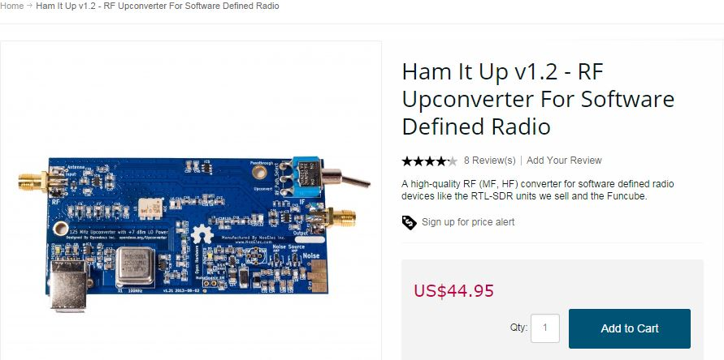

Now shipping v1.2! Major changes include:

Sturdier USB-B connector supplants the micro-B connector used on v1.0
Filters completely redesigned for 125MHz operation to move the LO away from the broadcast FM band. Of course, a high-quality 125MHz oscillator is included
USB shield separated from USB ground
Other components in the RF path revised for improved SNR

Ham/amateur radio enthusiasts rejoice! Our MF/HF converter for software defined radio is finally available for sale. Don't let our price fool you, though. We believe this is the best SDR up converter currently available.

Female SMA for both input and output for a wide array of connectivity options
In-line SMA connectors. Much easier to connect and manipulate than side-by-side SMA connectors
Antenna protection on RF input; in-circuit in both enable and pass-through mode
Solely high-quality components used in the RF signal path
Powered by common USB-B USB for a multitude of power options
RF-suitable power supply regulation (TPS79333)
PTC fuse on USB power input to protect your up converter from short circuits
Up converter enable/pass-through toggle switch--less fiddling with small, delicate cables and connectors
Socketed oscillator for a simple upgrade path
Stable 25ppm oscillator included
LO disabled in pass-through mode
A maximum input level of +1dBm with LO at +7dBm
High-quality 2-layer PCB with ENIG finish
Designed to fit standard off-the-shelf Hammond enclosures
2 mounting holes for standard PC screws
Designed and manufactured in conjunction with Opendous Inc., an excellent open-hardware design company
Full project documentation--schematics, PCB design files, assembly information--is freely available. DIY'ers rejoice! We will have a limited number of bare PCBs available for those who want to 'roll their own'
A portion of the proceeds from your purchase will be used to support this and other open-hardware, open-source initiatives.

BONUS! We had space left on the PCB, so rather than waste it we have added a noise source circuit at no additional cost! We have even populated most of the components for you. We have kits of the components required to complete this bonus noise source circuit available for a small additional fee. Details of the noise source circuit are available with the project documentation, and a detailed image of the circuit can be seen in the pictures above.
Operation:
Before operating your unit for the first time, and every time you run with a new SDR, we recommend running the tuning procedure located here. It is not a mandatory procedure but may help fine-tune your, erm. tuning. Pop the included oscillator into its socket and you are ready to go!
Connect your antenna to the RF input
Connect your SDR to the IF output
Ensure your toggle switch is in the enable position
Plug your USB power source into the USB-B USB jack
Fire up your favourite SDR software. Tune to 125MHz + (+/- the tuning offset from the tuning procedure) + your desired frequency and enjoy!

Installatie video

http://www.youtube.com/watch?v=Rnof4xGkdAo#t=419

************************************************************************************I purchased mine month and a half ago. It transforms your RTL2832U R820T SDR DVB-T DAB dongle into a general coverage receiver from DC to 1.766 GHz all modes. Weather facsimile, ADS-B, Military, Weather reports over HF, Amateur radio, SSTV, RTTY, FM Stereo, AM broadcast MW and SW, Why spend $500 or more for the same range of frequency? Here is my video example with the Ham It Up converter in action.
https://www.youtube.com/watch?v=aIuGZr0oYi8 (Posted on 9/11/2014)

************************************************************************************
I bought this along time ago, and I am working on getting another one for my tablet and new desktop computer for the bedroom listening post. It covers the long wave band through the short wave bands with no problems. I like to use it for DXing signals far away using a long wire antenna with a 600 ohm to 50 ohm balun. I also use it with my Kaito KA35 antenna for AM and Longwave DXing. The thing I do recommend is a RF preamplifier for weaker signal reception and I hope Noo Elec starts selling one.(Posted on 5/9/2014)

Bought mine of their Amazon store and love it. It came quick (got stuck at the border but that had nothing to do with NooElec) and is working like a charm. I love that they updated it to a 125Mhz rock, but I don't like that they are using the large USB connector. Others complained about the micro so they changed it to this one, but I much prefer the small one as I have more of that cable time around.
Also, I would like to know if this thing is capable of VLF reception?
I posted some YouTube vids on my website at
http://ve7wnk.ca/?p=387 http://ve7wnk.ca/?p=376
Cheers, VE7WNK
************************************************************************************To date the up converter is dead. It appears the 125 MHz oscillator is the culprit as tuning the RTL stick to 125 MHz (using SDR#) shows no oscillator spur as I would expect. The RTL stick works great...I'll gladly revise this review once NooElec replaces the up converter...(Posted on 1/18/2014)

An excellent up converter with hardly any noise injected into the signal. Works as intended and within 5 minutes had a working short wave receiver.
The up-converter looses 10db but this is to be expected, but I didn't notice as there is so much to pick up on the HF bands.
I would strongly recommend placing the up-converter and card into a box and with a bit of soldering run the lot from one usb port.
As for delivery, being in the UK the converter took almost 3 weeks to arrive. Not a problem with NooElect but the postal service. The up-converter had a nice holiday in Miami for several days. Maybe overseas purchasers should be made aware that it can take up to 4 weeks to arrive. Not a problem but would have been nice to now.
(Posted on 11/25/2013)

This item is a great purchase for someone getting into SDR for the first time. I received mine on Jan. 24 and have just finished initially testing it with their SDR Starter Bundle which includes a DVB-T Dongle.

Its performance has been excellent. The hardware combination of the up converter, the dongle and the free download software, SDR# (not included with any purchase) work well together.

It was easy for me to get it all going with no hassle other than my own ignorance. The up converter certainly works as advertised, and its construction quality is very impressive for any amount of money. I consider this to be a wonderful buy.

I, therefore, give both NooElec service and the up-converter a "5-Star" rating due to its performance, ease of use, and quality construction.
Thanks Again NooElec for a quality product and excellent service.

Video ingebruikname en demo

http://www.youtube.com/watch?v=Rnof4xGkdAo

http://www.youtube.com/watch?v=njw5rM2MSi8

