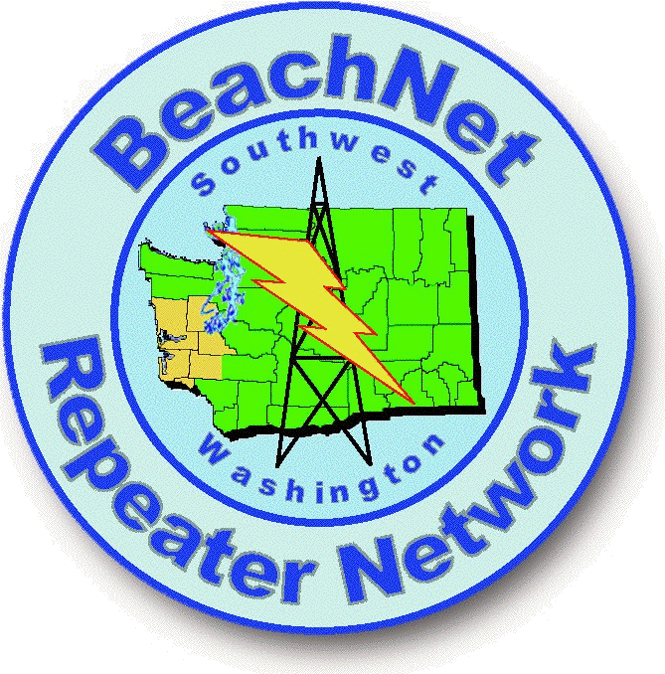

BeachNet System

User Reference Manual
http://www.qsl.net/nm7r/index.htm

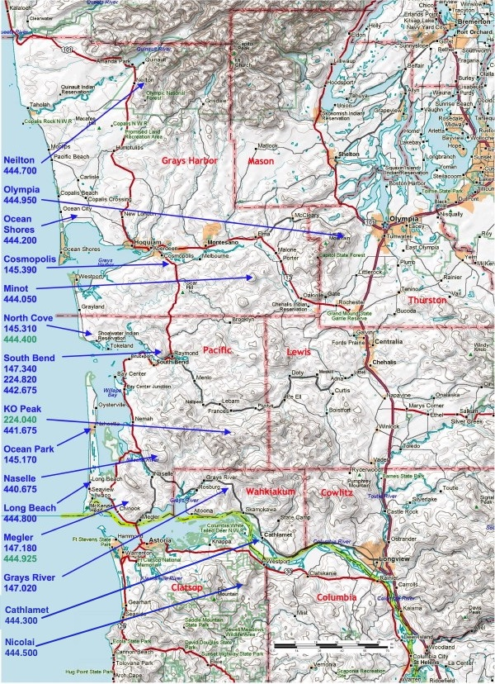The BeachNet system is located in Pacific, Grays Harbor, Wahkiakum and Thurston Counties, in the southwest corner of WA, and Clatsop County, OR. As of July 2017, the system consists of twenty repeaters and six remote receivers at eighteen sites. The main network comprises six 2-meter, one 1.25-meter and ten 70-centimeter repeaters continuously linked together (frequencies in Blue on the map). A transmission received on any of these repeaters is heard over the entire system. Most of our repeaters use a standard offset and CTCSS (PL) tone of either 118.8 or 82.5 Hz. The system roughly covers a rectangle with corners near Kalaloch, WA (NW), Seaside, OR (SW), Longview, WA, (SE), and Tacoma, WA, (NE).
Although 2-meter, 125-cm and 70-cm transceivers are necessary to access the entire network, substantial utility is available on each band individually.

Loading the entire frequency list into adjacent radio memories makes it a simple matter of stepping “up” or “down” to remain connected to the network via the best “port”, as the user moves around the area. All communities and major highways within this area enjoy ready access on VHF, UHF or both with a normal mobile “Ham” rig. Handheld access is available in many pop-ulated areas. The system was engineered assuming a “normal” user equiped with a 40-Watt VHF, 30-Watt UHF or 25-Watt 1.25-meter mobile radio using a 3dB-gain vertical whip antenna 4.5-feet above the ground.

The user is cautioned, when loading BeachNet repeaters into a radio memory, to “Encode” the CTCSS tone, but generally do not “Decode” the tone. Only a few of our repeater transmit the CTCSS tone, and loading “Decode” will cause your radio to ignore these repeaters. Only KO Peak, South Bend, and Naselle reliably transmit tone all the time. Other machines either only transmit tone sometimes (for signaling) or not at all.

The North Cove 444.400 and KO Peak 224.040 repeaters can be linked into the network, but normally operate as stand-alone machines. We also host a dedicated IRLP node repeater in the Long Beach/Astoria area on 444.925, which is also not linked to the network. These are highlighted in green on th emap to remind the user they are not normally linked in.

This User Manual is intended only as a quick reference. There is a wealth of other information available on the website for those who wish to learn more.

http://www.qsl.net/nm7r

Please Use and enjoy the BeachNet system. That’s why we built it!

BeachNet Operational Policies

Any appropriately licensed Amateur Radio Operator, not otherwise excluded, is welcome on the BeachNet Repeater System, provided they abide by the following...

1. Observe and obey all FCC Regulations with respect to the Amateur Radio Service, as contained in Title 47, Part 97, of the Code of Federal Regulations (CFR). Lead by example.

2. Respect all Amateurs using the BeachNet Repeater System, and strive to encourage the participation and enjoyment of others. Leave a pause between every transmission to allow another user to join in. Extend the hand of friendship. We are all part of the Amateur Radio Fraternity. This two-way radio hobby is a lot more fun if there are other Hams to talk to.

3. We live in an area dominated by a tourist economy. Make our guests feel welcome. Be the friendly, helpful Ham they talk about when they return home.

4. Help make Amateur Radio in general, and the BeachNet Repeater System in particular, a pleasant place to hang out. You do not have to "like" every other Ham, but be civil and polite, even friendly. You may have nothing in common with the other person except a love of radio, but that is enough. Keep it light. Keep it fun. If you can't say something nice, don't say anything at all.

5. Emergency communication has absolute top priority at all times. The best way to be ready in an emergency is to become familiar with the resources at hand. BeachNet is one of those resources. The more familiar we all are with its strengths and limitations, the more value our community can derive from the Amateur Radio Service when it is needed most.

6. Jamming and deliberate interference are to be ignored. Do not talk to a jammer on the air. Do not talk about a jammer on the air. That is exactly the recognition they want. It is possible talking to a "suspect" could be considered "entrapment", making prosecution more difficult. The FCC has successfully prosecuted jammers in the past, with license revocation, fines and even jail time. If you hear anyone abusing the system, and have specific information as to time, place or identity, please contact a control operator by telephone or email. If presented with such an issue, the owners, licensees and control operators will handle the situation.

7. Control Operators will be designated at the sole discretion of the system owners/licensees. Only Control Operators are authorized to send Dual-Tone-Multi-Function (DTMF) "Touch Tone"® signals over the system to command the repeaters, remote bases, auxiliary receivers and other components that comprise the BeachNet system. Except as explicitly authorized by a Control Operator, Owner, or Licensee, no other user shall send DTMF control tones over the BeachNet System. Any attempt to "Hack" a repeater system by an unauthorized person is considered a very serious offense within the Amateur Community, equivalent to attempting to pick the lock in order to break into the home station of another Amateur.

8. The BeachNet Owners, Licensees and Control Operators retain the authority, expressed in 97.205(e), to exclude any individual from using the BeachNet System.

BeachNet Linked Repeaters, North to South by County:

Thurston County
Olympia 444.950 +5Mhz 118.8Hz Page 5

Grays Harbor County
Neilton (Quinault) 444.700 +5Mhz 118.8Hz Page 6
Ocean Shores 444.200 +5Mhz 118.8Hz Page 7
Cosmopolis 145.390 -600khz 118.8Hz Page 8
Minot 444.050 +5Mhz 118.8Hz Page 9

Pacific County
North Cove (Not Linked) 444.400 +5Mhz 118.8Hz Page10
North Cove 145.310 -600khz 118.8Hz Page 10
North Cove (Naselle Receiver) 145.310 -600khz 114.8Hz Page 10
South Bend/Raymond 442.675 +5Mhz 118.8Hz Page 11
South Bend/Raymond 147.340 +600khz 82.5Hz Page 11
South Bend/Raymond 224.820 -1.6Mhz 82.5Hz Page 12
Ocean Park 145.170 -600khz 118.8Hz Page 13
KO Peak 441.675 +5Mhz 118.8Hz Page 14
KO Peak (Not Linked) 224.040 -1.6Mhz 118.8Hz Page 14
Naselle 440.675 +5Mhz 118.8Hz Page 15
Long Beach 444.800 +5Mhz 118.8Hz Page 16
Megler (Chinook) 147.180 +600khz 82.5Hz Page 17
Megler Remote Receivers 147.180 +600khz 82.5Hz Page 18
Megler (Chinook) (Not Linked) 444.925 +5MHz 82.5Hz Page 22

Wahkiakum County
Grays River (KM Hill) 147.020 +600khz 118.8Hz Page 19
Cathlamet 444.300 +5MHz 118.8Hz Page 20

Clatsop County
Nicolai Mountain 444.500 +5Mhz 118.8Hz Page 21
Olympia

46-58-22N 123-08-14W 2730 FT

Location: The Olympia repeater is located on Capitol Peak, south of the city of Olympia and west of the Olympia airport.

Frequency: 444.950
Transmit Offset: +5 MHz
CTCSS: 118.8

Coverage: The repeater covers eastern Grays Harbor County, most of Mason and Thurston counties and parts of Lewis County, as well as much of southern Puget Sound to well north of Tacoma.

Hardware: The repeater consists of a GE Mastr-II 110-watt continuous duty base station chassis, Phelps-Dodge 6-cavity duplexer and Diamond X-510 dual-band antenna (inside the fiberglass radome from a commercial “Stationmaster” antenna), and fed with 120-feet of LDF5-50 7/8” hardline. The link uses a modified GE Rangr mobile radio running 10 watts through 100-feet of LDF4-50 half-inch hardline to a 10.2 dB yagi pointed at KO Peak. The packet bridge (see below) uses two GE Mastr-II 40-watt mobile radios and a dual-port TNC/controller. All four transmitters are fitted with 2-section isolators and bandpass cavities. The main antenna is shared by the repeater and both packet radios using a 4-cavity VHF combiner and a VHF/UHF diplexer.

Packet Radio: The station incorporates a dual port packet bridge between the 145.63 coastal “District Three EOC Net” frequency, and the 145.01 Puget Sound net frequency. To use the bridge to pass packet signals in either direction, digipeat “via n7ujk-10”. For digipeating on 145.63, use “via n7ujk-8”, and to digipeat on 145.01 use “via n7ujk-9”. The nearly 3000-foot elevation makes this a strategic relay point for this popular digital mode.

Doyle Wenzel (N7UJK) of Aberdeen is the owner, licensee, and site custodian. He has complete control operator authority concerning this site. He is an authorized BeachNet control operator, permitted to use all system features. Doyle is the local contact in Grays Harbor for the BeachNet system.
Neilton

47-23-22.7N 123-52-01.2W 2100FT

Location: The Neilton site is located in northern Grays Harbor County, at 2100 feet, overlooking the town of Neilton and Lake Quinault.

Frequency: 444.700
Transmit Offset: +5 MHz
CTCSS: 118.8

Coverage: The repeater covers highway 101 from north of Kalaloch, south to Hoquiam, as well as Westport, and much of western Grays Harbor County.

Hardware: The repeater is a GE Mastr-II 110-watt continuous duty base station with a Sinclair BpBr duplexer feeding a gain vertical mounted at the building roof level. The linking path to KO Peak is 66 miles, unobstructed line-of-sight. The link radio is a GE Rangr running 10 watts to a Cushcraft 10.5 dB gain yagi about 65 feet above ground level.

Packet Radio: The NEILTN Packet node operates on 145.630, covering western Grays Harbor County as part of the District Three EOC Packet Network. The repeater and packet station share a dual-band antenna.

Doyle Wenzel (N7UJK) of Aberdeen is the site custodian, and the only one with physical access. He has complete control operator authority concerning this site. He is an authorized BeachNet control operator, permitted to use all system features. Doyle is the local contact in Grays Harbor for the BeachNet system.

Ocean Shores

47-03-37.3N 124-06-52.6W 240FT

Location: The Ocean Shores repeater is located about five miles north of Ocean Shores, and a few miles inland, at the county's Saddle Hill, radio site. This site is used for 911-Emergency communications, and has extensive security and surveillance features, including 24/7 video monitoring and alarms. This Amateur UHF repeater is included to provide an additional layer of back-up communications, when all else fails. In normal day-to-day operations, this machine provides convenient routine communications from this remote corner of the county. It is interesting to note that the county spontaneously offered space for this repeater, recognizing the value it provides the community.

Frequency: 444.200
Transmit Offset: +5MHz
CTCSS: 118.8Hz

Coverage: Although the area is already served by the 145.390, Cosmopolis (20 miles east), 145.310, North Cove (17 miles south), and 444.700, Neilton (30 miles north) repeaters, this area represents the fringe of their coverage. The Ocean Shores UHF repeater provides high quality local access to the BeachNet System.

The coverage is good over the entire south shore of the harbor, including Westport. The north shore coverage is very good as far as the outskirts of Hoquiam, where it becomes spotty due to terrain shadowing. Along the ocean beach, there is good coverage, as far south as the Pacific County line, and north well past Copalis Beach. The town of Ocean Shores is well served. The coverage extends more than 20 miles seaward.

Hardware: The repeater consists of a GE Mastr-II 40-watt continuous duty base station (running 30-watts) with a CAT 200B controller mounted in a site-supplied open rack and using a generator backed-up battery power supply. The duplexer is a 4-cavity Sinclair BpBr feeding a commercial multi-bay folded-dipole array antenna through 80 feet of LDF5-50 7/8-inch hardline. The remote base uses a GE Rangr 16-channel UHF transceiver running a few watts, with a directional antenna to provide flexible linking.

Doyle Wenzel (N7UJK) of Aberdeen is the site custodian, and the only one with physical access. He has complete control operator authority concerning this site. He is an authorized BeachNet control operator, permitted to use all system features. Doyle is the local contact in Grays Harbor for the BeachNet system.
Cosmopolis

46-56-00.6N 123-44-02.5W 550FT

Location: The “Cosi” repeater is located on Cosmopolis Hill at about 550 feet elevation. This is just a mile or two northwest of the junction of Highway 101 and State Route 107 (the “Montesano cutoff”), overlooking Cosmopolis and Aberdeen.

Frequency: 145.390
Transmit Offset: -600 kHz
CTCSS: 118.8

Coverage: The coverage area includes Ocean Shores, Hoquiam, Aberdeen, Montesano and the Chehalis River Valley, east to Elma. The coverage also extends south down 101 for several miles to the Pacific County line, and north into NW Grays Harbor County.

The purpose of this repeater goes beyond just augmenting our system coverage along highway 101, although it is in a very strategic location for that mission. The installation primarily offers 2-meter coverage to most of Grays Harbor. “Cosi” has good tactical coverage within Grays Harbor County even as a stand-alone repeater, reaching the major cities of this coastal county quite well. For those without UHF capability it provides a link between Grays Harbor County and the rest of BeachNet, as well as Pacific County and Camp Murray, the Washington State EOC.

Hardware: The repeater comprises a GE Mastr-II 100-watt station chassis running about 60 watts, a Wacom BpBr duplexer and a GE Rangr 10-watt link radio. The controller is mounted in a metal project box with basic manual controls and there is a GE Mastr-II power supply. The station is secured in a floor-to-ceiling open rack inside the building. The main antenna is a Hustler G6-270 6-dB gain dual-band vertical mounted well up the tower, and shared by the repeater and link using a diplexer, fed with LDF5-50 7/8” hardline.

The system link can optionally be shifted to (one of) the Minot, Neilton, Aberdeen or Olympia sites, providing intra-County VHF/UHF interoperability for emergency relief communications. In an emergency situation, the Grays Harbor repeaters would be disconnected from BeachNet, and linked together to form a county-wide net.

Doyle Wenzel (N7UJK) of Aberdeen is the site custodian, and the only one with physical access. He has complete control operator authority concerning this site. He is an authorized BeachNet control operator, permitted to use all system features. Doyle is the local contact in Grays Harbor for the BeachNet system.

Minot

46-53-29N 123-25-01W 1730 FT

Location: The Minot site is located a few miles south of Elma, and west of Centralia at a height of 1730 feet. This is southeast of the general vicinity of the two large cooling towers built near Elma for the WPPSS project years ago.

Frequency: 444.050
Transmit Offset: +5 MHz
CTCSS: 118.8

Coverage: The repeater covers eastern Grays Harbor County from Hoquiam to McCleary on Highway 8. Coverage extends along Hwy 12 to Chehalis. Pacific County also has coverage from Raymond north and east on Hwy 6.

Hardware: The repeater consists of a GE MASTR-II 110-watt continuous-duty base station chassis, with a Phelps-Dodge 6-cavity duplexer. A GE Mastr-II mobile radio running 10 watts to a 10.5 dB yagi pointed at KO Peak makes the network link connection. The repeater antenna is a dual band vertical (shared with the MINOT packet node), about 30 feet above ground level, spaced off the side of the tower. The packet radio is also a Mastr-II mobile. All three transmitters are fitted with dual-section isolators and bandpass cavities.

Packet Radio: The MINOT Packet node operates on 145.630, covering central and eastern Grays Harbor County, as part of the coastal District Three EOC Packet Network.

Doyle Wenzel (N7UJK) of Aberdeen is the site custodian, and the only one with physical access. He has complete control operator authority concerning this site. He is an authorized BeachNet control operator, permitted to use all system features. Doyle is the local contact in Grays Harbor for the BeachNet system.
North Cove

46-43-52.6N 124-02-42.9W 400FT

Location: The North Cove site is on the ocean bluff, above “Wash-away Beach”, just west of Tokeland, WA, at a ground elevation of 400 feet, accessed via Panoramic Road.

Frequency: 145.310 444.400
Transmit Offset: -600 kHz +5 MHz
CTCSS: 118.8 118.8

Coverage: The North Cove VHF repeater provides excellent mobile coverage from Bear River at the south end of Willapa Bay, along Highway 101 on the bay shore, to South Bend. It also covers the Tokeland, Grayland and Westport areas along the coast between Willapa Bay and Grays Harbor. It “looks” right down the ocean side of the Long Beach Peninsula, providing coverage on the beach north of the Cranberry approach.

Hardware: The VHF rack-mount GE Mastr-II station (repeater) chassis incorporates the newer-style PLL exciter, and a CAT-200B controller. A GE Rangr UHF transceiver is used for the link to the rest of BeachNet, with an 11-element yagi low on the tower. The duplexer is a 4-cavity Sinclair Hybrid-Ring type, hung from the ceiling to conserve space in this small building.

The UHF repeater is a GE Mastr-II station chassis with an Arcom RC-210 controller and a 10-watt Ranger link radio with its own yagi antenna. The coverage is similar to that of the VHF machine, with which it shares the dual-band station antenna. The UHF machine normally operates as a local stand-alone, although it can be linked into the network, or a number of other repeaters, when desired. The UHF repeater is often linked with the UHF IRLP repeater on Megler to extend this exciting mode to north county.

The shared, dual-band Comet X-510 antenna (inside a Stationmaster shell) is 100 feet up the 140-foot tower, fed with 120-feet of LDF5-50 7/8” hardline, through a VHF/UHF diplexer. Other than the antenna system, the two repeaters operate independently, with the only audio connection between them via their links.

Remote Receiver: To augment coverage deficiencies in the area around Nemah and the Naselle River, a remote receiver for the VHF repeater is located at the Naselle site at 2000-feet. Use the 145.310 frequency and standard –600 kHz offset, but change your PL tone to 114.8 Hz to access the Naselle receiver.

Frank Wolfe (NM7R) of Nahcotta is the site custodian, and the only one with physical access. He has complete control operator authority concerning all of BeachNet, permitted to use all features. Frank is the official contact for the BeachNet system.
South Bend

46-41-44.1N 123-46-24.1W 1320FT

Location: This site is just across the Willapa River, on Holy Cross Mountain, northwest of South Bend, WA and southwest of Raymond, WA.

Frequency: 147.340 224.820 442.675
Transmit Offset: +600 kHz -1.6 MHz +5 MHz
CTCSS: 82.5Hz 82.5Hz 118.8Hz

The three Holy Cross repeaters are normally linked together and to the rest of the BeachNet system. Any of them can be separated, allowing one, two or all three to operate stand-alone, or linked among themselves in various configurations.

Coverage: The coverage of all three repeaters is excellent in the South Bend-Raymond-Willapa Valley area, as well as the north end of the Long Beach Peninsula. Highway 101 has good coverage, at least as far south as Bay Center, and north to the Pacific/Grays Harbor County line.

Hardware: The 147.340 repeater is a GE Mastr-II with a 40-watt power amplifier, running 20-watts out, with an isolator, and band-pass cavity to a Sinclair 4-can BpBr duplexer, feeding the Hustler G6-270 antenna, that it shares with the UHF repeater, through a diplexer and 100-feet of LMR-600. The receiver has a DCI band-pass filter and a PAR notch filter ahead of the UHS preamplifier. The 2-meter repeater doesn’t transmit PL.

The 442.675 repeater has a 100-watt PA, running 75-watts out to a Wacom 4-cavity BpBr duplexer. The UHF repeater transmits PL (118.8 Hz). The 2-meter and 70-cm repeaters share a power supply and Link-Comm controller, which also manages the network link and control receiver. The link radio is a 2-channel Mastr-II mobile feeding a 6-element yagi for the trip to KO Peak. The control receiver is a Mastr-II auxiliary receiver drawer with a similar yagi pointed at the county EOCs.

Packet Radio: The “HOLYX” Packet Nodes (145.010 & 145.630) are co-located. The coastal District Three EOC Packet Net uses 145.630, and the local Pacific County net uses 145.010, provide VHF packet coverage to most areas within Pacific County. Ask on the air for information, or visit the website at: http://www.qsl.net/nm7r/packet.htm

Frank Wolfe (NM7R) of Nahcotta is the site custodian, and the only one with physical access. He has complete control operator authority concerning all of BeachNet, permitted to use all features. Frank is the official contact for the BeachNet system.
South Bend

46-41-44.1N 123-46-24.1W 1320FT

Location: This site is just across the Willapa River, on Holy Cross Mountain, northwest of South Bend, WA and southwest of Raymond, WA.

Frequency: 147.340 224.820 442.675
Transmit Offset: +600 kHz -1.6 MHz +5 MHz
CTCSS: 82.5Hz 82.5Hz 118.8Hz

The Holy Cross 224.82 repeater is normally linked to the rest of the BeachNet system, which includes the 147.340 and 442.675 repeaters, through the main BeachNet hub on KO Peak. It could alternatively link directly to the 442.675 repeater, as well as a number of other BeachNet repeaters.

Coverage: The coverage of all three repeaters is excellent in the South Bend-Raymond-Willapa Valley area, as well as the north end of the Long Beach Peninsula. Highway 101 has good coverage, at least as far south as Bay Center, and north to the Pacific/Grays Harbor County line.

Hardware: The 224.820 repeater is a modified 150-MHz PLL High-Band Mastr-II, with a custom PA running 25-watts to a 4-section Sinclair BpBr duplexer. The 224.820 repeater transmits PL (82.5 Hz). The UHF link (30-watts) and 6-meter remote base (80-watts) radios are both GE Rangr mobiles. A custom wiring interface box connects everything to an Arcom RC-210 controller. The antenna is a CX-333 tri-band vertical with the 220 repeater, its UHF link and the separate 2-meter (145.010) packet (25-watts) radios all sharing through a triplexer. The 6-meter radio feeds a Ringo on the roof of the building.

Packet Radio: The “HOLYX” Packet Nodes (145.010 & 145.630) are co-located. The coastal District Three EOC Packet Net uses 145.630, and the local Pacific County net uses 145.010, provide VHF packet coverage to most areas within Pacific County. Ask on the air for information, or visit the website at: http://www.qsl.net/nm7r/packet.htm

Frank Wolfe (NM7R) of Nahcotta is the site custodian, and the only one with physical access. He has complete control operator authority concerning all of BeachNet, permitted to use all features. Frank is the official contact for the BeachNet system.

Ocean Park

46-31-00N 124-01-40W 80-FT

Location: The Ocean Park repeater is located in one corner of the garage at a rental house owned by NM7R, roughly one quarter mile north of Joe Johns Road, and east of Sandridge Road. Please do not bother the residents at this location. They have neither interest in, nor familiarity with, Amateur radio or the repeater. Being nice enough to let me invade a corner of their garage is plenty for them to do in support my hobby.

Frequency: 145.170
Transmit Offset: -600 kHz
CTCSS: 118.8

Coverage: This machine fills shadowed areas in and around the town of Ocean Park, WA, providing hand held coverage over this popular residential and resort area. Although there are several repeaters on the surrounding hills, making mobile use easy, hand held coverage had been challenging until this machine went in. With a low level antenna 40-feet above the ground, at a location where the land elevation is a bit over 40-feet, and running low power, this is a local-use machine. It nonetheless provides a vital emergency communications function in this major population center, with hand-held coverage out to 3-4 miles, and mobile coverage out to 10-miles or more. The coverage also extends to Highway 101 around much of Willapa Bay, where it would otherwise be shadowed.

Hardware: The repeater is a GE Mastr-II base station with a 110-watt continuous duty Power Amplifier (running 40-watts out), mounted in a 30-inch GE cabinet, with the Link Comm controller. The duplexer is a 4-cavity, 8-inch Wacom BpBr. The link radio is a 16-channel GE Rangr, running 25 watts and sharing the Hustler G6-270 dual band vertical with the repeater. The antenna is mounted to a 20-foot piece of 2-1/2-inch heavy aluminum tubing, clamped to a 28-foot Rohn-25 tower, ground mounted and braced to the garage eave, and is fed with 50-feet of LDF4-50 Andrew 1/2-inch hardline, mounted in cushions for most of the exposed portion of its run.

Frank Wolfe (NM7R) of Nahcotta is the site custodian, and the only one with physical access. He has complete control operator authority concerning all of BeachNet, permitted to use all features. Frank is the official contact for the BeachNet system.

KO Peak

46-27-40.6N 123-33-02.0W 2995FT

Location: KO Peak is in eastern Pacific County, about 6 miles due south of the town of Lebam. The site elevation is about 3000 feet, with an 80-foot tower (on a 15 foot building).

Frequency: 441.675 224.040
Transmit Offset: +5 MHz -1.6 MHz
CTCSS: 118.8 118.8

Coverage: The repeater is accessible from Astoria and Seaside on the south, most of the Columbia River valley as far up river as Longview, parts of Interstate 5 north of Toledo (all the way north to Chehalis), and parts of Grays Harbor County.

Hardware: The KO Peak repeater is a GE Mastr-II with a 100-watt continuous duty transmitter, running 75-watts out through a circulator, a low-pass filter, a Sinclair 6-section band-pass/notch duplexer and 120-feet of LDF5-50 7/8-inch hardline to a high gain Sinclair repeater antenna at the top of the tower. The KO Peak station includes a remote base, a collection of transceivers on the mountain, which can be remotely controlled over any port on the network. Virtually any frequency in the 29.5-29.7, 50-54, 144-148, 222-225, and 440-450 MHz FM bands can be dialed up, either in receive-only or two-way mode. This allows the network to connect either to a simplex station or another repeater for further communications range enhancement. This feature provides quite a bit of flexibility, since the transceiver antenna elevation is 3050 feet, looking down on both Portland and Seattle. Control of the remote base is reserved for the control operators, but any user may join the QSO.

The ACC RC-850 repeater controller incorporates a scheduler feature that allows everything about the state of the repeater to be changed automatically. There are, for example, scheduled events in place to turn the remote base on in a linked state with the Astoria repeaters for the Pacific and Clatsop county ARES/RACES nets, on Monday and Thursday nights. See our website for a current list of events: www.qsl.net/nm7r

There is also a 1.25-meter repeater co-located on KO Peak. Normally operating as a stand-alone repeater, it can be linked into BeachNet when desired using the remote base. The antenna for the 224.040 station is a Sinclair “Stationmaster” type at the top of the tower. The radio is a modified Motorola mobile.

Frank Wolfe (NM7R) of Nahcotta is the site custodian, and the only one with physical access. He has complete control operator authority concerning all of BeachNet, permitted to use all features. Frank is the official contact for the BeachNet system.

Naselle

46-25-20N 123-47-54W 2050FT

Location: The site overlooks the Naselle, WA area from 2000 feet on “Radar Ridge”.

Frequency: 440.675
Transmit Offset: +5 MHz
CTCSS: 118.8

Coverage: The coverage area of this repeater includes the Naselle area and the bulk of central Pacific County, including much of the Long Beach Peninsula. To the south, it is accessible from Astoria to Seaside, east to Clatskanie, and north on Hwy 101 almost to South Bend, as well as along the north shore of Willapa Bay, including Tokeland.

Hardware: The repeater consists of a GE Mastr-II continuous-duty 110-watt station, running 75-watts through a 2-section isolator, 4-section Sinclair BpBr duplexer, 4-section DCI band-pass filter and 120-feet of LDF5-50 7/8-inch Heliax to the (11 dB UHF/9 dB VHF) x510 dual band antenna (inside a Stationmaster radome shell). This antenna is shared, through a diplexer, with the VHF receivers.

The station incorporates a remote base, with transceivers on the 144-148, 222-225 and 440-450 MHz bands. There is no dedicated link transceiver, however the normal idle condition, uses the UHF remote base to link two-way with the KO Peak linking hub. The three remote base transceivers feed a Comet 333 tri-band vertical at the 60-foot level.

There are two remote VHF receivers co-located at the Naselle site, one on the Megler and the other on the North Cove VHF frequency. These share the X510 dual-band vertical at the top of the tower, through a constant impedance splitter.

A Megler remote receiver package, part of the Receiver Voting System, (see page 17) receives a signal on the Megler input, and relays it to the Megler station on a discrete 430-MHz frequency using a Rangr radio and yagi antenna.

To complement the North Cove coverage, there is a manually selectable receiver on Naselle. Dial up 145.310; with a standard -600 kHz offset and a CTCSS (PL) tone of 114.8 (instead of the usual 118.8). This will let you use the North Cove repeater throughout the Naselle area, and north on Highway 101 at least to Bay Center with a clear signal, using a receiver at 2000-feet elevation instead of the repeater’s which is at 500-feet.

Frank Wolfe (NM7R) of Nahcotta is the site custodian, and the only one with physical access. He has complete control operator authority concerning all of BeachNet, permitted to use all features. Frank is the official contact for the BeachNet system.
Long Beach

46-21-07.8N 124-03-06.4W 120FT

Location: The Long Beach repeater is located in downtown, next to the County Shops, one block north and three blocks east of the stop light at the main intersection (the Bolstad traffic signal). The repeater antenna is at the 100-foot level on the 120-foot tower adjacent to the building. Since the highest elevation on the Peninsula, north of Seaview, is about 40 feet, this is a relatively good site.

Frequency: 444.800
Transmit Offset: +5 MHz
CTCSS: 118.8

Coverage: The repeater covers the south end of the Long Beach Peninsula, with a mobile station, including the towns of Long Beach and Seaview, and most of lwaco and Chinook, including most of the south half of the Peninsula. It provides saturation coverage in Long Beach, allowing handheld monitoring around town and inside buildings with a high degree of confidence that calls will not be missed.

Hardware: The repeater consists of a GE Mastr-II continuous duty 110-watt station, with an ACC RC-85 controller, Sinclair BpBr duplexer, and Astron power supply. The repeater incorporates a remote base, with transceivers on the 144-148, 222-225 and 440-450 MHz bands. The UHF remote base antenna is a yagi, about 60 feet up, pointed toward KO Peak, 25 miles away, over two mountain ridges higher than the path. The 2-meter and 1.25-meter remotes use a vertical antenna at the 100-foot level.

The Pacific County Alternate Emergency Operating Center (AEOC) is housed in the South County Administrative Facility, less than a mile east. In addition to the radio gear installed there for emergency operations (HF, 2-meter/70-cm voice and 2-meter packet), the nearby repeater and remote base adds flexibility. It is an easy matter to use the remote base to connect to any of a number of distant repeaters, allowing local handheld use of what might otherwise be a difficult-to-access station. In these situations, the rest of BeachNet is still available through the Megler and Naselle repeaters.

Frank Wolfe (NM7R) of Nahcotta is the site custodian, and the only one with physical access. He has complete control operator authority concerning all of BeachNet, permitted to use all features. Frank is the official contact for the BeachNet system.

Megler

46-17-10.5N 123-53-51.2W 1320FT

Location: The repeater is located at the Pacific County Megler Radio Site, at 1320 feet in the hills just northeast of Chinook, Washington. There are actually several sites called “Megler”. This is the northwestern-most (and highest) of those sites.

Frequency: 147.180
Transmit Offset: +600 kHz
CTCSS: 82.5 Hz

Coverage: The site has a clear view of the Long Beach Peninsula, providing good coverage, which extends south to Seaside, and east to Clatskanie. The site offers handheld coverage in Astoria, Chinook, Ilwaco, Seaview and Long Beach. There are four remote receivers to augment and enhance coverage, filling what might otherwise be “dead spots”. Details of the remote receivers follow on the next page.

Hardware: The Megler station uses a GE Mastr-II 110-watt continuous-duty station, running 60-watts. The repeater antenna is a Comet X-510, dual-band, (8-dB-VHF/11-dB-UHF) gain vertical, mounted on the roof of the building, shared with the 444.925 IRLP Node 3105 repeater. Details on that station are on the last page of this Guide. A Hustler UHF vertical receives the UHF signals from the four remote receivers (part of the VHF repeater system).

The network link to KO Peak uses a GE Rangr radio, running 10 watts to a 10 dB yagi for the 20.4-mile unobstructed line-of-sight path. The link can be optionally switched to connect through the Naselle site instead.

The 444.925 IRLP UHF repeater is co-located at the site, sharing antennas and rack space. It is not linked to BeachNet, and is listed separately at the back of this guide.

Frank Wolfe (NM7R) of Nahcotta is the site custodian, and the only one with physical access. He has complete control operator authority concerning all of BeachNet, permitted to use all features. Frank is the official contact for the BeachNet system.

Remote Receiver Voting System for Megler Repeater

To address coverage deficiencies, there are four remote receivers located in Warrenton OR, Seaside OR, Cape Disappointment WA, and Naselle WA. They are intended to improve repeater coverage in areas where your signal into the repeater would otherwise be unsatisfactory. There is no special action required on the part of the user to access these receivers. All the receivers are listening all the time, with their signals sent to the Megler site to be evaluated for best quality. At any given moment, the transmit signal is the best available from among the five receivers:

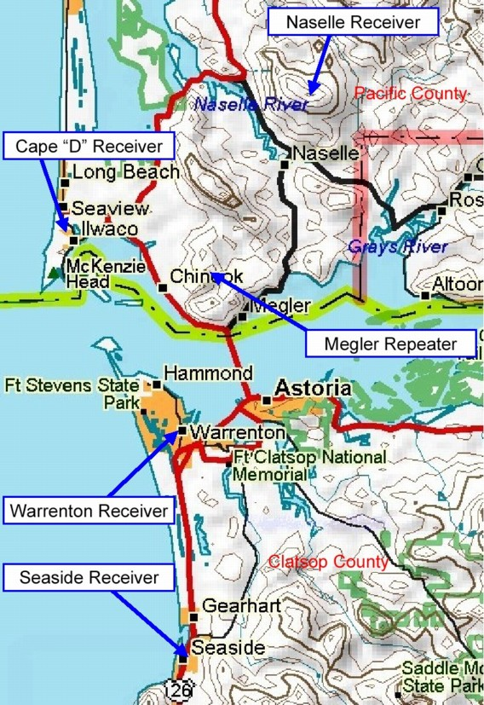
The Warrenton receiver provides VHF line-of-sight coverage of Highway 101 on the Washington side of the Columbia, on Hwy 401 east of the bridge, and south Astoria.

The Naselle receiver covers much of Pacific County.

The Cape D receiver overlooks the State Park, as well as Ilwaco and Seaview.

The Seaside, OR, receiver provides spot coverage for the SeaPac Ham Convention and the Hood-To-Coast Relay annual events.

The Megler repeater site receiver is also in the voting mix.

Each of the four remote receiver packages consists of a VHF GE Rangr mobile radio, and a UHF GE Rangr mobile radio. The antennas vary. the UHF links go to Megler. Each of the four remote receiver link channels is picked up at the Megler repeater site on a Hustler UHF vertical, split four ways with a home-brew constant-impedance divider, and routed to four GE Rangr UHF mobile radios used as link receivers. The recovered audio signals are routed to the LDG receiver voter along with the main repeater receiver and the best of the five is fed to the transmitter through a GE Audio Card.

If you can hear the Megler 147.180 repeater, you can probably work it, mobile.

Frank Wolfe (NM7R) of Nahcotta is the site custodian, and the only one with physical access. He has complete control operator authority concerning all of BeachNet, permitted to use all features. Frank is the official contact for the BeachNet system.
Grays River

46-20-40N 123-30-45W 800 FT

Location: The Grays River repeater is located on KM Hill, in Wahkiakum County, at a county-owned site, about half way between Naselle and Cathlamet, WA.

Frequency: 147.020
Transmit Offset: +600 kHz
CTCSS: 118.8

Coverage: This repeater fills in coverage along Oregon Highway 30 and Washington Highway 4 in the Lower Columbia River valley between Longview and Astoria. Coverage on Hwy 4 is from east of Cathlamet westward to Naselle. On the Oregon side of the Columbia, the coverage along Hwy 30 is reliable east of Bradley summit, to Clatskanie.

Hardware: The repeater consists of a GE Mastr-II 110-watt continuous duty base station chassis, using two antennas with notch and bandpass cavities for maximum sensitivity. The receive antenna is at the top of the tower, 90 feet above ground, at this 800-foot site, while the transmit antenna is 60 feet below it. The receive antenna is fed with Andrews LDF5-50, 7/8-inch hardline, while the lower antenna, used for the UHF link and the repeater transmitter, is fed with half-inch LDF4-50 hardline.

The UHF link is normally connected through KO Peak and the rest of BeachNet, but it can also be switched to link through the Nicolai site to provide intra-county communications in time of communications emergency.

There is emergency generator power at this site.

Packet Radio: The KMHILL Packet node operates on 145.630 from this site as part of the Western Washington coastal EOC Packet Net, with a gain antenna near the top of the tower.

Frank Wolfe (NM7R) of Nahcotta is the site custodian, and the only one with physical access. He has complete control operator authority concerning all of BeachNet, permitted to use all features. Frank is the official contact for the BeachNet system.

Cathlamet

46-07-16N 123-13-43W 187 FT

Location: The Cathlamet repeater is located in the city of Cathlamet, WA, the Wahkiakum County seat, at an elevated site with good coverage of the entire town and surrounding area. The purpose of this repeater is to serve the needs of the county EOC in times of emergency, and to provide a social focus for the local Hams. This repeater normally operates connected to the network to tie this small rural community into the greater region.

Frequency: 444.300
Transmit Offset: +5 MHz
CTCSS: 118.8

Coverage: This repeater covers the eastern portion of Wahkiakum County with substantial overlap into the coverage area of the Grays River repeater. The two-combined offer coverage of most of the inhabited area of the county.

Hardware: The repeater consists of a GE Mastr-II 60-watt continuous duty repeater station chassis, using a Motorola four-cavity Band-Pass-Band-Notch duplexer. The link radio is a GE Rangr capable of linking to several local area repeaters.

Gordon Spalding, WA6TTR, of Cathlament is the site custodian. He has complete control operator authority concerning this site. Gordon is the local contact in Wahkiakum County for the BeachNet system.

Nicolai

46-05-10.5N 123-27-07.8W 3007 FT

Location: The Nicolai repeater is on Nicolai Mountain, 20 miles east of Astoria, Oregon, about 5 miles south of the Bradley State Park on Highway 30.

Frequency: 444.500
Transmit Offset: +5 MHz
CTCSS: 118.8

Coverage: The repeater covers Clatsop and Columbia Counties in Oregon, and Wahkiakum and Cowlitz Counties, in Washington, including the Longview area, and Interstate-Five north, well into range of the Olympia repeater.

Hardware: The repeater consists of a GE Mastr-II 110-watt continuous duty base station chassis, with a Decibel Products 4 cavity duplexer. There is a VHF packet station included that uses a 3dB vertical mounted on an ice bridge. The UHF repeater uses a Comet X510 antenna. The link transceiver uses a separate Cushcraft 10-dB Yagi antenna to connect to BeachNet.

Site Power: There is no commercial power at this site, which uses a pair of 285-Watt solar panels and a propane fired generator (remotely controlled through the UHF repeater) to keep a 1700-AmpHour battery bank charged.

Packet Radio: The NICOLI Packet node operates on 145.630 from this site as part of the Western Washington coastal EOC Packet Net. The packet station serves as a link to the W7CWY-10 Winlink RMS node in Cathlamet, and also sends a telemetry beacon with battery voltage information every half-hour.

Gordon Spalding, WA6TTR, of Cathlament is the site custodian. He has complete control operator authority concerning this site. Gordon is the local contact in Wahkiakum County for the BeachNet system.

IRLP Node 3105, Chinook WA

Megler

46-17-10.5N 123-53-51.2W 1320FT

Location: The repeater is located at the Pacific County Megler Radio Site, at 1320 feet in the hills just northeast of Chinook, Washington. There are actually several sites called “Megler”. This is the northwestern-most (and highest) of those sites.

Frequency: 444.925
Transmit Offset: +5 MHz
CTCSS: 82.5

Coverage: The site has a clear view of the Long Beach Peninsula, providing good coverage, which extends south to Seaside, and east to Clatskanie. The site offers handheld coverage in Astoria, Chinook, Ilwaco, Seaview and Long Beach.

Hardware: The repeater is a 110-watt continuous duty GE Mastr-II running 75-watts to a shared Comet X-510 dual band 11dB antenna on the roof of the building. It uses a GE auxiliary receiver (150-MHz, modified to 220-MHz) for an uplink receiver and an Arcom-RC-210 controller, with a circulator, low-pass filter, Motorola 4-cavity band-pass duplexer and a GE power supply. It uses the transmitted PL tone for system signaling.

IRLP (Internet Radio Linking Project) uses Voice-Over-The-Internet technology to link a Node (a repeater or simplex radio) to another distant Node. Normally connections are very clear and conversations proceed as if the participants are all using a single local repeater. For a listing of all available nodes, go here: http://status.irlp.net/index.php?PSTART=3&mode=3

The 9000-series Node Numbers are used for “Reflectors”, a special class of node. Whereas a Node can normally only connect to other Nodes one-to-one, a Reflector can support many simultaneous connections. By dialing up a Reflector, you can join a conversation potentially involving many Amateurs from all over the world.

This “Chinook” Node, number 3105, is a WIN System Affiliate repeater, frequently connected to the Western Intertie Network. You are completely welcome to disconnect the node and connect to other IRLP stations. Please review the web page first for orientation and commands: http://www.qsl.net/nm7r/IRLP.htm

The repeater is available for use by any licensed Amateur, and may be used for general local rag-chew when not being used on IRLP. No club affiliation or dues are required to use the repeater or IRLP feature. Donations (to NM7R) are greatly appreciated.

For more information please see: http://status.irlp.net/IRLPnodedetail.php?nodeid=3105

