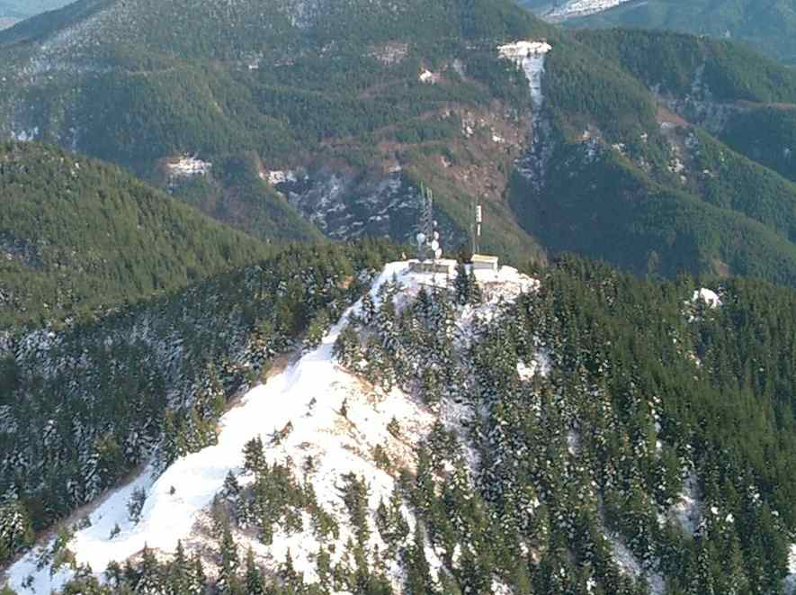
Welcome to the Washington Coast

“Nature’s Best Effort”
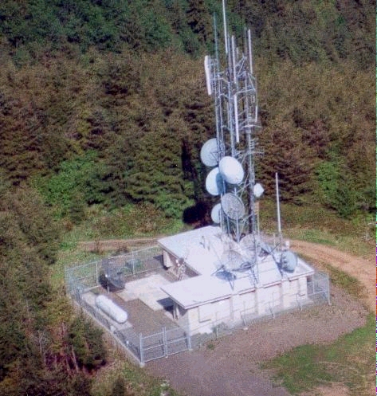
All ham repeaters in Coastal Southwest Washington are available for general, casual use by any licensed Amateur operator. Please feel free to enjoy them while in the area. That’s why we put them on the air.

You are invited to participate in our ARES nets at 7:30 Thursday evenings on any of these linked frequencies:
145.170; 145.310; 145.390; 147.020; 147.180; 147.340; 224.820; 440.675; 441.675; 442.675; 444.050; 444.200; 444.300; 444.500; 444.700; 444.800; 444.950

Join us for breakfast, second Saturday of every month, Hunters Inn, Naselle, WA, 9AM.

On the Web: http://www.qsl.net/nm7r

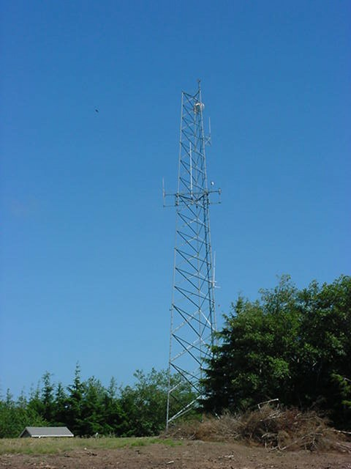
The “Hams” of coastal Washington would like to welcome you to our area. Please enjoy our extensive radio facilities while exploring the scenic wonders that the region has to offer. You will find hand-held coverage in many population centers, and easy access with standard mobile equipment just about everywhere.
K. O. Peak

BeachNet is a linked system, allowing the users of any of our repeaters to communicate freely with each other. While traveling around the region, use whichever machine provides the best coverage at the moment. Regardless of which “port” you use, you will be heard over the entire system.
Megler

Key up and pause for a second before talking to give the links time to come on line. This will avoid having your first words cut off.

Many folks find it handy to program the entire list of frequencies into adjacent memories. They use the “Up/Down” feature, found on most radios, to make a quick change to the next repeater when driving around the area.

In addition to BeachNet, there are several other repeaters in the area, sponsored by individuals and groups. There are even IRLP nodes for you to use. You will find the “locals” friendly and ready to help make your stay in the area more enjoyable.
North Cove

Information in this brochure (v17.1) accurate as of Feb 2017.
Photos courtesy of KC7YWU (sk), AC7AS and NM7R.
Amateur Radio
VHF/UHF Radio Repeaters
covering the

Discovery Coast, Washington State

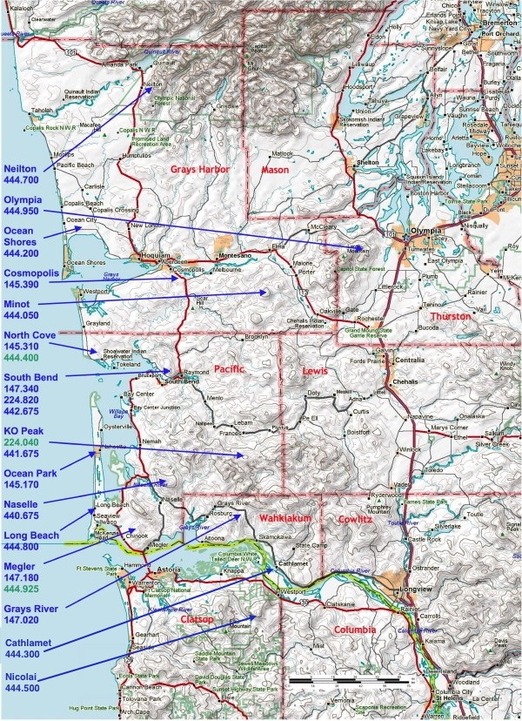
BeachNet Amateur Radio Repeater Network

Neilton:
444.700 (+5 MHz) 118.8 Hz

Olympia:
444.950 (+5 MHz) 118.8 Hz

Ocean Shores:
444.200 (+5 MHz) 118.8 Hz

Cosmopolis:
145.390 (-600 kHz) 118.8 Hz

Minot:
444.050 (+5 MHz) 118.8 Hz

North Cove:
145.310 (-600 kHz) 118.8 Hz
145.310 (-600 kHz) 114.8 Hz†
444.400 (+5 MHz) 118.8 Hz*

South Bend:
147.340 (+600 kHz) 82.5 Hz
224.820 (-1.6 MHz) 82.5 Hz
442.675 (+5 MHz) 118.8 Hz

KO Peak:
441.675 (+5 MHz) 118.8 Hz
224.040 (-1.6 MHz) 118.8 Hz*

Ocean Park:
145.170 -600 kHz) 118.8 Hz

Naselle:
440.675 (+5 MHz) 118.8 Hz

Long Beach:
444.800 (+5 MHz) 118.8 Hz

Megler, Chinook:
147.180 (+600 kHz) 82.5 Hz

Grays River:
147.020 (+600 kHz) 118.8 Hz

Cathlamet:
444.300 (+5 MHz) 118.8 Hz

Nicolai:
444.500 (+5 MHz) 118.8 Hz

*(Not normally linked into network)

The Megler repeater incorporates a voting multi-receiver system, for best possible performance.

Other Area Repeaters
Aberdeen:
147.160 (+600 kHz) no PL
444.600 (+5 MHz) 100.0 Hz

Ocean Shores:
146.640 (-600 kHz) 103.5 Hz

K.O. Peak (K7MMI):
147.200 (+600 kHz) 127.3 Hz

Ilwaco:
146.860 (-600 kHz) 118.8 Hz

Astoria:
145.450 (-600 kHz) 118.8 Hz
146.660 (-600 kHz) 118.8 Hz
146.740 (-600 kHz) 118.8 Hz
444.775 (+5 MHz) 118.8 Hz

BeachNet hosts ARES nets: Sundays at 7:00 PM Grays Harbor
Sundays at 7:15 PM WWA District 3
Mondays at 7:00 PM Clatsop Co.
Thursdays at 7:30 PM Pacific Co.

You are encouraged to check in.

BeachNet links to the AB7F System nightly 9:30-10:30 PM

IRLP –
Astoria-Seaside-Long Beach:
444.925 (+5 MHz) 82.5 Hz
South Bend-Raymond:
147.570 simplex 127.3 Hz
Aberdeen:
147.470 simplex 100.0 Hz

On the Web: http://www.qsl.net/nm7r
BeachNet is an open system. All licensed Amateurs are welcome on our repeaters. No membership or club affiliation is required. However, contributions are always welcome.

