Alachua County ARES
Operation Hurricane Test
May 6, 2017

After Action Report/Improvement Plan
May 22, 2017 – APPROVED
With Update to Improvement Plan to July 26 2017

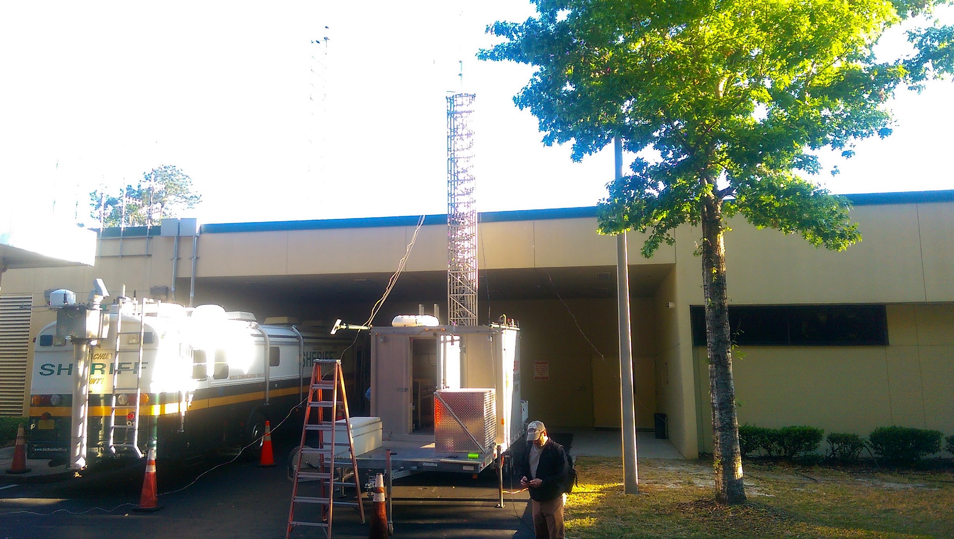
Mobile antenna tower getting ready to deploy at the EOC

This page is intentionally blank.

Handling Instructions

- Points of Contact:

Alachua County ARES Hurricane Test:
Name: Jeff Capehart, Asst. Section Manager.
FCC License: W4UFL
Phone: (352) 219 3901
Name: Gordon Gibby MD, Volunteer
FCC License: KX4Z
SHARES License: NCS521
Exercise Developer
Phone: (352) 331-6639

This page is intentionally blank.

Contents

Administrative Handling Instructions 1

Contents 3

Executive Summary 5

Section 1: Exercise Overview 9

Section 2: Exercise Design Summary 11

Section 3: Analysis of Capabilites 15

Section 4: Conclusion 23

Appendix A: Improvement Plan 25
Appendix B: Lessons Learned 31
Appendix C: Participant Feedback Summary 33
Appendix D: Exercise Events Summary Table 35
Appendix E: Acronyms 36

This page is intentionally blank.

Executive Summary

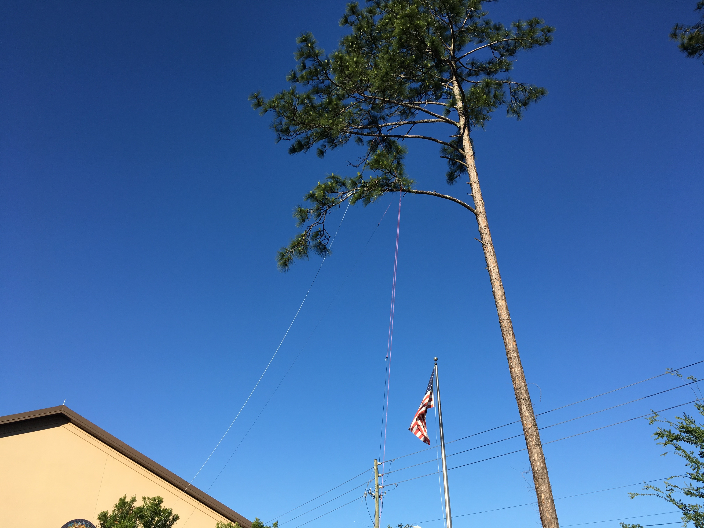
An emergency antenna placed during the test at one of our facilities.

The Amateur Radio Emergency Service (ARES) typically organizes at the County Level and upward. The Alachua County ARES volunteer group held a Full Scale Exercise “Hurricane Test” on Saturday May 6th, after extensive training. The exercise team included 13 local participating volunteers, 4 local evaluating volunteers, and participation by the Alachua County Emergency Operations Center management, and the Division of Forestry of the State of Florida. The exercise was primarily planned by Gordon Gibby MD KX4Z after encouragement from Dave Welker, of the Hospital Emergency Communications group in Marion County.

The major theme of this exercise was to test our ability to perform emergency communication via amateur radio in a simulated setting of complete loss of normal telecommunications, including telephone and Internet. Exactly this scenario has played out in real life multiple times recently in our nation, including Hurricane Katrina devastation of multiple Gulf States, and Hurricane Sandy northeast devastation. Although Alachua County is fairly inland, a very strong hurricane could bring this level of devastation to our own location, particularly with tornado activity....and there are other, more sinister world scenarios that could bring about a similar communications loss. Thus this situation is one for which amateur radio members of the community should train, in order to serve their communities.

The following stated objectives were developed for this Hurricane Test, which was a far more detailed full scale exercise than this group has held before.

 | OBJECTIVES
1 | Assess the capabilities of groups and individuals at EOC, Red Cross, up to 2 local shelter sites, and 1 local hospital, to create, manage, and position antennas in response to communications goals and weather-induced damage of existing antennas and repeaters; provided that during this exercise no person shall go onto any roof or use any slingshot or other lofting mechanism in the vicinity of any power line greater than 240VAC
2 | Assess the capability to place an emergency simplex repeater and utilize it to provide communications between all the locations involved in the Exercise.
3 | Assess the capability to utilize WINLINK text messages, ICS forms, and attachments on both VHF and HF frequencies to meet realistic emergency communications needs.
4 | Assess the capability to flexibly find and employ backup power systems of any available type at all locations involved in the Exercise
5 | Assess the capability to move (when travel is “safe” ) to a new location and expeditiously resume communications on VHF.
6 | Assess capabilities to send MT63-2000L bulletins over VHF frequencies, and to receive and store them.
7 | Assess capabilities of individual volunteers to participate in PACKET CHAT.
8 | Assess the capability of LINBPQ packet chat functions to serve as many as 6 simultaneous roundtable discussants trying to determine the best solution to a communications problem.
9 | Provide an opportunity for participants to utilize ICS Forms 211 (Incident Check In Form) and 214 (Activity Log), using handwriting, and inside WINLINK, Form 213 (General Message Form), as well as refer to Form 205 (Incident Communications Plan) to facilitate communications.

The purpose of this report is to analyze exercise results, identify strengths to be maintained and built upon, identify potential areas for further improvement, and support development of corrective actions.
Major Strengths
The major strengths identified during this exercise are as follows:

- At least 53 messages were transacted. This is orders of magnitude more structured communications transacted than ever accomplished before in Alachua County ARES exercises.
- The majority of participating ham radio volunteers, through months of training, have developed significant digital communications skills, particularly related to WINLINK radio-email communications, both locally and to/from distant sources.
- The digital communications infrastructure developed within Alachua County within the last year allows effective digital communications to continue in spite of simulated loss of the entire analog voice repeater system, over a region reaching up to 4000 square miles, a good portion of which is due to the generous provision of Forest Grove Firetower for amateur digital usage by the Division of Forestry. This very important resource dramatically strengthens our digital coverage of the western portion of Alachua County.
- The Division of Forestry can provide significant improvements in VHF antenna positioning to the EOC in emergencies.
- Approximately 55% of known ARES members participated in this event.

Primary Areas for Improvement
Throughout the exercise, several opportunities for improvement in the Alachua County ARES ability to respond to the incident were identified. The primary areas for improvement, including recommendations, are as follows:

- Some volunteer participants did not understand the need for “word-perfect” transmission of “record traffic.” Training has already addressed this lack of knowledge.
- The simplex repeater (used for the first time in this exercise) had significant receiver sensitivity shortcomings, and was not able to pick up the Newberry Hurricane Shelter. The receiver will be replaced and the system retested.
- Although the WINLINK VHF digital catchment system worked adequately, after a few hours of unattended automated operation, the shortwave (HF) computerized system to forward emails out of the county in the event of total Internet loss, bogged down. A software upgrade seemed to ameliorate this shortcoming, but the system needs further testing, and this requires significant effort.
- Although an Evaluator found that shortwave (HF) connections were successful both to the local automated shortwave email gateway, and to others through the Southeast, and an operator at the Senior Center also had HF success, operators at the EOC and at the Newberry Sports Complex had some significant problems that seem to relate to lack of experience or assets. Additional training in the form of a 34 hour license-upgrade “bootcamp” has already been held, but additional training and testing will be needed to improve these shortwave (HF) skills and abilities.
- There were significant training deficiencies noted among some volunteers, in the areas of digital communications, net control skills, software configuration, and in regards to software packages added only shortly before this Exercise. Additional training will be needed, along with additional effort by some volunteers, to achieve the necessary level of proficiency.
- Because of a lack of adequate volunteer participants, the hospital extension portion of the full scale exercise was judged as “impossible” by the team at the EOC. We had 55% participation by the identified local ARES members; however, increasing our well-trained team size, by finding new members or increasing local participation should be a significant goal of local amateur radio leadership.

Operation Hurricane Test successfully provided participants in the largest Alachua County ARES full scale exercise ever conducted, to explore their current plans, roles and responsibilities in the event that amateur radio communications became urgently needed due to normal telecommunications failures. While several areas for improvement were identified, the overall exercise demonstrated that we have developed workable communications infrastructure, skills and strategies, and that with additional effort we can provide a very useful backup communication system where needed.

Section 1: Exercise Overview
Exercise Details
Exercise Name
2017 ARES Hurricane Test
Type of Exercise
Full Scale Exercise
Exercise Start Date
May 6 2017
Exercise End Date
May 6 2017
Duration
4 hours
Location
4 locations: Alachua County EOC; Senior Center (Hurricane shelter); Red Cross; Easton-Newberry Sports Complex (Hurricane shelter)
Sponsor
Alachua County ARES, a component of the American Radio Relay League (ARRL)
Program
Amateur Radio Emergency Service
Mission
Communications Support
Capabilities
VHF local communications, analog voice and digital (AX.25 packet)
HF local and national communications, analog voice and digital (PSK31, WINLINK)
Radio Email to anywhere, via WINLINK
Scenario Type
Total Communications Failures
Exercise Planning Team
Gordon L. Gibby MD KX4Z NCS521
Jeff Capehart W4UFL

Participating Organizations
Alachua County, Florida
Emergency Operations Center
Red Cross (use of their building)
Senior Center (use of their building)
Easton-Newberry Sports Complex (use of their grounds)

State
Division of Forestry, State of Florida (gracious provision of 100 foot mobile antenna tower)
Number of Participants
- Players - 13
- Controllers - 1
- Evaluators – 3

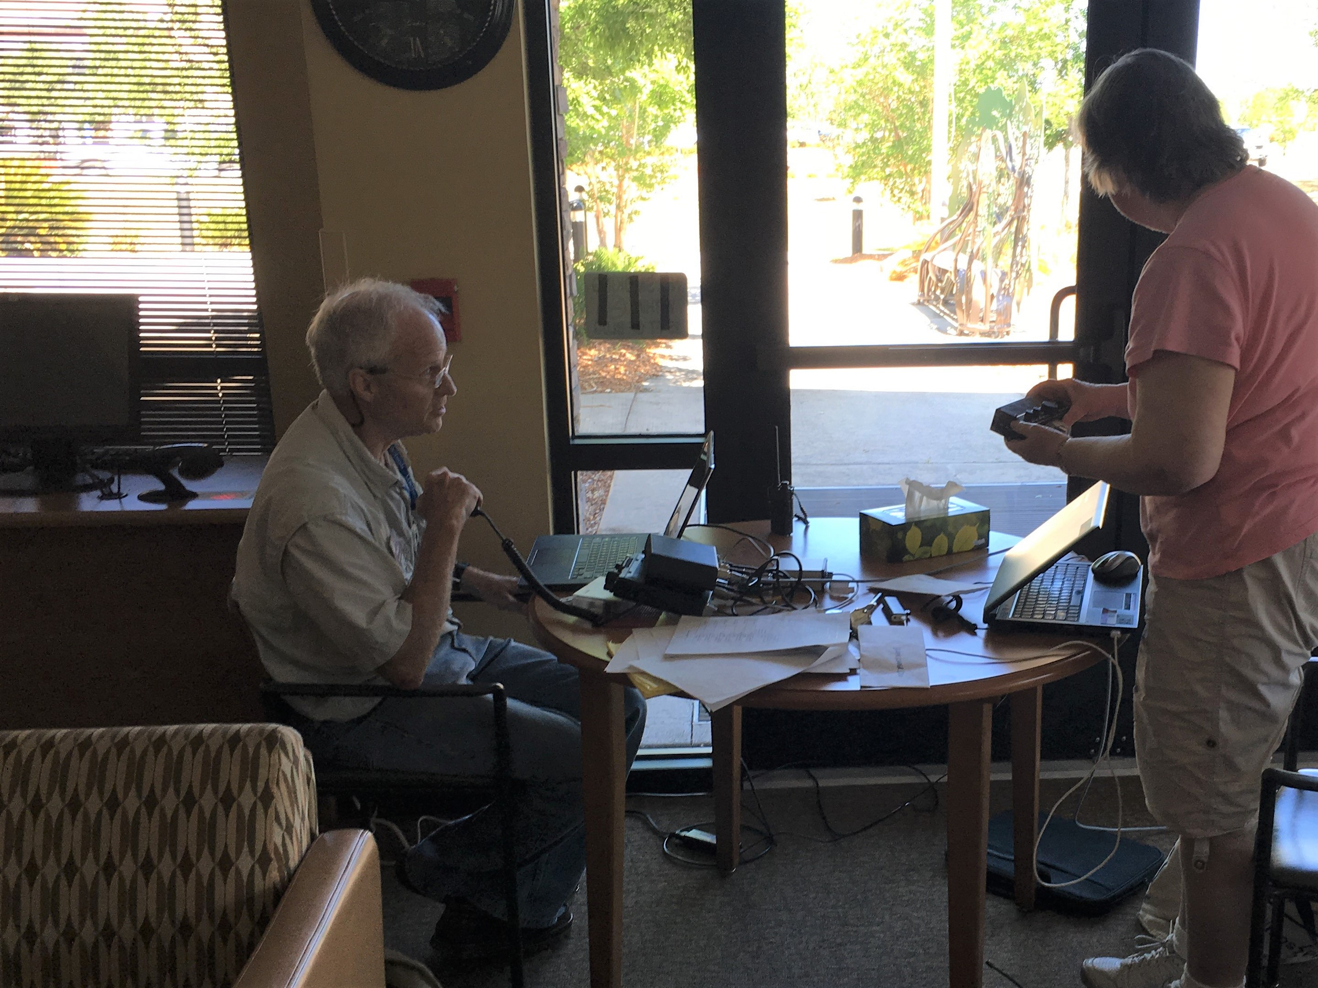
Amateur Radio Volunteers at the Gainesville Senior Center (a hurricane shelter)

Section 2: Exercise Design Summary
Exercise Purpose and Design
The Alachua ARES Hurricane Test Full Scale Exercise was developed to give the local ARES component a very realistic simulation of the communications tasks and hurdles they might face if their skills were actually needed after a hurricane. Previous years' testing has been somewhat minimal, so this was a tremendous step up in the “communications bar” the volunteer amateur radio operators tackled.

Training for this type of scenario – total loss or overwhelming of local conventional communications systems (telephone/Internet) began almost nine months before this exercise, as local skills, assets, and strategies began to be sharpened.

Development of this exercise began 3 months before with completion of a FEMA 120 Exercise Development course by the Exercise Developer after encouragement by Dave Welker, of the Marion County Hospital Emergency Communications group.

As the Exercise Planning was reaching completion, with a 25+ page Participant Workbook and 35+ page supervisory document, local training of volunteer ARES members accelerated with group and individual training sessions, including a real-equipment, power down simulation carried out at a private residence to give particpants a very similar experience to what they would face during the Full Scale Exercise.

Complicating this Full Scale Exercise was the fact that Amateur Radio emergency communications techniques and systems are not standardized nationwide. Amateur radio is not a monolithic radio service; instead participants draw from a plethora of modalities, skills, frequencies, and procedures to communicate, from extreme low frequency ground wave, to VHF repeater, voice, digital, and even Earth-Satellite or Earth-Moon-Earth communications. The local group leaders were both continuously training participants, while themselves learning at the same time, and developing increasingly better understanding of which techniques were optimal for the planned scenario. A specific example of this is that a significant technique & software package (EASYTERM by UZ7HO) was discovered within the last two months of planning, and required intensive individual training of location leaders to make it possible to have as an alternate communications possibility during the Full Scale Exercise. The net result was a much greater understanding of the best communications techniques at the end of the Full Scale Exercie, and an acute understanding of local weaknesses.

Exercise Objectives
The list below includes the objectives established for the Full Scale Exercise. As might be expected with an exercise of this complexity, being such a radical expansion of previous local amateur radio emergency communications capabilities tests, not all of the exercise objectives were even demonstrated, and there was uneven performance across the locations, modalities, and objectives.

- Objective 1: Assess the capabilities of groups and individuals at EOC, Red Cross, up to 2 local shelter sites, and 1 local hospital, to create, manage, and position antennas in response to communications goals and weather-induced damage of existing antennas and repeaters; provided that during this exercise no person shall go onto any roof or use any slingshot or other lofting mechanism in the vicinity of any power line greater than 240VAC
Capability: ANTENNA PLACEMENT

- Objective 2: Assess the capability to place an emergency simplex repeater and utilize it to provide communications between all the locations involved in the Exercise.
Capability: EMERGENCY SIMPLEX REPEATER

- Objective 3: Assess the capability to utilize WINLINK text messages, ICS forms, and attachments on both VHF and HF frequencies to meet realistic emergency communications needs.
CAPABILITY: WINLINK COMMUNICATIONS

- Objective 4: Assess the capability to flexibly find and employ backup power systems of any available type at all locations involved in the Exercise
CAPABILITY: BACKUP POWER

- Objective 5: Assess the capability to move (when travel is “safe” ) to a new location and expeditiously resume communications on VHF.
CAPABILITY: MOBILE DEPLOYMENT

- Objective 6: Assess capabilities to send MT63-2000L bulletins over VHF frequencies, and to receive and store them.
CAPABILITY: MT63 SKILLS

- Objective 7: Assess capabilities of individual volunteers to participate in PACKET CHAT
CAPABILITY: PACKET CHAT

- Objective 8: Assess the capability of LINBPQ packet chat functions to serve as many as 6 simultaneous roundtable discussants trying to determine the best solution to a communications problem.
CAPABILITY: LINBPQ CHAT FUNCTIONS

- Objective 9: Provide an opportunity for participants to utilize ICS Forms 211 (Incident Check In Form) and 214 (Activity Log), using handwriting, and inside WINLINK, Form 213 (General Message Form), as well as refer to Form 205 (Incident Communications Plan) to facilitate communications.
CAPABILITY: ICS FORMS

Scenario Summary
Saturday, May 6 2017

Our scenario included 4 different time periods representing 3 days' scenario of a devastating hurricane that temporarily destroyed some or all of local conventional communications systems, including telephone and Internet.

Preparation | Initial Response | Continued Recovery | Continued Recovery | Cleanup
0830 Actual Time | 0900 Actual Time | 1000 Actual Time | 1100 Actual Time | 1200 Actual Time
Day 1, Noon, storm approaching | Day 1 2359, storm has passed | Day 2 Noon | Day 2 2359 | Day 3 Noon

Participants in the Exercise were unaware of what communications difficulties would be simulated in each segment of the Exercise. At each time slot, they opened sealed envelopes and were given (in both hardcopy and flash drive format) the current situation and their goals for the segment.

SCHEDULE OF HANDICAPS:
 | 0830  Day 1 Noon | 0900  Day 1 MN | 1000  Day 2 Noon | 1100  Day 2 MN | 1200  Day 3 Noon
Universal Handicaps | No handicaps | Telephone / Internet Down  Ham radio voice repeaters down. | Telephone / Internet Down  Ham radio voice repeaters down. | Telephone / Internet Down.  2 Ham radio voice repeaters up: SARNET &  146.91 work | Everything works
EOC |  |  | Fixed antennas fail
RED CROSS |  | Utility power out. | Utility power out, antennas down. | Utility power out.
NEWBERRY |  | Fixed antennas fail. | Utility power out. | Utility power out.
SR CENTER |  |  | Utility power out.

Note: facilities which had to put up their own antennas from the very beginning did not have to take them down during “antenna out” periods; they were considered to have already passed that test.

At each time period, each location was assigned one or more messages to communicate. These were of several possible types, including short “Tactical” messages (a line or two of instructions that could be easily delivered by voice), ICS-213 “record” traffic (which needs to be communicated with word-perfect fidelity); email attachments such as a map or spreadsheet, or a discussion to be held over radio.

In addition, the EOC was suddenly tasked with a requirement to dispatch a mobile communications team to a nearby hospital to carry out a simulated emergency communications task related to an extreme emergency at the hospital (need to evacuate an entire building due to damage sustained).

At all times after the initial 30 minutes, teams at all four locations had no means to communicate with, or assess the situation of, any other location, other than by amateur radio communications – simulating what would happen if an actual telecommunications emergency were to occur.

Section 3: Analysis of Capabilities
This section of the report reviews the performance of the exercised capabilities, activities, and tasks. In this section, observations are organized by capability and associated activities. The capabilities linked to the exercise objectives of Operation Hurricane Test are listed below, followed by corresponding activities. Each activity is followed by related observations, which include references, analysis, and recommendations.

Capability 1: Antenna Placement
Capability Summary: Fixed, pre-existing antennas should obviously perform for necessary communications. However, these may be damaged by high winds, and volunteers need to have the skills to efficiently replace them with ad-hoc created or installed antennas.

Activity 1.1: At some point, each location had to install new antennas.

Observation 1.1.1: Mixed. Our previous documentation has shown very significant deficiencies in fixed, pre-existing antennas at all locations. There are no fixed antennas at the Newberry Hurricane Shelter or the Senior Center. The antennas at the EOC have been shown inadequate for HF communications of all types, and inadequate for VHF communications should repeaters fail. During this exercise volunteers placed antennas at all sites, with general but not universal success:

- EOC, Division of Forestry placed a mobile 50 foot tower, with VHF antennas at the top (success); HF antenna affixed to the tower however did not achieve successful communications (possibly due to operator inexperience with equipment).

- Senior Center: volunteers placed VHF and HF antennas with skillful use of lines placed over nearby pine tree limbs using a “Chuck-It” dog toy.

- Newberry: Volunteers placed VHF and HF antennas, using a rope to the foul-ball pole. They had difficulties getting their HF antenna to work, but generally succeeded with their VHF antenna.

- Red Cross: Utilized good fixed antenna and added ad-hoc vhf antennas as needed. Did not place an HF antenna.

Analysis: Well-known limitations of the EOC and Newberry hurricane shelter antenna situations still remain to be addressed. Volunteer skill at achieving height seems to have become significant, while there are still some technical gaps in the ability to couple power effectively to some antennas, as demonstrated by difficulties at the Newberry center.

REFERENCES:
Previous documentation of EOC antenna issues: http://qsl.net/kx4z/EOCTotalAntennaProposal.pdf
http://www.qsl.net/kx4z/MyNewVHFandHFproposal2.pdf

EOC “how-to” document on HF systems:
http://qsl.net/kx4z/EOCHFWinlinkExpressPrimer.pdf

Recommendations:
- Raise EOC VHF amateur radio antennas to at least the 50 foot level on their existing tower, to match the level used by the Division of Forestry mobile tower. (Appendix A, #6)
- Even with a 50 foot tall antenna, the relatively low-lying EOC location was unable to reach the SARNET all-Florida UHF repeater system. They will require voice relay to reach that system (Appendix A, #22)
- Establish an EOC horizontal multi-band horizontal dipole. Route cable as needed to reach these antennas, and provide access for ad-hoc replacement should the fixed antennas be damaged during hurricanes. (Appendix A: #11)
- EOC needed additional “ladder line” transmission line on the provided emergency random length dipole (Appendix A, #17)
- Provide more training opportunities for EOC HF capabilities (Appendix A, #23)
- Install VHF antennas at the Easton-Newberry Sports Complex. Provide a pull rope to allow an HF wire antenna to be raised if needed. (Appendix A: #12)
- Provide a ladder for Easton-Newberry team (Appendix A, #19)
- Provide more chances for HF antenna training for Newberry volunteer personnel (Appendix A #15, #30)
- Install VHF antennas at the Senior Center (planned, but not completed)
- Install HF antenna at the Red Cross (no plans at present time)

Capability 2: Emergency Simplex Repeater
Capability Summary: If existing duplex amateur voice repeaters are overwhelmed, or out of service, a portable simplex repeater (that acts like a digital voice recorder, and replays over the air, from a high location, messages received) can provide voice coverage to a devastated area.

Activity 6.1 Emplace a portable simplex voice repeater and utilize when advantageous.
Observation 6.1.1: Mixed. Team leaders wisely placed this asset prior to the beginning of the test, taking advantage of high antennas in the W4DFU Dental Tower amateur radio station, which is available to several of the volunteers, and very amenable to emergency usage. However, there was both a transmitter power limitation (caused by a poorly chosen power cabling) and a receiver sensitivity issue).
Analysis Transmitter power issue is both easily fixed, and did not hamper outbound voice communications to Newberry, the farthest location. However, the receiver sensitivity issue could be a low-performance transceiver or a high-noise environment on the top of the dental tower (where an APRS system is co-existent).
Recommendation:
- Fix the transmitter power cabling issue.
- Test an improved receiver to determine what is the exact cause of the sensitivity problem. (Appendix A, #7)

Capability 3: WINLINK Communications
Capability Summary: WINLINK provides a world-wide, radio-based email capability that has been leveraged by mariners, emergency communications personnel, missionaries, and the Federal Government. Allowing both email and attachments, it can speed digital messages toward areas where the Internet is still working, and then forward them by the far-faster internet email facilities, or in a complete national disaster, can slowly move email to “Message Pickup Stations” by radio alone. It is the premier HF radio-based email system in the world today.

Activity 3.1 Generate, forward, and retrieve multiple emails and attachments via WINLINK, either using HF, or VHF capabilities.
Observation 3.1.1: Strength. Three out of the 4 locations were successful at utilizing the capabilities of WINLINK to get communications accomplished when the voice repeater were simulated “down”.
Analysis Our local ARES group has developed a significant strength in this area, following the lead of the Marion County Hospital Emergency Communications group.

Observation 3.1.2: Weaknesses. There were problems with the automated HF-based relay station's software. The Red Cross location was unable to develop digital messaging operational status.
Analysis All WINLINK software (both client and server) is free, volunteer-developed software, and although the system is now 2 decades old, updates and corrections appear almost weekly. Some of the hiccups of the automated relay station (KX4Z) were corrected with a software update (Appendix A, #1, #2, #3, #8), but it would be wise for more local amateurs to lose their dependence on that automated station by developing their own client HF station capabailities, following the example of the Marion County Hospital Emergency Communications group. Additionally, simple software mis-configurations caused the failure at the Red Cross, and were exacerbated by interpersonel difficulties that can be avoided. Additional training has already corrected the software mis-configuration. (Appendix A, #4)
Recommendations:
- Strongly encourage all ARES personnel to develop WINLINK capabilities, monitor the capabilities of volunteers, and take their proven skills into account in assignments.
- Encourage client hf WINLINK skills (Appendix A, #18).
- Train on peer-to-peer WINLINK (Appendix A #26).
- Develop EASYTERM skills as local alternative to WINLINK email. (Appendix A, #14, #25)

Capability 4: Backup Power
Capability Summary:
Electrical Utility power loss is one of the most frequent occurrences in hurricanes, and is a major cause of loss of traditional communications. Amateur radio emergency volunteers need to have alternate power capabilities.
Activity 4.1 At some point during the exercise, every location except the EOC (which has strong backup power facilities) was simulated “power down” and had to work off alternate power.
Observation 4.1.1: Strength. Every one of our power-down facilities had battery, generator, vehicular or other backup power source.
Analysis Considerable effort into this strength has borne results. It was practiced at the table-top exercise conducted just a few weeks before the Full Scale Exercise.

Recommendation:
- Continue to develop strengths.

Capability 5: Mobile Deployment
Capability Summary: In a true communications emergency, it is likely that there will be additional locations that suddenly develop an emergency need for communications. Amateur radio volunteers should maintain the ability to service those needs through mobile vehicles, possibly including dis-mountable VHF and HF gear that can be set up quickly at a new fixed site, including antennas.

Activity 5.1 An unexpected request was delivered to the EOC location to provide mobile emergency communications to a simulated official of the Shands Hospital.
Observation 5.1.1: Weakness. Due to inadequate available personnel, and the general crush of task assignments and relative skills available at the EOC, the team was unable to send a mobile team to the requested site.
Analysis Simply not enough volunteers. We had reasonable participation from the existing registered ARES volunteers in Alachua County (55%) but we will need to develop an even larger number of trained, exercise-participating volunteers.
Recommendation:
Find ways to develop new volunteers. Additional “marketing” through CERT and other training, and encouragement of local GARS , GARC and other club members to participate might help. (Appendix A, #10, #28)

Capability 6: MT63 Skills
Capability Summary:
MT63 is a fast digital keyboard-based and potentiallly file-based mechanism to send accurate broadcast (1-to-many) information that can be very effective in sending bullets and broadcast messages.

Activity 6.1 Utilize digital means to send broadcast bulletins to mutliple centers.
Observation 6.1.1: Weakness. Our teams just didn't try MT63 during this exercise. Instead, they utilized WINLINK and/or EASYTERM as alternatives.
Analysis This isn't all bad, in that we have multiple overlapping skill sets to accomplish the desired communication and the teams were specifically instructed that any means was fair game to get messages across. However, their recent familiarity with WINLINK outweighed their more distant expertise with FLDIGI software that includes MT63 protocol.
Recommendation:
- Continue strengths in WINLINK.
- Develop additional strengths in EASYTERM
- If time permits, retrain users on FLDIGI – as more become HF capable, they may develop this skill outside of our ARES training anyway.

Capability 7: Packet Chat
Capability Summary: Packet Chat skills were hoped to provide a way for participants to allow multi-party typed (digital) discussion similar to what can happen on a voice radio frequency. These skills were tested by a small number of participants in Thursday evening packet roundtables associated with other ARES training nets, and were easily acquired by participants. However, the function itself on the digital repeaters was found to be easily overloaded, so the utility of this skill without higher speed “mesh” communications networks is questionable.

Activity 7.1 Carry out a packet roundtable chat discussion of alternatives for simulated hospital evacuation.
Observation 7.1.1: Weakness. The packet chat capabilities of the existing infrastructure aren't sufficient to carry out this Activity for more than 2 or 3 participants.
Analysis This weakness was known before the Exercise was carried out, but not at the time of development of the Exercise. It was somewhat awkwardly handled with suggestions to carry out the roundtable via simple voice communications. Due to other difficulties in other tasks, this wasn't well communicated during the Exercise and a good roundtable discussion simply never occurred over any medium during the Exercise.
Recommendation: During the next similar simulation, better explain the nature of the roundtable and its need and function, and offer better options to carry it out.

Capability 8: LINBPQ Chat Functions
Capability Summary: LINBPQ, the software employed in much of the digital infrastructure created in the amateur community locally in the last year, allows for a “roundtable” chat discussion, forwarding each person's typed comments to the others involved. Unfortunately, the limitations of 1200 Baud Packet AX.25 are that this is unwieldy for more than about 3 active participants. Although in the planning stages it was hoped to be a useful function, by the time the Exercise had arrived, it was already known that the technology has siginificant limitations and its use was not as strongly advocated, with alternatives over voice suggested.

Activity 8.1 Roundtable discussion of simulated issues at Shands Hospital.
Observation 8.1.1: Weakness. Both due to ICS-213 communications weaknesses at the Red Cross and the weakness of this technology itself, this roundtable was not accomplished.
Analysis Unless our group is able to bring about higher-speed technologies such as “mesh” tcp/ip high speed connections, voice communications will be a more effective method to carry out any required roundtable discussions.

Recommendation:
Further investigation into mesh technologies.

Capability 9: ICS Forms
Capability Summary: ARES volunteers have been becoming more accustomed to standard FEMA/ICS forms through efforts of Jeff Capehart at previous simulation events. It is desirable that they be familiar with personnel log in forms, and essential that they be familiar with communications logs and message formats, particularly ICS-213 (“general message”).

Activity 9.1 Utilize ICS-205 frequency chart, ICS personnel log in forms, ICS communications logs, and transfer ICS-213 record traffic.
Observation 9.1.1: Strength. Most facilities utilized the personnel, communications logs, and ICS-213 forms well.
Analysis WINLINK makes sending ICS-213 particuarly easy for those who are facile with this software.

Observation 9.1.2: Weakness. Personnel at the Red Cross improperly transmitted ICS-213 “record” traffic as a one-line summary due to lack of skill at digital communications.
Analysis This was a particularly important finding, a very significant legal difficulty. Education has already taken place in a group setting to explain how crucial it is that “record” traffic be transmitted word-perfectly. Further training of the individuals involved needs to take place to afford them better communications skills.

Observation 9.1.3: Weakness. Some facilities did not stick to expected and published callsigns in the ICS-205, making contact via WINLINK more difficult.
Analysis Unable to send WINLINK email properly if intended recipients are using an unexpected callsign/email.. .

Recommendation:
- Group education on the importance of word-perfect transmission of “record” traffic (Appendix A, #5, accomplished).
- Individual remedial training on digital communications skills (not yet accomplished).
- Group education on sticking to published callsigns/email addresses (already accomplished, Appendix A #24)

ADDITIONAL ISSUES/RECOMMENDATIONS

- EOC needed additional transceivers to remain “accessible” on more frequencies simultaneously. Addressed in Appendix A, #9, and possible additional transceivers are being considered.

- Team Dynamics might have benefited from having a group meeting at the kickoff of the exercise. Recommend having a “breakfast” before the next Full Scale Exercise (Appendix A, #13)

- Volunteers at the Senior Center had a problem with people just walking in to see what they were doing. Recommend signs or caution tape next time. (Appendix A, #16)

- The EOC has no means for amateur stations to connect to ad-hoc antennas outside; cables through penetrations were not available and the EOC team had to work in a covered portico outside the building. Recommend providing cables through penetrations to avoid personnel being exposed to elements/interference/harm from being outside.

- Newberry volunteer participants were also unable to be protected inside due to a very high cost of having the building made available for emergency exercises such as this. Recommend Newberry finding a way to make the building available for responsible individuals to use for emergency preparedness exercises such as this, once a year, for 5-6 hours. (The Senior Center found a way, without any charge.) (Appendix A, #20)

- Net Control duties were a significant consumer of volunteer time. When the EOC passed control unexpectedly to Newberry, antenna preparations at Newberry were delayed. Recommendation: train additional net control operators, and carefully consider the consequences, duties etc of emergent replacement personnel when considered. (Appendix A, #21)

Section 4: Conclusion

Operation ARES HURRICANE TEST was conducted on May 6, 2017 to test Alachua County ARES capabilities to provide backup emergency communications to a small sliver of Alachua County communications needs.

This was undoubtedly the largest, most ambitious Full Scale Exercise ever carried out by Alachua County ARES, at least within known history. A very wide array of communications skills were put to the test, including simplex VHF voice, simplex VHF repeater, duplex VHF repeater, HF WINLINK, VHF WINLINK, and keyboard and file-transfer VHF packet communications. Multiple voice and digital (AX.25) repeaters were utilized. Alachua County is blessed with more than 5 duplex voice repeaters, and we now have more than 7 AX.25 digital repeaters, and are reconnected to the state-wide SEDAN packet digital network.

These digital skills (WINLINK, packet, HF) are quite new to our local volunteers, and this exercise was a huge stretch for their skills, assets, and strategies. Furthermore, we strenuously tested their abilities to emplace emergency antennas and provide alternative power --- all things that would be important in a real hurricane / communications emergency.

As expected, there were successes and failure. Amazingly, at least 53 messages were successfully transacted – including some to neighboring counties, likely a first for our group as well.

One of our volunteers put our next tasks very eloquently, when Larry Rovak said we needed to just keep “growing our infrastructure.”

We intend to do just that.

APPENDIX A

ISSUES NOTED / Improvement Plan
(updates ongoing on web site qsl.net/nf4rc)

Updated as of JULY 26 2017
No. | Issue | Suggestion | Actual Action Taken
1 | RMS_RELAY 3.0.37.0 will not even start without internet access |  | RESOLVED  Upgraded to RMS_RELAY 3.0.38.0 which DOES start without internet. Does not need authorization code. Now works perfectly:  a) boots even if internet down  b) automatically switches to radio mode if internet lost  c) automatically goes back to internet if it becomes available.  Good job, Winlink development team!
2 | RMS_RELAY 3.0.36.0 ceased actually transferring email after about 9 messages transferred | Upgrade | RESOLVED  Upgraded to RMS_RELAY 3.0.38.0 which did transfer the messages.
3 | RMS_RELAY 3.0.38.0 crashed in early evening | Possibly due to erroneous listing of AC4QS as MPS? | RESOLVED  Crash posted to WINLINK program development google group for analysis/fix There were no actions taken there.  NOTE: Has not recurred. Software has operated for > 7 days without problems. Considered resolved.  UPDATE: Pactor modem seems to have developed problem; replaced, will have repaired.
4 | Art & Cindy unable to make soundcards connect for digital at Red Cross | Gordon to meet with them and try to figure out. | RESOLVED  FIXED! There were several issues with soundmodem configuration:  a) needed “single channel output”  b) needed “1200 baud AX.25 VHF”  c) needed center frequency set back to 1700 Hz (had gotten bumped)  Made a “cheat sheet “ envelope for them...need to make more for other people...  UPDATE: provided additional documentation on web site.
4A | Make cheatsheet soundmodem setup helps for other people to avoid problems. |  | RESOLVED  DONE, and posted to the web. http://www.qsl.net/nf4rc/UnderstandingAudioChannelConfiguration.pdf
5 | ICS-213 messages not being transferred word-perfect | Further training on this important issue will be held. | RESOLVED  Further training on this was held at the ARES meeting on Wednesday, May 10th, and everyone present indicated they understood the importance of word perfect transmission of record traffic.
6 | Even with 50 foot tower, EOC unable to reach Senior Center & Newberry Sports complex |  | Un-resolved. Jeff Bielling says they are at the mercy of the Sherriff 's department as to when ham radio antennas at the EOC will be raised to 50 feet. We don't have a firm date on when VHF antennas at the Newberry shelter will be installed. Best solution remains digital connections, and slingshots to emplace temporary antennas. EOC volutneers should be ready to place antennas in the trees south of the facility.  UPDATE: July meeting held with John Moorhouse, Ryan Lee and Jeff Bielling with G. Gibby and C. Grant. One week later, full specs for purchases for boh HF and VHF antennas (for the EOC only) were provided. Now awaiting installation.
7 | Newberry sports complex could HEAR the simp reptr at Dental Tower, but couldn't SEND to it | Replace the Baofeng transceiver with a transceiver with better receiver sensitivity | UPDATE: advertising for a Champion to take over the simplex repeater.
8 | After about 11AM, the packet gateways at KX4Z started to fail at receiving emails | Not sure what caused this, no one was home to observe. Figure out a way to investigate this, or make a way to have that part of the system reboot on command?? | Possibly related to the RMS-RELAY that got replaced. Testing not yet accomplished. May require human oversight at KX4Z.  UPDATE: Emergency additional Gateway NF4RC authorized and undergoing testing July.
9 | EOC needed more VHF receivers--unable to monitor all necessary frequencies |  | Proposal for EOC to purchase additional transceivers is being considered. Otherwise, volunteers should bring additional system.  UPDATE: new transceivers for SHELTERS have arrived.
10 | EOC couldn't service all their requests -- unable to dispatch team to Shands | We needed more volunteers at the EOC. | RESOLVED  Volunteers from Red Cross will be moved to the EOC to increase their number.
11 | EOC HF station simply couldn't be heard, while HF from elsewhere was easily getting into KX4Z gateway on 80 meters | 1. need observable wattage output in line at EOC  2. EOC crew needs more experience at HF  3. EOC crew needs more antenna experience  4 EOC crew needs to be able to rapidly test WINLINK automated connections as a way to know their output success and propagation success | PROGRESS:  1. Don't yet have a wattmeter – GLG has one to donate IF the antenna gets installed....  2. 7 hours of training completed on 6/10/2017 with significant improvement in performance on EOC gear – discovered Yaesu requires HIGH mic signal input. GLG has a new $25TNC to donate....as progress on HF antenna occurs.  3. Four different antennas temporarily raised on 6/10/2017 with significant improvement in volunteer understanding Those antennas made contacts.  4. EOC crew got much better at moving to new frequencies, learned how to use the pushbutton frequency entry.
12 | HF difficulties at newberry | Difficulty getting antenna to match with tuning system. | Consider additional practice/training with random length tuning system.  PARTIALLY RESOLVED:  One volunteer gained significant additional experience with automated matching systems 6/10/2017. Consider obtaining auto-matching system. .
13. | Have Breakfast FIRST | Probably better to have group meet together before start, and delay the start to allow better setup time/completion | RESOLVED  Future plans will include a get-together meeting at the start.
14 | Frustrating not to get acknowlledgement of receipt of winlink digital messages | ? Consider read receipts?  ? Consider YAPP for local transfer? | RESOLVED: additional training in EASYTERM was held.  Further training in EASYTERM is planned....
15 | Newberry building casts a huge radio shadow -- needed way to move antennas well away from building | 1. Expected VHF antenna on top of building will go a long way.  2. Possible way to hang HF antenna from top of building to stretch outward might help  3. Finding a way to connect to the light pole rung might allow for an antenna a long way from the building -- but need considerable feed line available | IN PROGRESS  Jeff Bielling is working with GARS board to install fixed antennas, which are now purchased (July 2017) and awaiting installation.
16 | Senior Center -- people wandered into the building! | Need signs or caution tape to explain and protect | (need to buy caution tape)
17 | EOC needed longer ladder line to reach their anttenna | Get more ladder line | RESOLVED  Gordon ordered additional ladder line. A large amount was then left at the EOC after the June antenna training.
18 | Troupe found 40 meter digital spots full of QRM | (FCC allows only narrow range) -- consider using other winlink gateways out of the auto-slice | RESOLVED  Use other gateways out of the auto slice.
19. | Newberry needed a LADDER |  | RESOLVED  next time recommend ladders for people who will need to work on higher antennas.
20 | Newberry -- stuck outside -- needed more time to seet up survival “field day” paraphenalia -- couldn't read monitor screens in sunlight | Delay start of radio portion  Find some way to get inside or find cover -- that shed? | RESOLVED  1. Provide more defined “set up time” after the breakfast next time.  2. Make presentation to authorities in Newberry to gain increased coopertion.
21 | when net control duties passed to Newberry, it hampered their setup | Shortage of trained helpers.  Ask if someone can realistically take on a task.  (KX4Z might could have done it) | PARTIALY RESOLVED:  Traffic handling on ARES net practice began on 6/8/2017.
22 | Note: EOC was able to reach the SARNET |  | (No action needed but note successful SARNET connection)
23 | Even with 50 foot tower, the best simplex from EOC to Newberry was S0 not workable | Even with proposed EOC VHF antenna height improvement, repeaters of some sort are still needed to reach Newberry. Expect same problem to High Springs  - harden repeaters (NEWB and 146.91 worked very well)  - develop HF skills/assets | Considerable HF training was provided at the General/Extra Class course, but other issues not yet resolved.  Additional HF Training (7 hours) completed on 6/10/2017  JULY: Full specs for new antennas delivered to EOC/Ryan in July, one week after our meeting.
24 | EOC & Senior Center used varying call signs on digital | Better advertisement of expected call signs, and better sticking to announced call signs. | RESOLVED  Was discussed at the May 10th ARES meeting so that people will stick to published call signs a bit better.
25 | Unfamiliarity with EASYTERM |  | PARTIALLY RESOLVED: Additional training was held at the July meeting, however, very few people succeeded in a Training Exercise to reach a vhf NF4RC test station. Unclear what it will take to get more participation & understanding.
26 | No training so far on peer to peer WINLINK |  | Group requested training on WINLINK peer to peer at May 10th meeting Jeff Capehart is scheduling this.
27. | Didn't need so many USB drives -- possibly more copies of same thing? | Discuss best solution | RESOLVED  Agreed that we'll just send ONE usb drive to each center in future tests.
28 | Could have used more participation from home ARES members to help relay messages | ? Practice transferring ICS213 and ARRL Radiograms on Thursday night net?? | Jeff Capehart is working up plans to practice message passing.  Message passing training STARTED on ARES net on 6/8/2017.
29 | Make Eval sheets more understandable |  | RESOLVED  Devote some training time to this aspect with volunteer evaluations before next Full Scale Exercise.
30 | Antenna analyzer would have helped the newberry crew | As part of increased HF emphasis, work on procuring more antenna analyzers | Training for Gen/Extra was held that includes training on tuning antennas....

Appendix B: Lessons Learned
While the After Action Report/Improvement Plan includes recommendations which support development of specific post-exercise corrective actions, exercises may also reveal lessons learned which can be shared with the broader homeland security audience. Federal Emergency Management Agency (FEMA) maintains the Lessons Learned Information Sharing (LLIS.gov) system as a means of sharing post-exercise lessons learned with the emergency response community. This appendix provides jurisdictions and organizations with an opportunity to nominate lessons learned from exercises for sharing on LLIS.gov.
For reference, the following are the categories and definitions used in LLIS.gov:
- Lesson Learned: Knowledge and experience, positive or negative, derived from actual incidents, such as the 9/11 attacks and Hurricane Katrina, as well as those derived from observations and historical study of operations, training, and exercises.
- Best Practices: Exemplary, peer-validated techniques, procedures, good ideas, or solutions that work and are solidly grounded in actual operations, training, and exercise experience.
- Good Stories: Exemplary, but non-peer-validated, initiatives (implemented by various jurisdictions) that have shown success in their specific environments and that may provide useful information to other communities and organizations.
- Practice Note: A brief description of innovative practices, procedures, methods, programs, or tactics that an organization uses to adapt to changing conditions or to overcome an obstacle or challenge.
Exercise Lessons Learned
The following subject headings are lessons derived from the Alachua County, Florida FSE on May 6, 2017 that are proposed for inclusion in the Department of Homeland Security’s Lessons Learned/Best Practices web portal, LLIS.gov:

- The importance of effective Amateur Radio antennas at the EOC and expected hurricane shelter sites cannot be overemphasized, if effective backup communications are to be provided. It is crucial that this well-known weakness be corrected.

- The assistance of State, Local, and Private entities contributed greatly to the learning opportunities afforded by our exercise.

Appendix C: Participant Feedback Summary

Participant Feedback Form
(Suggested for use in subsequent Exercises)

Exercise Name: Operation White Powder Exercise Date: Dec. 12, 2007

Participant Name: Title:

Agency:

Role: Player Observer Facilitator Evaluator

Part I: Recommendations and Corrective Actions

- Based on the exercise today and the tasks identified, list the top 3 strengths and/or areas that need improvement.

- Is there anything you saw in the exercise that the evaluator(s) might not have been able to experience, observe, and record?

- Identify the corrective actions that should be taken to address the issues identified above. For each corrective action, indicate if it is a high, medium, or low priority.

- Describe the corrective actions that relate to your area of responsibility. Who should be assigned responsibility for each corrective action?

- List the applicable equipment, training, policies, plans, and procedures that should be reviewed, revised, or developed. Indicate the priority level for each.

Part II – Exercise Design and Conduct: Assessment

Please rate, on a scale of 1 to 5, your overall assessment of the exercise relative to the statements provided below, with 1 indicating strong disagreement with the statement and 5 indicating strong agreement.

Table C.1: Participant Assessment
Assessment Factor |  | Strongly  Disagree |  |  | Strongly Agree
a. | The exercise was well structured and organized. | 1 | 2 | 3 |  | 4 | 5
b. | The exercise scenario was plausible and realistic. | 1 | 2 | 3 |  | 4 | 5
c. | The facilitator/controller(s) was knowledgeable about the area of play and kept the exercise on target. | 1 | 2 | 3 |  | 4 | 5
d. | The exercise documentation provided to assist in preparing for and participating in the exercise was useful. | 1 | 2 | 3 |  | 4 | 5
e. | Participation in the exercise was appropriate for someone in my position. | 1 | 2 | 3 |  | 4 | 5
f. | The participants included the right people in terms of level and mix of disciplines. | 1 | 2 | 3 |  | 4 | 5
g. | This exercise allowed my agency/jurisdiction to practice and improve priority capabilities. | 1 | 2 | 3 |  | 4 | 5
h. | After this exercise, I believe my agency/jurisdiction is better prepared to deal successfully with the scenario that was exercised. | 1 | 2 | 3 |  | 4 | 5

Part III – Participant Feedback

Please provide any recommendations on how this exercise or future exercises could be improved or enhanced.

Appendix D: Exercise Events Summary Table

Table D.1: Exercise Events Summary
Date | Time | Scenario Event, Simulated Player Inject, Player Action | Event/Action
05/03/17 | 830 | All systems operational, participants establish connections | Roll call. Confirm understanding of methods by which each site can be reached, through multiple methods.
05/03/17 | 900 | Hurricane damage: loss of all normal communications.  Voice duplex repeater failure.  Request for roundtable discussion.  Request for mobile comms team to be send to Shands Hospital.  Red Cross: No power.  Newberry: Antenna fail. | Re-establish communications by alternate methods, roll call, dispatch comms team, begin transferring assigned messages.
05/03/17 | 1000 | EOC fixed antenna failure  Red Cross antenna failure, power out.  Newberry power out.  Red Cross power out. | Re-establish communications by alternate methods, roll call, begin transferring assigned messages.
05/03/17 | 1100 | Red Cross power out.  Newberry power out.  146.91 and SARNET repeaters reactivate. | Re-establish communications by alternate methods, roll call, begin transferring assigned messages.
05/03/17 | 1200 | All systems working again. | Complete passage of any remaining messages, close down operation.

Appendix E: Acronyms

Table F.1: Acronyms
Acronym | Meaning
AAR | After Action Report
ALS | Advanced life support
CDC | Centers for Disease Control and Prevention
DHS | Department of Homeland Security
EDS | Emergency Dispensing Site
EMA | Emergency Management Agency
EMS | Emergency Medical Services
FEMA | Federal Emergency Management Agency
FOUO | For Official Use Only
FPC | Final Planning Conference
HF | High Frequency (shortwave)
HSEEP | Homeland Security Exercise and Evaluation Program
IAP | Incident Action Plan
IC | Incident Commander
ICS | Incident Command System
IC/UC | Incident Command/Unified Command
IPC | Initial Planning Conference
LLIS | Lessons Learned Information Sharing
MDPH | Massachusetts Department of Public Health
MEMA | Massachusetts Emergency Management Agency
MPC | Midterm Planning Conference
MRC | Medical Reserve Corps
MSEL | Master Scenario Events List
NIMS | National Incident Management System
POC | Point of contact
RSS | Receipt, Stage and Storage facility
SARNET | Statewide Amateur Radio Networking (a connected series of amateur radio repeaters)
SNS | Strategic National Stockpile
TCL | Target Capabilities List
UC | Unified Command
VHF | Very High Frequency (30-300 MHz)
WINLINK | A radio email system, see www.winlink.org

