HUDGINS
WHISKEY
BOTTLED 21 DEC 1999
100 PROOF
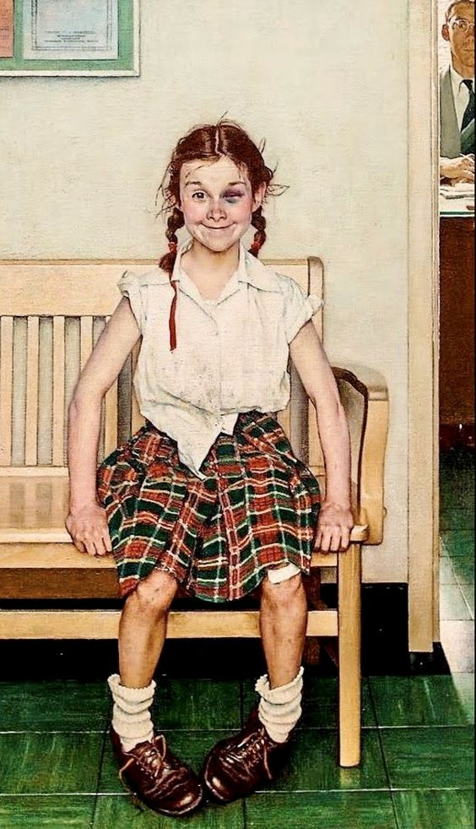
BRINGS OUT THE BEST IN YOU
1/2 GAL EVERCLEAR
1/2 GAL DISTILLED WATER
2 OZ BRANDY WOOD CHIPS
2 TBSP GLYCERINE
2 TBSP AGAVE SWEETNER
2 TBSP PECAN NECTER

