HUDGINS HOOCH
BOTTLED 11 October 2020
100 PROOF
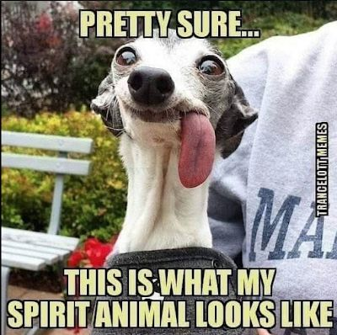
BRINGS OUT THE BEST IN YOU
1/2 GAL EVERCLEAR 1/2 GAL DISTILLED WATER
2 OZ BRANDY WOOD CHIPS 2 Oz GLYCERINE
2 Oz AGAVE SWEETNER 2 Oz PECAN NECTER
2 Oz = 1/4 Cup

