Activity I.D. No.:

Los Angeles County Operational Area
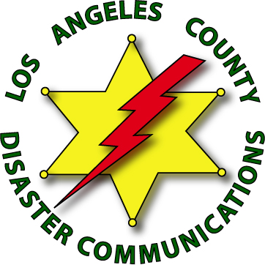
Disaster Communications Service

After Action Report (AAR)

District: |  |  |  | Date:
Activity:
Date of Event: | Time: |  |  | To Date: |  |  | Time:
Number of DCS Members: |  | Hours: | Please Attach A Copy of the Sign-In Sheet
DCS Incident Commander: Unit I.D.
Net Control Operator(s): Unit I.D., Unit I.D.
DCS Safety Officer(s): Unit I.D., Unit I.D.
Command Post Location / Address:
Purpose of Activity:
Who Requested DCS? Name: |  |  |  |  |  | Agency:
Overview of the Event / How Was DCS Used:
Suggestions / Issues:
Equipment / Modes of Communications Used:
Other Agencies Involved:
Prepared By: Unit I.D. |  |  |  |  | Date:
After Action Reports are to be submitted to the Administrative Staff no later than 10 working days after the Event / Incident

Revised 03.02.15

