Activity I.D. No.:

Los Angeles County Operational Area
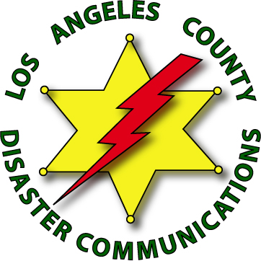
Disaster Communications Service

Activity Request

District: |  |  | Date:
Activity:
DCS Incident Commander:
Date of Event: |  | Time: | To Date: |  |  |  | Time:
Location/Address of Activity:

Purpose of Activity:
Who’s Requesting? Name:  Authorizer’s E-Mail Address: |  |  |  |  | LASD Unit:
How Will DCS Be Used:
Equipment / Modes of Communications Needed:
Uniform Required: Class C
Will Food Be Available? Yes No |  |  | Cost: $0
Other Agencies Involved:
Approvals:
DCO: Unit ID: |  |  |  | Date:
Administrative Staff Approval:
Approved Disapproved
 | ___________________________________ |  |  |  |  | Date:
Name | Signature
Unit I.D.:

Revised 03.02.15 AR_E_03.02.15

