Activity I.D. No.: 17_09.06.2019

Los Angeles County Operational Area
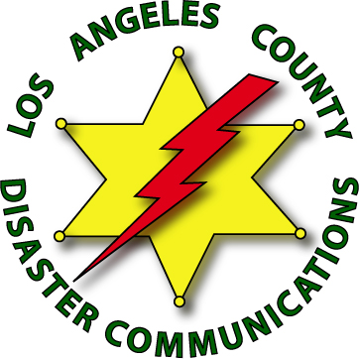
Disaster Communications Service

After Action Report (AAR)

District: Lomita / South Los Angeles |  |  |  | Date: 9/15/2019
Activity: 2019 Lomita Fiar
Date of Event: 9/6/2019 | Time: 1600 |  |  | To Date: 9/8/2019 |  |  | Time: 2130
Number of DCS Members: 9 |  | Hours: 101 | Please Attach A Copy of the Sign-In Sheet
DCS Incident Commander: Diana Feinberg, Staff 60 Deane Bouvier, Staff 50
Net Control Operator(s): N/A Unit I.D., Unit I.D.
DCS Safety Officer(s): Diana Feinberg, Staff 60 Deane Bouvier, Staff 50,
Command Post Location / Address: St. Margaret Mary Alacoque Church, 25511 Eshelman Ave., Lomita, CA
Purpose of Activity: Support Lomita Station deputies and VOPs to provide secruity screening of patrons
Who Requested DCS? Name: Sgt. Tina McCoy |  |  |  |  |  | Agency: Lomita Sheriff Station
Overview of the Event / How Was DCS Used: DCS members searched all bags, backpacks, purses, and baby strollers of patrons for items not to be brought into the Fair
Suggestions / Issues: Suggestions for next year already communicated to Lomita Station IC. DCS couldl use more participants next year…several members who signed-up had to cancel their participation at last-minute due to unrelated health issues.
Equipment / Modes of Communications Used: LASD Motorola XTS-5000 radios with speaker mics issued for the event, frequencies were CTAC-1 and Mutual Aid-1…DCS, VOPs, and Deputies all on same frequency.
Other Agencies Involved: Deputies from other LASD stations including Carson and Lakewood
Prepared By: Diana Feinberg Staff 60. |  |  |  |  | Date: 9/15/2019
After Action Reports are to be submitted to the Administrative Staff no later than 10 working days after the Event / Incident

Revised 03.02.15

