Conversor de RGB a PAL
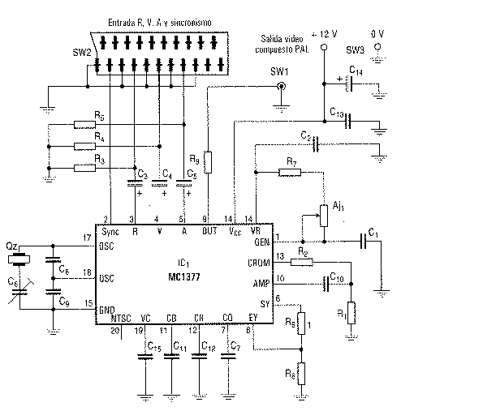

Alimentación:
    - V max: simple 12V DC
    - I max: 0.3A

Componentes:
R1 1 kΩ | C1 1 nF | IC1 MC1377
R2 2.2 kΩ | C2 100 nF | Qz cristal 4.433691
R3 75 Ω | C3 22 µF
R4 75 Ω | C4 22 µF
R5 75 Ω | C5 22 µF
R6 1 kΩ | C6 30 pF variable
R7 33 kΩ | C7 10 nF
R8 1 kΩ | C8 220 pF
R9 22 Ω | C9 220 pF
AJ1 33 kΩ potenciómetro | C10 1nF
 | C11 100 nF
 | C12 100 nF
 | C13 100 nF
 | C14 47 µF
 | C15 10 nF

