Enhanced 5 Digit Alarm Keypad
Circuit : Ron J
Email Ron
Description:
This is an enhanced 5 digit keypad which may be used with the Modular Alarm System.
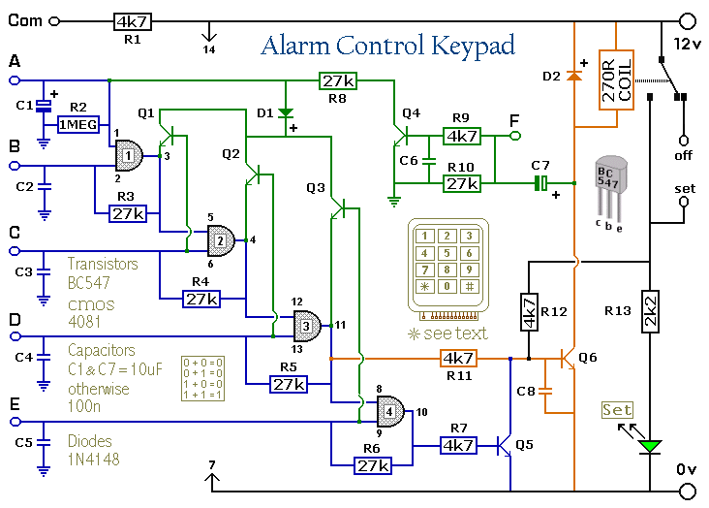
Notes:
This switch will suit the Modular Burglar Alarm circuit. However, it also has other applications. The Keypad must be the kind with a common terminal and a separate connection for each key. On a 12-key pad, look for 13 terminals. The matrix type with 7 terminals will NOT do. Choose the five keys you want as your code, and connect them to 'A, B, C, D & E'. Wire the common to R1 and all the remaining keys to 'F'. Because your choice can include the non-numeric symbols, almost 100 000 different codes are available. The Alarm is set using the first four of your five chosen keys. When 'A, B, C & D' are pressed in the right order and within the time set by C1 and R2 (about 10 seconds), current through R11 switches Q6 on. The relay energizes, and then holds itself on by providing base current for Q6 through R12. The 12-volt output switches from the "off " to the "set " terminal, and the LED lights. To switch the Alarm off again it is necessary to press A, B, C, D & E in the right order. The IC is a quad 2-input AND gate, a Cmos 4081. These gates only produce a high output when both inputs are high. Pressing 'A' takes pin 1 high for a period of time set by C1 and R2. This 'enables' gate 1, so that when 'B' is pressed, the output at pin 3 will go high. This output does two jobs. It locks itself high using R3 and it enables gate 2 by taking pin 5 high. The remaining gates operate in the same way, each locking itself on through a resistor and enabling its successor. If the correct code is entered within the time allowed, pin 10 will switch Q5 on and so connect the base of Q6 to ground. This causes Q6 to switch off and the relay to drop out. Any keys not wired to 'A, B, C, D or E ' are connected to the base of Q4 by R9. Whenever one of these 'wrong' keys is pressed, Q4 takes pin 1 low. This removes the 'enable' from gate 1, and the code entry process fails. If C, D or E is pressed out of sequence, Q1, Q2 or Q3 will also take pin 1 low, with the same result. You can change the code by altering the keypad connections. If you make a mistake entering the code, just start again. If you need a more secure code you can use a bigger keypad with more 'wrong' keys wired to 'F'. A 16-key pad gives over half a million different codes. All components are shown lying flat on the board; but some are actually mounted upright. The links are bare copper wires on the component side. Two of the links must be fitted before the IC.
Veroboard Layout
