Modular Burglar Alarm
Circuit: Ron J
Email Ron
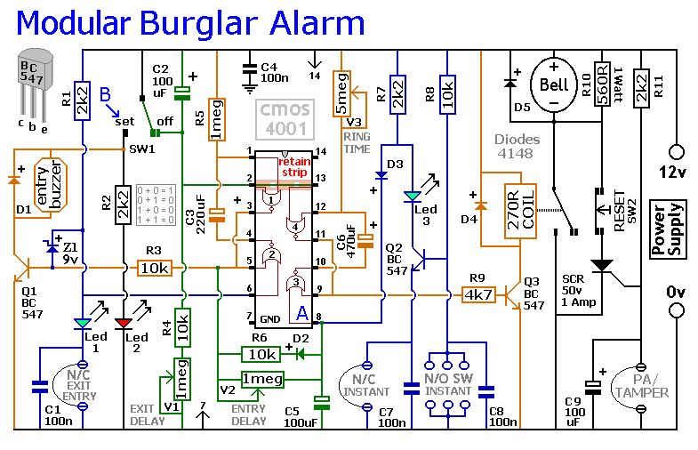
This circuit features automatic Exit and Entry delays and a timed Bell Cut-off. It has provision for both normally-closed and normally-open contacts, and a 24-hour Personal Attack/Tamper zone. It is connected permanently to the 12-volt supply and its operation is "enabled" by opening SW1. By using the expansion modules, you can add as many zones as you require; some or all of which may be the inertia (shock) sensor type. All the green LEDs should be lighting before you open SW1. You then have up to about a minute to leave the building. As you do so, the Buzzer will sound. It should stop sounding when you shut the door behind you. This indicates that the Exit/Entry loop has been successfully restored within the time allowed. When you re-enter the building you have up to about a minute to move SW1 to the off position. If SW1 is not switched off in time, the relay will energise and sound the main bell. It will ring for up to about 40 minutes. But it can be turned off at any time by SW1. The "Instant" zone has no Entry Delay. If you don't want to use N/O switches, leave out R8, C8 and Q2; and fit a link between Led 3 and C7. The 24 Hour PA/Tamper protection is provided by the SCR/Thyristor. If any of the switches in the N/C loop is opened, R11 will trigger the SCR and the bell will ring. In this case the bell has no time limit. Once the loop is closed again, the SCR may be reset by pressing SW2 and temporarily interrupting the current flow. The basic circuit will be satisfactory in many situations. However, it's much easier to find a fault when the alarm is divided into zones and the control panel can remember which zone has caused the activation. The expansion modules are designed to do this. Although they will work with the existing instant zone, they are intended to replace it. When a zone is activated, its red LED will light and remain lit until the reset button is pressed. All the modules can share a single reset button.
The Modular Burglar Alarm Support Material includes the stripboard layout of the prototype, a parts list, a complete circuit description and more.
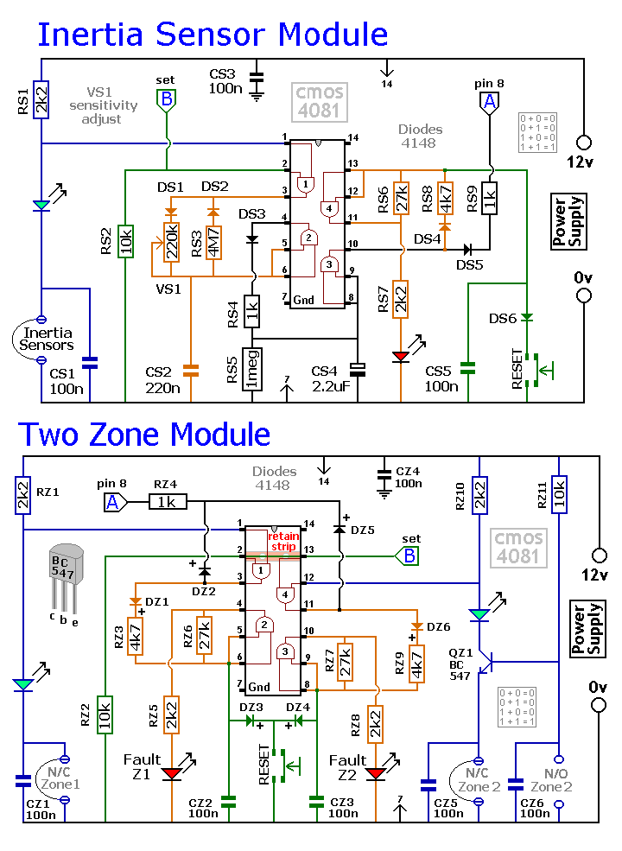

Return to Alarm Circuits

